

**Sri Lanka Institute of Information Technology**

**HEALTHCARE HOSPITAL MANAGEMENT SYSTEM**

**Assignment 2020**

**Project ID: S1152.3**

IT17041126-Gamlath G.R.N.A

IT17049382-Senarathna J.C

IT16109254-Wijethunga H.N.W

IT17004978-Kariyawasam K.M.T.R

IT17142656-Madushanka R.M.J

IT15089700-P.S.N Fernando

# Repository link

<https://github.com/newilksliit/IT3030PAF2020_GroupProject_GroupS1152.3>

Contents

Member Details 2

SE Methodology 3

Gantt chart 4

Requirements 4

Stakeholder Analysis (Onion Diagram) 4

Requirements Analysis 4

Functional Requirements 4

Non-Functional Requirements 5

Technical Requirements 5

Requirement Modeling (Use case diagram) 6

Systems’ Overall Design 6

Overall Architecture 6

Overall DB design (ER) 6

Activity Diagram 7

Individual Components 7

Registration and Login 7

Class Diagram 7

Activity Diagram 7

Online Appointments making 8

Class Diagram 8

Activity Diagram 8

Online Payment 9

Class Diagram 9

Activity Diagram 9

References 10

# Member Details

|  |  |  |
| --- | --- | --- |
| **Student ID** | **Name** | **Workload Distribution** |
| IT17041126 | Gamlath G.R.N.A | Users, doctors and hospitals must register to the system in order to use this system. Registered users and doctors must login to the system. |
| IT17049382 | Senarathna J.C | Registered users can make appointments with the registered doctors who visit the registered hospitals. |
| IT16109254 | Wijethunga H.N.W | Registered users can make payments for their appointments online. |

# SE Methodology

This project followed Agile Model for development. This project was built with the assumption that the end users’ needs are ever changing in a dynamic medical environment. Agile is all about teamwork, transparency, and technical excellence.

# Gantt chart

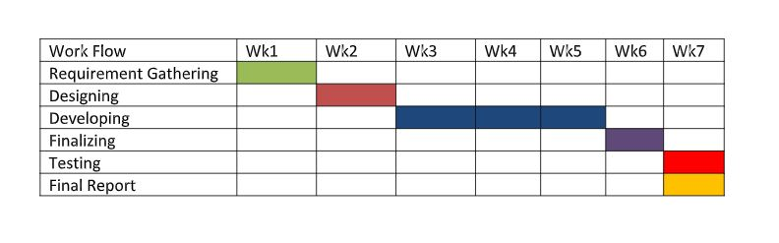

# Requirements

## Stakeholder Analysis (Onion Diagram)

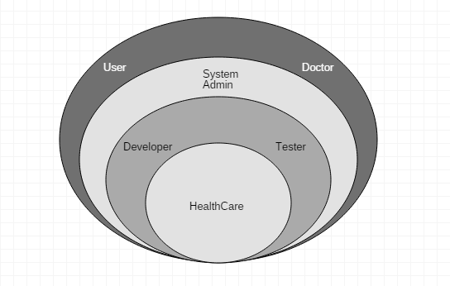

## Requirements Analysis

### Functional Requirements

* In order to use this hospital management system, hospitals, doctors and users must register with the system.
* Registered users can make appointments with the registered doctors who visit the registered hospitals.
* Users are able to add appointments/remove appointments after logging in to the system.
* Users are able to make payments for their appointments online.

### Non-Functional Requirements

* The system must automatically logout all users after a period of inactivity.
* The system provides storage of all databases on redundant computers with automatic switchover.
* The systems’ backend servers shall only be accessible to authenticated administrators.

### Technical Requirements

* Availability
* Open-Source

## Requirement Modeling (Use case diagram)

# Systems’ Overall Design

## Overall Architecture

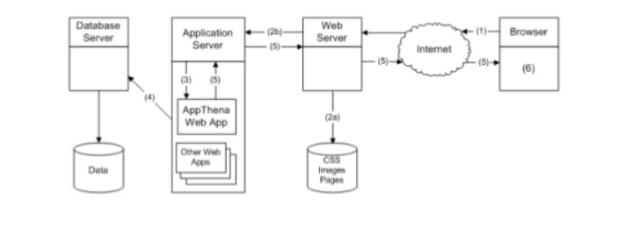

## Overall DB design (ER)

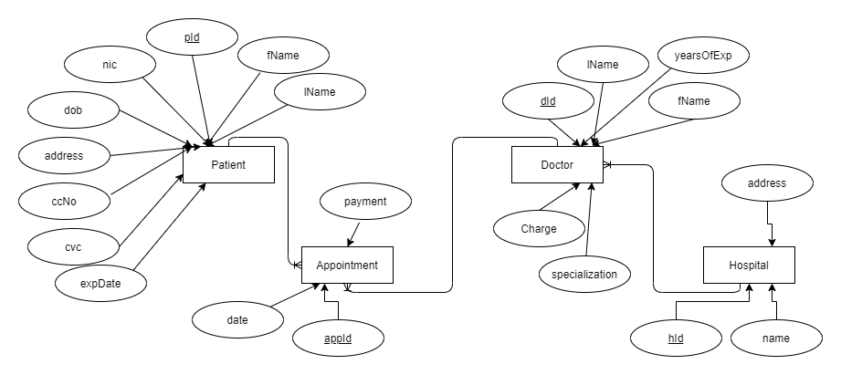

## Activity Diagram

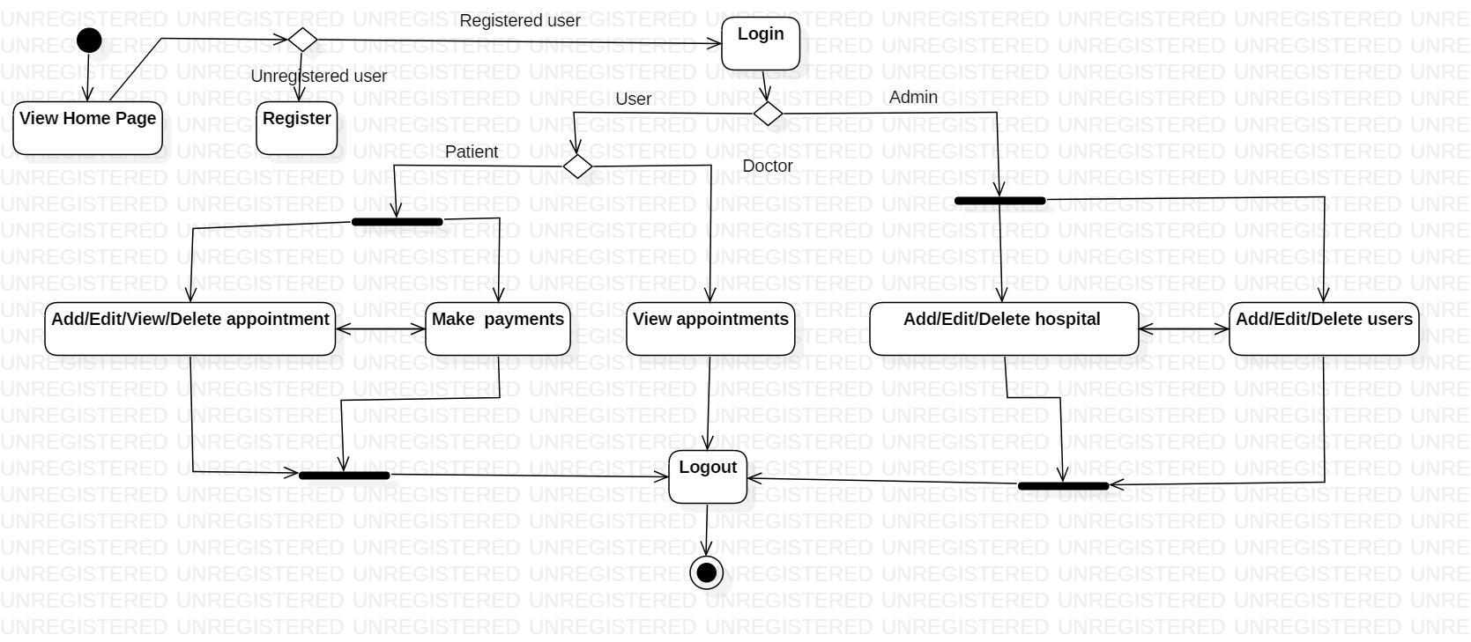

**Sequence Diagram**

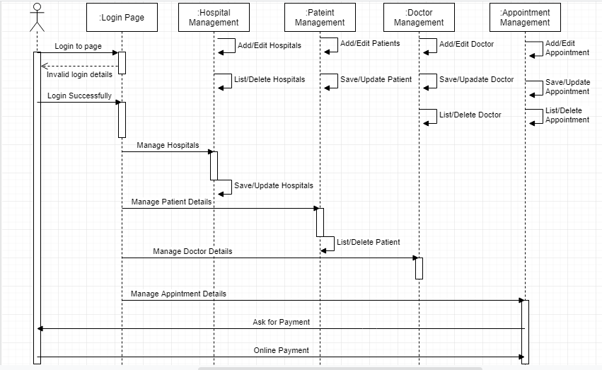

# Individual Components

## Registration and Login

Users, doctors and hospitals must register to the system in order to use this system. Registered users and doctors must login to the system. It is assumed that the Admin is the one who can register hospitals in the system.

### Class Diagram

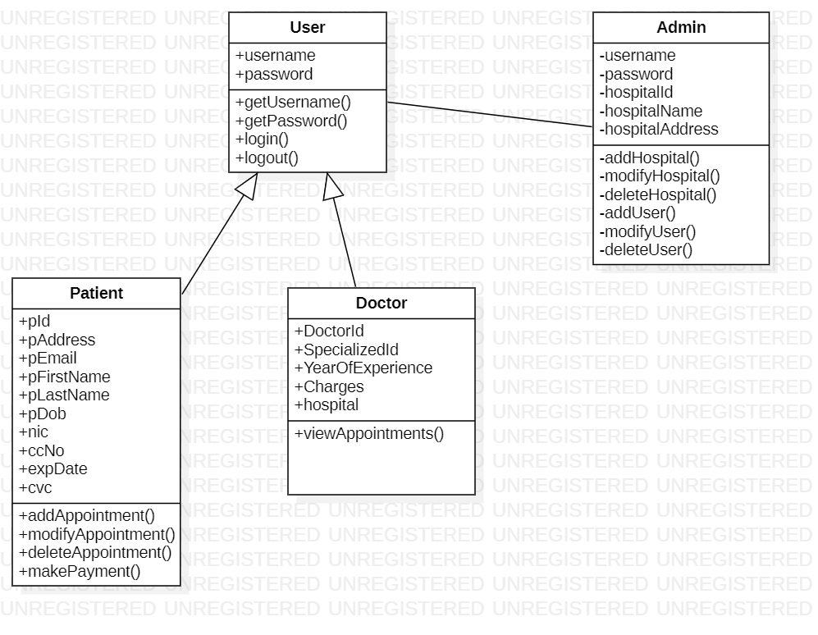

### Activity Diagram

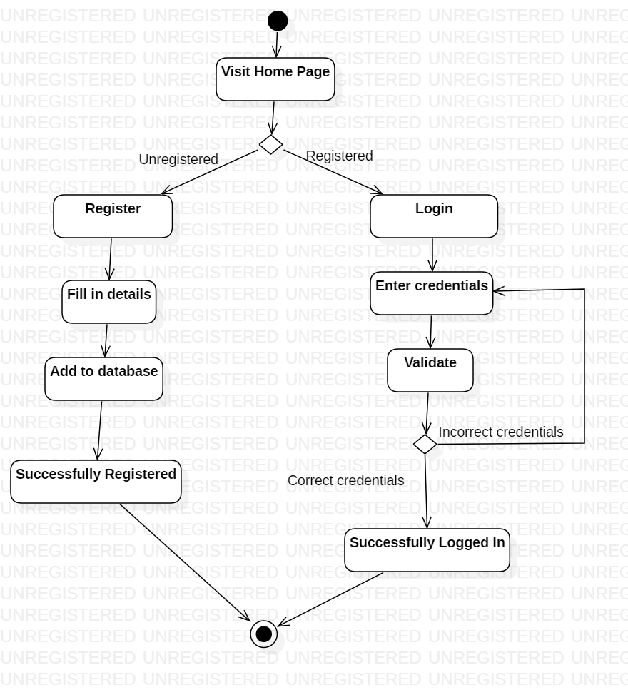

## Online Appointments making

Registered users can make appointments with the registered doctors who visit the registered hospitals.

### Class Diagram

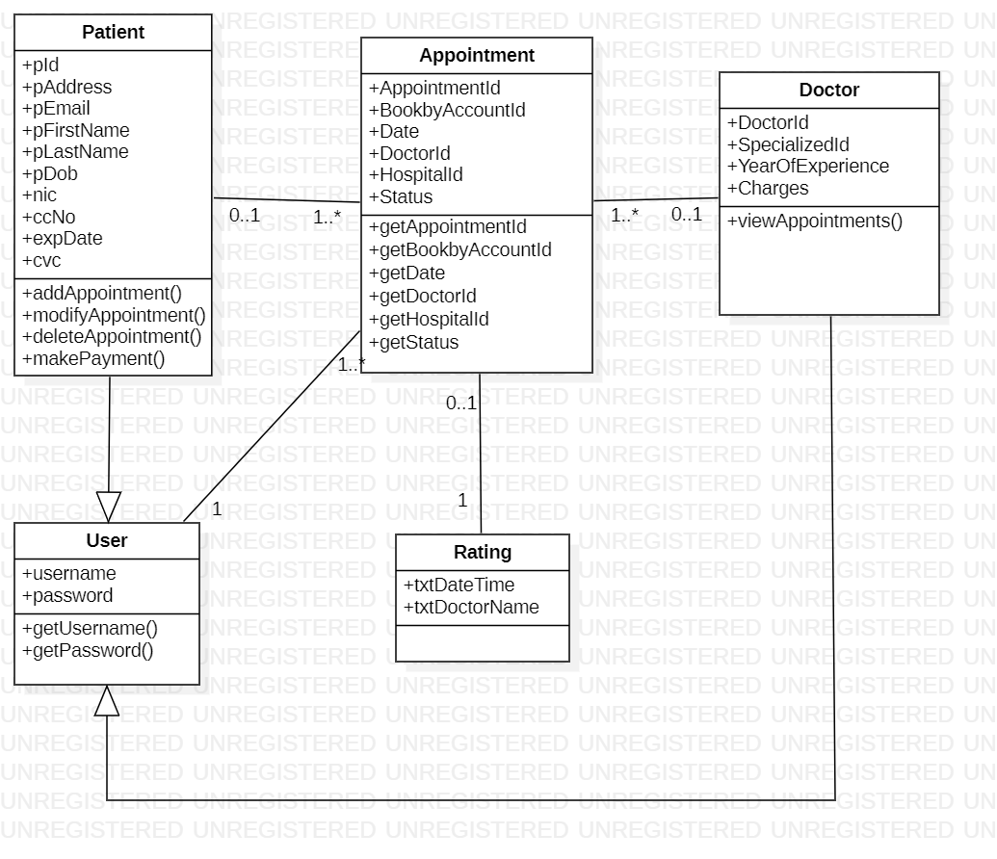

### Activity Diagram

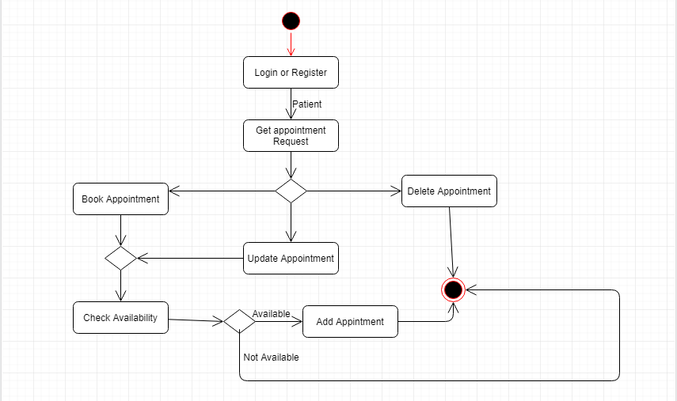

## Online Payment

Registered users can make payments for their appointments online.

### Class Diagram

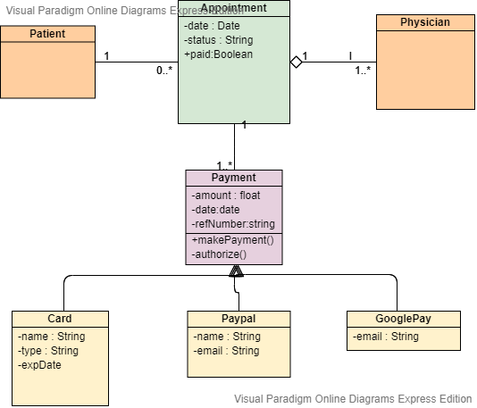

### Activity Diagram

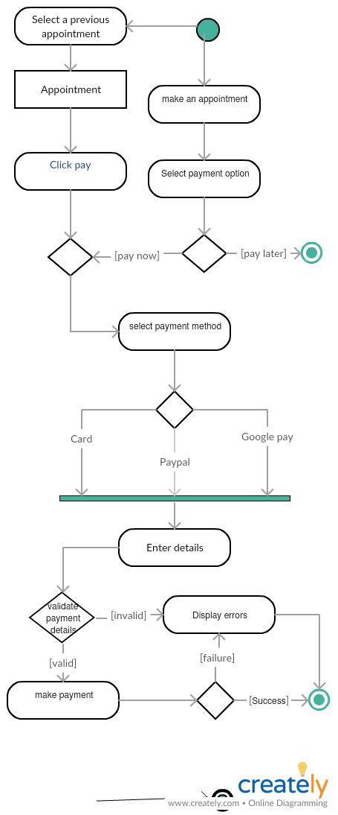

# References

<https://stackoverflow.com>

<https://www.youtube.com>

<https://www.wikipedia.com>