**Executive Summary**

As US-China relations continue to fracture, Beijing backed representatives are increasingly turning towards Twitter to shape public opinion. The Chinese Communist Party (CCP) has long wielded the powers of social media to achieve domestic objectives -- notably by censoring information and enacting the Great Firewall -- and is now demonstrating a willingness to leverage Western technologies to further advance those goals abroad. Chinese Foreign Ministry spokesman Zhao Lijian demonstrates the growing prevalence of Twitter diplomacy, launching aggressive attacks at both the United States and Australia.

While Beijing’s foray into Western-owned social media is relatively new, the large-scaled pivot and coordinated messaging indicate a resolute effort to recalibrate and refine attempts to influence US-based audiences. Continued civil and political unrest, and the disruption caused by COVID-19, have created an opportunity for the CCP to increase activity and extend the reach of their influence apparatus. Given the myriad of domestic challenges requiring immediate attention from the incoming Biden administration, there is potential for the CCP to further hone and amplify their messaging.

This report uses tweet and account information of over 23,000 distinct Twitter accounts captured by Twitters Public Safety team to examine the effectiveness of China’s Twitter-based influence operations, and to identify major topics used throughout the campaign.

The analysis reveals:

* **The Chinese Communist Party has struggled thus far to engage with their intended audience**. A blend of newly created and poorly performing accounts propagate party sentiment, but the lack of engagement activity demonstrates an inadequate understanding on how to navigate the Western social media environment.
* **The surge in usage following sensitive internal events indicates a rallying towards topics and a coordinated effort to promulgate views.**
* The influence operation has largely focused on (3) key issues, including shaping sentiments around Chinese dissident and millionaire **Guo Wengui**, targeting the **Hong Kong** protests, and continued defense on handling of **COVID-19**.

## **Engagement Metrics**

Between April 2020 and June 2020, roughly 350,000 distinct tweets were sent by the flagged accounts. The composition of tweet language suggests clear intent and a prioritization in shaping the views of Overseas Chinese, as Chinese language messages were the most prevalent. The figure below demonstrates the top four commonly used languages by state-backed influencers, with Chinese language tweets encompassing over 80% of the tweets.

However, the engagement metrics and sophistication of the campaign pale in comparison to those launched by Russian-backed actors [1]. Without censorship, China struggles to guide conversation and galvanize public discourse. An overwhelming majority of tweets generate little to no engagement in the form of replies or likes, and most accounts are severely lacking in relationship metrics such as the number of followers.

The inability to spur discourse is further evidenced by the metrics associated with individual twitter accounts. Of the nineteen Chinese language accounts with over 500 published tweets, only three had reply levels exceeding 100 replies. Total like counts and retweet totals associated with each account yielded similar results.

*\*\*\*The chart below identifies the user accounts with over 500 distinct tweets and assigns the total like count each account has received.*

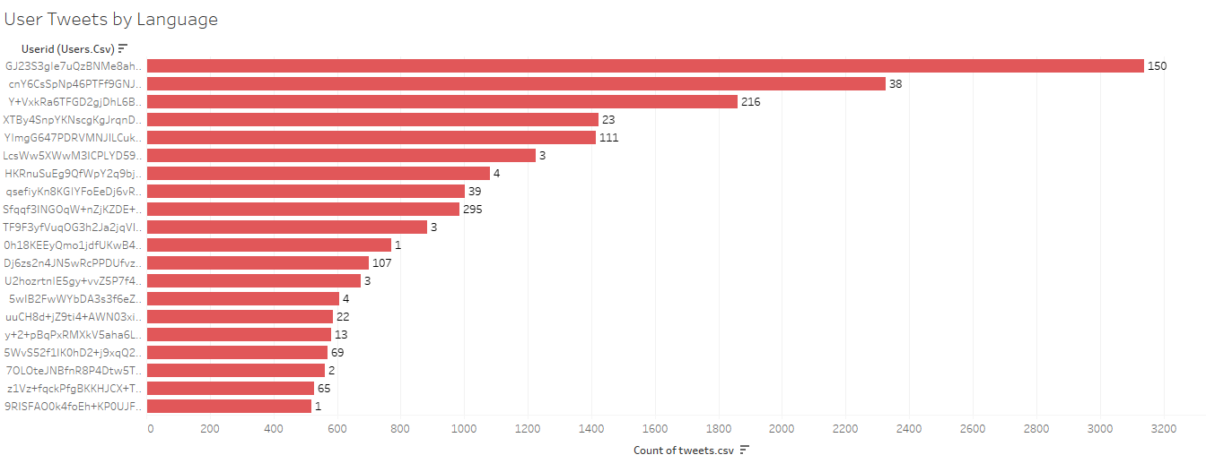

**Timeframe**

Throughout the intensifying US-China tariff war, Twitter activity from CCP-backed accounts remained rather listless, with information propagation entrusted to top-level officials. Recent activity, however, suggests Beijing has opted for a new approach, transmitting a barrage of information through an increased number of accounts. The timeline reveals a surge of activity in November 2019, coinciding with escalating tensions in Hong Kong. Notably, activity jumped dramatically following the stand-off at Hong Kong Polytechnic University on November 17, 2019, in which several pro-democracy protestors squared off with members of the Hong Kong Police Force.

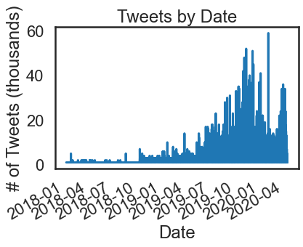

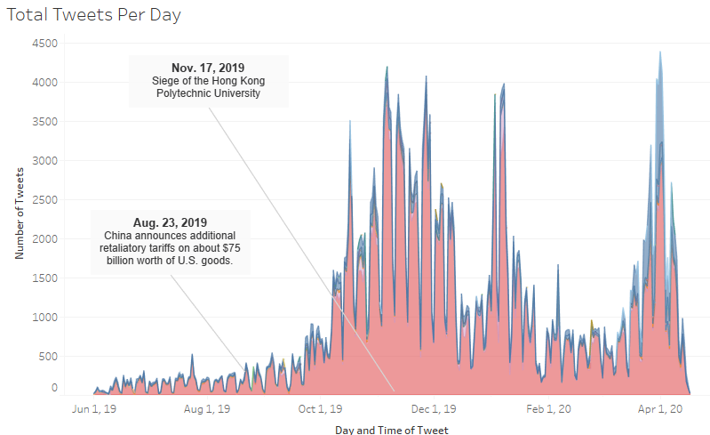

**Content**

Natural Language Processing (NLP) and Machine Learning tools were employed to parse text and identify major themes reverberated throughout the campaign. This study was conducted by parsing the content of the tweet. The analysis indicates that three main topics are prominently featured: Guo Wengui (Miles Guo), Hong Kong, and COVID-19.

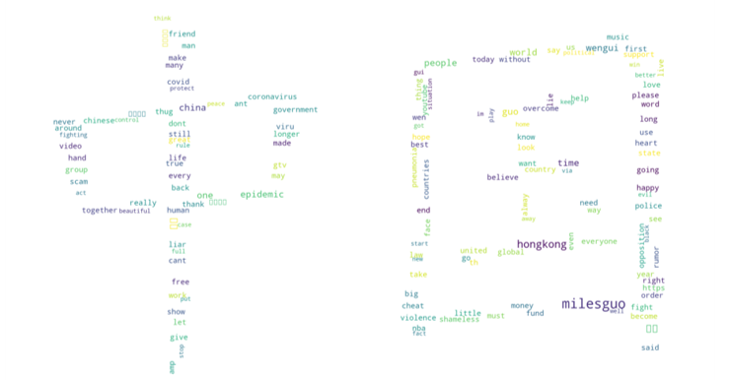The influence operation has incorporated and coupled several US domestic issues with pro-Chinese narratives, likely to highlight contradictions in US foreign policy. This is exuded in comparing the US handling of Black Lives Matter (BLM) demonstrations to those in Hong Kong.

The Tri-gram table denotes the most frequently used word pairings in the data set and was generated using the Python NLTK library. The results, particularly for tri-gram ID 2, 3, and 4, indicate a more aggressive tone and sentiment when providing information on Guo Wengui.