Topic | Type | Description
/world/world_demo/dynamic_pose/info | Pose | Full state (pose & twist) of all dynamic entities
/world/world_demo/model/tugbot/joint_state | JointState | All joint positions, velocities & efforts
Camera Back (RGB)
/world/.../link/camera_back/sensor/color/camera_info | CameraInfo (RGB) | Intrinsics & distortion parameters
/world/.../link/camera_back/sensor/color/image | Image (RGB) | Raw color frames
Camera Back (Depth)
/world/.../link/camera_back/sensor/depth/camera_info | CameraInfo (Depth) | Intrinsics for depth sensor
/world/.../link/camera_back/sensor/depth/depth_image | Image (Depth) | Depth image (per‐pixel distance)
/world/.../link/camera_back/sensor/depth/depth_image/points | PointCloud | Unprojected 3D point cloud
Camera Front (RGB)
/world/.../link/camera_front/sensor/color/camera_info | CameraInfo (RGB) | Intrinsics & distortion parameters
/world/.../link/camera_front/sensor/color/image | Image (RGB) | Raw color frames
Camera Front (Depth)
/world/.../link/camera_front/sensor/depth/camera_info | CameraInfo (Depth) | Intrinsics for depth sensor
/world/.../link/camera_front/sensor/depth/depth_image | Image (Depth) | Depth image (per‐pixel distance)
/world/.../link/camera_front/sensor/depth/depth_image/points | PointCloud | Unprojected 3D point cloud
Gripper Contact
/world/.../link/gripper/sensor/sensor_contact/scan | ContactScan | Distance readings around gripper
/world/.../link/gripper/sensor/sensor_contact/scan/points | PointCloud | Points where contact sensor “hits”
IMU
/world/.../link/imu_link/sensor/imu/imu | IMU | Accelerometer + gyroscope
Lidar
/world/.../link/scan_front/sensor/scan_front/scan | LaserScan (front) | 2D range scan
/world/.../link/scan_front/sensor/scan_front/scan/points | PointCloud (front) | 3D points from front lidar
/world/.../link/scan_back/sensor/scan_back/scan | LaserScan (rear) | 2D range scan
/world/.../link/scan_back/sensor/scan_back/scan/points | PointCloud (rear) | 3D points from rear lidar
/world/.../link/scan_omni/sensor/scan_omni/scan | LaserScan (omni) | 360° 2D range scan
/world/.../link/scan_omni/sensor/scan_omni/scan/points | PointCloud (omni) | 3D points from omni‐directional lidar

- Launch simulation (Gazebo or Isaac)
- Manually drive robot using keyboard or joystick
- Record data using a Python script or ROS2 bag
- Extract frames + commands, resize, and store
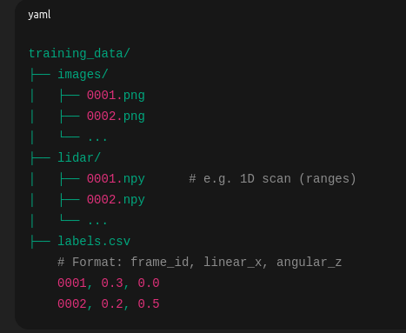

Architecture Overview I

🔹 Input:
- image_seq: (Batch, Time, 1, 64, 64)
- lidar_seq: (Batch, Time, 64) → 64-beam LiDAR data

🔹 Model Flow:
- CNN processes each frame → image_features
- FC network processes each LiDAR scan → lidar_features
- Both are concatenated into fused_features[t]
- Fused features are passed through LTC neurons using odeint over time
- Final hidden state is used to predict [linear_x, angular_z]

Architecture Overview II
Input: (Batch, Time, 1, 64, 64) → 10 grayscale frames
CNN: Extracts spatial features from each frame
LNN: Evolves features over time using LTC neurons
Output: (Batch, 2) → [linear_x, angular_z]

Input sequence (video clip)
────────────────────────────────────────────────────────────────────────────
Shape: (B, T, 66, 200, 3)

│
▼
[TimeDistributed CNN encoder] ← same CNN applied to EACH frame independently
────────────────────────────────────────────────────────────────────────────
For every t = 1..T:
(66,200,3) ─Conv5x5,s2→ (31,98,24)
Conv5x5,s2→ (14,47,36)
Conv5x5,s2→ ( 5,22,48)
Conv3x3,s1→ ( 3,20,64)
Conv3x3,s1→ ( 1,18,64)
Flatten → (1152)
Dense100 → (100)
Dense50 → ( 50)
Dense128 → (128) = per-frame feature x_t

Stack features over time:
Output shape after TimeDistributed CNN: (B, T, 128)

│
▼
[Liquid core: CfC (ncps)] ← the "liquid neurons" live here
────────────────────────────────────────────────────────────────────────────
RNN over time:
h_t = CfC(x_t, h_{t-1}) (continuous-time dynamics with learnable time constants)

Input shape : (B, T, 128)
Output shape: (B, T, H) where H = hidden_dim (e.g., 128 liquid neurons)

│
▼
[TimeDistributed Steering Head]
────────────────────────────────────────────────────────────────────────────
For every t:
h_t → Dense64(ReLU) → Dense1(linear) → ŷ_t (predicted steering at time t)

Output shape: (B, T, 1)
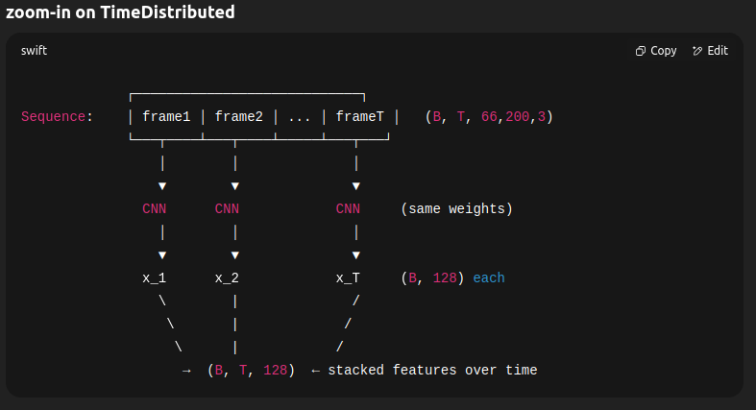
load a batch → CNN encode → CfC → output → backprop → next batch.
Quick decision tree
Train 1×CfC(128).
  - Underfits? → try 1×CfC(192) or (256).
  - Still underfits? → 2×CfC (128→64) with dropout 0.15 and clipnorm.
  - Overfits? → reduce hidden_dim or increase regularization/augmentation.

Imu senosr topic
entity_name: "tugbot::imu_link::imu"
orientation {
x: 4.7667540498731861e-07
y: 3.5466561305861331e-07
z: 0.59846353674410624
w: 0.80115004536440171
}
angular_velocity { rad/s
x: 4.7045270970681156e-14
y: -5.2406113955569839e-14
z: 3.0809133840712358e-15
}
linear_acceleration { m/s2
x: 2.2191654280798264e-08
y: 1.164519685164992e-05
z: 9.8000000000008214 gravity
}

header {
stamp {
sec: 1182
nsec: 990000000
}
data {
key: "frame_id"
value: "tugbot::imu_link::imu"
}
data {
key: "seq"
value: "2957"
}
}

bridge the topic
ros2 run ros_gz_bridge parameter_bridge \
/world/world_demo/model/tugbot/link/camera_front/sensor/color/image@sensor_msgs/msg/Image@gz.msgs.Image \
/world/world_demo/model/tugbot/link/scan_front/sensor/scan_front/scan@sensor_msgs/msg/LaserScan@gz.msgs.LaserScan \
/model/tugbot/odometry@nav_msgs/msg/Odometry@gz.msgs.Odometry \
/model/tugbot/cmd_vel@geometry_msgs/msg/Twist@gz.msgs.Twist
inside the workspace
- chmod +x src/tugbot_recorder/tugbot_recorder/recorder.py
- colcon build
- source install/setup.bash
do this in every new terminal before running your package
- ros2 run tugbot_recorder recorder

Using Ros2 bag is option to record all the topic values and then convert or down sample the data to required format

LNN without nav2
For each timestep t, feed:
- Camera image → perceives the environment (aisles, racks, people).
- Current visible marker(s) → IDs and relative poses (distance & angle).
- Optional odometry → velocity, angular velocity (helps with smooth motion).
So input could look like:
[ image_t , visible_marker_IDs_t , relative_poses_t , odometry_t ]

LNN with nave2

