Socket Client (subscriber) Documentation

Code explanation

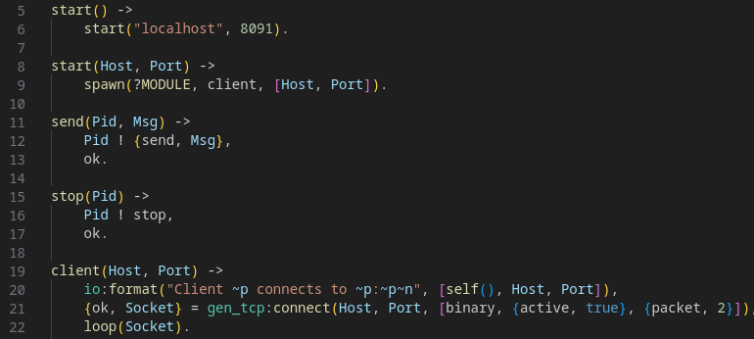

start spawns client.

client opens a connection socket and then just idles forever with function loop().

You can start client on any host and port. To do it use subscriber:start(Host,Port)
or subscriber:start_server() w/o any arguments to start server on default host “localhost” and port 8091

On 21 string specified that program receive:

1. binary data and receive them how messages cause of {active, true}
2. a 2-byte service packet cause of {packet, 2}
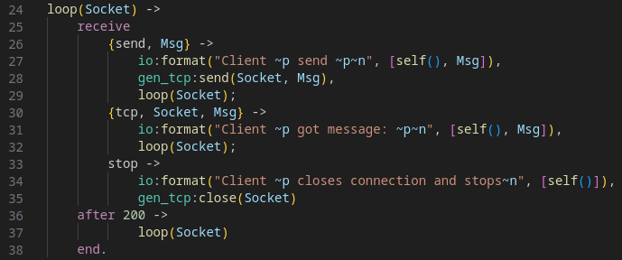
Client can send() messages, and got messages. Also client can stop() connection. Аfter using the above functions, the program calls loop again

Example of session
