**Socket Client (subscriber) Documentation**

**Code explanation**

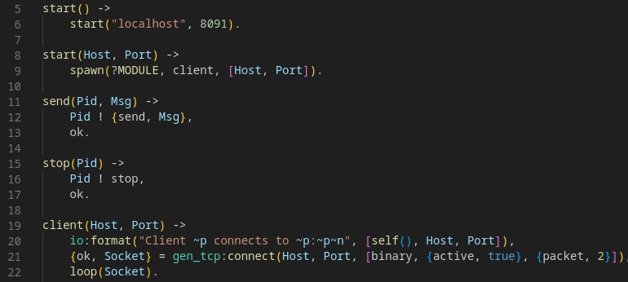

*start* spawns client.

*client* opens a connection socket and then just idles forever with function *loop()*.

You can start client on any host and port. To do it use *subscriber:start(Host,Port)*

or *subscriber:start_server()* w/o any arguments to start server on default host “localhost” and port 8091

On 21 string specified that program receive:

1. binary data and receive them how messages cause of *{active, true}*

2. a 2-byte service packet cause of *{packet, 2}*

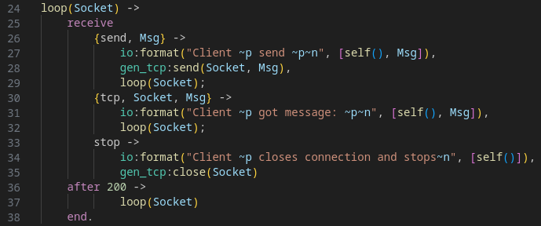

Client can *send()* messages, and got messages. Also client can *stop()* connection. Аfter using the above functions, the program calls loop again

**Example of session**

