# Functional Requirements

1. For every animal it is associated an employee (caretaker) which takes care of: the history of that animal, routine, disposition, medical, documents, notes etc
2. The application have different users which can have multiple roles: administrator, simple user, moderator. Depending on the role each user have some rights in the application.
3. The application offers the possibility to operate CRUD modification for all persisted entities from domain model. The Create, Update and Delete operations can be done only by the user with the role of administrator.
4. An animal can have multiple state: NEW, ADOPTED, SICK, AGRESSIVE, EUTHANIZE, HEALTHY, ISOLATED. An animal is no longer managed once it enters in EUTHANIZE state. An animal with ADOPTED state continue to exist in our system/database in order to provide any information the new owner of that animal could require, but it will be labeled with INACTIVE status.
5. A medic can prescribe treatment to an animal. The treatment will be represented by a description and o period of time in which it is applied. The type of treatment can be vaccine delousing or medication.
6. Based on the decisions taken by a medic, the state of an animal can be changed. If the medic decide that a animal can not be saved it will be euthanized.
7. The applications will manage multiple shelters in which there are multiple animals.
8. The animals from our shelters can be adopted if only their state is HEALTHY.
9. The aggresive animals and also the sick ones will be isolated.

# USE CASE diagram

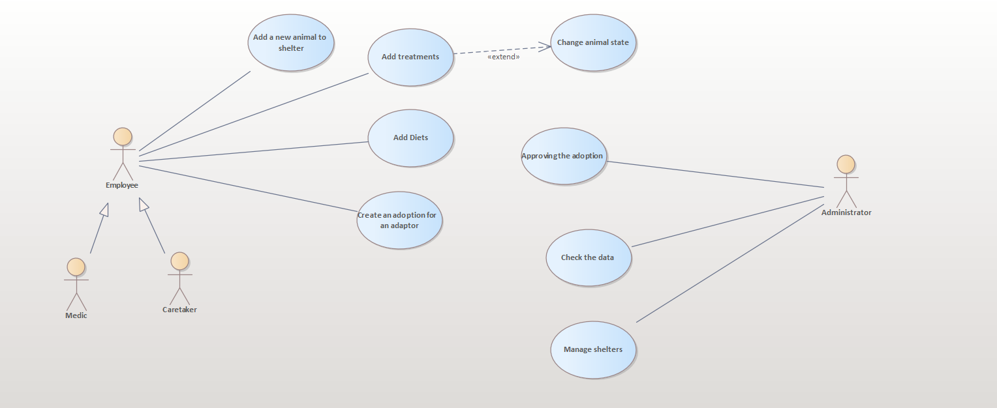

# Domain Model – Business Entitites

