Working Title
High Level Design (HLD)

CSC.154.0001 - Group 4
Eric Perry
Eric Hodge
Oras Alhammadi
George Saad
Steven Torres

February 15, 2019
Version 1.0
Revisions

Version | Primary  Author(s) | Description of Version | Date Completed
1st Draft | Eric Perry  Eric Hodge  Steven Torres  Oras Alhammadi  George Saad | Initial Draft of HLD Doc for Working Title (Group 4’s Project – Spring 2019) | 02/22/19

Review & Approval
Requirements Document Approval History

Table of Contents

Working Title 1
CSC.154.0001 - Group 4 1
1. General Description 4
1.1 Introduction 4
1.2 Scope of this Document 4
1.3 Overview 4
1.4 Division of Responsibilities 4
2. Architecture 5
3. Security 5
4. Hardware 5
5. User Interface 5
6. External Interface 5
7. Reports 5
8. Database 5
9. UML Diagrams 6
9.1 Use Case Diagram 6
9.2 Database UI Interaction Diagram 7
9.3 Application Database Interaction Diagram 8
9.4 Activity Diagram 9
9.5 Database Structure Diagram 9
9.6 Suggested WaitStaff Class Diagram 10

1. General Description

1.1 Introduction

The document is a high level design overview for (Working Title) App, an application for tracking and managing an ingredients inventory for food industry clients.

1.2 Scope of this Document

The scope of this document will cover the structure of the program, architecture, data persistence and flow, user work flow, and hardware requirements.

1.3 Overview

(Working Title) is an inventory management and tracking application that utilizes a relational database. The system stores an inventory of individual ingredients as well as tables of menu items linked to those ingredients. Users will be able to update, in real time, inventory quantities while processing orders from front house to back house. Wait staff and cooks will be notified if an order cannot be completed due to inventory shortage. Managers will be able to view ingredient and menu item history, to include frequency of use/order by period of time, as well as place orders with vendors online or print out an purchase inventory. Market prices for ingredients will also be available through third party integration of APIs/EPIs.

1.4 Division of Responsibilities

The following responsibilities have been assigned to group members:
Eric Perry – Project Manager, Front-end to Back-end Integration
Eric Hodge – Project Manager, Back-end to Database Integration
Steven Torres – Front-end design
Oras Alhammadi – Back-end design
Geroge Saad – Database design

2. Architecture
The (Working Title) app will utilize a Two-Tier Client/Server architecture to allow multiple work stations connected to a single database. The software will utilize the Model-View-Controller (MVC) architecture pattern. By utilizing MVC, the user’s computer will control data flow, presentation, and computation, freeing up the database from the responsibilities of computational processing.

3. Security
The (Working Title) app will allow for individual user accounts with password. Different levels of user accounts will dictate what application views are available to the user. The application will utilize UTF-8 encoded hash and salt implemented with Py-bcrypt.

4. Hardware
The (Working Title) app will be designed to run on work stations conforming to the Object Linking & Embedding for Retail Point of Sale (OPOS) Standard as developed for Microsoft Windows based systems as well as standard Windows based PCs.

5. User Interface
The server account user interface will offer touchscreen capability to work with common OPOS work stations and is coded with standard HTML5/CSS/JS as a single page application.
The manager account user interface will be served as a web based application, offering the ability to open new sections within their own tab.
The WaitStaff view will utilize an imaged based user interface with menu items separated into groups. When a menu item is selected, the user will have the option to change ingredients or add a note for special instructions. When submitting an order, the app will display a summary of the order and a confirmation button before submitting the order and printing the order ticket in the back house.

6. External Interface
The (Working Title) app will interface with external API/EPIs such as The Farmer’s Market API to assist with online ordering of ingredients and real time market pricing.

7. Reports
The (Working Title) app will create reports through web based application views. Reports will allow for aggregation of historical pricing and use of ingredients and dishes in a customizable time period. Additionally, reports for current inventory, inventory to order, and inventory on order will be available.

8. Database
The (Working Title) app will utilize a MySQL database for storage and retrieval of inventory, inventory quantities, menu items, archived reports, and managerial notes.

9. UML Diagrams

9.1 Use Case Diagram
Log in
Add user
Update supplier
Request notification
Take order
View invoice
Deliver order
Pay bill
Enter name
Enter password
Using port number
Display port number
After checking quality

supplier

Change password

Check notification
manager

9.2 Database UI Interaction Diagram
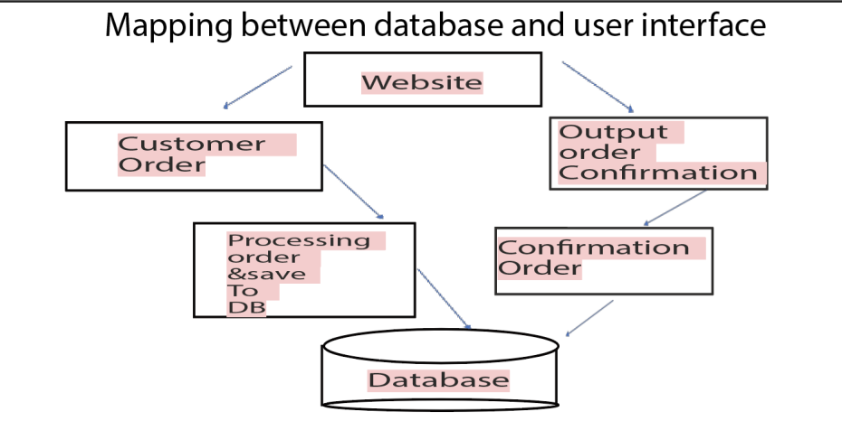

9.3 Application Database Interaction Diagram
Execution Environment Execution Environment
Python MySQL
Ingredient Management
Recipe Management

Database Subsystem
Vendor Management
Occasion Management

Updates Management
Correction Management

Order Management
Login Subsystem

9.4 Activity Diagram
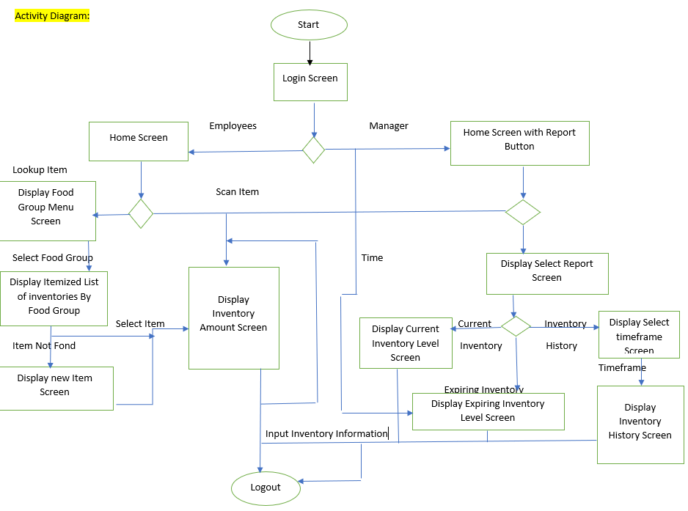

9.5 Database Structure Diagram
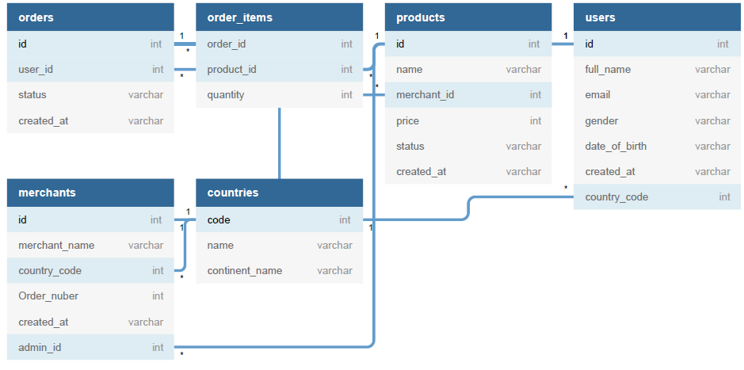

9.6 Suggested WaitStaff Class Diagram
Show below is the suggest flow and classes utilized in a WaitStaff transaction.
