Working Title
Software Requirements Specification (SRS)

CSC.154.0001 - Group 4
Eric Perry
Eric Hodge
Oras Alhammadi
George Saad
Steven Torres

February 15, 2019
Version 1.0
Revisions

Version | Primary  Author(s) | Description of Version | Date Completed
1st Draft | Eric Perry  Eric Hodge  Steven Torres  Oras Alhammadi  George Saad | Initial Draft of SRS Doc for Working Title (Group 4’s Project – Spring 2019) | 02/15/19

Review & Approval
Requirements Document Approval History

Table of Contents

Working Title 1
CSC.154.0001 - Group 4 1
1. General Description 4
2. Business Requirements 5
3. User Requirements 5
4.1 User Interfaces 6
4.2 Hardware Interfaces 7
4.3 Communications Interfaces 7
4.4 Software Interfaces 7
5. Non-Functional Requirements 8
6. Other Non-Functional Attributes 8
7. Operational Scenarios 8
8. Preliminary Use Case Models and Sequence Diagrams 9
8.1 Use Case Model 9
8.2 Sequence Diagrams 9
9. Updated Schedule 9
10. Appendices 9
11.1 Definitions, Acronyms, Abbreviations 9

1. General Description
1.1 Introduction

The document is a compilation of identified requirements for (Working Title) App, an application for tracking and managing ingredients inventory for food industry clients.

1.2 Scope of this Document

The scope of this document will cover various categories of requirements for the (Working Title) app. It will include user stories to highlight user work flow and identify the needs of various forms of users when utilizing the app.

1.3 Overview

(Working Title) is an inventory management and tracking application that utilizes a relational database. The system stores an inventory of individual ingredients as well as tables of menu items linked to those ingredients. Users will be able to update, in real time, inventory quantities while processing orders from front house to back house. Wait staff and cooks will be notified if an order cannot be completed due to inventory shortage. Managers will be able to view ingredient and menu item history, to include frequency of use/order by period of time, as well as place orders with vendors online or print out an purchase inventory. Market prices for ingredients will also be available through third party integration of APIs/EPIs.

1.4 Business Context

Wait staff will be able to assist with accurate inventory management by simply placing orders in the system.

2. Business Requirements
2.1 Tracking Inventory

Detailed metric tracking including ticket resolution time, requester submission method, issue cause and resolution method. Access to these metrics will allow smart business decisions in reaction to a changing environment as well as predictive decisions.

2.2 Detailed Inventory history

The system will update the database in real-time when orders are placed and compare previously recorded days or weeks for user to increase or decrease inventory count for upcoming week. There will also be a separate section to track the expiration date of each item and a place for food thrown out.

3. User Requirements
- Will be able to store menu items with the exact ingredients and cost for each menu item.
- Will be able to add, modify, or delete daily count for full weeks’ worth of inventory.
- Will be able to track the expiration date of each item and a place for food thrown out and the average amount an item is order over a week, month, and year.
- Will receive an alarm when certain inventory items are low(highlighted in yellow) or out(highlighted in red).
- Application will take orders from the front of house and send an order ticket to the kitchen.
- Application must have separate user permissions for managers, servers, cooks, and maintenance team.
4. Interface Requirements

4.1 User Interfaces

4.1.1 GUI

- The application’s GUI will be implemented within the web browser using a combination of HTML/CSS and the Bootstrap framework.
- Inventory history look-up will primarily be displayed in tabbed windows on the user’s home page. By clicking on different tabs, users can switch between the various days for comparison or editing.

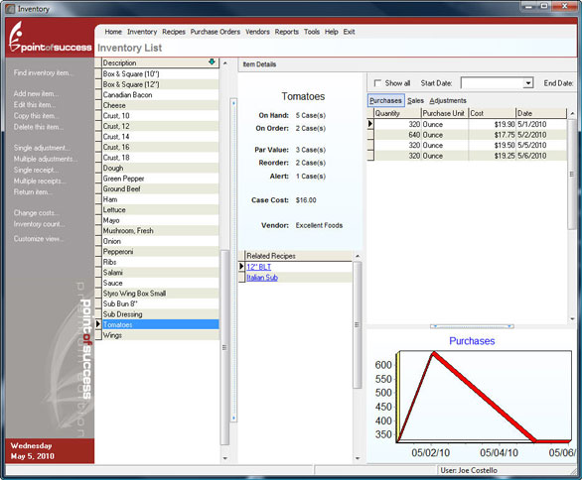
* Example user interface from a similar application (pointofsuccess.com).

4.1.2 CLI
4.1.3 API
4.1.4 Diagnostics or ROM

4.2 Hardware Interfaces

4.3 Communications Interfaces

4.4 Software Interfaces
- A Javascript back-end will provide the GUI’s functionality and database connectivity.
- An SQL database will store and serve ticket data upon request.

5. Non-Functional Requirements

- Application should be available from 9 A.M. to 11 P.M. Monday to Friday.
- Application should be able to hold 10,000 item records initially.
- Application should be able to add 10,000 records a year for 7 years.
- Application should have records available on the system for a least 7 years.
- Application should deconflict simultaneous updates from two different input sources.

6. Other Non-Functional Attributes
- Manageability
- Environmental
- Data Integrity
- Availability
- Reliability
- Recoverability
- Maintainability
- Serviceability

7. Operational Scenarios
Scenario A:

Manager:

Sits down at office computer and uses the mouse to double click to start the program, it loads up to the login page. The manager puts in there given username and password. After less than a minute the home page loads. The manager decides they want to check yesterday’s inventory used and compare it to the same day the week before. They click the tab labeled ‘Inventory History’ which takes them to a new window with multiple dropdown list where they can choose the year, month, week and day. The manager picks a day, then on the home page repeats the process to pull up another day to compare. Then the manager decides they need to change the cost of some of the ingredients because their suppliers increased the cost. On the home page they click the tab labeled ‘manual inventory update’ which will open a separate window with a list of categories of the inventory as well as a search box. The manager knows which items they have to change so they type the item in the search box which will show the item with all the associated information in an edit mode. They change the cost and then at the bottom and the top of the page there is a ‘Submit’ button that will confirm the change.

Scenario B:

Front of house staff (bartenders, server, hostess):

A couple come in to the restaurant and are greeted and sat by the hostess. The server introduces themselves and gives them water. The customers have very complicated orders. The server writes it down and then proceeds to put order in using company supplied ordering system that has all the modification buttons for the complicated customer orders. The ordering system automatically routes the information to the kitchen ticket printer and also to the inventory tracker. The inventory tracker will then make the calculation to update the database with amount of ingredients required for that menu item, also taking into account the modifications.

Scenario C:

Add Scenarios as needed:

8. Preliminary Use Case Models and Sequence Diagrams
This section presents a list of the fundamental sequence diagrams and use cases that satisfy the system’s requirements. The purpose is to provide an alternative, "structural" view of the requirements stated above and how they might be satisfied in the system.

8.1 Use Case Model

8.2 Sequence Diagrams

9. Updated Schedule
The updated PERT/GANTT chart is attached at the end of the document

10. Appendices

11.1 Definitions, Acronyms, Abbreviations
Front of House – FOH
Back of House – BOH
Management – MGM
Back House -

