Working Title
Low Level Design (LLD)

CSC.154.0001 - Group 4
Eric Perry
Eric Hodge
Oras Alhammadi
George Saad
Steven Torres

May 2, 2019
Version 2.0
Revisions

Version | Primary  Author(s) | Description of Version | Date Completed
1st Draft | Eric Perry  Eric Hodge  Steven Torres  Oras Alhammadi  George Saad | Initial Draft of LLD Doc for Working Title (Group 4’s Project – Spring 2019) | 03/01/19
2nd Draft | Eric Perry  Eric Hodge  Steven Torres  Oras Alhammadi | Final draft for submission of the HLD | 05/02/19

Review & Approval
Requirements Document Approval History

Table of Contents

Working Title 1
CSC.154.0001 - Group 4 1
1. General Description 4
1.1 Introduction 4
1.2 Scope of this Document 4
1.3 Overview 4
1.4 Division of Responsibilities 4
1.5 Knowledge Gaps 4
2. Design Overview 5
2.1 Architecture 5
2.2 Subsystems 5
3. Access Matrix 6
4. Recommended Classes 7
5. Database 10

1. General Description

1.1 Introduction
The document is a low level design overview for (Working Title) App, an application for tracking and managing an ingredients inventory for food industry clients.

1.2 Scope of this Document
The scope of this document will describe possible classes and their inheritance hierarchies and a tentative layout of the tables for the database.

1.3 Overview
(Working Title) is an inventory management and tracking application that utilizes a relational database. The system stores an inventory of individual ingredients as well as tables of menu items linked to those ingredients. Users will be able to update, in real time, inventory quantities while processing orders from front house to back house. Wait staff and cooks will be notified if an order cannot be completed due to inventory shortage. Managers will be able to view ingredient and menu item history, to include frequency of use/order by period of time, as well as place orders with vendors online or print out n purchase inventory.

1.4 Division of Responsibilities
The following responsibilities have been assigned to group members:
Eric Perry – Project Manager, Front-end to Back-end Integration
Eric Hodge – Project Manager, Back-end to Database Integration
Steven Torres – Front-end design
Oras Alhammadi – Back-end design
Geroge Saad – Database design

1.5 Knowledge Gaps
Implementation of the application design in this document requires the use of some technologies that team members may be unfamiliar with. This section identifies technologies that may be required to produced the desired functionality of application but may not be fully represented in diagrams:
Front-End GUI: Electron
Front-Back Integration: Flask
Back-DB Integration: SQLAlchemy ORM

2. Design Overview

2.1 Architecture
The application utilizes a two tier Client/Server architecture utilizing the Model-View-Controller pattern.
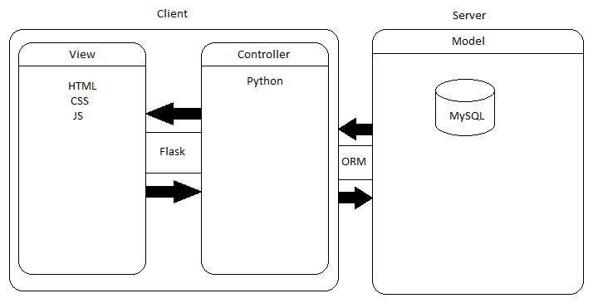

2.2 Subsystems
This section describes possible divisions of the application to be developed in Scrum Sprints.
ManagerInterface | This subsystem defines an interface between the user and the system. The user through this interface can access and execute different functions on the various subsystem.
IngredientsManagement | This subsystem provides services to manage the ingredients inventory of the system such as providing list of available ingredients, providing details of individual ingredients in term of the current inventory levels, threshold levels etc. This subsystem requires services of database subsystem to retrieve required details.
RecipeManagment | This subsystem provides services to manage the Recipes in inventory such as adding/updating/removing a recipe to/from the inventory. This subsystem requires the service of database subsystem to retrieve the list of ingredients that make up the recipe.
VendorManagement | This subsystem provides services to manage the vendor that deliver ingredients such as providing details of the vendor, providing list of ingredients that the vendor supplies. This subsystem communicates with database subsystem to retrieve the list of vendors and the ingredients list to match them with vendor names.
PredictionManagment | This subsystem provides prediction of usage per ingredient to the user. This subsystem communicates with the database to access past data of used resources from the database subsystem and then apply algorithm on the retrieved data to give estimates of usage to the user.
OrderManagement | This subsystem provides services to generate orders for vendors for the ingredients that are below threshold levels and provide like editing a generated order and cancelling a generated order.
OccasionManagment | This subsystem provides services to the user to add an occasion date to the system so that the system prepares itself for an upcoming event on which day the sales will be more than usual day sales. This subsystem requires the services of database subsystem to update/remove occasion days from the database.
CorrectionManagement | This subsystem provides services to the user to correct the levels of inventory and avoid inventory slips. The user here uses this service to match the actual inventory levels with the inventory levels in the system.
UpdatesManagement | This subsystem provides services to the user to perform update to the database.
DatabaseSubsystem | This subsystem connects to the database and provides requested database to the other subsystems that request data from it.
FrontEndManagement | This subsystem calls and shows the information on the screen for the end-user and, provides access to all the other classes and options.

3. Access Matrix
Below describes a list of classes and methods that should be visible to the user type – manager.

Class | Functions accessible to manager
Recipe | addRecipe()  removeRecipe()  updateRecipe()
Ingredient | getIngredientsList()  addIngredient()  updateIngredient()
Vendor | getVendorDetails()  getIngredientListFromVendor()
Prediction | getPredictedUsage()
Updates | updateAfterSales()  updateAfterReceiving()
Occasion | addOccasion()
Order | sendOrder()  editOrder()  cancelOrder()

4. Class Structure

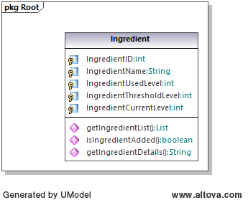

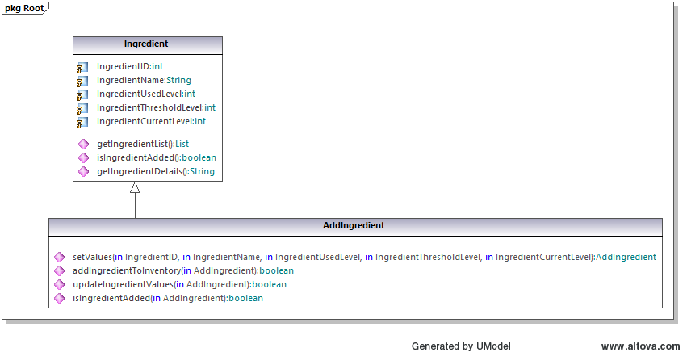

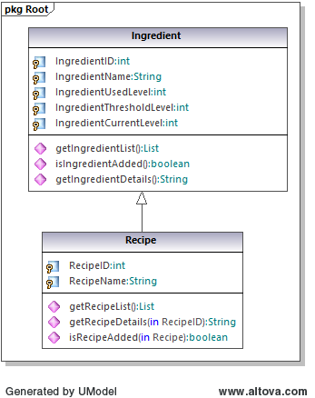

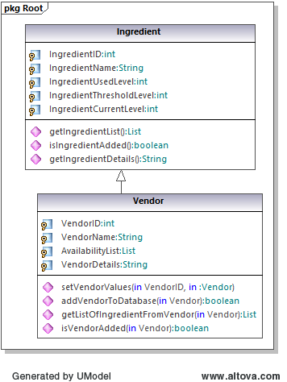

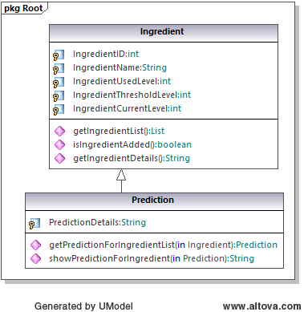

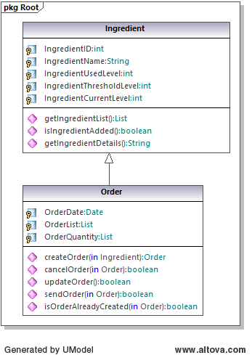
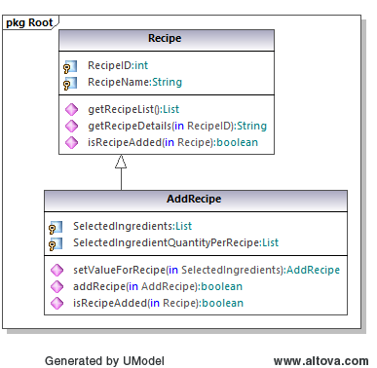
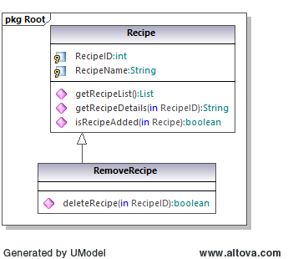

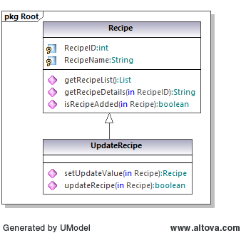
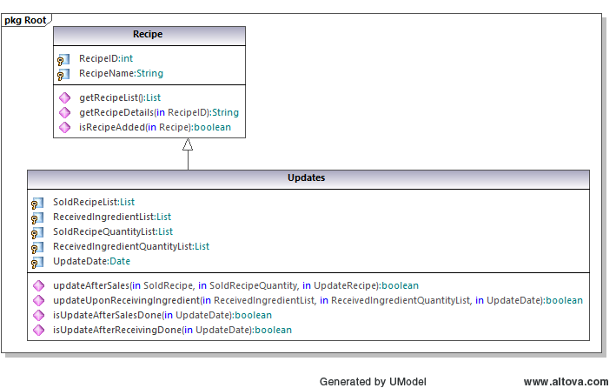

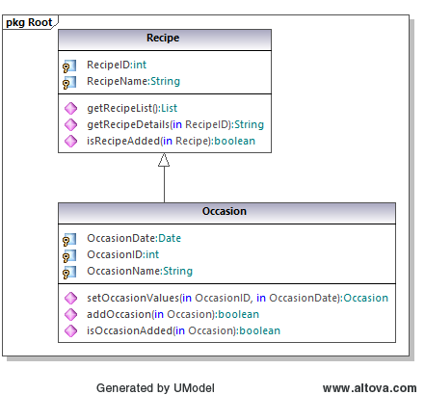

5. Database
The below diagram shows the names of tables and their fields with their relationships.
