# ________________________________________________________________

**CSC174 server-side javascript**

________________________________________________________________________

# Unit 06 LAB: Wake tech credit uNion web site

# Objectives

In this lab assignment, students will learn:

* understand how Node Package Manager (NPM) works to allow Node.js developers to share and consume each other's code
* use basic NPM commands to download, update, share, and remove third-party modules from the community
* understand package.json, the heart of NPM
* understand Node.js semantic versioning and popular Node.js packages

# COURSE PREPARATION

You should have done your reading assignment listed under “Reading Assignment” and “Video Assignment” sections in BlackBoard. You should also have reviewed the lecture slides in BlackBoard. There is an optional section called “In Case You Don’t Know” in BlackBoard for those who have limited exposure to JavaScript language.

# WHat to submit

For this lab you need to submit the following files:

* **app.js (Part One)**
* **Short answer questions sheet (Part Two)**

# grading rubric:

Be sure to follow the Coding Standard Guidelines. You must properly indent and comment your code. This assignment is worth 100 points. (70 points from Part One and 30 points from Part Two)

* Indent code and insert comments to document your program. [5 pts]
* Program must be implemented and run with no syntax errors. [30 pts]
* Program must be implemented and run with no logic errors. [30 pts]
* Required source files should be zipped and uploaded to BlackBoard assignment drop box before the deadline. [5 points]

# ________________________________________________________________

**Part One: A Simple hello web site**

________________________________________________________________________

**Project Description:**

You are given a Wake Tech Credit Union web site made by Node.js. It’s a fake bank your instructor made and is actually hosted at <http://wtcu.herokuapp.com/>. It has the loan calculator we did in Unit 02 Lab and Google Web Speech customer form we did in Unit 03 Lab. You can play around.

The instructor should provide you the source code in ***unit06_lab.zip*** file in BlackBoard Unit 06 Lab sections. There are many files and folders in this project seen below:

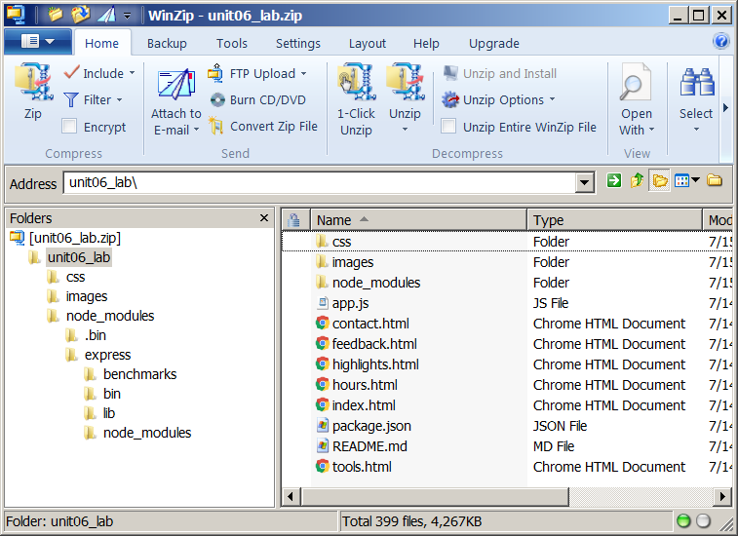

Extract this zipped file to your computer and run it from a Windows command window or MacOS terminal window using the node command like below:

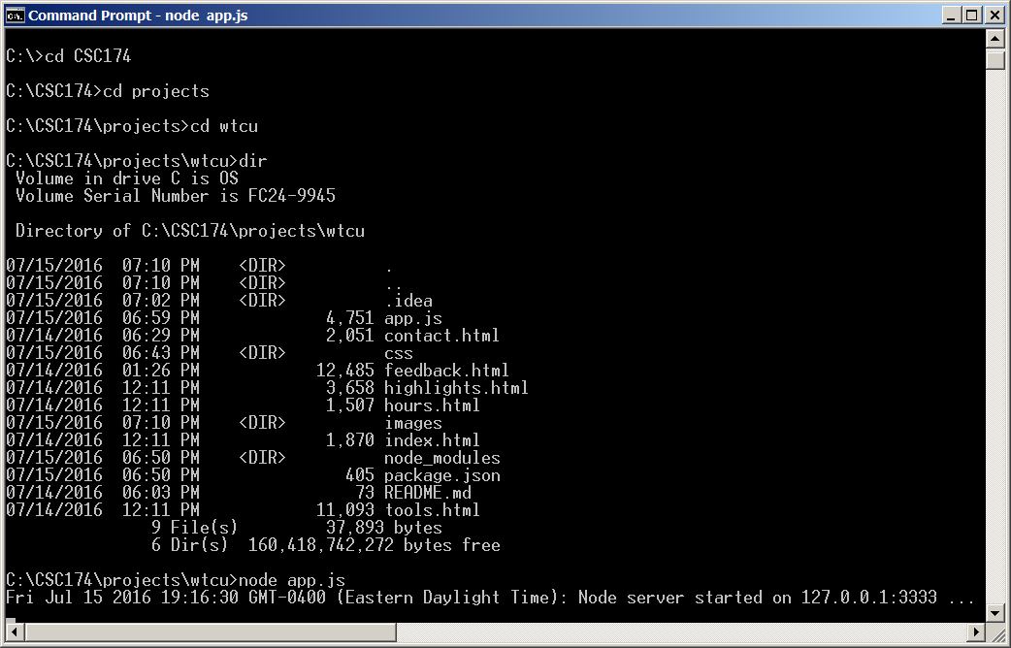

Now you have a locally deployed Wake Tech Credit Union web site at <http://localhost:3333/>. Use a browser and open it and you should see something like this:



Go to the FEEDBACK page and record some customer feedback text like below:

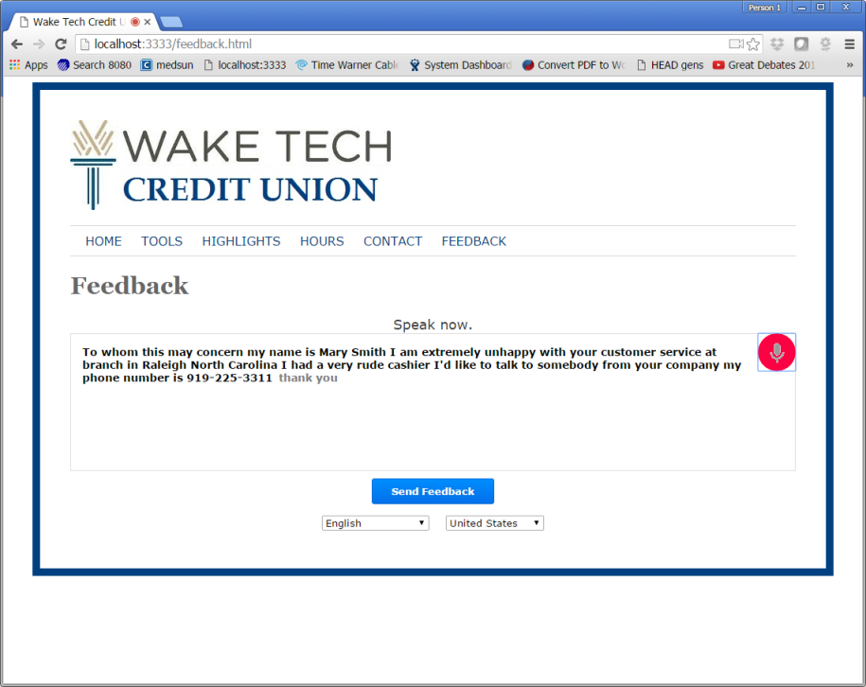

After you have sent the feedback, you should see the log in the console like below.



You can stop this program by pressing <ctrl> + C.

Your job is to use NPM to download a free module called “colors” described in our textbook. Modify app.js file so that the customer’s feedback text will be shown as green in the black console.

Here is an example:

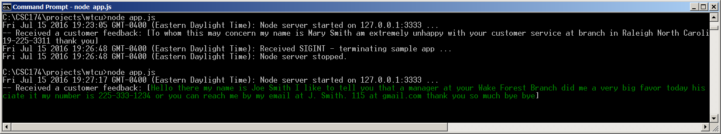

You need to submit only the modified app.js file.

# ________________________________________________________________

**Part Two: Short answer questions**

*All questions are based on the project source code provided by the instructor.

Question 1: Inside app.js there are two ***require()*** function calls. What type of modules are these? Are they third-party modules, Node.js built-in modules, or programmer defined modules? (They can be two different types. Answer for each separately if that’s the case.)

Express – a third party module

FS – a core module

Question 2: Based on the ***package.json*** file in this project, answer the following question: What is the entry point to this program?

What third-party module(s) does this project depend on?

What version is current project?

App.js

Express 3.4.8

Version 1.0.0

Question 3: What do you have to do if you decided to remove the “colors” module after you have installed it? What command do you need to run?

Have npm remove the dependencies

npm rm colors --save