# ________________________________________________________________

**CSC174 server-side javascript**

________________________________________________________________________

# Unit 10 LAB: save customer feedback to mongo db

# Objectives

In this lab assignment, students will learn:

* How to install and run a MongDB
* NoSQL database in general
* How to create, insert, update, delete, and query MongoDB from Node.js

# COURSE PREPARATION

You should have done your reading assignment listed under “Reading Assignment” and “Video Assignment” sections in BlackBoard. You should also have reviewed the lecture slides in BlackBoard. There is an optional section called “In Case You Don’t Know” in BlackBoard for those who have limited exposure to JavaScript language.

# WHat to submit

For this lab you need to submit the following files:

* **app.js**

# grading rubric:

Be sure to follow the Coding Standard Guidelines. You must properly indent and comment your code. This assignment is worth 100 points.

* Indent code and insert comments to document your program. [10 pts]
* Program must be implemented and run with no syntax errors. [40 pts]
* Program must be implemented and run with no logic errors. [40 pts]
* Required source files should be zipped and uploaded to BlackBoard assignment drop box before the deadline. [10 points]

# ________________________________________________________________

**Save Customer Feedback to a MongoDB**

________________________________________________________________________

**Project Description:**

This project is based on Wake Tech Credit Union web site we created in Unit 07 Lab. You can find all the source code from a zip file named ***unit10_lab.zip*** from BlackBoard Unit 10 lesson section. Your job is to save each customer’s feedback to a local MongoDB with the following settings:

Database URL: ***mongodb://127.0.0.1:27017/local***

Database name: ***local*** (You can deduce from the above URL.)

Collection name: ***feedback***

Document format: **{“date”: “7/16/2016”, “content”: “This is a test for customer feedback.”}**

**Hint:**

1. You need to download MongoDB and install it locally on your machine.
2. You need to make sure you have a folder ***C:\data\db*** created. This is the default location where all MongoDB’s data files are saved.
3. You need to create the collection named feedback through Mongo shell commands:

***use local***

***db.createCollection(“feedback”)***

1. You only need to change is in app.js file (Line 115 to 126).
2. To test if your program works, you need to enter some customer feedback first using Google Speech activation, or using mongo shell to manually add some documents. Then you can verify by visiting the log page: <http://localhost:3333/log>. You should see something like this:

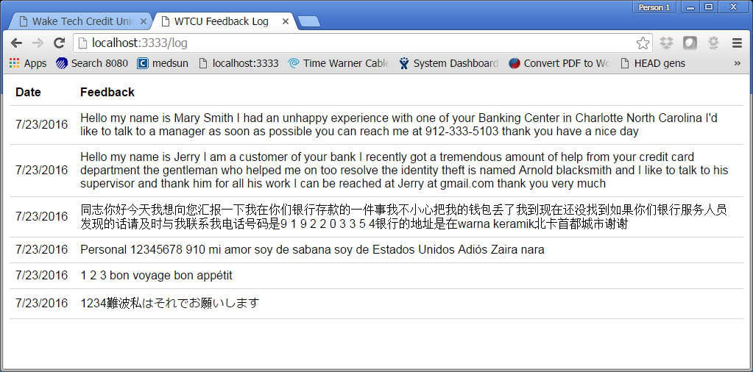

You only need to submit the modified app.js file.

# ________________________________________________________________

**How to download and install MongoDB**

________________________________________________________________________

Step 1: Go to MongoDB website and choose the latest enterprise server version for your computer. (This example shows a typical Windows machine.)

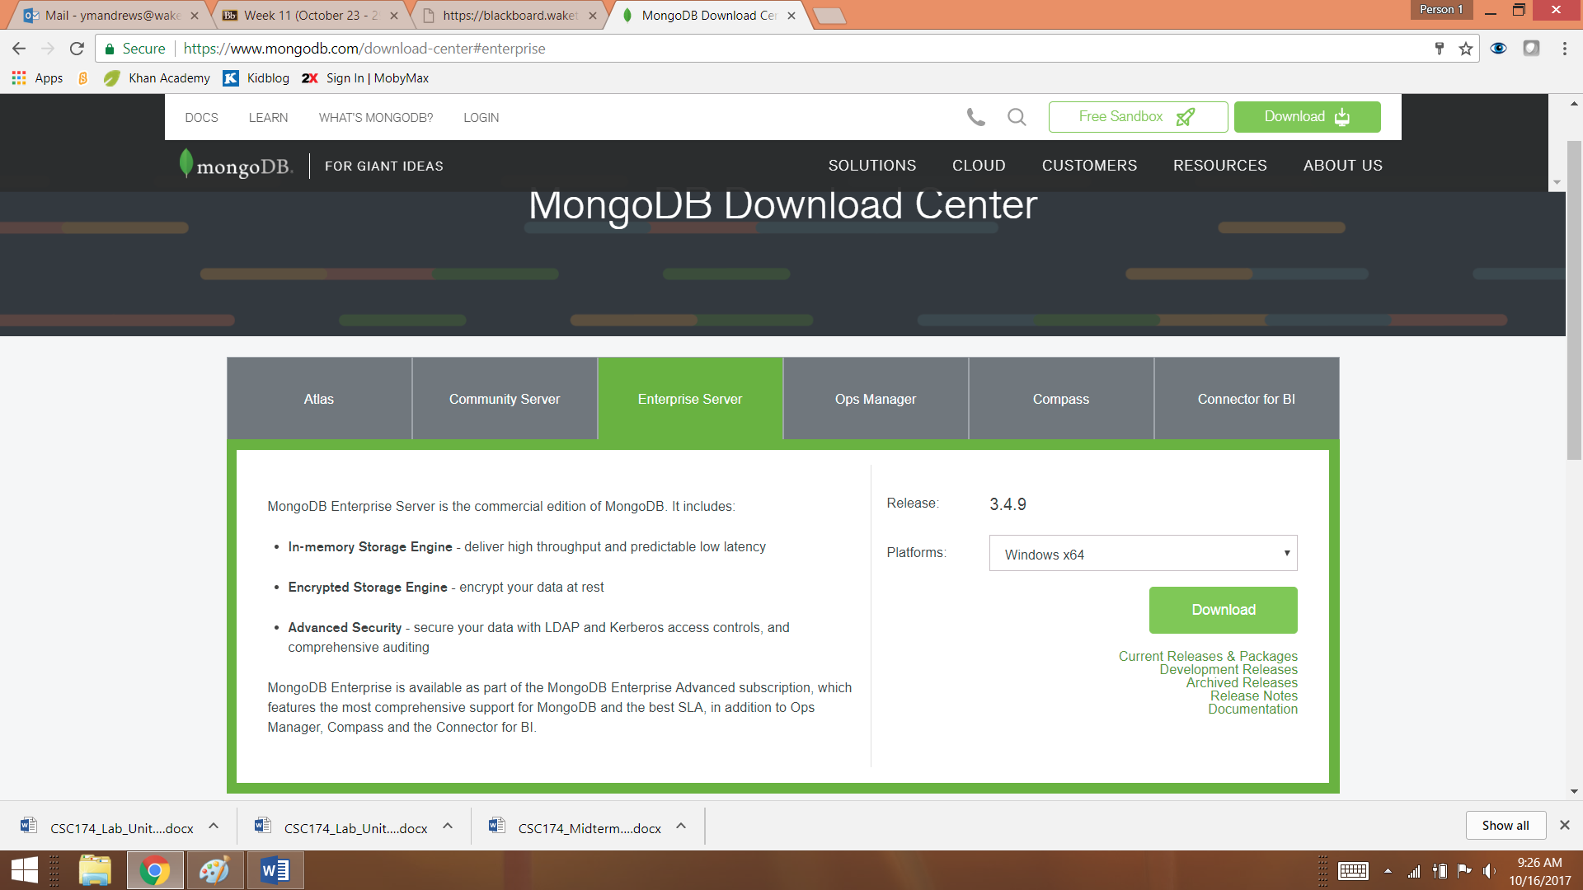

Step 2: You will be asked to fill out some information for this free product. Just use your Wake Tech information.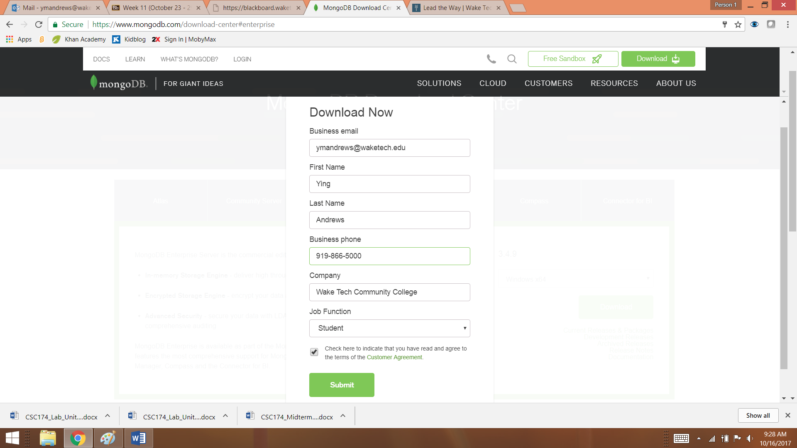

Step 3: Check “Customer Agreement” checkbox and click “Submit” button. You will be prompted with three different options to proceed: Installation Guide, archive, and msi. You can choose whichever one you like. For this example, we will choose “archive”. It will take a few minutes for the download to complete depending on your Internet speed.

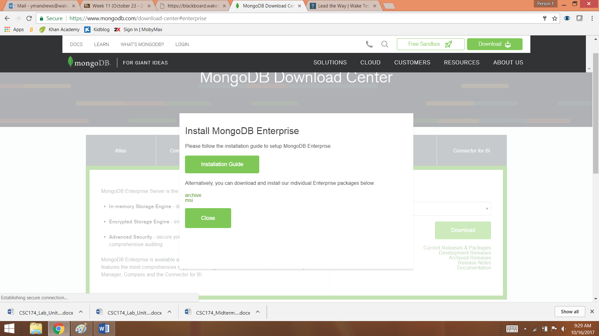

Step 4: Unzip the download file to a directory on your machine. In this example, we extract the files to C:\ drive.

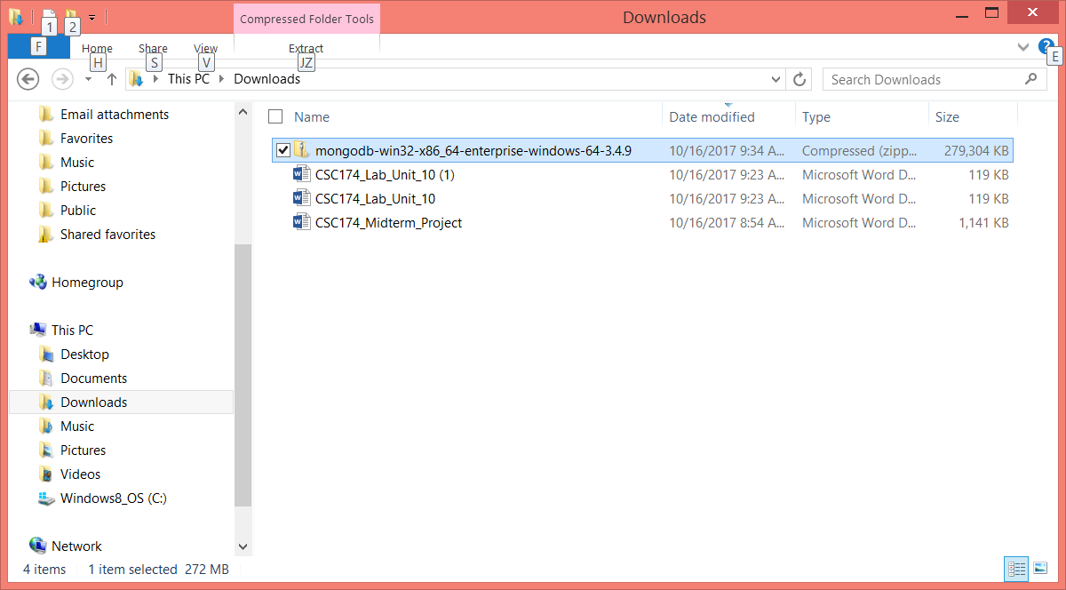

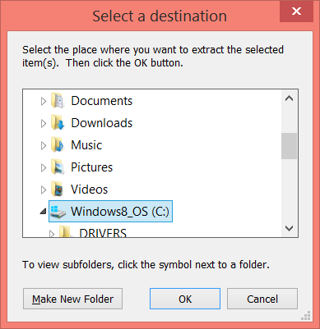 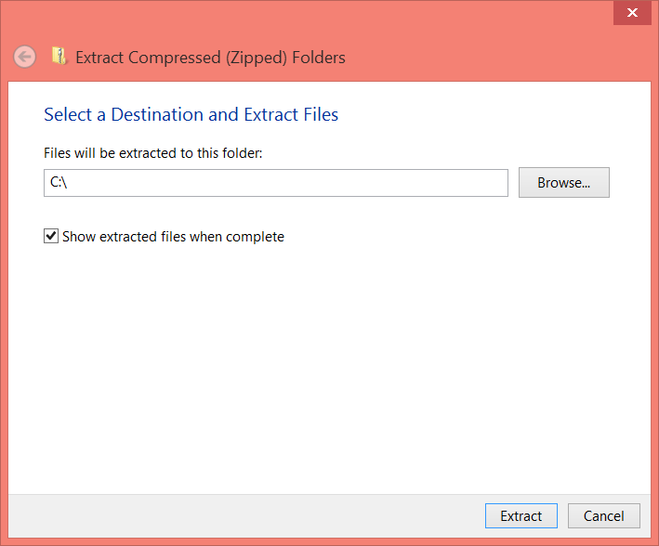

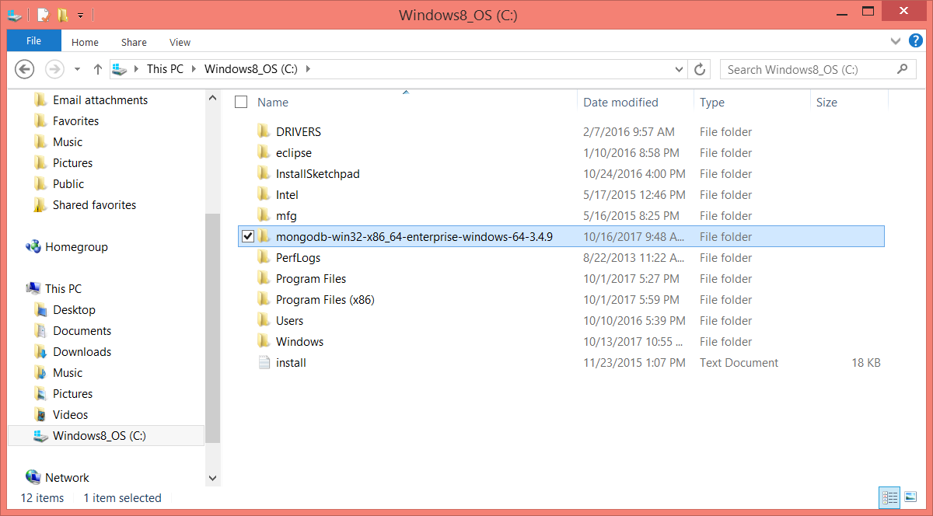

In order to make less typing later when running the program via Windows command line tool, we can rename this folder to “mongodb”.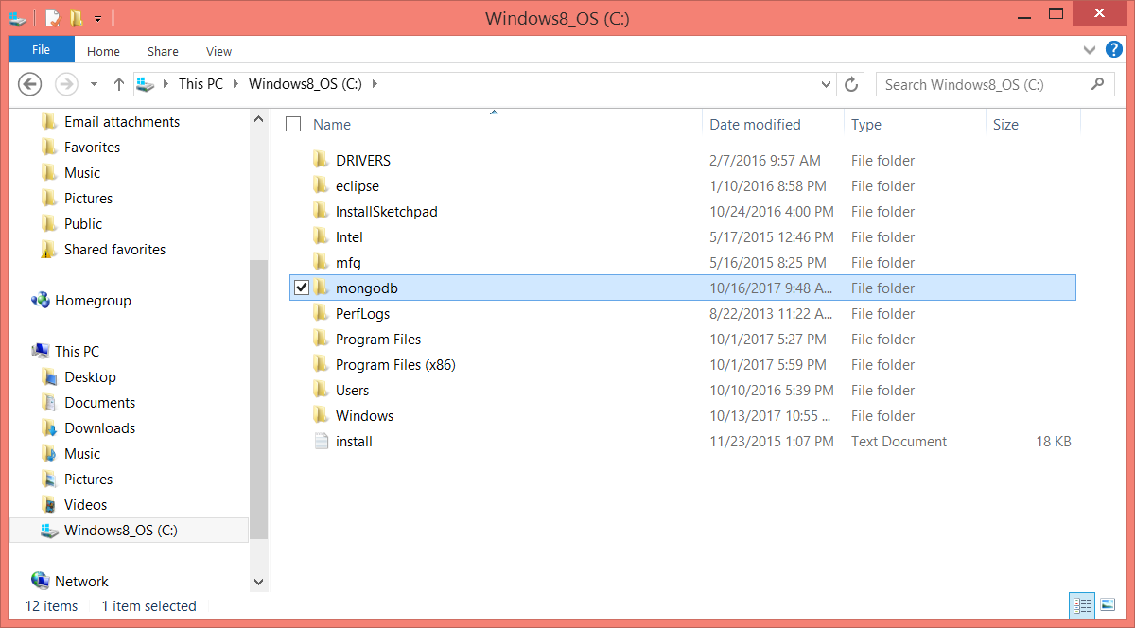

Step 5: Create a default location for the database to store data. In this example we created C:\data\db as described in the textbook. Right now it’s empty.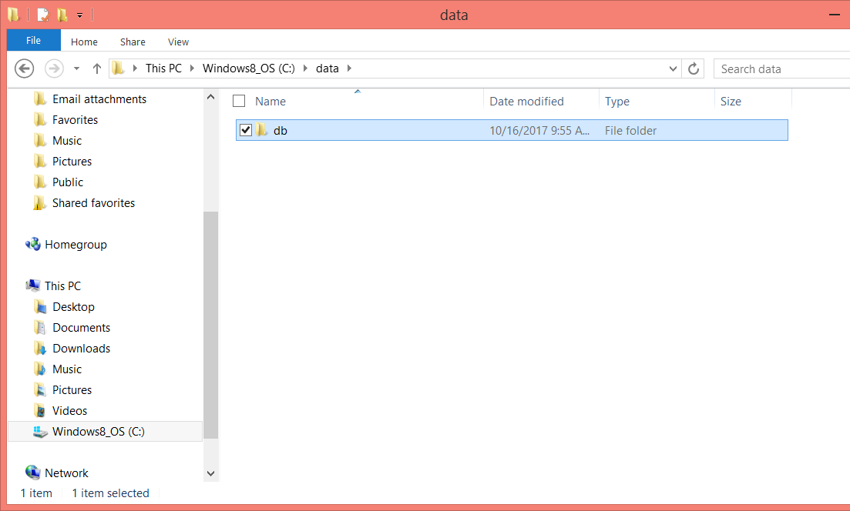

Step 6: Verify your installation is working. Open a Windows command line tool and change directory to C:\mongodb\bin directory or wherever you have unzipped your installation files are. Type commend: **mongod** and you should see something like this:

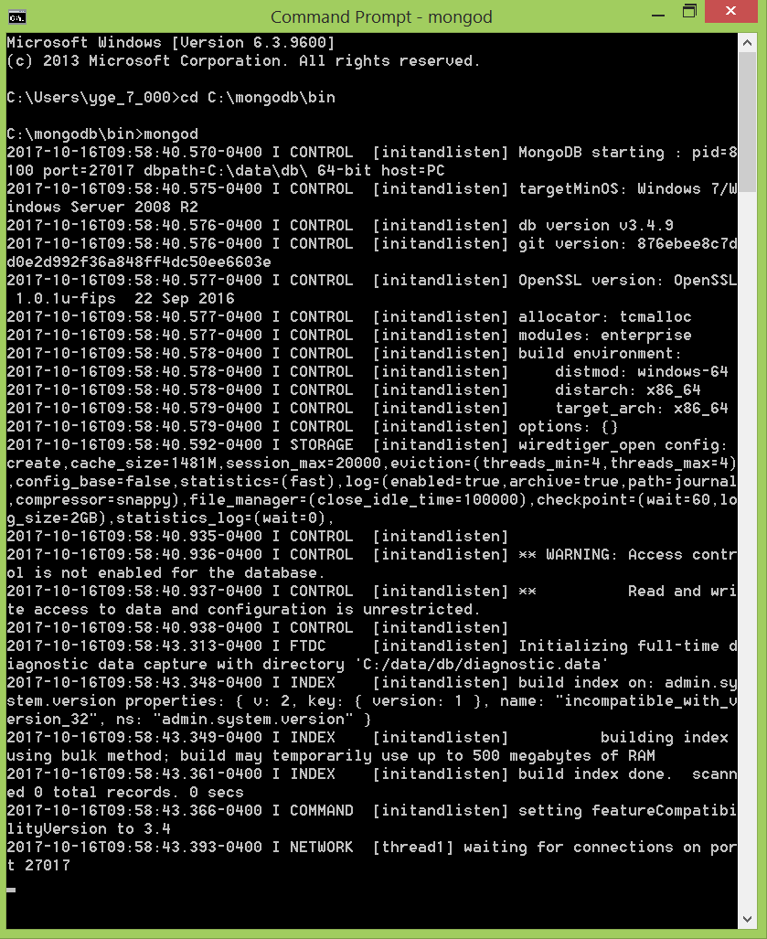

You may get Windows Firewall prompt. Just allow.

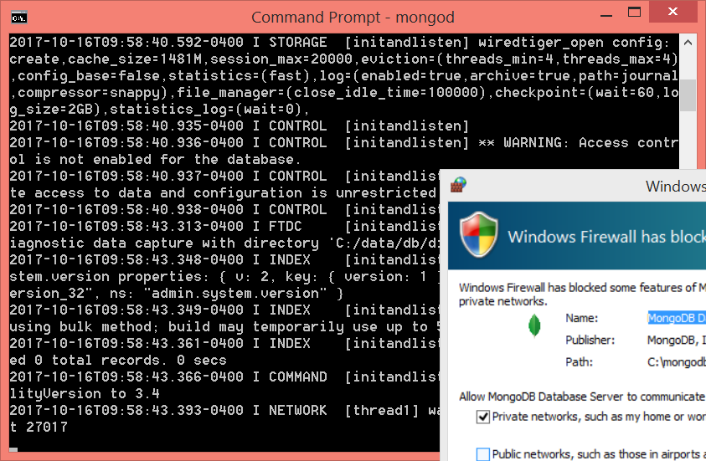

That’s it.

Once you have installed and started your MongoDB, you may not be able to see the content of the database easily if you are not familiar with command lines environment via terminals or shells. You may want to download some free MongoDB GUI tools to help you manage and verify the data in your database if that's the case.

This web site recommends 4 of them: https://scalegrid.io/blog/which-is-the-best-mongodb-gui/.  I tried a free edition of MongoBooster and it seems to be really easy to use. This is their download site: https://mongobooster.com/downloads.