# ________________________________________________________________

**CSC174 server-side javascript**

________________________________________________________________________

# Unit 11 LAB: a to-do list applicaiton

# Objectives

In this lab assignment, students will learn:

* How to use AngularJS, Express, and Mongodb to create a simple web application.
* Model-View-Control (MVC) design pattern in web applications through Angular JS
* Single Page Application (SPA) framework for web development
* How to create, insert, update, delete, and query MongoDB from Node.js (re-enforcement from last unit.)

# COURSE PREPARATION

You should have done your reading assignment listed under “Reading Assignment” and “Video Assignment” sections in BlackBoard. You should also have reviewed the lecture slides in BlackBoard. There is an optional section called “In Case You Don’t Know” in BlackBoard for those who have limited exposure to JavaScript language.

# WHat to submit

For this lab you need to submit the following files:

* **main.js**
* **index.html**

# grading rubric:

Be sure to follow the Coding Standard Guidelines. You must properly indent and comment your code. This assignment is worth 100 points.

* Indent code and insert comments to document your program. [10 pts]
* Program must be implemented and run with no syntax errors. [40 pts]
* Program must be implemented and run with no logic errors. [40 pts]
* Required source files should be zipped and uploaded to BlackBoard assignment drop box before the deadline. [10 points]

# ________________________________________________________________

**Add Due Date to the To-Do List Application**

________________________________________________________________________

**Project Description:**

This project is based on the textbook example in Figure 9-6. You can find all the source code from a zip file named ***unit11_lab.zip*** from BlackBoard Unit 11 lesson section. Your job is to add a due date text box to the application and save it to the MongoDB. A screenshot of the completed project should look like this:

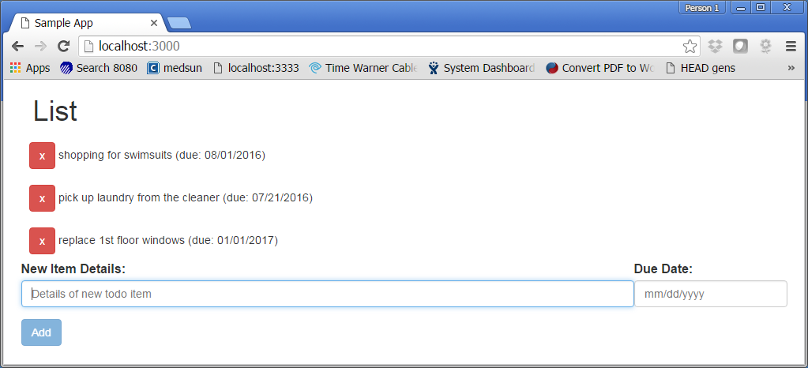

If you use Mongo Shell you can see the data are saved in the database:

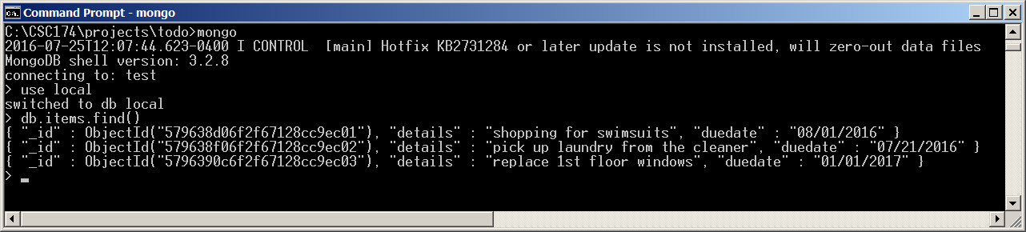

Here are the settings of the database:

Database URL: ***mongodb://127.0.0.1:27017/local***

Database name: ***local*** (You can deduce from the above URL.)

Collection name: ***items***

Document format: **{“details”: “shopping for swimsuits”, “duedate”: “08/01/2016”}**

**Hint:**

1. You need to download MongoDB and install it locally on your machine.
2. You need to make sure you have a folder ***C:\data\db*** created. This is the default location where all MongoDB’s data files are saved.
3. You need to create the collection named feedback through Mongo shell commands:

***use local***

***db.createCollection(“items”)***

1. You only need to change main.js and index.html files.

You only need to submit the modified main.js and index.html files.