# ________________________________________________________________

**CSC174 server-side javascript**

________________________________________________________________________

# Unit 14 LAB: AN Html color converter

# Objectives

In this lab assignment, students will learn:

* Test Driven Development (TDD) methodology
* How to write test scripts to unit test Node.js programs using Mocha framework

# COURSE PREPARATION

You should have done your reading assignment listed under “Reading Assignment” and “Video Assignment” sections in BlackBoard. You should also have reviewed the lecture slides in BlackBoard. There is an optional section called “In Case You Don’t Know” in BlackBoard for those who have limited exposure to JavaScript language.

# WHat to submit

For this lab you need to submit the following files:

* **app\converter.js**
* **app\server.js**
* **test\converter.js**
* **test\server.js**

# grading rubric:

Be sure to follow the Coding Standard Guidelines. You must properly indent and comment your code. This assignment is worth 100 points.

* Indent code and insert comments to document your program. [10 pts]
* Program must be implemented and run with no syntax errors. [40 pts]
* Program must be implemented and run with no logic errors. [40 pts]
* Required source files should be zipped and uploaded to BlackBoard assignment drop box before the deadline. [10 points]

# ________________________________________________________________

**An HTML Color Converter**

________________________________________________________________________

**Project Description:**

This project is based on a mocha tutorial at: <https://semaphoreci.com/community/tutorials/getting-started-with-node-js-and-mocha>. It uses ***express***, ***mocha***, ***chai*** and ***request*** modules. You can find all the source files in *unit14_lab.zip* file in BlackBoard.

This project converts HTML color code between its RGB and HEX formats. You can google on this topic if it sounds foreign to you, but you really shouldn’t if you are writing any code related to the web. There are two real program scripts here: app\converter.js and app\server.js. They contain the functionality of the program. Then there are two mocha testing scripts here: test\converter.js and test\server.js. You can run them either from a Windows command line window/MacOS terminal or from an IDE such as WebStorm.

You job is to modify these 4 files and add a temperature converter between Celcius and Fahrenheit. The converted result is rounded to an integer using Math.round() function. In your mocha testing scripts, you need to test the conversion between 0 degrees Celcius and 32 degrees Fahrenheit.

Here are some WebStorm screenshots when I ran the completed projects with temperature conversion added.

***Start the app\server.js program in WebStorm:***

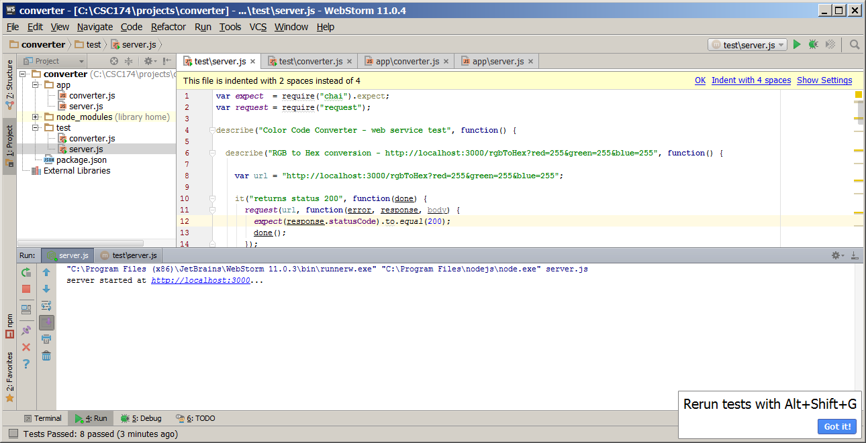

***Running test\converter.js in WebStorm and I got the following passing results:***

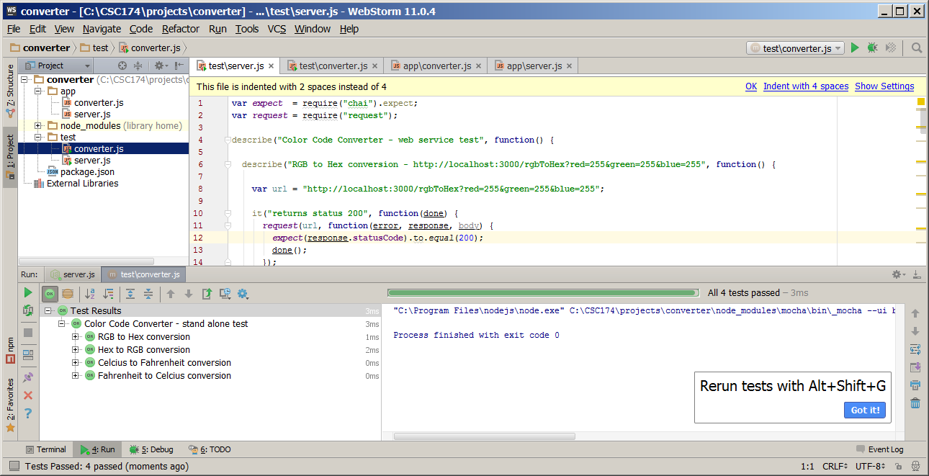

***Running test\server.js in WebStorm and I got the following passing results:***

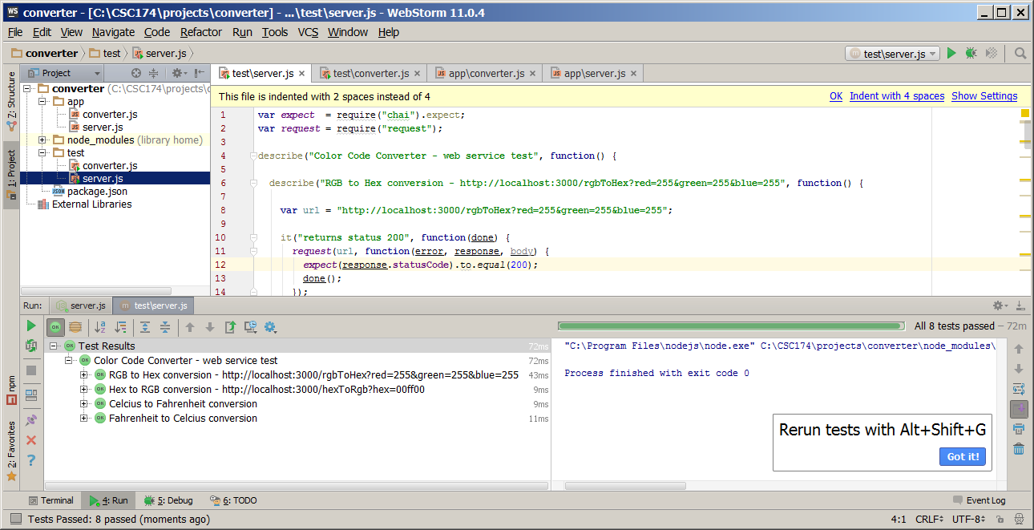

***Running app\server.js in Windows command window:***

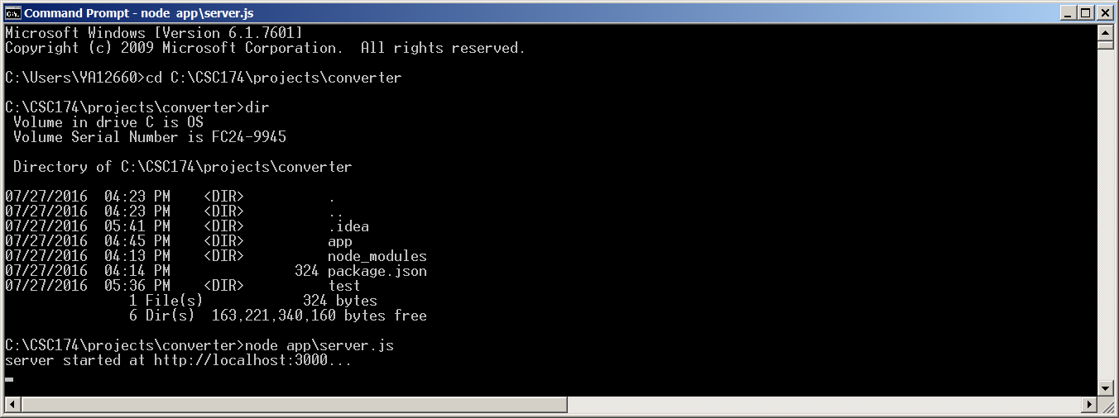

***Running test\converter.js and test\server.js in Windows command window:***

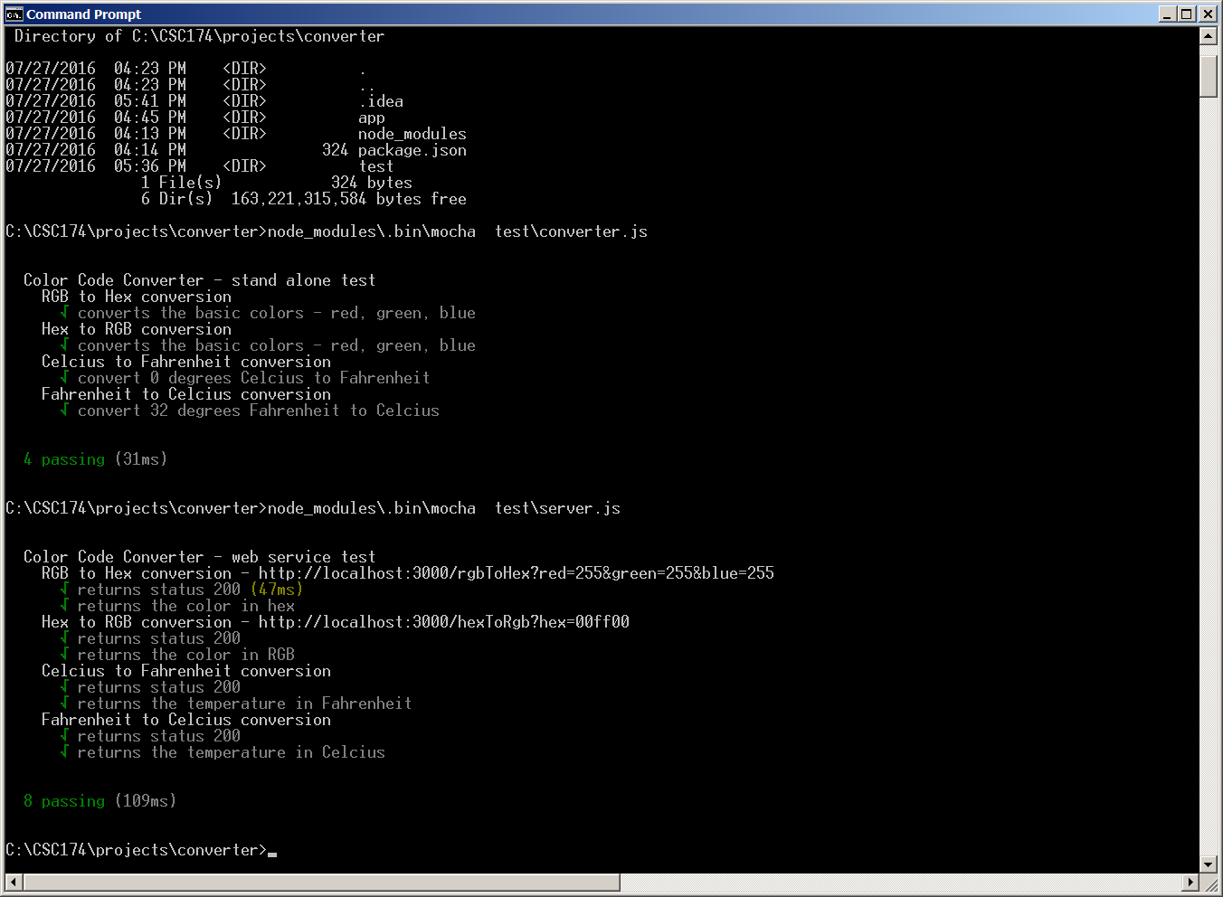

Hint:

1. Add two new functions and export them in app\converter.js file:

*exports.celciusToFahrenheit = function(celcius) {*

*return Math.round(celcius * 9 / 5 + 32);*

*};*

*exports.fahrenheitToCelcius = function(fahrenheit) {*

*return Math.round((fahrenheit - 32) * 5 / 9);*

*};*

1. Add two new express route entries in app\server.js file:

*app.get("/celciusToFahrenheit", function(req, res) {*

*var celcius = req.query.celcius;*

*var fahrenheit = converter.celciusToFahrenheit(celcius);*

*res.send(JSON.stringify(fahrenheit));*

*});*

*app.get("/fahrenheitToCelcius", function(req, res) {*

*var fahrenheit = req.query.fahrenheit;*

*var celcius = converter.fahrenheitToCelcius(fahrenheit);*

*res.send(JSON.stringify(celcius));*

*});*

1. Add mocha testing code (describe and it) in the test\converter.js and test\server.js files to test the added new code above.