**CS 445 Final Project Memo**

**Changyu Wu, A20337986**

* **Status**

1. This project is incomplete. Missing parts are:

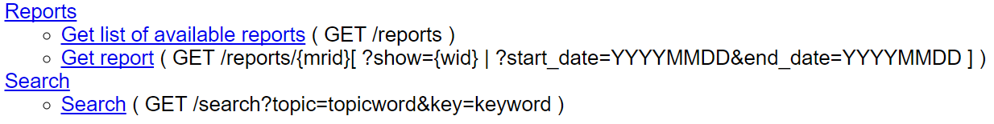

Other than these two missing parts, all other parts are completed and meet all of the requirements.

1. Although, I did 3 bonus questions: deleteTicket, deleteOrder and deleteShow
2. 2 calendar days late

* **Link to repository on Github.com**

<https://github.com/newlifepop/CS-445-Final-Project>

* **Lines of code**

Approximately 3,000 lines of code

* **Lines of code in unit tests**

Approximately 250 lines of code

* **Cyclomatic Complexity**

3

* **Number of hours spent completing the project**

Approximately 24 hours

* **Number of hours spent completing submission**

Approximately 2 hours

* **Challenges**

1. No prior experience with Java
2. No prior experience with Tomcat

* **Solutions**

Spent 2 nights sleeplessly getting familiar with Java. Then read the sample code and finally able to complete the project