Gini & HHI by provider and by jurisdiction, per country over time.
HHI on the 0–10,000 scale. Jurisdiction = China / USA / Other.

Gini (by provider)

Nedko (CDN)
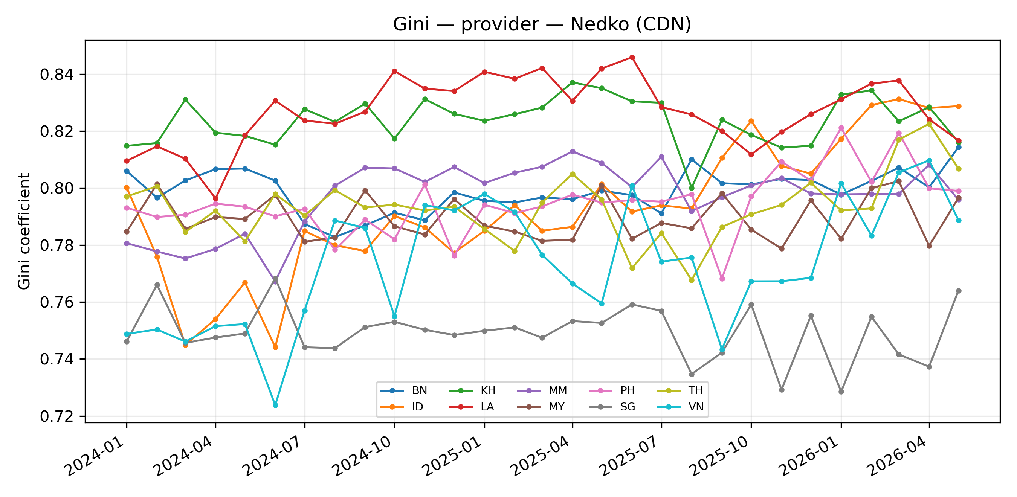
Figure: Gini of provider concentration, Nedko (CDN), per country over time.
Table: market share (%) by provider × year × country (Nedko (CDN)). Cells = mean monthly share in that year.
Country | Provider | 2024 | 2025 | 2026
BN | CloudFlare | 53.5 | 55.9 | 58.6
 | Netlify | 31.9 | 31.0 | 29.2
 | Amazon CloudFront | 6.5 | 5.6 | 5.0
 | Fastly | 3.4 | 2.6 | 2.3
 | Imperva | 0.6 | 0.5 | 0.5
 | CDN77 | 0.7 | 1.1 | 1.5
 | Akamai | 0.6 | 0.4 | 0.5
 | Alibaba Cloud CDN | 0.7 | 0.6 | 0.4
 | Azure CDN | 1.1 | 1.3 | 1.0
 | BunnyCDN | 0.2 | 0.3 | 0.3
 | Google Cloud CDN | 0.3 | 0.2 | 0.2
 | Vercel | 0.2 | 0.3 | 0.3
 | Tencent Cloud CDN | 0.0 | 0.0 | –
 | Sucuri | 0.3 | 0.2 | 0.2
 | SiteGround CDN | – | – | –
ID | CloudFlare | 53.9 | 59.2 | 66.5
 | Netlify | 27.4 | 24.0 | 20.1
 | Amazon CloudFront | 14.0 | 11.2 | 8.1
 | Fastly | 1.5 | 1.7 | 1.4
 | Imperva | 0.3 | 0.2 | 0.1
 | CDN77 | 0.6 | 0.8 | 1.0
 | Akamai | 0.6 | 0.6 | 0.6
 | Alibaba Cloud CDN | 0.6 | 0.8 | 0.8
 | Azure CDN | 0.1 | 0.1 | 0.1
 | BunnyCDN | 0.2 | 0.4 | 0.4
 | Google Cloud CDN | 0.3 | 0.6 | 0.5
 | Vercel | 0.2 | 0.1 | 0.1
 | Tencent Cloud CDN | – | 0.0 | 0.1
 | Sucuri | 0.1 | 0.2 | 0.1
 | SiteGround CDN | – | – | –
KH | CloudFlare | 55.4 | 56.4 | 59.9
 | Netlify | 33.7 | 32.4 | 29.8
 | Amazon CloudFront | 5.0 | 4.6 | 3.3
 | Fastly | 1.9 | 2.4 | 2.6
 | Imperva | 0.4 | 0.2 | 0.0
 | CDN77 | 0.7 | 1.2 | 1.5
 | Akamai | 0.9 | 0.7 | 0.6
 | Alibaba Cloud CDN | 0.6 | 0.5 | 0.5
 | Azure CDN | 0.4 | 0.3 | 0.4
 | BunnyCDN | 0.3 | 0.3 | 0.6
 | Google Cloud CDN | 0.2 | 0.1 | 0.1
 | Vercel | 0.1 | 0.3 | 0.4
 | Tencent Cloud CDN | 0.2 | 0.2 | 0.2
 | Sucuri | 0.1 | 0.1 | 0.1
 | SiteGround CDN | 0.2 | 0.1 | 0.1
LA | CloudFlare | 62.1 | 65.7 | 67.4
 | Netlify | 28.1 | 25.0 | 22.6
 | Amazon CloudFront | 5.0 | 4.4 | 4.0
 | Fastly | 1.3 | 0.9 | 1.1
 | Imperva | 0.5 | 0.2 | 0.1
 | CDN77 | 0.3 | 1.0 | 2.1
 | Akamai | 0.8 | 0.7 | 0.8
 | Alibaba Cloud CDN | 0.3 | 0.5 | 0.3
 | Azure CDN | 0.5 | 0.2 | 0.2
 | BunnyCDN | 0.4 | 0.3 | 0.4
 | Google Cloud CDN | 0.4 | 0.3 | 0.1
 | Vercel | 0.1 | 0.3 | 0.5
 | Tencent Cloud CDN | 0.2 | 0.3 | 0.2
 | Sucuri | 0.0 | 0.1 | 0.0
 | SiteGround CDN | – | – | –
MM | CloudFlare | 61.1 | 62.8 | 62.7
 | Netlify | 26.3 | 25.7 | 26.6
 | Amazon CloudFront | 6.1 | 5.0 | 3.5
 | Fastly | 2.3 | 2.0 | 2.5
 | Imperva | 0.9 | 1.1 | 0.6
 | CDN77 | 0.4 | 1.1 | 1.4
 | Akamai | 0.9 | 0.8 | 0.6
 | Alibaba Cloud CDN | 0.6 | 0.5 | 0.7
 | Azure CDN | 0.3 | 0.3 | 0.5
 | BunnyCDN | 0.4 | 0.4 | 0.4
 | Google Cloud CDN | 0.5 | 0.2 | 0.2
 | Vercel | 0.1 | 0.2 | 0.2
 | Tencent Cloud CDN | 0.0 | 0.0 | –
 | Sucuri | – | – | –
 | SiteGround CDN | – | – | –
MY | CloudFlare | 52.7 | 54.0 | 53.5
 | Netlify | 31.7 | 30.1 | 31.0
 | Amazon CloudFront | 6.2 | 6.4 | 6.1
 | Fastly | 2.9 | 2.7 | 2.8
 | Imperva | 2.8 | 2.6 | 2.5
 | CDN77 | 1.1 | 1.2 | 1.3
 | Akamai | 0.7 | 0.4 | 0.4
 | Alibaba Cloud CDN | 0.3 | 0.4 | 0.5
 | Azure CDN | 0.7 | 0.4 | 0.3
 | BunnyCDN | 0.2 | 0.7 | 0.8
 | Google Cloud CDN | 0.5 | 0.6 | 0.4
 | Vercel | 0.1 | 0.2 | 0.3
 | Tencent Cloud CDN | 0.1 | 0.1 | 0.1
 | Sucuri | 0.0 | 0.0 | 0.1
 | SiteGround CDN | – | – | –
PH | CloudFlare | 50.0 | 55.8 | 62.7
 | Netlify | 31.6 | 28.4 | 22.8
 | Amazon CloudFront | 10.7 | 9.1 | 8.5
 | Fastly | 2.9 | 2.4 | 2.2
 | Imperva | 0.7 | 0.2 | 0.4
 | CDN77 | 0.8 | 1.2 | 1.4
 | Akamai | 1.1 | 0.7 | 0.5
 | Alibaba Cloud CDN | 0.7 | 0.9 | 0.8
 | Azure CDN | 0.7 | 0.4 | 0.2
 | BunnyCDN | 0.1 | 0.1 | 0.2
 | Google Cloud CDN | 0.3 | 0.3 | 0.1
 | Vercel | 0.1 | 0.3 | 0.2
 | Tencent Cloud CDN | – | – | –
 | Sucuri | 0.3 | 0.1 | 0.0
 | SiteGround CDN | 0.1 | – | –
SG | CloudFlare | 44.3 | 46.5 | 48.9
 | Netlify | 31.3 | 30.3 | 28.5
 | Amazon CloudFront | 12.8 | 11.9 | 10.9
 | Fastly | 4.0 | 3.7 | 3.6
 | Imperva | 2.8 | 2.7 | 3.4
 | CDN77 | 1.0 | 1.2 | 1.3
 | Akamai | 1.0 | 0.8 | 0.7
 | Alibaba Cloud CDN | 1.2 | 1.2 | 1.1
 | Azure CDN | 0.7 | 0.6 | 0.6
 | BunnyCDN | 0.2 | 0.2 | 0.3
 | Google Cloud CDN | 0.1 | 0.1 | –
 | Vercel | 0.2 | 0.3 | 0.4
 | Tencent Cloud CDN | 0.3 | 0.3 | 0.3
 | Sucuri | 0.0 | 0.0 | 0.0
 | SiteGround CDN | – | – | –
TH | CloudFlare | 57.3 | 56.1 | 61.9
 | Netlify | 28.2 | 29.2 | 26.8
 | Amazon CloudFront | 6.2 | 6.7 | 5.5
 | Fastly | 1.3 | 1.4 | 0.9
 | Imperva | 2.8 | 2.3 | 1.2
 | CDN77 | 1.0 | 1.3 | 1.3
 | Akamai | 0.7 | 0.6 | 0.5
 | Alibaba Cloud CDN | 0.6 | 0.5 | 0.4
 | Azure CDN | 0.8 | 0.7 | 0.3
 | BunnyCDN | 0.4 | 0.6 | 0.7
 | Google Cloud CDN | 0.2 | 0.1 | –
 | Vercel | 0.2 | 0.3 | 0.4
 | Tencent Cloud CDN | 0.2 | 0.2 | 0.1
 | Sucuri | – | 0.0 | 0.1
 | SiteGround CDN | – | – | –
VN | CloudFlare | 45.5 | 52.4 | 57.6
 | Netlify | 43.6 | 36.5 | 29.4
 | Amazon CloudFront | 7.5 | 7.9 | 9.4
 | Fastly | 1.1 | 0.9 | 0.8
 | Imperva | 0.2 | 0.1 | 0.3
 | CDN77 | 0.7 | 0.8 | 0.9
 | Akamai | 0.5 | 0.4 | 0.3
 | Alibaba Cloud CDN | 0.2 | 0.3 | 0.6
 | Azure CDN | 0.5 | 0.4 | 0.2
 | BunnyCDN | 0.2 | 0.1 | 0.1
 | Google Cloud CDN | 0.1 | 0.1 | 0.2
 | Vercel | 0.1 | 0.1 | 0.1
 | Tencent Cloud CDN | – | – | –
 | Sucuri | – | – | –
 | SiteGround CDN | – | – | –

ISOC (CDN)
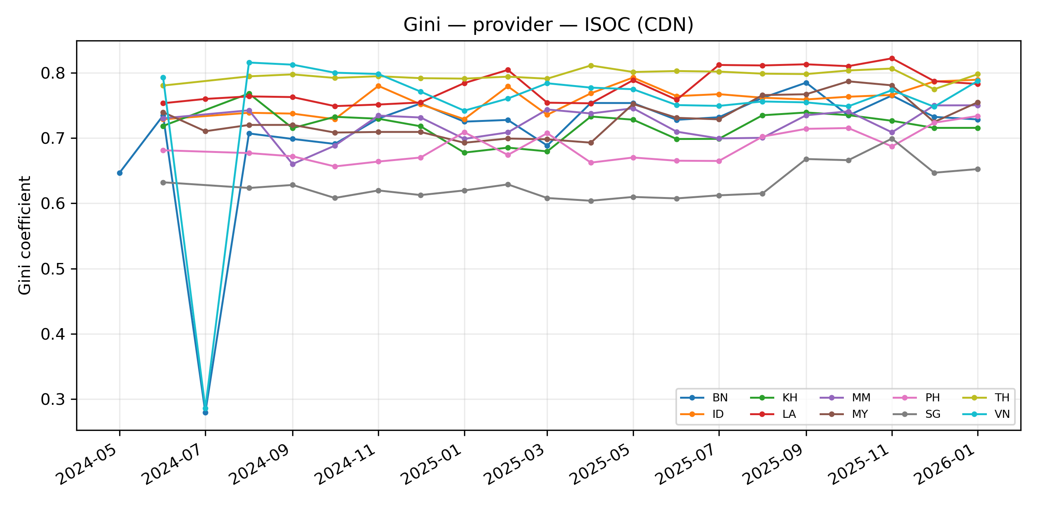
Figure: Gini of provider concentration, ISOC (CDN), per country over time.
Table: market share (%) by provider × year × country (ISOC (CDN)). Cells = mean monthly share in that year.
Country | Provider | 2024 | 2025 | 2026
BN | cloudflare | 65.2 | 74.4 | 75.0
 | amazon | 7.7 | 9.6 | 8.5
 | akamai | 16.7 | 7.4 | 8.0
 | fastly | 4.0 | 4.0 | 4.0
 | alibaba | 0.4 | 0.9 | 1.0
 | microsoft | 4.5 | 2.5 | 2.1
 | facebook | 0.7 | 1.0 | 1.0
 | cloudfront | 0.7 | – | –
 | cdn77 | 0.0 | 0.1 | 0.4
 | gcore | 0.0 | 0.1 | –
 | bunnycdn | 0.0 | – | –
 | netflix | – | 0.0 | –
 | wordpress | – | 0.0 | –
 | edgio | – | – | –
ID | cloudflare | 73.1 | 76.4 | 77.9
 | amazon | 17.2 | 15.0 | 13.2
 | akamai | 3.6 | 3.6 | 3.7
 | fastly | 1.4 | 1.6 | 1.2
 | alibaba | 1.1 | 1.4 | 1.5
 | microsoft | 0.7 | 0.5 | 0.4
 | facebook | 1.2 | 1.1 | 1.0
 | cloudfront | 1.8 | – | –
 | cdn77 | 0.1 | 0.3 | 0.8
 | gcore | – | – | –
 | bunnycdn | 0.0 | 0.0 | 0.3
 | netflix | – | – | –
 | wordpress | – | – | –
 | edgio | – | – | –
KH | cloudflare | 73.7 | 72.6 | 70.6
 | amazon | 11.0 | 12.4 | 14.2
 | akamai | 6.8 | 7.1 | 6.6
 | fastly | 2.4 | 3.0 | 3.2
 | alibaba | 2.2 | 2.4 | 2.4
 | microsoft | 1.0 | 0.7 | 0.9
 | facebook | 1.7 | 1.7 | 1.6
 | cloudfront | 1.2 | – | –
 | cdn77 | 0.1 | 0.1 | 0.5
 | gcore | – | – | –
 | bunnycdn | – | – | –
 | netflix | – | – | –
 | wordpress | 0.0 | – | –
 | edgio | – | – | –
LA | cloudflare | 83.3 | 83.6 | 83.0
 | amazon | 6.4 | 7.1 | 7.3
 | akamai | 5.2 | 5.0 | 5.5
 | fastly | 1.2 | 1.0 | 1.0
 | alibaba | 0.6 | 0.9 | 0.7
 | microsoft | 1.0 | 0.7 | 0.7
 | facebook | 1.4 | 1.5 | 1.4
 | cloudfront | 0.8 | – | –
 | cdn77 | – | 0.1 | 0.4
 | gcore | – | 0.1 | –
 | bunnycdn | – | 0.0 | –
 | netflix | – | 0.0 | –
 | wordpress | – | – | –
 | edgio | – | – | –
MM | cloudflare | 73.0 | 75.5 | 78.8
 | amazon | 12.2 | 10.8 | 8.4
 | akamai | 5.3 | 5.9 | 4.7
 | fastly | 2.4 | 2.3 | 3.6
 | alibaba | 3.9 | 3.4 | 2.1
 | microsoft | 1.3 | 1.5 | 1.7
 | facebook | 0.3 | 0.5 | 0.5
 | cloudfront | 1.4 | – | –
 | cdn77 | 0.1 | 0.1 | 0.1
 | gcore | – | 0.0 | –
 | bunnycdn | 0.0 | – | –
 | netflix | – | – | –
 | wordpress | – | – | –
 | edgio | – | – | –
MY | cloudflare | 76.0 | 74.5 | 73.2
 | amazon | 9.1 | 10.7 | 12.6
 | akamai | 7.3 | 6.7 | 6.2
 | fastly | 3.3 | 3.1 | 2.3
 | alibaba | 0.4 | 1.0 | 1.4
 | microsoft | 2.2 | 2.6 | 2.4
 | facebook | 1.0 | 1.3 | 1.4
 | cloudfront | 0.7 | – | –
 | cdn77 | 0.0 | 0.1 | 0.3
 | gcore | – | 0.1 | –
 | bunnycdn | – | – | –
 | netflix | – | 0.0 | 0.1
 | wordpress | – | – | –
 | edgio | – | – | –
PH | cloudflare | 62.2 | 66.5 | 72.3
 | amazon | 21.5 | 18.7 | 14.7
 | akamai | 7.3 | 6.8 | 5.5
 | fastly | 3.3 | 3.0 | 2.8
 | alibaba | 1.1 | 1.7 | 2.1
 | microsoft | 1.8 | 2.0 | 1.6
 | facebook | 1.1 | 1.1 | 0.9
 | cloudfront | 1.7 | – | –
 | cdn77 | 0.0 | 0.1 | 0.1
 | gcore | – | – | –
 | bunnycdn | – | – | –
 | netflix | – | 0.0 | –
 | wordpress | – | – | –
 | edgio | – | – | –
SG | cloudflare | 57.8 | 58.8 | 58.6
 | amazon | 16.7 | 17.0 | 16.6
 | akamai | 14.1 | 14.0 | 13.9
 | fastly | 5.2 | 4.6 | 4.5
 | alibaba | 1.6 | 2.2 | 2.1
 | microsoft | 2.1 | 2.2 | 2.7
 | facebook | 1.0 | 1.1 | 1.3
 | cloudfront | 1.5 | – | –
 | cdn77 | – | 0.1 | 0.3
 | gcore | – | – | –
 | bunnycdn | – | – | –
 | netflix | – | 0.0 | –
 | wordpress | – | – | –
 | edgio | 0.0 | – | –
TH | cloudflare | 79.5 | 77.9 | 78.0
 | amazon | 8.7 | 8.7 | 7.3
 | akamai | 6.2 | 8.1 | 8.8
 | fastly | 1.3 | 1.0 | 1.3
 | alibaba | 1.4 | 2.0 | 1.6
 | microsoft | 1.3 | 1.2 | 1.3
 | facebook | 0.6 | 0.8 | 0.8
 | cloudfront | 0.7 | – | –
 | cdn77 | 0.1 | 0.2 | 0.6
 | gcore | – | 0.1 | –
 | bunnycdn | 0.1 | 0.1 | 0.1
 | netflix | – | 0.0 | 0.1
 | wordpress | – | – | –
 | edgio | – | – | –
VN | cloudflare | 68.5 | 80.2 | 81.4
 | amazon | 9.4 | 11.8 | 11.5
 | akamai | 14.2 | 3.3 | 3.1
 | fastly | 0.6 | 1.1 | 1.1
 | alibaba | 1.1 | 1.9 | 1.1
 | microsoft | 3.7 | 0.6 | 0.4
 | facebook | 1.0 | 1.1 | 1.1
 | cloudfront | 1.2 | – | –
 | cdn77 | 0.1 | 0.0 | –
 | gcore | 0.1 | – | –
 | bunnycdn | 0.0 | – | –
 | netflix | – | 0.0 | 0.1
 | wordpress | 0.0 | – | –
 | edgio | – | – | –

OpenINTEL (IP infrastructure)
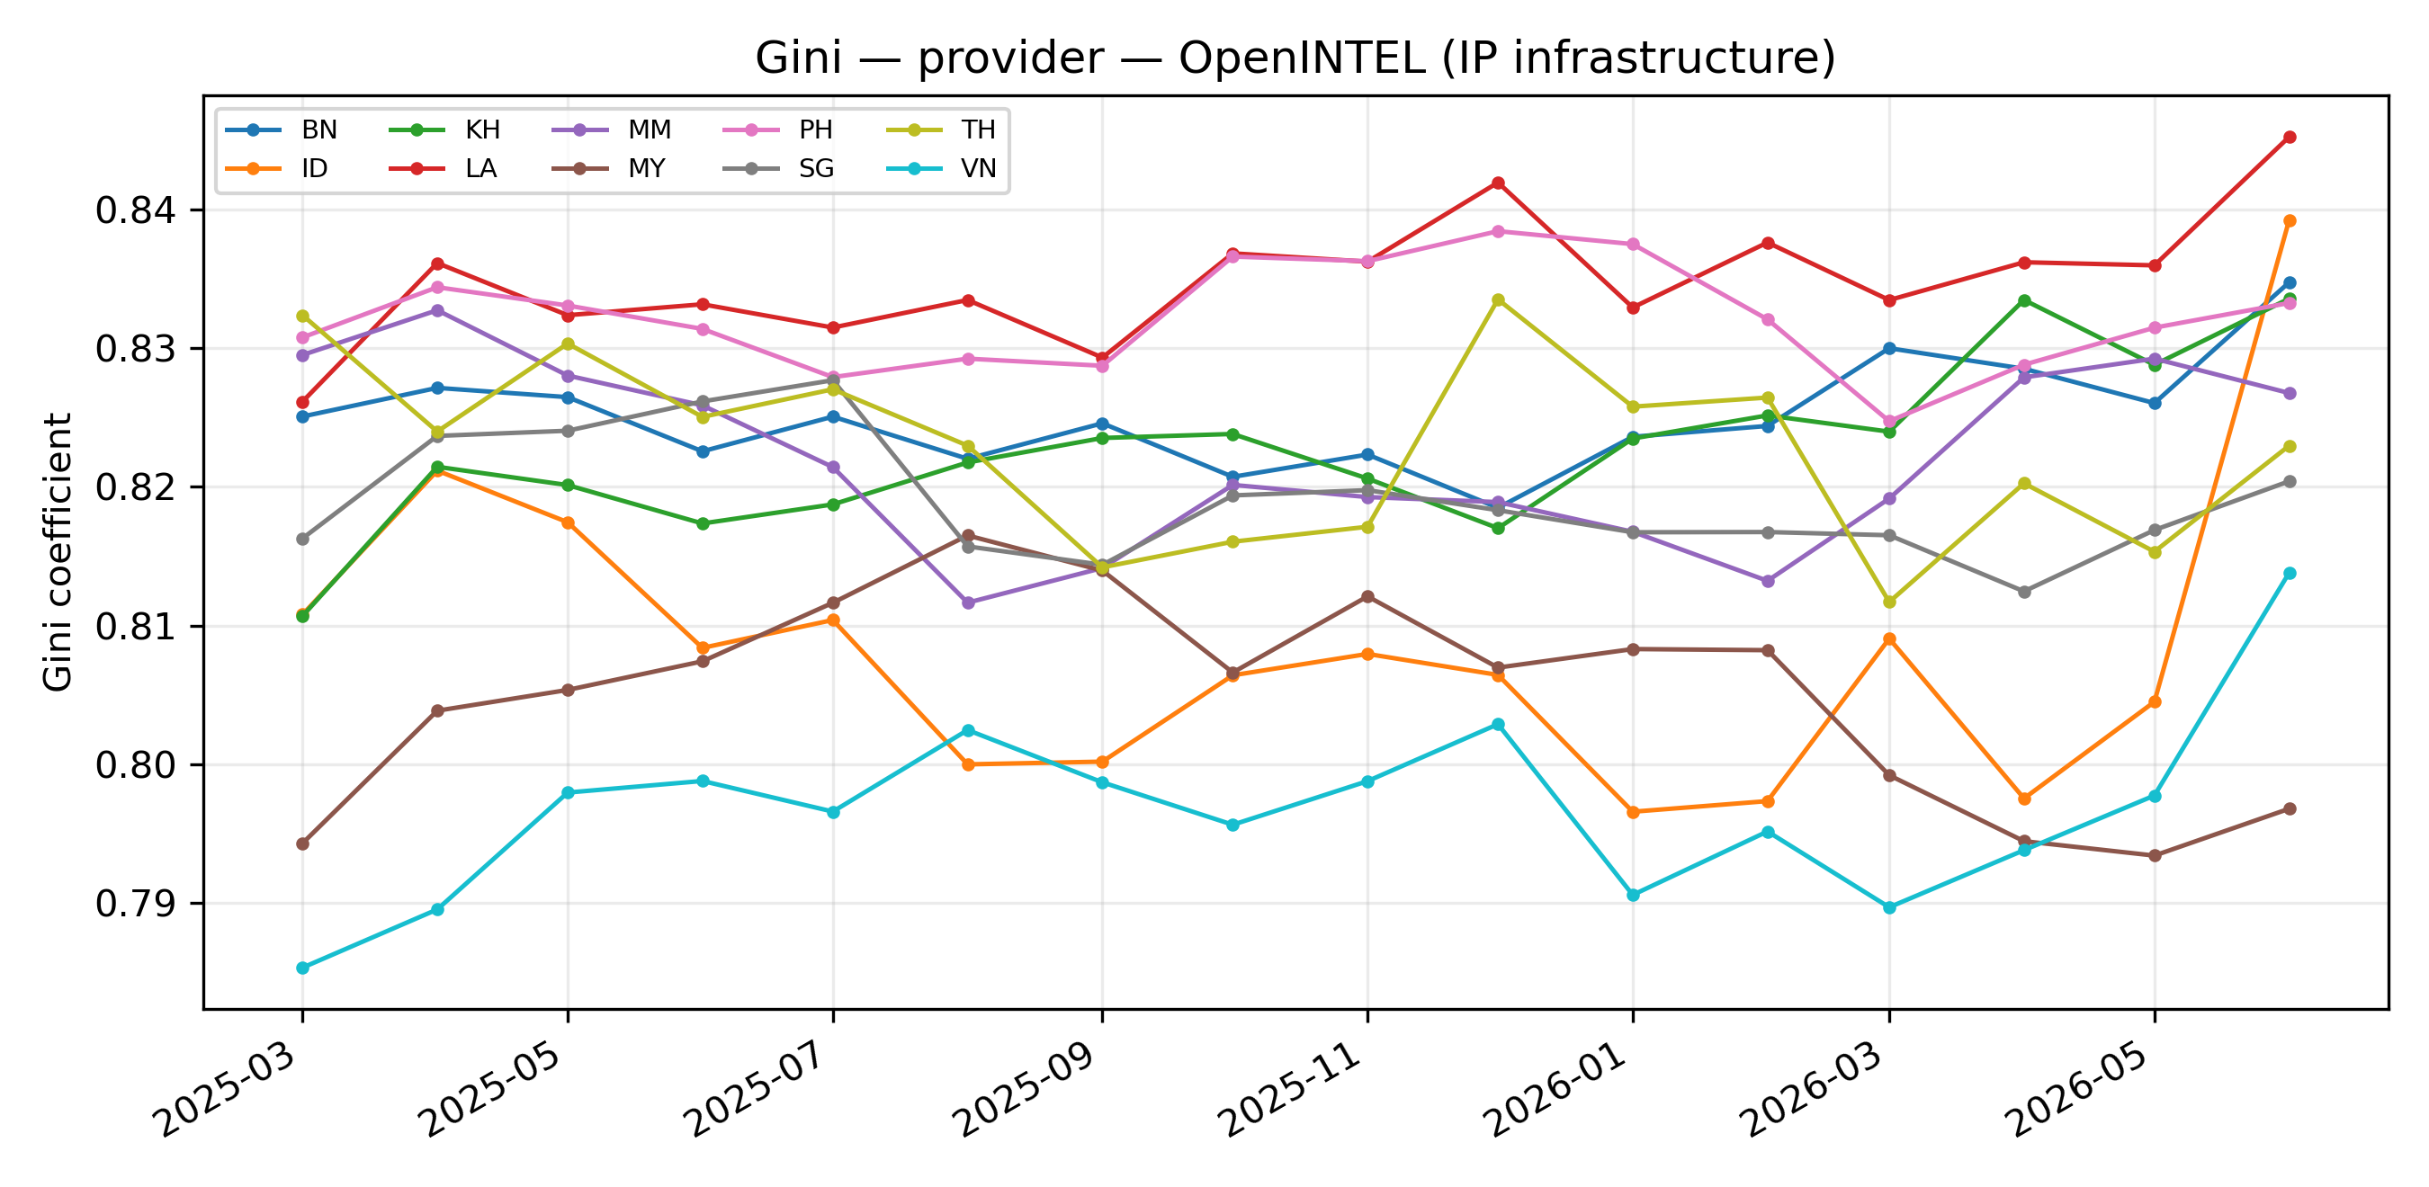
Figure: Gini of provider concentration, OpenINTEL (IP infrastructure), per country over time.
Table: market share (%) by provider × year × country (OpenINTEL (IP infrastructure)). Cells = mean monthly share in that year.
Country | Provider | 2025 | 2026
BN | Cloudflare, Inc. (CLOUDFLARENET) | 52.8 | 53.3
 | Amazon.com, Inc. (AMAZON-02) | 6.5 | 6.7
 | Google LLC (GOOGLE) | 3.1 | 2.8
 | Akamai International B.V. (AKAMAI-ASN1) | 2.4 | 2.8
 | Akamai Technologies, Inc. (AKAMAI-AS) | 3.1 | 2.7
 | Fastly, Inc. (FASTLY) | 2.9 | 2.3
 | DataWeb Global Group B.V. (ADVANCEDHOSTERS-AS) | 2.5 | 3.0
 | Google LLC (GOOGLE-CLOUD-PLATFORM) | 1.3 | 1.0
 | OVH SAS (OVH) | 1.9 | 1.5
 | Microsoft Corporation (MICROSOFT-CORP-MSN-AS-BLOCK) | 1.6 | 2.0
 | Facebook, Inc. (FACEBOOK) | 0.7 | 0.7
 | Incapsula Inc (INCAPSULA) | 0.3 | 0.4
 | Other | 20.9 | 20.8
ID | Cloudflare, Inc. (CLOUDFLARENET) | 46.1 | 46.7
 | Amazon.com, Inc. (AMAZON-02) | 11.5 | 9.4
 | Google LLC (GOOGLE) | 4.0 | 3.5
 | Akamai International B.V. (AKAMAI-ASN1) | 2.3 | 2.6
 | Akamai Technologies, Inc. (AKAMAI-AS) | 0.9 | 1.0
 | Fastly, Inc. (FASTLY) | 1.4 | 1.5
 | DataWeb Global Group B.V. (ADVANCEDHOSTERS-AS) | 1.4 | 1.3
 | Google LLC (GOOGLE-CLOUD-PLATFORM) | 2.7 | 2.7
 | OVH SAS (OVH) | 4.6 | 4.3
 | Microsoft Corporation (MICROSOFT-CORP-MSN-AS-BLOCK) | 0.5 | 0.5
 | Facebook, Inc. (FACEBOOK) | 1.0 | 1.0
 | Incapsula Inc (INCAPSULA) | 0.3 | 0.2
 | Other | 23.4 | 25.3
KH | Cloudflare, Inc. (CLOUDFLARENET) | 52.4 | 53.7
 | Amazon.com, Inc. (AMAZON-02) | 8.8 | 7.9
 | Google LLC (GOOGLE) | 4.1 | 3.7
 | Akamai International B.V. (AKAMAI-ASN1) | 2.4 | 2.8
 | Akamai Technologies, Inc. (AKAMAI-AS) | 2.6 | 2.3
 | Fastly, Inc. (FASTLY) | 2.3 | 2.1
 | DataWeb Global Group B.V. (ADVANCEDHOSTERS-AS) | 1.8 | 1.7
 | Google LLC (GOOGLE-CLOUD-PLATFORM) | 1.2 | 1.6
 | OVH SAS (OVH) | 1.0 | 1.0
 | Microsoft Corporation (MICROSOFT-CORP-MSN-AS-BLOCK) | 0.5 | 0.6
 | Facebook, Inc. (FACEBOOK) | 1.3 | 1.0
 | Incapsula Inc (INCAPSULA) | 0.1 | –
 | Other | 21.4 | 21.5
LA | Cloudflare, Inc. (CLOUDFLARENET) | 60.8 | 60.7
 | Amazon.com, Inc. (AMAZON-02) | 5.3 | 5.5
 | Google LLC (GOOGLE) | 3.3 | 3.1
 | Akamai International B.V. (AKAMAI-ASN1) | 1.6 | 2.1
 | Akamai Technologies, Inc. (AKAMAI-AS) | 2.0 | 1.7
 | Fastly, Inc. (FASTLY) | 0.9 | 1.0
 | DataWeb Global Group B.V. (ADVANCEDHOSTERS-AS) | 2.4 | 2.6
 | Google LLC (GOOGLE-CLOUD-PLATFORM) | 2.0 | 2.1
 | OVH SAS (OVH) | 0.6 | 0.8
 | Microsoft Corporation (MICROSOFT-CORP-MSN-AS-BLOCK) | 0.5 | 0.4
 | Facebook, Inc. (FACEBOOK) | 1.1 | 1.1
 | Incapsula Inc (INCAPSULA) | 0.1 | –
 | Other | 19.4 | 19.0
MM | Cloudflare, Inc. (CLOUDFLARENET) | 54.5 | 56.9
 | Amazon.com, Inc. (AMAZON-02) | 7.5 | 5.8
 | Google LLC (GOOGLE) | 3.0 | 3.3
 | Akamai International B.V. (AKAMAI-ASN1) | 2.2 | 2.0
 | Akamai Technologies, Inc. (AKAMAI-AS) | 1.7 | 1.3
 | Fastly, Inc. (FASTLY) | 2.0 | 2.4
 | DataWeb Global Group B.V. (ADVANCEDHOSTERS-AS) | 2.2 | 2.2
 | Google LLC (GOOGLE-CLOUD-PLATFORM) | 1.4 | 1.2
 | OVH SAS (OVH) | 0.9 | 0.7
 | Microsoft Corporation (MICROSOFT-CORP-MSN-AS-BLOCK) | 1.1 | 1.2
 | Facebook, Inc. (FACEBOOK) | 0.4 | 0.4
 | Incapsula Inc (INCAPSULA) | 1.2 | 0.6
 | Other | 21.8 | 22.0
MY | Cloudflare, Inc. (CLOUDFLARENET) | 49.8 | 43.9
 | Amazon.com, Inc. (AMAZON-02) | 7.6 | 7.6
 | Google LLC (GOOGLE) | 3.0 | 3.0
 | Akamai International B.V. (AKAMAI-ASN1) | 2.3 | 2.6
 | Akamai Technologies, Inc. (AKAMAI-AS) | 2.0 | 1.9
 | Fastly, Inc. (FASTLY) | 2.1 | 2.0
 | DataWeb Global Group B.V. (ADVANCEDHOSTERS-AS) | 2.8 | 2.4
 | Google LLC (GOOGLE-CLOUD-PLATFORM) | 1.1 | 1.2
 | OVH SAS (OVH) | 1.3 | 0.8
 | Microsoft Corporation (MICROSOFT-CORP-MSN-AS-BLOCK) | 1.3 | 1.3
 | Facebook, Inc. (FACEBOOK) | 0.9 | 0.9
 | Incapsula Inc (INCAPSULA) | 2.1 | 1.9
 | Other | 23.5 | 30.4
PH | Cloudflare, Inc. (CLOUDFLARENET) | 50.8 | 52.4
 | Amazon.com, Inc. (AMAZON-02) | 14.1 | 12.5
 | Google LLC (GOOGLE) | 3.1 | 3.1
 | Akamai International B.V. (AKAMAI-ASN1) | 2.5 | 2.5
 | Akamai Technologies, Inc. (AKAMAI-AS) | 2.6 | 2.7
 | Fastly, Inc. (FASTLY) | 2.4 | 2.3
 | DataWeb Global Group B.V. (ADVANCEDHOSTERS-AS) | 1.0 | 1.3
 | Google LLC (GOOGLE-CLOUD-PLATFORM) | 1.8 | 1.5
 | OVH SAS (OVH) | 0.9 | 0.9
 | Microsoft Corporation (MICROSOFT-CORP-MSN-AS-BLOCK) | 1.6 | 1.2
 | Facebook, Inc. (FACEBOOK) | 0.9 | 0.9
 | Incapsula Inc (INCAPSULA) | 0.1 | 0.2
 | Other | 18.1 | 18.5
SG | Cloudflare, Inc. (CLOUDFLARENET) | 42.4 | 42.9
 | Amazon.com, Inc. (AMAZON-02) | 12.4 | 12.2
 | Google LLC (GOOGLE) | 3.2 | 3.3
 | Akamai International B.V. (AKAMAI-ASN1) | 5.3 | 5.2
 | Akamai Technologies, Inc. (AKAMAI-AS) | 5.2 | 4.2
 | Fastly, Inc. (FASTLY) | 3.6 | 3.2
 | DataWeb Global Group B.V. (ADVANCEDHOSTERS-AS) | 2.1 | 1.9
 | Google LLC (GOOGLE-CLOUD-PLATFORM) | 0.9 | 0.8
 | OVH SAS (OVH) | 0.9 | 0.8
 | Microsoft Corporation (MICROSOFT-CORP-MSN-AS-BLOCK) | 1.7 | 2.0
 | Facebook, Inc. (FACEBOOK) | 0.9 | 0.8
 | Incapsula Inc (INCAPSULA) | 2.3 | 2.4
 | Other | 19.2 | 20.4
TH | Cloudflare, Inc. (CLOUDFLARENET) | 57.6 | 56.6
 | Amazon.com, Inc. (AMAZON-02) | 6.7 | 6.2
 | Google LLC (GOOGLE) | 2.7 | 3.0
 | Akamai International B.V. (AKAMAI-ASN1) | 1.1 | 1.7
 | Akamai Technologies, Inc. (AKAMAI-AS) | 1.6 | 1.3
 | Fastly, Inc. (FASTLY) | 1.0 | 0.8
 | DataWeb Global Group B.V. (ADVANCEDHOSTERS-AS) | 1.1 | 1.3
 | Google LLC (GOOGLE-CLOUD-PLATFORM) | 0.8 | 0.8
 | OVH SAS (OVH) | 0.9 | 1.0
 | Microsoft Corporation (MICROSOFT-CORP-MSN-AS-BLOCK) | 0.9 | 1.1
 | Facebook, Inc. (FACEBOOK) | 0.6 | 0.6
 | Incapsula Inc (INCAPSULA) | 1.7 | 1.1
 | Other | 23.3 | 24.4
VN | Cloudflare, Inc. (CLOUDFLARENET) | 46.4 | 45.2
 | Amazon.com, Inc. (AMAZON-02) | 8.3 | 9.8
 | Google LLC (GOOGLE) | 2.9 | 3.3
 | Akamai International B.V. (AKAMAI-ASN1) | 1.2 | 1.5
 | Akamai Technologies, Inc. (AKAMAI-AS) | 1.2 | 1.0
 | Fastly, Inc. (FASTLY) | 1.0 | 1.1
 | DataWeb Global Group B.V. (ADVANCEDHOSTERS-AS) | 0.9 | 0.9
 | Google LLC (GOOGLE-CLOUD-PLATFORM) | 1.0 | 0.8
 | OVH SAS (OVH) | 0.6 | 0.6
 | Microsoft Corporation (MICROSOFT-CORP-MSN-AS-BLOCK) | 0.4 | 0.4
 | Facebook, Inc. (FACEBOOK) | 0.8 | 0.9
 | Incapsula Inc (INCAPSULA) | 0.1 | 0.1
 | Other | 35.0 | 34.5

Gini (by jurisdiction)

Nedko (CDN)
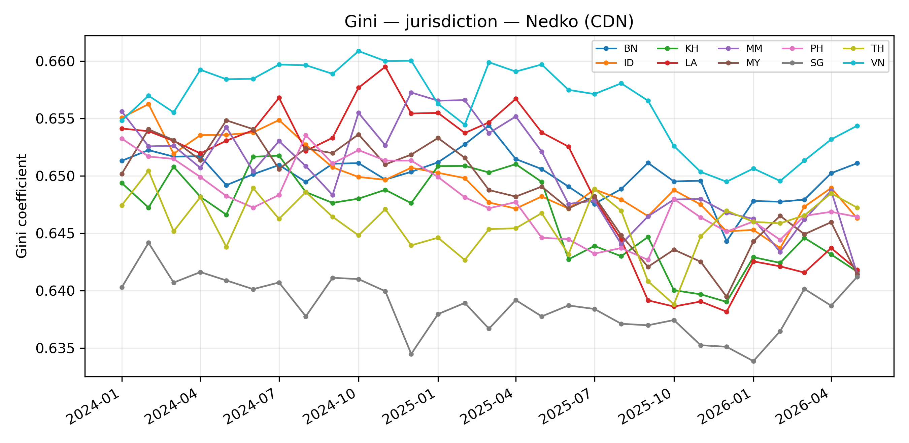
Figure: Gini of jurisdiction concentration, Nedko (CDN), per country over time.
Table: market share (%) by jurisdiction × year × country (Nedko (CDN)). Cells = mean monthly share in that year.
Country | Jurisdiction | 2024 | 2025 | 2026
BN | China | 0.7 | 0.6 | 0.4
 | USA | 98.3 | 98.1 | 97.7
 | Other | 1.0 | 1.4 | 1.9
ID | China | 0.6 | 0.9 | 0.8
 | USA | 98.5 | 98.0 | 97.8
 | Other | 0.8 | 1.2 | 1.4
KH | China | 0.8 | 0.7 | 0.7
 | USA | 98.1 | 97.6 | 97.1
 | Other | 1.2 | 1.7 | 2.1
LA | China | 0.6 | 0.7 | 0.6
 | USA | 98.7 | 97.9 | 96.9
 | Other | 0.7 | 1.4 | 2.5
MM | China | 0.6 | 0.5 | 0.7
 | USA | 98.5 | 98.0 | 97.5
 | Other | 0.9 | 1.5 | 1.8
MY | China | 0.4 | 0.6 | 0.6
 | USA | 98.3 | 97.6 | 97.3
 | Other | 1.3 | 1.9 | 2.1
PH | China | 0.7 | 0.9 | 0.8
 | USA | 98.3 | 97.8 | 97.7
 | Other | 1.1 | 1.3 | 1.6
SG | China | 1.5 | 1.6 | 1.4
 | USA | 97.3 | 97.0 | 97.1
 | Other | 1.2 | 1.4 | 1.5
TH | China | 0.8 | 0.7 | 0.5
 | USA | 97.8 | 97.4 | 97.5
 | Other | 1.4 | 1.9 | 2.0
VN | China | 0.2 | 0.3 | 0.6
 | USA | 99.0 | 98.7 | 98.4
 | Other | 0.8 | 0.9 | 1.0

ISOC (CDN)
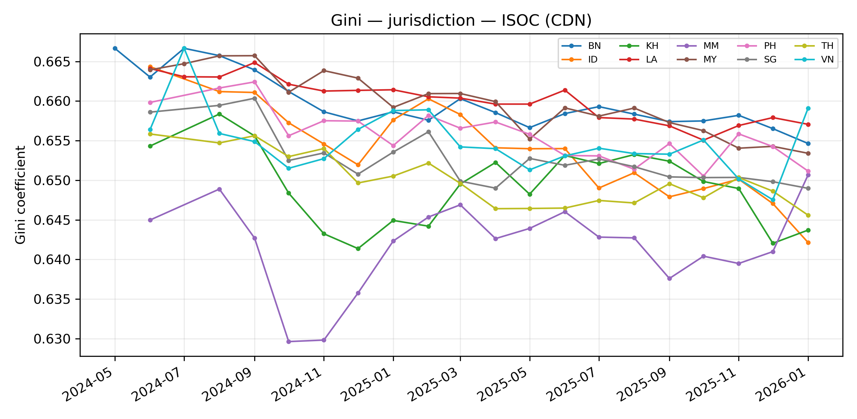
Figure: Gini of jurisdiction concentration, ISOC (CDN), per country over time.
Table: market share (%) by jurisdiction × year × country (ISOC (CDN)). Cells = mean monthly share in that year.
Country | Jurisdiction | 2024 | 2025 | 2026
BN | China | 0.4 | 0.9 | 1.0
 | USA | 99.5 | 98.9 | 98.6
 | Other | 0.1 | 0.2 | 0.4
ID | China | 1.1 | 1.4 | 1.5
 | USA | 98.9 | 98.3 | 97.4
 | Other | 0.1 | 0.3 | 1.1
KH | China | 2.2 | 2.4 | 2.4
 | USA | 97.7 | 97.5 | 97.1
 | Other | 0.1 | 0.1 | 0.5
LA | China | 0.6 | 0.9 | 0.7
 | USA | 99.4 | 99.0 | 99.0
 | Other | – | 0.2 | 0.4
MM | China | 3.9 | 3.4 | 2.1
 | USA | 95.9 | 96.5 | 97.7
 | Other | 0.1 | 0.1 | 0.1
MY | China | 0.4 | 1.0 | 1.4
 | USA | 99.6 | 98.8 | 98.3
 | Other | 0.0 | 0.2 | 0.3
PH | China | 1.1 | 1.7 | 2.1
 | USA | 98.9 | 98.2 | 97.8
 | Other | 0.0 | 0.1 | 0.1
SG | China | 1.6 | 2.2 | 2.1
 | USA | 98.4 | 97.8 | 97.6
 | Other | – | 0.1 | 0.3
TH | China | 1.4 | 2.0 | 1.6
 | USA | 98.3 | 97.7 | 97.6
 | Other | 0.3 | 0.4 | 0.8
VN | China | 1.1 | 1.9 | 1.1
 | USA | 98.7 | 98.1 | 98.9
 | Other | 0.2 | 0.0 | –

OpenINTEL (IP infrastructure)
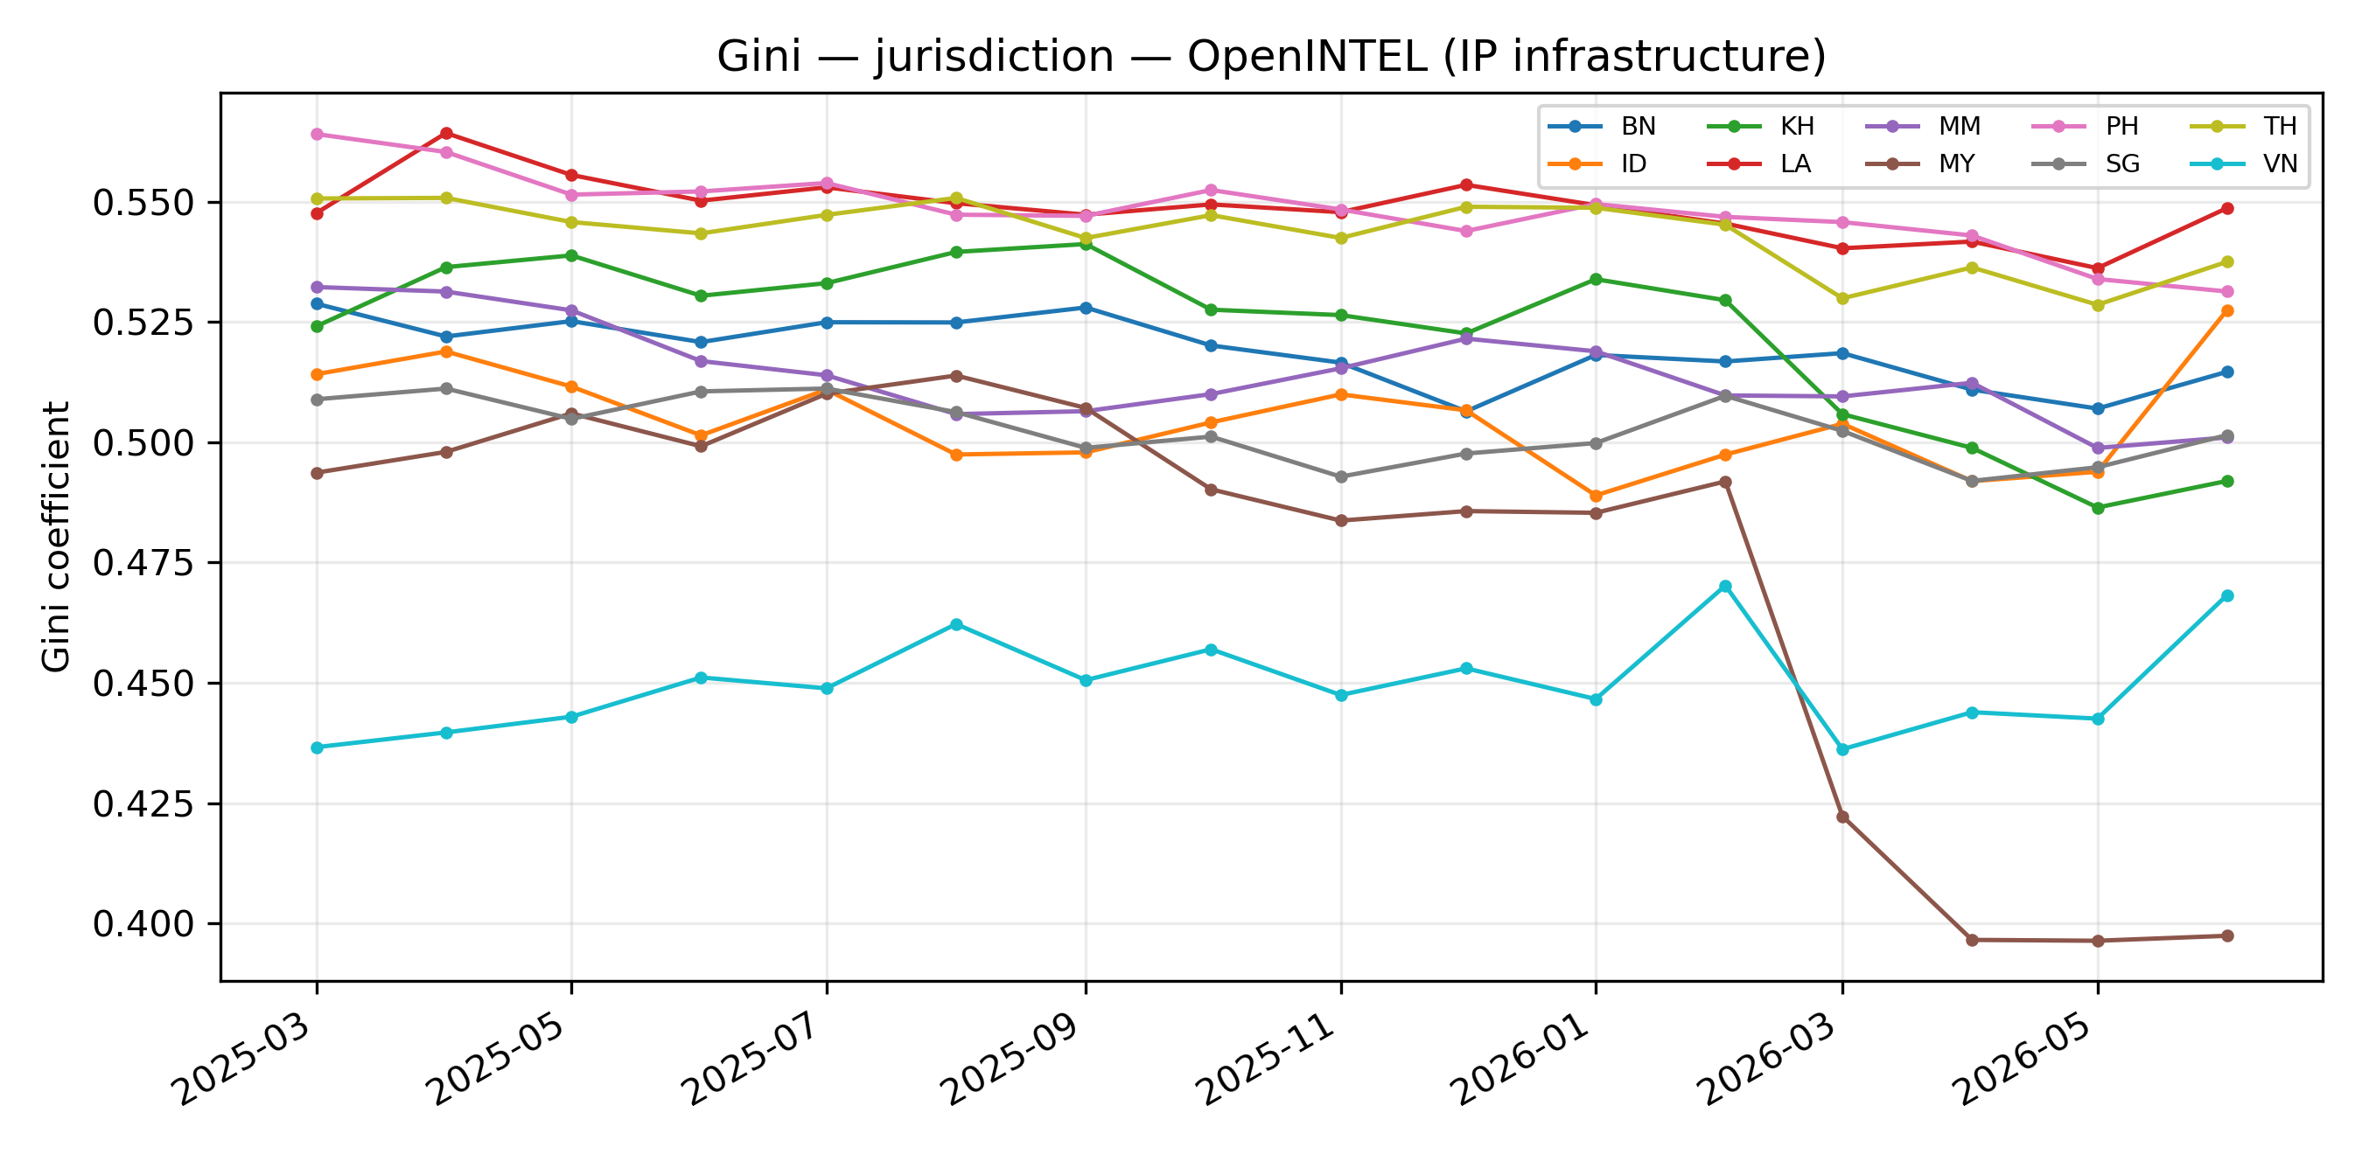
Figure: Gini of jurisdiction concentration, OpenINTEL (IP infrastructure), per country over time.
Table: market share (%) by jurisdiction × year × country (OpenINTEL (IP infrastructure)). Cells = mean monthly share in that year.
Country | Jurisdiction | 2025 | 2026
BN | China | 0.8 | 0.6
 | USA | 79.0 | 77.7
 | Other | 20.2 | 21.7
ID | China | 1.4 | 1.4
 | USA | 77.5 | 76.4
 | Other | 21.2 | 22.2
KH | China | 1.4 | 2.7
 | USA | 81.3 | 78.9
 | Other | 17.3 | 18.4
LA | China | 0.6 | 0.4
 | USA | 83.4 | 81.9
 | Other | 16.1 | 17.7
MM | China | 2.0 | 2.4
 | USA | 79.7 | 78.6
 | Other | 18.2 | 19.0
MY | China | 1.3 | 4.8
 | USA | 76.1 | 69.5
 | Other | 22.5 | 25.8
PH | China | 1.5 | 1.4
 | USA | 84.3 | 82.7
 | Other | 14.2 | 15.9
SG | China | 3.7 | 3.2
 | USA | 79.4 | 78.2
 | Other | 16.9 | 18.5
TH | China | 1.5 | 0.8
 | USA | 83.5 | 81.5
 | Other | 15.0 | 17.7
VN | China | 0.9 | 0.7
 | USA | 68.3 | 68.4
 | Other | 30.8 | 30.8

HHI (by provider)

Nedko (CDN)
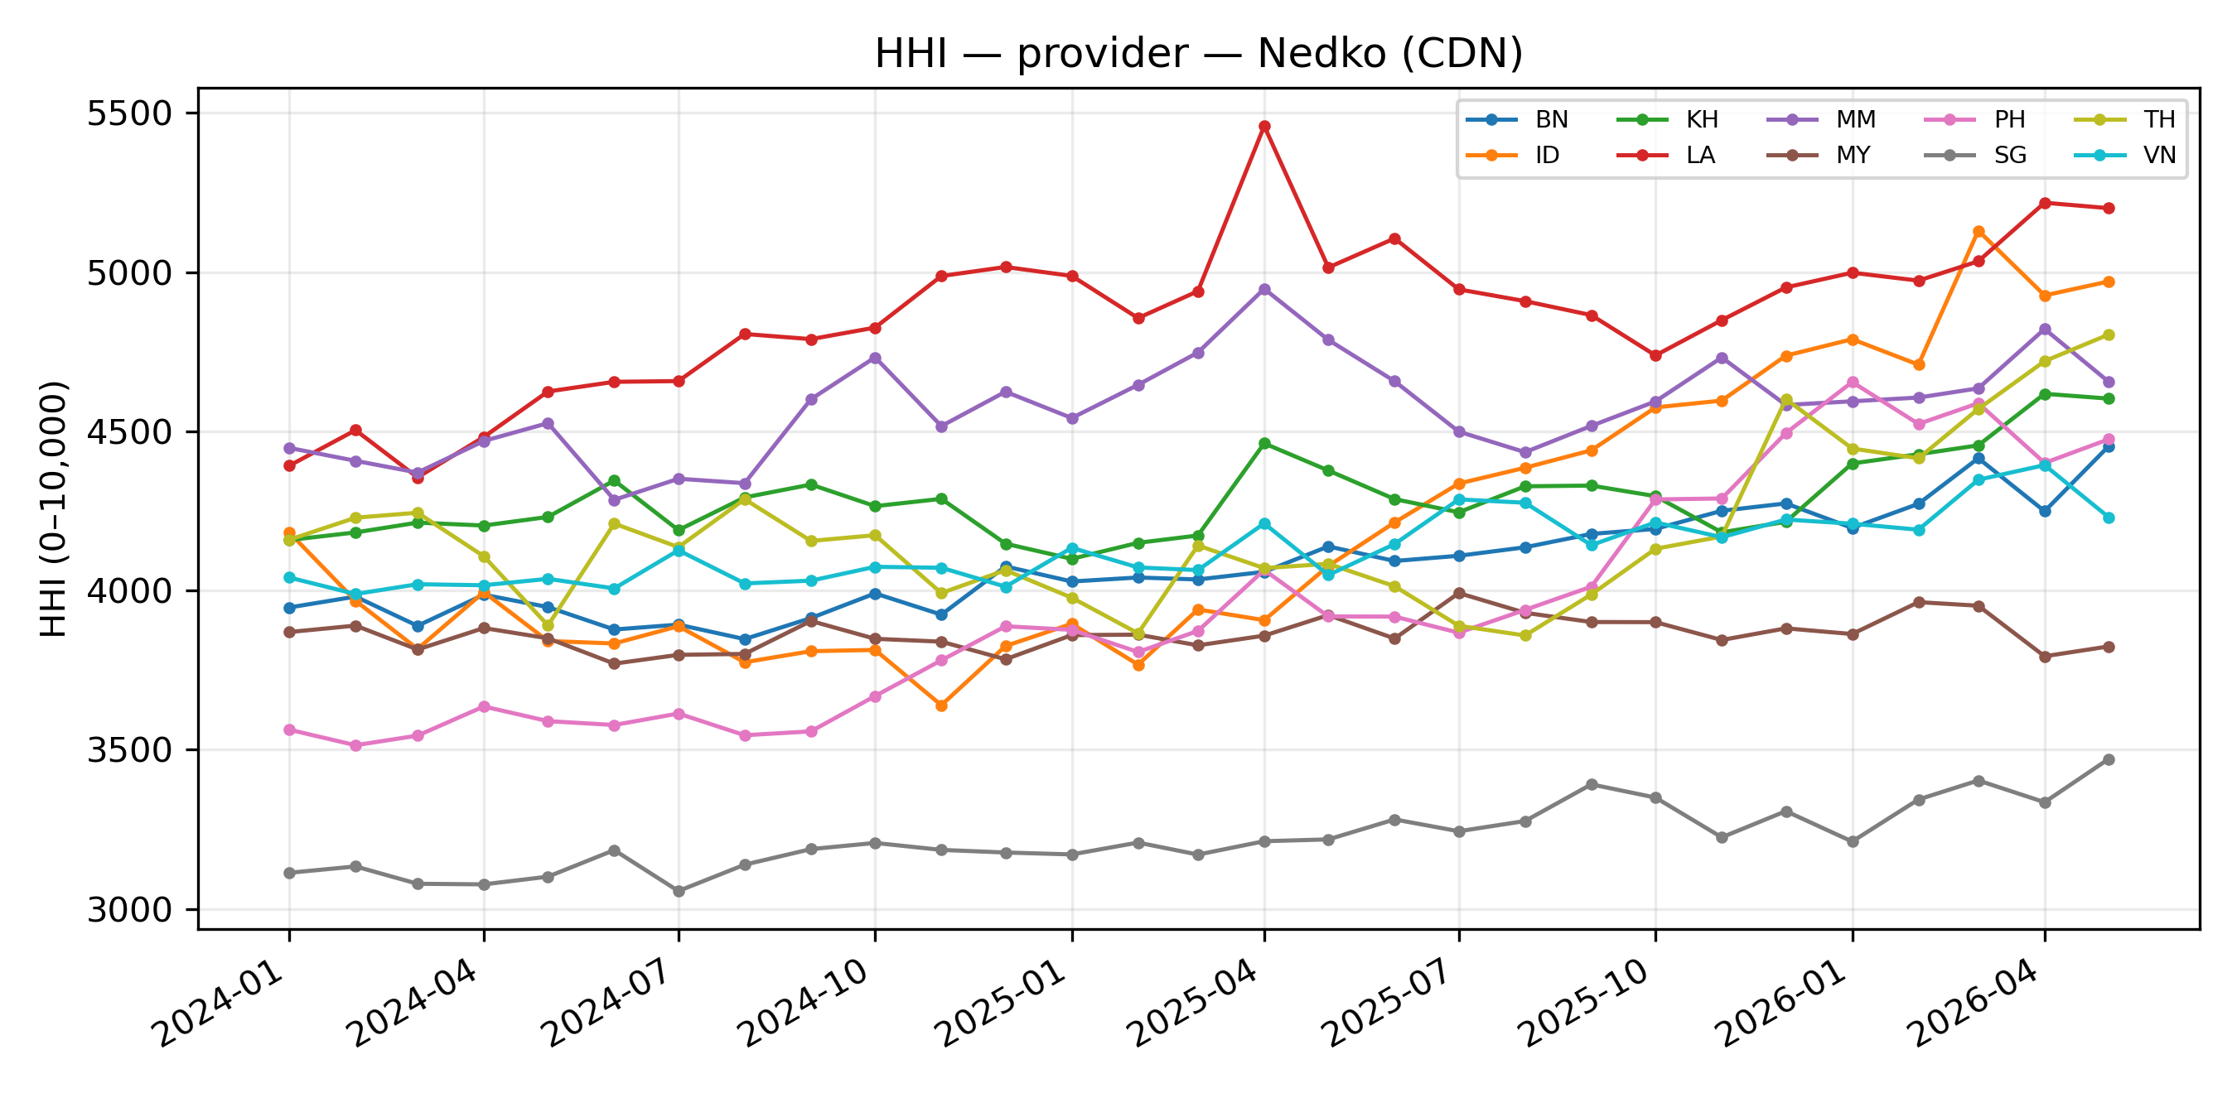
Figure: HHI of provider concentration, Nedko (CDN), per country over time.
Table: market share (%) by provider × year × country (Nedko (CDN)). Cells = mean monthly share in that year.
Country | Provider | 2024 | 2025 | 2026
BN | CloudFlare | 53.5 | 55.9 | 58.6
 | Netlify | 31.9 | 31.0 | 29.2
 | Amazon CloudFront | 6.5 | 5.6 | 5.0
 | Fastly | 3.4 | 2.6 | 2.3
 | Imperva | 0.6 | 0.5 | 0.5
 | CDN77 | 0.7 | 1.1 | 1.5
 | Akamai | 0.6 | 0.4 | 0.5
 | Alibaba Cloud CDN | 0.7 | 0.6 | 0.4
 | Azure CDN | 1.1 | 1.3 | 1.0
 | BunnyCDN | 0.2 | 0.3 | 0.3
 | Google Cloud CDN | 0.3 | 0.2 | 0.2
 | Vercel | 0.2 | 0.3 | 0.3
 | Tencent Cloud CDN | 0.0 | 0.0 | –
 | Sucuri | 0.3 | 0.2 | 0.2
 | SiteGround CDN | – | – | –
ID | CloudFlare | 53.9 | 59.2 | 66.5
 | Netlify | 27.4 | 24.0 | 20.1
 | Amazon CloudFront | 14.0 | 11.2 | 8.1
 | Fastly | 1.5 | 1.7 | 1.4
 | Imperva | 0.3 | 0.2 | 0.1
 | CDN77 | 0.6 | 0.8 | 1.0
 | Akamai | 0.6 | 0.6 | 0.6
 | Alibaba Cloud CDN | 0.6 | 0.8 | 0.8
 | Azure CDN | 0.1 | 0.1 | 0.1
 | BunnyCDN | 0.2 | 0.4 | 0.4
 | Google Cloud CDN | 0.3 | 0.6 | 0.5
 | Vercel | 0.2 | 0.1 | 0.1
 | Tencent Cloud CDN | – | 0.0 | 0.1
 | Sucuri | 0.1 | 0.2 | 0.1
 | SiteGround CDN | – | – | –
KH | CloudFlare | 55.4 | 56.4 | 59.9
 | Netlify | 33.7 | 32.4 | 29.8
 | Amazon CloudFront | 5.0 | 4.6 | 3.3
 | Fastly | 1.9 | 2.4 | 2.6
 | Imperva | 0.4 | 0.2 | 0.0
 | CDN77 | 0.7 | 1.2 | 1.5
 | Akamai | 0.9 | 0.7 | 0.6
 | Alibaba Cloud CDN | 0.6 | 0.5 | 0.5
 | Azure CDN | 0.4 | 0.3 | 0.4
 | BunnyCDN | 0.3 | 0.3 | 0.6
 | Google Cloud CDN | 0.2 | 0.1 | 0.1
 | Vercel | 0.1 | 0.3 | 0.4
 | Tencent Cloud CDN | 0.2 | 0.2 | 0.2
 | Sucuri | 0.1 | 0.1 | 0.1
 | SiteGround CDN | 0.2 | 0.1 | 0.1
LA | CloudFlare | 62.1 | 65.7 | 67.4
 | Netlify | 28.1 | 25.0 | 22.6
 | Amazon CloudFront | 5.0 | 4.4 | 4.0
 | Fastly | 1.3 | 0.9 | 1.1
 | Imperva | 0.5 | 0.2 | 0.1
 | CDN77 | 0.3 | 1.0 | 2.1
 | Akamai | 0.8 | 0.7 | 0.8
 | Alibaba Cloud CDN | 0.3 | 0.5 | 0.3
 | Azure CDN | 0.5 | 0.2 | 0.2
 | BunnyCDN | 0.4 | 0.3 | 0.4
 | Google Cloud CDN | 0.4 | 0.3 | 0.1
 | Vercel | 0.1 | 0.3 | 0.5
 | Tencent Cloud CDN | 0.2 | 0.3 | 0.2
 | Sucuri | 0.0 | 0.1 | 0.0
 | SiteGround CDN | – | – | –
MM | CloudFlare | 61.1 | 62.8 | 62.7
 | Netlify | 26.3 | 25.7 | 26.6
 | Amazon CloudFront | 6.1 | 5.0 | 3.5
 | Fastly | 2.3 | 2.0 | 2.5
 | Imperva | 0.9 | 1.1 | 0.6
 | CDN77 | 0.4 | 1.1 | 1.4
 | Akamai | 0.9 | 0.8 | 0.6
 | Alibaba Cloud CDN | 0.6 | 0.5 | 0.7
 | Azure CDN | 0.3 | 0.3 | 0.5
 | BunnyCDN | 0.4 | 0.4 | 0.4
 | Google Cloud CDN | 0.5 | 0.2 | 0.2
 | Vercel | 0.1 | 0.2 | 0.2
 | Tencent Cloud CDN | 0.0 | 0.0 | –
 | Sucuri | – | – | –
 | SiteGround CDN | – | – | –
MY | CloudFlare | 52.7 | 54.0 | 53.5
 | Netlify | 31.7 | 30.1 | 31.0
 | Amazon CloudFront | 6.2 | 6.4 | 6.1
 | Fastly | 2.9 | 2.7 | 2.8
 | Imperva | 2.8 | 2.6 | 2.5
 | CDN77 | 1.1 | 1.2 | 1.3
 | Akamai | 0.7 | 0.4 | 0.4
 | Alibaba Cloud CDN | 0.3 | 0.4 | 0.5
 | Azure CDN | 0.7 | 0.4 | 0.3
 | BunnyCDN | 0.2 | 0.7 | 0.8
 | Google Cloud CDN | 0.5 | 0.6 | 0.4
 | Vercel | 0.1 | 0.2 | 0.3
 | Tencent Cloud CDN | 0.1 | 0.1 | 0.1
 | Sucuri | 0.0 | 0.0 | 0.1
 | SiteGround CDN | – | – | –
PH | CloudFlare | 50.0 | 55.8 | 62.7
 | Netlify | 31.6 | 28.4 | 22.8
 | Amazon CloudFront | 10.7 | 9.1 | 8.5
 | Fastly | 2.9 | 2.4 | 2.2
 | Imperva | 0.7 | 0.2 | 0.4
 | CDN77 | 0.8 | 1.2 | 1.4
 | Akamai | 1.1 | 0.7 | 0.5
 | Alibaba Cloud CDN | 0.7 | 0.9 | 0.8
 | Azure CDN | 0.7 | 0.4 | 0.2
 | BunnyCDN | 0.1 | 0.1 | 0.2
 | Google Cloud CDN | 0.3 | 0.3 | 0.1
 | Vercel | 0.1 | 0.3 | 0.2
 | Tencent Cloud CDN | – | – | –
 | Sucuri | 0.3 | 0.1 | 0.0
 | SiteGround CDN | 0.1 | – | –
SG | CloudFlare | 44.3 | 46.5 | 48.9
 | Netlify | 31.3 | 30.3 | 28.5
 | Amazon CloudFront | 12.8 | 11.9 | 10.9
 | Fastly | 4.0 | 3.7 | 3.6
 | Imperva | 2.8 | 2.7 | 3.4
 | CDN77 | 1.0 | 1.2 | 1.3
 | Akamai | 1.0 | 0.8 | 0.7
 | Alibaba Cloud CDN | 1.2 | 1.2 | 1.1
 | Azure CDN | 0.7 | 0.6 | 0.6
 | BunnyCDN | 0.2 | 0.2 | 0.3
 | Google Cloud CDN | 0.1 | 0.1 | –
 | Vercel | 0.2 | 0.3 | 0.4
 | Tencent Cloud CDN | 0.3 | 0.3 | 0.3
 | Sucuri | 0.0 | 0.0 | 0.0
 | SiteGround CDN | – | – | –
TH | CloudFlare | 57.3 | 56.1 | 61.9
 | Netlify | 28.2 | 29.2 | 26.8
 | Amazon CloudFront | 6.2 | 6.7 | 5.5
 | Fastly | 1.3 | 1.4 | 0.9
 | Imperva | 2.8 | 2.3 | 1.2
 | CDN77 | 1.0 | 1.3 | 1.3
 | Akamai | 0.7 | 0.6 | 0.5
 | Alibaba Cloud CDN | 0.6 | 0.5 | 0.4
 | Azure CDN | 0.8 | 0.7 | 0.3
 | BunnyCDN | 0.4 | 0.6 | 0.7
 | Google Cloud CDN | 0.2 | 0.1 | –
 | Vercel | 0.2 | 0.3 | 0.4
 | Tencent Cloud CDN | 0.2 | 0.2 | 0.1
 | Sucuri | – | 0.0 | 0.1
 | SiteGround CDN | – | – | –
VN | CloudFlare | 45.5 | 52.4 | 57.6
 | Netlify | 43.6 | 36.5 | 29.4
 | Amazon CloudFront | 7.5 | 7.9 | 9.4
 | Fastly | 1.1 | 0.9 | 0.8
 | Imperva | 0.2 | 0.1 | 0.3
 | CDN77 | 0.7 | 0.8 | 0.9
 | Akamai | 0.5 | 0.4 | 0.3
 | Alibaba Cloud CDN | 0.2 | 0.3 | 0.6
 | Azure CDN | 0.5 | 0.4 | 0.2
 | BunnyCDN | 0.2 | 0.1 | 0.1
 | Google Cloud CDN | 0.1 | 0.1 | 0.2
 | Vercel | 0.1 | 0.1 | 0.1
 | Tencent Cloud CDN | – | – | –
 | Sucuri | – | – | –
 | SiteGround CDN | – | – | –

ISOC (CDN)
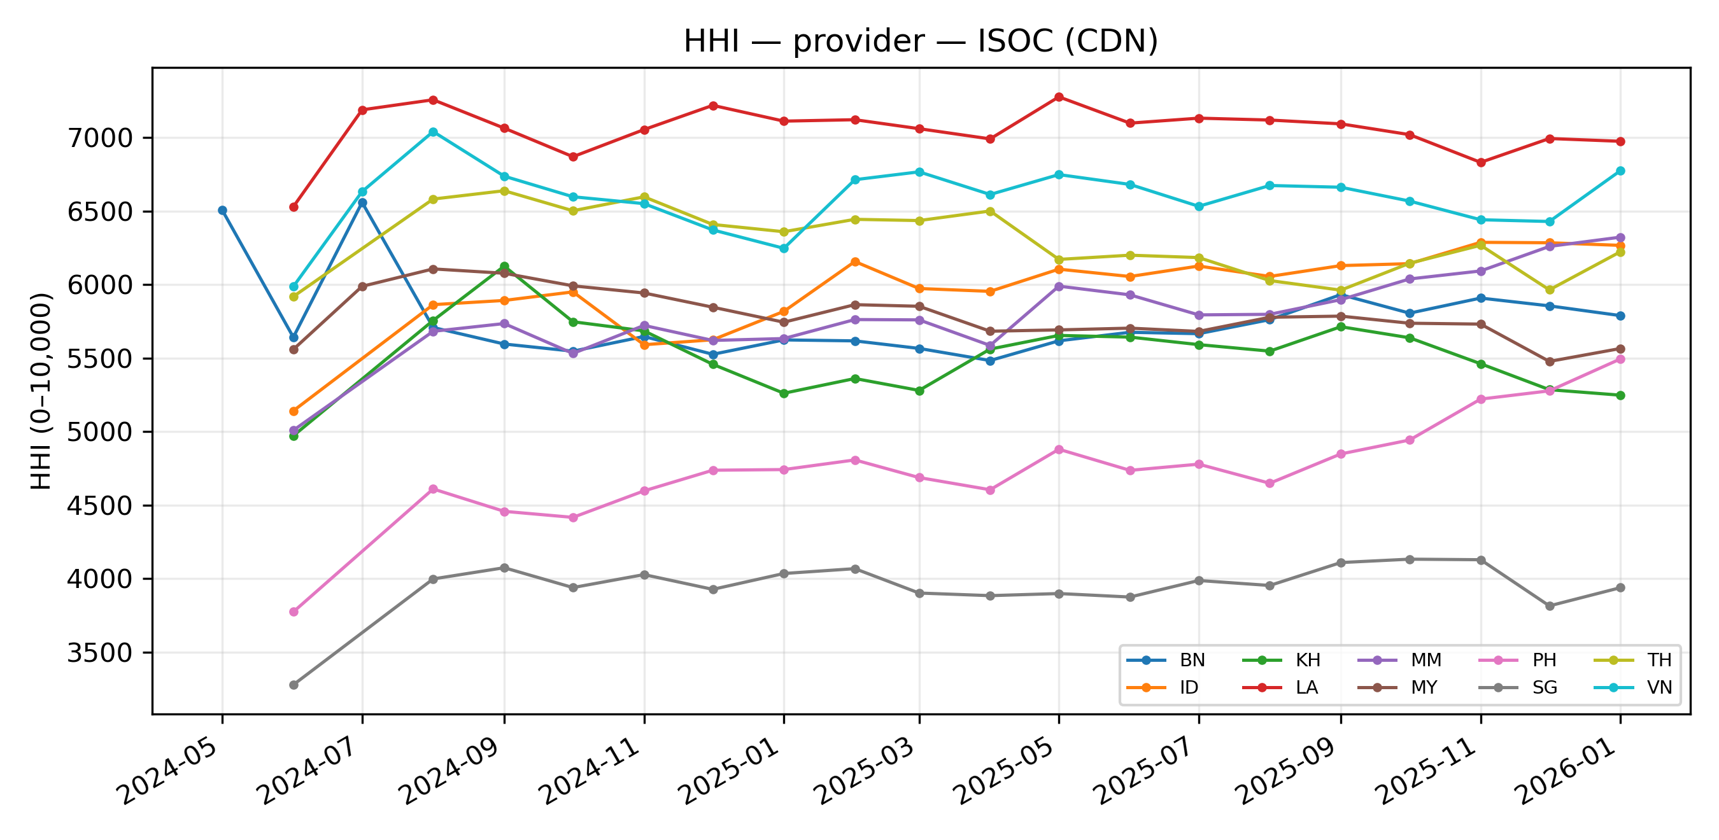
Figure: HHI of provider concentration, ISOC (CDN), per country over time.
Table: market share (%) by provider × year × country (ISOC (CDN)). Cells = mean monthly share in that year.
Country | Provider | 2024 | 2025 | 2026
BN | cloudflare | 65.2 | 74.4 | 75.0
 | amazon | 7.7 | 9.6 | 8.5
 | akamai | 16.7 | 7.4 | 8.0
 | fastly | 4.0 | 4.0 | 4.0
 | alibaba | 0.4 | 0.9 | 1.0
 | microsoft | 4.5 | 2.5 | 2.1
 | facebook | 0.7 | 1.0 | 1.0
 | cloudfront | 0.7 | – | –
 | cdn77 | 0.0 | 0.1 | 0.4
 | gcore | 0.0 | 0.1 | –
 | bunnycdn | 0.0 | – | –
 | netflix | – | 0.0 | –
 | wordpress | – | 0.0 | –
 | edgio | – | – | –
ID | cloudflare | 73.1 | 76.4 | 77.9
 | amazon | 17.2 | 15.0 | 13.2
 | akamai | 3.6 | 3.6 | 3.7
 | fastly | 1.4 | 1.6 | 1.2
 | alibaba | 1.1 | 1.4 | 1.5
 | microsoft | 0.7 | 0.5 | 0.4
 | facebook | 1.2 | 1.1 | 1.0
 | cloudfront | 1.8 | – | –
 | cdn77 | 0.1 | 0.3 | 0.8
 | gcore | – | – | –
 | bunnycdn | 0.0 | 0.0 | 0.3
 | netflix | – | – | –
 | wordpress | – | – | –
 | edgio | – | – | –
KH | cloudflare | 73.7 | 72.6 | 70.6
 | amazon | 11.0 | 12.4 | 14.2
 | akamai | 6.8 | 7.1 | 6.6
 | fastly | 2.4 | 3.0 | 3.2
 | alibaba | 2.2 | 2.4 | 2.4
 | microsoft | 1.0 | 0.7 | 0.9
 | facebook | 1.7 | 1.7 | 1.6
 | cloudfront | 1.2 | – | –
 | cdn77 | 0.1 | 0.1 | 0.5
 | gcore | – | – | –
 | bunnycdn | – | – | –
 | netflix | – | – | –
 | wordpress | 0.0 | – | –
 | edgio | – | – | –
LA | cloudflare | 83.3 | 83.6 | 83.0
 | amazon | 6.4 | 7.1 | 7.3
 | akamai | 5.2 | 5.0 | 5.5
 | fastly | 1.2 | 1.0 | 1.0
 | alibaba | 0.6 | 0.9 | 0.7
 | microsoft | 1.0 | 0.7 | 0.7
 | facebook | 1.4 | 1.5 | 1.4
 | cloudfront | 0.8 | – | –
 | cdn77 | – | 0.1 | 0.4
 | gcore | – | 0.1 | –
 | bunnycdn | – | 0.0 | –
 | netflix | – | 0.0 | –
 | wordpress | – | – | –
 | edgio | – | – | –
MM | cloudflare | 73.0 | 75.5 | 78.8
 | amazon | 12.2 | 10.8 | 8.4
 | akamai | 5.3 | 5.9 | 4.7
 | fastly | 2.4 | 2.3 | 3.6
 | alibaba | 3.9 | 3.4 | 2.1
 | microsoft | 1.3 | 1.5 | 1.7
 | facebook | 0.3 | 0.5 | 0.5
 | cloudfront | 1.4 | – | –
 | cdn77 | 0.1 | 0.1 | 0.1
 | gcore | – | 0.0 | –
 | bunnycdn | 0.0 | – | –
 | netflix | – | – | –
 | wordpress | – | – | –
 | edgio | – | – | –
MY | cloudflare | 76.0 | 74.5 | 73.2
 | amazon | 9.1 | 10.7 | 12.6
 | akamai | 7.3 | 6.7 | 6.2
 | fastly | 3.3 | 3.1 | 2.3
 | alibaba | 0.4 | 1.0 | 1.4
 | microsoft | 2.2 | 2.6 | 2.4
 | facebook | 1.0 | 1.3 | 1.4
 | cloudfront | 0.7 | – | –
 | cdn77 | 0.0 | 0.1 | 0.3
 | gcore | – | 0.1 | –
 | bunnycdn | – | – | –
 | netflix | – | 0.0 | 0.1
 | wordpress | – | – | –
 | edgio | – | – | –
PH | cloudflare | 62.2 | 66.5 | 72.3
 | amazon | 21.5 | 18.7 | 14.7
 | akamai | 7.3 | 6.8 | 5.5
 | fastly | 3.3 | 3.0 | 2.8
 | alibaba | 1.1 | 1.7 | 2.1
 | microsoft | 1.8 | 2.0 | 1.6
 | facebook | 1.1 | 1.1 | 0.9
 | cloudfront | 1.7 | – | –
 | cdn77 | 0.0 | 0.1 | 0.1
 | gcore | – | – | –
 | bunnycdn | – | – | –
 | netflix | – | 0.0 | –
 | wordpress | – | – | –
 | edgio | – | – | –
SG | cloudflare | 57.8 | 58.8 | 58.6
 | amazon | 16.7 | 17.0 | 16.6
 | akamai | 14.1 | 14.0 | 13.9
 | fastly | 5.2 | 4.6 | 4.5
 | alibaba | 1.6 | 2.2 | 2.1
 | microsoft | 2.1 | 2.2 | 2.7
 | facebook | 1.0 | 1.1 | 1.3
 | cloudfront | 1.5 | – | –
 | cdn77 | – | 0.1 | 0.3
 | gcore | – | – | –
 | bunnycdn | – | – | –
 | netflix | – | 0.0 | –
 | wordpress | – | – | –
 | edgio | 0.0 | – | –
TH | cloudflare | 79.5 | 77.9 | 78.0
 | amazon | 8.7 | 8.7 | 7.3
 | akamai | 6.2 | 8.1 | 8.8
 | fastly | 1.3 | 1.0 | 1.3
 | alibaba | 1.4 | 2.0 | 1.6
 | microsoft | 1.3 | 1.2 | 1.3
 | facebook | 0.6 | 0.8 | 0.8
 | cloudfront | 0.7 | – | –
 | cdn77 | 0.1 | 0.2 | 0.6
 | gcore | – | 0.1 | –
 | bunnycdn | 0.1 | 0.1 | 0.1
 | netflix | – | 0.0 | 0.1
 | wordpress | – | – | –
 | edgio | – | – | –
VN | cloudflare | 68.5 | 80.2 | 81.4
 | amazon | 9.4 | 11.8 | 11.5
 | akamai | 14.2 | 3.3 | 3.1
 | fastly | 0.6 | 1.1 | 1.1
 | alibaba | 1.1 | 1.9 | 1.1
 | microsoft | 3.7 | 0.6 | 0.4
 | facebook | 1.0 | 1.1 | 1.1
 | cloudfront | 1.2 | – | –
 | cdn77 | 0.1 | 0.0 | –
 | gcore | 0.1 | – | –
 | bunnycdn | 0.0 | – | –
 | netflix | – | 0.0 | 0.1
 | wordpress | 0.0 | – | –
 | edgio | – | – | –

OpenINTEL (IP infrastructure)
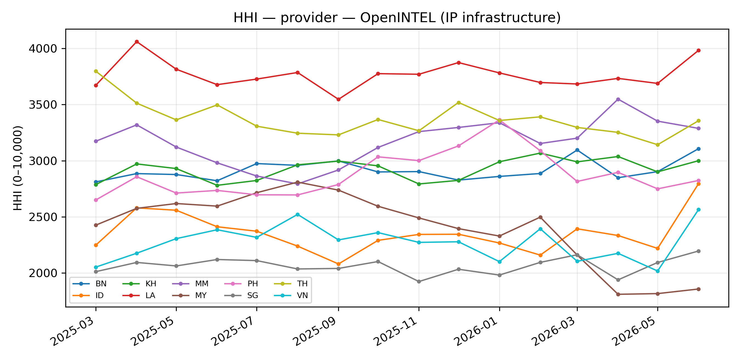
Figure: HHI of provider concentration, OpenINTEL (IP infrastructure), per country over time.
Table: market share (%) by provider × year × country (OpenINTEL (IP infrastructure)). Cells = mean monthly share in that year.
Country | Provider | 2025 | 2026
BN | Cloudflare, Inc. (CLOUDFLARENET) | 52.8 | 53.3
 | Amazon.com, Inc. (AMAZON-02) | 6.5 | 6.7
 | Google LLC (GOOGLE) | 3.1 | 2.8
 | Akamai International B.V. (AKAMAI-ASN1) | 2.4 | 2.8
 | Akamai Technologies, Inc. (AKAMAI-AS) | 3.1 | 2.7
 | Fastly, Inc. (FASTLY) | 2.9 | 2.3
 | DataWeb Global Group B.V. (ADVANCEDHOSTERS-AS) | 2.5 | 3.0
 | Google LLC (GOOGLE-CLOUD-PLATFORM) | 1.3 | 1.0
 | OVH SAS (OVH) | 1.9 | 1.5
 | Microsoft Corporation (MICROSOFT-CORP-MSN-AS-BLOCK) | 1.6 | 2.0
 | Facebook, Inc. (FACEBOOK) | 0.7 | 0.7
 | Incapsula Inc (INCAPSULA) | 0.3 | 0.4
 | Other | 20.9 | 20.8
ID | Cloudflare, Inc. (CLOUDFLARENET) | 46.1 | 46.7
 | Amazon.com, Inc. (AMAZON-02) | 11.5 | 9.4
 | Google LLC (GOOGLE) | 4.0 | 3.5
 | Akamai International B.V. (AKAMAI-ASN1) | 2.3 | 2.6
 | Akamai Technologies, Inc. (AKAMAI-AS) | 0.9 | 1.0
 | Fastly, Inc. (FASTLY) | 1.4 | 1.5
 | DataWeb Global Group B.V. (ADVANCEDHOSTERS-AS) | 1.4 | 1.3
 | Google LLC (GOOGLE-CLOUD-PLATFORM) | 2.7 | 2.7
 | OVH SAS (OVH) | 4.6 | 4.3
 | Microsoft Corporation (MICROSOFT-CORP-MSN-AS-BLOCK) | 0.5 | 0.5
 | Facebook, Inc. (FACEBOOK) | 1.0 | 1.0
 | Incapsula Inc (INCAPSULA) | 0.3 | 0.2
 | Other | 23.4 | 25.3
KH | Cloudflare, Inc. (CLOUDFLARENET) | 52.4 | 53.7
 | Amazon.com, Inc. (AMAZON-02) | 8.8 | 7.9
 | Google LLC (GOOGLE) | 4.1 | 3.7
 | Akamai International B.V. (AKAMAI-ASN1) | 2.4 | 2.8
 | Akamai Technologies, Inc. (AKAMAI-AS) | 2.6 | 2.3
 | Fastly, Inc. (FASTLY) | 2.3 | 2.1
 | DataWeb Global Group B.V. (ADVANCEDHOSTERS-AS) | 1.8 | 1.7
 | Google LLC (GOOGLE-CLOUD-PLATFORM) | 1.2 | 1.6
 | OVH SAS (OVH) | 1.0 | 1.0
 | Microsoft Corporation (MICROSOFT-CORP-MSN-AS-BLOCK) | 0.5 | 0.6
 | Facebook, Inc. (FACEBOOK) | 1.3 | 1.0
 | Incapsula Inc (INCAPSULA) | 0.1 | –
 | Other | 21.4 | 21.5
LA | Cloudflare, Inc. (CLOUDFLARENET) | 60.8 | 60.7
 | Amazon.com, Inc. (AMAZON-02) | 5.3 | 5.5
 | Google LLC (GOOGLE) | 3.3 | 3.1
 | Akamai International B.V. (AKAMAI-ASN1) | 1.6 | 2.1
 | Akamai Technologies, Inc. (AKAMAI-AS) | 2.0 | 1.7
 | Fastly, Inc. (FASTLY) | 0.9 | 1.0
 | DataWeb Global Group B.V. (ADVANCEDHOSTERS-AS) | 2.4 | 2.6
 | Google LLC (GOOGLE-CLOUD-PLATFORM) | 2.0 | 2.1
 | OVH SAS (OVH) | 0.6 | 0.8
 | Microsoft Corporation (MICROSOFT-CORP-MSN-AS-BLOCK) | 0.5 | 0.4
 | Facebook, Inc. (FACEBOOK) | 1.1 | 1.1
 | Incapsula Inc (INCAPSULA) | 0.1 | –
 | Other | 19.4 | 19.0
MM | Cloudflare, Inc. (CLOUDFLARENET) | 54.5 | 56.9
 | Amazon.com, Inc. (AMAZON-02) | 7.5 | 5.8
 | Google LLC (GOOGLE) | 3.0 | 3.3
 | Akamai International B.V. (AKAMAI-ASN1) | 2.2 | 2.0
 | Akamai Technologies, Inc. (AKAMAI-AS) | 1.7 | 1.3
 | Fastly, Inc. (FASTLY) | 2.0 | 2.4
 | DataWeb Global Group B.V. (ADVANCEDHOSTERS-AS) | 2.2 | 2.2
 | Google LLC (GOOGLE-CLOUD-PLATFORM) | 1.4 | 1.2
 | OVH SAS (OVH) | 0.9 | 0.7
 | Microsoft Corporation (MICROSOFT-CORP-MSN-AS-BLOCK) | 1.1 | 1.2
 | Facebook, Inc. (FACEBOOK) | 0.4 | 0.4
 | Incapsula Inc (INCAPSULA) | 1.2 | 0.6
 | Other | 21.8 | 22.0
MY | Cloudflare, Inc. (CLOUDFLARENET) | 49.8 | 43.9
 | Amazon.com, Inc. (AMAZON-02) | 7.6 | 7.6
 | Google LLC (GOOGLE) | 3.0 | 3.0
 | Akamai International B.V. (AKAMAI-ASN1) | 2.3 | 2.6
 | Akamai Technologies, Inc. (AKAMAI-AS) | 2.0 | 1.9
 | Fastly, Inc. (FASTLY) | 2.1 | 2.0
 | DataWeb Global Group B.V. (ADVANCEDHOSTERS-AS) | 2.8 | 2.4
 | Google LLC (GOOGLE-CLOUD-PLATFORM) | 1.1 | 1.2
 | OVH SAS (OVH) | 1.3 | 0.8
 | Microsoft Corporation (MICROSOFT-CORP-MSN-AS-BLOCK) | 1.3 | 1.3
 | Facebook, Inc. (FACEBOOK) | 0.9 | 0.9
 | Incapsula Inc (INCAPSULA) | 2.1 | 1.9
 | Other | 23.5 | 30.4
PH | Cloudflare, Inc. (CLOUDFLARENET) | 50.8 | 52.4
 | Amazon.com, Inc. (AMAZON-02) | 14.1 | 12.5
 | Google LLC (GOOGLE) | 3.1 | 3.1
 | Akamai International B.V. (AKAMAI-ASN1) | 2.5 | 2.5
 | Akamai Technologies, Inc. (AKAMAI-AS) | 2.6 | 2.7
 | Fastly, Inc. (FASTLY) | 2.4 | 2.3
 | DataWeb Global Group B.V. (ADVANCEDHOSTERS-AS) | 1.0 | 1.3
 | Google LLC (GOOGLE-CLOUD-PLATFORM) | 1.8 | 1.5
 | OVH SAS (OVH) | 0.9 | 0.9
 | Microsoft Corporation (MICROSOFT-CORP-MSN-AS-BLOCK) | 1.6 | 1.2
 | Facebook, Inc. (FACEBOOK) | 0.9 | 0.9
 | Incapsula Inc (INCAPSULA) | 0.1 | 0.2
 | Other | 18.1 | 18.5
SG | Cloudflare, Inc. (CLOUDFLARENET) | 42.4 | 42.9
 | Amazon.com, Inc. (AMAZON-02) | 12.4 | 12.2
 | Google LLC (GOOGLE) | 3.2 | 3.3
 | Akamai International B.V. (AKAMAI-ASN1) | 5.3 | 5.2
 | Akamai Technologies, Inc. (AKAMAI-AS) | 5.2 | 4.2
 | Fastly, Inc. (FASTLY) | 3.6 | 3.2
 | DataWeb Global Group B.V. (ADVANCEDHOSTERS-AS) | 2.1 | 1.9
 | Google LLC (GOOGLE-CLOUD-PLATFORM) | 0.9 | 0.8
 | OVH SAS (OVH) | 0.9 | 0.8
 | Microsoft Corporation (MICROSOFT-CORP-MSN-AS-BLOCK) | 1.7 | 2.0
 | Facebook, Inc. (FACEBOOK) | 0.9 | 0.8
 | Incapsula Inc (INCAPSULA) | 2.3 | 2.4
 | Other | 19.2 | 20.4
TH | Cloudflare, Inc. (CLOUDFLARENET) | 57.6 | 56.6
 | Amazon.com, Inc. (AMAZON-02) | 6.7 | 6.2
 | Google LLC (GOOGLE) | 2.7 | 3.0
 | Akamai International B.V. (AKAMAI-ASN1) | 1.1 | 1.7
 | Akamai Technologies, Inc. (AKAMAI-AS) | 1.6 | 1.3
 | Fastly, Inc. (FASTLY) | 1.0 | 0.8
 | DataWeb Global Group B.V. (ADVANCEDHOSTERS-AS) | 1.1 | 1.3
 | Google LLC (GOOGLE-CLOUD-PLATFORM) | 0.8 | 0.8
 | OVH SAS (OVH) | 0.9 | 1.0
 | Microsoft Corporation (MICROSOFT-CORP-MSN-AS-BLOCK) | 0.9 | 1.1
 | Facebook, Inc. (FACEBOOK) | 0.6 | 0.6
 | Incapsula Inc (INCAPSULA) | 1.7 | 1.1
 | Other | 23.3 | 24.4
VN | Cloudflare, Inc. (CLOUDFLARENET) | 46.4 | 45.2
 | Amazon.com, Inc. (AMAZON-02) | 8.3 | 9.8
 | Google LLC (GOOGLE) | 2.9 | 3.3
 | Akamai International B.V. (AKAMAI-ASN1) | 1.2 | 1.5
 | Akamai Technologies, Inc. (AKAMAI-AS) | 1.2 | 1.0
 | Fastly, Inc. (FASTLY) | 1.0 | 1.1
 | DataWeb Global Group B.V. (ADVANCEDHOSTERS-AS) | 0.9 | 0.9
 | Google LLC (GOOGLE-CLOUD-PLATFORM) | 1.0 | 0.8
 | OVH SAS (OVH) | 0.6 | 0.6
 | Microsoft Corporation (MICROSOFT-CORP-MSN-AS-BLOCK) | 0.4 | 0.4
 | Facebook, Inc. (FACEBOOK) | 0.8 | 0.9
 | Incapsula Inc (INCAPSULA) | 0.1 | 0.1
 | Other | 35.0 | 34.5

HHI (by jurisdiction)

Nedko (CDN)
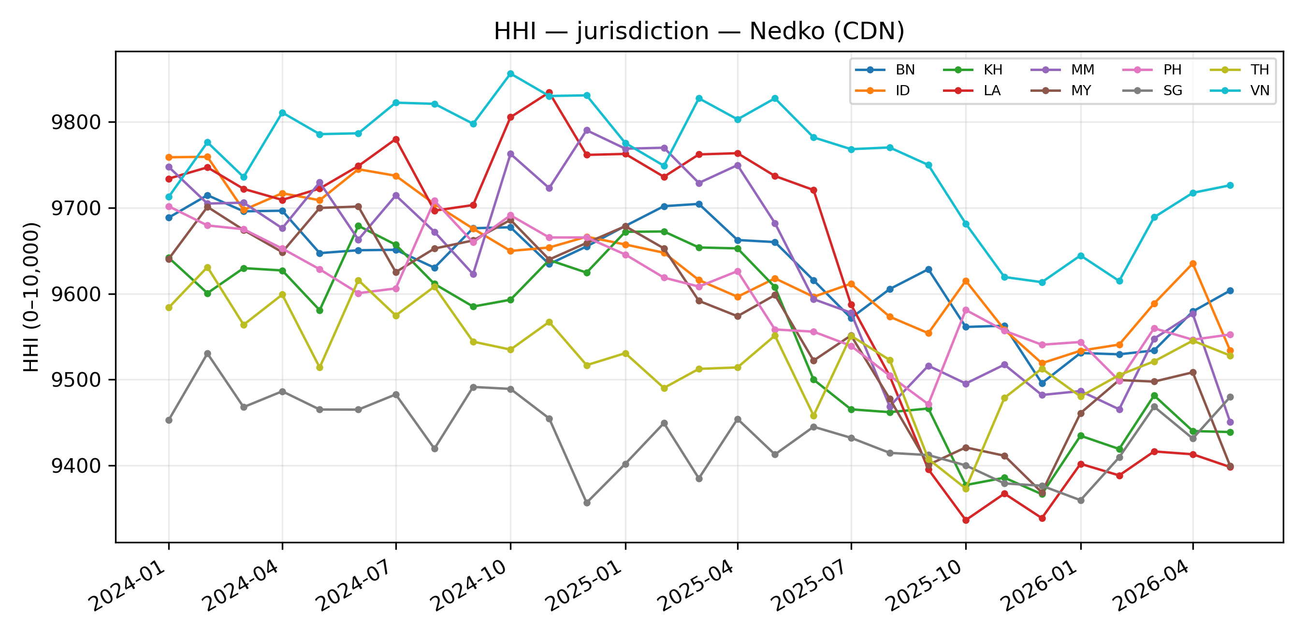
Figure: HHI of jurisdiction concentration, Nedko (CDN), per country over time.
Table: market share (%) by jurisdiction × year × country (Nedko (CDN)). Cells = mean monthly share in that year.
Country | Jurisdiction | 2024 | 2025 | 2026
BN | China | 0.7 | 0.6 | 0.4
 | USA | 98.3 | 98.1 | 97.7
 | Other | 1.0 | 1.4 | 1.9
ID | China | 0.6 | 0.9 | 0.8
 | USA | 98.5 | 98.0 | 97.8
 | Other | 0.8 | 1.2 | 1.4
KH | China | 0.8 | 0.7 | 0.7
 | USA | 98.1 | 97.6 | 97.1
 | Other | 1.2 | 1.7 | 2.1
LA | China | 0.6 | 0.7 | 0.6
 | USA | 98.7 | 97.9 | 96.9
 | Other | 0.7 | 1.4 | 2.5
MM | China | 0.6 | 0.5 | 0.7
 | USA | 98.5 | 98.0 | 97.5
 | Other | 0.9 | 1.5 | 1.8
MY | China | 0.4 | 0.6 | 0.6
 | USA | 98.3 | 97.6 | 97.3
 | Other | 1.3 | 1.9 | 2.1
PH | China | 0.7 | 0.9 | 0.8
 | USA | 98.3 | 97.8 | 97.7
 | Other | 1.1 | 1.3 | 1.6
SG | China | 1.5 | 1.6 | 1.4
 | USA | 97.3 | 97.0 | 97.1
 | Other | 1.2 | 1.4 | 1.5
TH | China | 0.8 | 0.7 | 0.5
 | USA | 97.8 | 97.4 | 97.5
 | Other | 1.4 | 1.9 | 2.0
VN | China | 0.2 | 0.3 | 0.6
 | USA | 99.0 | 98.7 | 98.4
 | Other | 0.8 | 0.9 | 1.0

ISOC (CDN)
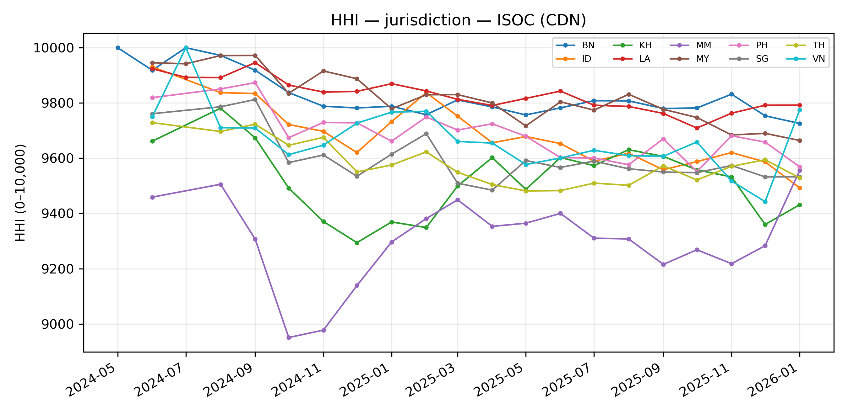
Figure: HHI of jurisdiction concentration, ISOC (CDN), per country over time.
Table: market share (%) by jurisdiction × year × country (ISOC (CDN)). Cells = mean monthly share in that year.
Country | Jurisdiction | 2024 | 2025 | 2026
BN | China | 0.4 | 0.9 | 1.0
 | USA | 99.5 | 98.9 | 98.6
 | Other | 0.1 | 0.2 | 0.4
ID | China | 1.1 | 1.4 | 1.5
 | USA | 98.9 | 98.3 | 97.4
 | Other | 0.1 | 0.3 | 1.1
KH | China | 2.2 | 2.4 | 2.4
 | USA | 97.7 | 97.5 | 97.1
 | Other | 0.1 | 0.1 | 0.5
LA | China | 0.6 | 0.9 | 0.7
 | USA | 99.4 | 99.0 | 99.0
 | Other | – | 0.2 | 0.4
MM | China | 3.9 | 3.4 | 2.1
 | USA | 95.9 | 96.5 | 97.7
 | Other | 0.1 | 0.1 | 0.1
MY | China | 0.4 | 1.0 | 1.4
 | USA | 99.6 | 98.8 | 98.3
 | Other | 0.0 | 0.2 | 0.3
PH | China | 1.1 | 1.7 | 2.1
 | USA | 98.9 | 98.2 | 97.8
 | Other | 0.0 | 0.1 | 0.1
SG | China | 1.6 | 2.2 | 2.1
 | USA | 98.4 | 97.8 | 97.6
 | Other | – | 0.1 | 0.3
TH | China | 1.4 | 2.0 | 1.6
 | USA | 98.3 | 97.7 | 97.6
 | Other | 0.3 | 0.4 | 0.8
VN | China | 1.1 | 1.9 | 1.1
 | USA | 98.7 | 98.1 | 98.9
 | Other | 0.2 | 0.0 | –

OpenINTEL (IP infrastructure)
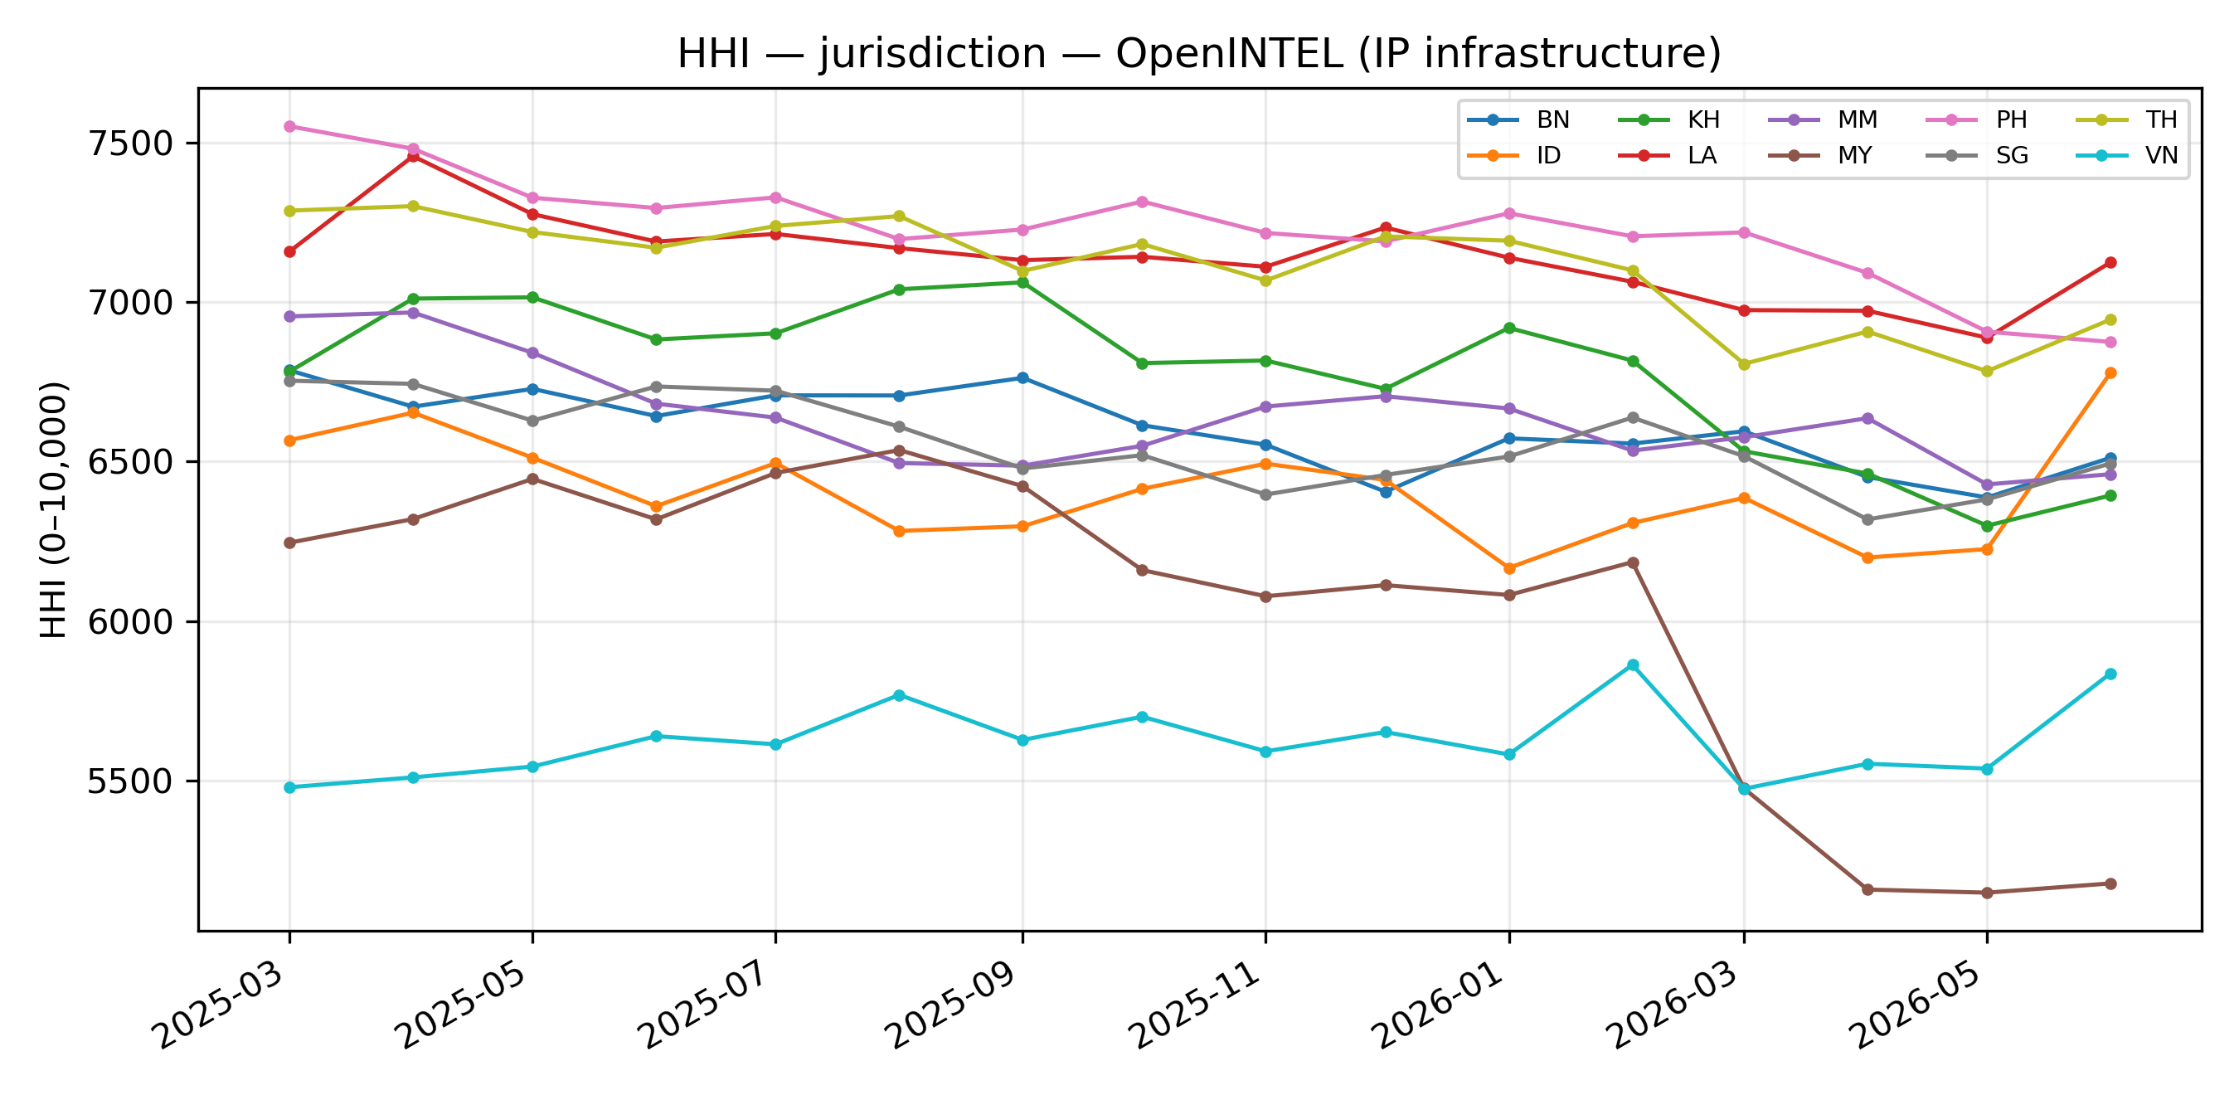
Figure: HHI of jurisdiction concentration, OpenINTEL (IP infrastructure), per country over time.
Table: market share (%) by jurisdiction × year × country (OpenINTEL (IP infrastructure)). Cells = mean monthly share in that year.
Country | Jurisdiction | 2025 | 2026
BN | China | 0.8 | 0.6
 | USA | 79.0 | 77.7
 | Other | 20.2 | 21.7
ID | China | 1.4 | 1.4
 | USA | 77.5 | 76.4
 | Other | 21.2 | 22.2
KH | China | 1.4 | 2.7
 | USA | 81.3 | 78.9
 | Other | 17.3 | 18.4
LA | China | 0.6 | 0.4
 | USA | 83.4 | 81.9
 | Other | 16.1 | 17.7
MM | China | 2.0 | 2.4
 | USA | 79.7 | 78.6
 | Other | 18.2 | 19.0
MY | China | 1.3 | 4.8
 | USA | 76.1 | 69.5
 | Other | 22.5 | 25.8
PH | China | 1.5 | 1.4
 | USA | 84.3 | 82.7
 | Other | 14.2 | 15.9
SG | China | 3.7 | 3.2
 | USA | 79.4 | 78.2
 | Other | 16.9 | 18.5
TH | China | 1.5 | 0.8
 | USA | 83.5 | 81.5
 | Other | 15.0 | 17.7
VN | China | 0.9 | 0.7
 | USA | 68.3 | 68.4
 | Other | 30.8 | 30.8

