Financing Britain's future: the changing position of UK capital markets and the challenge of economic growth
London remains one of the world's leading financial centres. Its banks, insurers, investment managers and professional services firms operate across international markets, attracting capital from businesses and investors throughout the world. Yet beneath this international success lies a problem for Britain's domestic economy. The London Stock Exchange has struggled to attract new companies, institutional investors have reduced their exposure to British equities and concerns persist about the availability of finance for businesses seeking to expand. The contrast is striking. According to the Financial Conduct Authority (FCA), the number of commercial-company initial public offerings (IPOs) on the UK Main Market fell from 43 in 2021 to just 14 in 2025 (FCA, 2026). Analysis by EY suggests that the weakness continued into 2026, when only eight companies listed on the London Stock Exchange during the first nine months of the year, raising approximately £607m (EY, 2026). Although the capital raised exceeded the equivalent period in 2025, the relatively small number of new listings raises questions about London's attractiveness as a destination for equity finance.
The consequences potentially extend beyond the stock exchange. Public equity markets allow companies to raise capital, expand their operations and invest in new technologies. Rajan and Zingales demonstrate how industries dependent on external finance can benefit from more developed financial markets. Their research suggests that the organisation of financial systems matters for economic growth, particularly when businesses cannot finance expansion entirely through their existing earnings. However, access to finance is not simply a matter of making more money available. Myers and Majluf explain how differences in information between company managers and potential investors can complicate decisions to raise equity. Investors may be uncertain about a company's true value, while managers may hesitate to issue shares if they believe those shares are undervalued. Even where investment opportunities exist, companies can therefore encounter financial obstacles.
This distinction complicates the familiar argument that Britain's economic prospects depend upon reviving the London Stock Exchange: an internationally successful financial centre does not necessarily provide sufficient investment to domestic businesses. Equally, a decline in public listings does not automatically mean that productive companies are unable to obtain finance through other sources, including private investors, banks and international markets. The question is therefore not simply whether London is losing ground to New York or Hong Kong; it is whether Britain's difficulties reflect a shortage of capital, a failure to allocate existing capital productively, or wider structural weaknesses that discourage businesses from investing in the first place.

The retreat from British equities
The decline in London's public equity market provides a clear starting point: companies undertake IPOs to sell shares to investors and obtain equity capital, typically allowing them to finance expansion without taking on additional debt. A successful listing can also provide existing shareholders with an opportunity to sell their investments and establish a publicly observable market valuation. Public markets can generate wider economic benefits. Research by Babina, Ouimet and Zarutskie examines how IPOs influence employment and the movement of skilled workers between businesses. Their findings suggest that public listings can have consequences beyond the capital raised, affecting recruitment and the allocation of labour. A weakening IPO market may therefore have implications for the wider economy, although evidence from American companies cannot automatically be transferred to Britain.
Nevertheless, the number of IPOs should not be confused with the overall performance of a stock market. Market capitalisation measures the total value of listed companies, whereas equity issuance measures the capital raised through selling shares. A market can increase in value even as fewer businesses choose to list. Indeed, FCA figures show that the total market capitalisation of the UK Main Market was approximately £3.84trn in 2021 and £4.12trn in 2025, despite the decline in IPO activity (FCA, 2026). This matters because rising share prices may benefit existing shareholders without providing additional capital directly to businesses. Equally, fewer listings may reflect temporary economic conditions rather than a permanent deterioration in market quality. Interest rates, investor confidence and expectations about future profits can all influence whether a company chooses to issue shares.
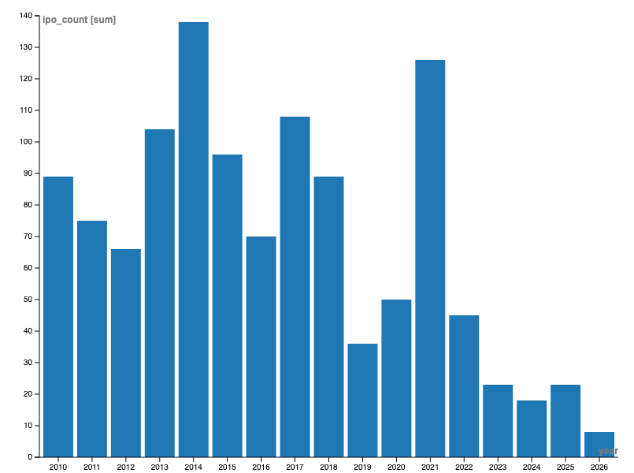
Figure 1. London IPO activity, 2010–2026
Annual number of initial public offerings on the London Stock Exchange. Data for 2026 cover January–September only. Source: London Stock Exchange Group and EY. Historical data compiled from published IPO statistics; coverage and definitions require final reconciliation.
Another explanation concerns valuation. Companies seeking to raise equity generally prefer markets in which investors are willing to pay more for their expected future earnings. Higher valuations can allow businesses to raise a given amount of capital while surrendering a smaller proportion of ownership. If comparable US companies achieve consistently higher valuations, listing in New York may appear more attractive. The Economist examines the relatively low valuations of British shares and the difficulty of explaining why some apparently profitable businesses trade at substantial discounts. However, lower valuations do not necessarily imply that British investors are making irrational decisions. Differences in profitability, expected growth, industrial composition and risk can produce legitimate differences in share prices.
America's stock market contains a substantial concentration of large technology companies, whereas London's leading indices include significant exposure to financial services, energy, mining and consumer goods. These sectors often have different growth expectations. Comparing the valuations of entire national markets without accounting for their industrial composition can therefore produce misleading conclusions. Modigliani and Miller provide an important theoretical foundation for understanding the cost of capital and corporate financing decisions. Under their restrictive assumptions of perfect capital markets, a company's financing structure does not independently determine its total value. Real markets, however, involve taxation, information asymmetries and other imperfections. The theoretical distinction helps explain why the conditions under which companies raise finance can still matter considerably.
The UK's difficulties have consequently generated debate about whether its regulatory environment discourages listings. Gözlügöl questions the assumption that regulation is principally responsible for the decline of British stock markets. Although reducing unnecessary administrative costs may improve market attractiveness, deregulation alone cannot guarantee stronger investor demand or higher valuations. The quality of businesses available for investment remains equally important. Yet London's difficulties are not confined to the companies seeking finance. They also concern the institutions supplying it. Historically, British pension funds represented a major source of domestic equity investment. As long-term investors managing retirement savings, they could provide relatively stable demand for shares in listed businesses. Their gradual withdrawal from UK equities has become one of the most frequently cited explanations for the weakening of London's investor base.
Government research published in November 2024 estimates that UK equities accounted for approximately 32% of private-sector defined-benefit pension assets in 2006. By 2023, that proportion had fallen below 2%, while allocations to government bonds, or gilts, had increased from approximately 15% to 37% (Department for Work and Pensions, 2024, p. 9).
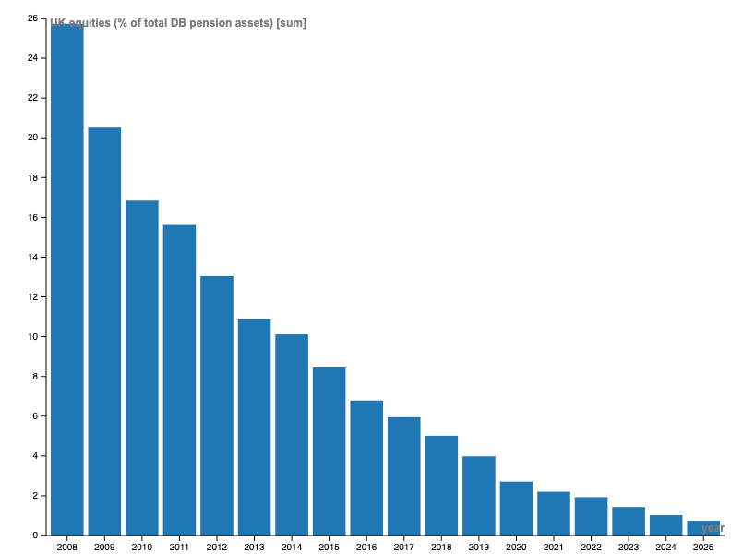
Figure 2. The decline of UK pension fund investment in domestic equities, 2008–2025
Source: Pension Protection Fund, Purple Book (historical asset-allocation data). UK equity holdings expressed as a percentage of total private-sector defined-benefit pension scheme assets; calculated from published allocations.
At first glance, this appears to suggest that British pension funds have abandoned domestic businesses. However, the explanation is more complicated. Markowitz established that effective portfolio diversification depends not simply on holding more securities, but on combining investments whose returns are not closely correlated. This principle helps explain why pension funds may invest internationally to reduce their exposure to risks concentrated in a single national economy. Investing overseas may therefore reflect sound financial judgement rather than a lack of confidence in British companies.
The changing structure of pension provision offers another explanation. Defined-benefit schemes promise retirement payments based on specified conditions, creating financial obligations extending many years into the future. As these schemes mature, managers increasingly seek assets with predictable income streams that can help meet their liabilities. Government bonds may therefore become more attractive than equities, whose values fluctuate with market conditions. Defined-contribution schemes operate differently. Retirement outcomes depend more directly on the contributions made and the investment performance achieved. These distinctions matter because proposals to redirect pension investment towards British assets cannot assume that all pension funds face identical responsibilities or risks. Drawing on evidence from Denmark, Nielsson et al. find that greater exposure to equities through pension savings can encourage households to invest in shares outside their pension accounts, contributing to deeper capital markets. Their research offers a framework for understanding how pension investment decisions can influence financial-market development. However, the existence of this relationship does not establish that requiring more investment in domestic equities would necessarily improve economic performance.
A reduced domestic investor base could weaken market liquidity and make it more difficult for some British businesses to raise equity. Yet British companies can also attract international investors, obtain bank loans or raise capital privately. The decline in domestic pension investment is therefore a legitimate concern, but not conclusive evidence of a shortage of finance. The important distinction is between the amount of money invested in British shares and the ability of productive British businesses to obtain capital on competitive terms. If international investors are willing to finance attractive domestic opportunities, the nationality of the investor may be less important than the investment itself. This creates a difficult policy question. If pension funds have financially defensible reasons to diversify internationally, should the government nevertheless encourage them to invest more of their assets at home?

The temptation to intervene
Successive British governments have sought to strengthen domestic investment by changing the incentives and structures governing institutional finance. Pension funds have become a particular focus because they manage substantial financial resources over long periods. Redirecting even a relatively small proportion of those assets could potentially provide significant capital for businesses, infrastructure and emerging industries. The Mansion House Accord, announced in May 2025, illustrates this approach. Seventeen major workplace pension providers expressed an intention to allocate at least 10% of their defined-contribution default funds to private markets by 2030, including at least 5% of total assets to UK private-market investments (Pensions UK, 2025).
This distinction is important. Private markets include investments such as unlisted companies, infrastructure, property and private credit. The Accord is therefore not simply a commitment to purchase more shares on the London Stock Exchange. Rather, it seeks to increase investment in assets that may provide opportunities for long-term returns while supporting productive activity. Progress is measurable, although its economic consequences remain uncertain. In October 2026, Pensions UK reported that signatories held £11.1bn in UK private markets at the end of 2025. This represented 3.3% of their relevant defined-contribution growth-phase assets (Pensions UK, 2026). The figures suggest that investment commitments are beginning to translate into allocations, but they do not yet demonstrate whether additional finance has improved productivity or generated economic growth.
Martin Wolf argues that pension reform can help improve Britain's financial system. Larger, better-organised pension schemes may be able to diversify across a wider range of investments and achieve economies of scale. In principle, these changes could benefit savers while increasing the availability of capital for British businesses. There is a reasonable economic argument for this position. Smaller pension funds may lack the specialist expertise required to evaluate complex investments in infrastructure, venture capital or private businesses. Consolidation could reduce administrative costs, improve professional investment management and provide access to opportunities that would otherwise be difficult to assess. Yet scale alone does not guarantee better investment decisions. Cheffins, Reddy and Willey question whether adopting elements of Canada's pension model would necessarily resolve the difficulties facing British equity markets. Large investment institutions are still responsible for generating appropriate returns. They may conclude that attractive opportunities lie outside Britain, regardless of their size or organisational structure.
This reveals a tension between government objectives and the responsibilities of financial institutions. Governments want domestic investment to support growth, employment and future tax revenues. Pension managers must protect the interests of their members, balancing investment returns against risk. These objectives may complement one another, but they are not identical. Encouraging investment in British businesses could benefit both parties if those businesses offer competitive financial opportunities. However, directing pension savings towards domestic assets simply because they are British could expose investors to excessive concentration risk. A policy intended to improve national prosperity should not automatically require retirement savers to accept lower expected returns or greater financial uncertainty.
Political considerations further complicate the debate. Governments operate within electoral cycles and face pressure to demonstrate visible economic progress. Pension funds manage commitments lasting decades. Infrastructure investments, meanwhile, may require substantial initial expenditure before generating reliable returns. The different timescales involved make cooperation difficult, particularly when political priorities change.
Private-market investments also carry disadvantages. Unlike publicly traded shares, they may be difficult to sell quickly. Their valuations are often less transparent, while management fees and investment costs can be substantial. Such assets may still provide attractive long-term returns, but their benefits must be assessed rather than assumed. The government's role is therefore better understood as improving investment conditions than simply prescribing investment destinations. For example, reducing uncertainty surrounding infrastructure projects, supporting new businesses and improving access to reliable market information could increase the number of suitable opportunities available to institutional investors.
Regulatory reform may also contribute, but its effects require careful evaluation. Gözlügöl challenges the view that deregulation alone can restore Britain's public equity markets. Making listing procedures simpler may reduce costs, yet it cannot automatically create profitable businesses or persuade investors to purchase shares at higher valuations. A stronger policy approach would attempt to identify the barriers preventing potentially productive investments from proceeding. These might include limited access to early-stage finance, inadequate infrastructure, uncertainty about future demand or difficulties bringing new technologies to market. Such measures could encourage capital to flow towards British businesses because the opportunities had improved, rather than because investors were pressured to favour domestic assets. The case for intervention consequently rests upon whether it can improve the allocation of capital without undermining investors' financial responsibilities. But even successful reform raises a more fundamental problem. Increasing the amount of money invested in Britain does not necessarily mean that Britain's economy will become more productive.

The harder question of growth
Financial markets perform an important role in modern economies, but their success should not be confused with economic growth. Share prices measure what investors are willing to pay for claims on future company earnings. Economic growth depends upon increases in the production of goods and services, supported by investment, technological progress, labour productivity and other economic conditions. The difference becomes clearer when considering how financial transactions operate. Suppose a pension fund purchases £10m of existing shares in a British company. Ownership of those shares transfers from one investor to another, but the company does not automatically receive £10m to spend on new equipment, research or employees. The transaction occurs in the secondary market, where existing securities are traded.
By contrast, when a company issues new shares, the proceeds can provide additional funds for investment. This is an important function of the primary equity market. A liquid secondary market may nevertheless support new issuance by making shares more attractive to investors, who know they can sell their holdings more easily. The distinction prevents a common misunderstanding: rising demand for British equities is not equivalent to an identical increase in productive investment. Rajan and Zingales show why financial development can matter for economic growth, particularly for industries dependent upon external finance. Yet their findings do not imply that every increase in financial-market activity generates additional economic output. The effectiveness of finance depends partly on whether businesses can use the capital to undertake worthwhile investments. Consider a manufacturing company seeking funds to purchase more advanced machinery. If the equipment improves productivity and the company can sell its additional output profitably, investment may raise economic activity and support higher wages. However, if demand for its products is weak, additional machinery may remain underused. The availability of finance alone cannot make an unprofitable investment worthwhile. Britain's economic difficulties must therefore be examined beyond the stock exchange.
Indraccolo investigates the divergence between British and American productivity performance, drawing attention to differences in business investment, technological development and the ability of firms to generate economic value. This suggests that Britain's problems cannot necessarily be explained by insufficient financial capital alone. Investment decisions depend upon several interconnected conditions. Businesses need confidence that customers will purchase their products, access to suitably skilled workers, reliable infrastructure and opportunities to adopt or develop new technologies. The expected return on an investment must also justify its cost and risk. If these conditions are unfavourable, simply increasing the supply of available finance may achieve little. Companies are unlikely to undertake expensive expansion projects merely because borrowing becomes easier or investors become more willing to provide equity. Conversely, businesses with attractive investment opportunities may obtain funding from international investors even when domestic institutional demand is weak. Capital moves across national boundaries in search of opportunities, particularly in developed financial markets with established legal and regulatory institutions. This international dimension complicates the relationship between the London Stock Exchange and Britain's domestic economy.
Many companies listed on the FTSE indices generate substantial revenues outside Britain. Their profits depend upon global economic conditions, exchange rates, commodity prices and demand in foreign markets. Rising valuations for internationally active businesses may therefore occur even when British domestic productivity remains weak. The reverse is also possible. A British company investing in domestic infrastructure or new manufacturing technology may contribute to national productivity without appearing in a major stock-market index. Private investment, bank finance and retained business earnings can all support productive activity outside public equity markets.
[Figure 3: UK financial-market performance, business investment and labour productivity, 2010–2026]
Source: Office for National Statistics, London Stock Exchange Group and OECD. Proposed indexed comparison, 2010 = 100. Financial-market returns, business investment and labour productivity should be measured separately using comparable annual observations.
These distinctions help explain why the performance of a stock-market index is an imperfect measure of national economic prosperity. Although share prices and economic activity may influence one another, movements in the two measures need not coincide. Nor does a statistical relationship between them establish that one directly causes the other. Regional differences provide another reason to question whether aggregate financial-market performance adequately describes Britain's economic position. Daams, Mayer and McCann examine how financial conditions and capital shocks can influence the geography of economic prosperity. Their research indicates that the availability and cost of finance may differ between regions, affecting opportunities for business development. An economy can therefore possess sophisticated financial institutions while some areas continue to face significant difficulties obtaining suitable capital. This creates a challenge for policymakers. Increasing the amount of investment managed in London does not necessarily ensure that businesses elsewhere in Britain benefit. Capital may continue to concentrate in established sectors, major cities and companies with a proven record of profitability.
Smaller businesses and innovative firms may face different obstacles. Their future revenues can be uncertain, their assets may provide limited security for lenders, and potential investors may find it difficult to assess their commercial prospects. Myers and Majluf's analysis of information asymmetry is relevant here: uncertainty about a company's true value can affect its ability to raise external finance. These difficulties can justify carefully targeted intervention. Public investment programmes, financing partnerships and support for research and innovation may help viable businesses overcome barriers that private markets do not always resolve independently.
However, government intervention brings its own risks. Public authorities may struggle to identify commercially successful projects, while political pressure can encourage investment in activities with limited economic returns. Subsidising poorly performing businesses may preserve employment temporarily without establishing sustainable long-term productivity. The policy problem is therefore not a simple choice between government intervention and free markets. It concerns identifying the circumstances in which intervention can improve economic outcomes, and distinguishing these from situations where public resources might merely replace private investment.
Two explanations for Britain's difficulties consequently remain plausible. The first concerns constraints on capital. Some productive businesses may be unable to obtain appropriate finance, preventing them from expanding, innovating or adopting more efficient technologies. Strengthening financial markets, improving access to investment and reducing unnecessary financing costs could help address these obstacles. The second concerns the demand for productive investment. Businesses may be reluctant to expand because of weak expected demand, uncertain economic conditions, infrastructure limitations or insufficient opportunities to earn attractive returns. Under these circumstances, directing more capital into the economy may have relatively limited effects unless the underlying conditions improve. These explanations are not mutually exclusive. Some businesses may struggle to obtain finance despite possessing attractive opportunities, while others may have access to capital but lack a convincing commercial reason to invest. Different sectors and regions may experience different combinations of the two problems. Recognising these differences is essential to evaluating proposed financial reforms. A programme designed to increase pension investment in British assets may benefit firms that genuinely face financing constraints. Yet its effects will be weaker if insufficient attractive investment opportunities exist or if the additional finance is directed predominantly towards existing assets.
The same principle applies to efforts to revive public listings. A more active London Stock Exchange could strengthen the financing options available to British companies, improve market liquidity and make equity issuance more attractive. But a successful stock market cannot substitute for an economy capable of producing competitive businesses with convincing growth prospects. The challenge for Britain is consequently more substantial than simply reversing the decline in IPOs or persuading pension funds to purchase more domestic shares. Financial reform should help create a system in which capital can reach productive businesses at appropriate costs, while investors retain incentives to assess risk and seek worthwhile returns. Achieving this may require improvements in financial regulation, infrastructure, innovation, skills and the wider business environment.
Such an approach recognises that the interests of investors and the national economy can align without assuming that they always do. Stronger domestic investment should follow from better opportunities rather than from an expectation that British institutions have a responsibility to favour British assets regardless of their financial merits. London's continuing international importance provides Britain with considerable financial expertise, established institutions and access to global capital. Those advantages should not be underestimated. Yet they have not prevented the decline in new public listings or the retreat of domestic pension funds from UK equities.
Neither development, taken independently, demonstrates that Britain's economic difficulties arise primarily from insufficient capital. International diversification can reflect sensible risk management, while companies may choose alternative financing arrangements for legitimate commercial reasons. Government intervention can improve access to investment, but its economic value ultimately depends on how effectively the resulting capital is deployed. Britain's financial future therefore depends not simply on attracting more money into its capital markets, but on creating the conditions in which investment can support productive businesses, innovation and sustainable economic growth. Stronger markets would be an important means of achieving that objective. They should not become an end in themselves.

References
Babina, Tania, Paige Ouimet, and Rebecca Zarutskie. ‘IPOs, Human Capital, and Labor Reallocation’. Journal of Financial and Quantitative Analysis 60, no. 6 (2025): 2584–614. https://doi.org/10.1017/S0022109024000772.
Cheffins, Brian, R., Bobby Reddy V., and Kim Willey. ‘Can Canada’s Pension Model Cure the UK Stock Market’s Doom Loop?’ Company Lawyer 46 (2025): 189–98.
Daams, Michiel N., Colin Mayer, and Philip McCann. ‘Regions, Cities and Finance: The Role of Capital Shocks and Banking Reforms in Shaping the UK Geography of Prosperity’. Fiscal Studies 46, no. 4 (2025): 475–90. https://doi.org/10.1111/1475-5890.70002.
Gözlügöl, Alperen A. ‘The Decline of Stock Markets in the UK: Is Regulation to Blame and Deregulation a Fix?’ Journal of Corporate Law Studies 25, no. 1 (2025): 77–119. https://doi.org/10.1080/14735970.2025.2495412.
Indraccolo, Leonardo. Bridging the Gap: Understanding the UK-US Productivity Decoupling. IMF Selected Issues Paper. International Monetary Fund, 2025. https://www.imf.org/en/Publications/selected-issues-papers.
Markowitz, Harry. ‘Portfolio Selection’. The Journal of Finance 7, no. 1 (1952): 77–91. https://doi.org/10.1111/j.1540-6261.1952.tb01525.x.
Modigliani, Franco, and Merton H. Miller. ‘The Cost of Capital, Corporation Finance and the Theory of Investment’. The American Economic Review 48, no. 3 (1958): 261–97.
Myers, Stewart, C., and Nicholas Majluf S. ‘Corporate Financing and Investment Decisions When Firms Have Information the Investors Do Not Have’. Journal of Financial Economics 13, no. 2 (1984): 187–224. https://doi.org/10.1016/0304-405X(84)90023-0.
Nielsson, Ulf, Oliver-Alexander Press, Jesper Rangvid, and Ofer Setty. Pension Fund Asset Allocation, Household Investments and Capital Market Depth. Nos 6–2026. Tel Aviv University, 2026. https://doi.org/10.2139/ssrn.5126849.
Rajan, Raghuram, and Luigi Zingales. ‘Financial Dependence and Growth’. American Economic Review (Cambridge, MA) 88, no. 3 (1998): 559–86. https://doi.org/10.2307/116849.
The Economist. The Mystery of Britain’s Dirt-Cheap Stockmarket | World News. Finance & Economics–Buttonwood. 2023.
Wolf, Martin. ‘British Pension Policy Is Finally Stepping in the Right Direction’. Opinion. Financial Times, 9 June 2025. https://www.ft.com/content/34d454ea-f4b8-4e49-8532-b9e666e5d396.

Rajan and Zingales, ‘Financial Dependence and Growth’, 559–561.
Myers and Majluf, ‘Corporate Financing and Investment Decisions When Firms Have Information the Investors Do Not Have’, 187–198.
Babina et al., ‘IPOs, Human Capital, and Labor Reallocation’, 2584.
The Economist, The Mystery of Britain’s Dirt-Cheap Stockmarket | World News, 65.
Modigliani and Miller, ‘The Cost of Capital, Corporation Finance and the Theory of Investment’, 4.
Gözlügöl, ‘The Decline of Stock Markets in the UK’, 78–79.
Markowitz, ‘Portfolio Selection’, 5.
Nielsson et al., Pension Fund Asset Allocation, Household Investments and Capital Market Depth, 6.
Wolf, ‘British Pension Policy Is Finally Stepping in the Right Direction’.
Cheffins et al., ‘Can Canada’s Pension Model Cure the UK Stock Market’s Doom Loop?’, 189–98.
Gözlügöl, ‘The Decline of Stock Markets in the UK’, 116–117.
Rajan and Zingales, ‘Financial Dependence and Growth’, 560–561.
Indraccolo, Bridging the Gap: Understanding the UK-US Productivity Decoupling, 5–6, 13–17.
Daams et al., ‘Regions, Cities and Finance’, 476–481.
Myers and Majluf, ‘Corporate Financing and Investment Decisions When Firms Have Information the Investors Do Not Have’, 187–189.

