The political economy of Hong Kong's housing crisis
Hong Kong presents an economic contradiction. As one of Asia's leading financial centres, it has accumulated considerable wealth, attracted international investment and established a reputation for free-market economics. Yet affordable housing remains beyond the reach of many residents. Seeing this first hand I find this contrast particularly striking. The city's prosperity is evident in its financial institutions and impressive skyline, but less apparent in the living conditions of some households. I would argue that Hong Kong's housing crisis cannot be explained by geographical scarcity alone. It also reflects the political institutions and economic incentives governing land, property development and housing provision.
The conventional economic explanation begins with scarcity. Hong Kong's mountainous geography limits developable land, while population density creates considerable demand for housing. When supply cannot respond quickly to rising demand, prices increase. Economists describe this relationship through the price elasticity of supply: where housing supply is relatively inelastic, even modest increases in demand can produce substantial price increases without significantly expanding housing availability.
However, geographical constraints tell only part of the story. Planning regulations, infrastructure investment, land allocation and construction delays also restrict supply. Furthermore, property prices respond to interest rates, household incomes and investment expectations. Cheng's comparative research on Hong Kong and Singapore demonstrates how financial regulation and land supply policies can produce different outcomes despite similarities between the two economies. I therefore question whether Hong Kong's housing difficulties are primarily determined by geography or by the institutions controlling the development of available land.
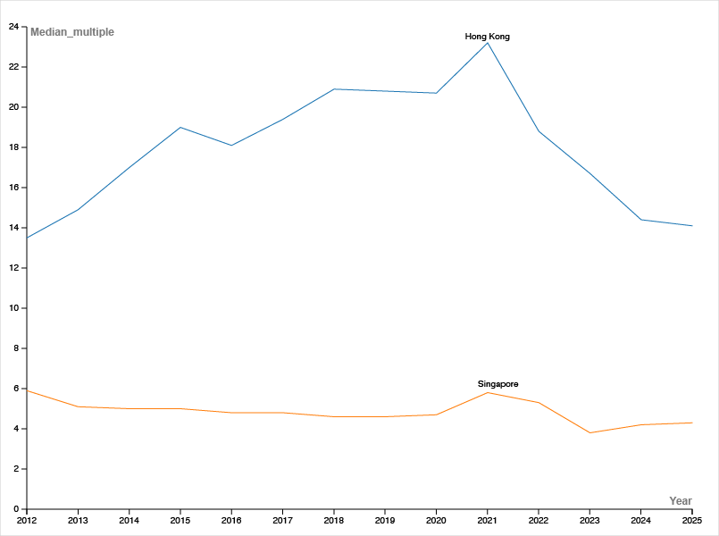
Figure 1Comparative housing affordability in Hong Kong and Singapore, 2012–2025.

This distinction becomes particularly important when examining Hong Kong's political economy too. Unlike conventional freehold property markets, government retains extensive control over land through its leasehold system. Brown and Loh identify a contradiction between Hong Kong's free-market reputation and its interventionist approach to land management. Land premiums and property-related taxation have historically provided substantial government revenue, creating a financial relationship between public expenditure and property value. This raises a difficult question. If government finances benefit from land transactions, does the administration face competing incentives when attempting to improve affordability? Lower property prices may benefit prospective buyers but reduce the value of existing assets and certain sources of government revenue. Equally, developers and homeowners have economic interests in maintaining property values.
Nevertheless, these competing interests do not prove that the government deliberately restricts supply. Lee and Allmendinger provide a more persuasive political explanation by examining how public consultation framed Hong Kong's housing difficulties predominantly as a land shortage. Their research suggests that emphasising consensus around increasing supply can marginalise alternative questions about land distribution and institutional responsibility. I find this argument compelling because it demonstrates how political decisions influence not only housing policy but also which explanations of the crisis receive attention.
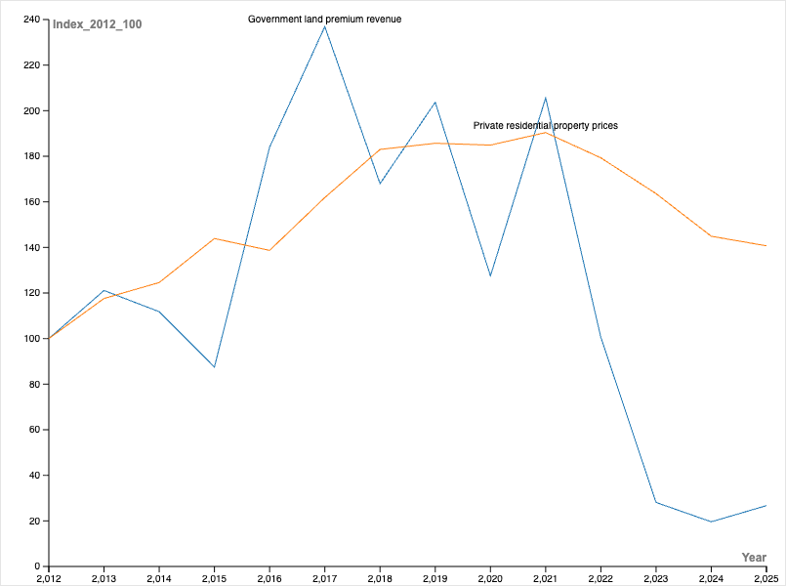
Figure 2. Government land-premium revenue and private residential property prices in Hong Kong, 2012–2025.
Government intervention, however, should not automatically be regarded as ineffective. Public housing accommodated 44.6% of Hong Kong's population in 2025, while government forecasts anticipate approximately 176,000 additional public housing flats between 2027/28 and 2031/32. These commitments demonstrate an effort to address longstanding housing shortages, although their impact on affordability remains uncertain.
Recent scholarship also challenges the assumption that intervention necessarily produces equitable outcomes. Wong examines Hong Kong's Tenants Purchase Scheme (TPS), finding that subsidised homeownership increased the proportion of relatively affluent households remaining in participating estates. This suggests that policies intended to improve housing opportunities can unintentionally reduce access for lower-income applicants.
The consequences extend beyond property prices. Ronald and colleagues demonstrate how housing inequality increasingly influences relationships between generations. Their research found that 64% of surveyed parents believed their adult children's generation faced the worst housing opportunities. For younger residents, economic independence may therefore depend increasingly on family wealth rather than employment income–a dependency that has become increasingly entrenched in Hong Kong’s socioeconomic structure. This raises concerns about social mobility and whether housing policy distributes economic opportunities fairly.
Nevertheless, stronger intervention involves trade-offs. Increasing subsidies may improve affordability for recipients while placing pressure on public finances. Tighter regulation may discourage speculative investment but cannot independently resolve shortages of suitable accommodation. Effective policy must therefore consider both economic efficiency and distributional consequences.
Ultimately, I believe Hong Kong's housing crisis illustrates the limitations of measuring economic success through financial prosperity alone. Geography creates genuine constraints, but political institutions influence how those constraints translate into housing opportunities. The challenge is not simply to construct more homes, but to develop a system that allocates land efficiently without reinforcing existing inequalities. Hong Kong's experience suggests that the success of an economy should be judged not only by the wealth it generates, but also by how effectively its institutions enable people to participate in that prosperity.

References
Brown, Stephen, and Christine Loh. Hong Kong: The Political Economy of Land. Civic Exchange, 2002.
Cheng, Ruijie. ‘A Tale of Two Cities: The Effectiveness of Macroprudential and Regulatory Policies in the Housing Markets – Singapore versus Hong Kong SAR’. International Journal of Housing Markets and Analysis, 7 January 2026, 1–32. https://doi.org/10.1108/IJHMA-10-2025-0235.
Housing Bureau. ‘Housing Bureau - Publications - Housing - Public Housing Production Forecast’. Housing Bureau, Housing Bureau. Accessed 1 November 2026. https://www.hb.gov.hk/eng/publications/housing/public/phpf/index.html?utm_source=chatgpt.com.
Housing Bureau. Housing in Figures 2026. Housing Bureau, 2026.
Lee, Ada H. Y., and Phil Allmendinger. ‘“Consensus” as a Tool of Foreclosure: Hong Kong’s Land Supply Consultation’. Planning Theory & Practice 25, no. 1 (2024): 9–28. https://doi.org/10.1080/14649357.2024.2313236.
Ronald, Richard, Maggie Lau, and Henry Hin-Yan Chan. ‘Housing Opportunities and Family Reciprocity: Intergenerational Support for Young People and the Role of Housing and Welfare Policy in Hong Kong’. Journal of Social Policy 55, no. 3 (2026): 1018–41. https://doi.org/10.1017/S004727942510127X.
Wong, Michael B. ‘Subsidize Rent or Subsidize Homeownership? Evidence from a Hong Kong Experiment’. Regional Science and Urban Economics 121 (September 2026): 104254. https://doi.org/10.1016/j.regsciurbeco.2026.104254.

Cheng, ‘A Tale of Two Cities’, 5, 15.
Brown and Loh, Hong Kong: The Political Economy of Land, 1.
Lee and Allmendinger, ‘“Consensus” as a Tool of Foreclosure’, 21.
Housing Bureau, Housing in Figures 2026, 1.
Housing Bureau, ‘Housing Bureau - Publications - Housing - Public Housing Production Forecast’.
Wong, ‘Subsidize Rent or Subsidize Homeownership?’, 13.
Ronald et al., ‘Housing Opportunities and Family Reciprocity’, 1037–1038.

