European industrial policy and the economic consequences of Chinese EV competition
In October 2024, the European Union imposed additional tariffs on electric vehicles (EVs) manufactured in China, including 17% on BYD, the Chinese electric-car giant, and 35.3% on SAIC, a state-owned automotive group. I find this decision revealing. Europe promotes free trade and wants drivers to switch to cleaner vehicles, yet it is restricting imports from some of the manufacturers capable of supplying them affordably. The dispute raises a question extending beyond car prices: when does protecting an industry support economic progress, and when does it obstruct it?
China's position in EVs is difficult to ignore. According to the International Energy Agency, it produced approximately 16 million electric cars in 2025, nearly three-quarters of the global total, and exported more than 2.5 million. Government subsidies contributed to this expansion, but subsidies alone cannot explain it. High production volumes spread fixed costs across more vehicles, while investment in batteries and supply chains improves efficiency. Otero-Iglesias and colleagues argue that China's investment-led economic model can reinforce export competitiveness even as weak domestic consumption creates excess capacity. This complicates the idea that strong exports necessarily indicate a healthy domestic economy.
Economic theory provides competing interpretations. Brander and Spencer demonstrate how export subsidies can shift profits towards domestic firms in markets characterised by imperfect competition. Yet their model does not prove that every Chinese producer depends on continuing subsidies, or that retaliatory tariffs improve welfare. Comparative advantage suggests that consumers may benefit from importing vehicles produced at lower opportunity cost. The difficulty is distinguishing productivity gains from advantages created by state support, especially when the two have developed together.
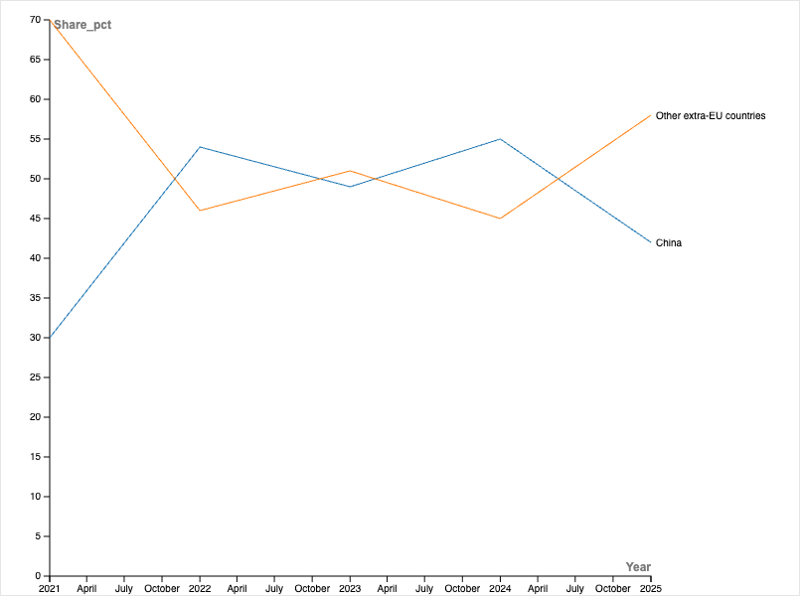
Figure 1. China's share of EU battery-electric vehicle imports, 2021–2025.
Europe's response also reflects the political importance of car manufacturing. The industry supports skilled jobs, regional suppliers and technological expertise, particularly in countries where automotive production is central to industrial identity. The European Commission justified its duties as a response to subsidisation threatening injury to EU manufacturers. Correcting a trade distortion, however, is not identical to preserving a strategic industry. One attempts to restore fair competition; the other may protect domestic production even where imports are cheaper. Both have costs, but their objectives should not be confused.
Rodrik argues that effective industrial policy should identify barriers to innovation through cooperation between governments and firms, rather than simply subsidise established businesses. This suggests that tariffs might create time for European producers to adapt, but cannot substitute for investment in battery technology, infrastructure and productive capacity. Geels offers a further political explanation: established European manufacturers have influenced policy and slowed aspects of the clean-technology transition, while Chinese institutions have supported new entrants and rapid manufacturing. His analysis is persuasive, although different political systems cannot be compared solely by the speed at which they deliver industrial change.
Kramer shows that EU climate policy has increasingly combined market-based measures, such as carbon pricing, with active support for green industries. I see the EV dispute as part of that change. Governments are no longer concerned only with correcting market failures; they also want to influence which industries and technologies develop within their borders. Strategic independence matters when supply chains are concentrated overseas. Nevertheless, subsidising domestic firms without demanding improvement risks transferring public money to producers that remain uncompetitive.
The consequences of tariffs are similarly uncertain. Import duties may increase vehicle prices, but manufacturers could instead accept lower margins, sell different models or relocate production to Europe. A 2026 modelling study by Dou and colleagues finds that effects on EV adoption depend heavily on these responses, with particular risks for price-sensitive buyers and lower-income European. This is important because a policy that protects industrial employment may simultaneously make cleaner transport less accessible. Conversely, attracting Chinese manufacturers to produce within Europe could preserve access to relatively affordable cars while developing local employment and expertise.
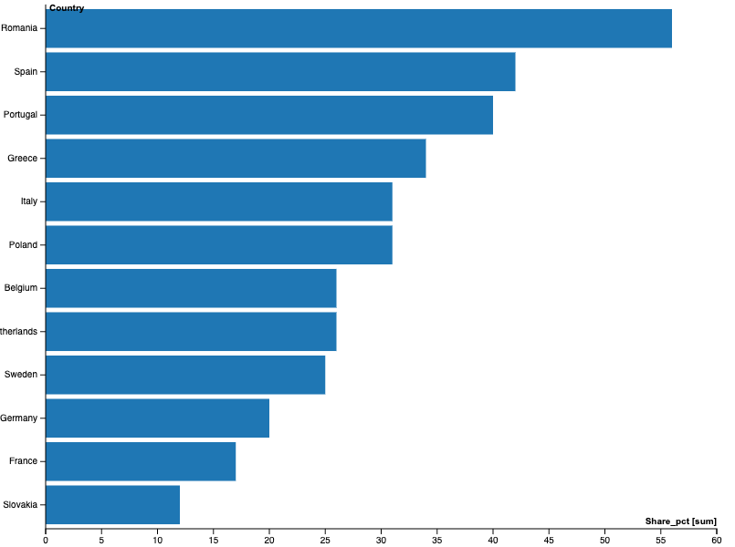
Figure 2. China-manufactured electric vehicles as a share of new battery-electric vehicle sales in selected European Union countries, January–June 2024.
Neither unrestricted imports nor permanent protection offers an uncomplicated solution. Cheaper EVs could accelerate emissions reductions, but dependence on foreign supply chains introduces economic and political risks. Tariffs could protect jobs temporarily yet lessen the pressure on European firms to innovate. There is also the danger of a subsidy race. If both sides continue supporting producers simply to defend market share, public spending may rise without creating equivalent gains in innovation or consumer welfare. I therefore think intervention should be judged against clear outcomes: greater productivity, stronger technological capability and a competitive industry that no longer requires extraordinary support.
Europe's challenge is not simply to resist Chinese EV competition. It is to learn from the scale and coordination behind China's success without assuming that the same state-led model can be reproduced across European economies. Protection may provide breathing space, but only innovation and investment can make that space worthwhile. Otherwise, industrial policy risks preserving the weaknesses it was intended to overcome.

References
Brander, James A., and Barbara J. Spencer. ‘Export Subsidies and International Market Share Rivalry’. Journal of International Economics 18, nos 1–2 (1985): 83–100. https://doi.org/10.1016/0022-1996(85)90006-6.
Dou, Hao, Shuyan Jiang, Shiqi Shawn Ou, et al. ‘Distributional Impacts of EU Tariffs on Chinese Electric Vehicles across European Markets’. Nature Energy 11, no. 9 (2026): 1364–77. https://doi.org/10.1038/s41560-026-02105-7.
European Commission. ‘Definitive Duties on BEV Imports from China’. Text. 2024. https://ec.europa.eu/detail/en/ip_24_5589.
Geels, Frank W. ‘How China Overtook Europe and America in Clean-Tech Transitions (2000–2025): Combining Socio-Technical Transition and Political Economy Theories to Analyse Global Industrial Shifts’. Energy Research & Social Science 139 (September 2026): 104885. https://doi.org/10.1016/j.erss.2026.104885.
Kramer, Niklas. ‘Carbon Pricing, Green Industrial Policy, and the Evolution of Ideas in EU Climate Policy’. Journal of European Public Policy, 10 September 2026, 1–25. https://doi.org/10.1080/13501763.2026.2729119.
Otero-Iglesias, Miguel, Federico Steinberg, and Agustín González-Agote. ‘China’s Dual Circulation Strategy and Its Impact on European Industry: The Case of the Electric Vehicle’. Asia Europe Journal, ahead of print, 26 August 2026. https://doi.org/10.1007/s10308-026-00785-0.
Rodrik, Dani. ‘Industrial Policy for the Twenty-First Century’. Preprint, SSRN, 2004. https://doi.org/10.2139/ssrn.617544.

Eur. Comm., ‘Definitive Duties on BEV Imports from China’.
Otero-Iglesias et al., ‘China’s Dual Circulation Strategy and Its Impact on European Industry’, 21.
Brander and Spencer, ‘Export Subsidies and International Market Share Rivalry’, 87.
Eur. Comm., ‘Definitive Duties on BEV Imports from China’.
Rodrik, ‘Industrial Policy for the Twenty-First Century’, 3.
Geels, ‘How China Overtook Europe and America in Clean-Tech Transitions (2000–2025)’, 1.
Kramer, ‘Carbon Pricing, Green Industrial Policy, and the Evolution of Ideas in EU Climate Policy’, 18.
Dou et al., ‘Distributional Impacts of EU Tariffs on Chinese Electric Vehicles across European Markets’, 19.

