Process Scheduler
On a modern computer system there can be many programs being executed at any one time. It’s the responsibility of the CPU (Central Processing Unit) to actually execute the instructions for these programs. However, with multiple programs somewhere between
start and finish at the same time something has to keep track all these programs. Tracking these programs includes knowing where they are up to, what they are doing and what resources they own. One of the responsibilities of the operating system is to keep track of this information. It does this by using processes. Nearly all of the work, in some operating systems all of the work, is performed by processes. The concepts presented by RCOSjava includes:
- process
What is a process?

- process states
During its lifetime a process will move through a number of different states. Each state has its own characteristics and there are limitations on which state transitions make sense.

- process description
The operating system must be able to keep track of processes and the resources they own. This information is stored in a number of operating system data structures including Process Control Blocks (PCBs).

- operations on processes
There are a number of standard operations which are performed with operating systems, including creation, termination and switching.

- process scheduling
Typically there are multiple processes on a computer which much share the computers resources, particularly the Central Processing Unit (CPU). Process Scheduling deals with the decisions of how to share those resources amongst processes.

Process
A process is a program in execution; process execution must progress in a sequential fashion.

Generally, a process includes:
- program counter
- stack
- data section

Process States
As a process executes, it changes state:
- new: The process is being created.
- running: Instructions are being executed.
- waiting: The process is waiting for some event to occur.
- ready: The process is waiting to be assigned to a processor.
- terminated: The process has finished execution.

Process Description
The Process Control Block is information associated with each process. Each process in RCOSjava contains the following information:
- Process ID,
- Process priority,
- Process state,
- Program counter,
- Stack Pointer,
- Base Pointer,
- Priority,
- Memory management information including code and stack Pages,
- Accounting information including CPU ticks, and
- I/O status information including file name and file size.

To display the current PCB of a process simply click on the process represented by a coloured circle in the process scheduler. A type example of the process scheduler running looks like:
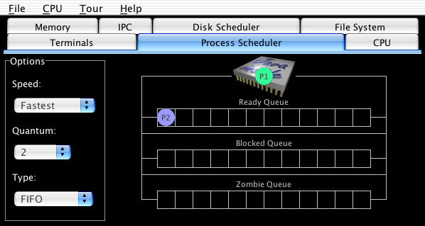

This shows the two processes, “Process 1” (“P1”, green circle) and “Process 2” (“P2”, blue circle). By clicking on the “Process 1” circle you get the separate process control block window:

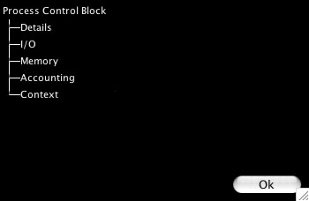

By selecting these options you can open up each of these categories:

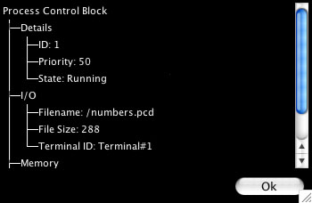

Operations on Processes
Processes in RCOSjava are created, undergo switching and are terminated.

Process Creation
RCOSjava creates a process using the following steps:
- Reading in executable code of a program from the file system,
- Allocation of a new process by the Process Scheduler,
- Requesting and allocation if available of memory, and finally
- Requesting and allocation if available of a terminal to be used by the process.

To create a new process go to the “File”, “New Process” menu:
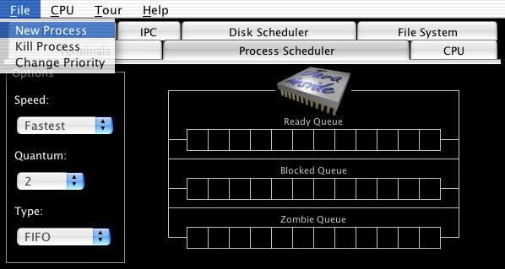

This displays the available executable files:

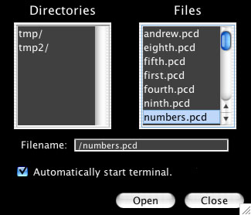

You can pick whether or not to create a new terminal when loading the process leaving selected “Automatically start terminal”. Either double click on the process name or select the process name and hit “Open”. The process will automatically start running.

Switching
Process and context switching are closely related concepts, but they are not the same. It is important that the difference between a process and a context switch is made.

Context
First, let’s define what the context actually is. All CPUs contain a number of registers that provide information about the current state of execution. Some of these were mentioned previously include such registers as the program counter, stack pointer and base pointer. It is this information that specifies the current execution state of the CPU.

Context Switch
A context switch involves saving the current context of the CPU and replacing it with another context. What this does is saves the current program/process, allows you to run another program/process and then at a later stage return back to the original process by restoring its context. As far as the original program/process knows, nothing interesting has happened.

Context switches usually happen whenever there is an interrupt. There are four general types of interrupts, software, hardware, error and timer.

Context is a hardware concept; it is tied to the CPU of the system. Context switches are performed hundreds, thousands and even millions of times a second and are usually supported by hardware in someway.

To view the current CPU context go to the CPU Animator screen.

Process Switch
Process switching is where the current running process is replaced by another process. This occurs in a number of situations including:
- the current running process finishes,
- the current running process requests some I/O and moves from the running to the waiting state,
- the current running process uses up its time on the CPU and moves from the running to the ready state.

Since it involves processes, remember processes are an operating system construct; a process switch relies heavily on operating system code and data structures. The steps involved in a process switch include:
- interrupt occurs
All process switches will be initiated by an interrupt. When a process finishes it usually executes a system call (implemented as a software interrupt) called exit that destroys the process. When a processes share of time on the CPU is finished this is indicated by a timer interrupt. When a process moves from the blocked state to the ready state it is usually because of an I/O interrupt. Moving from running to blocked it is usually because of a request to do I/O (a software interrupt).

Since the process switch almost always starts with an interrupt the first thing that happens is a context switch from the current running process to the interrupt handler of the operating system.

- saving the context of the current running process

- restore the context of the operating system, in particular the interrupt handler
The interrupt handler determines which part of the operating system will handle the interrupt. Timer, software and I/O interrupts will be handled by different sections of the operating system. However, some part of these operating system sections will eventually initiate a process switch, which uses exactly the same steps.

- change the PCB of the old running process to represent the change in state
The process could be going from running to blocked, zombie, or ready.

- move the PCB of the old running process to the queue associated with its new state
In many cases this will entail simply changing a pointer. Remember, it is important that this process be very efficient so it can be done quickly. Copying large amounts of data (e.g. the PCB) every time there is a process switch just wouldn’t make good sense.

- select another process from the ready queue
This is a very important step. It is important because it can take a long time (by far the largest portion of a process switch) but also because which process is chosen can directly influence the performance of the

- change the PCB of the chosen process to represent its new state

- "move" the PCB of the new process from its current queue to running

- replace the context of the kernel with that of the new process. After this step the new running process starts off from where it left off the last time it executed.

Process and context switch: the relationship
A context switch doesn’t mean a process switch occurs. For example, one of the types of interrupts is the timer interrupt. Most computer systems have a timer, which generates an interrupt at regular intervals. What usually happens at a timer interrupt is the following:
- there is a context switch to an interrupt handler (part of the operating system)
- the interrupt handler decides whether the timer interrupt means that anything should change
- if it decides, no, then it restores the context of the previously running process.

This is an example of where a context switch does not mean a process switch.

However a process switch always involves a context switch (perhaps even more than one). Looking through the rough list of steps of what occurs during a process switch you will see that there are a number of context switches within a process switch.

Process Termination
A process will terminate when it either exits or aborts:

- When a process finished executing its last statement it asks the operating system to delete it (exit).
  - Output data from child to parent (via wait).
  - Process' resources are deallocated by operating system.
- Parent may terminate execution of children processes (abort).
  - Child has exceeded allocated resources.
  - Task assigned to child is no longer required.
  - Parent is exiting.
  - Operating system does not allow child to continue if its parent terminates.
  - Cascading termination.

You can terminate a program by selecting a currently executing process from the “File”, “Kill Process” menu:
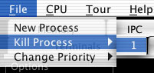

This shows killing the process with the process id of 1.

Process Scheduling
The process scheduler in RCOSjava monitors the following states of a process:
- Zombie queue – set of processes waiting to have an I/O device allocated.
- Blocked queue – set of processes waiting on an I/O event to occur.
- Ready queue - set of all processes residing in main memory, ready and waiting to execute.
- Process migration between the various queues.

The scheduling of the CPU is done by efficiently choosing the process to be executed from the Ready queue. It selects from among the processes in memory that are ready to execute, and allocates the CPU to one of them.

CPU scheduling decisions may take place when a process:
- switches from running to waiting state.
- switches from running to ready state.
- switches from waiting to ready.
- terminates.

Scheduling under 1 and 4 is called non-preemptive. RCOSjava performs preemptive scheduling i.e. scheduling takes place under all states.

The criteria for picking a scheduling algorithm is based on:
- Maximizing CPU utilization - keep the CPU as busy as possible
- Maximizing Throughput – the number of processes that complete their execution per time unit
- Minimizing Turnaround time - amount of time to execute a particular process
- Minimizing Waiting time - amount of time a process has been waiting in the ready queue
- Minimizing Response time - amount of time it takes from when a request was submitted until the first response is produced, not output (for time sharing environment)

RCOSjava implements several round robin priority scheduling algorithms.

Round Robin scheduling is where each process gets a small unit of CPU time (time quantum), usually 10--100 milliseconds. After this time has elapsed, the process is preempted and added to the end of the ready queue.

If there are n processes in the ready queue and the time quantum is q, then each process gets 1/n of the CPU time in chunks of at most q time units at once. No process waits more than (n - 1)q time units.

You can change the quantum of the process scheduling at any time using the quantum drop down box display here:

If the quantum is to large is too large then there is a large waiting time. If the quantum is too small there performance is degraded as the overhead of context switching increases.

RCOSjava implements 3 types of queuing algorithms:
- FIFO – First In, First Out
Each process, irrespective of priority, is executed in the order that they are added to the queue. The process that was added last on the queue is the first to be executed,
- LIFO – Last In, First Out
Each process, irrespective of priority, is executed in the reverse order that they are added to the queue. The process that was added to the queue the first is executed first.
- Priority
Each process, is executed based on priority in a FIFO manner. The process with the highest priority is executed first. If the priorities of two processes is the same then the process that was added last is the first to be executed.

The priority queue allows a demonstration of process starvation. Low priority processes may never execute. The solution is aging - as time progresses the priority of the process increases.

To change a processes priority go to the “File”, “Change Priority” menu:

