Composing Community Data Collection Log – Rhetorical Observations (Revised 2026)
Do not alter log’s grid, questions, or landscape orientation, but please delete those question blocks you don’t use.

Date/Time physical space was observed: 17 September 2026, early morning and again Tuesday at approx. 10:45 a.m.

Answer TWO (2) question sets below (choose what you see the most evidence for). | Descriptions, Photographs, Claims, & Citations: Here you’ll give detailed answers to the questions and photographic evidence, including selfies of yourself in the space; this is evidence for your claims as you create a vivid picture for readers.
Question Set 1:  1.) How does Kairos (lucky timing) work in this space for you to personally get the most out of it?  2.) Share two different kairotic moments you’ve personally experienced in this space and share how each one has personally affected you.  3.) Take two photographs as additional evidence for these experiences and a third selfie photo as evidence of your being there in this space.  4.) How does Kairos affect your feelings of belonging to this space/UCF community?  5.) Make a claim (turn the answer to (4.) into a crisp statement you can argue about how kairos affects your sense of belonging/not belonging)?  6.) Directly quote (cite) from Downs or Lueck something you can use to help you explain what kairos is and/or why it’s important to understand its effects on you and others. | 1.) How Kairos works in this space for me  I get the most out of the RWC when I arrive in the early morning, before the building fills. I do not control that timing. My class schedule decides when I am free, and the other students decide how crowded the floor is. When those two things happen to line up, the racks are open and I can run my workout in the order I planned it. When they do not line up, the same building gives me a worse workout with the exact same equipment. Nothing about the room changes. Only the hour changes, and I do not get to choose the hour. That is kairos working on me.  2.) Two kairotic moments I have personally experienced here  Moment one: an early morning session. The building is quiet. The only sounds are treadmill belts, a plate being set down, and short exchanges between two people. Every rack in the free weight area is open. I move straight down my plan without waiting for anything. The quiet tells me that everyone here came to finish a task and leave, which is what I came to do too. Effect on me: I leave feeling like the session belonged to me. I get my full three exercises per muscle group, and my head is clear for the rest of the day.  Moment two: Tuesday at about 10:45 a.m. This is the one hour in my week when I cannot train early. By that hour the RWC is packed and loud, with constant movement between stations and conversation layered over the equipment noise. This week I went in for chest, back and shoulders. After my first exercise the plan stopped working, because the next machine I needed was occupied, and so was the one after that. I spent the session walking the floor looking for whatever was open and building my workout around other people. Effect on me: I run on a schedule, so improvising annoys me. I did two exercises per muscle group instead of three, and I left earlier than I normally would, because I did not want to keep waiting. I walked out of that session with less done and in a worse mood, and the only thing that had changed since the morning before was how many people were in the room.  3.) Photographs  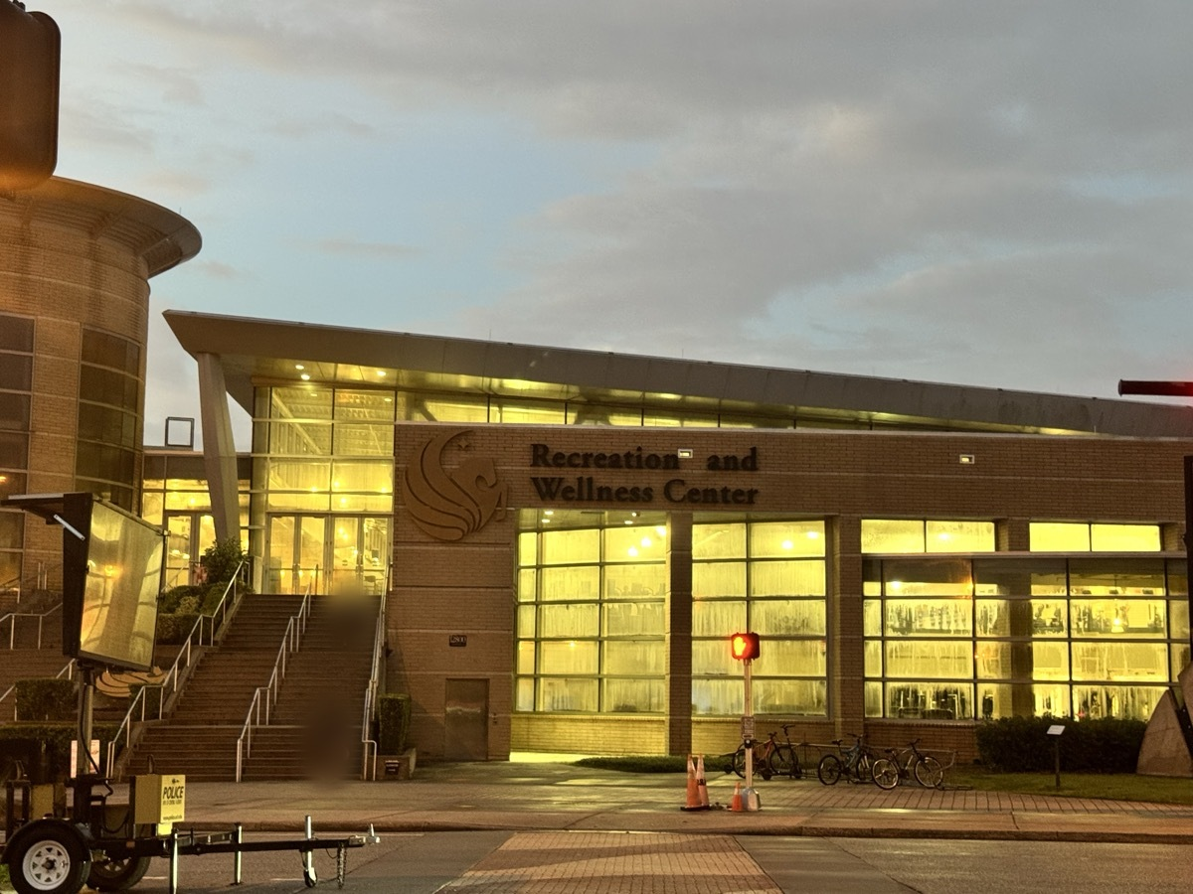  Figure 1: The RWC from outside in early morning light. The low sun and the empty approach show the hour I normally train, before the building fills. Photo taken by me, 17 September 2026. A face in the background is blurred for privacy.  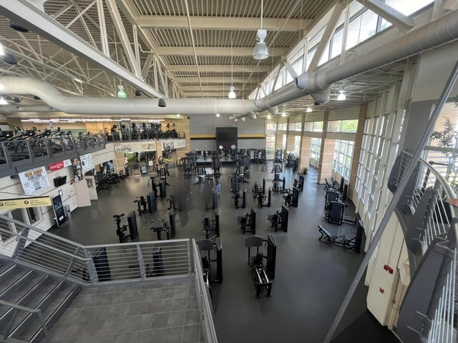  Figure 2: The lower floor of the RWC with every machine open and nobody on the floor. This is the condition I train in during the early morning, and it is what makes the first kairotic moment possible. The second kairotic moment is the same room at 10:45 on a Tuesday, when every one of these stations is occupied. Photo by u/Jswee1, r/ucf, March 2024; see Image Credits at the end of this answer.  Image Credit: Jswee1 [u/Jswee1]. "New gym equipment opens Monday." Reddit, r/ucf, Mar. 2024, www.reddit.com/r/ucf/comments/1bkm4e9/new_gym_equipment_opens_monday/. Accessed 17 Sept. 2026.  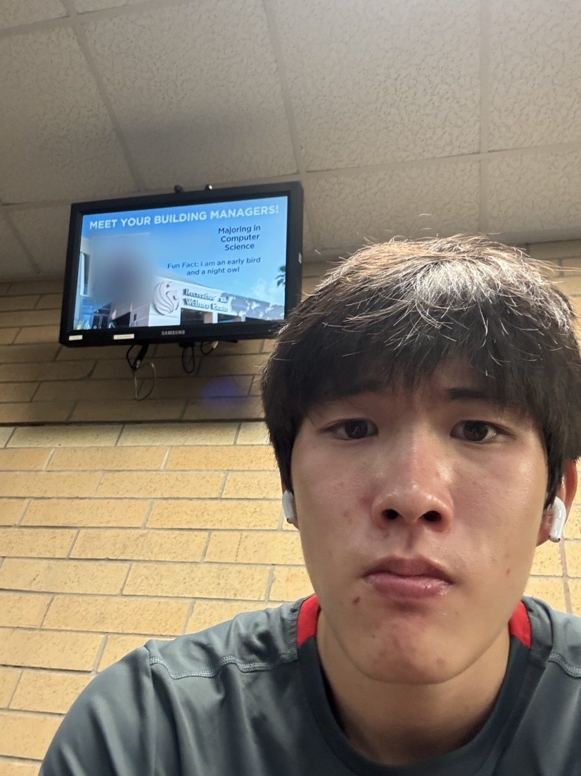  Figure 3: Me on the upper level of the RWC before a morning session, AirPods already in. Photo taken by me, 17 September 2026. The staff photo and name on the screen behind me are blurred for privacy.  4.) How Kairos affects my feelings of belonging to this space and the UCF community  My sense of belonging here rises and falls with the clock. In the early morning I belong completely. There is room for me, the pace of the floor matches my pace, and I read the other people there as doing the same thing I am doing. At 10:45 on a Tuesday I feel like I am in the way and like other people are in my way. I am still a paying UCF student with the same access to the same building at both hours. The difference is whether the space has room for me. Whether I belong here depends on what time I walk in.  5.) My claim  At the Recreation and Wellness Center, my sense of belonging is produced by timing rather than by membership, because the same building that makes room for me in the early morning crowds me out at 10:45 a.m. without changing a single object in it.  6.) Direct quote from Downs or Lueck  Downs gives the ancient Greek term for this. Kairos, he writes, “translates to something like ‘timely good fortune’ or simply ‘lucky timing’” (467). He goes on to say that kairos is the principle that rhetors have “far-from-complete control” of what they do, because circumstances beyond their control can intervene to change the moment and what it makes sense to say in that moment (467). That is exactly my situation in this building. The RWC is the same building on Monday morning and on Tuesday at 10:45. The circumstances around me are what change, and they are not mine to control. Downs also reminds us that many parts of a rhetorical ecology we must respond to are well outside our control as rhetors (467), which is why my sense of belonging here tracks the hour.
Question Set 2:  1.) Identification: What identity/identities is the space constructing for you, and how do you know this?  2.) Give two very detailed examples (evidence) how identification is used to…  (a.) create a sense of camaraderie or feelings of community togetherness, and/or  (b.) create an experience of connection with the physical space.  3.) Connect this identification to ethos (character, beliefs, customs, and/or values) of the physical space: How is your identification with this space creating ethos? Explain your answer.  4.) Take two photographs as additional evidence for these experiences and a third selfie photo as evidence of your being there in this space.  5.) Make a claim that clearly states how identification is creating a personal sense of belonging/not belonging for you in this space.  6.) Directly quote (cite) from Downs or Lueck something you can use to help you explain what identification is and/or why it’s important to understand its effects on you & others. | 1.) What identity the space is constructing for me, and how I know  The RWC constructs me as a person who trains, and nothing else. The building is almost empty of decoration, and where the walls are not glass they are mirror. There is no logo and no lettering anywhere on the workout floor. The only UCF color in the whole free weight area is a gold stripe and a black stripe painted across grey cinderblock at eye level. That is the entire visual claim the school makes on a two-level building, and it is a small one. The layout is the standard commercial gym template: cardio by the doors, machines in the middle, free weights and squat racks at the very back. I have trained in that layout for years and I keep a squat rack in my garage at home, so I already knew how to read the room the first time I walked in. That is how I know what identity is being built. The building is speaking to lifters.  The identity is also temporary. There is not a single table or chair on the workout floor, and student workers enforce a rule that bags and loose items go in a locker before you start. So the real identity is lifter who is currently training. The moment I want to sit, read or work, the building has nowhere to put me.  2.) Two detailed examples of identification  (a.) Camaraderie and community togetherness: Huy  Recently I was on the dip machine when another student came over to me. We exchanged names. His name is Huy, he is from Vietnam, and he is studying electrical engineering. I am an electrical engineering major, so the conversation moved past small talk immediately. I asked him whether the courses were hard, and we talked through my whole time at that machine. When I finished, I asked for his number, because my thought walking out was that he would make a good mentor. Almost none of that identification was verbal. Huy and I lined up with each other before either of us said anything about engineering. We were both Asian, in the same part of the building, doing the same kind of exercise. The RWC holds every experience level at once, beginners, longtime lifters and older members, all on the same floor, and nobody gets sorted into a section by how much they know. That range does not turn into a hierarchy. Walking up to a stranger to ask to work in is normal here, and it usually turns into a short conversation.  (b.) Connection with the physical space: mirrors, the weight stack, and my garage  Mirrors cover most of the interior wall surface. They are sold as a tool for checking form, but I use them differently. Progress over several years is an abstraction, and a mirror turns it into something I can see right now. The printed numbers on a cable stack do the same job. The pin sits in a number, and that number can be compared to the number it sat in last year. Moving the pin one plate lower tells the whole story in one number, with no words at all. On top of that, the free weight area at the back of the RWC is a larger version of a space I already own, because of the squat rack in my garage. So the room reads as an extension of somewhere I already belong, and the mirrors and the weight stacks keep handing me evidence of that.  3.) How this identification creates ethos  The ethos of the RWC is effort, competence and self-regulation, and the identification is what produces it. The staff almost never speak. What signage exists is short and functional: wipe your machine down, re-rack your weights, a health poster or two. Because the walls are either window or mirror, there is very little room for messaging, so most of the character of the room is carried by the users. Every person who re-racks a plate, or leaves one out, is telling the next person what the norms actually are. So the people on the floor build and maintain the ethos, including me.  The Huy conversation shows the two working together. We identified first and the ethos arrived second. Once he said electrical engineering, he had standing with me that no amount of gym conversation would have produced, because now he knew something I needed to know and he had no reason to mislead me. Downs explains that Aristotle tied credibility to ethos, which is Greek for “one’s accustomed place or habit of being” and carries “the idea that you know someone by where they dwell, by their ‘haunts’” (475). That definition fits a gym better than almost any other building. Huy and I knew something real about each other purely from the fact that we both haunt the back of this floor at the same hour, and that was enough to start on.  4.) Photographs  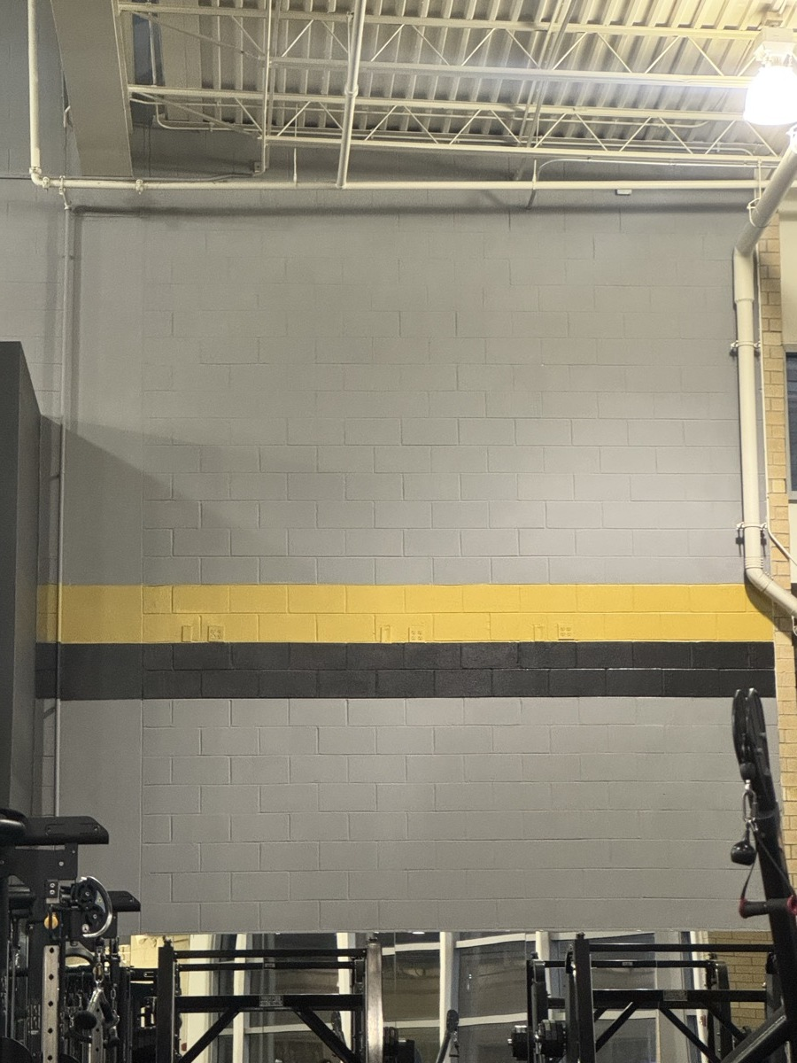  Figure 4: The only UCF color in the free weight area, a gold stripe and a black stripe on gray cinderblock, with no logo and no lettering. Evidence that the space identifies me as a lifter rather than as a student. Photo taken by me, 17 September 2026.  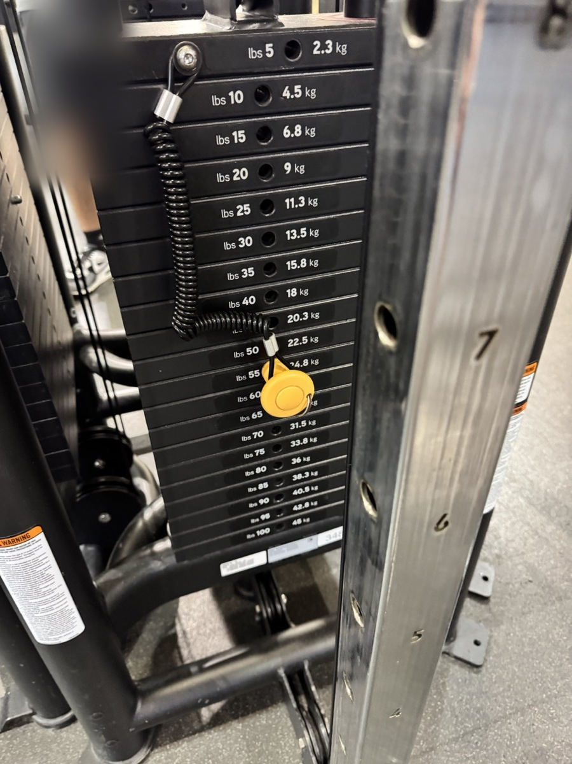  Figure 5: The printed numbers on a cable stack. The pin sits in a number, so the machine turns my training into a record I can read without words. Photo taken by me, 17 September 2026.  Figure 6: Me in the RWC on the morning of 17 September 2026. This is the same photograph as Figure 3, repeated here so this question set carries its own evidence that I was physically in this space. Photo taken by me.  5.) My claim  Identification at the Recreation and Wellness Center creates belonging for me without any help from UCF, because the building identifies me as a lifter rather than as a student, and that identification is confirmed by other users and by the equipment instead of by the institution.  6.) Direct quote from Downs or Lueck  Downs explains identification as recognizing yourself in another person. He writes that when we trust a rhetor deeply, “it is because we see some important aspect of ourselves in them” (475), and he quotes Kenneth Burke, who says that A is “identified with” B insofar as their interests are joined (475). That is the clearest explanation I have for why walking up to a stranger on this floor felt normal before a single word was spoken. Huy and I had joined interests before we knew we shared a major. Understanding identification matters because it shows that my belonging in this building is produced by other lifters recognizing themselves in me, and me in them, rather than by anything the university put on the walls.  Work Cited  Downs, Doug. “Rhetoric: Making Sense of Human Interaction and Meaning-Making.” Writing about Writing, edited by Elizabeth Wardle and Doug Downs, 5th ed., Bedford/St. Martin’s, 2022, pp. 458-481.

