Michael Wong
Professor Baker
ENC 1101
8 October 2026
Same Gym, Different Logo
Commercial gyms are close to identical, and that is the point of them. Cardio machines sit near the door, weight machines fill the middle, and free weights and squat racks go in the back. The UCF Recreation and Wellness Center follows that template almost exactly. Entering from the upper level, the cardio machines are directly in front of the doors. Down the stairs are the weight machines, the courts, the pool, and at the very back, the free weights and squat racks. I have trained in this layout for years, at the Crunch near my home and on the squat rack in my garage, so the RWC felt familiar the first day I walked in. A familiar place becomes comfortable fast, and in a comfortable place I feel confident.
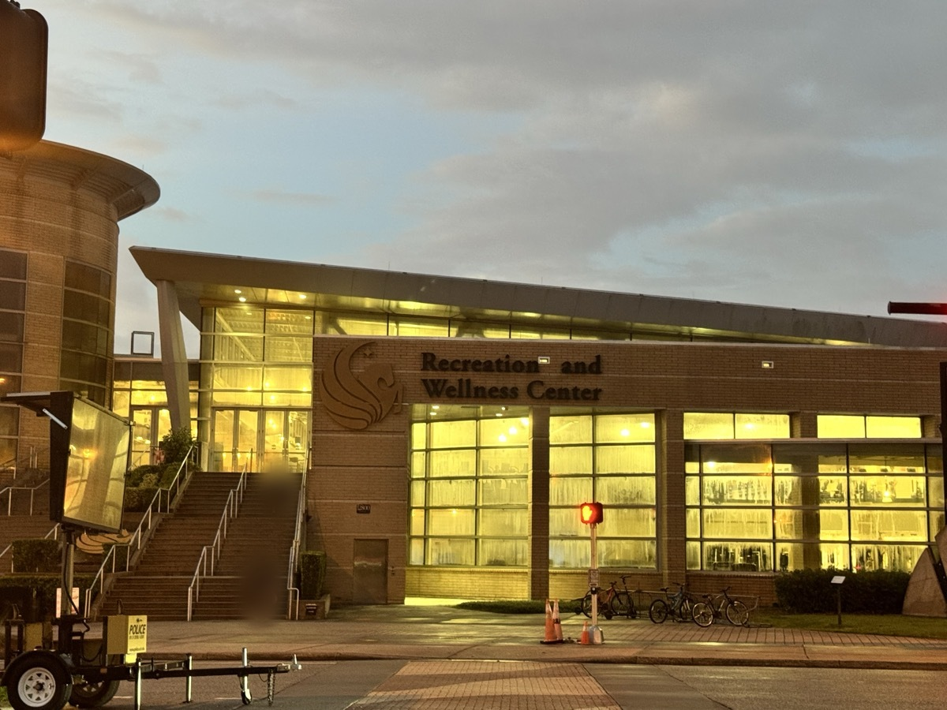
Figure 1: The RWC from outside in early morning light. The empty approach shows the hour I normally train, before the building fills. Photo taken by me.
Doug Downs calls a space like this a rhetorical ecology, “a network of myriad interconnecting and almost inseparable elements” (466). The RWC has a lot of rhetors, and most of them never say anything. UCF set the policies and chose where its logo goes. The architects put the least intimidating equipment in sight of the door. Student workers enforce the rules, and the few signs are short: wipe your machine down, re-rack your weights. The users are rhetors too. Every person who re-racks a plate, or leaves one out, tells the next person what the norms are. One element in this ecology is out of everyone’s hands, and that is time. Looking at the RWC this way, I found two things it does to me. First, the RWC borrows both its layout and its branding from commercial gyms like Crunch, and the UCF logo turns that familiar gym into a reminder that I belong to a community where I am growing up. Second, timing decides what the crowd does to my sense of belonging, and that can go either way.
The Logo Where I Am Already Looking
Before this project, the only piece of UCF I had noticed in the building was a gold stripe and a black stripe painted across a gray brick wall in the free weight area. When I started looking at the RWC as a researcher instead of as a lifter, I found the logo in many more places. It is on the direction signs. It sits on small gold banners on top of the squat racks. The TVs show the student managers who run the building, and the TVs next to them play the news. I had walked past all of it for weeks. So why did I not see it? I think it is because UCF does exactly what Crunch does. At Crunch, the logo is printed on the dumbbells and across the turf field in the middle of the gym, so you cannot pick up a weight without seeing who owns it. Both gyms put their name where people are already looking, and a logo that is everywhere is easy to stop noticing.
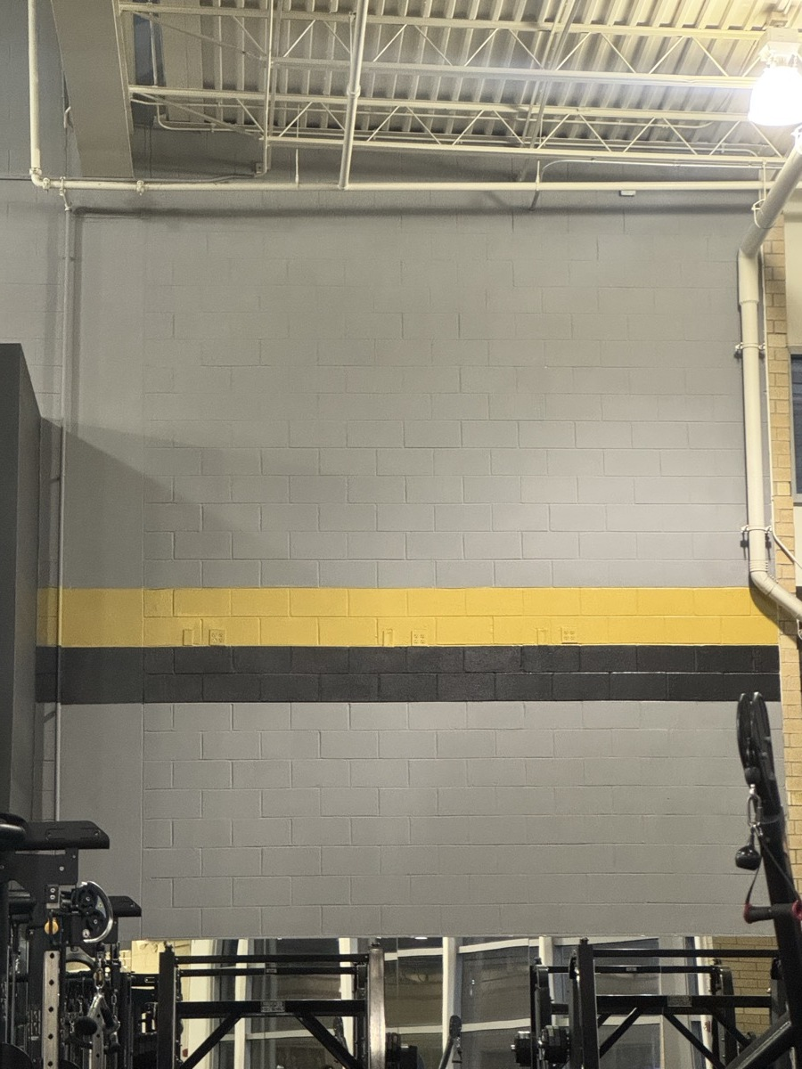
Figure 2: The gold and black stripe on gray brick in the free weight area. For weeks, this was the only UCF detail I noticed. Photo taken by me.
The RWC borrows both its layout and its branding from commercial gyms like Crunch, and the familiar layout is what makes me confident there. But the UCF logo does something a Crunch logo does not. It reminds me that I belong to a community where I am growing up, not just a gym where I train.
Downs explains this kind of belonging as identification. He quotes Kenneth Burke, who says that A is “identified with” B insofar as their interests are joined (475), and Downs adds that when we trust a rhetor deeply, “it is because we see some important aspect of ourselves in them” (475). A logo is a rhetor asking me to identify with it. At Crunch, the logo asks me to identify with a brand. At the RWC, the gold banner on the squat rack asks me to identify with a school, and it works. When I see it, I think about what college is for me beyond studying: meeting new people, having freedom from my parents, choosing what I do with my day, and making my own chore schedule. The logo reminds me that the RWC is one more place where I can meet people and learn. To me it feels like community.
The student managers on the TVs add to that feeling. Downs writes that ethos is Greek for “one’s accustomed place or habit of being,” with “the idea that you know someone by where they dwell, by their ‘haunts’” (475). The student workers haunt the same building I do. They are close to my age, and they probably work out too, so they feel more approachable to me than some adult staff would, and I expect them to be more understanding. The news on the other TVs pulls the other way. It gives the RWC the feel of a business gym, and at both the RWC and Crunch I catch myself watching it between sets. That habit is exactly why the TVs are a smart place for UCF to put its student managers. The school puts its people where my eyes already go.
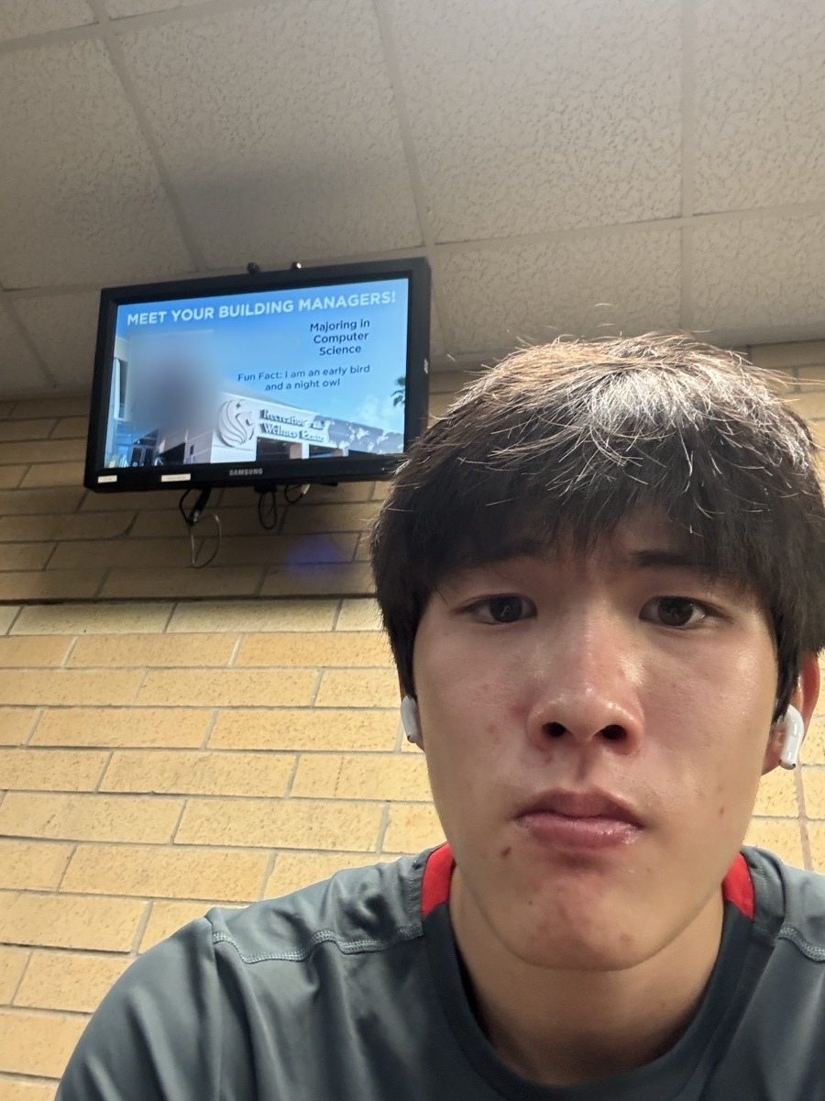
Figure 3: Me on the upper level before a morning session. The screen behind me introduces the student building managers; the staff member’s photo and name are blurred. Photo taken by me.
On the surface, the RWC is a commercial gym. The layout gets me comfortable, but the logo is what turns that comfort into a feeling that I belong to UCF.
The Same Hour, Two Ways
I train in the early morning, and in the early morning the RWC is quiet. The racks are open, and I move straight down my plan. The one hour in my week when I cannot train early is Tuesday at about 10:45 a.m., right after my ENC class. By then the building is packed and loud. I am not angry that the machines are taken. I am just not a fan of crowded places. People often ask me how many sets I have left or whether they can work in with me, and that does not bother me. What bothers me is knowing that someone is waiting on me. It makes me self-conscious of my time and I feel rushed, so I rest less between sets. On one Tuesday I did two exercises per muscle group instead of three and left early, because I did not want to keep waiting either.
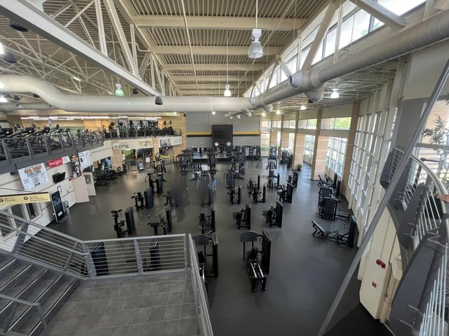
Figure 4: The lower floor of the RWC with most machines open. This is close to what the floor looks like when I train in the early morning. At 10:45 on a Tuesday, most of these stations are taken. Photo by u/Jswee1, r/ucf; see Image Credits.
Downs gives the Greek term for this. Kairos, he writes, “translates to something like ‘timely good fortune’ or simply ‘lucky timing’” (467). He explains that rhetors have “far-from-complete control” over their situation, because circumstances outside their control can change the moment (467). I do not choose how many other students decide to show up at the time I go. The equipment on Tuesday is the same as on Monday morning. Only the timing changed, and it changed how much room I had to belong.
But the timing on Tuesday did not only take something from me. The day I met Huy was a Tuesday at the same crowded hour, after my ENC class. I was on the dip machine when he came over. He is from Vietnam, and he studies electrical engineering, which is my major too, so we talked through my whole time on that machine. I asked for his number because I thought he could be a good mentor. I have not seen him since.
At the RWC, timing decides what the crowd does to my sense of belonging. The same Tuesday hour that rushes my workout and makes me feel in the way also put me next to another engineering student I would never have met at 7 a.m. Kairos is lucky timing, and luck can go either way.
So What?
Both findings matter to me personally because the RWC is a place I am in almost every day. Before this class, I just used it. Learning about rhetoric, and principles like kairos and identification, helped me see that the building is designed to give its users a specific experience. It looks like every commercial gym I have used, so I was confident there from the first day, and the logo I had been walking past for weeks turned out to be part of why it feels like UCF.
The weight stack is a good example of that familiarity. The pin sits in a printed number, and that number means the same thing at the RWC, at Crunch, and on the equipment I know from home. It does not matter which gym I walk into or what hour I get there. The same weight will be there, and I do not have to start from scratch. Even on a crowded Tuesday, when I am rushed and resting less, the number on the stack tells me I am still making progress.
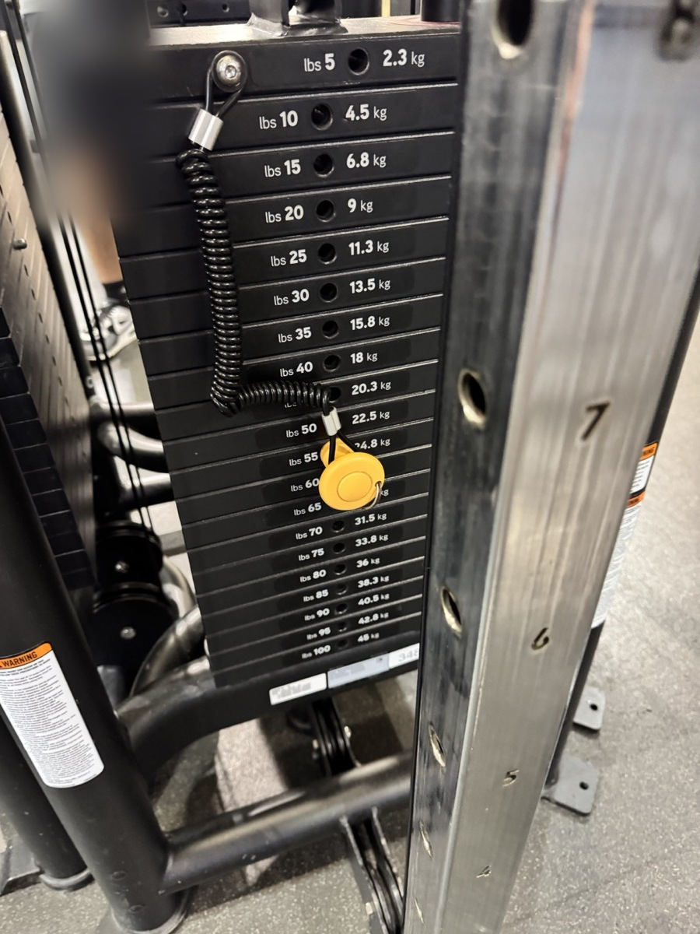
Figure 5: The printed numbers on a cable stack at the RWC. The same numbers mean the same weight at any gym, so my progress comes with me. Photo taken by me.
For learning about rhetoric, this project showed me that a building can argue without saying anything, and that it can push some people out as easily as it pulls others in. The RWC has no tables and nowhere to sit, and it makes me put my things in a locker before I start. Those choices push out the academic side of being a student. The building welcomes me as someone who trains, not as someone who wants to sit down and study. Timing works the same way. The same room can include me or crowd me out depending on the hour.
Learning about rhetors will help me later, at UCF and anywhere else I go. It helps me look for the real intentions behind a place, and it reminds me that other people can take their own meanings from the same things I see. A logo or a crowded hour does not mean the same thing to everyone.
For other UCF students, I think the takeaway is that UCF does not only mean a school. It works more like a city that is meant to help you grow and learn life skills, not just academics. The gym is one part of that city. If it feels crowded, it may just be the hour, and the crowded hour might be the one where you meet someone worth knowing.

Image Credits
Figures 1, 2, 3, and 5 are my own photos. Figure 4 is credited below.
Jswee1 [u/Jswee1]. “New gym equipment opens Monday.” Reddit, r/ucf, Mar. 2024, www.reddit.com/r/ucf/comments/1bkm4e9/new_gym_equipment_opens_monday/. Accessed 29 Sept. 2026.

Work Cited
Downs, Doug. “Rhetoric: Making Sense of Human Interaction and Meaning-Making.” Writing about Writing, edited by Elizabeth Wardle and Doug Downs, 3rd ed., Bedford/St. Martin’s, 2017, pp. 458–481.

