Michael Wong
Professor Baker
ENC 1101
17 September 2026
Major Project 1: Field Research Notes
Space observed: UCF Recreation and Wellness Center
Part 1: Describing the Space
1.1 What objects are in and around the space? How are they arranged? Cluttered or sparse?
The building is split over two levels and organized into zones rather than one open room. Entering on the upper level, the cardio machines sit directly in front of the doors. Two food stands share that floor and sell smoothies and sandwiches. Off to one side is a turf area with medicine balls, resistance bands, and pull-up bars.
Down the stairs is everything else: the weight machines, the basketball and racket courts, the lap pool, and the rock climbing wall. The free weights and squat racks are at the very back, which is where I spend nearly all my time.
It is dense with equipment but not cluttered. Walking lanes stay clear and the machines are in rows. The decoration is the opposite — almost nothing. Where the walls are not glass, they are mirror.
1.2 What can you hear? Is it loud or quiet? What does that tell you about the space?
- Early morning (when I normally go): quiet. Treadmill belts, a plate being set down, short exchanges.
- Tuesday around 10:45 a.m. (the one time I cannot go early): packed and loud, constant movement and overlapping conversation.
- I train with both AirPods in, so the sound does not reach me directly. I read the room by watching movement instead.
The difference tells me the same building is two different places depending on the hour. In the morning people come to finish a task and leave. By late morning it is a social destination.
1.3 What actions does the space promote? What does it shut down?
- Promotes: lifting, cardio, court sports, swimming, climbing, socializing, buying food.
- Shuts down: sitting down to work. There is not a single table or chair on the workout floor.
- Also shut down: keeping your belongings with you. Student workers enforce a rule that bags and loose items go in a locker.
When I am in there I feel motivated to train and almost nothing else. The building gives me no way to do anything but move.
1.4 What colors, shapes, or signs are included? How are they arranged?
- Large windows along the exterior. A lot of natural light, and a view outside that I use between sets instead of my phone.
- Mirrors covering most of the interior wall surface.
- Very little signage: health posters, "wipe your machine down," "re-rack your weights."
- Almost no UCF color. The one exception is a single wall in the free weight area with a gold stripe and a black stripe painted on gray cinderblock. No logo, no lettering.
Because the walls are either window or mirror, there is barely any room for messaging. What survived is what the staff decided they could not leave unsaid.
1.5 Does the design evoke a specific feeling, memory, or association?
It feels like a commercial gym, because the layout is the same as any large chain gym. That familiarity works in my favor since I already know how to read the room.
It also connects to something personal. I keep a squat rack in my garage at home, so the free weight area is a bigger version of a space I already own. Standing in it reminds me of the progress I have made over several years, and the mirrors make that argument without a single word.
The other association is mental. The gym is where I clear my head and put energy into something that is not academic. It is alone time inside a shared building.
1.6 What are the characteristics of the people in and around the space?
- Every experience level at once: beginners, longtime lifters, and older members.
- Nobody is sorted into a section by how much they know.
- People are consistently friendly. I am comfortable walking up to a stranger to ask to work in, and it usually turns into a short conversation.
Part 2: Introduction Photographs
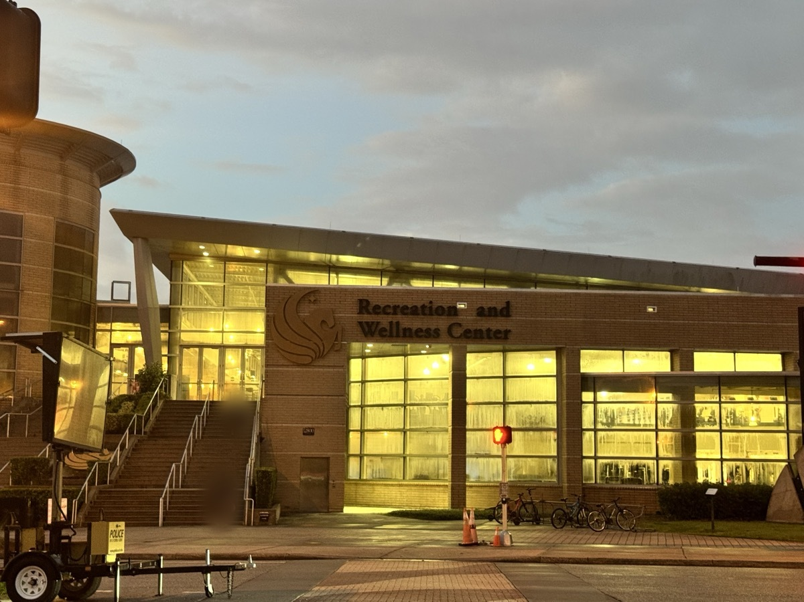
Figure 1: The RWC from outside in early morning light, before the building fills. Faces blurred for privacy.
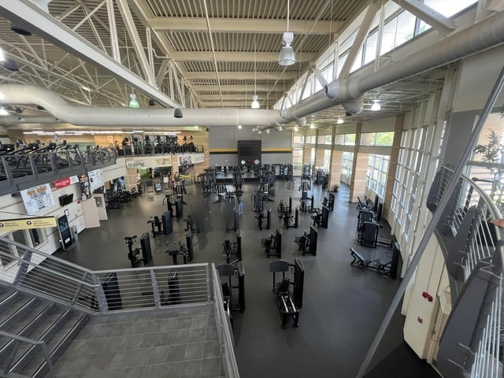
Figure 2: The lower floor. Machines, benches and racks, and no seating anywhere. Photo by u/Jswee1, r/ucf.
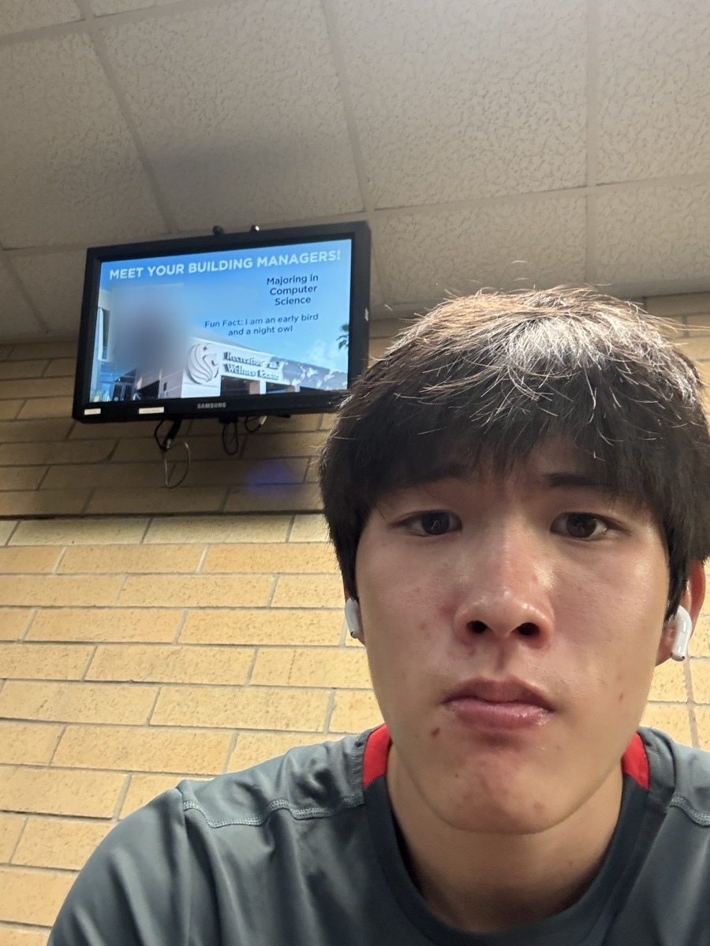
Figure 3: Me on the upper level before a morning session, AirPods already in. The staff photo and name on the screen behind me are blurred.
Part 3: The Rhetorical Ecology
3.1 Who are the rhetors?
- UCF administration, who commissioned the building and set its policies.
- Architects, who chose the two-level split, the glass front, and putting the least intimidating equipment in the sightline of the door.
- Staff and student workers, who enforce the rules and post the signage.
- Equipment manufacturers, whose weight stacks carry printed numbers that turn effort into a readable score.
- The food vendors.
- Other users. Every person who re-racks a plate or leaves one out tells the next person what the norms really are.
- Non-human things. The mirrors point you at yourself, the windows point you outside, and the missing tables tell you not to settle in.
3.2 Who are the audiences and users?
- Students who lift.
- Students who use the pool, the courts, or the climbing wall.
- Students passing through for food.
- Student workers, who enforce rules they also live under.
- People outside the building. The exterior is glass, so there is an audience that can see in, and knowing that changes how it feels to be inside.
3.3 What is the exigence? What need called the space into being?
This is the need behind the building, not what any one person wants out of it, and there is more than one:
- A university with tens of thousands of students, many without access to a private gym, has to provide somewhere for them to be physically active.
- Academic stress needs a release valve, because student health affects whether students stay enrolled.
- A large campus needs shared physical space where students meet outside of class.
- A modern glass recreation center gets shown to prospective students, so the building is partly an argument aimed at people who do not attend UCF yet.
None of those needs belongs to one person. They belong to the university.
3.4 What are the motivations of the rhetors?
- Locker rule: safety and liability. Loose bags on a weight floor are a tripping hazard and a theft risk.
- No tables or chairs: keep the floor moving so people cycle through instead of settling in.
- Wipe-down signs: hygiene in a high-traffic shared space.
- Re-racking signs: equipment life and injury prevention.
- Glass exterior: visibility and institutional pride. A building you can see into advertises itself.
- Mirrors: form correction, but also motivation.
- Food stands: convenience and revenue.
- Beginner-friendly equipment near the entrance: it lets a nervous first-timer start without walking through the most intimidating part of the building.
Part 4: What the Ecology Does for My Experience
4a What helps me belong?
- The layout copies the commercial gym template, so I already know how to behave. I never feel like an outsider learning a room.
- The free weight area reads as an extension of my garage rack at home.
- The mirrors and the weight stacks record progress. They are the building telling me I changed.
- The social norms. Asking a stranger to work in is normal, not intrusive.
- Morning quiet plus natural light. The gym becomes where I clear my head.
4b What hinders my belonging?
- My belonging is conditional on my purpose. With no tables or chairs, I belong only while I am training.
- The locker rule makes me surrender my belongings before I can participate, which makes the floor feel controlled.
- The Tuesday crowd. Racks that are mine at seven in the morning have to be negotiated for at 10:45.
- My AirPods. I shut out the building’s sound and social energy myself, which trades some belonging away on purpose.
4c Field notes: two specific encounters
Encounter 1 — Huy. I was on the dip machine when another Asian student came over. We exchanged names. His name is Huy, he is from Vietnam, and he is studying electrical engineering. I am an electrical engineering major, so the conversation moved past small talk immediately. I asked whether the courses were hard and we talked through my whole time at that machine. When I finished, I asked for his number. Walking out, my thought was that he would make a good mentor because he is doing the same degree. We had identified with each other before either of us said anything about engineering — same rough age, same part of the building, same kind of work, and both visibly Asian in a gym where that is not the default.
Encounter 2 — the 10:45 Tuesday. I went in for chest, back, and shoulders. After my first exercise the plan stopped working, because the next machine I needed was occupied and so was the one after that. I spent the session walking the floor looking for whatever was open and reordering my workout around other people’s. I run on a schedule, so improvising annoys me. I did two exercises per muscle group instead of three and left earlier than usual. Nothing about the building had changed since the morning before. The only thing that changed was how many people were in it.
Part 5: Photographic Evidence of Belonging
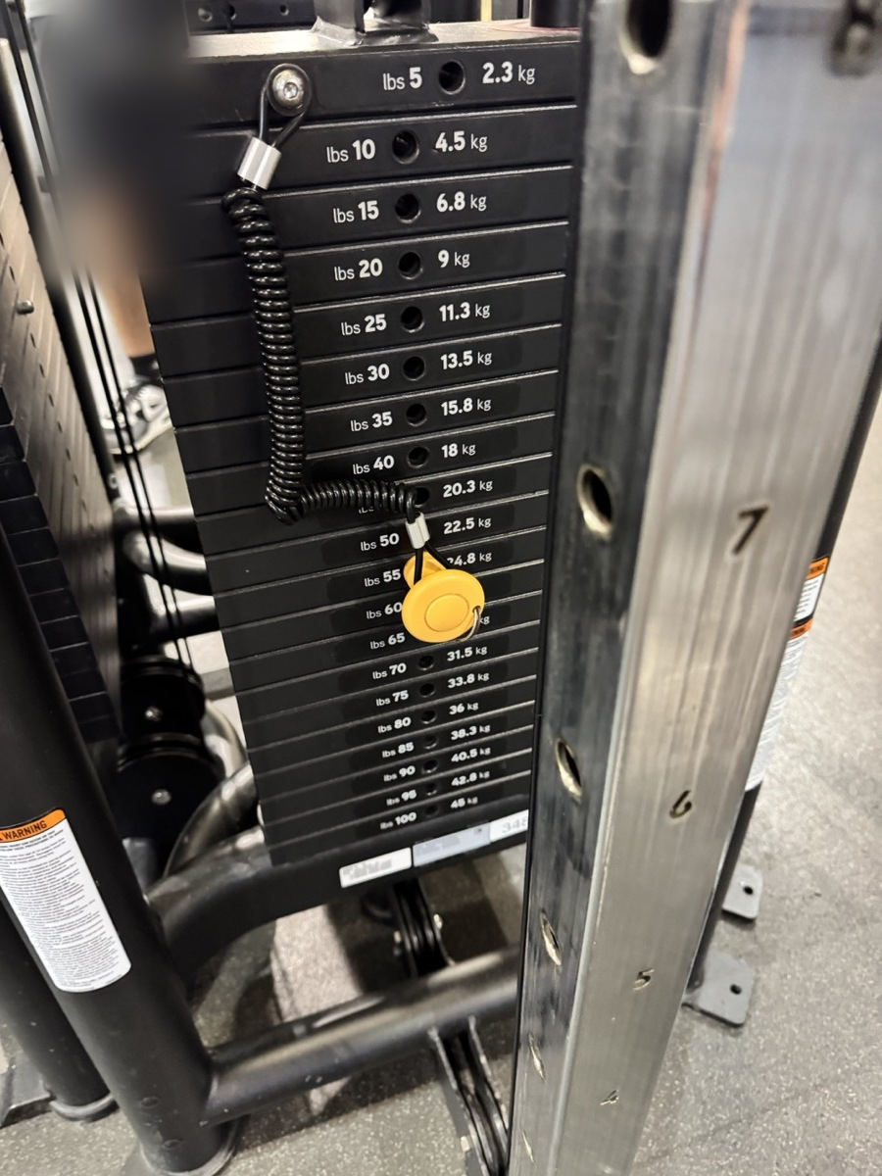
Figure 4: The numbers on a cable stack turn training into a record. Moving the pin one plate lower than last semester is the building telling me I changed. This is where my belonging is strongest.
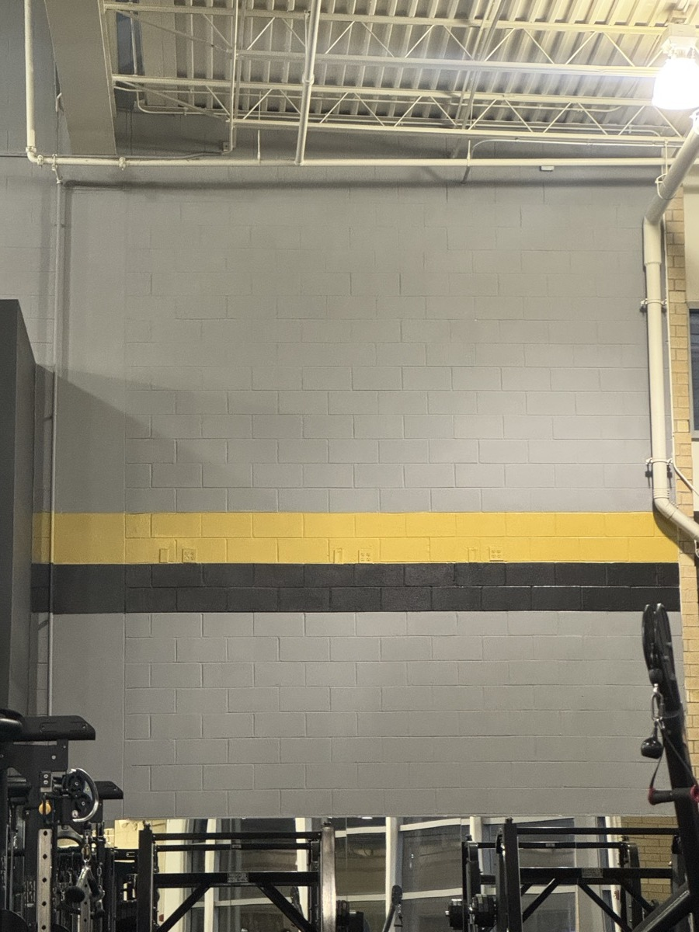
Figure 5: The only UCF color in the room: a gold stripe and a black stripe on gray cinderblock, no logo. The school barely claims the building, which lets me arrive just as someone who lifts.
Figure 6: Every object on the floor is a machine, a bench, or a rack. No table, no chair, nowhere to sit that is not equipment. This is where my belonging stops. Photo by u/Jswee1, r/ucf.
Part 6: The Downs Passage
Downs describes a rhetorical ecology as “a network of myriad interconnecting and almost inseparable elements” (466).
The word that matters is inseparable. No single feature of the RWC produces how I feel in it. The mirrors motivate me because they sit beside free weights that echo my garage, in the quiet of a morning, under natural light, among strangers who will share equipment with me. Change one element and the meaning changes even though nothing physical has moved. That is exactly what happens at 10:45 on a Tuesday.
6b Other Downs terms I can use, and where they are in the reading
- Nonverbal communication (p. 461) — gym clothes, body language, my AirPods, how Huy and I read each other
- Bodies matter as much as minds (p. 463) — the whole space is physical; this is the strongest fit
- Rhetoric is always motivated (p. 464) — Part 3.4, the reasons behind each rule
- Ecology (p. 466) — the core definition
- Rhetors are a network (p. 466) — Part 3.1
- Exigence (p. 467) — Part 3.3
- Kairos (p. 467) — the 10:45 Tuesday
- Narrative (p. 468) — the weight stack tells a story in one number
- Presence (p. 469) — the mirrors make progress visible right now
- Mythos (p. 471) — re-rack your weights, do not hog a rack, let people work in
- Value (p. 472) — morning crowd wants efficiency, late morning crowd wants company
- Identification and ethos (p. 475) — why Huy and I connected before we spoke
Sources Consulted
Downs, Doug. “Rhetoric: Making Sense of Human Interaction and Meaning-Making.” Writing about Writing, edited by Elizabeth Wardle and Doug Downs, 3rd ed., Bedford/St. Martin’s, 2016, pp. 458–481.
Jswee1 [u/Jswee1]. “New gym equipment opens Monday.” Reddit, r/ucf, Mar. 2024, www.reddit.com/r/ucf/comments/1bkm4e9/new_gym_equipment_opens_monday/. Accessed 17 Sept. 2026.
“Recreation and Wellness Center.” UCF Recreation and Wellness Center, https://rwc.sswb.ucf.edu/. Accessed 17 Sept. 2026.

