# Designing Machine Learning Systems - Chip Huyen

## Chapter 8 – Data Distribution Shifts and Monitoring

* Ex: A company hires a consulting firm to develop an ML model to help them predict how many of each grocery item they’d need next week, so they could restock items accordingly
* The consulting firm took 6 months to develop the model
* When the consulting firm handed it over, his company deployed it and was very happy with its performance, + they could finally boast to investors that they were an AI-powered company
* However, a year later, numbers went down 🡪 demand for some items was consistently being overestimated, which caused the extra items to expire, + at the same time, demand for some items was consistently being underestimated, leading to lost sales (This seems to be a fairly common pattern for inventory prediction)
* Initially, his inventory team manually changed the model’s predictions to correct patterns they noticed, but eventually, the model’s predictions became so bad that they could no longer use it
* They had 3 options: pay the same consulting firm an obscene amount of money to update the model, pay another consulting firm even more money because this firm would need time to get up to speed, or hire an in-house team to maintain the model onward.
* His company learned the hard way an important lesson that the rest of the industry is also discovering: **Deploying a model isn’t the end of the process**
* A **model’s performance degrades over time in production**
* Once a model has been deployed, we **still have to continually monitor its performance to detect issues as well as deploy updates to fix these issues**
* There are various reasons why ML models that perform great during development fail in production
* One especially prevalent and thorny issue that affects almost all ML models in production: **data distribution shifts** **= when the data distribution in production differs and diverges from the data distribution the model was exposed to during training**

### Causes of ML System Failures

* Before we identify the cause of ML system failures, let’s briefly discuss what an ML system failure is
* **A failure happens when one or more expectations of the system is violated**
* In ***traditional software***, we mostly care about a system’s **operational expectations: whether the system executes its logic within the expected operational metrics (e.g., latency and throughput)**
* For an ***ML system***, we care about **both its operational metrics and its ML performance metrics**
* Ex: An English-French machine translation system’s operational expectation might be that, given an English sentence, the system returns a French translation within a 1-second latency
* Its ML performance expectation is that the returned translation is an accurate translation of the original English sentence 99% of the time
* If you enter an English sentence into the system and don’t get back a translation, the first expectation is violated, so this is a system failure
* If you get back a translation that isn’t correct, it’s not necessarily a system failure because the accuracy expectation allows some margin of error
* However, if you keep entering different English sentences into the system and keep getting back wrong translations, the second expectation is violated, which makes it a system failure
* **Operational expectation violations are easier to detect**, as they’re usually accompanied by an operational breakage such as a timeout, 404 error on a webpage, out-of-memory error, or a segmentation fault
* However, **ML performance expectation violations are harder to detect as doing so requires measuring and monitoring the performance of ML models in production**
* Ex: For English-French machine translation system, detecting whether returned translations are correct 99% of the time is difficult if we don’t know what the correct translations are supposed to be
* See: countless examples of Google Translate’s painfully wrong translations being used by users because they aren’t aware that these are wrong translations
* For this reason, we say that **ML systems often fail “silently”**
* To effectively detect and fix ML system failures in production, it’s **useful to understand why a model, after proving to work well during development, would fail in production**
* We’ll examine **two types of failures**: **software system failures** and **ML-specific failures**.

#### Software System Failures

* **Software system failures are failures that would have happened to non-ML systems**.
* Some examples of software system failures:
* **1) Dependency failure**
* A **software package or a codebase that your system depends on breaks**, which leads your system to break
* This failure mode is **common when the dependency is maintained by a third party**, and **especially common if the third party that maintains the dependency no longer exists**
* This is one of the reasons **why many companies are hesitant to use products by startups**, and why many companies **prefer to use OSS**
* When a product you use is no longer maintained by its creators, **if that product is open-source, at least you’ll be able to access the codebase + maintain it yourself**
* **2) Deployment failure**
* Failures caused by **deployment errors**, such as when you accidentally deploy the binaries of an older version of your model instead of the current version, or when your systems don’t have the right permissions to read or write certain files
* **3) Hardware failures**
* When the **hardware that you use** to deploy your model, such as CPUs or GPUs, **doesn’t behave the way it should**
* Ex: the CPUs you use might overheat and break down
* **4) Downtime or crashing**
* If a **component of your system runs from a server** **somewhere**, such as AWS or a hosted service, and that **server is down, your system will also be down**
* ***Just because some failures are not specific to ML doesn’t mean they’re not important for MLE’s to understand***
* 2020: Daniel Papasian and Todd Underwood, 2 Google MLE’s, looked at 96 cases where a large ML pipeline at Google broke
* They reviewed data from over the previous 15 years to determine the causes and found out that 60 out of these 96 failures happened due to causes not directly related to ML (Daniel Papasian and Todd Underwood, “How ML Breaks: A Decade of Outages for One Large ML Pipeline”
* <https://www.youtube.com/watch?v=hBMHohkRgAA>
* <https://www.usenix.org/conference/opml20/presentation/papasian>
* **A non-ML failure might still be indirectly due to ML**
* Ex: A server can crash for non-ML systems, but because **ML systems tend to require more compute power, it might cause this server to crash more often**
* **Most of the issues are related to distributed systems** (e.g., where the workflow scheduler or orchestrator makes a mistake), **or related to the data pipeline** (e.g., where data from multiple sources is joined incorrectly or the wrong data structures are being used)
* **Addressing software system failures requires not ML skills, but traditional SWE skills**
* **Because of the importance of traditional SWE skills in deploying ML systems, MLE is mostly engineering, not ML**
* If interested in learning how to make ML systems reliable from the SWE perspective, try “Reliable Machine Learning”, published by O’Reilly with Todd Underwood as one of the authors
* <https://www.oreilly.com/library/view/reliable-machine-learning/9781098106218/>
* A reason for the prevalence of software system failures is that because ML adoption in the industry is still nascent, **tooling around ML production is limited and best practices are not yet well developed or standardized**
* However, **as toolings and best practices for ML production mature, there are reasons to believe that the proportion of software system failures will decrease and the proportion of ML-specific failures will increase**

#### ML-Specific Failures

* **ML-specific failures are *failures specific to ML systems***: **data collection + processing problems, poor hyperparameters, changes in the training pipeline not correctly replicated in the inference pipeline and vice versa, data distribution shifts that cause a model’s performance to deteriorate over time, edge cases, + degenerate feedback loops**
* **Even though they account for a small portion of failures, they can be more dangerous than non-ML failures as they’re hard to detect + fix, and can prevent ML systems from being used altogether**
* 3 new but very common problems that arise after a model has been deployed: **production data differing from training data**, **edge cases**, and **degenerate feedback loops**

##### Production data differing from training data

* When we say that **“an ML model learns from the training data”,** it means that **the model learns the underlying distribution of the training data with the goal of leveraging this learned distribution to generate accurate predictions for unseen data (data it didn’t see during training)**
* When a **model is able to generate accurate predictions for unseen data**, we say that the model “**generalizes to unseen data**”
* The **test data that we use to evaluate a model during development is supposed to represent unseen data**, and the **model’s performance on the test data is supposed to give us an *idea* of how well the model will generalize**
* ML courses say it’s “essential for the training data *and* the unseen data to come from a *similar* distribution”
* The **assumption is that the unseen data comes from a *stationary* distribution that is *the same* as the training data distribution**
* **If the unseen data comes from a different distribution, the model might not generalize well**
* **This assumption is incorrect in most cases for 2 reasons**
* **1) The underlying distribution of the real-world data is unlikely to be *the same* as the underlying distribution of the training data**
* **Curating a training dataset that can accurately represent the data that a model will encounter in production turns out to be very difficult**
* Real-world data is multifaceted and, in many cases, virtually infinite, whereas **training data is finite and constrained by the time, compute, + human resources** available during the dataset creation + processing
* There are **many different selection and sampling biases that can happen** and make real-world data **diverge from training data**
* Can be something as minor as real-world data using a different type of encoding of emojis
* This type of divergence leads to **a common failure mode: the train-serving skew: a model that does great in development but performs poorly when deployed**
* **2) The real world isn’t *stationary***
* Things change. Data distributions shift
* In 2019, when people searched for Wuhan, they likely wanted to get travel information, but since COVID-19, when people search for Wuhan, they likely want to know about the place where COVID-19 originated
* Another **common failure mode is that a model does great when first deployed, but its performance degrades over time as the data distribution changes**
* This failure mode needs to be **continually monitored and detected for as long as a model remains in production**
* Some people have the impression that data shifts only happen because of unusual events, which implies they don’t happen often (COVID-19)
* **Data shifts happen all the time, suddenly, gradually, or seasonally**
* Can happen suddenly because of a specific event, such as when existing competitors change their pricing policies and you have to update your price predictions in response, when you launch your product in a new region, when a celebrity mentions your product + causes a surge in new users, and so on
* Can happen gradually because social norms, cultures, languages, trends, industries, etc. just change over time
* Can also happen due to seasonal variations (ex: people might be more likely to request rideshares in the winter when it’s cold and snowy than in the spring)
* **Due to the complexity of ML systems and the poor practices in deploying them, a large percentage of what might look like data shifts on monitoring dashboards are caused by internal errors**
* Ex: Bugs in the data pipeline, missing values incorrectly inputted, inconsistencies between the features extracted during training and inference, features standardized using statistics from the wrong subset of data wrong model version, or bugs in the app interface that force users to change their behaviors
* **Data Distribution Shifts is an error mode that affects almost all ML models**

##### Edge cases

* Imagine there existed a self-driving car that can drive you safely 99.99% of the time, but the other 0.01% of the time, it might get into a catastrophic accident that can leave you permanently injured or even dead. *Would you use that car?* (If tempted to say no, you’re not alone)
* **An ML model that performs well on most cases but fails on a small number of cases might not be usable if these failures cause catastrophic consequences**
* For this reason, major self-driving car companies are focusing on making their systems work on **edge cases = the data samples so extreme that they cause the model to make catastrophic mistakes**
* **Even though edge cases generally refer to data samples drawn from the *same* distribution, if there is a sudden increase in the number of data samples in which your model doesn’t perform well, it could be an indication that the underlying data distribution has shifted**
* Autonomous vehicles are often used to illustrate how **edge cases can prevent an ML system from being deployed**, but **this is also true for *any* safety-critical application** such as medical diagnosis, traffic control, e-discovery (discovery in legal proceedings, such as litigation, government investigations, or FOIA requests, where information sought is in electronic format.), etc.
* It **can also be true for non-safety-critical applications**
* Imagine a customer service chatbot that gives reasonable responses to most of the requests, but sometimes, it spits out outrageously racist or sexist content
* This chatbot will be a brand risk for any company that wants to use it, thus rendering it unusable

###### Edge Cases and Outliers

* You might wonder about **the differences between an outlier and an** **edge case**
* The **definition of what makes an edge case varies by discipline**
* In ML, because of its recent adoption in production, edge cases are still being discovered, which makes their definition contentious
* For us:
* **Outliers** refer to **data**: **an example that differs significantly from other examples**
* **Edge cases** refer to **performance**: **an example where a model performs significantly worse than other examples**
* **An outlier can cause a model to perform unusually poorly, *which makes it an edge case***
* However, **not all outliers are edge cases**
* Ex: A person jaywalking on a highway is an outlier, but it’s not an edge case if your self-driving car can accurately detect that person and decide on a motion response appropriately
* **During model development, outliers can negatively affect your model’s performance**, as shown below

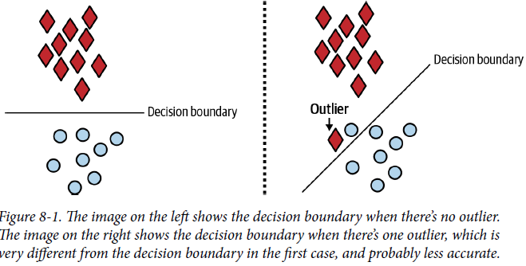

* **In many cases, it might be beneficial to remove outliers as it helps your model to learn better decision boundaries and generalize better to unseen data**
* However, **during inference, you don’t usually have the option to remove or ignore queries that differ significantly from other queries**
* You can choose to transform it (Ex: when you enter “mechin learnin” into Google Search, Google might ask if you mean “machine learning”
* But **most likely you’ll want to develop a model so that it can perform well even on unexpected inputs**

##### Degenerate feedback loops

* A **feedback loop in ML** **= the time it takes from when a prediction is shown until the time feedback on the prediction is provided**
* The **feedback can be used to extract natural labels to evaluate the model’s performance and train the next iteration of the model**
* A **degenerate feedback loop can happen when the predictions *themselves* influence the feedback, which, in turn, influences the next iteration of the model**
* More formally, a **degenerate feedback loop** is **created when a system’s outputs are used to generate the system’s future inputs, which, in turn, influence the system’s future outputs**
* In ML, **a system’s predictions can influence how users interact with the system, and because users’ interactions with the system are sometimes used as training data to the *same* system, degenerate feedback loops can occur and cause unintended consequences**
* Degenerate feedback loops are **especially common in tasks with natural labels from users**, such as recommender systems and ads CTR prediction
* Ex: You build a system to recommend to users some songs that they might like
* The songs that are ranked high by the system are shown first to users
* Because they are shown first, users click on them more, which makes the system more confident that these recommendations are good
* In the beginning, the rankings of 2 songs, A and B, might be only marginally different, but because A was originally ranked a bit higher, it showed up higher in the recommendation list, making users click on A more, which made the system rank A even higher
* After a while, A’s ranking became much higher than B’s
* **Degenerate feedback loops are one reason why popular movies, books, or songs keep getting more popular, which makes it hard for new items to break into popular lists**
* This type of scenario is **incredibly common in production, is heavily researched**, and goes by **many different names, including “exposure bias,” “popularity bias,” “filter bubbles,” and sometimes “echo chambers”**
* Ex: Building a resume-screening model to predict whether someone with a certain resume is qualified for the job
* The model finds feature X accurately predicts whether someone is qualified, so it recommends resumes with feature X (like “went to Stanford,” “worked at Google,” or “identifies as male”)
* Recruiters only interview people whose resumes are recommended by the model, which means they only interview candidates with feature X, which means the company only hires candidates with feature X
* This, in turn, makes the model put even *more* weight on feature X (This is related to “survivorship bias”)
* **Having visibility into how your model makes predictions (such as measuring the importance of each feature for the model) can help detect the bias** toward feature X in this case.
* **Left unattended, degenerate feedback loops can cause a model to perform sub-optimally at best**
* **At worst, they can perpetuate and magnify biases embedded in data**, such as biasing against candidates without feature X

###### Detecting degenerate feedback loops.

* If degenerate feedback loops are so bad, **how do we know if a feedback loop in a system is degenerate?**
* **When a system is offline, degenerate feedback loops are difficult to detect**
* **Degenerate loops result from user feedback, and systems won’t have users until they’re online (i.e., deployed to users)**
* For the task of recommender systems, it’s possible to detect degenerate feedback loops by measuring the popularity diversity of a system’s outputs even when the system is offline
* An item’s popularity can be measured based on how many times it has been interacted with (e.g., seen, liked, bought, etc.) in the past
* The popularity of all the items will likely follow a long-tail distribution: a small number of items are interacted with a lot, while most items are rarely interacted with at all
* Various metrics such as **aggregate diversity** and **average coverage of long-tail items**can help you measure the diversity of the outputs of a recommender system
* Low scores mean that the outputs of your system are homogeneous, which might be caused by popularity bias
* In 2021, Chia et al. went a step further and proposed the measurement of **hit rate against popularity**
* First, divide items into buckets based on their popularity (e.g., bucket 1 consists of items that have been interacted with < 100 times, bucket 2 consists of items that have been interacted with > 100 times but < 1,000 times, etc.)
* Then they measured prediction accuracy of a recommender system for each bucket
* If a recommender system is much better at recommending popular items than recommending less popular items, it likely suffers from popularity bias
* **Once your system is in production and you notice that its predictions become more homogeneous over time, it likely suffers from degenerate feedback loops**

###### Correcting degenerate feedback loops.

* Because degenerate feedback loops are a common problem, there are **many proposed methods on how to correct them**
* 2 common methods = **randomization** and **positional features**
* **Degenerate feedback loops can cause a system’s outputs to be more homogeneous over time**, and **introducing randomization in the predictions can reduce their homogeneity**
* In the case of recommender systems, instead of showing users only items the system ranks highly for them, we show users random items and use their feedback to determine the true quality of these items
* This is the approach that TikTok follows: Each new video is randomly assigned an initial pool of traffic (which can be up to 100s of impressions)
* This pool of traffic is used to evaluate each video’s unbiased quality to determine whether it should be moved to a bigger pool of traffic or be marked as irrelevant
* **Randomization has been shown to improve diversity, but at the cost of user experience**.
* Showing users completely random items might cause users to lose interest in our product
* **An intelligent exploration strategy can help increase item diversity with acceptable prediction accuracy loss**
* Schnabel et al. use a small amount of randomization and causal inference techniques to estimate the unbiased value of each song
* They were able to show that this algorithm was able to correct a recommender system to make recommendations fair to creators
* **Degenerate feedback loops are caused by users’ feedback on predictions, and users’ feedback on a prediction is biased based on where it is shown**
* Consider the preceding recommender system example, where each time you recommend 5 songs to users
* You realize the top recommended song is much more likely to be clicked on compared to the other 4 songs
* You are unsure whether your model is exceptionally good at picking the top song, or whether users click on any song as long as it’s recommended on top
* **If the position in which a prediction is shown affects its feedback in any way, you might want to encode the position information using positional features**
* **Positional features can be numerical** (e.g., positions are 1, 2, 3,...) or **Boolean** (e.g., whether a prediction is shown in the first position or not)
* Note that “positional features” are *different* from “positional *embeddings*”
* Naive example: During training, you add “whether a song is recommended first” as a feature to your training data, as shown in the table below
* This feature allows your model to learn how much being a top recommendation influences how likely a song is clicked on

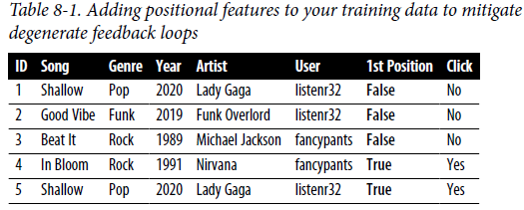

* During inference, you want to predict whether a user will click on a song regardless of where the song is recommended, so you might want to set the 1st Position feature to be False
* Then you look at the model’s predictions for various songs for each user and can choose the order in which to show each song.
* This is a naive example because doing this alone might not be enough to combat degenerate feedback loops
* **A more sophisticated approach would be to use two different models**
* First model predicts the probability the user will see and consider a recommendation taking into account the position at which that recommendation will be shown
* Second model then predicts the probability that the user will click on the item given that they saw and considered it
* *The second model doesn’t concern positions at all*

### Data Distribution Shifts

* **One especially sticky cause of ML system failures: data distribution shifts, or data shifts for short**
* **Data distribution shift** = **the phenomenon in supervised learning when the data a model works with changes over time, which causes model predictions to become less accurate as time passes**
* The **distribution of the data the model is *trained* on** is called the **source distribution**
* The **distribution of the data the model runs *inference*** **on** is called the **target distribution**
* Even though discussions around data distribution shift have only become common in recent years with the growing adoption of ML in the industry, data distribution shift in systems that learned from data has been studied as early as in 1986
* There’s also a book on dataset distribution shifts, “Dataset Shift in Machine Learning” by Quinonero-Candela et al., published by MIT Press in 2008

#### Types of Data Distribution Shifts

* While data distribution shift is often used interchangeably with **concept drift** and **covariate shift** and occasionally **label shift**, these are **3 distinct subtypes of data shift**
* A discussion on different types of data shifts is math-heavy and mostly useful from a **research perspective: to develop efficient algorithms to detect and address data shifts requires understanding the causes of those shifts**
* **In production, when encountering a distribution shift, data scientists don’t usually stop to wonder what type of shift it is, *they mostly care about what they can do to handle this shift***
* To understand what concept drift, covariate shift, and label shift mean, we first need to define a couple of mathematical notations
* Let’s call the inputs to a model X and its outputs Y
* We know that in supervised learning, the **training data can be viewed as a set of samples from the joint distribution P(X, Y)**, and then **ML usually models** **P(Y|X)**
* This **joint distribution P(X, Y) can be decomposed in two ways:**
* **P(X, Y) = P(Y|X)P(X)**
* **P(X, Y) = P(X|Y)P(Y)**
* **P(Y|X)** denotes the **conditional probability of an output given an input** (Ex: the probability of an email being spam given the content of the email
* **P(X)** denotes **probability density of the input**, **P(Y)** denotes **probability density of the output**
* **Covariate shift** **= When P(X) changes but P(Y|X) remains the same**
* This refers to the *first decomposition of the joint distribution*
* **Label shift** **= When P(Y) changes but P(X|Y) remains the same**
* This refers to the *second decomposition of the joint distribution*
* **Concept drift** = **When P(Y|X) changes but P(X) remains the same**
* This refers to the *first decomposition of the joint distribution*
* You might wonder what about the case when P(X|Y) changes but P(Y) remains the same, as in the second decomposition
* Rarely if ever encounter any research in this setting, as it would be too difficult to study

##### Covariate shift

* **Covariate shift** = one of the most widely studied forms of data distribution shift
* In statistics, a **covariate** is **an independent variable that can influence the outcome of a given statistical trial, but which is not of direct interest**
* Consider running an experiment to determine how locations affect housing prices
* The housing price variable is your **direct interest**, but you know the square footage affects the price, so the square footage is a **covariate**
* **In supervised ML, the label is the variable of direct interest, and the input features are covariate variables**
* Mathematically, **covariate shift is when P(X) changes, but P(Y|X) remains the same,** which **means that the distribution of the input changes, but the conditional probability of an output given an input remains the same**
* Consider the task of detecting breast cancer
* You know the risk of breast cancer is higher for women over the age of 40, so you have a variable “age” as your input
* You might have more women over the age of 40 in your training data than in your inference data, so the input distributions differ for your training and inference data
* *However*, for an example with a given age, such as above 40, the probability that this example has breast cancer is constant
* So, P(Y|X), the probability of having breast cancer given age over 40, is the same
* **During model *development*, covariate shifts can happen due to:**
* **1) Biases during the data selection process, which could result from difficulty in collecting examples for certain classes**
* Suppose that to study breast cancer, you get data from a clinic where women go to test for breast cancer
* Because people over 40 are encouraged by their doctors to get checkups, your data is dominated by women over 40
* For this reason, **covariate shift is closely related to the sample selection bias problem**
* **2) The training data being artificially altered to make it easier for your model to learn**
* It’s hard for ML models to learn from imbalanced datasets, so you might want to collect more samples of the rare classes or oversample your data on the rare classes to make it easier for your model to learn the rare classes.
* **3) The model’s learning process, especially through active learning** **(instead of randomly selecting samples to train a model on, use the samples most helpful to that model according to some heuristics)**
* This means that **the training input distribution is altered by the learning process to differ from the real-world input distribution**, and **covariate shifts are a by-product**
* In ***production*, covariate shift usually happens because of major changes in the environment or in the way your application is used**
* Imagine you have a model to predict how likely a free user will be to convert to a paid user
* The income level of the user is a feature
* Your company’s marketing department recently launched a campaign that attracts users from a demographic more affluent than your current demographic
* The input distribution into your model has changed, but the probability that a user with a given income level will convert remains the same
* **If you *know in advance* how the real-world input distribution will differ from your training input distribution, you can leverage techniques such as importance weightingto train your model to work for the real-world data**
* **Importance weighting consists of 2 steps:**
* **1) Estimate the density ratio between the real-world input distribution and the training input distribution**
* **2) Weight the training data according to this ratio and train an ML model on this weighted data**
* However, **because we don’t know in advance how the distribution will change in the real world, it’s very difficult to preemptively train models to make them robust to new, unknown distributions**
* There *has* been research that attempts to help models learn representations of latent variables that are invariant across data distributions, but there is little adoption not in the industry as of now

##### Label shift

* **Label shift**, also known as **prior shift**, **prior probability shift**, or **target shift**, is when **P(Y) changes but P(X|Y) remains the same**
* Can think of this as the case **when the output distribution changes but, *for a given output*, the input distribution stays the same**
* Remember that **covariate shift is when the input distribution changes**
* **When the *input* distribution changes, the output distribution *also* changes, resulting in both covariate shift and label shift happening at the same time**
* For the breast cancer example, because there are more women over 40 in our training data than in our inference data, the percentage of POSITIVE labels is higher during training
* However, if you randomly select person A with breast cancer from your training data and person B with breast cancer from your test data, A and B have the same probability of being over 40
* This means that P(X|Y), or probability of age over 40 given having breast cancer, is the same
* So, this is also a case of label shift
* **However, not all covariate shifts result in label shifts**
* Another example: Imagine there is now a preventive drug that every woman takes that helps reduce their chance of getting breast cancer
* The probability P(Y|X) reduces for women of all ages, so it’s no longer a case of covariate shift
* However, given a person with breast cancer, the age distribution remains the same, so this is still a case of label shift
* **Because label shift is closely related to covariate shift, methods for detecting and adapting models to label shifts are similar to covariate shift adaptation methods**

##### Concept drift

* **Concept drift**, also known as **posterior shift**, is when the **input distribution remains the same but the conditional distribution of the output given an input changes**
* Can think of this as “same input, different output.”
* Consider you’re in charge of a model that predicts the price of a house based on its features
* Before COVID-19, a 3-bedroom apartment in San Francisco could cost $2M
* However, at the beginning of COVID-19, many people left SF, so the same apartment would cost only $1.5M
* So, even though the distribution of house features remains the same, the conditional distribution of the price of a house given its features has changed
* **In many cases, concept drifts are cyclic or seasonal**
* Rideshare prices will fluctuate on weekdays vs. weekends, and flight ticket prices rise during holiday seasons
* **Companies might have different models to deal with cyclic and seasonal drifts**
* Might have one model to predict rideshare prices on weekdays and another for weekends

#### General Data Distribution Shifts

* There are other types of changes in the real world that, even though not well studied in research, can still degrade your models’ performance
* **There’s no rule that says that only one type of shift should happen at one time**
* A **model might suffer from multiple types of drift, which makes handling them a lot more difficult**

##### Feature change

* **Features changes** = like when **new features are added, older features are removed, or the set of all possible values of a feature changes** (think of this as the case where *both* P(X) and P(Y|X) change)
* Ex: Your model was using years for the “age” feature, but now it uses months, so the range of this feature’s values has drifted
* Maybe a model’s performance plummeted because a bug in the pipeline caused a feature to become NaNs

##### Label schema change

* **Label schema change** is when **the set of possible values for Ychange**
* With ***label shift*,** **P(Y) changes but *P(X|Y) remains the same***
* With ***label schema change***, ***both* P(Y) and P(X|Y) change**
* A **schema** **describes the structure of the data**, so the **label schema of a task describes the structure of the labels of that task**
* Ex: A dictionary that maps from a class to an integer value, such as {“POSITIVE”: 0, “NEGATIVE”: 1}, is a schema
* With **regression tasks**, label schema change **could happen because of changes in the possible range of label values**
* Imagine you’re building a model to predict someone’s credit score
* Originally, you used a credit score system that ranged from 300 to 850, but you switched to a new system that ranges from 250 to 900
* With **classification tasks**, label schema change **could happen because you have new classes**
* Suppose you are building a model to diagnose diseases and there’s a new disease to diagnose
* **Classes can also become outdated or more fine-grained**
* Imagine that you’re in charge of a sentiment analysis model for tweets that mention your brand.
* Originally, your model predicted only 3 classes: POSITIVE, NEGATIVE, and NEUTRAL
* However, your marketing department realized the most damaging tweets are the angry ones, so they wanted to break the NEGATIVE class into 2 sub-classes: SAD and ANGRY
* Instead of having 3 classes, your task now has 4 classes
* **When the number of classes changes, your model’s structure might change and you might need to both relabel your data and retrain your model from scratch.**
* If you use a NN using **softmax** as your last layer for your classification tax, the dimension of this softmax layer is [number_of_hidden_units × number_of_classes]
* When the number of classes changes, the number of parameters in your softmax layer changes
* **Label schema change is especially common with** **high-cardinality tasks** (tasks with a high number of classes), such as product or documentation categorization

#### Detecting Data Distribution Shifts

* **Data distribution shifts are only a problem if they cause your model’s performance to degrade**
* So, the **first idea might be to monitor your model’s accuracy-related metrics** (accuracy, F1 score, recall, AUC-ROC, etc.) **in production to see whether they have changed**
* **“Change” here usually means “decrease,” but if a model’s accuracy suddenly goes up or fluctuates significantly for no reason that you’re aware of, you’d want to investigate**
* **Accuracy-related metrics work by comparing the model’s predictions to ground truth labels** (you don’t need ground truth labels if you use an unsupervised learning method, but the **vast majority of applications today are supervised**)
* **During model development, you have access to labels, but in production, you don’t always have access to labels, and even if you do, labels will be delayed**
* **Having access to labels within a reasonable time window will vastly help with giving you visibility into your model’s performance**
* **When ground truth labels are unavailable or too delayed to be useful, we can monitor other distributions of interest instead**
* The **distributions of interest** are: the **input distribution P(X)**, **label distribution P(Y)**, and the **conditional distributions P(X|Y) and P(Y|X)**
* While we **don’t need to know the ground truth labels Yto monitor the *input* distribution, monitoring the label distribution and both of the conditional distributions require knowing Y**
* In research, **there have been efforts to understand and detect label shifts without labels from the target distribution**
* One such effort is **Black Box Shift Estimation** by Lipton et al. (2018)
* However, **in the industry, most drift detection methods focus on detecting changes in the *input* distribution, especially the distributions of features**, as discussed earlier

##### Statistical methods

* **In industry, a simple method many companies use to detect whether the 2 distributions are the same is to compare their statistics like min, max, mean, median, variance, various quantiles (such as 5th, 25th, 75th, or 95th quantile), skewness, kurtosis, etc.**
* Ex: You can compute the median and variance of the values of a feature during inference and compare them to the metrics computed during training
* As of October 2021, even TensorFlow Extended’s built-in data validation tools use only summary statistics to detect the skew between the training and serving data and shifts between different days of training data
* **This is a good start, but these metrics are far from sufficient**
* **Mean, median, and variance are *only useful with the distributions for which the mean/median/variance are actual useful summaries***
* If those **metrics differ significantly, the inference distribution might have shifted from the training distribution**
* However, **if those metrics are similar, there’s no guarantee that there’s no shift**
* A **more sophisticated solution is to use a two-sample hypothesis test/two-sample test = a test to determine whether the difference between 2 populations (2 sets of data) is statistically significant**
* If the **difference is statistically significant**, then the **probability that the difference is a random fluctuation due to sampling variability is very low**, and, **therefore, the difference is caused by the fact that these 2 populations come from 2 distinct distributions**
* *If you consider the data from yesterday to be the source population and the data from today to be the target population and they are statistically different, it’s likely that the underlying data distribution has shifted between yesterday and today*
* A **caveat is that just because the difference is statistically significant doesn’t mean that it is practically important**
* However, **a good heuristic is that if you are able to detect the difference from a relatively small sample, then it is probably a serious difference**.
* **If it takes a huge number of samples to detect, the difference is probably not worth worrying about**
* A **basic two-sample test** is the **Kolmogorov–Smirnov test** (**K-S or KS test**) = **a nonparametric statistical test** (doesn’t require any parameters of the underlying distribution to work) that **doesn’t make any assumption about the underlying distribution** (can work for any distribution)
* However, **1 major drawback of the KS test = it can only be used for one-dimensional data**
* If your model’s predictions and labels are one-dimensional (scalar numbers), then the KS test is useful to detect label or prediction shifts
* **However, it won’t work for high-dimensional data, and features are usually high-dimensional**
* **KS tests can also be expensive and produce too many false positive alerts**
* Another test is **Least-Squares Density Difference**, an **algorithm that is based on the least squares density-difference estimation method**
* There is also **MMD (Maximum Mean Discrepancy)**, a **kernel-based technique for multivariate two-sample testing** and its **variant** **Learned Kernel MMD**
* MMD is popular in research, but not so much in industry as of now
* **Alibi Detect** is a great open-source package with the implementations of many drift detection algorithms, as shown below

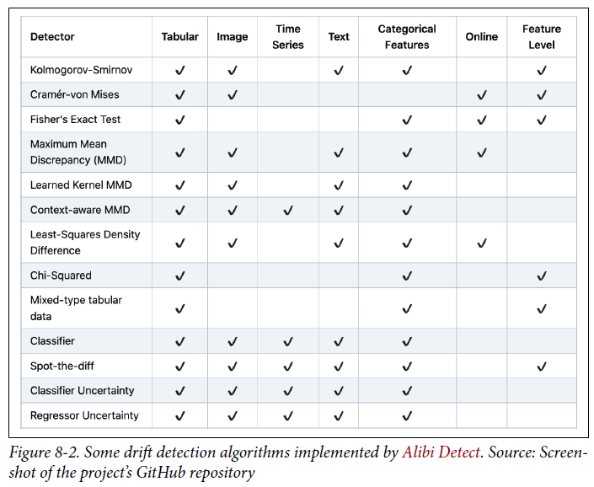

* **Because two-sample tests often work better on low-dimensional data than on high-dimensional data, it’s highly recommended that you reduce the dimensionality of your data before performing a two-sample test on it**

##### Time scale windows for detecting shifts

* **Not all types of shifts are equal** **(some are harder to detect than others)**
* **Shifts can happen at different rates, and abrupt changes are easier to detect than slow, gradual changes**
* **Shifts can also happen across 2 dimensions**: **spatial** or **temporal**.
* **Spatial shifts** = **shifts that happen across access points** (such as your application gets a new group of users or your application is now served on a different type of device)
* **Temporal shifts** **= shifts that happen over time**
* **To detect temporal shifts, a common approach is to treat input data to ML applications as time-series data**
* With temporal shifts, the **time scale window of the data we look at affects the shifts we can detect**
* If your data has a weekly cycle, then a time scale of less than a week won’t detect the cycle
* Consider the data below

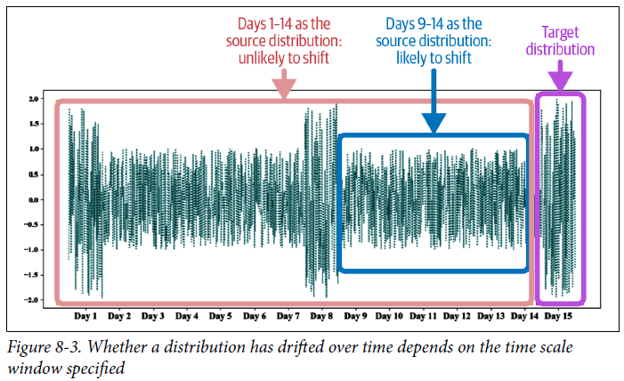

* If we use data from day 9 to 14 as the source distribution, day 15 looks like a shift
* *However, if we use data from day 1 to day 14 as the source distribution, then all data points from day 15 are likely being generated by that same distribution*
* As illustrated by this example, **detecting temporal shifts is hard when shifts are confounded by seasonal variation**
* When computing running statistics over time, it’s important to differentiate between **cumulative** and **sliding statistics**
* **Sliding statistics** are **computed within a single time scale window** (e.g., an hour)
* **Cumulative statistics** are **continually updated with more data**
* This means, **for the beginning of each time scale window, the sliding accuracy is reset, whereas the cumulative sliding accuracy is not**
* Because **cumulative statistics contain information from previous time windows, they might obscure what happens in a specific time window**
* Below shows an example of how cumulative accuracy can hide the sudden dip in accuracy between hours 16 and 18.

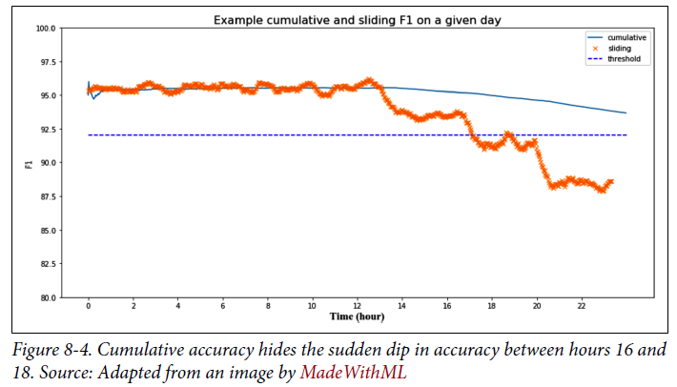

* **Working with data in the temporal space makes things so much more complicated, requiring knowledge of time-series analysis techniques such as time-series decompositions and more**
* If interested in time-series decomposition, Lyft engineering has a great case study on how they decompose their time-series data to deal with the seasonality of the market.
* <https://eng.lyft.com/how-to-deal-with-the-seasonality-of-a-market-584cc94d6b75>
* **As of today, many companies use the distribution of the training data as the base distribution and monitor the production data distribution at a certain granularity level, such as hourly and daily**
* The **shorter your time scale window, the faster you’ll be able to detect changes in your data distribution**
* However, **too short a time scale window can lead to false alarms of shifts**, like the example above
* **Some platforms, especially those dealing with real-time data analytics such as monitoring, provide a merge operation that allows merging statistics from shorter time scale windows to create statistics for larger time scale windows**
* Ex: You can compute the data statistics you care about hourly, then merge these hourly statistics chunks into daily views
* **More advanced monitoring platforms even attempt a root cause analysis (RCA) feature** that **automatically analyzes statistics across various time window sizes to detect exactly the time window where a change in data happened**

#### Addressing Data Distribution Shifts

* **How companies address data shifts depends on how sophisticated their ML infrastructure setups are**
* At one end of the spectrum, we have **companies that have just started with ML and are still working on getting ML models into production**, so they **might not have gotten to the point where data shifts are catastrophic to them**
* However, at some point in the future (maybe 3 months, maybe 6), they **might realize that their initial deployed models have degraded to the point that they do more harm than good**
* They **will then need to adapt their models to the shifted distributions or to replace them with other solutions**
* At the same time, **many companies assume that data shifts are inevitable**, so they **periodically retrain their models** (once a month, a week, or a day) **regardless of the extent of the shift**
* **How to determine the optimal frequency to retrain your models is an important decision that many companies still determine based on gut feelings instead of experimental data**
* This is also because smaller companies don’t have enough data on their models
* **When you don’t have a lot of data, it’s better to have a time-based regimen than to overfit your regime to insufficient data**
* To **make a model work with a new distribution in production**, there are **3 main approaches**:
* **1) Train models using massive datasets**
* Currently dominates research
* The **hope here** is that **if the training dataset is large enough, the model will be able to learn such a comprehensive distribution that whatever data points the model will encounter in production will likely come from this distribution**
* **2) Adapt a trained model to a target distribution *without requiring new labels***
* Less popular in research
* Zhang et al. (2013) used causal interpretations together with kernel embedding of conditional and marginal distributions to correct models’ predictions for both covariate shifts and label shifts without using labels from the target distribution
* Similarly, Zhao et al. (2020) proposed **domain-invariant representation learning**: **an unsupervised domain adaptation technique that can learn data representations invariant to changing distributions**
* However, **this area of research is heavily underexplored and hasn’t found wide adoption in industry**
* **3) Retrain your model using the labeled data from the target distribution**
* **What is usually done in the industry today**
* However, **retraining your model is not so straightforward**
* It can mean **retraining your model from scratch on both the old and new data** *or* **continuing training the *existing* model on new data** (also called **fine-tuning**)
* **If you want to retrain your model, there are 2 questions**:
* **1) Whether to train your model from scratch** (**stateless retraining**) or **continue training it from the last checkpoint (stateful training)**
* **2) What data to use:** data from the last 24 hours, last week, last 6 months, or from the point when data has started to drift
* **Might need to run experiments to figure out which retraining strategy works best for *you***
* Some monitoring vendors claim that their solutions are able to detect not only *when* your model should be retrained, but also *what data* to retrain on
* *Difficult to verify the validity of these claims*
* We use **“retraining” to refer to both training from scratch and fine-tuning**
* Readers familiar with data shift literature might often see data shifts mentioned along with **domain adaptation** and **transfer learning**
* If you consider a distribution to be a “domain”, then the question of how to adapt your model to new distributions is similar to the question of how to adapt your model to different domains
* Similarly, if you consider learning a joint distribution P(X, Y) as a task, then adapting a model trained on one joint distribution for another joint distribution can be framed as a form of transfer learning = the family of methods where a model developed for a task is reused as the starting point for a model on a second task
* The difference is that **with transfer learning, you don’t retrain the base model from scratch for the second task**
* However, **to adapt your model to a new distribution, you might need to retrain your model from scratch**
* **Addressing data distribution shifts doesn’t have to start after the shifts have happened**
* It’s **possible to design your system to make it more robust to shifts**
* **A** **system uses multiple features, and different features shift at different rates**
* Consider building a model to predict whether a user will download an app
* You might be tempted to use that app’s ranking in the app store as a feature since higher-ranking apps tend to be downloaded more
* However, app ranking changes very quickly
* You might want to instead bucket each app’s ranking into general categories such as top 10, between 11 and 100, between 101 and 1,000, between 1,001 and 10,000, and so on
* At the same time, an app’s categories might change a lot less frequently, but they might have less power to predict whether a user will download that app
* **When choosing features for your models, you might want to consider the trade-off between the performance and the stability of a feature**
* **A feature might be really good for accuracy but deteriorate quickly, forcing you to train your model more often**
* You **might also want to design your system to make it easier for it to adapt to shifts**
* Ex: Housing prices might change a lot faster in major cities like San Francisco than in rural Arizona, so a housing price prediction model serving rural Arizona might need to be updated less frequently than a model serving SF
* If you use the *same* model to serve both markets, you’ll have to use data from *both* markets to update your model at the rate demanded by SF
* However, if you use a *separate* model for each, you can update each only when necessary
* **Again, not *all* performance degradation of models in production requires ML solutions**
* **Many ML failures today are still caused by human errors**
* If your model failure is caused by human errors, you’d **first need to find *those* errors to fix them**
* **Detecting a data shift is hard, but determining what causes a shift can be even harder**

### Monitoring and Observability

* As the industry realized that many things can go wrong with an ML system, many companies started investing in monitoring and observability for their ML systems in production
* **Monitoring and observability are sometimes used interchangeably, but they are different**.
* **Monitoring** refers **to the act of tracking, measuring, and logging different metrics that can help us determine when something goes wrong**
* **Observability** means **setting up our system in a way that gives us visibility into our system to help us investigate what went wrong**
* The process of setting up our system in this way is also called “**instrumentation**”
* Examples of instrumentation are: adding timers to functions, counting NaNs in features, tracking how inputs are transformed through systems, logging unusual events such as unusually long inputs, etc.
* **Observability is part of monitoring**
* **Without some level of observability, monitoring is impossible**
* **Monitoring is all about metrics**
* Because ML systems are software systems, **the first class of metrics you’d need to monitor are the operational metrics**, **metrics designed to convey the health of your systems**
* They are generally divided into **3 levels**: **the network the system is run on, the machine the system is run on, and the application that the system runs**
* Examples of these metrics are latency; throughput; the number of prediction requests your model receives in the last minute, hour, day; the percentage of requests that return with a 2xx code; CPU/GPU utilization; memory utilization; etc.
* **No matter how good an ML model is, if the system is down, you’re not going to benefit from it**
* Ex: **1 of the most important characteristics of a software system in production is** **availability (how often the system is available to offer reasonable performance to users**)
* This characteristic is **measured by** **uptime**, the **percentage of time a system is up**
* The **conditions to determine whether a system is up are defined in the service level objectives (SLOs) or service level agreements (SLAs)**
* Ex: An SLA may specify that the service is considered to be “up” if it has a median latency of less than 200ms and a 99th percentile under 2s
* A service provider might offer an SLA that specifies their uptime guarantee, such as 99.99% of the time, and if this guarantee is not met, they’ll give their customers back money
* Ex: As of October 2021, AWS EC2 service offers a monthly uptime percentage of at least 99.99% (four nines), and if the monthly uptime percentage is lower than that, they’ll give you back a service credit toward future EC2 payments
* A 99.99% monthly uptime means the service is only allowed to be down a little over 4 minutes a month, and 99.999% means only 26 seconds a month
* **However, for ML systems, the system health extends beyond the system uptime**
* **If your ML system is up but its predictions are garbage, users aren’t going to be happy**
* Another class of **metrics** **you’d want to monitor are** **ML-specific metrics that tell you the health of your ML models**

#### ML-Specific Metrics

* Within **ML-specific metrics**, there are generally **4 artifacts to monitor**: **a model’s accuracy-related metrics, predictions, features, and raw inputs**
* These artifacts generated at 4 different stages of an ML system pipeline, as shown below

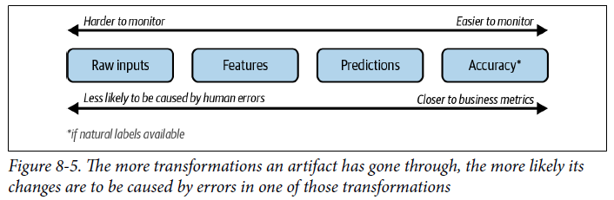

* **The deeper into the pipeline an artifact is, the more transformations it has gone through, which makes a change in that artifact more likely to be caused by errors in one of those transformations**
* **However, the more transformations an artifact has gone through, the more structured it’s become + the closer it is to metrics you actually care about, which makes it *easier to monitor***

##### Monitoring accuracy-related metrics

* **If your system receives any type of user feedback for the predictions it makes** (click, hide, purchase, upvote, downvote, favorite, bookmark, share, etc.) **you should definitely log and track it**
* **Some feedback can be used to infer natural labels, which can then be used to calculate your model’s accuracy-related metrics** = **the most direct metrics to help you decide whether a model’s performance has degraded**
* Even if the feedback *can’t* be used to infer natural labels directly, it **can be used to detect changes in your ML model’s performance**
* Ex: When building a system to recommend to users what videos to watch next on YouTube, you want to track not only whether users click on a recommended video (CTR), but *also* the duration of time users spend on that video and whether they complete watching it (completion rate)
* If, over time, CTR remains the same but completion rate drops, it might mean that your recommender system is getting worse
* *Be careful when using the completion rate as a metric to optimize for, as it might bias your recommender system toward short videos*
* **It’s also possible to engineer your system so that you can *collect* users’ feedback**
* Ex: Google Translate has the option for users to upvote or downvote a translation
* If the number of downvotes the system receives suddenly goes up, there might be issues
* Downvotes can also be used to guide the labeling process, such as getting human experts to generate new translations for samples with downvotes, to train the next iteration of their models

##### Monitoring predictions

* **Prediction is the most common artifact to monitor**
* If it’s a **regression task, each prediction is a continuous value** (e.g., predicted price of a house), and for a **classification task**, **each prediction is a discrete value corresponding to the predicted category**
* **Because each prediction is usually just a number (low dimension), predictions are easy to visualize, + their summary statistics are straightforward to compute and interpret**
* You **can monitor predictions for distribution shifts**
* **Because predictions are low dimensional, it’s also easier to compute two-sample tests to detect whether the prediction distribution has shifted**
* ***Prediction distribution shifts are also a proxy for input distribution shifts***
* **Assuming the function that maps from input to output doesn’t change (the weights and biases of your model haven’t changed), then a change in the prediction distribution generally indicates a change in the underlying input distribution**
* You **can also monitor predictions for anything odd happening**, such as predicting an unusual number of False in a row
* **There could be a long delay between predictions and ground truth labels**
* **Changes in accuracy-related metrics might not become obvious for days or weeks, whereas a model predicting all False for 10 minutes can be detected *immediately***

##### Monitoring features

* **ML monitoring solutions in the industry focus on tracking changes in *features***, **both the features that a model uses as inputs + the intermediate transformations from raw inputs into final features**
* **Feature monitoring is appealing because compared to raw input data, features are well structured following a predefined schema**
* **The** first step of feature monitoring is **feature validation: ensuring that your features follow an expected schema**
* The **expected schemas are usually generated from training data or from common sense**
* **If these expectations are violated in production, there might be a shift in the underlying distribution**
* Here are some of the things you can check for a given feature:
* If the min, max, or median values of a feature are within an acceptable range
* If the values of a feature satisfy a REGEX format
* If all the values of a feature belong to a predefined set
* If the values of a feature are always greater than the values of another feature
* Because features are often organized into tables (each column representing a feature, each row a data sample) **feature validation is also known as table testing or table validation**
* Some call them **unit tests for data**
* There are many open-source libraries that help you do basic feature validation, the 2 most common being Great Expectations and Deequ, which is by AWS
* Below shows some built-in feature validation functions by Great Expectations and an example of how to use them

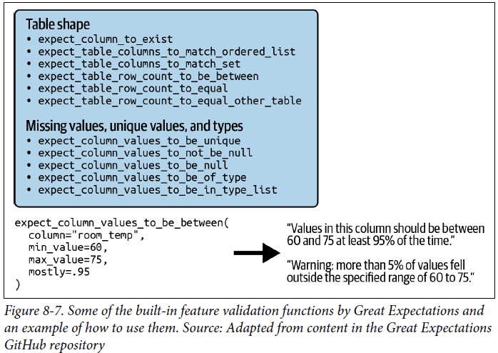

* Beyond basic feature validation, you **can also use two-sample tests to detect whether the underlying distribution of a feature or a set of features has shifted**
* **Since a feature or a set of features can be high-dimensional, you might need to reduce their dimension before performing the test on them, which can make the test less effective**.
* There are **4 major concerns when doing feature monitoring**:
* **1) A company might have hundreds of models in production, and each model uses hundreds, if not thousands, of features**
* Even something as simple as computing summary statistics for all these features every hour can be **expensive, not only in terms of compute required but also memory used**
* **Tracking (i.e., constantly computing) too many metrics can also slow down your system and increase both the latency that your users experience and the time it takes for you to detect anomalies in your system**
* **2) While tracking features is useful for debugging purposes, it’s not very useful for detecting model performance degradation**
* In theory, a small distribution shift can cause catastrophic failure, but **in practice, an individual feature’s minor changes might not harm the model’s performance at all**
* **Feature distributions shift all the time, and most of these changes are benign**
* If you want to be **alerted whenever a feature seems to have drifted**, you might soon be **overwhelmed by alerts and realize that most of these alerts are false positives**, which can cause a phenomenon called “**alert fatigue**” where the **monitoring team stops paying attention to the alerts because they are so frequent**
* The **problem of feature monitoring becomes the problem of trying to decide which feature shifts are critical and which are not**
* **3) Feature extraction is often done in multiple steps (such as filling missing values and standardization), using multiple libraries (such as pandas, Spark), on multiple services (such as BigQuery or Snowflake)**
* You might have an RDB as an input to the feature extraction process and a NumPy array as the output
* **Even if you detect a harmful change in a feature, it might be impossible to detect whether this change is caused by a change in the underlying input distribution or whether it’s caused by an error in one of the multiple processing steps**
* **4) The schema that your features follow can change over time.**
* If you don’t have a way to **version your schemas** and **map each of your features to its expected schema**, the **cause of the reported alert might be due to the mismatched schema rather than a change in the data**
* **These concerns are not to dismiss the importance of feature monitoring, as changes in the feature space are a useful source of signals to understand the health of your ML systems**
* Hopefully, thinking about these concerns can help you choose a feature monitoring solution that works for you

##### Monitoring raw inputs

* As discussed, **a change in the features might be caused by problems in processing steps and not by changes in data**
* What if we monitor the raw inputs *before* they are processed?
* **The raw input data might not be easier to monitor, as it can come from multiple sources in different formats, following multiple structures**
* **The way many ML workflows are set up today also makes it impossible for MLE’s to get *direct* access to raw input data**, as the raw input data is **often managed by a data platform team who processes and moves the data to a location like a data warehouse**, and the **MLE’s can only query for data from that data warehouse where the data is *already partially processed***
* Therefore, **monitoring raw inputs is often a responsibility of the data platform team, not the data science or ML team**

#### Monitoring Toolbox

* **Measuring, tracking, and interpreting metrics for complex systems is a non-trivial task**, and engineers rely on a set of **tools** to help them do so
* It’s common for the industry to herald **metrics**, **logs**, and **traces** as the **3 pillars of monitoring.**
* However, their differentiations are murky
* They seem to be generated from the perspective of people who develop monitoring systems: **traces are a form of logs and metrics can be computed from logs**
* We will focus on the **set of tools from the perspective of users of the monitoring systems: logs**, **dashboards**, and **alerts**

##### Logs

* Traditional software systems rely on **logs** **to record events produced at runtime**
* An **event** is **anything that can be of interest to the system developers, either at the time the event happens or later for debugging and analysis purposes**
* Examples of events: when a container starts, the amount of memory it takes, when a function is called, when that function finishes running, the other functions that this function calls, the input and output of that function, etc.
* Also, don’t forget to log crashes, stack traces, error codes, and more
* Ian Malpass at Etsy: “If it moves, we track it”
* They **also track things that haven’t changed yet, in case they’ll move later**
* The **number of logs can grow very large very quickly**
* When **something goes wrong**, you’ll **need to query your logs for the sequence of events that caused it, a process that can feel like searching for a needle in a haystack**
* In the early days of software deployment, an application might be one single service.
* When something happened, you knew where that happened
* But today, **a system might consist of many different components: containers, schedulers, microservices, polyglot persistence, mesh routing, ephemeral auto-scaling instances, serverless Lambda functions, etc.**
* A request may do 20–30 hops from when it’s sent until when a response is received
* The **hard part might not be in detecting *when* something happened, but *where* the problem was**
* **When we log an event, we want to make it as easy as possible for us to find it later**.
* **This practice with microservice architecture is called distributed tracing**
* We want to **give each process a unique ID so that, when something goes wrong, the error message will (hopefully) contain that ID**
* This **allows us to search for the log messages associated with it**
* We **also want to record with each event all the metadata necessary**: time when it happens, service where it happens, function that is called, user associated with the process, if any, etc.
* Because logs have grown so large and so difficult to manage, there have been **many tools developed to help companies manage and analyze logs**
* The log management market is estimated to be worth $2.3B in 2021, and it’s expected to grow to $4.1B by 2026
* **Analyzing billions of logged events *manually* is futile, so many companies use ML to analyze logs**
* Ex: Use case of ML in log analysis is **anomaly detection: to detect abnormal events in your system**
* A more sophisticated model might even classify each event in terms of its priorities such as usual, abnormal, exception, error, and fatal
* Another use case of ML in log analysis: **when a service fails, it might be helpful to know the probability of *related* services being affected**
* This could be especially useful when the system is under cyberattack
* **Many companies process logs in batch processes**
* In this scenario, you **collect a large number of logs**, then **periodically query over them looking for specific events using SQL or process them using a batch process like in a Spark or Hadoop or Hive cluster**
* This **makes the processing of logs efficient because you can leverage distributed and MapReduce processes to increase your processing throughput**
* However, **because you process logs periodically, you can only discover problems periodically**
* **To discover anomalies in your logs as soon as they happen, you want to process your events as soon as they are logged**
* **This makes log processing a stream processing problem**
* Can use **real-time transport such as Kafka or Amazon Kinesis** to transport events as they are logged
* To search for events with specific characteristics in real time, you can leverage **a streaming SQL engine like KSQL or Flink SQL**

##### Dashboards

* A picture is worth a thousand words, and **a series of numbers might mean nothing to you, but visualizing them on a graph might reveal the relationships among these numbers**
* **Dashboards to visualize metrics are critical for monitoring**
* Another use of dashboards is to **make monitoring accessible to non-engineers**
* Monitoring isn’t just for the developers of a system, but also for non-engineering stakeholders, including PM’s and business developers.
* **Even though graphs can help a lot with understanding metrics, they aren’t sufficient on their** own.
* You **still need experience and statistical knowledge**
* Consider the two graphs below

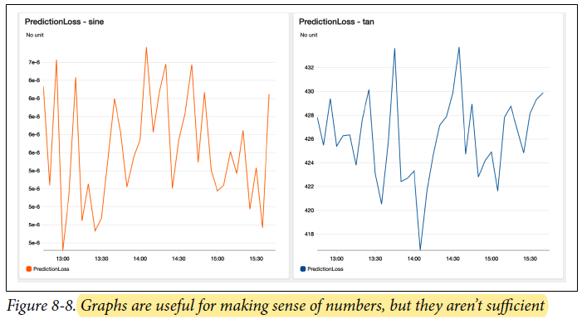

* The only thing that is obvious from these graphs is that loss fluctuates a lot
* If there’s a distribution shift in any of these two graphs, we can’t tell
* **It’s easier to plot a graph of a wiggling line than to understand what the wiggly line means**
* **Excessive metrics on a dashboard can also be counterproductive, a phenomenon known as** **dashboard rot**
* It’s important to **pick the right metrics or abstract out lower-level metrics to compute higher-level signals that make better sense for your specific tasks**

##### Alerts

* When a monitoring system detects something suspicious, it’s necessary to alert the right people
* **An alert consists of the following 3 components:**
* **1) An alert policy**
* This **describes the condition for an alert**
* Might want to create alerts if a metric breaches a threshold, maybe over a certain duration
* Ex: might want to be notified when a model’s accuracy is under 90%, or that the HTTP response latency is higher than a second for at least 10 minutes.
* **2) Notification channels**
* These **describe *who* is to be notified when the condition is met**
* The alerts will be shown in the monitoring service you employ, such as Amazon CloudWatch or GCP Cloud Monitoring, but you **also want to reach responsible people when they’re not on these monitoring services**
* Ex: Might configure alerts to be sent to an company’s group email address such as mlops-monitoring@[company email domain], or to post to a Slack channel such as #mlops-monitoring or to PagerDuty
* **3) A description of the alert**
* This **helps the alerted person understand what’s going on**
* The description **should be as detailed as possible**, such as:
* ## Recommender model accuracy below 90%

${timestamp}: This alert originated from the service ${service-name}

* ***Depending on the audience* of the alert, it’s often necessary to make the alert *actionable* by providing mitigation instructions or a runbook (a compilation of routine procedures and operations that might help with handling the alert)**
* **Alert fatigue is a real phenomenon** that can be demoralizing
* Nobody likes to be awakened in the middle of the night for something outside of their responsibilities
* **It’s also dangerous, as being exposed to trivial alerts can desensitize people to critical alerts**
* It’s **important to set meaningful conditions so that only critical alerts are sent out**

#### Observability

* Since the mid-2010s, the industry has started embracing the term “**observability**” instead of “monitoring”
* **Monitoring makes no assumption about the relationship between the internal state of a system and its outputs**
* You **monitor the external outputs of the system to figure out *when* something goes wrong inside the system**
* But there’s **no guarantee that the external outputs will help you figure out *what* goes wrong**
* In the early days of software deployment, software systems were simple enough that monitoring external outputs was sufficient for software maintenance
* A system used to consist of only a few components, and a team used to have control over the entire codebase
* If something went wrong, it was possible to make changes to the system to test and figure out what went wrong
* However, **software systems have grown significantly more complex over the last decade**
* Today, a software system consists of **many components, many of which are services run by other companies** (cloud native services) which means **a team doesn’t even have control of the inside of all the components of their system**
* When something goes wrong, a team can no longer just break apart their system to find out
* A **team has to rely on *external* outputs of their system to figure out what’s going on *internally***
* **Observability** is a term used to address this challenge
* A **concept drawn from** **control theory**, + **refers to bringing “better visibility into understanding the complex behavior of software using [outputs] collected from the system at run time”**

##### Telemetry

* **A system’s outputs collected at runtime are also called telemetry**, another term that has emerged in the software monitoring industry over the last decade, which basically means “**remote measures**”
* In the monitoring context, it **refers to logs and metrics collected from remote components such as cloud services or applications run on customer devices**
* In other words, **observability makes an assumption stronger than traditional monitoring: that the internal states of a system can be inferred from knowledge of its external outputs**
* **Internal states** **can be current states**, such as “GPU utilization right now,” **and historical states**, such as “average GPU utilization over the last day.”
* **When something goes wrong with an observable system, we should be able to figure out what went wrong by looking at system logs and metrics without having to ship new code to the system**.
* **Observability is about instrumenting your system in a way to ensure that sufficient information about a system’s runtime is collected and analyzed**
* ***Monitoring centers around metrics, and metrics are usually aggregated***
* ***Observability* allows more fine-grain metrics, so that you can know not only when a model’s performance degrades but also for what types of inputs or what subgroups of users or over what period of time the model degrades**
* Ex: You should be able to query your logs for the answers to questions like: “show me all the users for which model A returned wrong predictions over the last hour, grouped by zip codes” or “show me the outliers requests in the last 10 minutes” or “show me all the intermediate outputs of this input through the system.”
* **To achieve this, you need to have logged your system’s outputs using tags and other identifying keywords to allow these outputs to later be sliced and diced along different dimensions of your data**
* **In ML, observability encompasses interpretability**, which **helps us understand how an ML model works**, and **observability helps us understand how the *entire ML system*, which *includes the ML model*, works**
* Ex: When a model’s performance degrades over the last hour, being able to interpret which feature contributes the most to all the wrong predictions made over the last hour will help with figuring out what went wrong with the system and how to fix it
* **Even though monitoring is a powerful concept, it’s inherently *passive***
* You **wait for a shift to happen to detect it**, and **monitoring helps unearth the problem without correcting it**
* **Continual learning** is **a paradigm that can *actively* help you update models to address shifts**

### Summary

* **The importance of understanding how and why ML systems fail in production, the literature surrounding it is limited**
* We usually think of research preceding production, but this is an area of ML where **research is still trying to catch up with production**
* To understand failures of ML systems, we differentiated between **2 types of failures: software systems failures (failures that also happen to non-ML systems) and ML-specific failures**
* Even though the **majority of ML failures today are non-ML-specific, as tooling and infrastructure around MLOps matures, this might change**
* We discussed **3 major causes of ML-specific failures**: **production data differing from training data**, **edge cases**, and **degenerate feedback loops**
* The first 2 causes are related to data, whereas the last cause is related to system design because it happens when the system’s outputs influence the same system’s input
* We zeroed into one failure that has gathered much attention in recent years: **data distribution shifts** + looked into 3 types of shifts: **covariate shift**, **label shift**, and **concept drift**
* Even though studying distribution shifts is a growing subfield of ML research, the research community hasn’t yet found a standard narrative
* Different papers call the same phenomena by different names
* Many studies are still based on the assumption that we know in advance how the distribution will shift or have the labels for the data from both the source and target distributions
* However, in reality, we don’t know what the future data will be like, and obtaining labels for new data might be costly, slow, or just infeasible
* **To be able to detect shifts, we need to monitor our deployed systems**
* Monitoring is an important set of practices for any SWE system in production, not just ML, and it’s an area of ML where we should learn as much as we can from the DevOps world
* **Monitoring is all about metrics**: **operational metrics** (metrics that should be monitored with any software systems such as latency, throughput, and CPU utilization) + **ML-specific metrics**
* Monitoring can be applied to accuracy-related metrics, predictions, features, and/or raw inputs
* **Monitoring is hard because even if it’s cheap to compute metrics, understanding metrics isn’t straightforward**
* It’s easy to build dashboards to show graphs, but it’s much **more difficult to understand what a graph means, whether it shows signs of drift, and, if there’s drift, whether it’s caused by an underlying data distribution change or by errors in the pipeline**
* An **understanding of statistics** might be required to make sense of the numbers and graphs.
* Detecting model performance’s degradation in production is the first step
* The next step is how to **adapt our systems to changing environments**