# Designing Machine Learning Systems - Chip Huyen

## Chapter 9 – Continual Learning and Test in Production

* There are various ways an ML system can fail in production, and one especially thorny problem that has generated much discussion among both researchers and practitioners is **data distribution shifts**
* There are also multiple monitoring techniques and tools to detect data distribution shifts
* ***how do we adapt our models to data distribution shifts?* By *continually* updating our ML models**
* There’s **continual learning** and **its challenges** (it’s **largely an infrastructural problem**, and there’s a 4-stage plan to make continual learning a reality
* After you’ve set up your infrastructure to allow you to update your models as frequently as you want, you might want to consider the question **“How often *should* I retrain my models?”**
* If a model is retrained to adapt to the changing environment, evaluating it on a stationary test set isn’t enough, which leads to seemingly terrifying but necessary concept: **test in production = a process as a way to test your systems with live data in production to ensure that your updated model indeed works without catastrophic consequences.**
* **Test in production is complementary to monitoring**
* If **monitoring** means **passively** keeping track of outputs of whatever model is being used, **test in production** means **proactively** choosing *which model* to produce outputs so we can evaluate it
* The **goal of both monitoring and test in production is to understand a model’s performance and figure out when to update it**
* The **goal of continual learning is to safely and efficiently automate the update**
* **All of these concepts allow us to design an ML system that is maintainable and adaptable to changing environments**

### Continual Learning

* When hearing “continual learning,” many people think of the training paradigm where a model updates itself with *every incoming sample* in production
* **Very few companies actually do that for 2 reasons**
* **1) If your model is a NN, learning with *every* incoming sample makes it susceptible to catastrophic forgetting** = the **tendency of a NN to completely and abruptly forget previously-learned information upon learning new information**
* **2)** **It can make training more expensive**
* **Most hardware backends today were designed for batch processing**, so **processing only one sample at a time causes a huge waste of compute power + is unable to exploit data parallelism**
* **Companies that employ continual learning in production update their models in micro-batches**
* Ex: Might update the existing model after every 512 or 1,024 examples
* **The optimal number of examples in each micro-batch is task dependent**
* **The updated model shouldn’t be deployed until it’s been evaluated**
* This means you **shouldn’t make changes to the existing model *directly***
* Instead, **create a replica of the existing model and update this replica on new data, and only replace the existing model with the updated replica if the updated replica proves to be better**
* The **existing model is called the champion model**, and the **updated replica is called the challenger**

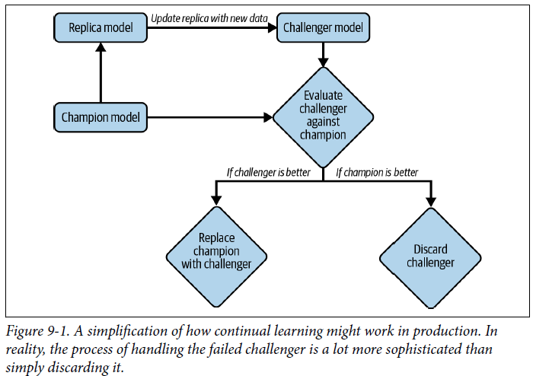

* The above is an oversimplification of the process for the sake of understanding
* In reality, **a company might have *multiple* challengers at the same time**, and **handling the failed challenger is a lot more sophisticated than simply discarding it**
* Still, the term “continual learning” makes people imagine updating models very frequently, such as every 5 or 10 minutes
* Many **people argue that most companies don’t need to update their models that frequently because of 2 reasons**
* 1) They **don’t have enough traffic** (i.e., **new** **data**) for that retraining schedule to make sense
* 2) Their **models don’t decay that fast**
* ***If changing the retraining schedule from a week to a day gives no return and causes more overhead, there’s no need to do it***

#### Stateless vs. Stateful Training

* However, **continual learning *isn’t* about the retraining *frequency*, but rather *the manner* in which the model is retrained**
* **Most companies do stateless retraining = the model is trained from scratch each time**
* **Continual learning means *also* allowing stateful training** = the **model continues training on new data**
* It’s “stateful training” instead of “stateful *re*-training” because there’s no *re***-**training here, the model continues training from the last state)
* Stateful training is also known as **fine-tuning** or **incremental learning**
* The difference between stateless retraining and stateful training is visualized below

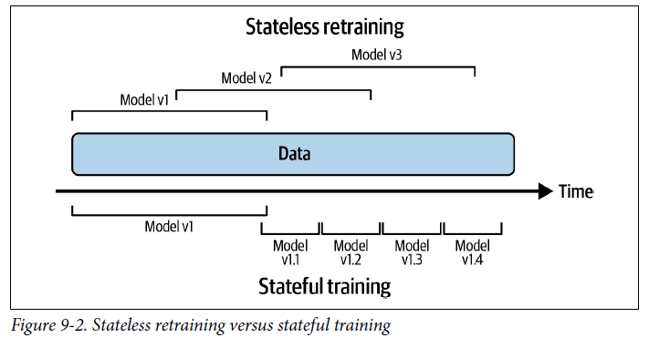

* **Stateful training allows you to update your model with less data**
* Training a model **from scratch tends to require a lot more data than fine-tuning the same model**
* Ex: If you retrain your model from scratch, you might need to use all data from the last 3 months
* However, if you fine-tune your model from yesterday’s checkpoint, you only need to use data from the last day
* Grubhub found that stateful training allows their models to converge faster + require much less compute power
* Going from daily stateless retraining to daily stateful training reduced training compute costs 45X and increased their purchase-through rate by 20%
* One **beautiful property that is often overlooked** is that **with stateful training, it *might* be possible to avoid storing data altogether**
* In traditional ***stateless* retraining**, a data **sample might be reused during multiple training iterations of a model**, which means that data needs to be stored
* *This isn’t always possible, especially for data with strict privacy requirements*
* In the **stateful training** paradigm**, each model update is trained using only the *fresh* data,** so a data **sample is used only once for training**, as shown in the prior graph
* This means it’s **possible to train your model without having to store data in *permanent* storage, which helps eliminate many concerns about data privacy**
* However, **this is overlooked because today’s let’s-keep-track-of-everything practice still makes many companies reluctant to throw away data**
* **Stateful training *doesn’t* mean *NO* training from scratch**
* Companies that have most successfully used stateful training **also occasionally train their model from scratch on a large amount of data to calibrate it**
* Alternatively, they might also **train the model from scratch in parallel with stateful training and then combine both updated models using techniques such as parameter server**
* Once your **infrastructure is set up to allow both stateless retraining *and* stateful training, training frequency is just a knob to twist**
* You can update your models **once an hour, a day, or whenever a distribution shift is detected**.
* **Continual learning is about setting up infrastructure in a way that allows you, a data scientist or MLE, to update models whenever it is needed, whether from scratch or fine-tuning, and to deploy this update quickly**
* You might wonder: stateful training sounds cool, but **how does this work if I want to add a new feature or another layer to my model?**
* To answer this, we must differentiate **2 types of model updates**:
* **1) Model iteration** = A **new feature is added to an existing model architecture** or the **model architecture is changed**
* **2) Data iteration** = **model architecture and features remain the *same***, but you **refresh this model with new data**
* As of today, **stateful training is mostly applied for *data* iteration, as changing a model architecture or adding a new feature still requires training the resulting model from scratch**
* There *has* been research showing it might be possible to bypass training from scratch for model iteration via techniques such as **knowledge transfer** (Google, 2015) + **model surgery** (OpenAI, 2019)
* OpenAI: “Surgery transfers trained weights from 1 network to another after a selection process to determine which sections of the model are unchanged and which must be re-initialized”
* Several large research labs have experimented with this; however, **there are no clear results in the industry**

##### Terminology Ambiguity

* We use the term “**continual learning**” instead of “online learning” because “online learning” makes people usually think of online education
* Also, some people use “online learning” to refer to the specific setting where a model learns from each incoming new sample
* *In* ***this setting*,** **continual learning is a *generalization* of online learning.**
* We also use the term “continual learning” instead of “continuous learning”
* **Continuous learning** = a regime in which a model continuously learns w/ each incoming sample
* Whereas with **continual learning**, **learning is done in a series of batches or micro-batches**
* ***Continuous* learning is sometimes used to refer to continuous delivery of ML**, which is **closely related to continual learning as both help companies to speed up the iteration cycle of ML models**
* *However*, the *difference* is that “**continuous learning**,” when used in this sense, is **from the *DevOps perspective* about setting up the pipeline for continuous delivery**
* Whereas “**continual learning**” is from the **ML perspective**.

#### Why Continual Learning?

* **Continual learning is about setting up infrastructure so that you can update your models and deploy these changes as fast as you want**
* ***But why would you need the ability to update your models as fast as you want?***
* **1st use case of continual learning = to combat data distribution shifts, especially when the shifts happen suddenly**
* Ex: You’re building a model to determine prices for a ride-sharing service
* Historically, ride demand on a Thursday evening in a particular neighborhood is slow, so the model predicts low ride prices, which makes it less appealing for drivers to get on the road
* However, on *this* Thursday evening, there’s a big event in the neighborhood, and suddenly ride demand surges
* *If your model can’t respond to this change quickly enough by increasing its price prediction and mobilizing more drivers to that neighborhood, riders will have to wait a long time for a ride, which causes negative user experience*
* They might even switch to a competitor, which causes you to lose revenue.
* **Another use case of continual learning** = **to adapt to rare events**
* Ex: You work for an ecommerce website
* Black Friday is an important shopping event that happens only once a year
* There’s no way you will be able to gather enough historical data for your model to be able to make accurate predictions on how your customers will behave throughout Black Friday this year
* **To improve performance, your model should learn throughout the day with *fresh* data**
* In 2019, Alibaba acquired Data Artisans, the team leading development of the stream processing framework Apache Flink, for $103 million so that the team could help them adapt Flink for ML use cases
* Their flagship use case was making better recommendations on Singles Day, a shopping occasion in China similar to Black Friday in the US
* A **huge challenge for ML production today that continual learning can help overcome is the continuous cold start problem**, which arises when **your model has to make predictions for a *new* user *without any historical data***
* Ex: To recommend to a user what movies they might want to watch, a recommender system often needs to know what that user has watched before
* But if that user is new, you won’t have their watch history and will have to generate them something generic (e.g., the most popular movies on your site right now)
* The problem is also equally challenging if you want your model to figure out when to recommend a new movie that no one has watched and given feedback on yet
* ***Continuous* cold start is a generalization of the cold start problem,** as **it can happen not *just* with new users but also with *existing* users**
* Ex: It can happen because an existing user switches from a laptop to a mobile phone, and their behavior on a phone is different from their behavior on a laptop
* It can happen because users are not logged in (most news sites don’t require readers to log in to read)
* It can also happen when a user visits a service so infrequently that whatever historical data the service has about this user is outdated
* Ex: Most people only book hotels and flights a few times a year
* Coveo, a company that provides search engine and recommender systems to ecommerce websites, found that it is common for an ecommerce site to have more than 70% of their shoppers visit their site less than 3 times a year
* **If your model doesn’t adapt quickly enough, it won’t be able to make recommendations relevant to these users until the next time the model is updated**
* By that time, these **users might have already left the service because they don’t find anything relevant to them**
* **If we could make our models adapt to each user *within their visiting session*, the models would be able to make accurate, relevant predictions to users *even on their first visit***
* Ex: TikTok has successfully applied continual learning to adapt their recommender system to each user *within minutes*
* You download the app and, after a few videos, TikTok’s algorithms are able to predict with high accuracy what you want to watch next
* Not everyone should try to build something as addictive as TikTok, but it’s proof that continual learning can unlock powerful predictive potential.
* **“Why continual learning?” should be rephrased as “why *not* continual learning?”**
* **Continual learning is a *superset* of batch learning, as it allows you to do everything traditional batch learning can do, but continual learning also allows you to unlock use cases that batch learning can’t**
* **If continual learning takes the same effort to set up and costs the same to do as batch learning, there’s no reason not to do continual learning**
* There are **still a lot of challenges in setting up continual learning**
* However, **MLOps tooling for continual learning is maturing, which means, one day not too far in the future, it might be as easy to set up continual learning as batch learning**

#### Continual Learning Challenges

* Even though continual learning has many use cases and many companies have applied it with great success, continual learning still has many challenges
* **3 major challenges**: fresh **data access**, **evaluation**, and **algorithms**

##### Fresh data access challenge

* First challenge = the challenge to **get fresh data**
* If you want to update your model every hour, you need new data every hour
* Currently, many companies pull new training data from their data warehouses
* **The speed at which you can pull data from your data warehouses depends on the speed at which this data is deposited *into* your data warehouses**
* The speed can be slow, especially if data comes from multiple sources
* **An alternative is to allow pull data before it’s deposited into data warehouses** (e.g., **directly from real-time transports** such as Kafka and Kinesis that transport data from applications to data warehouses), as shown below

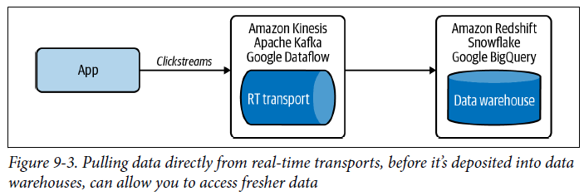

* ***Being able to pull fresh data isn’t enough***
* **If your model needs *labeled* data to update, as most models today do, this data will need to be labeled as well**
* **In many applications, the speed at which a model can be updated is bottlenecked by the speed at which data is labeled**
* **Best candidates for continual learning = tasks where you can get natural labels with *short feedback loops***
* Ex: Dynamic pricing (based on estimated demand + availability), estimating time of arrival, stock price prediction, ads CTR prediction, and recommender systems for online content like tweets, songs, short videos, articles, etc.
* However, these **natural labels are usually not generated as *labels*, but rather as *behavioral activities* that need to be *extracted into labels***
* Ex: You run an ecommerce website, and your application might register that at 10:33 p.m., user A clicks on the product with the ID of 32345
* Your system needs to **look back into the logs to** see if this product ID was ever recommended to this user, and if yes, what query prompted this recommendation
* This is so that your system can match this query to this recommendation and label this recommendation as a good recommendation, as shown below

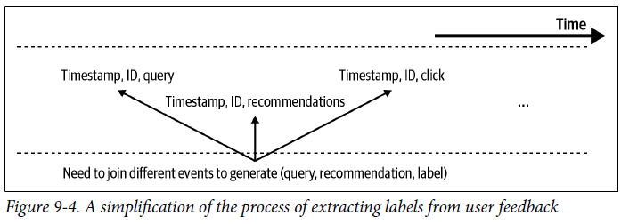

* The **process of looking back into the *logs* to extract labels is called label computation**
* It **can be quite costly if the number of logs is large**
* Label computation **can be done with batch processing** (e.g., waiting for logs to be deposited into data warehouses first before running a batch job to extract all labels from logs at once)
* However, as discussed previously, **this means that we’d need to wait for data to be deposited first, then wait for the next batch job to run**
* A much **faster approach would be to leverage stream processing to extract labels from the real-time transports *directly***
* If your model’s speed iteration is **bottlenecked by labeling speed**, it’s also possible to **speed up the labeling process by leveraging programmatic labeling tools like Snorkel to generate fast labels with minimal human intervention**
* Might also be possible to **leverage crowdsourced labels to quickly annotate fresh data**
* Given that **tooling around streaming is still nascent, architecting an efficient streaming-first infrastructure for accessing fresh data + extracting fast labels from real-time transports can be engineering-intensive and costly**
* **Good news = tooling around streaming is growing fast**
* Confluent (the platform built on top of Kafka) is a $16B company as of Oct. 2021, in late 2020 Snowflake started a team focusing on streaming, and as of Sep. 2021, Materialize has raised $100M to develop a streaming SQL database
* **As tooling around streaming matures, it’ll be much easier and cheaper for companies to develop a streaming-first infrastructure for ML**

##### Evaluation challenge

* **The *biggest* challenge of continual learning *isn’t* in writing a function to continually update a model,** since you can do that by writing a script!
* **The biggest challenge is in making sure that this update is *good enough* to be deployed**
* We’ve discussed how **ML systems make catastrophic failures in production** (millions of minorities being unjustly denied loans, drivers trusting autopilot too much being involved in fatal crashes, etc.)
* The **risks for catastrophic failures amplify with continual learning**
* **1) The more frequently you update your models, the more opportunities there are for updates to fail**
* **2) Continual learning makes your models more susceptible to coordinated manipulation and adversarial attacks**
* Because your models learn online from real-world data, it makes it easier for users to input malicious data to trick models into learning wrong things
* 2016: Microsoft released Tay, a chatbot capable of learning through “casual and playful conversation” on Twitter
* As soon as Tay launched, trolls started tweeting the bot racist and misogynist remarks, and the bot soon began to post inflammatory and offensive tweets, causing Microsoft to shut down the bot 16 hours after its launch
* To avoid similar or worse incidents, it’s **crucial to thoroughly test each of your model updates to ensure its performance and safety before deploying the updates to a wider audience**
* Already discussed **model offline evaluation**, + will later discuss **online evaluation (test in PROD)**
* **When designing the evaluation pipeline for continual learning, keep in mind that evaluation takes time, which can be another bottleneck for model update frequency.**
* Ex: An online payment company has an ML system to detect fraudulent transactions (which consists of multiple ML models.)
* Fraud patterns change quickly, so they’d like to update their system quickly to adapt to the changing patterns
* They can’t deploy the new model before it’s been A/B tested against the current model
* However, due to the **imbalanced nature of the task** (most transactions aren’t fraud), it takes them approximately 2 weeks to see enough fraud transactions to be able to accurately assess which model is better
* **Bandits** can be used as a more data-efficient alternative to A/B testing
* Therefore, they can only update their system every 2 weeks

##### Algorithm challenge

* Compared to the fresh data challenge and the evaluation, **this is a “softer” challenge as it only affects certain algorithms and certain training frequencies**
* To be precise, it **only affects matrix-based and tree-based models that want to be updated very fast** **(e.g., hourly)**
* Consider 2 different models: a NN and a matrix-based model, such as collaborative filtering
* The collaborative filtering model uses a **user-item matrix** and a **dimension reduction technique**
* You can update the NN model with a data batch of any size
* You can even perform the update step with just one data sample
* *However, if you want to update the collaborative filtering model*, you first need to use the *entire* dataset to build the user-item matrix before performing dimensionality reduction on it
* Of course, you can apply dimensionality reduction to your matrix each time you update the matrix with a new data sample, but if your matrix is large, the dimensionality reduction step would be too slow and expensive to perform frequently
* Therefore, this model is less suitable for learning with a partial dataset than the preceding NN model
* It’s **much easier to adapt models like NN’s than matrix-based and tree-based models to the continual learning paradigm**
* However, there ***have* been algorithms to create tree-based models that can learn from incremental amounts of** **data**
* Most notably Hoeffding Tree and its variants Hoeffding Window Tree and Hoeffding Adaptive Tree
* **But their uses aren’t yet widespread.**
* **Not only does the learning algorithm need to work with partial datasets, but the feature extract code has to as well**
* It’s **often necessary to scale features using statistics such as the min, max, median, + variance**
* To compute these statistics for a dataset, you **often need to do a pass over the entire dataset**
* When your model can only see a small subset of data at a time, **in theory, you can compute these statistics for each subset of data**
* However, **this means that these statistics will fluctuate a lot between different subsets**
* Statistics computed from one subset might differ wildly from the next subset, **making it difficult for the model trained on one subset to generalize to the next subset**
* To **keep these statistics stable across different subsets, you might want to compute these statistics *online***
* Instead of using the mean or variance from *all* data at once, you **compute or *approximate* these statistics *incrementally as you see new data***
* Such as the algorithms outlined in “Optimal Quantile Approximation in Streams.”
* <https://arxiv.org/abs/1603.05346>
* Popular frameworks today offer some capacity for computing running statistics (Ex: sklearn’s StandardScaler has a `partial_fit` that allows a feature scaler to be used with running statistics)
* ***But the built-in methods are slow and don’t support a wide range of running statistics***

#### 4 Stages of Continual Learning

* **Continual learning isn’t something that companies start out with as of now**
* The move toward **continual learning happens in 4 stages**

##### Stage 1: Manual, stateless retraining

* In the **beginning**, the **ML team often focuses on developing ML models to solve as many business problems as possible**
* Ex: For an ecommerce website, you might develop 4 models in the following succession:
* 1. A model to detect fraudulent transactions
* 2. A model to recommend relevant products to users
* 3. A model to predict whether a seller is abusing a system
* 4. A model to predict how long it will take to ship an order
* Because your **team is focusing on developing new models, updating existing models takes a backseat**
* You **update an existing model only when** the following **2 conditions are met**:
* **1) The model’s performance has degraded to the point that it’s doing more harm than good**
* **2) Your team has *time* to update it**
* Some of your models are being updated once every 6 months, some once a quarter, and some have been out in the wild for a year and haven’t been updated at all.
* The **process of updating a model is manual and ad hoc at this stage**
* Someone, usually a data engineer, has to query the data warehouse for new data
* Someone *else* cleans this new data, extracts features from it, retrains that model from scratch on both the old + new data, and then exports the updated model into a binary format
* Then someone *else* takes that binary format and deploys the updated model
* Oftentimes, the **code encapsulating data, features, + model logic was changed during retraining but changes failed to be replicated to production, causing bugs that are hard to track down**
* **A vast majority of companies outside tech (e.g., any company that adopted ML < 3 years ago and doesn’t have an ML platform team) are in this stage**

##### Stage 2: Automated retraining

* After a few years, your team has managed to deploy models to solve most of the obvious problems.
* You have anywhere between 5 and 10 models in production
* **Your priority is no longer to develop new models, but to maintain and improve existing models**
* The ad hoc, manual process of updating models from the previous stage has grown into a pain point too big to be ignored
* **Your team decides to write a script to automatically execute all the retraining steps, which is then run periodically using a batch process** such as Spark.
* **Most companies with somewhat mature ML infrastructure are in this stage**
* **Some sophisticated companies run experiments to determine optimal retraining frequency**
* However, **for most companies in this stage, retraining frequency is set based on gut feeling** (e.g., “once a day seems about right” or “kick off retraining each night when we have idle compute.”)
* When creating scripts to automate the retraining process for your system, you need to **take into account that different models in your system might require different retraining schedules**
* Ex: Consider a recommender system that consists of 2 models: one to generate embeddings for all products, and another to rank the relevance of each product given a query
* An embedding model might need to be retrained a lot less frequently than a ranking model
* Because products’ characteristics don’t change that often, you might be able to get away with retraining embeddings once a week (maybe more frequently if you have a lot of new items each day.), whereas your ranking models might need to be retrained once a day
* The **automating script might get even more complicated if there are dependencies among your models**
* Ex: Because a ranking model depends on embeddings, when the embeddings change, the ranking model should be updated too
* Requirements
* If your company has ML models in production, it’s likely that your company already has most of the infrastructure pieces needed for automated retraining
* The **feasibility of this stage revolves around the feasibility of writing a script to automate your workflow and configure your infrastructure** to automatically:
* 1. Pull data.
* 2. Downsample or upsample this data if necessary.
* 3. Extract features.
* 4. Process and/or annotate labels to create training data.
* 5. Kick off the training process.
* 6. Evaluate the newly trained model.
* 7. Deploy it
* **How long it will take to write this script depends on many factors**, including the script writer’s competency
* However, **in general, the 3 major factors that affect the feasibility of this script are**: **scheduler, data, and model store**.
* **1) A scheduler** = basically a tool that handles **task scheduling**
* If you don’t already have a scheduler, you’ll need time to set up one
* However, if you already have a scheduler (such as Airflow or Argo), wiring the scripts together shouldn’t be that hard
* **2)** **Availability and accessibility of your data**
* Do you need to gather data yourself into your data warehouse? Will you have to join data from multiple organizations? Do you need to extract a lot of features from scratch? Will you also need to label your data?
* The more questions you answer yes to, the more time it will take to set up this script.
* **Most people’s time might be spent here**
* **3) A model store** to **automatically version + store all artifacts needed to reproduce models**
* The simplest model store is probably just an S3 bucket that stores serialized blobs of models in some structured manner
* *However*, **blob storage like S3 is neither very good at versioning artifacts nor human-readable**
* You might need a more mature model store like Amazon SageMaker (managed service) and Databricks’ MLflow (open-source)

###### Feature Reuse (Log and Wait)

* When creating training data from new data to update your model, remember that the new data has already gone through the prediction service
* This prediction service has already extracted features from this new data to input into models for predictions
* **Some companies reuse these extracted features for model retraining, which both saves computation and allows for consistency between prediction and training**, and this approach is known as **“log and wait”, a classic approach to reduce the train-serving skew**
* **Log and wait isn’t yet a popular approach, but it’s getting more popular**
* Faire has a great blog post discussing the pros and cons of their “log and wait” approach
* <https://craft.faire.com/building-faires-new-marketplace-ranking-infrastructure-a53bf938aba0>

##### Stage 3: Automated, stateful training

* **In stage 2, each time you retrain your model, you train it from scratch (stateless retraining)**
* This **makes your retraining costly, especially for retraining with a higher frequency**
* You decide that you want to do **stateful training**
* Why train on data from the last 3 months every day when you can continue training using only data from the last day?
* In *this* stage, you **reconfigure your automatic updating script so that, when the model update is kicked off, it first locates the previous checkpoint and loads it into memory before continuing training on this checkpoint**
* Requirements
* The main thing you need in this stage is a **change in mindset**: retraining from scratch is such a norm (many companies are so used to data scientists handing off a model to engineers to deploy from scratch each time) that **many companies don’t think about setting up their infrastructure to enable stateful training**
* Once committed to stateful training, reconfiguring the updating script is straightforward
* **The main thing you need at this stage is a way to track your data and model lineage**
* Imagine you first upload model version 1.0, which is updated with new data to create model version 1.1, and so on to create model 1.2. Then *another* model is uploaded and called model version 2.0, which is updated with new data to create model version 2.1
* After a while, you might have model version 3.32, version 2.11, version 1.64, etc.
* You **might want to know how these models evolve over time, which model was used as its base model, and which data was used to update it so that you can reproduce and debug it**
* **No existing model store has this model lineage capacity, so you’ll likely have to build the solution in-house**
* If you want **to pull fresh data from the real-time transports** instead of from data warehouses, and your **streaming infrastructure isn’t mature enough**, you might **need to revamp your streaming pipeline**

##### Stage 4: Continual learning

* **At stage 3, your models are still updated based on a fixed schedule set out by developers**
* **Finding the optimal schedule isn’t straightforward and can be situation dependent**
* Ex: Last week, nothing much happened in the market, so your models didn’t decay that fast
* However, this week, a lot of events happen, so your models decay much faster and require a much faster retraining schedule
* **Instead of relying on a fixed schedule, you might want your models to be automatically updated whenever data distributions shift and the model’s performance plummets.**
* **The holy grail is when you combine continual learning with edge deployment**
* Imagine you can **ship a base model with a new device** (phone, watch, drone, etc.), and the model on that device will **continually update and adapt to its environment as needed** ***without having to sync with a centralized server***
* There will be no need for a centralized server, which means no centralized server cost
* There will also be no need to transfer data back and forth between device and cloud, which means better data security and privacy!
* Requirements
* **The move from stage 3 to stage 4 is steep**
* You’ll **first need a mechanism to trigger model updates**. This trigger can be:
* *Time*-based (Ex: every 5 minutes)
* *Performance*-based (Ex: whenever model performance plummets)
* *Volume*-based (Ex: whenever the total amount of labeled data increases by 5%)
* *Drift*-based (Ex: whenever a major data distribution shift is detected)
* **For this trigger mechanism to work, you’ll need a solid monitoring solution**
* Remember, the **hard part is *not* to detect the changes, but to determine *which* of these changes matter**
* If your monitoring solution gives a lot of false alerts, your model will end up being updated much more frequently than it needs to be
* You’ll **also need a solid pipeline to continually evaluate your model updates**
* Writing a function to update your models isn’t much different from what you’d do in stage 3
* The **hard part is to ensure that the updated model is working *properly*** **via testing**

#### How Often to Update Your Models

* Now that your **infrastructure has been set up to update a model quickly, you started asking the Big Question: “How often should I update my models?”**
* Before attempting to answer that question, we **first need to figure out how much gain your model will get from being updated with fresh data**
* The **more gain a model can get from fresher data, the more frequently it should be retrained**

##### Value of data freshness

* The **question of how often to update a model becomes a lot easier if we know how much the model performance will improve with updating**
* Ex: If we switch from retraining our model every month to every week, how much performance gain can we get? What if we switch to daily retraining?
* People keep saying that data distributions shift, so fresher data is better, but ***how much better is fresher data?***
* **One way to figure out the gain is by *training* your model on the data from *different time windows* in the *past* and *evaluating* it on the data from *today* to see how the performance changes**
* Ex: Consider that you have data from the year 2020.
* To measure the value of data freshness, you can experiment with training model version A on data from January to June 2020, model version B on data from April to September, and model version C on data from June to November, then *test* each of these model versions on the data from December, as shown below

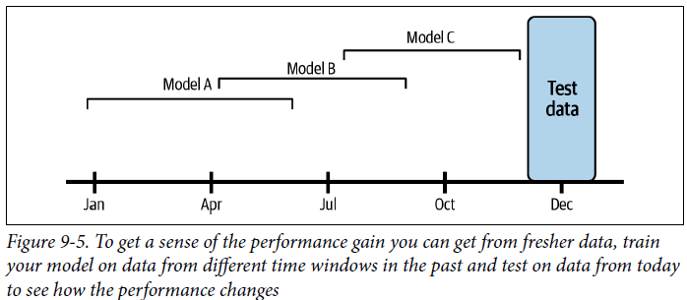

* The difference in the performance of these versions will give you a sense of the performance gain your model can get from fresher data
* *If the model trained on data from a quarter ago is much worse than the model trained on data from a month ago, you know that you shouldn’t wait a quarter to retrain your model*
* This was a simple example to illustrate how the data freshness experiment works
* **In practice, you might want your experiments to be much more fine-grained, operating not in months but in weeks, days, even hours or minutes**
* 2014 Facebook did a similar experiment for ad CTR prediction and found they could reduce the model’s loss by 1% by going from retraining weekly to retraining daily, and *this performance gain was significant enough for them to switch their retraining pipeline from weekly to daily*
* Given that online contents today are so much more diverse + users’ attention online changes much faster, we can imagine the value of data freshness for ad CTR is even higher
* **Some companies with sophisticated ML infrastructure have found enough performance gain to switch their retraining pipeline to every few *minutes*** (Qian Yu, “Machine Learning with Flink in Weibo,” QCon 2019)
* <https://www.youtube.com/watch?v=WQ520rWgd9A>

###### Model iteration versus data iteration

* We discussed earlier that not all model updates are the same and we differentiated between **model iteration** **(adding a new feature to an existing model architecture or changing model architecture)** and **data iteration** **(same model architecture + features but you refresh this model with new data)**
* You **might wonder not only how often to update your model, but also what *kind* of model updates to perform.**
* **In theory, you can do both types of updates, and in practice, you *should* do both from time to time**
* ***However, the more resources you spend in one approach, the fewer resources you can spend in another***
* On the one hand, **if you find that iterating on your data doesn’t give you much performance gain, then you should spend your resources on finding a better model**
* On the other hand, **if finding a better model architecture requires 100X compute for training and gives you 1% performance whereas updating the *same* model on data from the last 3 hours requires only 1X compute and also gives 1% performance gain, you’ll be better off iterating on data**
* Maybe in the near future, we’ll get more theoretical understanding to know in what situation an approach will work better, but **as of today, no book can give you the answer on which approach will work better for your *specific* model on your *specific* task**
* You’ll **have to do experiments to find out**
* **The question on how often to update your model is a difficult one to answer with many nuances**
* In the beginning, when your **infrastructure is nascent and the process of updating a model is manual and slow, the answer is: as often as you *can***
* However, **as infrastructure matures + the process of updating a model is partially automated and can be done in a matter of hours, if not minutes, the answer to this question is contingent on the answer to the following question: “How much performance gain would I get from fresher data?”**
* **It’s important to run experiments to quantify the value of data freshness to your models**

### Test in Production

* We’ve talked about the danger of deploying models that haven’t been sufficiently evaluated
* **To sufficiently evaluate your models, you first need a *mixture* of offline evaluation and online evaluation**
* To understand why offline evaluation isn’t enough, let’s go over **2 major test types for offline evaluation**: **test splits** and **backtests**.
* The first type of model evaluation you might think about is the good old **test splits** that you can use to evaluate your models offline
* These test splits are **usually static** and ***have* to be static so that you have a trusted benchmark to compare multiple models**
* It’ll be hard to compare test results of 2 models if they are tested on different test sets
* However, **if you update the model to adapt to a *new* data distribution, it’s not sufficient to evaluate this new model on test splits from the *old* distribution**
* **Assuming that the fresher the data, the more likely it is to come from the current distribution, one idea is to test your model on the most recent data that you have access to**
* So, after you’ve updated your model on the data from the last day, you might want to test this model on the data from the last hour (assuming that data from the last hour wasn’t included in the data used to update your model)
* The **method of testing a predictive model on data from a specific period of time in the past** is known as a **backtest.**
* *The question is whether backtests are sufficient to replace static test splits*. **Not quite**.
* **If something went wrong with your data pipeline and some data from the last hour is corrupted, evaluating your model solely on this recent data isn’t sufficient.**
* **With backtests, you should still evaluate your model on a static test set that you have extensively studied and (mostly) trust as a form of sanity check**
* Because data distributions shift, the fact that a model does well on the data from the last hour doesn’t mean that it will continue doing well on the data in the future
* **The only way to know whether a model will do well in production is to deploy it**
* This insight **led to one seemingly terrifying but necessary concept: test in production**
* However, **test in production doesn’t have to be scary, there are techniques to help**
* **you evaluate your models in production (mostly) safely** such as **shadow deployment, A/B testing, canary analysis, interleaving experiments, and bandits**

#### Shadow Deployment

* **Shadow deployment** might be the **safest way to deploy your model or any software update**
* Shadow deployment **works as follows**:
* **1. Deploy the candidate model in parallel with the existing model.**
* **2. For each incoming request, route it to both models to make predictions, but only serve the existing model’s prediction to the user.**
* **3. Log the predictions from the new model for analysis purposes.**
* **Only when you’ve found that the new model’s predictions are satisfactory do you replace the existing model with the new model**
* Because you don’t serve the new model’s predictions to users until you’ve made sure that the model’s predictions are satisfactory, the risk of this new model doing something funky is low, at least not higher than the existing model
* However, this technique **isn’t always favorable because it’s expensive**
* It **doubles the number of predictions your system has to generate, which generally means doubling your inference compute cost**

#### A/B Testing

* **A/B testing** is a way to **compare 2 variants of an object, typically by testing responses to these variants, and determining which is more effective**
* In our case, we have the **existing model as one variant**, and the **candidate model (the recently updated model) as another variant**
* We’ll use A/B testing to **determine which model is better according to some predefined metrics**
* A/B testing has become so prevalent that, as of 2017, companies like Microsoft and Google each conduct over 10,000 A/B tests annually
* It is many MLE’s first response to how to evaluate ML models in production
* **A/B testing works as follows:**
* **1. Deploy the candidate model alongside the existing model.**
* **2. A percentage of traffic is routed to the new model for predictions; the rest is routed to the existing model for predictions**
* It’s **common for both variants to serve prediction traffic at the same time**
* However, there are **cases where one model’s predictions might affect another model’s predictions, which, in turn, influence the other model’s predictions**.
* Ex: In ridesharing’s dynamic pricing, a model’s predicted prices might influence the number of available drivers and riders
* In these cases, you **might have to run your variants alternatively** **(e.g., serve model A one day and then serve model B the next day)**
* **3. Monitor and analyze the predictions and user feedback, if any, from both models to determine whether the difference in the two models’ performance is statistically significant**
* **To do A/B testing the right way requires doing *many* things *right***
* For example, **2 important things are**:
* **1) A/B testing consists of a randomized experiment**
* The **traffic routed to each model has to be *truly* random**
* **If not, the test result will be invalid**
* Ex: If there’s a selection bias in the way traffic is routed, such as users exposed to model A are usually on phones whereas users exposed to model B are usually on desktops, then if A has better accuracy than B, we can’t tell whether it’s because A is better than B or whether “being on a phone” influences the prediction quality
* **2) An A/B test should be run on a sufficient number of samples to gain enough confidence about the outcome**
* **How to calculate the number of samples needed for an A/B test is a simple question with a very complicated answer**
* The **gist** here is that **if your A/B test result shows that a model is better than another with statistical significance, you can determine which model is indeed better**
* To measure statistical significance, **A/B testing uses statistical hypothesis testing such as two-sample tests** **= determining if the difference between 2 populations is statistically significant**
* In the distribution shift use case, if a statistical difference suggests that the 2 populations come from different distributions, this means that the original distribution has shifted
* **In the A/B testing use case, statistical differences mean we’ve gathered sufficient evidence to show that one variant is better than the other variant**
* **Statistical significance, while useful, isn’t foolproof**
* Say we run a two-sample test and get the result of model A is better than model B with p-value of p= 0.05 or 5%, and we define statistical significance as p ≤ 0.5
* This means if we run the same A/B testing experiment multiple times, (100 – 5 =) 95% of the time, we’ll get the result “A is better than B”, + the other 5% of the time, “B is better than A”
* So, ***even if the result is statistically significant*, it’s possible that if we run the experiment again, we’ll pick another model**
* **Even if your A/B test result isn’t statistically significant, it doesn’t mean that this A/B test fails**
* If you’ve run an A/B test with a lot of samples and the difference between the 2 tested models is statistically insignificant, maybe there isn’t much difference between these two models, and it’s probably OK for you to use either
* If interested in learning more about A/B testing and other statistical concepts important in ML:
* Trustworthy Online Controlled Experiments (A Practical Guide to A/B Testing) by Ron Kohav
* Introduction to Statistics for Data Science: <https://towardsdatascience.com/introduction-to-statistics-e9d72d818745>
* **Often, in production, you don’t have just one candidate, but *multiple* candidate models**
* **It’s possible to do A/B testing with > 2 variants 🡪 A/B/C testing or even A/B/C/D testing**

#### Canary Release

* **Canary release** = a technique to **reduce the risk of introducing a new software version in production by slowly rolling out the change to a small subset of users before rolling it out to the entire infrastructure and making it available to everybody**
* ***In the context of ML deployment*, canary release works as follows**:
* **1. Deploy the candidate model (the canary) alongside the existing model**
* **2. A portion of the traffic is routed to the candidate model.**
* **3. If its performance is satisfactory, increase the traffic to the candidate model**
* **If not, abort the canary and route all the traffic back to the existing model.**
* **4. Stop when either the canary serves all the traffic (the candidate model has replaced the existing model) or when the canary is aborted**
* **The candidate model’s performance is measured against the existing model’s performance according to the metrics you care about**
* If the candidate model’s key metrics degrade significantly, the canary is aborted, and all the traffic will be routed to the existing model
* **Canary releases can be used to implement A/B testing due to the similarities in their setups**
* However, you **can do canary analysis without A/B testing**
* Ex: You don’t have to randomize the traffic to route to each model
* **A plausible scenario is that you first roll out the candidate model to a less critical market before rolling out to everybody**
* For how canary release works in industry, Netflix and Google have a great shared blog post on how automated canary analysis is used at their companies: <https://netflixtechblog.com/automated-canary-analysis-at-netflix-with-kayenta-3260bc7acc69>

#### Interleaving Experiments

* Imagine you have 2 recommender systems, A and B, and you want to evaluate which is better
* Each time, a model recommends 10 items users might like
* With A/B testing, you’d divide your users into 2 groups: one group exposed to A and the other to B
* *Each user will be exposed to the recommendations made by one model*
* **What if instead of exposing a user to recommendations from a model, we expose that user to recommendations from *both* models and see which model’s recommendations they will click on?**
* That’s the idea behind **interleaving experiments**
* Originally proposed by Thorsten Joachims in 2002 for the problems of search rankings
* In experiments, **Netflix found that interleaving “reliably identifies the best algorithms with *considerably smaller sample size* compared to traditional A/B testing.”**
* Below shows how interleaving differs from A/B testing:

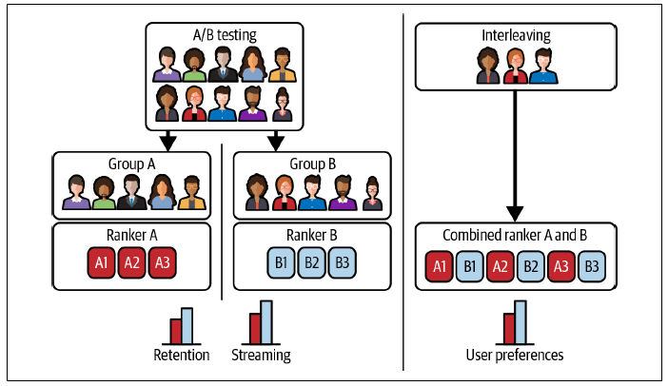

* **In A/B testing, core metrics (retention, streaming, etc.) are measured and compared between the 2 groups**
* In **interleaving**, the **two *algorithms* can be compared by measuring user *preferences***
* Because **interleaving can be decided by user preferences**, there’s **no guarantee that user preference will lead to better core metrics**
* When we show recommendations from multiple models to users, it’s **important to note that the position of a recommendation influences how likely a user will click on it**
* Ex: Users are much more likely to click on the top recommendation than the bottom recommendation
* For interleaving to yield valid results, we **must ensure that at *any given position*, a recommendation is equally likely to be generated by A or B**
* To ensure this, one method we can use is **team-draft interleaving**, which mimics the drafting process in sports
* For each recommendation position, randomly select A or B with equal probability, and the chosen model picks the top recommendation that hasn’t already been picked
* A visualization of how this team-drafting method works is shown below

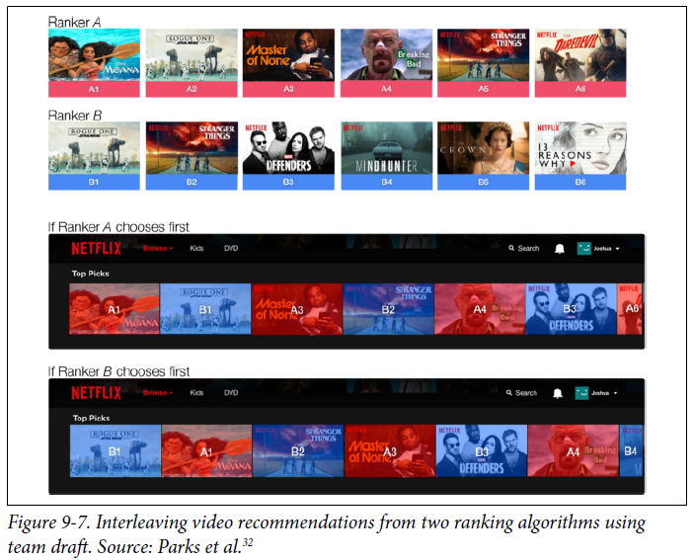

#### Bandits

* **Bandit algorithms** originated in gambling
* A casino has multiple slot machines with different payouts
* A slot machine is also known as a **one-armed bandit**, hence the name
* You don’t know which slot machine gives the highest payout.
* You can experiment over time to find out which slot machine is the best while maximizing your payout
* **Multi-armed bandits** = **algorithms that allow you to balance between exploitation** (choosing the slot machine that has paid the most in the past) **and exploration** (choosing other slot machines that may pay off even more)
* As of today, the **standard method for testing models in production is A/B testing**.
* With A/B testing, you **randomly route traffic to each model for predictions and measure at the end of your trial which model works better**
* **A/B testing is stateless**: you **can route traffic to each model without having to know about their current performance**
* You **can do A/B testing even with batch prediction**.
* **When you have multiple models to evaluate, each model can be considered a slot machine whose payout (i.e., prediction accuracy) you don’t know**
* **Bandits allow you to determine how to route traffic to each model for prediction to determine the best model while maximizing prediction accuracy for your users**
* **Bandit is stateful: before routing a request to a model, you need to calculate *all* models’ current performance**
* This requires 3 things:
* 1) Your **model must be able to make online predictions**.
* 2) Preferably **short feedback loops**
* You **need to get feedback on whether a prediction is good or not**
* This is **usually true for tasks where labels can be determined from users’ feedback**, like in recommendations
* If users click on a recommendation, it’s inferred to be good
* **If the feedback loops are short, you can update the payoff of each model quickly**
* 3) A **mechanism to collect feedback, calculate + keep track of each model’s performance, and route prediction requests to different models based on their current performance**
* **Bandits are well-studied in academia and have been shown to be a lot more data-efficient than A/B testing (in many cases, bandits are even optimal)**
* **Bandits require less data to determine which model is the best and, at the same time, reduce opportunity cost as they route traffic to the better model more quickly**
* Discussions on bandits
* LinkedIn, Netflix, Facebook, Dropbox: <https://netflixtechblog.com/ml-platform-meetup-infra-for-contextual-bandits-and-reinforcement-learning-4a90305948ef>
* Zillow: <https://medium.com/zillow-tech-hub/luca-472e5fc3b49c>
* Stitch Fix: <https://multithreaded.stitchfix.com/blog/2020/08/05/bandits/>
* For a more theoretical view, see Ch. 2 of Reinforcement Learning(Sutton and Barto, 2020)
* In an experiment by Google’s Greg Rafferty, A/B testing required over 630,000 samples to get a confidence interval of 95%, whereas a simple bandit algorithm (Thompson Sampling) determined that a model was 5% better than the other with < 12,000 samples
* However, **bandits are a lot more difficult to implement than A/B testing** because it **requires computing and keeping track of models’ payoffs**
* Therefore, **bandit algorithms are not widely used in industry other than at a few big tech companies**

##### Bandit Algorithms

* Many of the solutions for the multi-armed bandit problem can be used here
* The simplest algorithm for exploration is ε-greedy
* For a percentage of time, say 90% or ε = 0.9, you route traffic to the model that is currently the best-performing one, and for the other 10% of the time, you route traffic to a random model
* This means that for each of the predictions your system generates, 90% of them come from the best-at-that-point-in-time model
* 2 of the most popular exploration algorithms are Thompson Sampling and Upper Confidence Bound (UCB)
* Thompson Sampling selects a model with a probability that this model is optimal given the current knowledge
* In our case, it means the algorithm selects the model based on its probability of having a higher value (better performance) than all other models
* On the other hand, UCB selects the item with the highest upper confidence bound
* We say that UCB implements **optimism in the face of uncertainty**, it gives an “uncertainty bonus,” also called “exploration bonus,” to the items it’s uncertain about

##### Contextual bandits as an exploration strategy

* **If bandits for model evaluation are to determine the payout (i.e., prediction accuracy) of each *model*, contextual bandits are to determine the payout of each *action***
* In the case of recommendations/ads, an **action** is an item/ad to show to users, and the **payout** is how likely it is a user will click on it
* Contextual bandits, like other bandits, are an **amazing technique to improve the data efficiency of your model**
* Some people also call bandits for model evaluation “contextual bandits”, which makes conversations confusing, so here, **“contextual bandits” refer to exploration strategies to determine the payout of predictions**
* Ex: Building a recommender system with 1,000 items to recommend (a 1,000-arm bandit problem)
* Each time, you can only recommend the top 10 most relevant items to a user
* In bandit terms, you’ll have to **choose the best 10 arms**
* Shown items get user feedback, inferred via whether the user clicks on them
* But you *won’t get feedback on the other 990 items*
* This is known as the **partial feedback problem**, also known as **bandit feedback**
* You **can also think of contextual bandits as a classification problem with bandit feedback**
* Ex: Each time a user clicks on an item, this item gets 1 value point
* When an item has 0 value points, it could either be because the item has never been shown to a user, or because it’s been shown but not clicked on
* You want to show users items with the highest value to them, but if you keep showing users *only* the items with the most value points, you’ll keep recommending the same popular items, and the never-before-shown items will keep having 0 value points.
* **Contextual bandits are algorithms that help you balance between showing users the items they will like and showing the items that you want feedback on**
* It’s the **same exploration-exploitation trade-off that many might have encountered in RL**
* **Contextual bandits** are also called **“one-shot” RL problems**
* **Multi-armed bandit****=** **classic RL problem that exemplifies the exploration–exploitation trade-off dilemma**
* The name comes from imagining a gambler at a row of slot machines (sometimes known as “one-armed bandits”) who has to decide which machines to play, how many times to play each machine + in which order to play them, and whether to continue with the current machine or try a different machine
* In **RL**, you **might need to take a series of actions before seeing the rewards**
* In **contextual bandits**, you **can get bandit feedback *right away* after actions** (e.g., after recommending an ad, get feedback on whether a user clicked on that recommendation)
* Contextual bandits are **well researched** and have been **shown to improve models’ performance significantly**
* Report by Twitter: <https://arxiv.org/abs/2008.00727>
* Report by Google: <https://arxiv.org/abs/1909.03212>
* However, **contextual bandits are even harder to implement than model bandits, since the exploration strategy depends on the ML model’s architecture** (e.g., whether it’s a decision tree or a NN), **which makes it less generalizable across use cases**
* If interested in combining contextual bandits with DL: Twitter’s “Deep Bayesian Bandits: Exploring in Online Personalized Recommendations”, <https://arxiv.org/abs/2008.00727>

#### Who Should Run Tests?

* We’ve gone through multiple types of tests for ML models
* However, it’s **important to note that a good evaluation pipeline is not only about what tests to run, but also about *who should run those tests***
* **In ML, the evaluation process is often owned by data Scientists (the same people who developed the model are responsible for evaluating it)**
* **Data scientists *tend to* evaluate their new model ad hoc using the sets of tests that they like**
* **This process is imbued with biases** (data scientists have contexts about their models that most users don’t, which means they **probably won’t use this model in a way most of their users will**)
* **The ad hoc nature of the process means that the results might be variable**
* One data scientist might perform a set of tests and find that model A is better than model B, while another data scientist might report differently
* **The lack of a way to ensure models’ quality in production has led to many models failing after being deployed**, which, in turn, fuels data scientists’ anxiety when deploying models
* To mitigate this issue, **it’s important for each team to outline clear pipelines on how models should be evaluated (e.g., the tests to run, the order in which they should run, the thresholds they must pass in order to be promoted to the next stage, etc.)**
* Better, **these pipelines should be automated and kicked off whenever there’s a new model update**
* The **results should be reported and reviewed, similar to the CI/CD process for traditional SWE**
* **It’s crucial to understand that a good evaluation process involves not only what tests to run but also who should run those tests**

### Summary

* Discussed the 4 stages a company might go through in the process of modernizing their infrastructure for **continual learning**: from the **manual, training from scratch stage to automated, stateless continual learning**
* Examined the question **“How often *should* I update my models?”** by considering the value of **data freshness** to their models and the trade-offs between **model iteration** and **data iteration**
* Similar to online prediction, **continual learning requires a mature streaming infrastructure**
* The training part of continual learning can be done in batch, but the online evaluation part requires streaming
* Many engineers worry that **streaming is hard and costly**
* This was **true** **3 years ago**, but **streaming technologies have matured significantly since then**
* **More and more companies are providing solutions to make it easier for companies to move to streaming** (Spark Streaming, Snowflake Streaming, Materialize, Decodable, Vectorize, etc.)
* **Continual learning is a problem specific to ML, but it largely requires an infrastructural solution**
* **To be able to speed up the iteration cycle and detect failures in new model updates quickly, we need to set up our infrastructure in the right way**
* This **requires the data science/ML team and the platform team to work together**