# Kimball Data Warehouse Toolkit

## Ch 4 - Inventory

* Chapter 3: Retail Sales = developed a dimensional model for the sales transactions in a large grocery chain
* We remain now w/in the same industry but move up the value chain to tackle the inventory process
* The designs developed in this chapter apply to a broad set of inventory pipelines both inside and outside the retail industry
* More important, this chapter provides a thorough discussion of the **EDW bus architecture**, which is **essential to creating an integrated DW/BI system** + **provides a framework for planning the overall environment, even though it will be built incrementally**
* We underscore the importance of using **common conformed dimensions and facts** across dimensional models, + close by encouraging adoption of an **enterprise data governance** **program**
* **Concepts**:
* Representing organizational value chains via a series of dimensional models
* **Semi-additive facts**
* 3 fact table types: **periodic snapshots**, **transaction**, and **accumulating snapshots**
* **EDW bus architecture and bus matrix**
* **Opportunity/stakeholder matrix**
* **Conformed dimensions and facts**, and their impact on **agile methods**
* Importance of data governance

### Value Chain Introduction

* Most organizations have an underlying **value chain**of key business processes, which **identifies the natural, logical flow of an organization’s primary activities**
* Ex: A retailer issues purchase orders to product manufacturers, the products are delivered to the retailer’s warehouse, where they are held in inventory
* A delivery is then made to an individual store, where again the products sit in inventory until a consumer makes a purchase
* The figure below illustrates this subset of a retailer’s value chain

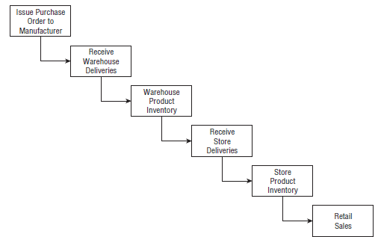

* Obviously, products sourced from manufacturers that deliver directly to the retail store would bypass the warehousing processes
* **Operational source systems typically produce transactions or snapshots at each step of the value chain**
* The **primary objective of most analytic DW/BI systems is to monitor the performance results of these key processes**
* **Because each process produces *unique* metrics at *unique* time intervals with *unique* granularity + dimensionality, each process typically spawns 1 or more fact tables**
* To this end, the **value chain provides high-level insight into the overall data architecture for an enterprise DW/BI environment**

### Inventory Models

* In the meantime, we’ll discuss several *complementary* inventory models
* 1) The inventory **periodic snapshot**= **product inventory levels are measured at regular intervals + placed as separate rows in a fact table** that **appear over time as a series of data layers in the dimensional model, much like geologic layers represent the accumulation of sediment over long periods of time**
* 2) Every **transaction** that impacts inventory levels as products move through the warehouse is **recorded**
* 3) The **inventory accumulating snapshot** = a **fact table row is inserted for each product delivery and then the row is updated as the product moves through the warehouse**
* Each model tells a different story
* **For some analytic requirements, 2 or even all 3 models may be appropriate *simultaneously***

#### Inventory Periodic Snapshots

* Optimized inventory levels in the stores can have a major impact on chain profitability
* Making sure the right product is in the right store at the right time minimizes out-of-stocks + reduces overall inventory carrying costs
* A retailer wants to analyze daily quantity-on-hand inventory levels by product + store
* **It is time to put the four-step dimensional design process to work again**
* **Business process** we’re interested in analyzing = **periodic snapshotting of retail store inventory**
* The **most atomic level of detail** provided by the operational inventory system is **a daily inventory for each product in each store**
* The **dimensions immediately fall out of this grain declaration: date, product, store**
* This often happens with periodic snapshot fact tables where you cannot express the granularity in the context of a transaction, so a list of dimensions is needed instead
* In *this* case study, there are *no* additional descriptive dimensions at this granularity
* Ex: Promotion dimensions are typically associated with product movement, such as when the product is ordered, received, or sold, but *NOT* with inventory
* The simplest view of inventory involves only a **single fact: quantity on hand**
* This leads to an exceptionally clean dimensional design, as shown below

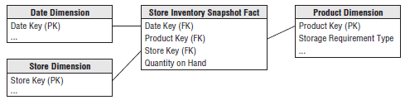

* The date dimension table in this case study = identical to table developed in Ch. 3 for retail store sales, while the product and store dimensions may be decorated w/ additional attributes that’d be useful for inventory analysis
* Ex: The product dimension could be enhanced with columns such as minimum reorder quantity or storage requirement, assuming they are constant + discrete descriptors of each product
* *If the minimum reorder quantity varies for a product by store, it couldn’t be included as a product dimension attribute*
* Ex: In the store dimension, you might include attributes to identify the frozen + refrigerated storage square footages
* Even a schema as simple as above can be very useful
* Numerous insights can be derived if inventory levels are measured frequently for many products in many locations
* **However, this specific inventory periodic snapshot fact table faces a serious challenge**
* Retail fact table was reasonably sparse b/c you don’t sell every product in every shopping cart
* **Inventory, on the other hand, generates dense snapshot tables**
* Because the retailer strives to avoid out-of-stock situations in which the product is not available, there may be a row in the fact table for EVERY product in EVERY store EVERY day
* In that case you’d include the 0 out-of-stock measurements as explicit rows
* For a grocery retailer with 60,000 products stocked in 100 stores, approximately 6 million rows (60,000 products x 100 stores) would be inserted with each nightly fact table load
* *However, b/c the row width is just 14 bytes, a fact table would grow by only 84 MB w/ each load*
* Although the data *volumes* in this case are manageable, the **denseness of some periodic snapshots may mandate compromises**
* Perhaps the most obvious = to **reduce the snapshot frequencies over time**
* It may be acceptable to keep the last 60 days of inventory at the daily level + then revert to less granular weekly snapshots for historical data
* In this way, instead of retaining 1,095 snapshots during a 3-year period, the number could be reduced to 208 total snapshots
* *The 60 daily and 148 weekly snapshots should be stored in 2 separate fact tables given their unique periodicity*

##### Semi-Additive Facts

* Stressed the importance of **fact additivity** in Chapter 3
* In the inventory snapshot schema, quantity on hand can be summarized across products or stores and result in a valid total
* **Inventory levels, however, are NOT additive across *dates*, because they represent snapshots of a level or balance at one point in time**
* Because inventory levels (and *all* forms of financial account balances) are **additive across *some* dimensions but not *all***, we refer to them as **semi-additive facts**.
* The semi-additive nature of inventory balance facts is even more understandable if you think about checking account balances
* Ex: On Monday, presume you have $50 in your account
* On Tuesday, the balance remains unchanged, but on Wednesday, you deposit another $50 so the balance is now $100, and the account has no further activity through the end of the week
* On Friday, you *can’t merely add up the daily balances during the week* and declare that the ending balance is$400 (based on $50 + $50 + $100 + $100 + $100)
* The **most useful way to combine account balances + inventory levels** **across dates** is to **average** them (resulting in an $80 average balance in the checking example)
* See: A bank referring to the average daily balance on a monthly account summary
* **NOTE: All measures that record a static level (inventory levels, financial account balances, + measures of intensity such as room temp) are inherently non-additive across the date dimension + possibly other dimensions**
* **In these cases, the measure may be aggregated across dates by averaging over the number of time periods**
* Unfortunately, you ***cannot* use the SQL AVG function to calculate the average over time**
* This function averages over *all the rows received by the query*, NOT just the number of dates
* Ex: If a query requested the average inventory for a cluster of 3 products in 4 stores across 7 dates (e.g., the average daily inventory of a brand in a geographic region during a week), the SQL AVG function would divide the summed inventory value by 84 (3 products × 4 stores × 7 dates)
* Obviously, the *correct* answer is to divide the summed inventory value by 7, which is the number of daily time periods
* **OLAP products provide the capability to define aggregation rules within the cube, so semi-additive measures like balances are less problematic if the data is deployed via OLAP cubes**

##### Enhanced Inventory Facts

* The simplistic view in the periodic inventory snapshot fact table enables you to see a time series of inventory levels
* **For most inventory analysis, quantity on hand isn’t enough** + it needs to be used in conjunction with additional facts to measure the velocity of inventory movement + develop other interesting metrics, such as the number of turns and number of days’ supply
* If quantity sold (or equivalently, quantity shipped for a warehouse location) was added to each fact row, you could calculate the number of turns and days’ supply.
* For daily inventory snapshots, the number of turns measured each day is calculated as the quantity sold divided by the quantity on hand
* For an extended time span, such as a year, the number of turns is the total quantity sold divided by the daily average quantity on hand
* The number of days’ supply is a similar calculation
* Over a time span, the number of days’ supply is the final quantity on hand divided by the average quantity sold
* In addition to the quantity sold, inventory analysts are also interested in the **extended value** of the inventory at cost, as well as the **value at the latest selling price.**
* The initial periodic snapshot is embellished in the figure below

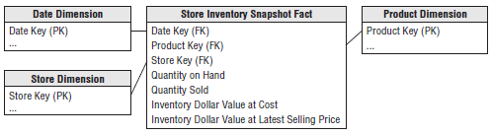

* Notice that quantity on hand is **semi-additive**, but the **other measures in the enhanced periodic snapshot are all fully additive**
* The quantity sold amount has been rolled up to the snapshot’s daily granularity
* The valuation columns are extended, additive amounts
* In some periodic snapshot inventory schemas, it is useful to store the beginning balance, the inventory change or delta, along with the ending balance
* In this scenario, the balances are again semi-additive, whereas the deltas are fully additive across all the dimensions
* **Overall, the periodic snapshot is the most common inventory schema**
* We’ll discuss 2 alternative perspectives that complement the inventory snapshot just designed
* For a change of pace, rather than describing these models in the context of the retail store inventory, we’ll move up the value chain to discuss the inventory located in the warehouses

#### Inventory Transactions

* 2nd way to model an inventory business process = to **record every transaction that affects inventory**
* Inventory transactions at the warehouse might include the following:
* Receive product.
* Place product into inspection hold.
* Release product from inspection hold.
* Return product to vendor due to inspection failure.
* Place product in bin.
* Pick product from bin.
* Package product for shipment.
* Ship product to customer.
* Receive product from customer.
* Return product to inventory from customer return.
* Remove product from inventory.
* Each inventory transaction identifies the date, product, warehouse, vendor, transaction type, + in most cases, a single amount representing the inventory quantity impact caused by the transaction
* *Assuming the granularity of the fact table is one row per inventory transaction*, the resulting schema is illustrated below

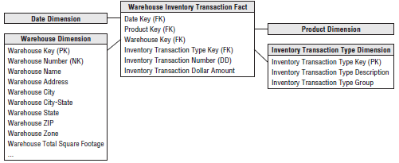

* Even though this transaction fact table is simple, it contains detailed information that mirrors individual inventory manipulations
* The transaction fact table is useful for measuring the frequency + timing of specific transaction types to answer questions that couldn’t be answered by the less granular periodic snapshot
* Even so, **it is impractical to use the transaction fact table as the sole basis for analyzing inventory performance**
* Although it’s theoretically possible to reconstruct an exact inventory position at any moment in time by rolling all possible transactions forward from a known inventory position, it is **too cumbersome + impractical for broad analytic questions that span dates, products, warehouses, or vendors**
* **NOTE: Remember there’s more to life than transactions alone**
* Some form of a snapshot table to give a more cumulative view of a process often *complements* a transaction fact table
* Before leaving the transaction fact table, our example presumes each type of transaction impacting inventory levels positively or negatively has consistent dimensionality: date, product, warehouse, vendor, and transaction type
* We recognize **some transaction types may have varied dimensionality in the real world**
* Ex: A shipper may be associated with the warehouse receipts + shipments, while customer information is likely associated with shipments + customer returns
* **If the transactions’ dimensionality varies by event, then a *series* of related fact tables should be designed rather than capturing all inventory transactions in a *single* fact table**
* **NOTE**: **If performance measurements have different natural granularity or dimensionality, they likely result from separate processes that should be modeled as separate fact tables**

#### Inventory Accumulating Snapshots

* The final inventory model is the **accumulating snapshot fact tables** = used for processes that have a **definite beginning, definite end, and identifiable milestones in between**
* In this inventory model, **one row is placed in the fact table when a particular product is received at the warehouse + the disposition of the product is tracked on this single fact row until it leaves the warehouse**
* In this example, the accumulating snapshot model is **only possible if you can reliably distinguish products received in one shipment from those received at a later time**
* It is also appropriate if you track product movement by product serial number or lot number
* Now assume inventory levels for a product lot captured a series of well-defined events/milestones as it moves through the warehouse, such as receiving, inspection, bin placement, and shipping
* As illustrated below, the inventory accumulating snapshot fact table with its multitude of dates + facts looks quite different from the transaction or periodic snapshot schemas.

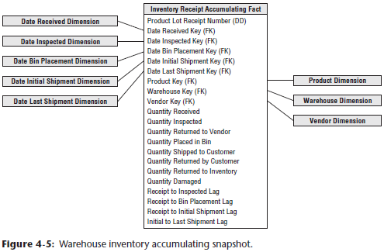

* The accumulating snapshot fact table provides an updated status of the lot as it moves through standard milestones represented by multiple date-valued FKs
* Each accumulating snapshot fact table row is updated repeatedly until the products received in a lot are completely depleted from the warehouse, as shown below:

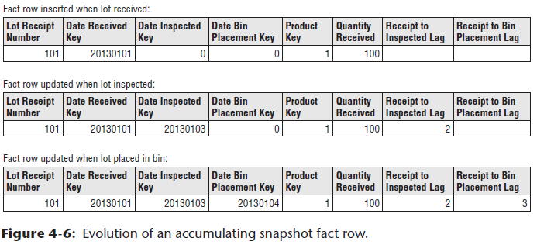

### Fact Table Types

* Just **3 fundamental types of fact tables: transaction, periodic snapshot, accumulating snapshot**.
* Amazingly, this **simple pattern holds true regardless of the industry**
* All 3 types serve a useful purpose
* You **often need 3 complementary fact tables to get a complete picture of the business, yet the administration + rhythm of the 3 fact tables are quite different**
* The figure below compares + contrasts the variations

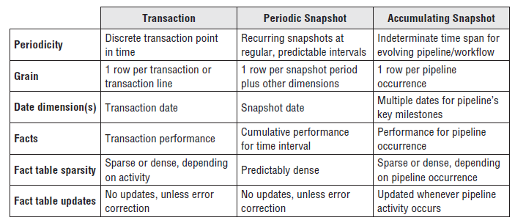

#### Transaction Fact Tables

* **Most fundamental view of the business’s operations is at the individual transaction/transaction line level**
* These **transaction fact tables represent an event that occurred at an instantaneous point in time**
* A **row exists in the fact table for a given customer/product only if a transaction event occurred**
* Conversely, a *given customer or product likely is linked to multiple rows in the fact table because hopefully the customer or product is involved in more than one transaction*
* **Transaction data fits easily into a dimensional framework**
* **Atomic transaction data is the most naturally dimensional data, enabling you to analyze behavior in extreme detail**
* **After a transaction has been posted in the fact table, you typically *don’t* revisit it**
* Having made a solid case for the charm of transaction detail, you may be thinking that all you need is a big, fast server to handle the gory transaction minutiae, + your job is over
* **Unfortunately, even with transaction level data, there are business questions that are impractical to answer using only these details**
* As indicated earlier, **you cannot survive on transactions alone**

#### Periodic Snapshot Fact Tables

* **Periodic snapshots are needed to see the *cumulative performance* of the business at regular, predictable time intervals**
* Unlike the transaction fact table where a row is loaded for each event occurrence, with the periodic snapshot, you **take a picture of the activity at the end of a day, week, or month, then another picture at the end of the next period, and so on**
* Periodic snapshots are **stacked consecutively into the fact table**
* The **periodic snapshot fact table often is the only place to easily retrieve a regular, predictable view of longitudinal performance trends**
* *When transactions equate to little pieces of revenue, you can move easily from individual transactions to a daily snapshot merely by adding up the transactions.*
* In this situation, a periodic snapshot represents an aggregation of transactional activity that occurred during a time period + you’d build a snapshot only if needed for performance reasons
* The design of the snapshot table is closely related to the design of its companion transaction table in this case
* **The fact tables share many dimension tables; the snapshot usually has fewer dimensions overall**
* Conversely, there are **usually more facts in a summarized periodic snapshot table than in a transactional table because any activity that happens during the period is fair game for a metric in a periodic snapshot**
* **In many businesses, however, transaction details are not easily summarized to present management performance metrics**
* As seen this inventory case study, **crawling through the transactions would be extremely time-consuming, + the logic required to interpret the effect of different kinds of transactions on inventory levels could be horrendously complicated**, presuming you even have access to the required historical data
* A **periodic snapshot** again comes to the rescue to provide management with a **quick, flexible view of inventory levels**
* **Hopefully**, the **data for this snapshot schema is sourced *directly* from an operational system that handles these complex calculations**
* **If not, the ETL system must also implement this complex logic to correctly interpret the impact of each transaction type**

#### Accumulating Snapshot Fact Tables

* 3rd type of fact table is the accumulating snapshot, not as common as the other 2, but can be very insightful
* **Accumulating snapshots** represent processes that have **a definite beginning and definite end together with a standard set of intermediate process steps**
* Accumulating snapshots are **most appropriate when business users want to perform workflow or pipeline analysis**
* Accumulating snapshots **always have multiple date FK, representing the predictable major events or process milestones (sometimes there’s an additional date column that indicates when the snapshot row was last updated)**
* Chapter 6: Order Management 🡪 these dates are each handled by a role-playing date dimension
* *Because most of these dates are not known when the fact row is first loaded, a default surrogate date key is used for the undefined dates*

##### Lags Between Milestones and Milestone Counts

* Because **accumulating snapshots often represent the efficiency and elapsed time of a workflow or pipeline**, the **fact table typically contains metrics representing the durations or lags between key milestones**
* It would be difficult to answer duration questions using a transaction fact table because you’d need to correlate rows to calculate time lapses
* Sometimes the lag metrics are simply the raw difference between the milestone dates or date/time stamps
* In other situations, the lag calculation is made more complicated by taking workdays + holidays into consideration.
* **Accumulating snapshot fact tables sometimes include milestone completion counters**, valued as either 0 or 1
* **Finally, accumulating snapshots often have a FK to a *status* dimension**, which is **updated to reflect the pipeline’s latest status**

##### Accumulating Snapshot Updates and OLAP Cubes

* In sharp contrast to the other 2 fact table types, you ***purposely* revisit accumulating snapshot fact table rows to update them**
* **Unlike the periodic snapshot where prior snapshots are preserved, the accumulating snapshot merely reflects the most current status and metrics**
* **Accumulating snapshots do NOT attempt to accommodate complex scenarios that occur infrequently**
* **The analysis of these outliers can always be done with the transaction fact table**
* It is worth noting that **accumulating snapshots are typically problematic for OLAP cubes**
* Because updates to an accumulating snapshot force both facts + dimension FKs to change, much of the cube would need to be reprocessed w/ updates to these snapshots, unless the fact row is only loaded once the pipeline occurrence is complete

#### Complementary Fact Table Types

* **Sometimes accumulating + periodic snapshots work in conjunction w/ one another**, such as when you **incrementally build a monthly snapshot by adding effect of each day’s transactions to a rolling accumulating snapshot while also storing 36 months of historical data in a periodic snapshot**
* Ideally, when the last day of the month has been reached, the accumulating snapshot simply becomes the new regular month in the time series, + a new accumulating snapshot is started the next day
* **Transactions and snapshots are the yin and yang of dimensional designs**
* **Used together, companion transaction + snapshot fact tables provide a complete view of the business**
* **Both are needed because there is often no simple way to combine these two contrasting perspectives in a single fact table**
* Although there is **some theoretical data redundancy** between transaction + snapshot tables, you **don’t object to such redundancy because as DW/BI publishers, your mission is to publish data so that the organization can effectively analyze it**
* These **separate types of fact tables each provide different vantage points on the same story**
* Amazingly, these 3 types of fact tables turn out to be all the fact table types needed for the use cases described in this book

### Value Chain Integration

* Both business + IT organizations are typically interested in **value chain integration**
* Business management needs to look across the business’s processes to better evaluate performance
* Ex: Numerous DW/BI projects have focused on better understanding customer behavior from an end-to-end perspective
* Obviously, this requires the ability to consistently look at customer information across processes, such as quotes, orders, invoicing, payments, + customer service
* Similarly, organizations want to analyze their products across processes, or their employees, students, vendors, and so on.
* IT managers recognize integration is needed to deliver on the promises of data warehousing + BI
* Many consider it their fiduciary responsibility to manage an organization’s information assets
* They know they’re not fulfilling their responsibilities if they allow standalone, nonintegrated databases to proliferate
* In addition to addressing the business’s needs, IT also benefits from **integration** because it **allows the organization to better leverage scarce resources and gain efficiencies through the use of reusable components**
* Fortunately, senior managers who typically are most interested in integration also have the necessary organizational influence and economic willpower to make it happen
* If they don’t place a high value on integration, you face a much more serious organizational challenge, or put more bluntly, your integration project will probably fail
* It shouldn’t be the sole responsibility of the DW/BI manager to garner organizational consensus for integration across the value chain
* The political support of senior management is important; it takes the DW/BI manager off the hook + places the burden on senior leadership’s shoulders where it belongs.
* So far, we’ve modeled data from several processes of the retailer’s value chain
* Although separate fact tables in separate dimensional schemas represent the data from each process, the models share several common business dimensions: date, product, and store
* We’ve logically represented this dimension sharing below

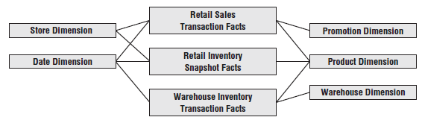

* **Using shared, common dimensions is absolutely critical to designing dimensional models that can be integrated**

### Enterprise Data Warehouse Bus Architecture

* Obviously, building an enterprise’s DW/BI system in one galactic effort is too daunting, yet building it as isolated pieces defeats the overriding goal of consistency
* **For long-term DW/BI success, you need to use an architected, incremental approach to build the enterprise’s warehouse** 🡪 the **enterprise data warehouse bus architecture**

#### Understanding the Bus Architecture

* A **bus** = a **common structure to which everything connects + from which everything derives power**
* The **bus in a computer is a standard interface specification that enables you to plug in a disk drive, DVD, or any number of other specialized cards or devices**
* **Because of the computer’s bus standard, these peripheral devices work together + usefully coexist, even though they were manufactured at different times by different vendors.**
* **NOTE**: **By defining a standard bus interface for the DW/BI environment, separate dimensional models can be implemented by different groups at different times**
* The **separate business process subject areas plug together + usefully coexist *if they adhere to the standard***
* If you refer back to the value chain diagram below on the left, you can envision many business processes plugging into the EDW bus, as illustrated below on the right

 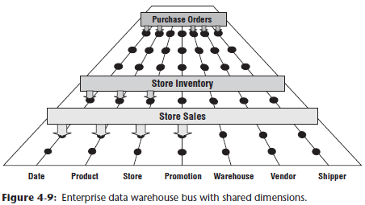

* Ultimately, **all the processes of an organization’s value chain create a family of dimensional models that share a comprehensive set of common, conformed dimensions**
* The **EDW bus architecture provides a rational approach to decomposing the enterprise DW/BI planning task**
* The **master suite of standardized dimensions + facts has a uniform interpretation across the enterprise**, + this **establishes the data architecture framework**
* You can **then tackle the implementation of separate process-centric dimensional models, with each implementation closely adhering to the architecture**
* **As the separate dimensional models become available, they fit together like the pieces of a puzzle.**
* **At some point, enough dimensional models exist to make good on the promise of an integrated enterprise DW/BI environment**
* The bus architecture enables DW/BI managers to get the best of both worlds.
* They **have an architectural framework guiding the overall design, but the problem has been divided into bite-sized business process chunks that can be implemented in realistic time frames**
* Separate development teams follow the architecture while working fairly independently + asynchronously
* **The bus architecture is independent of technology and database platforms**
* All flavors of relational and OLAP-based dimensional models can be full participants in the EDW bus if they are designed around conformed dimensions + facts
* DW/BI systems inevitably consist of separate machines with different OS + database management systems
* **Designed coherently, they share a common architecture of conformed dimensions and facts, allowing them to be fused into an integrated whole**

#### Enterprise Data Warehouse Bus Matrix

* We recommend using an **EDW bus matrix**to **document + communicate the bus architecture**, as illustrated below (or, the **conformance** or **event matrix**)

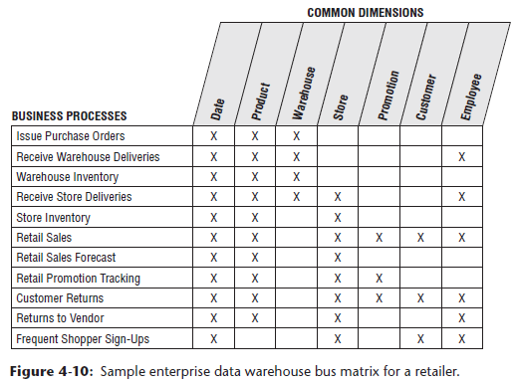

* Working in a tabular fashion, the organization’s **business processes are represented as matrix rows**
* It is important to remember you are **identifying business *processes*, NOT the organization’s business *departments***
* **Matrix rows translate into dimensional models** representing the organization’s primary activities + events, often recognizable by their operational source
* **When it’s time to tackle a DW/BI development project, start with a *single* business process matrix row, b/c that minimizes the risk of signing up for an overly ambitious implementation**
* Most implementation risk comes from biting off too much ETL system design + development
* Focusing on the results of a *single* process, often captured by a *single* underlying source system, reduces ETL development risk
* After individual business processes are enumerated, you sometimes identify more complex consolidated processes
* **Although dimensional models that cross processes can be immensely beneficial in terms of both query performance + ease of use, they are typically more difficult to implement because ETL effort grows with each additional major source integrated into a single dimensional model**
* **Focus on the individual processes as building blocks before tackling the task of consolidating.**
* Profitability = classic example of a consolidated process in which separate revenue and cost factors are combined from different processes to provide a complete view of profitability
* Although a granular profitability dimensional model is exciting, it is definitely not the first dimensional model you should attempt to implement
* Could easily drown while trying to wrangle all the revenue and cost components
* The **columns of the bus matrix represent the common dimensions used across the enterprise**
* It is **often helpful to create a list of core dimensions before filling in the matrix to assess whether a given dimension should be associated with a business process**
* Number of bus matrix rows and columns varies by organization.
* For many, the matrix is surprisingly square with approximately 25 to 50 rows + a comparable number of columns
* In other industries, like insurance, there tend to be more columns than rows
* **After the core processes + dimensions are identified, shade/“X” matrix cells to indicate which columns are related to each row, + you can immediately see the logical relationships and interplay between the organization’s conformed dimensions and key business processes**

##### Multiple Matrix Uses

* Creating the **EDW bus matrix is** one of the most important DW/BI implementation deliverables
* It is **a hybrid resource that serves multiple purposes, including architecture planning, database design, data governance coordination, project estimating, + organizational communication**

Although it is relatively straightforward to lay out the rows and columns, the **enterprise bus matrix defines the overall data architecture for the DW/BI system** + **delivers the big picture perspective, *regardless of database or technology preferences***

* The **matrix’s columns address the demands of master data management + data integration head-on**
* **As core dimensions participating in multiple dimensional models are defined by folks w/ data governance responsibilities + built by a DW/BI team, you can envision their use *across processes* rather than designing in a vacuum based on the needs of a single process, or even worse, a single department**
* **Shared dimensions supply potent integration glue, allowing the business to drill *across* processes**
* **Each business process-centric implementation project incrementally builds out the overall architecture**
* Multiple development teams can work on components of the matrix independently + asynchronously, with confidence they’ll fit together
* PM’s can look across the process rows to see the dimensionality of each dimensional model at a glance, + this vantage point is useful as they’re gauging the magnitude of the project’s effort
* A project focused on a business process w/ fewer dimensions usually requires less effort, especially if the politically-charged dimensions are already sitting on the shelf.
* The **matrix enables you to communicate effectively within *and* across data governance + DW/BI teams**
* Even more important, **can use the matrix to communicate upward + outward throughout an organization**
* The **matrix is a succinct deliverable that visually conveys the master plan**
* IT management needs to understand this perspective to coordinate across project teams + resist the organizational urge to deploy more departmental solutions quickly
* They must also ensure that distributed DW/BI development teams are committed to the bus architecture
* Business management needs to also appreciate the holistic plan 🡪 you want them to understand the staging of the DW/BI rollout by business process.
* In addition, a **matrix illustrates the importance of identifying experts from the business to serve as data governance leaders for the common dimensions**
* It is a tribute to its simplicity that **the matrix can be used effectively to communicate with developers, architects, modelers, and PM’s, as well as senior IT and business management**

##### Opportunity/Stakeholder Matrix

* You can draft a ***different* matrix** that leverages the ***same* business process rows**, but **replaces the dimension columns with business functions**, such as merchandising, marketing, store operations, + finance
* Based on each function’s requirements, matrix **cells are shaded to indicate which business functions are interested in which business processes (and projects)**, as illustrated below

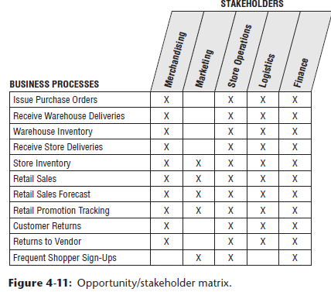

* It **also identifies which groups need to be invited to the detailed requirements, dimensional modeling, and BI application specification parties after a process-centric row is queued up as a project**.

##### Common Bus Matrix Mistakes

* When drafting a bus matrix, people sometimes struggle with the level of detail expressed by each row, resulting in the following missteps:
* **Departmental or overly-encompassing rows**
* Bus matrix rows *shouldn’t* correspond to the boxes on a corporate organization chart representing functional groups
* Some departments may be responsible or acutely interested in a single business process, but the matrix rows shouldn’t look like a list of the CEO’s direct reports
* **Report-centric or too narrowly-defined rows**
* At the opposite extreme, a bus matrix shouldn’t resemble a laundry list of requested reports
* **A single business process supports numerous analyses**, +the **matrix row should reference the *business process*, NOT the derivative reports or analytics**
* When defining matrix columns, architects naturally fall into the similar traps of defining columns that are either too broad or too narrow:
* **Overly-generalized columns**
* A “person” column on the bus matrix may refer to a wide variety of people, from internal employees to external suppliers + customer contacts
* Because there’s virtually zero overlap between these populations, it adds confusion to lump them into a single, generic dimension
* Similarly, it’s not beneficial to put internal + external addresses referring to corporate facilities, employee addresses, + customer sites into a generic location column in the matrix
* **Separate columns for each level of a hierarchy**
* The **columns of a bus matrix should refer to dimensions at their most granular level**
* Some business process rows may require an aggregated version of the detailed dimension, such as inventory snapshot metrics at the weekly level
* Rather than creating separate matrix columns for each level of the calendar hierarchy, use a single column for dates
* To express levels of detail above a daily grain, you can denote the granularity w/in the matrix cell
* Alternatively, subdivide the date column to indicate the hierarchical level associated with each business process row
* It’s **important to retain the overarching identification of common dimensions deployed at different levels of granularity**
* Some industry pundits advocate matrices that treat every dimension table attribute as a separate, independent column, which defeats the concept of dimensions + results in a completely unruly matrix

##### Retrofitting Existing Models to a Bus Matrix

* It is **unacceptable to build separate dimensional models that ignore a framework tying them together**
* **Isolated, independent dimensional models are worse than simply a lost opportunity for analysis**
* They **deliver access to irreconcilable views of the organization** + **further enshrine the reports that cannot be compared with one another**
* **Independent dimensional models** become legacy implementations in their own right
* **By their existence, they block the development of a coherent DW/BI environment**
* So, what happens if you’re *not* starting with a blank slate?
* Perhaps several dimensional models were constructed w/out regard to a conformed dimensions architecture, can you rescue your stovepipes and convert them to the bus architecture?
* To answer this question, **start first with an honest appraisal of your existing non-integrated dimensional structures**
* This typically entails **meetings w/ the separate teams** (including clandestine pseudo-IT teams within business organizations) to **determine the gap between the current environment + the organization’s architected goal**
* **When the gap is understood, develop an incremental plan to convert the standalone dimensional models to the enterprise architecture**, + such a plan needs to be internally sold
* **Senior IT and business management must understand the current state of data chaos, the risks of doing nothing, + the benefits of moving forward according to your game plan**
* Management also needs to appreciate that **the conversion will require a significant commitment of support, resources, and funding**
* If an existing dimensional model is based on a sound dimensional design, perhaps you can map an existing dimension to a standardized version
* The original dimension table would be rebuilt using a cross-reference map
* Likewise, the fact table would need to be reprocessed to replace the original dimension keys with the conformed dimension keys
* Of course, **if the original and conformed dimension tables contain different attributes, rework of the preexisting BI applications and queries is inevitable**
* **More typically, existing dimensional models are riddled with dimensional modeling errors beyond the lack of adherence to standardized dimensions**
* In some cases, the stovepipe dimensional model has outlived its useful life
* Isolated dimensional models often are built for a specific functional area
* When others try to leverage the data, they typically discover the dimensional model was implemented at an inappropriate level of granularity and is missing key dimensionality
* **The effort required to retrofit these dimensional models into the enterprise DW/BI architecture may exceed the effort to start over from scratch**
* As difficult as it is to admit, **stovepipe dimensional models often have to be shut down and rebuilt in the proper bus architecture framework**

### Conformed Dimensions

* **Conformed** **dimensions have the same meaning + values across different fact tables/subject areas**
* Now that we understand the importance of the EDW bus architecture, let’s further explore the standardized **conformed dimensions** that **serve as the cornerstone of the bus because they’re shared across business process fact tables**
* Conformed dimensions go by many other aliases (common dimensions, master dimensions, reference dimensions, shared dimensions, etc.)
* **Conformed dimensions should be *built* *once* in the ETL system + then *replicated* either logically or physically throughout the enterprise DW/BI environment**
* *When built, it’s important that DW/BI development teams take the pledge to use these dimensions*
* It’s a policy decision that is critical to making the enterprise DW/BI system function, so their usage should be mandated by the organization’s CIO
* Conformed dimensions come in several different flavors, as described in the following sections.

#### Drilling Across Fact Tables

* In addition to **consistency** + **reusability**, **conformed dimensions enable combining performance measurements from different business processes in a single report**, as illustrated below

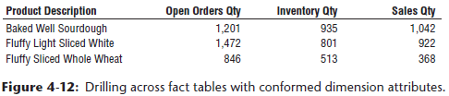

* You can use **multipass SQL** to **query each dimensional model separately and then outer-join the query results based on a common dimension attribute,** such as product name above
* **Multipass SQL:** **Query capability** supported by some data access tools in which the **results of separate star-schema queries are combined column by column via the conformed dimension**
* The **full outer-join ensures all rows are included in the combined report, even if they only appear in 1 set of query results**
* This **linkage**, often referred to as **drill across**, is **straightforward if the dimension table attribute values are identical**
* **Drilling across is supported by many BI products and platforms**
* Their implementations differ on whether the results are joined in temp tables, the application server, or the report
* Vendors also use different terms to describe this technique, including **multipass**, **multi-select**, **multi-fact**, or **stitch queries**
* **Because metrics from different fact tables are brought together with a drill-across query, often any cross-fact calculations *must* be done in the BI application *after* the separate conformed results have been returned.**

#### Identical Conformed Dimensions

* At the **most basic level, conformed dimensions mean the same thing with every possible fact table to which they are joined**
* The date dimension table connected to the sales facts is identical to the date dimension table connected to the inventory facts
* **Identical conformed dimensions have consistent dimension keys, attribute column names, attribute definitions, + attribute values (which translate into consistent report labels + groupings)**
* Dimension attributes *don’t* conform if say called Month in one dimension and Month Name in another
* Likewise, don’t conform if the attribute value is “July” in one dimension and “JULY” in another
* **Identical conformed dimensions in two dimensional models may be *the same physical table within the database***
* However, **given the typical complexity of the DW/BI system’s technical environment with multiple database platforms, it is** ***more likely* that the dimension is *built once in the ETL system* and then *duplicated synchronously outward to each dimensional model***
* In either case, the conformed date dimensions in both dimensional models have the same number of rows, key values, attribute labels, attribute data definitions, + attribute values
* **Attribute column names should be uniquely labeled across dimensions**
* **Most conformed dimensions are defined naturally at the most granular level possible**
* The product dimension’s grain will be the individual product, the date dimension’s grain will be the individual day, etc.
* However, **sometimes dimensions at the same level of granularity do not fully conform**
* Ex: There might be product and store attributes needed for inventory analysis, but they aren’t appropriate for analyzing retail sales data
* **The dimension tables still conform if the keys + common columns are identical, but the supplemental attributes used by the inventory schema are NOT conformed**
* It is **physically impossible to drill across processes using these add-on attributes**

#### Shrunken Rollup Conformed Dimension with Attribute Subset

* **Dimensions also conform when they contain a subset of attributes from a more granular dimension**
* **Shrunken rollup dimensions** are **required when a fact table captures performance metrics at a higher level of granularity than the atomic base dimension**
* This would be the case if you had a weekly inventory snapshot in addition to the daily snapshot
* **In other situations, facts are generated by another business process at a higher level of granularity**
* Ex: The retail sales process captures data at the atomic product level, whereas forecasting generates data at the brand level
* ***You couldn’t share a single product dimension table across the two business process schemas because the granularity is different***
* **The product and brand dimensions still conform if the brand table attributes are a strict subset of the atomic product table’s attributes**
* **Attributes common to both the detailed and rolled-up dimension tables**, such as brand + category descriptions, **should be labeled, defined, + identically valued in both tables**, as illustrated below

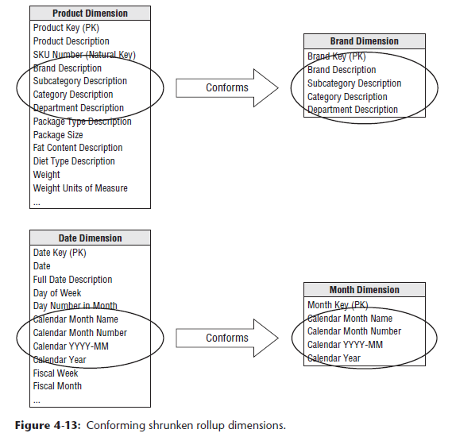 

* However, the **PKs of the detailed and rollup dimension tables are separate**.
* **NOTE**: **Shrunken rollup dimensions conform to the base atomic dimension *if the attributes are a strict subset of the atomic dimension’s attributes***

#### Shrunken Conformed Dimension with Row Subset

* Another case of conformed dimension subsetting occurs when **2 dimensions are at the same level of detail, but one represents only a subset of rows**
* Ex: A corporate product dimension contains rows for the full portfolio of products across multiple disparate lines of business
* Analysts in the separate businesses may want to view only *their* subset of the corporate dimension, restricted to the product rows for *their* business
* By using a subset of rows, they aren’t encumbered with the corporation’s entire product set

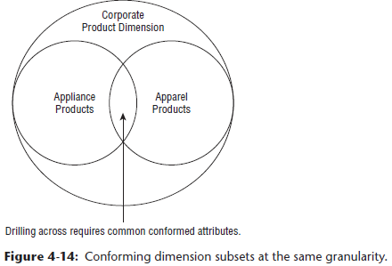

* Of course, **the fact table joined to this subset-ted dimension must be limited to the same subset of products.**
* If a user **attempts to use a shrunken subset dimension while accessing a fact table consisting of the *complete* product set, they may encounter unexpected query results because referential integrity would be violated**
* **Be cognizant of the potential opportunity for user confusion or error with dimension row subsetting**
* We further elaborate on dimension subsets when we discuss supertype and subtype dimensions in Chapter 10: Financial Services
* **Conformed date and month dimensions are a unique example of both row and column dimension subsetting**
* Obviously, you can’t simply use the same date dimension table for daily and monthly fact tables because of the difference in rollup granularity
* However, a month dimension may consist of the month-end daily date table rows w/ the exclusion of all columns that don’t apply at the monthly granularity, such as weekday/weekend indicator, week ending date, holiday indicator, day number within year, + others
* Sometimes a month-end indicator on the daily date dimension is used to facilitate creation of this month dimension table

#### Shrunken Conformed Dimensions on the Bus Matrix

* The **bus matrix identifies the reuse of common dimensions across business processes.**
* Typically, the **shaded cells of the matrix indicate that the *atomic dimension* is associated with a given process**
* **When shrunken rollup or subset dimensions are involved, you want to reinforce their conformance with the atomic dimensions**.
* Therefore, you **don’t want to create a new, unrelated column on the bus matrix**
* 2 viable approaches to represent the shrunken dimensions within the matrix, as illustrated below
* **1) Mark the cell for the atomic dimension, but then *textually* document the rollup or row subset granularity within the cell**
* **2) Subdivide the dimension column to indicate the common rollup or subset granularities, such as day and month if processes collect data at both of these grains**

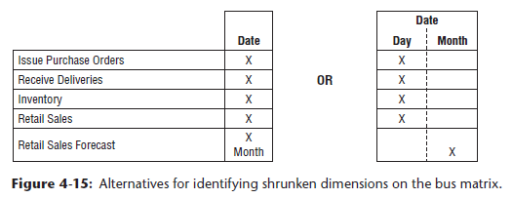

#### Limited Conformity

* Now that we’ve preached about importance of conformed dimensions, we discuss the situation in which it **may not be realistic or necessary to establish conformed dimensions for an organization**
* If a conglomerate has **subsidiaries spanning widely varied industries, there may be little point in trying to integrate**
* If each line of business has unique customers and unique products + there’s no interest in cross-selling across lines, it may not make sense to attempt an enterprise architecture because there likely isn’t much perceived business value
* **Willingness to seek a common definition for product, customer, or other core dimensions is a major litmus test for an organization theoretically intent on building an enterprise DW/BI system**
* If an **organization is unwilling to agree on common definitions**, they **shouldn’t attempt to build an enterprise DW/BI environment**
* It’d be **better to build separate, self-contained DW’s for each subsidiary**
* *But then don’t complain when someone asks for “enterprise performance” without going through this logic.*
* Although organizations may find it difficult to combine data across disparate lines of business, **some** **degree of integration is typically an ultimate goal**
* Rather than declaring it can’t possibly be done, start down the path toward conformity
* Perhaps there are a handful of attributes that can be conformed across lines of business
* Even if it is merely a product description, category, + line of business attribute common to all businesses, this least-common-denominator approach is still a step in the right direction
* **Don’t need to get *everyone* to agree on everything related to a dimension before proceeding**

#### Importance of Data Governance and Stewardship

* **Key conformed dimensions challenge:** **reaching enterprise consensus on dimension attribute names and contents** (and the handling of **content changes** in Chapter 5: Procurement)
* **In many organizations, business rules and data definitions have traditionally been established departmentally**
* **Consequences** of this commonly-encountered lack of data governance + control are **ubiquitous departmental data silos that perpetuate similar but slightly different versions of the truth**
* Business and IT management need to recognize the importance of addressing this shortfall if you stand any chance of bringing order to the chaos
* **If management is reluctant to drive change, the project will never achieve its goals**
* Once the data governance issues + opportunities are acknowledged by senior leadership, resources need to be identified to spearhead the effort
* IT is often tempted to try leading the charge, frustrated by isolated projects re-creating data around the organization, consuming countless IT + outside resources while delivering inconsistent solutions that ultimately just increase the complexity of the organization’s data architecture at significant cost
* Although IT can facilitate the definition of conformed dimensions, it is seldom successful as the sole driver, even if it’s a temporary assignment
* **IT simply lacks the organizational authority to make things happen**

##### Business-Driven Governance

* **To boost the likelihood of business acceptance, SME’s from the business need to lead the initiative**
* Leading a cross-organizational governance program is not for the faint of heart
* The governance resources identified by business leadership should have the following characteristics:
* Respect from the organization
* Broad knowledge of the enterprise’s operations
* Ability to balance organizational needs against departmental requirements
* Gravitas and authority to challenge the status quo and enforce policies
* Strong communication skills
* Politically savvy negotiation and consensus building skills
* Not everyone is cut out for the job, + typically those tapped to spearhead the governance program are highly valued + in demand
* **It takes the right skills, experience, + confidence to rationalize diverse business perspectives and drive the design of common reference data, together with the necessary organizational compromises**
* Over the years, some have criticized conformed dimensions as being too hard
* Yes, it’s **difficult to get people in different corners of the business to agree on common attribute names, definitions, and values, but that’s the crux of unified, integrated data**
* **If everyone demands their own labels + business rules, there’s no chance of delivering on the promises made to establish a single version of the truth**
* **A data governance program is critical in facilitating a culture shift away from a typical siloed environment in which each department retains control of their data + analytics to one where information is shared + leveraged across the organization.**

##### Governance Objectives

* **1 of the key objectives of the data governance function is to reach agreement on data definitions, labels, + domain values so that everyone is speaking the same language**
* **Otherwise, the same words may describe different things, different words may describe the same thing, + the same value may have different meaning**
* **Establishing common master data is often a *politically charged* issue**
* Challenges are cultural + geopolitical rather than technical
* Defining a foundation of master descriptive conformed dimensions requires effort
* But, after it’s agreed upon, subsequent DW/BI efforts can leverage the work, both ensuring consistency + reducing the implementation’s delivery cycle time.
* **In addition to tackling data definitions + contents, the data governance function also establishes policies + responsibilities for data quality + accuracy, as well as data security + access controls**
* Historically, DW/BI teams created “recipes” for conformed dimensions + managed the data cleansing + integration mapping in the ETL system, the operational systems focused on accurately capturing performance metrics, all the while there was often little effort to ensure consistent common reference data
* **Enterprise resource planning (ERP) systems promised to fill the void, but many organizations still rely on separate best-of-breed point solutions for niche requirements**
* Recently, **operational master data management (MDM) solutions** **have addressed the need for centralized master data at the source where the transactions are captured**
* **Although tech can encourage data integration, it doesn’t fix the problem 🡪 A strong data governance function is a necessary prerequisite for conforming information, regardless of technical approach**

#### Conformed Dimensions and Agile Movement

* Some lament that although they want to deliver + share consistently defined master conformed dimensions in their DW/BI environments, it’s “just not feasible.”
* They explain they would if they could, but with senior management focused on using **agile development techniques**, it’s “impossible” to take the time to get organizational agreement on conformed dimensions
* You can challenge that **conformed dimensions *enable* agile DW/BI development, along with agile decision making.**
* **Conformed dimensions allow a dimension table to be built + maintained *once* rather than re-creating slightly different versions during each development cycle**.
* **Reusing conformed dimensions across projects is where you get the leverage for more agile DW/BI development**
* **As you flesh out the portfolio of master conformed dimensions, the development crank starts turning faster and faster + time-to-market for a new business process data source shrinks as developers reuse existing conformed dimensions**
* **Ultimately, new ETL development focuses almost exclusively on delivering more fact tables because the associated dimension tables are already sitting on the shelf ready to go**.
* **Defining a conformed dimension requires organizational consensus and commitment to data stewardship**
* ***But you don’t need to get everyone to agree on every attribute in every dimension table***
* At a minimum, you should **identify a subset of attributes that have significance across the enterprise**, + these commonly referenced descriptive characteristics **become the starter set of conformed attributes, enabling drill-across integration**
* Even just a single attribute, such as enterprise product category, is a viable starting point for the integration effort
* Over time, you can **iteratively expand from this minimalist starting point by adding attributes**
* These dimensions could be tackled during architectural agile **sprints**
* **When a series of sprint deliverables combine to deliver sufficient value, they constitute a release to the business users**
* If you **fail to focus on conformed dimensions** because you’re under pressure to deliver something yesterday, **departmental analytic data silos will likely have inconsistent categorizations + labels**
* Even more troubling, **data sets may look like they can be compared + integrated due to similar labels, but the underlying business rules may be slightly different**
* Business users **waste inordinate amounts of time trying to reconcile + resolve** these data inconsistencies, which **negatively impact their ability to be agile decision makers**.
* **Senior IT managers who are demanding agile systems development practices should be exerting even greater organizational pressure, in conjunction w/ their peers in the business, on the development of consistent conformed dimensions if interested in both long-term development efficiencies and long-term decision-making effectiveness across the enterprise**.

### Conformed Facts

* The **central task of setting up conformed dimensions to tie dimensional models together is 95% or more of the data architecture effort**
* The **remaining 5% of the effort goes into establishing conformed fact definitions**
* Revenue, profit, standard prices and costs, measures of quality and customer satisfaction, and other KPIs are facts that must also conform
* **If facts live in more than 1 dimensional model, the underlying definitions + equations for these facts must be the same if they are to be called the same thing**
* **If labeled identically, they need to be defined in the same dimensional context + with the same units of measure from dimensional model to dimensional model**
* Ex: If several business processes report revenue, these separate revenue metrics can be added + compared *only if they have the same financial definitions*
* If there are definitional differences, it’s essential that the revenue facts be labeled uniquely
* **NOTE: You must be disciplined in your data naming practices**
* **If impossible to conform a fact exactly, give different names to the different interpretations so that business users do not combine these incompatible facts in calculations**
* Sometimes a fact has a **natural unit of measure in one fact table and another natural unit of measure in another fact table**
* Ex: The flow of product down the retail value chain may best be measured in *shipping cases* at the warehouse but in *scanned units* at the store
* Even if all the dimensional considerations have been correctly taken into account, it would be difficult to use these 2 incompatible units of measure in one drill-across report
* **Usual solution to this kind of problem = refer users to a conversion factor buried in the product dimension table + hope the user can find the conversion factor + correctly use it**
* This is **unacceptable for both overhead and vulnerability to error**
* **Correct solution = carry the fact in *both* units of measure, so a report can easily glide down the value chain, picking off comparable facts**
* Chapter 6: Order Management talks more about multiple units of measure