# Kimball Data Warehouse Toolkit

## Ch 5 - Procurement

* We explore **procurement** processes in this chapter, a subject area w/ obvious cross-industry appeal b/c it is **applicable to any organization that acquires products or services for either use or resale**
* In addition to developing several purchasing models, this chapter provides in-depth coverage of the **techniques for handling dimension table attribute value changes**
* **Although descriptive attributes in dimension tables are relatively static, they are subject to change over time**
* Product lines are restructured causing product hierarchies to change, customers move causing their geographic information to change, etc.
* **Concepts**:
* Bus matrix snippet for procurement processes
* **Blended** versus separate transaction schemas
* **Slowly changing dimension (SCD)** technique types 0 through 7, covering both basic and advanced hybrid scenarios

### Procurement Case Study

* Thus far we have studied *downstream* sales and inventory processes in the retailer’s value chain
* We explained the importance of mapping out the **EDW bus architecture** where **conformed dimensions are used across process-centric fact tables**
* Now, we extend these concepts as we **work our way further *up* a value chain** to procurement processes
* For many companies, **procurement** is a **critical business activity**
* Effective procurement of products at the right price for resale is obviously important to retailers + distributors
* Also has strong bottom-line implications for any organization that buys products as raw materials for manufacturing
* Significant cost savings opportunities are associated with reducing the number of suppliers + negotiating agreements with preferred suppliers
* **Demand planning drives efficient materials management**
* **After demand is forecasted, procurement’s goal = source the appropriate materials or products in the most economical manner**
* **Procurement involves a wide range of activities** from negotiating contracts to issuing purchase requisitions and purchase orders (POs) to tracking receipts + authorizing payments
* The following list has a sense of **a procurement organization’s common analytic requirements**:
* Which materials or products are *most frequently purchased*?
* *How many vendors* supply such products and *at what prices*?
* Looking at demand *across the enterprise* (rather than at a single physical location), are there opportunities to negotiate favorable pricing by consolidating suppliers, single sourcing, or making guaranteed buys?
* Are employees purchasing from the preferred vendors or skirting the negotiated vendor agreements with maverick spending?
* Are you receiving the negotiated pricing from your vendors or is there vendor-contract purchase price variance?
* How are your vendors performing? What is the vendor’s fill rate? On-time delivery performance? Late deliveries outstanding? % back-ordered? Rejection rate based on receipt inspection?

### Procurement Transactions and Bus Matrix

* As you begin working through the **4-step dimensional design process (define business process, select grain, identify dimensions, identify facts)**, you determine that procurement is the business process to be modeled
* In studying the process, you observe a flurry of procurement transactions, such as purchase requisitions, purchase orders, shipping notifications, receipts, + payments
* Similar to the approach taken in Chapter 4: Inventory, you *could* initially design a fact table with the grain of 1 row per procurement transaction with transaction date, product, vendor, contract terms, + procurement transaction type as key dimensions, where procurement transaction quantity and dollar amount are the facts
* The resulting design is shown below:

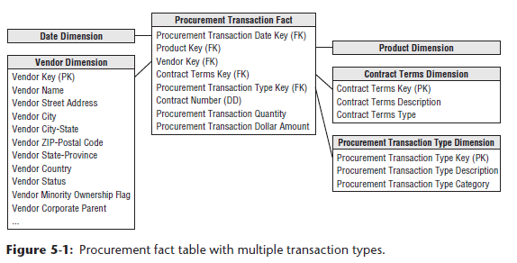

* If you work for the same grocery retailer from the earlier case studies, the **transaction date** and **product dimensions** are the same **conformed dimensions (have the same meaning + values across different fact tables/subject areas)** developed originally in Chapter 3: Retail Sales
* If you work w/ manufacturing procurement, raw materials products likely are located in a separate raw materials dimension table rather than included in the product dimension for salable products
* The **vendor**, **contract terms**, + **procurement transaction type** dimensions are new to this schema.
* The **vendor dimension** contains 1 row for each vendor, along with interesting descriptive attributes to support a variety of vendor analyses
* The **contract terms dimension** contains 1 row for each generalized set of negotiated terms, similar to the promotion dimension in Chapter 3
* The **procurement transaction type dimension** enables grouping or filtering on transaction types, such as purchase orders
* Contract number is a **degenerate dimension (no attributes/descriptive information, only a single identifier or key)** + could be used to determine the volume of business conducted under each negotiated contract

#### Single Vs. Multiple Transaction Fact Tables

* As you review the initial procurement schema design w/ business users, you learn several new details
* 1) The business users describe the various procurement transactions differently
* To the business, purchase orders, shipping notices, warehouse receipts, + vendor payments are all viewed as separate + unique processes.
* Several of the procurement transactions come from different source systems
* There is a purchasing system that provides purchase requisitions and purchase orders, a warehousing system that provides shipping notices and warehouse receipts, and an accounts payable system that deals with vendor payments
* 2) You further discover that **several transaction types have different dimensionality.**
* Ex: Discounts taken are applicable to vendor payments but *not* to the other transaction types
* Ex: Similarly, the name of the employee who received the goods at the warehouse applies to receipts but doesn’t make sense elsewhere
* 3) There are also a variety of interesting **control numbers**, such as purchase order and payment check numbers, created at various steps in the procurement pipeline.
* **These control numbers are perfect candidates for degenerate dimensions**
* **For certain transaction types, more than one control number may apply.**
* As you sort through these new details, you are **faced with a design decision**: Should you **build a blended transaction fact table with a transaction type dimension to view all procurement transactions together, or build separate fact tables for each transaction type?**
* ***Common design quandary surfacing in many transactional situations, not just procurement***
* As dimensional modelers, you **need to make design decisions based on a thorough understanding of the business requirements weighed against the realities of the underlying source data**
* There is **no simple formula to make the definite determination of whether to use a single fact table or multiple fact tables**
* A single fact table may be the most appropriate solution in some situations, whereas multiple fact tables are most appropriate in others
* When faced with this design decision, the **following considerations help sort out the options:**
* **What are the users’ analytic requirements?**
* Our **goal** **= to reduce complexity by presenting the data in the most effective form for business users**
* *How will the business users* ***most commonly analyze this data****?*
* *Which approach most naturally aligns with their business-centric perspective?*
* **Are there *really* multiple unique business processes?**
* In the procurement example, it seems *buying* products (purchase orders) is distinctly different from *receiving* products (receipts)
* The **existence of separate control numbers for each step in the process is a clue that you are dealing with separate processes**
* Given this situation, you’d lean toward separate fact tables
* By contrast, in Chapter 4’s inventory example, the varied inventory transactions were part of a *single* inventory process resulting in a single fact table design
* **Are multiple source systems capturing metrics with unique granularities?**
* There are 3 separate source systems in this case study: purchasing, warehousing, accounts payable
* **This would suggest separate fact tables**
* **What is the dimensionality of the facts?**
* In this procurement example, several dimensions are applicable to *some* transaction types but not to others
* This would **again lead you to separate fact tables**
* **A simple way to consider these trade-offs is to draft a bus matrix**
* As illustrated in below, you can include 2 additional columns identifying the atomic granularity and metrics for each row
* These matrix embellishments cause it to more closely resemble the detailed implementation bus matrix, more thoroughly discussed in Chapter 16: Insurance

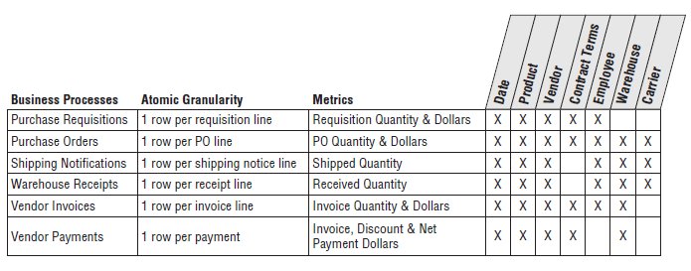

* Based on the bus matrix for this hypothetical case study, **multiple transaction fact tables would be implemented**, as illustrated below
* In this example, there are **separate fact tables** for purchase requisitions, purchase orders, shipping notices, warehouse receipts, + vendor payments
* This **decision was reached because users view these activities as separate and distinct business processes, the data comes from different source systems, and there is unique dimensionality for the various transaction types**
* **Multiple fact tables enable richer, more descriptive dimensions and attributes**
* **The single fact table approach would have required generalized labeling for some dimensions**
* Ex: Purchase order date and receipt date likely would be generalized to just “transaction date”
* Ex: Likewise, purchasing agent and receiving clerk would become “employee”
* **This generalization reduces the legibility of the resulting dimensional model**
* **Also, with separate fact tables, as you progress from purchase requisitions to payments, the fact tables inherit dimensions from the previous steps**
* **Multiple fact tables may require more time to manage and administer because there are more tables to load, index, and aggregate**
* Some would argue this approach increases the complexity of the ETL processes, but *actually*, it may *simplify* the ETL activities
* **Loading operational data from separate source systems into separate fact tables likely requires less complex ETL processing than attempting to integrate data from multiple sources into a single fact table**

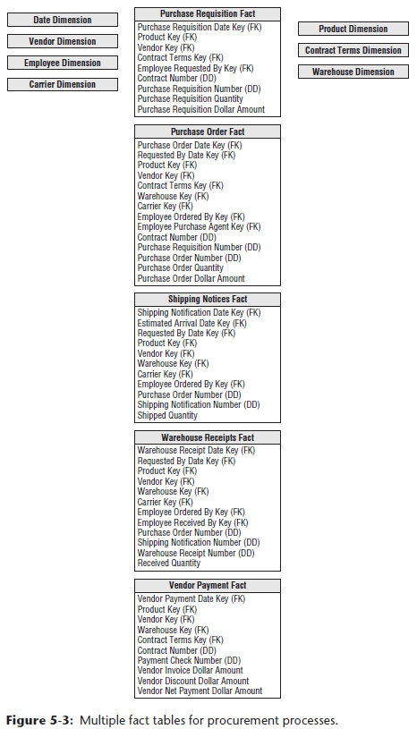

#### Complementary Procurement Snapshot

* *APART* from the decision regarding multiple procurement transaction fact tables, you **may also need to develop a snapshot fact table to fully address the business’s needs**
* As suggested in Chapter 4, an **accumulating snapshot such as below that crosses processes would be extremely useful if the business is interested in monitoring product movement as it proceeds through the procurement pipeline (including the duration of each stage)**
* Remember that **an accumulating snapshot is meant to model processes with well-defined milestones**
* **If the process is a continuous flow that never really ends, it is NOT a good candidate for an accumulating snapshot.**

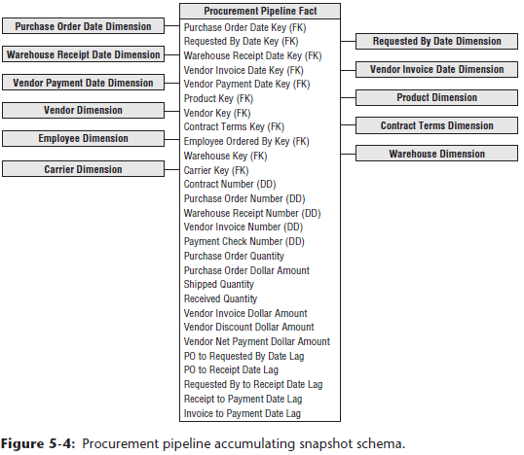

### Slowly Changing Dimensions Basics

* To this point, we have pretended dimensions are independent of time which, unfortunately, this is not the case in the real world
* **Although dimension table attributes are relatively static, they aren’t fixed forever, and attribute values change, *albeit rather* *slowly*, over time.**
* **Dimensional designers must proactively work with the business’s data governance reps to determine the appropriate change-handling strategy**
* **Shouldn’t simply jump to the conclusion that the business doesn’t care about dimension changes just because they weren’t mentioned during requirements gathering**
* Although IT may assume accurate change tracking is unnecessary, business users may assume the DW/BI system will allow them to see the impact of every attribute value change
* It is obviously better to get on the same page sooner rather than later
* **NOTE: The business’s data governance and stewardship representatives must be actively involved in decisions regarding the handling of SCD attributes, IT shouldn’t make determinations on its own**
* When change tracking is needed, it might **be tempting to put every changing attribute into the fact table on the assumption that dimension tables are static**, which is **unacceptable and unrealistic**.
* Instead, you **need strategies to deal with slowly changing attributes within dimension tables**
* **For each dimension table attribute, you must specify a strategy to handle change**
* In other words, ***when an attribute value changes in the operational world, how will you respond to the change in the dimensional model?***
* There are several basic techniques for dealing with attribute changes, + more advanced options
* **May need to employ a combination of these techniques within a single dimension table**

#### Type 0: Retain Original

* With type 0, a **dimension attribute value never changes**, so **facts are always grouped by this original value**
* Type 0 is **appropriate for any attribute labeled “original,”** such as customer original credit score
* **Also applies to most attributes in a date dimension**
* As staunchly advocated for in Chapter 3, **the dimension table’s PK is a surrogate key (unique identifier for some record or object in a table NOT derived from the table data) rather than relying on the natural operational key**
* Although we demoted the **natural key** to being an ordinary dimension attribute, it **still has special significance**
* Presuming it’s ***durable***, it would remain **inviolate (free from violation)**
* **Persistent durable keys are *always* type 0 attributes**
* Unless otherwise noted, throughout this SCD discussion, the **durable supernatural key is assumed to remain constant** (as described in Chapter 3)

#### Type 1: Overwrite

* With the **SCD type 1** response, you **overwrite the old attribute value in the dimension row, replacing it w/ the current value such that an attribute always reflects the *most recent* assignment**
* Ex: Assume you work for an electronics retailer where products roll up into the retail store’s departments
* One of the products is IntelliKidz software, and the existing row in the product dimension table for IntelliKidz looks like the top half of the figure below
* Of course, there’d be additional descriptive attributes in the product dimension, but we’ve abbreviated the attribute listing for clarity

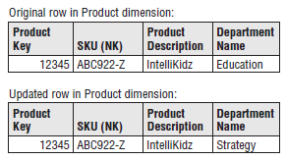

* Suppose a new merchandising person decides IntelliKidz software should be moved from the Education department to the Strategy department on February 1, 2013 to boost sales
* With a type 1 response, you simply update the existing row in the dimension table with the new department description, as illustrated in the updated row of the above figure
* In this case, **no dimension or fact table keys were modified** when IntelliKidz’s department changed
* Fact table rows still reference product key 12345, regardless of its departmental location
* ***If sales take off following the move to the Strategy department, you have no information to explain the performance improvement because the historical and more recent facts both appear as if IntelliKidz always rolled up into Strategy***
* The **type 1 response** is the **simplest approach for dimension attribute changes**
* In the dimension table, you **merely overwrite the preexisting value with the current assignment** while the **fact table is untouched**
* The **problem** with a type 1 response is that **you lose all history of attribute changes**
* **Because overwriting obliterates historical attribute values, you’re left solely with the attribute values *as they exist today***
* A **type 1 response is appropriate if the attribute change is an *insignificant* correction**
* It **also may be appropriate if there is no value in keeping the old description**
* However, **too often DW/BI teams use a type 1 response as the default for dealing with SCDs and end up totally missing the mark if the business needs to track historical changes accurately**
* After you implement a type 1, it’s difficult to change course in the future
* **NOTE: The type 1 response is easy to implement, but it does NOT maintain any history of prior attribute values**
* Also, be forewarned that **the *same* BI applications can produce *different* results before vs. after the type 1 attribute change**
* When the dimension attribute’s type 1 overwrite occurs, the fact rows are associated with the *new* descriptive context
* **Business users who rolled up sales by department on January 31 will get different department totals when they run the same report on February 1 following the type 1 overwrite.**
* There’s **another easily overlooked catch** to be aware of: **With a type 1 response** to deal with the relocation of IntelliKidz, **any preexisting aggregations based on the department value need to be *rebuilt***
* The aggregated summary data must *continue* to tie to the detailed atomic data, where it now appears that IntelliKidz has always rolled up into the Strategy department
* Finally, **if a dimensional model is deployed via an OLAP cube and the type 1 attribute is a hierarchical rollup attribute, like the product’s department in our example, the cube likely needs to be reprocessed when the type 1 attribute changes.**
* **At a *minimum*, similar to the relational environment, the cube’s performance aggregations need to be recalculated.**
* **WARNING: Even though type 1 changes appear the easiest to implement, remember they invalidate relational tables + OLAP cubes that have aggregated data over the affected attribute**

#### Type 2: Add New Row

* In Chapter 1: Data Warehousing, BI, and Dimensional Modeling Primer, we stated **one of the DW/BI system’s goals was to correctly represent history**
* A **type 2 response is the predominant technique for supporting this history-representing requirement** when it comes to SCD attributes
* Using the **type 2 approach**, when IntelliKidz’s department changed on February 1, 2013, **a new product dimension row** for IntelliKidz is **inserted to reflect the new department attribute value**.
* There are then *2* product dimension rows for IntelliKidz, as illustrated below, and each row contains a version of IntelliKidz’s attribute profile that was true *for a span of time.*

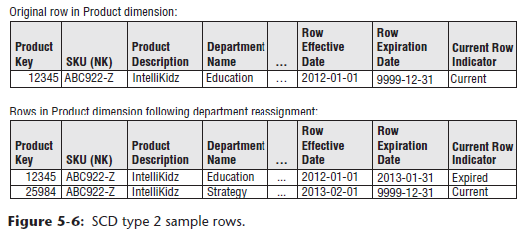

* With **type 2 changes**, the **fact table is again untouched 🡪** don’t go back to the historical fact table rows to modify the product key
* In the fact table, rows for IntelliKidz *prior to* February 1, 2013, would reference product key 12345 when the product rolled up to the Education department
* *After* February 1, new IntelliKidz fact rows would have *new* product key 25984 to reflect the move to the Strategy department.
* This is why we say **type 2 responses perfectly partition/segment history to account for the change**
* *Reports summarizing pre-February 1 facts look identical whether the report is generated before or after the type 2 change*
* ***Reinforce*** that **reported results may differ depending on whether attribute changes are handled as a type 1 or type 2**
* Let’s presume the electronic retailer sells $500 of IntelliKidz software during January 2013, followed by a $100 sale in February 2013
* If the department attribute is a type 1, results from a query reporting January and February sales would indicate $600 under “Strategy”
* Conversely, if the department name attribute is a type 2, sales would be reported as $500 for the Education department and $100 for the Strategy department
* ***Unlike the type 1 approach*, there is no need to revisit preexisting aggregation tables when using the type 2 technique**
* **Likewise, OLAP cubes do NOT need to be reprocessed if hierarchical attributes are handled as type 2**
* If constraining on the department attribute, the two product profiles are differentiated
* If constraining on product description, a query automatically fetches *both* IntelliKidz product dimension rows and *automatically joins* to the fact table for the *complete* product history
* **If you need to count the number of products correctly, then you’d just use the SKU natural key attribute as the basis of the distinct count rather than the surrogate key**
* **The natural key column becomes the glue that holds the separate type 2 rows for a single product together**
* **NOTE**: **The type 2 response is the primary workhorse technique for accurately tracking SCD attributes**
* **Type 2 is extremely powerful because the new dimension row automatically partitions history in the fact table.**
* Type 2 is the **safest response *if the business is not absolutely certain about the SCD business rules for an attribute***
* As discussed later, you **can provide the *illusion* of a type 1 overwrite when an attribute has been handled with the type 2 response**
* BUT the ***converse* is NOT true**
* If you treat an attribute as type 1, reverting to type 2 retroactively requires significant effort to create new dimension rows and then appropriately rekey the fact table

##### Type 2 Effective and Expiration Dates

* **When a dimension table includes type 2 attributes, you should include several administrative columns** on each row, as shown below



* The **effective and expiration dates refer to the moment when the row’s attribute values become valid or invalid**
* **Effective and expiration dates or date/timestamps are necessary in the ETL system because it needs to know which surrogate key is valid when loading historical fact rows**
* The effective and expiration dates **support precise time slicing of the dimension**, however there is **no need to constrain on these dates in the dimension table to get the right answer from the fact table**
* The row effective date is the first date the descriptive profile is valid
* When a new product is first loaded in the dimension table, the expiration date is set to December 31, 9999
* **By avoiding a null in the expiration date, you can reliably use a BETWEEN command to find the dimension rows that were in effect on a certain date**
* When a new profile row is added to the dimension to capture a type 2 attribute change, the previous row is **expired**
* **Typically suggested that the end date on the old row should be *just prior* to the effective date of the new row, leaving no gaps between these effective and expiration dates**
* The definition of “just prior” depends on the grain of the changes being tracked
* Typically, the effective and expiration dates represent changes that occur during a day
* **If tracking more granular changes, you’d use a date/timestamp instead**
* In this case, you may elect to apply different business rules, such as setting the row expiration date exactly equal to the effective date of the next row
* **This would require logic such as “>= effective date and < expiration date” constraints, invalidating the use of BETWEEN**
* Some argue that a **single effective date** is adequate, but this makes for **more complicated searches to locate the dimension row with the latest effective date that is <= to a date filter**
* **Storing an explicit *second* date simplifies the query processing**
* Likewise, a **“Current Row” indicator** is another useful **administrative dimension** attribute to **quickly constrain queries to only the current profiles**
* The **type 2 response to SCDs requires the use of surrogate keys**, but you’re already using them anyhow, right?
* Certainly **can’t use the operational natural key because there are multiple profile versions for the same natural key**
* It is **NOT sufficient to use the natural key with 2 or 2 version digits because you’d be vulnerable to the entire list of potential operational issues** (discussed in Chapter 3)
* Likewise, it’s **inadvisable to append an effective date to the otherwise PK of the dimension table to uniquely identify each version**
* **With the type 2 response, create a *new* dimension row with a *new* single-column PK to uniquely identify the new product profile**
* This **single-column PK establishes the linkage between the fact and dimension tables for a given set of product characteristics**
* There’s no need to create a confusing secondary JOIN based on the dimension row’s effective or expiration dates
* Some may be concerned about the administration of surrogate keys to support type 2 changes
* Chapter 19: ETL Subsystems and Techniques + Chapter 20: ETL System Design and Development Process and Tasks discuss a workflow for managing surrogate keys and accommodating type 2 changes in more detail

##### Type 1 Attributes in Type 2 Dimensions

* It is **not uncommon to mix *multiple* SCD techniques within the same dimension**
* **When type 1 *and* type 2 are *both* used in a dimension, sometimes a type 1 attribute change necessitates updating multiple dimension rows**
* Presume the dimension table includes a “product introduction date”
* If this attribute is corrected using type 1 logic after a type 2 change to another attribute occurs, introduction date should probably be updated on *both* versions of IntelliKidz’s profile, as illustrated below

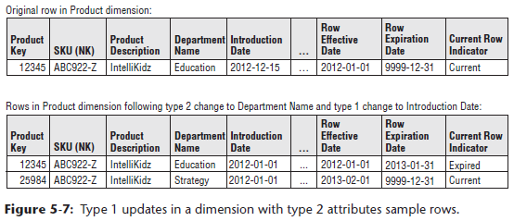

* **The data stewards need to be involved in defining the ETL business rules in scenarios like this**
* *Although the DW/BI team can facilitate discussion regarding proper update handling, the business’s data stewards should make the final determination, NOT the DW/BI team*

#### Type 3: Add New Attribute

* Although the **type 2 response partitions history**, it **does NOT enable you to associate the new attribute value with old fact history or vice versa**
* With the type 2 response, when you constrain the department attribute to Strategy, you see *only* IntelliKidz facts from *after* February 1, 2013
* **In most cases, this is exactly what you want**
* However, **sometimes you want to see fact data as if the change never occurred**.
* This happens most frequently with sales force reorganizations
* District boundaries may be redrawn, but some users still want the ability to roll up recent sales for prior districts just to see how they would have done under the old organizational structure
* For a few transitional months, there may be a need to track history for the new districts and conversely to track new fact data in terms of old district boundaries
* A type 2 response won’t support this requirement, but type 3 comes to the rescue
* In our software example, assume there is a legitimate business need to track *both* the new and prior values of the department attribute for a period of time around the February 1 change
* **With a type 3 response, you do NOT issue a new dimension row, but rather add a new *column* to capture the attribute change**, as illustrated below

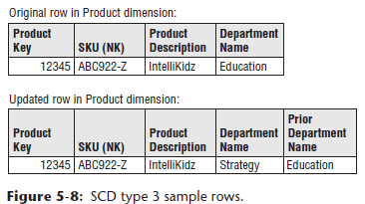

* We **altered the product dimension table to add a prior department attribute, and populate this new column with the existing department value (Education)**
* **The original department** **attribute is treated as a type 1 where you overwrite to reflect the current value** (Strategy)
* **All existing reports + queries immediately switch over to the new department description, *but* you can still report on the old department value by querying on the “prior” department attribute**
* **Don’t be fooled into thinking the higher-type number associated with type 3 indicates it’s “better”**
* **The techniques have not been presented in good, better, + best practice sequence**
* Frankly, **type 3 is infrequently used**
* **Appropriate when there’s a strong need to support 2 views of the world simultaneously**
* **Type 3 is distinguished from type 2 because the pair of “current” and “prior” attribute values are regarded as true *at the same time***
* **NOTE**: **The type 3 SCD technique enables you to see new *and* historical fact data by either the new *or* prior attribute values, sometimes called** **alternate realities**.
* **Type 3 is NOT useful for attributes that change unpredictably**, such as customer’s home state
* There would be no benefit in reporting facts based on a prior home state attribute that reflects a change from 10 days ago for some customers or 10 years ago for others
* **Unpredictable changes are typically handled best with type 2 instead**
* **Type 3 is most appropriate when there’s a *significant* change impacting *many* rows in the dimension table**, such as a product line or sales force reorganization.
* Such **en masse changes are prime candidates** because **business users often want the ability to analyze performance metrics using either the pre or post-hierarchy reorganization for a period of time**
* With **type 3 changes**, the **”prior” column is labeled to *distinctly* represent the pre-changed grouping**, such as 2012 department or pre-merger department
* **These column names provide clarity, but there may be unwanted ripples in the BI layer**
* Finally, **if the type 3 attribute represents a hierarchical rollup level within the dimension, then as discussed with type 1, the type 3 update and additional column would likely cause OLAP cubes to be reprocessed.**

##### Multiple Type 3 Attributes

* **If a dimension attribute changes with a *predictable rhythm*, sometimes the business wants to summarize performance metrics based on *any* of the historic attribute values**
* Imagine the product line is recategorized at the start of *every* year and the business wants to look at multiple years of historic facts based on the department assignment for the current year *or any prior year*
* In this case, **take advantage of the regular, predictable nature of these changes by *generalizing* the type 3 approach to a *series* of type 3 dimension attributes**, as illustrated below

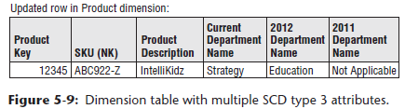

* On every dimension row, there is a current department attribute that is overwritten, + attributes for each annual designation, such as 2012 department
* Business users can roll up the facts with any of the department assignments
* If a product were introduced in 2013, the department attributes for 2012 and 2011 would contain Not Applicable values
* **The most recent assignment column should be identified as the current** department
* **This attribute will be used most frequently**
* You **don’t want to modify existing queries and reports to accommodate next year’s change**
* When the departments are reassigned in January 2014, alter the table to add a 2013 department attribute, populate this column with the current department values, and *then* overwrite the current attribute with the 2014 department assignment

#### Type 4: Add Mini-Dimension

* Thus far we’ve focused on *slow* evolutionary changes to dimension tables
* **What happens when the rate of change speeds up**, especially within a large multimillion-row dimension table?
* **Large dimensions present 2 challenges** that warrant special treatment: the **size of these dimensions can negatively impact browsing** and **query filtering performance**
* Plus, our tried-and-true **type 2 technique** for change tracking is **unappealing because we don’t want to add more rows to a dimension that already has millions of rows, *particularly if changes happen frequently***
* A **single technique comes to the rescue to address both the browsing performance and change tracking challenges** 🡪 **break off frequently-analyzed or frequently-changing attributes into a *separate* dimension, referred to as a mini-dimension**
* Ex: Create a mini-dimension for a group of more volatile customer demographic attributes, such as age, purchase frequency score, + income level, *presuming these columns are used extensively and changes to these attributes are important to the business*
* There would be **one row in the mini-dimension for each unique combination** of age, purchase frequency score, + income level encountered in the data, ***NOT* one row per customer**
* With this approach, the **mini-dimension becomes a set of demographic profiles**
* Although the number of rows in the customer dimension may be in the millions, the **number of mini-dimension rows should be a significantly smaller** **as you leave behind the more constant attributes in the original multimillion-row customer table**
* Sample rows for a demographic mini-dimension are illustrated below

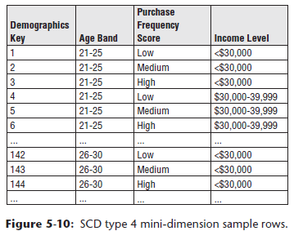

* **When creating the mini-dimension, continuously-variable attributes, such as income, are converted to banded ranges**
* In other words, the **attributes in the mini-dimension are typically forced to take on a relatively small number of discrete values**
* **Although this restricts use to a set of pre-defined bands, it drastically reduces the number of combinations in the mini-dimension**
* If you stored income at a specific dollar and cents value in the mini-dimension, when combined with the other demographic attributes, you could end up with as many rows in the mini-dimension as in the customer dimension itself
* The **use of band ranges is probably the most significant compromise associated with the mini-dimension technique**
* Although grouping facts from multiple band values is viable, **changing to more discreet bands** (such as $30,000-34,999) **at a *later* time is difficult**
* **If users *insist* on access to a specific raw data value, such as a credit bureau score that is updated monthly, it should be included in the fact table, in addition to being value banded in the demographic mini-dimension**
* Chapter 10: Financial Services discusses dynamic value banding of facts
* **However, such queries are much less efficient than constraining the value band in a mini-dimension table**
* **Every time a fact table row is built, 2 FKs related to the customer would be included: the customer dimension key and the mini-dimension demographics key** in effect at the time of the event, as shown below

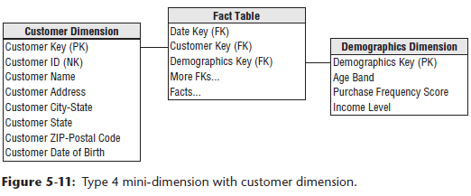

* **A mini-dimension delivers performance benefits by providing a smaller point of entry to the facts.**
* **Queries can avoid the huge customer dimension table unless attributes from that table are constrained or used as report labels**
* **When the mini-dimension key participates as a FK in the fact table, another benefit is that the fact table captures the demographic profile changes**
* Presume we’re loading data into a periodic snapshot fact table on a monthly basis
* Referring back to our sample demographic mini-dimension sample rows two figures above, if one customer, John Smith, were 25 years old with a low purchase frequency score and an income of $25,000, you’d begin by assigning demographics key 1 when loading the fact table
* If John has a birthday several weeks later and turns 26 years old, you’d assign demographics key 142 when the fact table was next loaded
* **Meanwhile, the demographics key on John’s earlier fact table rows would NOT be changed**
* **In this manner, the fact table tracks the age change**
* You’d continue to assign demographics key 142 when the fact table is loaded until there’s another change in John’s demographic profile
* If John receives a raise to $32,000 several months later, a new demographics key would be reflected in the next fact table load, + again, the earlier rows would be unchanged.
* **OLAP cubes also readily accommodate type 4 mini-dimensions**
* **Customer dimensions are somewhat unique in that customer attributes frequently are queried independently from the fact table**
* Ex: Users may want to know how many customers live in Dade County by age bracket for segmentation and profiling.
* Rather than forcing any analysis that combines customer + demographic data to link through the fact table, the most recent value of the demographics key also can exist as a FK on the customer dimension table
* Further describe this customer demographic **outrigger** as an SCD type 5 later
* **The demographic dimension cannot be allowed to grow too large**
* If you have 5 demographic attributes, each with 10 possible values, then the demographics dimension could have **100,000 (105) rows, a reasonable upper limit for the number of rows in a mini-dimension if you build out all the possible combinations in advance**
* An ***alternate* ETL approach is to build only the mini-dimension rows that *actually* occur in the data**
* However, **there are certainly cases where even this approach doesn’t help and you need to support more than 5 demographic attributes with 10 values each**
* We discuss the use of **multiple mini-dimensions** associated with a single fact table in Chapter 10
* **Demographic profile changes sometimes occur *outside* a business event, such as when a customer’s profile is updated in the absence of a sales transaction**
* **If the business requires accurate point-in-time profiling, a supplemental fact-less fact table (only used to establish relationships between elements of different dimensions) with effective and expiration dates can capture every relationship change between the customer and demographics dimensions**

### Hybrid Slowly Changing Dimension Techniques

* Now we discuss **hybrid** approaches that combine the basic **SCD techniques**
* Designers sometimes become enamored with these hybrids because they seem to provide the best of all worlds
* However, the **price paid for greater analytic flexibility is often greater complexity**
* Although IT professionals may be impressed by elegant flexibility, business users may be just as easily turned off by complexity
* **Should *not* pursue these options unless the business agrees they’re needed to address their requirements**
* These final **approaches are most relevant if you’ve been asked to preserve the historically accurate dimension attribute associated with a fact event, while supporting the option to *report historical facts according to the current attribute values***
* The basic SCD techniques do not enable this requirement easily on their own.

#### Type 5: Mini-Dimension and Type 1 Outrigger

* Returning to the **type 4 mini-dimension**, an **embellishment** to this technique = **add a current mini-dimension key as an attribute in the primary dimension**
* This **mini-dimension key reference is a type 1 attribute, overwritten with every profile change**
* Wouldn’t want to track this attribute as a type 2 because then you’d be capturing volatile changes w/in the large multimillion-row dimension and **avoiding this explosive growth was one of the original motivations for type 4**
* **Type 5** is **useful if you want a current profile count in the absence of fact table metrics or want to roll up historical facts based on the customer’s current profile**
* Logically represent the primary dimension and mini-dimension **outrigger** (**a dimension table/entity joined to other *dimension* tables in a star schema**) as a single table in the presentation area, as shown below

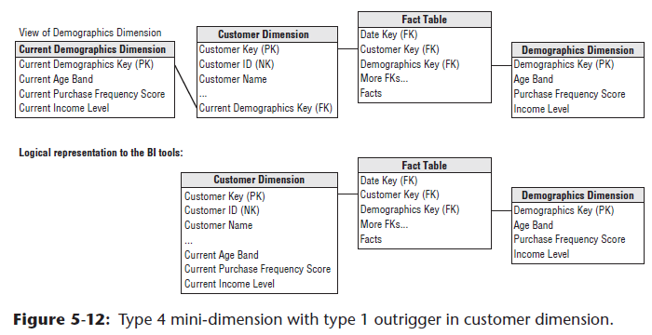

* **To minimize user confusion and potential error, the current attributes in this role-playing dimension should have *distinct* column names distinguishing them**, such as “current age band”.
* ***Even with unique labeling*, be aware that presenting users with 2 avenues for accessing demographic data, through either the mini-dimension or outrigger, can deliver more functionality and complexity than some can handle**
* **NOTE**: The **type 4 mini-dimension** terminology refers to **when the demographics key is part of the fact table composite key**
* If the demographics key is a FK in the customer dimension, it is referred to as an **outrigger+**

#### Type 6: Add Type 1 Attribute to Type 2 Dimension

* Returning to the electronics retailer’s product dimension, w/ **type 6,** you’d have **2 department attributes on each row**
* The *current* department column represents the current assignment, + the *historic* department column is a type 2 attribute representing the historically accurate department value.
* When IntelliKidz software is introduced, the product dimension row would look like the first scenario below

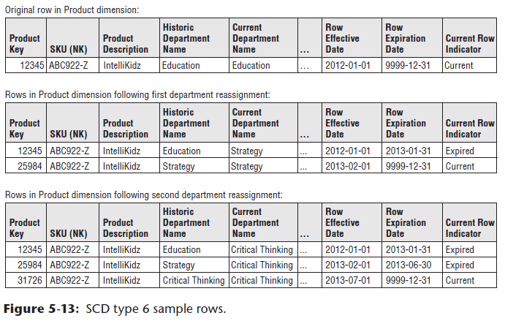

* **When the departments are restructured** and IntelliKidz is moved to the Strategy department, you’d **use a type 2 response to capture the attribute change by issuing a new row**
* In this new IntelliKidz dimension row, the **current department will be identical to the historical department**
* For **all previous instances** of IntelliKidz **dimension rows**, the **current department attribute will be overwritten to reflect the current structure**
* *Both* IntelliKidz rows would identify the Strategy department as the current department (refer to the 2nd scenario above)
* In this manner you **can use the historic attribute to group facts based on the attribute value that was in effect *when the facts occurred***
* Meanwhile, the ***current* attribute rolls up all the historical fact data** for both product keys 12345 and 25984 into the current department assignment
* If IntelliKidz were *then* moved into the Critical Thinking software department, the product table would look like the final set of rows above
* The current column groups all facts by the current assignment, while the historic column preserves the historic assignments accurately + segments the facts accordingly
* **Type 6: Issue a new *row* to capture the change (type 2) and add a new *column* to track the current assignment (type 3), where *subsequent changes are handled as a type 1 response***
* Again, **although this technique may be naturally appealing to some, it is important to always consider the business users’ perspective as you strive to arrive at a reasonable balance between flexibility and complexity**
* **May want to limit which columns are exposed to some users so they’re not overwhelmed by choices**

#### Type 7: Dual Type 1 and Type 2 Dimensions

* In thinking about **type** **6**, would the technique **be appropriate for supporting both current and historic perspectives for 150 attributes in a large dimension table**? 🡪 **NO**
* In this final hybrid **technique 7, the dimension natural key (*assuming it’s durable*) is included as a fact table FK, in addition to the surrogate key for type 2 tracking**, as illustrated below

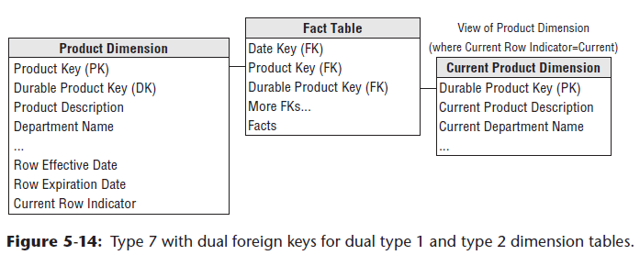

* **If the natural key is unwieldy or ever reassigned, you should use a *separate* durable supernatural key instead**
* **The type 2 dimension contains historically accurate attributes for filtering + grouping based on the effective values when the fact event occurred**
* **The durable key joins to a dimension with *just* the current type 1 values**
* Again, the **column labels in this table should be prefaced with “*current*” to reduce the risk of user confusion**
* Can **use these dimension attributes to summarize or filter facts based on the *current* profile, regardless of the attribute values in effect when the fact event occurred**.
* This approach **delivers the same functionality as type 6**
* Although the type 6 response spawns more attribute columns in a single dimension table, **this approach relies on 2 FKs in the fact table**
* **Type 7 invariably requires less ETL effort because the current type 1 attribute table could easily be delivered via a view of the type 2 dimension table, limited to the most current rows**
* The incremental cost of this final technique is the additional column carried in the fact table
* However, queries based on current attribute values would be filtering on a smaller dimension table than previously described with type 6.
* Of course, you *could avoid storing the durable key in the fact table by joining the type 1 view containing current attributes to the durable key in the type 2 dimension table itself*
* In this case, however, **queries that are only interested in current rollups would need to traverse from the type 1 outrigger through the more voluminous type 2 dimension before finally reaching the facts, which would likely negatively impact query performance for current reporting**
* A **variation of this dual type 1 and type 2 dimension table approach again relies on a view to deliver current type 1 attributes**
* However, in this case, the **view associates the current attribute values with all the durable key’s type 2 rows, as illustrated below**

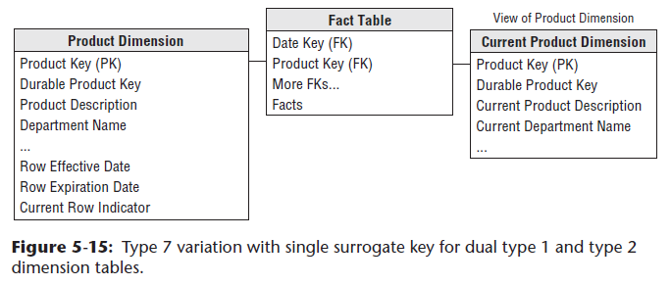

* Both dimension tables above have the same number of rows, but the contents of the tables are different, as shown below

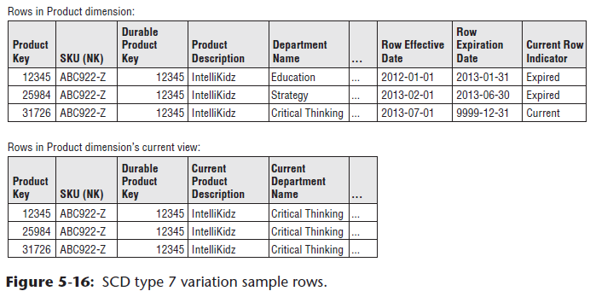

##### Type 7 for Random “As Of” Reporting

* Finally, although it’s uncommon, you might be asked to roll up historical facts based on any specific point-in-time profile, in addition to reporting by the attribute values in effect when the fact event occurred or by the attribute’s current values.
* Ex: Perhaps the business wants to report 3 years of historical metrics based on the hierarchy in effect on December 1 of last year
* In this case, you can use the dual dimension keys in the fact table to your advantage
* **First, filter on the type 2 dimension row effective and expiration dates to locate the rows in effect on December 1 of last year**
* With this constraint, a single row for each durable key in the type 2 dimension is identified.
* **Then join this filtered set to the durable key in the fact table to roll up any facts based on the point-in-time attribute values**
* It’s as if you’re defining the meaning of “current” on-the-fly
* Obviously, you must filter on the row effective and expiration dates, or you’ll have multiple type 2 rows for each durable key
* **Finally, only unveil this capability to a limited, highly analytic audience; this embellishment is not for the timid**

### Slowly Changing Dimension Recap

