# Kimball Data Warehouse Toolkit

## Ch 9 – Human Resources Management

* HR data is the last in the series dealing with **cross-industry business applications**
* Similar to the accounting + finance data described in Chapter 7, **HR information is disseminated broadly throughout the organization**
* Organizations want to better understand employee demographics, skills, earnings, + performance to maximize their impact
* **Concepts:**
* Dimension tables to track employee profile changes
* **Periodic headcount snapshots**
* Bus matrix for a snippet of HR-centric processes
* Pros and cons of packaged DW/BI solutions or data models
* **Recursive employee hierarchies**
* **Multivalued skill keyword attributes** handled via dimension attributes, outriggers, or bridges
* Survey questionnaire data + text comments

### Employee Profile Tracking

* Thus far the dimensional models we’ve designed closely resemble each other, where **Fact tables contain key performance metrics that typically can be added across all the dimensions**
* It is **easy for dimensional modelers to get lulled into a kind of additive complacency**
* *In most cases, this is exactly how it is supposed to work*
* *However*, with HR employee data, a **robust employee dimension supports numerous metrics required by the business on its own**.
* To frame the problem, assume you work in the HR department of a large enterprise
* Each employee has a detailed HR profile with at least 100 attributes, including hire date, job grade, salary, review dates, review outcomes, vacation entitlement, organization, education, address, insurance plan, + many others
* Employees are constantly hired, transferred, + promoted, as well as adjusting their profiles in a variety of ways
* A **high-priority business requirement is to accurately track and analyze employee profile changes**.
* Might immediately visualize a schema in which each employee profile change event is captured in a transaction-grained fact table, as depicted below

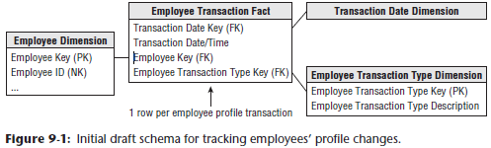

* The granularity of this somewhat generalized fact table would be 1 row per employee profile *transaction*
* Because **no numeric metrics are associated with changes made** to employee profiles, such as a new address or job grade promotion, the **fact table is fact-less**.
* In the above draft schema, dimensions include the transaction date, transaction type, + employee
* The **transaction type dimension** refers to **the reason code that caused the creation of this particular row**, such as a promotion or address change
* The **employee dimension** is extremely **wide** **with many attribute columns**
* We **envision using the type 2 SCD technique for tracking changed profile attributes within this employee dimension**
* Consequently, **with every employee profile transaction in the above fact table, you’d *also* create a new type 2 row in the employee dimension that represents the employee’s profile as a result of the profile change event**
* This **new row continues to accurately describe the employee until the next employee transaction occurs at some indeterminate time in the future**
* An alert reader is quick to point out that the **employee profile transaction fact table and type 2 employee dimension table have the same number of rows, + they’re almost always JOIN-ed to one another**
* At this point, dimensional modeling alarms should be going off 🡪 You **certainly don’t want to have as many rows in a fact table as you do in a related dimension table**
* *Instead* of using the initial schema above, you can **simplify the design by embellishing the employee dimension table to make it more powerful + thereby doing away with the profile transaction event fact table**

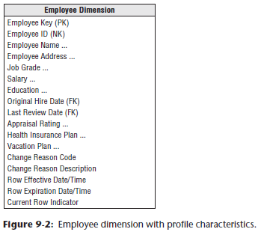

* As depicted above, the **employee dimension contains a snapshot of the employee profile characteristics following the employee’s profile change**
* The **“transaction type” description becomes a “change reason” attribute in the employee dimension to track the cause for the profile change**
* In **some cases**, the **affected characteristics are numeric**
* **If the numeric attributes are *summarized* rather than simply *constrained upon*, they belong in a fact table instead**.
* As you’d expect, the **surrogate employee key is the PK of the dimension table**
* The ***durable natural* employee ID used in the HR operational system to persistently identify an employee is included as a dimension *attribute***

#### Precise and Effective Expiration Timespans

* As discussed in Chapter 5: Procurement with the coverage of **SCD techniques**, you **should include 2 columns on the employee dimension to capture when a specific row is effective + then expired**
* These columns **define a precise timespan during which the employee’s profile is accurate**.
* Historically, when daily data latency was the norm, effective + expiration columns were dates
* However, if you load data from any business process on a more frequent basis, the columns should be datetime stamps, so that you can associate the appropriate employee profile row, which may diff er between 9 a.m. and 9 p.m. on the same day, to operational events
* The **expiration attribute for the current row is set to a future date**
* When a row needs to be expired because the ETL system has detected a new profile of attributes, the expiration attribute is typically set to “*just before*” said new row’s effective timestamp (meaning either the prior day, minute, or second)
* If the employee’s profile is accurately changed for a period of time, then the employee reverts back to an earlier set of characteristics, a new employee dimension row is inserted
* **Resist the urge to simply revisit the earlier profile row + modify the expiration date because multiple dimension rows would be effective at the same time.**
* The **current row indicator** enables the most recent status of any employee to be retrieved quickly
* If a new profile row occurs for this employee, the indicator in the former profile row needs to be updated to indicate it is no longer the current profile
* On its own, **a datetime stamped type 2 employee dimension answers a number of interesting HR inquiries**
* Can choose an exact historical point in time + ask how many employees you have + what their detailed profiles were at that specific moment by constraining the datetime to be equal to or greater than the effective datetime + strictly less than the expiration datetime
* The query can perform counts + constraints against all rows returned from such constraints

#### Dimension Change Reason Tracking

* **When a dimension row contains type 2 attributes, you can embellish it with a change reason**
* In this way, **some ETL-centric metadata is embedded with the actual data**
* The change reason attribute could contain a 2-character abbreviation for each changed attribute on a dimension row
* Ex: The change reason attribute value for a last name change could be LN or a more legible value, such as “Last Name”, depending on the intended usage and audience
* Ex: If someone asks how many people changed ZIP codes last year, the SELECT statement would include a LIKE operator and wild cards, such as "WHERE ChangeReason LIKE '%ZIP%’".
* **Because multiple dimension attributes may change concurrently + be represented by a single new row in the dimension, the change reason would be multivalued**
* As we’ll explore later when discussing employee skills, the **multiple reason codes could be handled as a single text string attribute**, such as “|Last Name|ZIP|” **or via a multivalued bridge table**
* **NOTE**: **The effective + expiration datetime stamps, along with a reason code description, on each row of a type 2 SCD allows very precise time slicing of the dimension by itself**
* Finally, employee profile changes may be captured in the underlying source system by a set of micro-transactions corresponding to each individual employee attribute change
* **In the DW/BI system, you may want to encapsulate the series of micro-transactions from the source system + treat them as a super transaction**, such as an employee promotion, because it would be **silly to treat these artificial micro-transactions as separate type 2 changes**
* The **new type 2 employee dimension row would reflect ALL the relevant changed attributes in one step**
* **Identifying these super transactions may be tricky**
* **Best way to ID = ensure the HR operational application captures the higher-level action**

#### Profile Changes as Type 2 Attributes or Fact Events

* We just described the handling of employee attribute changes as type 2 SCD attributes with profile effective and expiration dates within the Employee dimension
* Designers sometimes wholeheartedly embrace this pattern + try to leverage it to capture *every* employee-centric change 🡪 This **results in a dimension table with potentially hundreds of attributes + millions of rows for a 100,000-employee organization, given the attributes’ volatility**
* **Tracking changes within the employee dimension table enables you to easily associate the employee’s accurate profile with *multiple* business processes**
* Simply load these fact tables with the employee key in effect when the fact event occurred, and filter + group based on the full spectrum of employee attributes
* ***But the pendulum can swing too far***
* **Probably shouldn’t use the Employee dimension to track every employee review event, every benefit participation event, or every professional development event**
* As illustrated in the bus matrix below, **many of these events involve *other* dimensions**, like an event date, organization, benefit description, reviewer, approver, exit interviewer, separation reasons, the list goes on

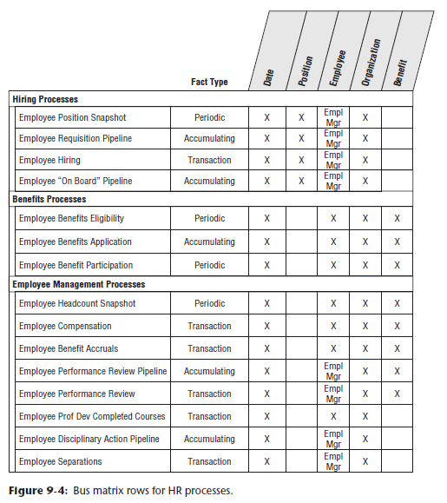

* Consequently, **most of such events should be handled as separate process-centric fact tables**.
* **Although many HR events are fact-less, capturing them within a fact table enables business users to easily count or trend by time periods and all the other associated dimensions**
* It’s certainly **common to include the outcome of these HR events**, like the job grade resulting from a promotion, **as an attribute on the employee dimension**
* But **designers sometimes err by including lots of FKs to outriggers for the reviewer, benefit, separation reason, + other dimensions within the employee dimension, resulting in an overloaded dimension that’s difficult to navigate**.

### Headcount Periodic Snapshot

* In addition to *profiling* employees in HR, you also want to report *statuses* of employees on a regular basis
* Business managers are interested in counts, statistics, + totals, including number of employees, salary paid, vacation days taken, vacation days accrued, number of new hires, + number of promotions
* They want to analyze the data by all possible slices, including time and organization, + employee characteristics
* As shown below, the **employee headcount periodic snapshot consists of an ordinary looking fact table with three dimensions: month, employee, and organization**

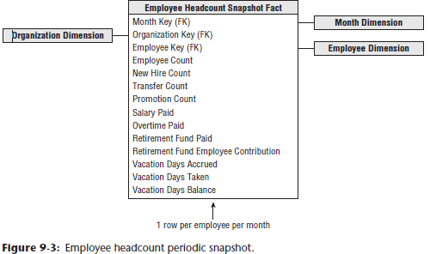

* The month dimension table contains the usual descriptors for the corporate calendar at the *month grain*
* The employee key corresponds to the employee dimension row *in effect at the end of the last day of the given reporting month* to guarantee the month-end report is a correct depiction of the employees’ profiles
* The organization dimension contains a description of the organization to which the employee belongs *at the close of the relevant month*
* **The facts in this headcount snapshot consist of monthly numeric metrics + counts that may be difficult to calculate from the employee dimension table *alone***.
* These **monthly counts + metrics are additive across *all* the dimensions or dimension attributes, *except for any facts labeled as balances***
* **All balances are *semi*-additive and must be *averaged* across the month dimension *after* adding across the other dimensions**

### Bus Matrix for HR Processes

* Although **an employee dimension with precise type 2 SCD tracking coupled with a monthly periodic snapshot of core HR performance metrics** is a good start, they **just scratch the surface when it comes to tracking HR data**
* The bus matrix below illustrates other processes that HR professionals + functional managers are likely keen to analyze



* We’ve embellished this preliminary bus matrix with the type of fact table that might be used for each process
* *However, your source data realities and business requirements may warrant a different or complementary treatment*
* **Some of these business processes capture performance metrics, but many result in fact-less fact tables, such as benefit eligibility or participation**

### Packaged Analytic Solutions and Data Models

* **Many organizations purchase a vendor solution to address their operational HR application needs,** + most of these products offer an add-on DW/BI solution
* In addition, other vendors sell standard data models, potentially with prebuilt data loaders for the popular HR application products.
* Vendors + proponents argue these standard, prebuilt solutions + models allow for more rapid, less risky implementations by reducing the scope of the data modeling + ETL development effort
* After all, every HR department hires employees, signs them up for benefits, compensates them, reviews them, + eventually processes employee separations
* Why bother re-creating the wheel by designing custom data models + solutions to support these common business processes when you can buy a standard data model or complete solution instead?
* **Although there are undoubtedly common functions, especially within the HR space, businesses typically have unique peculiarities**
* To handle these nuances, **most application software vendors introduce abstractions in their products, which enable them to be more easily “customized.”**
* These **abstractions**, like the party table and associated apparatus to describe each role or generic attribute column names rather than more meaningful labels, **provide flexibility to adapt to a variety of business situations**
* Although implementation adaptability is a win for vendors who want their products to address a broad range of potential customers’ business scenarios, the **downside is the associated complexity**
* HR professionals who live with the vendor’s product 24x7 are often willing to adjust their vocabulary to accommodate the abstractions
* But these **abstractions can feel like a foreign language for less-immersed functional managers**
* Delivering data to the business via a packaged DW/BI solution or industry-standard data model may bypass the necessary translations into the business’s vernacular
* Besides the reliance on the vendor’s terminology instead of incorporating the business’s vocabulary in the DW/BI solution, **another potential sharp corner is the integration of source data from other domains**
* **Can you readily conform the dimensions in the vendor solution or industry model with other internally available master data?**
* **If not, the packaged model is destined to become another isolated stovepipe data set**
* Clearly, this outcome is unappealing
* Although it may be less of an obstacle if all your operational systems are supported by the same ERP vendor, or you’re a small organization without an IT shop doing independent development
* *What can you realistically expect to gain from a packaged model?*
* **Prebuilt generic models can help identify core business processes + associate common dimensions**, which **provides some comfort for DW/BI teams feeling initially overwhelmed by the design task**
* After a few days or weeks studying the standard model, most teams gain enough confidence to want to customize the schema for *their* data
* However, **is this knowledge worth the price tag associated with the packaged solution or data model?**
* You **could likely gain the same insight by spending a few weeks with the business users**
* You’d **not only improve your understanding of the business’s needs, but also begin bonding business users to the DW/BI initiative**
* Also, **just because a packaged model or solution costs thousands of dollars doesn’t mean it exhibits generally accepted dimensional modeling best practices**
* Unfortunately, **some standard models embody common dimensional modeling design flaws**
* This isn’t surprising if the model’s designers focused more on best practices for source system data capture rather than those required for BI reporting + analytics
* It’s difficult to design a pre-defined generic model, even if the vendor owns the data capture source code.

### Recursive Employee Hierarchies

* A common employee characteristic is the name of the employee’s *manager*
* You *could* simply embed this attribute along with the other attributes in the employee dimension, but **if the business users want *more* than the manager’s name, more complex structures are necessary**
* 1 approach = **Include the manager’s employee key as *another* FK in the *fact* table**, as shown below

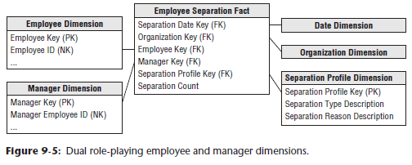

* This **manager employee key JOINs** to a **roleplaying employee dimension** where **every attribute name refers to “manager” to differentiate the manager’s profile from the employee’s**
* *This* approach **associates the employee + their manager whenever a row is inserted into a fact table**
* BI **analyses can easily filter + group by either employee or manager attributes with virtually identical query performance because both dimensions provide symmetrical access to the fact table**
* The **downside** of this approach = these **dual FKs *must* be embedded in *every* fact table to support managerial reporting**
* Another option = **Include the manager’s employee key as an attribute on the employee’s *dimension* row**
* The **manager key would JOIN to an outrigger consisting of a roleplay on the employee dimension where all the attributes reference “manager” to differentiate them from the employee’s characteristics**, as shown below

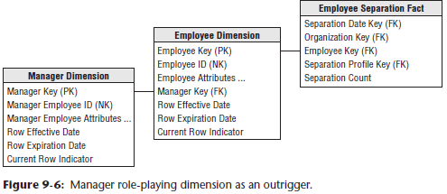

* If **the manager’s FK in the employee dimension is designated as a type 2 SCD attribute, then new employee rows would be generated with each manager change**
* *However*, **think carefully about the underlying ETL business rules**

#### Change Tracking on Embedded Manager Key

* Example of the above: Abby is Hayden’s manager
* With the **outrigger approach** just described, **Hayden’s employee dimension row would include an attribute linking to Abby’s row in the manager roleplay employee dimension**
* If **Hayden’s manager changes**, + assuming the business *wants* to track these historical changes, then **treating the manager FK as a type 2 SCD + creating a new row for Hayden to capture his new profile with a new manager would be appropriate**.
* *However*, **think about the desired outcome if Abby were *still* Hayden’s manager, but her employee profile changes**, perhaps caused by something as innocuous as a home address change
* *If* the home address is designated as a type 2 SCD attribute, this move would spawn a **new employee dimension row for Abby**
* If the manager key is *also* designated as a type 2 SCD attribute, then Abby’s new employee key would also spawn **a new dimension row for Hayden**
* Now, imagine Abby is the CEO of a large organization 🡪 A type 2 change in her profile would ripple through the *entire* table + you’d end up replicating a new profile row for *every* employee due to a single type 2 SCD attribute change on the CEO’s profile
* Does the business *want* to capture such manager profile changes?
* **If not, perhaps the manager key on the employee’s row should be the manager’s durable natural key linked to a roleplaying dimension limited to just the current row for each manager’s durable natural key in the dimension**
* If you **designate the manager’s key in the employee dimension to be a type 1 SCD attribute**, it would **always associate an employee with her current manager**
* Although this **simplistic approach obliterates history, it may completely satisfy the business user’s needs**

#### Drilling Up and Down Management Hierarchies

* **Adding an attribute** (either a textual label or a FK to a roleplaying dimension) **to an employee dimension row is appropriate for handling the fixed-depth, many-to-one employee-to-manager relationship**
* However, **more complex approaches might be required if the business wants to navigate a deeper recursive hierarchy, such as identifying an employee’s entire management chain or drilling down to identify the activity for all employees who directly or indirectly work for a given manager**
* If you use an OLAP tool to query employee data, the embedded manager key on every employee dimension row may suffice
* **Popular OLAP products contain a parent/child hierarchy structure that works smoothly with variable depth recursive hierarchies** (one of the strengths of OLAP products)
* However, **to query the recursive employee/manager relationship in the *relational* environment, you must use Oracle’s *nonstandard* CONNECT BY syntax or SQL’s recursive CTE syntax**
* **Both approaches are virtually unworkable for business users armed with a BI reporting tool**
* So, you’re left with options described in Chapter 7 for dealing with variable-depth customer hierarchies



* In the figure below, the **employee dimension** from the figure above **relates to the fact table** through a **bridge table**

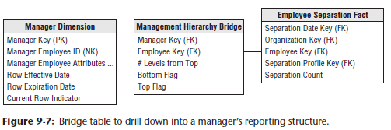

* The **bridge table** **has 1 row for each manager and each employee who is directly or indirectly in their management chain, + an additional row for the manager to himself**
* The bridge JOINs shown above enable you to drill down within a manager’s chain of command
* As previously described, there are **several disadvantages to this approach:**
* The **bridge table is somewhat challenging to build**, plus it **contains many rows, so query performance can suffer**
* The **BI UX is complicated for ad hoc queries**, although we’ve seen analysts effectively use it.
* Finally, **if users want to aggregate information up rather than down a management chain, the JOIN paths must be reversed**
* Once again, the **situation is further complicated if you want to track employee profile changes in conjunction with the bridge table**
* If the manager and employee reflect employee profiles with type 2 SCD changes, the **bridge table** **will** **experience rapid growth**, especially when senior management profile changes cause new keys to ripple across the organization
* ***Could* use durable natural keys in the bridge table**, instead of the employee keys which capture type 2 SCD profile changes
* Limiting the relationship to the management hierarchy’s current profiles is one thing
* However, **if the business wants to retain a history of employee/manager rollups, you need to embellish the bridge table with effective and expiration dates that capture the effective timespan for each employee/manager relationship**
* Propagation of new rows in this bridge table using durable keys is substantially reduced compared to the above figure’s bridge because new rows are added when reporting relationships change, *NOT* when *any* type 2 employee attribute is modified
* A **bridge table built on durable keys = easier to manage, but quite challenging to navigate,** especially given the need to associate the relevant organizational structures with the event dates in the fact table
* Given the complexities, the **bridge table should be buried within a canned BI application for all but a small subset of power BI users**
* The alternative approaches discussed in Chapter 7 for handling recursive hierarchies (like the pathstring attribute) are also relevant to the management hierarchy conundrum
* Unfortunately, there’s **no silver bullet solution for handling these complex structures in a simple + fast way**

### Multi-valued Skill Keyword Attributes

* Assume IT wants to supplement the employee dimension w/ technical skillset proficiency info
* Could consider these technical skills (programming languages, OSs, database platforms, etc.) to be **keywords** describing employees, + **each employee is tagged with a *number* of skill keywords**
* You want to search the IT employee population by their descriptive skills.
* If the technical **skills of interest were a *finite* number, you could include them as individual attributes in the employee dimension**
* The advantage of using **positional dimension attributes**, such as a Linux attribute with domain values such as “Linux Skills” and “No Linux Skills”, is they’re **easy to query and deliver fast query performance**
* This works well to a point but **falls apart when the number of potential skills expands**

#### Skill Keyword Bridge

* **More realistically, each employee will have a variable, unpredictable number of skills**
* In this case, the **skill keyword attribute is a prime candidate to be a multivalued dimension**
* Skill keywords, by their nature, are open-ended, + new skills are added regularly as domain values
* We’ll show 2 logically equivalent modeling schemes for handling open-ended sets of skills
* The figure below shows a **multivalued dimension design for handling the skills as an outrigger bridge table to the employee dimension table**

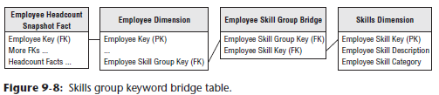

* **Sometimes the multivalued bridge table is JOIN-ed *directly* to a fact table** (see Chapter 14: Healthcare)
* The **skills group bridge identifies a given set of skill keywords**
* IT employees proficient in Oracle, Unix, *and* SQL would be assigned the *same* skills group key
* **In the skills group bridge table, there would be 3 rows for this particular group, one for each of the associated skill keywords** (Oracle, Unix, SQL)

##### AND/OR Query Dilemma

* Assuming you built the schema shown above, you are still **left with a serious query problem**
* Query requests against the skill keywords fall into 2 categories
* **OR queries** (ex: “Unix” OR “Linux” experience) **can be satisfied by a simple OR constraint on the skills description attribute in the skills dimension table**
* *However*, **AND queries** (ex: “Unix” AND “Linux” experience) are **difficult because the AND constraint is a constraint across 2 rows in the skills dimension**
* **SQL is notoriously poor at handling constraints across rows**
* The **answer = Create SQL code using UNIONs and INTERSECTIONs, probably in a custom interface that hides the complex logic from the business user**
* The SQL code would look like this:
* (SELECT employee_ID, employee_name

FROM Employee, SkillBridge, Skills

WHERE Employee.SkillGroupKey = SkillBridge.SkillGroupKey AND

SkillGroup.SkillKey = Skill.SkillKey AND Skill.Skill = "UNIX")

UNION / INTERSECTION

(SELECT employee_ID, employee_name

FROM Employee, SkillBridge, Skills

WHERE Employee.SkillGroupKey = SkillBridge.SkillGroupKey AND

SkillGroup.SkillKey = Skill.SkillKey AND Skill.Skill = "LINUX")

* Using the **UNION lists employees with Unix *or* Linux experience, whereas using INTERSECTION identifies employees with Unix *and* Linux experience**

#### Skill Keyword Text String

* **Can remove the many-to-many bridge and the need for UNION/INTERSECTION SQL by simplifying the design**
* **One approach = Add a skills list outrigger to the employee dimension containing one long text string concatenating all the skill keywords for that list key**
* **Need a special delimiter** such as a backslash/vertical bar at the beginning of the skills text string + after each skill in the list
* Thus, the skills string containing Unix and C++ would look like “|Unix|C++|”
* This **outrigger approach presumes a number of employees share a common list of skills**
* If the **lists are NOT reused frequently**, you could ***collapse* the skills list outrigger** by simply **including** the skills **list text string as an employee dimension attribute**, as shown below

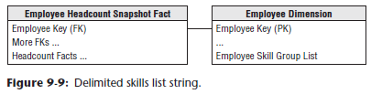

* **Text string searches can be challenging because of the ambiguity caused by searching on uppercase or lowercase** (UNIX or Unix or unix?)
* Resolve this by **coercing the skills list to upper case with the UPPER/LOWER function** in most SQL environments.
* With the design above the AND/OR dilemma can be addressed in a *single* SELECT statement
* OR constraint looks like this: UPPER(skill_list) like '%|UNIX|% OR UPPER(skill_list) like '%|LINUX|%'
* AND constraint = exact same structure: UPPER(skill_list) like '%|UNIX|' AND UPPER(skill_list) like '%|LINUX|%'
* % is a wild card pattern-matching character defined in SQL that matches 0+ characters
* The | delimiter is used explicitly in the constraints to exactly match the desired keywords and not get erroneous matches
* The **keyword list approach shown above can work in *any* RDB because it is based on standard SQL**
* **Although the text string approach facilitates AND/OR searching, it *doesn’t* support queries that count by skill keyword**

### Survey Questionnaire Data

* HR departments often collect survey data from employees, especially when gathering peer and/or management review data
* HR analyzes questionnaire responses to determine the average rating for a reviewed employee + within a department.
* **To handle questionnaire data in a dimensional model, a fact table with one row for each question on a respondent’s survey is typically created**, as illustrated below

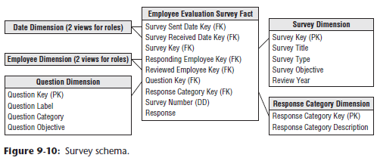

* **2 role-playing employee dimensions in the schema correspond to the *responding* employee and *reviewed* employee**
* The **survey dimension has descriptors about the survey instrument**
* The **question dimension provides the question + its categorization** (presumably, the same question is asked on multiple surveys)
* The survey and question dimensions can be useful when searching for specific topics in a broad database of questionnaires
* The **response dimension contains the responses + perhaps categories of responses**, such as favorable or hostile.
* Creating the **simple schema above supports robust slicing + dicing of survey data**
* Variations of this schema design would be useful for analyzing all types of survey data, including customer satisfaction and product usage feedback

#### Text Comments

* **Facts are typically thought of as continuously-valued numeric measures, while dimension attributes, on the other hand, are often drawn from a discrete list of domain values**
* So **how do you handle textual comments**, such as a manager’s remarks on a performance review or freeform feedback on a survey question, which **seem to defy clean classification into the fact *OR* dimension category?**
* Although IT professionals may instinctively want to simply exclude them from a dimensional design, **business users may demand they’re retained to further describe the performance metrics**
* After it’s been confirmed the business is unwilling to relinquish the text comments, you should **first determine if the comments can be parsed into well-behaved dimension attributes**
* Although there are **sometimes opportunities to categorize the text**, such as a compliment versus complaint, the **full text verbiage is typically also required**
* Because freeform text takes on so many potential values, designers are sometimes tempted to store the text comment within the fact table
* Although cognizant that **fact tables are typically limited to FKs, degenerate dimensions, + numeric facts**, they contend the text comment is just “another degenerate dimension”.
* Unfortunately, **text comments don’t qualify as degenerate dimensions**.
* **Freeform text fields *shouldn’t* be stored in the fact table because they just add bulky clutter to the table**
* **Depending on the database platform, this relatively low value bulk may get dragged along on every operation involving the fact table’s much more valuable performance metrics**
* **Rather than treating comments as textual metrics**, we recommend **retaining them outside the fact table**
* Comments should either be **captured** **in a separate comments dimensions (w/ a corresponding FK in the fact table) *OR* as an attribute on a transaction-grained dimension table**
* **In some situations, identical comments are observed multiple times**
* At a minimum, this **typically occurs with a “No Comment” comment**
* **If the cardinality of the comments is less than the number of transactions, the text should be captured in a comments dimension**.
* Otherwise, **if there’s a unique comment for *every* event, it’s treated as a transaction dimension attribute**
* **In either case, query performance when this sizeable dimension is joined to the fact table will be slow**
* **However, by the time users are viewing comments, they’ve likely (and hopefully) significantly filtered their query as they can realistically read only a limited number of comments**.
* Meanwhile, the more common analyses focusing on the fact table’s performance metrics won’t be burdened by the extra weight of the textual comments on every fact table query