for Loops

# Parts of a for loop:

1. Initialize variables. Here we declare new variables and set them equal to values. In this example, the variable i of type int is created and set to a value 1, and Java moves on to Step 2 (see below).
2. Test to continue. This is an expression that Java will evaluate (to true or false). If the expression evaluates to false, Java exits the for loop. If it evaluates to true, Java moves on to Step 3:
3. Loop body. This is a block of Java code containing one or more Java statements. Java executes each of these statements, then goes to Step 4:
4. Update variables. This tells Java what to do to update the variables involved in the for loop. After updating the variables (in this case, adding 1 to the int variable i), Java goes back to Step 2.

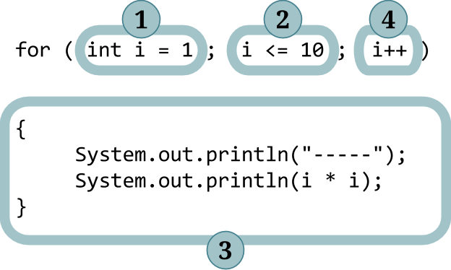

# 

# Flow of control in the for Loop:

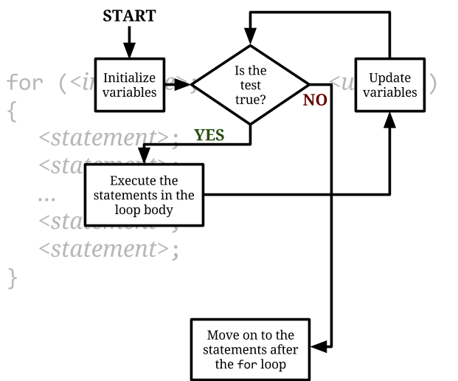

The for loop is an example of a **control structure**. A control structure is a structure of code that controls other statements.

**Content  
Management of complexity**

The chart above is a flow chart that represents, organizes and communicates the control of a program. As you create programs with added complexity, it’s important for you to have a way to manage this complexity. You can create flow charts to do this.

Flow charts can be used to show control in a loop, to show user input, to show processing and output, and to show conditional statements and decisions.

There are a number of flow chart creation programs available online, these can help you manage the complexity of your programs during the design stages.