Unit 2 Review

1. Define the following vocabulary terms

|  |  |
| --- | --- |
| **Scope:** | **Variable:** |

1. Provide an example of a variable declaration of type boolean:
2. Write the Java code to assign the value 3.14159 to the defined variable PI
3. Given that the variable count is already defined as an integer, write an example Java statement that would increment its value by one.

**Evaluate the following expressions:**

1. 1 + 2.0 + 3 + “4” + 5
2. (int)1.123 + 4 % 3
3. Draw a box around the scope of the variables a, b, and c

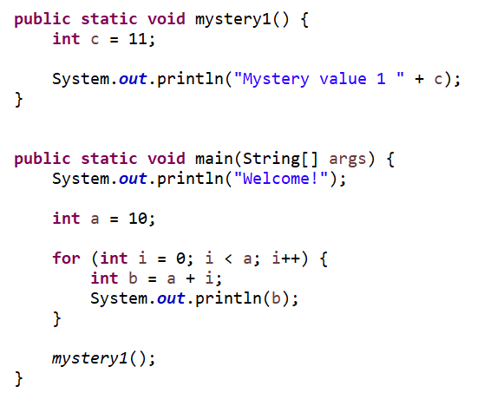

1. What is the value of x after the following code has executed?

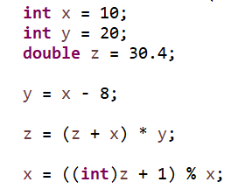

1. What would the following code print to the console?

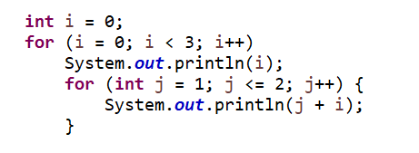

1. What would the following code print to the console?

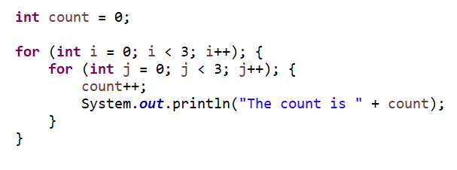

1. Write the java code to print the following using for loops.

----**----

---****---

--******--

-********-

--******--

---****---

----**----

public static void main(String[] args) {