**Number of Questions — 8**

**Directions:** Determine the answer to each of the following questions or incomplete statements, using the available space for any necessary scratch work. Then decide which is the best of the choices given and fill in the corresponding oval on the answer sheet. No credit will be given for anything written in the examination booklet (these pages). Do not spend too much time on any one problem.

**GO ON TO THE NEXT PAGE.**

1. What is information?
2. What is the binary number for the number 87?
3. In modern computers color is represented Red, Green, and Blue values. Each one of those values is represented with two hexadecimal (Base-16) digits. What is the largest Base-10 value that can be represented in two hexadecimal digits?

1. Using your answer from problem 3, how many different colors can be represented in RGB?
2. Convert the following Binary numbers to Decimal:
   1. 10100
   2. 011
   3. 1010

1. When communicating information over the internet, how do you ensure that the recipient receives a message?
2. ASCII is a character-encoding scheme that uses a numeric value to represent each character. For example, the uppercase letter "G" is represented by the decimal (base 10) value 71. A partial list of characters and their corresponding ASCII values are shown in the table below.

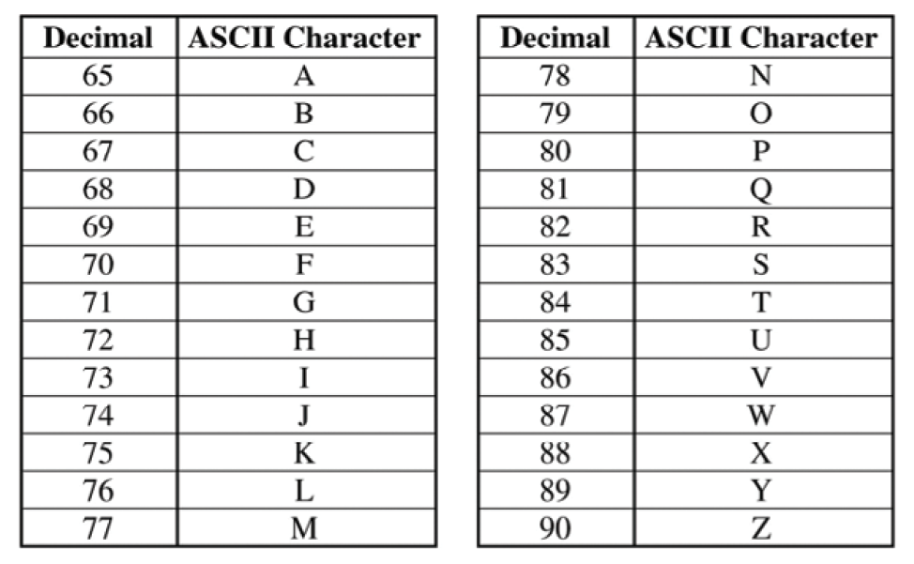

What does the following binary represent in ASCII?

01000001 01010000 00100000 01000011 01010011 01010000

1. What is the definition of a protocol?

9. Which of the following statements are true about routers and routing on the Internet. Choose two answers.

A. After a packet has left the sender it’s actually possible that it gets rerouted many times.

B. The sender of a message is responsible for calculating the complete route to the receiver.

C. A packet may be dropped along the way and will need to be resent.

D. Every router handling a packet has to communicate to the next router what is the optimal path to the destination.

10. A school starts tracking which websites each computer in the school is visiting by monitoring the packets leaving the school. A sample of the information they have collected appears below:

| IP Address | Time | URL |
| --- | --- | --- |
| ... | ... | ... |
| 1.1.1.1 | 10:30:23.22 | wikipedia.org |
| 1.5.1.8 | 10:31:29.71 | enyclopedia.com |
| 1.1.5.1 | 10:32:13.48 | news.com |
| 1.5.1.8 | 10:35:09.95 | sports.com |
| ... | ... | ... |
| 1.1.5.1 | 17:04:29.20 | fun.com |

Which of the following questions can NOT be answered using data collected by this monitoring?.

A. Which website is most often visited from school computers?

B. During what time periods is Wikipedia used the most?

C. Which students log on to each computer most often?

D. Which computers are used most often for web access before noon?

11. The following sentences describe how protocols on the Internet (e.g. IP, TCP, HTTP) make use of abstraction. Which ones are true? Select two answers.

A. High level protocols need only understand what functionality is delivered by low level protocols, without worrying about how exactly it is implemented.

B. Low level protocols are less useful and provide less functionality than high level protocols.

C. HTTP is a higher-level protocol than TCP/IP, as it relies on the abstraction of internet communications provided by TCP/IP.

D. High level protocols use higher-bit addressing than low level protocols (e.g. 32-bit addresses vs 16-bit).

12. According to the domain name system (DNS), what is the relationship between “bing.com” and “maps.bing.com”?

A. They are sister domains

B. maps.bing.com is a subdomain of bing.com

C. maps.bing.com is an address for bing.com

D. bing.com is a hyper-domain for maps.bing.com

13. Which of the following is true about TCP/IP packets? Choose two answers.

A. All packets that are part of the same message follow the same route to the destination

B. Packets may arrive at the destination out of order

C. Packets always reach their destination and are never dropped

D. Packets are always numbered

14. The protocols and standards for how the Internet works are defined by:

A. The telecommunications companies providing access to the Internet.

B. The Federal Communications Commission (FCC).

C. The IETF, a loosely organized collection of citizens and engineers.

D. A coalition of the top universities worldwide.

15. What is the purpose of a DNS server?

A. To ensure correct routing of all TCP packets to their destination

B. To calculate the least-cost path between two computers on the internet

C. To translate a domain name to an internet address

D. To provide a connection between different internet domains

16. The figure represents a network of physically linked computers labeled A through E. A line between two computers indicates that the computers can communicate directly with each other. Any information sent between two computers that are not directly connected must go through at least one other computer. The weight or cost of sending information from one computer to another is indicated by the number above the line.

For example, information can be sent directly between computers A and D and will cost 2. Information sent between computers B and C must go through either computer D (with total cost 4), or through computer E (with total cost 14)

**Question**:

Computer D sends a packet intended to reach computer E. Which computer should it forward the packet to in order to use the most cost-effective path?

A. Computer A

B. Computer B

C. Computer C

D. Any of the above would be the same

17. Imagine you are the original inventor of the Internet and you have decided to use 8 bits to encode Internet addresses. How many computers can you connect to the first version of the Internet?

A. 8

B. 64

C. 256

D. 4,294,967,296