EuroCRM Solution Overview Document
Knight Frank European CRM Platform

Author: Gary Newport
Date: 01/09/2026
Version: 1.0
Status: Draft
Contents
Version History 4
Executive Summary 5
Business Context 6
Business Goals and Objectives 6
Key Stakeholders 6
Business Capabilities 6
KPIs and Success 6
Solution Scope 6
In-Scope 6
Out-of-scope 6
Solution Architecture 6
Overview Diagrams 6
Key Components 6
Business Architecture 6
Application Architecture 6
Data Architecture 6
Technology Architecture 6
Alignment with Enterprise Architecture 6
Principles Compliance 6
Target State Alignment 6
Dependencies and Constraints 7
Key Functional and Non-Functional Requirements 7
Functional Requirements 7
Non-Functional Requirements 7
Risks and Issues 7
Solution Options and Trade-offs 7
Implementation Roadmap 7
Phases 7
Timelines 7
Key Dependencies 7
Cost and Benefits Summary 7
Estimated Costs 7
Expected Benefits 7
Governance and Approval 7
Approval 7
Governance Oversight 7
Compliance 8
Glossary 9
References 10

Version History
Version | Comments | Author | Status | Date
1.0 | Wiki content and diagrams consolidated into SOD | Gary Newport | Draft | 01/09/2026

Table of Contents
Update this field in Word to generate the table of contents.

Executive Summary
European CRM solution covering France, Germany, Spain, and Poland. This document defines the architecture approach for review and approval by the Technical Design Authority (TDA).
See problem statement for the business case driving this initiative.

Business Context

Programme Scope
The business scope is to create a common client, contact and property data foundation across Europe that helps our teams win more business, collaborate more effectively across borders, and reduce operational risk. In practical terms the programme is intended to:
• Create a single, trusted view of clients, contacts, properties and opportunities
• Improve lead and deal management from origination through to completion
• Enable better cross-border visibility and collaboration across the region
• Centralise fragmented data currently on spreadsheets and local databases, and reduce reliance on manual reporting processes
• Strengthen compliance, KYC and risk management controls
• Provide a foundation for reporting, analytics and future AI-driven insights

Current State
• Four separate European offices: France, Germany, Spain, Poland
• Existing CRM systems vary by region (to be confirmed)
• No unified customer data platform
• Client knowledge sits with individual brokers in email, Excel trackers, and shared folders
• Transaction reports are built manually in Excel

Problem Statement
See problem statement for detailed analysis.
Core Problems:
1. Fragmented Client Intelligence — If a broker in Madrid is tracking an investor whose strategy matches a Paris asset, neither side knows
2. Manual Reporting — Price, buyer, seller, asset, and fee data assembled manually after every close
3. Missing Cross-Sell Opportunities — Fragmented data means opportunities for cross-border and cross-service-line collaboration are lost

Regional Requirements
Region | Key Requirements | Regulatory Notes
France | City pre-emption, notarial deed requirements | CNIL, GDPR
Germany | TBD | BDSG, GDPR
Spain | Right-of-refusal on listed buildings | GDPR
Poland | TBD | GDPR

Drivers
• Need for consolidated customer view across service lines and countries
• Regulatory compliance across jurisdictions
• Operational efficiency across regions
• Ability to scale reporting as deal volume grows

Constraints
• Regional data residency requirements
• Existing system integrations
• TDA governance oversight
• Cross-border data sharing agreements required

Why We're Here — Problem Statement

Core Problems

1. Fragmented Client Intelligence
Client knowledge sits with individual brokers in email, Excel trackers, and shared folders. If a broker in Madrid is tracking an investor whose strategy matches a Paris asset, neither side knows. That connection only emerges by chance, if it emerges at all.

2. Manual Reporting
Transaction reports are built manually in Excel. Price, buyer, seller, asset, and fee data assembled manually after every close. As deal volume grows, reporting burden grows with it.

3. Missing Cross-Sell Opportunities
Fragmented data means opportunities for cross-border and cross-service-line collaboration are lost.

Impact
• Lost revenue from missed cross-sell opportunities
• Inability to scale reporting as deal volume grows
• No unified view of client relationships across service lines and countries

Business Goals and Objectives

Programme Scope
From a business perspective, the scope is to create a common client, contact and property data foundation across Europe that helps our teams win more business, collaborate more effectively across borders, and reduce operational risk.

Intended Outcomes
• Create a single, trusted view of clients, contacts, properties and opportunities
• Improve lead and deal management from origination through to completion
• Enable better cross-border visibility and collaboration across the region
• Centralise fragmented data currently on spreadsheets and local databases, and reduce reliance on manual reporting processes
• Strengthen compliance, KYC and risk management controls
• Provide a foundation for reporting, analytics and future AI-driven insights

Primary Goals
1. Unified Customer View — Single source of truth for customer data across all four European offices
2. Regulatory Compliance — Meet GDPR and regional data protection requirements
3. Process Standardisation — Consistent CRM workflows across France, Germany, Spain, Poland
4. Operational Efficiency — Reduce manual processes and improve data quality
5. Cross-Sell Enablement — Enable cross-border and cross-service-line collaboration
6. Scalable Reporting — Automate transaction reporting as deal volume grows

MVP Success Criteria
The MVP answers:
• "Who is this client to Knight Frank across every service line, every country?"
• "What does our EU pipeline look like?"
• "How do we run CM deals?"

Future Phase Goals
• How do we run every service line, in every country?
• Full Customer Insights & Journeys for marketing
• Centralised EU ERP for finance
• AI-powered matching and copilot capabilities

Success Criteria
• To be defined with business stakeholders
• KPIs to be established during requirements phase

Key Stakeholders

Stakeholder Register
Name | Role | Region | Interest | Influence
Gary Newport | Author/Solution Architect | Enterprise | High | High
Hannah Nguyen | Business Analyst/Solution Lead | Europe | High | High
TDA | Technical Design Authority | Enterprise | High | High
Nick Wadge | Chief Technology Officer | Enterprise | High | High
Marco Capelli | Regional Managing Directors | France, Germany, Spain, Poland | High | High
CM Team Heads | Capital Markets Service Line Leaders | Europe | High | Medium
Legal/Compliance | Data Protection Officers | Europe | High | Medium
Finance Team | Financial Controllers | Europe | Medium | Medium
IT Operations | Infrastructure & Support | Enterprise | Medium | Medium
End Users | Brokers, Analysts, Support Staff | Europe | High | Low

RACI Matrix
Activity | Solution Lead | TDA | CTO | Regional MDs | CM Team | Legal | Finance | IT Ops
Architecture Design | R | A | C | C | C | C | C | C
Environment Setup | R | A | C | I | I | I | I | R
Data Model Design | R | A | C | C | C | C | C | I
Security Configuration | R | A | C | I | I | C | I | R
Integration Design | R | A | C | I | I | I | C | R
UAT Coordination | R | A | I | C | R | C | C | I
Go-Live Approval | C | A | R | C | C | C | C | C
Post-Go-Live Support | C | I | I | I | I | I | I | R
R = Responsible, A = Accountable, C = Consulted, I = Informed

Key Roles

Solution Lead (Gary Newport)
• Owns overall solution design and delivery
• Coordinates across all workstreams
• Primary point of contact for TDA

Technical Design Authority (TDA)
• Approves architecture decisions
• Ensures compliance with enterprise standards
• Final sign-off on technical design

Chief Technology Officer (CTO)
• Sets enterprise architecture principles
• Approves technology stack decisions
• Escalation point for technical blockers

Regional Managing Directors
• Approve regional scope and priorities
• Provide business requirements
• Accept regional deliverables

Capital Markets Team Heads
• Define CM-specific requirements
• Validate BPF design
• Accept CM features during UAT

Legal/Compliance
• Review GDPR and regulatory requirements
• Approve data residency and audit features
• Validate compliance gates

Finance Team
• Define Finance integration requirements
• Validate WIP and billing flows
• Accept Finance bridge during UAT

IT Operations
• Provision environments and infrastructure
• Configure security and networking
• Provide ongoing support

End Users
• Participate in UAT
• Provide feedback on usability
• Adopt the system post-go-live

Communication Plan
Audience | Frequency | Format | Owner
TDA | Initially, End of each phase | Architecture review meeting | Solution Lead
CTO | Monthly | Steering committee | Solution Lead
Regional MDs | Bi-weekly | Progress report | Solution Lead
CM Team | Weekly | Sprint review | Solution Lead
Legal/Compliance | Bi-weekly | Compliance review | Solution Lead
Finance | Weekly | Integration sync | Integration Lead
IT Ops | Daily | Stand-up | Project Lead
End Users | Bi-weekly | Demo and feedback | Change Lead

Approval Requirements
• All identified stakeholders must approve
• TDA approval is mandatory
• See governance approval for workflow

Business Capabilities

Capability Map
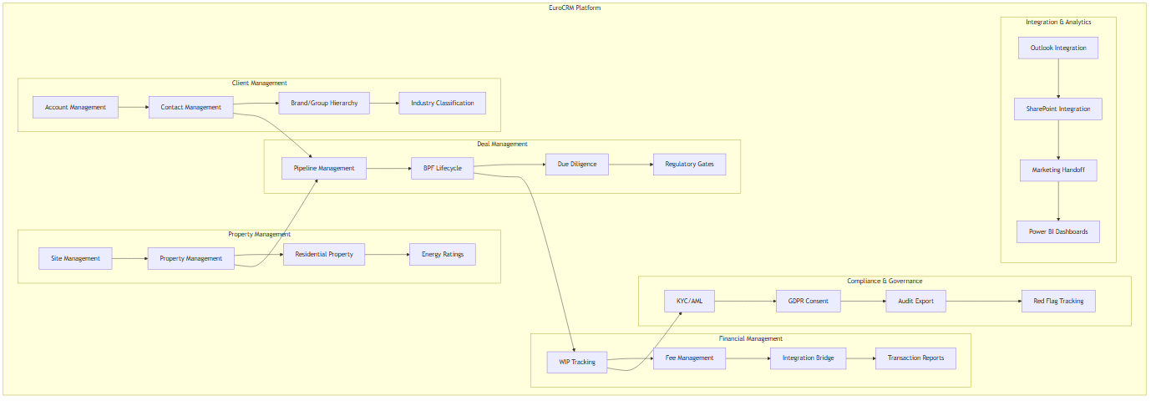

Core CRM Capabilities

Client Management
• Account Management: Legal entity records with SIC-coded industry classification (66 KF sectors)
• Contact Management: Individual contacts linked to accounts with roles and preferences
• Brand/Group Hierarchy: Two-tier model: Brand/Group → Legal Entity
• Industry Classification: SIC codes mapped to KF sectors with gap analysis

Property Management
• Site Management: Canonical physical sites with addresses and coordinates
• Property Management: Commercial and residential properties linked to sites
• Residential Property: Sales, lettings, and property management
• Energy Ratings: EPC and energy performance data

Deal Management
• Pipeline Management: 8-stage BPF from lead generation to completion
• BPF Lifecycle: Stage-specific activities, documents, and regulatory gates
• Due Diligence: NDA, KYC, data room access, red flag tracking
• Regulatory Gates: City pre-emption (France), right-of-refusal (Spain), notarial deed

Financial Management
• WIP Tracking: Work-in-progress with % complete tied to BPF stage
• Fee Management: Fee schedules with agreed fees and billing triggers
• Integration Bridge: 9 flows to D365 Finance (project creation, WIP sync, transaction reports)
• Transaction Reports: Auto-generated reports for deal completion

Compliance & Governance
• KYC/AML: Know Your Customer checks at legal entity level
• GDPR Consent: Data processing consent tracking with audit trail
• Audit Export: 7-year retention with exportable audit logs
• Red Flag Tracking: Conflict checks and risk identification

Integration & Analytics
• Outlook Integration: Email tracking and activity logging
• SharePoint Integration: Deal folder auto-provisioning and document management
• Marketing Handoff: CI-Journeys integration for campaign automation
• Power BI Dashboards: Regional reporting and analytics

Regional Capabilities

Multi-Country Support
• France: City pre-emption gate, notarial deed requirement
• Spain: Right-of-refusal gate, Community of Madrid preference
• Germany: Vacancy fee gate, Baugenehmigung requirement
• Poland: Municipal pre-emption gate, agricultural land restrictions

Multi-Service Line Support
• Capital Markets: Property sales and acquisitions
• Occupier Strategy & Solutions: Tenant representation and workplace consulting
• Valuations: Property valuations and advisory
• Residential: Sales, lettings, and property management
• Private Office: Ultra-high-net-worth individual services

Cross-Border Operations
• Multi-Jurisdiction KYC: Compliance checks across borders
• Intercompany Billing: Fee allocation across regions
• Portfolio Management: Cross-border property portfolios

Capability Maturity
Capability | Current State | Target State | Gap
Client Management | Manual spreadsheets | Centralised Dataverse | High
Property Management | Fragmented systems | Single source of truth | High
Deal Management | Email-based tracking | Automated BPF | High
Financial Management | Manual WIP tracking | Integrated bridge | Medium
Compliance & Governance | Ad-hoc processes | Automated gates | High
Integration & Analytics | Siloed data | Unified platform | High

KPIs and Success

KPIs and Success Metrics

Key Performance Indicators

Data Quality
KPI | Target | Measurement | Frequency | Owner
Client data accuracy | 98% | Data quality reports | Weekly | Data Lead
Property data completeness | 95% | Completeness checks | Weekly | Data Lead
Duplicate account rate | <2% | Duplicate detection | Monthly | Data Lead
Industry classification accuracy | 99% | SIC code validation | Monthly | Data Lead

User Adoption
KPI | Target | Measurement | Frequency | Owner
Active users | 80% of licensed users | System login/activity | Weekly | Change Lead
Daily active users | 70% of licensed users | System login/activity | Daily | Change Lead
User satisfaction score | 4.0/5.0 | Survey feedback | Monthly | Change Lead
Training completion rate | 100% | Training records | Per phase | Change Lead

Process Efficiency
KPI | Target | Measurement | Frequency | Owner
Deal cycle time | 20% reduction | BPF analytics | Monthly | CM Lead
Time to create deal record | <5 minutes | Activity tracking | Monthly | CM Lead
Document retrieval time | <30 seconds | SharePoint metrics | Monthly | IT Ops
Report generation time | <2 minutes | Power BI metrics | Monthly | BI Lead

Financial Performance
KPI | Target | Measurement | Frequency | Owner
WIP accuracy | 95% | Finance reconciliation | Monthly | Finance Lead
Fee collection rate | 98% | Billing reports | Monthly | Finance Lead
Integration error rate | <1% | Integration logs | Weekly | Integration Lead
Transaction report completion | 100% | Report tracking | Monthly | Finance Lead

Compliance
KPI | Target | Measurement | Frequency | Owner
KYC completion rate | 100% | KYC records | Monthly | Compliance Lead
GDPR consent rate | 100% | Consent tracking | Monthly | Compliance Lead
Audit trail completeness | 100% | Audit logs | Monthly | Compliance Lead
Red flag resolution time | <48 hours | Red flag records | Weekly | Compliance Lead

Success Criteria

Phase 0 Success Criteria
• [ ] Environments provisioned and accessible
• [ ] Core tables deployed and functional
• [ ] Security roles configured and tested
• [ ] SharePoint integration working
• [ ] Power BI dashboard created
• [ ] User acceptance testing passed

Phase 1 Success Criteria
• [ ] 8-stage BPF configured and tested
• [ ] All 12 CM entities deployed
• [ ] Finance bridge (9 flows) tested
• [ ] French regulatory gates implemented
• [ ] Copilot for Sales pilot completed
• [ ] User acceptance testing with Paris CM team passed
• [ ] Go-live readiness confirmed

Phase 2 Success Criteria
• [ ] Spanish regulatory gate implemented
• [ ] EIT cross-border overlay deployed
• [ ] Multi-jurisdiction KYC functional
• [ ] Hub coexistence strategy documented
• [ ] User acceptance testing with Madrid team passed

Measurement Framework

Data Collection
• Automated: System logs, activity tracking, integration metrics
• Manual: User surveys, feedback forms, training records
• External: Power BI dashboards, Excel reports

Reporting Cadence
• Daily: Active users, integration errors
• Weekly: Data quality, user adoption, financial accuracy
• Monthly: Comprehensive KPI report to steering committee
• Quarterly: Strategic review with CTO and regional MDs

Continuous Improvement
• Monthly KPI review with stakeholders
• Quarterly target adjustment based on performance
• Annual strategic alignment review

Related Documents
• business goals — Business objectives
• architecture business — Business process models
• implementation phases — Phase definitions

Solution Scope

Solution Scope — In-Scope

In-Scope Items

Platform
• Dataverse (EU-hosted)
• Power Apps Model-Driven Apps
• Power Automate (Cloud Flows)
• Power BI (Dashboards and Reports)
• Copilot for Sales (Pilot)
• Outlook Integration
• SharePoint Integration

Service Lines
• Capital Markets (MVP)
• Occupier Strategy & Solutions (Future)
• Valuations (Foundation)
• Residential (Foundation)
• Private Office (Foundation)

Countries
• France (MVP)
• Germany (Phase 0 foundation)
• Spain (Phase 0 foundation)
• Poland (Phase 0 foundation)

Entities
Entity | Phase | Category
Account | Phase 0 | CRM Lite
Contact | Phase 0 | CRM Lite
kf_Property | Phase 0 | CRM Lite
kf_EnergyRating | Phase 0 | Compliance
kf_GDPRRequest | Phase 0 | Compliance
kf_AuditExport | Phase 0 | Compliance
kf_SICCode | Phase 0 | Supporting
kf_Deal | Phase 1 | CM Deep Build
kf_DealProperty | Phase 1 | Core Shared
kf_Pitch | Phase 1 | CM Deep Build
kf_NDA | Phase 1 | CM Deep Build
kf_Bid | Phase 1 | CM Deep Build
kf_DDMilestone | Phase 1 | CM Deep Build
kf_RedFlag | Phase 1 | CM Deep Build
kf_FeeSchedule | Phase 1 | CM Deep Build
kf_KYCRecord | Phase 1 | CM Deep Build
kf_InvestorProfile | Phase 1 | CM Deep Build
kf_DataRoomAccess | Phase 1 | CM Deep Build
kf_TransactionReport | Phase 1 | CM Deep Build
kf_StageGateRule | Phase 1 | Supporting
kf_IntegrationLog | Phase 1 | Supporting
Lead | Phase 1 | Marketing

Integrations
• Outlook email tracking and activity logging
• SharePoint deal folder auto-provisioning
• D365 Finance bridge (9 flows)
• CI-Journeys marketing handoff
• Loqate address validation

Features
• 8-stage BPF for Capital Markets
• Regulatory gates (France, Spain)
• WIP tracking with % complete
• Fee management and billing triggers
• KYC/AML compliance
• GDPR consent tracking
• Audit trail with 7-year retention
• Red flag tracking
• Multi-jurisdiction conflict checks
• Cross-border portfolio management

Regional Scope
Region | Included | Phase | Notes
France | Yes | Phase 0-1 | MVP, CM team pilot
Germany | Yes | Phase 0 | Foundation only, CM in Phase 2
Spain | Yes | Phase 0 | Foundation only, CM in Phase 2
Poland | Yes | Phase 0 | Foundation only, CM in Phase 2

Service Line Scope
Service Line | Included | Phase | Notes
Capital Markets | Yes | Phase 0-1 | MVP
Occupier Strategy & Solutions | Future | Phase 3 | TBD
Valuations | Future | Phase 3 | TBD
Residential | Future | Phase 4 | TBD
Private Office | Future | Phase 4 | TBD

Data Domains
Domain | Included | Phase | Notes
Client | Yes | Phase 0 | Account, Contact, Brand/Group hierarchy
Property | Yes | Phase 0 | Site, Property, Residential Property
Deal | Yes | Phase 1 | 12 CM entities, 8-stage BPF
Compliance | Yes | Phase 0 | KYC, GDPR, Audit, Red Flags
Finance | Yes | Phase 1 | WIP, Fee Management, Transaction Reports
Supporting | Yes | Phase 0 | SIC Codes, HILUCS Codes, Energy Ratings

Solution Scope — Out-of-Scope

Out-of-Scope Items

Service Lines
• Occupier Strategy & Solutions (Phase 3)
• Valuations (Phase 3)
• Residential (Phase 4)
• Private Office (Phase 4)

Regions
• APAC (Phase 5)
• Americas (Phase 5)
• Middle East (Phase 5)

Features
• Marketing automation (CI-Journeys integration only)
• Legacy system decommissioning
• Custom development beyond platform capabilities
• Third-party system replacements
• Mobile app development (Phase 2 consideration)
• Advanced AI/ML beyond Copilot for Sales
• Custom Power Apps portals

Integrations
• Full Hub API integration (Phase 6)
• Consolidated Finance ERP (Phase 7)
• Advanced reporting beyond Power BI
• Third-party data providers (Loqate only for MVP)

Data
• Historical data migration (Phase 1 consideration)
• Data cleansing and deduplication (Phase 0 consideration)
• Archival of legacy data

Security
• Advanced threat protection
• Custom security models beyond BU/role-based
• Multi-factor authentication (Entra ID only)

Support
• 24/7 support (business hours only for MVP)
• On-site support (remote only)
• Custom training materials (standard templates only)

Deferred to Future Phases
Item | Phase | Reason
Mobile app | Phase 2 | Not required for MVP
Advanced AI/ML | Phase 2 | Copilot for Sales pilot only
Full Hub integration | Phase 6 | Manual transition for MVP
Finance ERP | Phase 7 | Bridge integration for MVP
Marketing automation | Phase 2 | CI-Journeys integration only
Additional service lines | Phase 3-4 | Phased approach
Regional expansion | Phase 5 | Phased approach

Assumptions
• Existing Microsoft 365 licensing covers Outlook and SharePoint integration
• D365 Finance environment is available for integration
• CI-Journeys is available for marketing handoff
• Loqate API key is provided by IT
• Power Platform licensing is approved by finance

Constraints
• TDA governance oversight required
• Regional data residency requirements (EU only)
• Existing system integrations must be maintained
• Budget and resource limitations (TBD)

Related Documents
• solution scope in scope — In-scope items
• implementation phases — Phase definitions
• dependencies and constraints — Dependencies and constraints

CRM Lite — MVP Scope

Key Principle
"The MVP is a shared client, contact, property and engagement foundation: a relationship and intelligence layer; not a full operational workflow system — which belongs to the Service Line deep build phase. Capital Markets is the first deeper workflow built on top."

Shared Foundation
Designed to be reusable across service lines and countries:
• Accounts; Contacts; Properties; Engagement Tracking; Security
• Single Client Record
• Cross-SL Contact Intelligence
• Shared Property Records
• Outlook Integration
• SharePoint Auto-Provision
• Power BI Dashboards
• RBAC / Business Units
• Engagement History
Core question answered: "Who is this client to Knight Frank across every service line, every country?"

First Service-Line Build
Capital Markets is the first vertical deployed on the shared foundation.
OSS, Valuations, etc. follow as separate Service Line solutions on the same backbone.

Core Master Data Requirements
• Single trusted view of property and clients across service lines and countries
• International standards for property and client type definitions

Pipeline & Relationships Requirements
• Engagement tracking and cross-border unified client view
• Full pipeline visibility with built-in WIP data

Productivity Tools Requirements
• Outlook sync
• SharePoint libraries
• Power BI dashboards
• Copilot for Sales

Data Architecture Requirements
• Layered Dataverse structure
• Layer 2 core, Layer 3 EUR defaults, Layer 4 country extensions, Layer 5 Service Line BPFs

Security & Compliance Requirements
• Cross-border data sharing agreement, EU data centres, GDPR consent baseline
• Role-based security, 7-year audit retention

Solution Architecture

Architecture — Overview Diagrams

Diagrams

Solution Architecture
Full component view showing layers, data domains, and integrations.
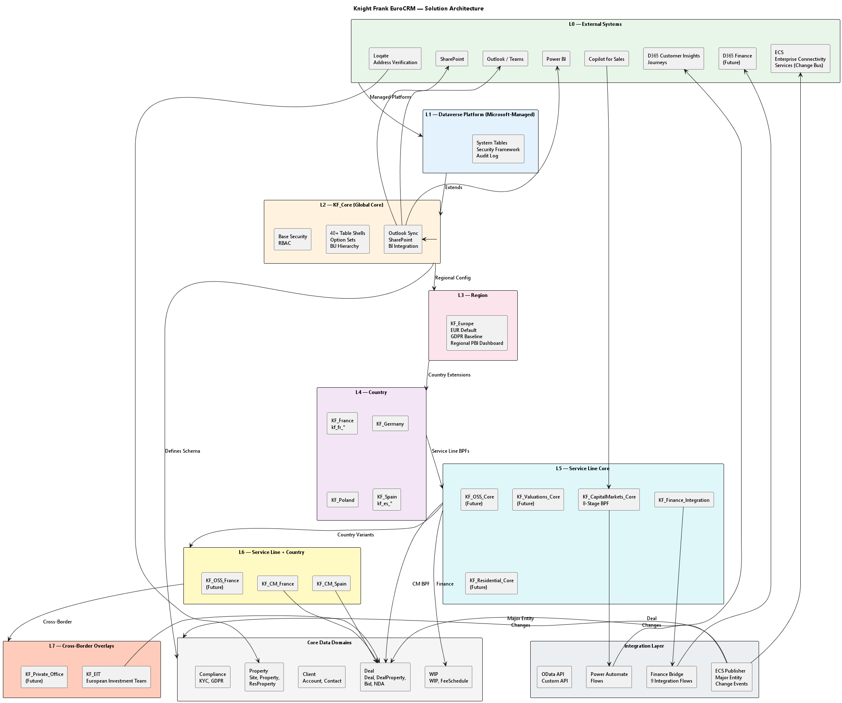

Layered Solution Model
Shows the L0-L7 layer hierarchy and extension rules.
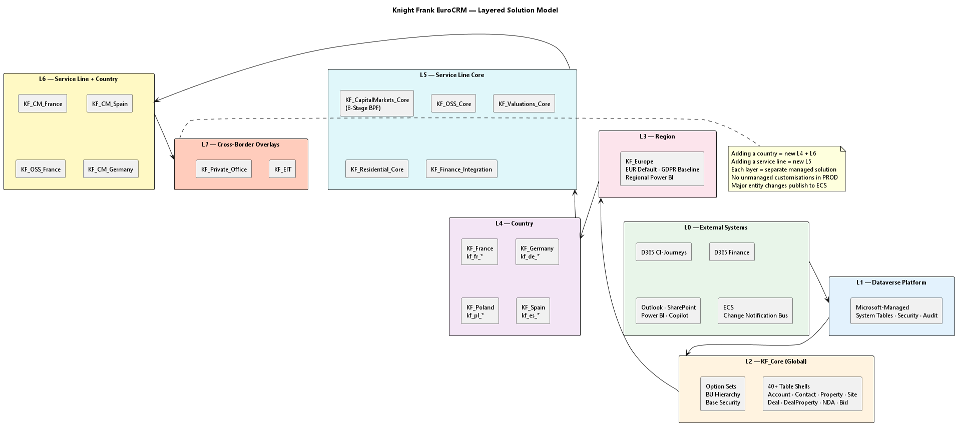

Data Flow & Integrations
Shows how data flows through the system and external integrations.
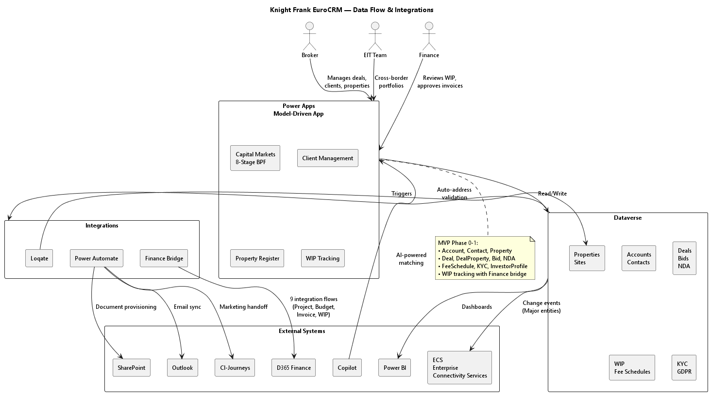

Diagram Sources
• wiki/architecture-diagram.puml — Full solution architecture
• wiki/architecture-layers.puml — Layered model
• wiki/architecture-dataflow.puml — Data flow and integrations

Status
Diagrams created from processed source materials. Ready for TDA review.

Architecture — Key Components

Platform Decision
Current Hypothesis: Power Apps model-driven apps on Dataverse are a better fit where the value sits in a custom Knight Frank data model rather than a packaged sales process.
See power apps rationale for detailed analysis.

Key Components

1. Dataverse Platform (L1)
Microsoft-managed foundation providing:
• Custom tables with relationships
• Business Process Flows (BPFs)
• Security roles + Business Units
• Dataverse audit trail
• API access (OData + custom)
• Mobile access

2. KF_Core (L2)
Global core layer defining the base schema:
• 40+ table shells — Account, Contact, Property, Site, Deal, DealProperty, NDA, Bid, etc.
• Option sets — All custom option sets defined at this layer
• BU hierarchy — Business Unit structure for security and data ownership
• Base security — RBAC roles and permissions
• Integration base — Outlook sync, SharePoint, Power BI connectors

3. Region Layer (L3)
KF_Europe configuration:
• EUR default currency
• GDPR baseline compliance
• Regional Power BI dashboard
• Cross-border data sharing rules

4. Country Layers (L4)
Country-specific extensions:
• KF_France — kf_fr columns, CNIL compliance, notarial requirements
• KF_Germany — kf_de columns, BDSG compliance
• KF_Poland — kf_pl columns
• KF_Spain — kf_es columns, right-of-refusal rules

5. Service Line Core (L5)
Service-line specific BPFs and workflows:
Service Line | Component | BPF Stages
Capital Markets | KF_CapitalMarkets_Core | 8-stage (Origination → Completion)
OSS | KF_OSS_Core | Future
Valuations | KF_Valuations_Core | Future
Residential | KF_Residential_Core | Future
Finance Integration | KF_Finance_Integration | WIP bridge to D365 Finance

6. Service Line + Country (L6)
Country variants inheriting from L5:
• KFCMFrance — French regulatory gates (city pre-emption, notarial deed)
• KFCMSpain — Spanish regulatory gates (right-of-refusal)
• KFOSSFrance — Future

7. Cross-Border Overlays (L7)
Multi-market entities:
• KF_EIT — European Investment Team for cross-border portfolios
• KF_Private_Office — UHNW individuals spanning CM, Residential, Valuations

Core Data Entities

Client Domain
Entity | Purpose
Account | Organisation, brand, legal entity, fund, SPV
Contact | Individual person linked to Account
kf_InvestorProfile | Investment strategy per Brand/Group

Property Domain
Entity | Purpose
kf_Site | Physical building or land parcel
kf_Property | Commercial asset register
kf_ResProperty | Residential asset register
kf_DealProperty | Junction: deal ↔ property

Deal Domain (Capital Markets)
Entity | Purpose
kf_Deal | Core deal record with 8-stage BPF
kf_Pitch | Competitive pitch tracking
kf_NDA | NDA management
kf_Bid | Multi-round bid management
kf_DDMilestone | Due diligence tracking
kf_RedFlag | Risk tracking

Compliance Domain
Entity | Purpose
kf_KYCRecord | KYC/AML at legal entity level
kf_GDPRRequest | GDPR data subject requests
kf_DataRoomAccess | Data room access management

Finance Domain
Entity | Purpose
kf_FeeSchedule | Fee structure per deal
kf_WIP | Work in progress tracking
kf_TransactionReport | Auto-generated transaction reports

Integration Components
Component | Target | Purpose
Power Automate | Outlook | Email sync, activity tracking
Power Automate | SharePoint | Auto-provision deal folders
Power Automate | CI-Journeys | Marketing handoff
Finance Bridge | D365 Finance | 9 integration flows (Project, Budget, Invoice, WIP)
Loqate | Dataverse | Auto-address validation for kf_Site
Copilot | Dataverse | AI-powered client matching
Power BI | Dataverse | Dashboards and reporting
ECS Publisher | ECS (Enterprise Connectivity Services) | Publish change notifications for Major entity create/update

ECS Publications
Every create/update of a Major entity (Client, Property, Deal domains — confirm definitive list with TDA) publishes a change notification to the Knight Frank ECS platform, the internal notification and message bus that keeps other systems informed of changes. Publication is performed from a Dataverse plugin / Power Automate flow; delivery is asynchronous and logged in kf_IntegrationLog. See architecture application for the detailed pattern.

Technical Rules
• KF_Core defines ALL option sets and custom tables as base
• No regional fork can create duplicate tables
• Each layer is a separate managed solution
• No unmanaged customisations in TEST, UAT, or PROD
• Layer 6 adds columns with country prefixes, never renames standard stages
• Adding a country = new L4 + L6 | Adding a service line = new L5

Related Documents
• solution package model — Layer model details
• client data model — Client entity schema
• property data model — Property entity schema
• capital markets data model — Capital Markets entity schema
• wip data model — WIP and Finance integration
• data model core tables — Layer 2 table definitions
• architecture diagram — Visual component diagram

Architecture — Business

Business Architecture Overview
The EuroCRM business architecture is structured around two layers:
1. Shared Foundation (CRM Lite) — Client, contact, property, and engagement tracking reusable across all service lines and countries
2. Service Line Builds — Vertical-specific workflows (Capital Markets first) built on top of the shared foundation

Core Business Capabilities

Client Management
Capability | Description | Entities
Client Hierarchy | Brand/Group → Legal Entity relationship model | Account, Contact
Client Classification | SIC-coded industry sectors, entity type (Fund, SPV, JV) | Account
Client Intelligence | Cross-border, cross-service-line client view | Account, Contact, InvestorProfile
GDPR Compliance | Processing consent, data subject requests | Contact, kf_GDPRRequest

Property Management
Capability | Description | Entities
Physical Asset Register | Canonical building/land parcel | kf_Site
Commercial Asset Register | Sector, type, status, tenure, areas, ESG | kf_Property
Residential Asset Register | Bedrooms, tenure, rent, guide price | kf_ResProperty
Address Validation | Loqate auto-lookup and kf_Site creation | kf_Site

Deal Management (Capital Markets)
Capability | Description | Entities
8-Stage Deal Lifecycle | Origination → Pitch → Instruction → Marketing → Bidding → Exclusivity → DD → Completion | kf_Deal
Pitch Tracking | Competitive pitch management | kf_Pitch
NDA Management | Counterparty legal entity and signatory | kf_NDA
Bid Management | Multi-round bidding with investor profiles | kf_Bid
Due Diligence | Milestone tracking with red flag management | kf_DDMilestone, kf_RedFlag
Portfolio Management | Junction record linking deals to multiple properties | kf_DealProperty

Compliance & Risk
Capability | Description | Entities
KYC/AML | Legal entity level checks, multi-jurisdiction | kf_KYCRecord
Regulatory Gates | Country-specific gates (France: pre-emption; Spain: right-of-refusal) | kf_Deal, kf_StageGateRule
Data Room Access | Virtual data room access management | kf_DataRoomAccess
Audit Trail | 7-year retention, export capability | kf_AuditExport

Finance & Reporting
Capability | Description | Entities
Fee Management | Fee structure per deal with schedule tracking | kf_FeeSchedule
WIP Tracking | Work in progress from deal creation to fee earned | kf_WIP
Transaction Reports | Auto-generated post-close reports | kf_TransactionReport
Finance Bridge | 9 integration flows to D365 Finance | kf_IntegrationLog

Business Process Flows

Capital Markets — 8-Stage BPF
Stage Gates:
• S2: Conflict check (EIT)
• S3: Multi-jurisdiction KYC (EIT)
• S7: City pre-emption (France), Notarial process (France), Right of refusal (Spain), Pre-emption delegation (EIT)
• S8: Notarial deed signing (France), Intercompany billing (EIT)
Finance Integration:
• Each stage maps to a % complete in D365 Finance (S1=5%, S2=15%, ... S8=100%)
• S3 fires Flow 1: Finance project created
• Deal won raises draft invoice request
• Monthly batch refreshes WIP balance

Client Onboarding
1. Account created (Brand/Group or Legal Entity)
2. Contact linked to Account
3. SIC classification assigned
4. National registration number validated
5. GDPR consent recorded (Layer 3)
6. KYC/AML checks (if Legal Entity)

Property Registration
1. User types address in CRM form
2. Loqate type-ahead returns validated matches
3. User selects match → fields auto-fill
4. Power Automate creates/matches kf_Site silently
5. kfProperty or kfResProperty linked to Site

Capability Map by Layer
Layer | Business Capabilities
L2 (Core) | Client hierarchy, Property register, Activity tracking, Document management
L3 (Region) | GDPR compliance, EUR currency, Regional reporting
L4 (Country) | Local regulatory gates, Country-specific forms, National registration validation
L5 (Service Line) | Deal lifecycle (CM), Engagement tracking (OSS), Valuation workflow (Val)
L6 (SL + Country) | Country-specific BPF extensions, Regulatory stage gates
L7 (Cross-Border) | Multi-market portfolios, Cross-border KYC, Intercompany billing

Service Line Business Processes
Service Line | Process | BPF | Status
Capital Markets | Deal lifecycle (8-stage) | KF_CapitalMarkets_Core | MVP Phase 1
Occupier Strategy & Solutions | Engagement workflow | KF_OSS_Core | Future Phase 3
Valuations | Valuation instruction | KF_Valuations_Core | Future Phase 3
Residential | Sales/Lettings pipeline | KF_Residential_Core | Future Phase 4
Property Management | Mandate management | KF_PropertyManagement_Core | Future Phase 3
Capital Advisory | Debt mandate | KF_CapitalAdvisory_Core | Future Phase 3
Development | Project tracking | KF_Development_Core | Future Phase 3
ESG Consultancy | Assessment workflow | KF_ESG_Core | Future Phase 3
Building Consultancy | Survey workflow | KF_BuildingConsultancy_Core | Future Phase 3
Investor Advisory | Mandate tracking | KF_InvestorAdvisory_Core | Future Phase 3
Workplace Consulting | Assessment workflow | KF_Workplace_Core | Future Phase 3
Leasing | Lease pipeline | KF_Leasing_Core | Future Phase 3

Related Documents
• business capabilities — Capability definitions
• client data model — Client entity schema
• property data model — Property entity schema
• capital markets data model — Capital Markets entity schema
• wip data model — WIP and Finance integration
• implementation phases — Phase definitions

Architecture — Application

Application Architecture Overview
EuroCRM is built on Power Apps model-driven apps on Dataverse — a custom CRM platform rather than a packaged sales process (D365 Sales). The application is structured as a set of managed solutions deployed across 8 layers (L0-L7).
See power apps rationale for the platform selection rationale.

Platform Selection Rationale

Why Not D365 Sales?
D365 Sales Assumption | KF Reality
Lead → Opportunity → Quote → Order → Invoice | Competitive pitching → NDA → Multi-round bidding → DD → Completion
Product Catalogue | Advisory services, not products
LinkedIn Sales Navigator | Custom investor intelligence
3 entities fit (Opportunity, Quote, Product) | 8 entities have no equivalent

Why Dataverse + Power Apps?
• Custom tables with relationships match KF's advisory lifecycle
• Business Process Flows (BPFs) support 8-stage deal workflow
• Security roles + Business Units enable country/service-line isolation
• Native Outlook, SharePoint, Power BI integration
• OData + custom API for Finance integration
• Mobile access for field brokers
• 7-year audit trail for compliance

Application Components

1. Model-Driven Apps
App | Layer | Purpose
KF CRM (Main) | L2-L7 | Unified client, property, deal management
KF Capital Markets | L5-L6 | 8-stage deal lifecycle with regulatory gates
KF Residential (Future) | L5 | Sales, lettings, property management
KF OSS (Future) | L5 | Occupier strategy and engagements

2. Business Process Flows (BPFs)
BPF | Layer | Stages
Capital Markets Deal | L5 | S1 Origination → S2 Pitch → S3 Instruction → S4 Marketing → S5 Bidding → S6 Exclusivity → S7 DD → S8 Completion
CM France Extension | L6 | Adds: City pre-emption, Notarial process, Notarial deed signing
CM Spain Extension | L6 | Adds: Right-of-refusal gate
CM EIT Extension | L7 | Adds: Multi-jurisdiction KYC, Conflict check, Intercompany billing
Finance Integration | L5 | Maps deal stage → Finance % complete

3. Forms and Views
Component | Purpose
Account forms | Brand/Group view, Legal Entity view, hierarchy
Contact forms | Individual profile, GDPR consent, activity history
Deal forms | 8-stage BPF, property sub-grid, fee schedule
Property forms | Commercial vs residential, site link, ESG data
Investor Profile forms | Strategy, target sectors, geographies, ticket size

4. Dashboards
Dashboard | Layer | Audience
Regional PBI | L3 | Europe leadership
Country PBI | L4 | Country managers
CM Pipeline | L5 | Capital Markets brokers
WIP Aging | L5 | Finance team
Cross-Border | L7 | EIT team

Integration Patterns

Synchronous Integrations
Pattern | Source → Target | Purpose
OData API | External → Dataverse | Real-time data queries
Custom API | Dataverse → External | Triggered operations
Plugin | Dataverse → Dataverse | Business rule enforcement

Asynchronous Integrations
Pattern | Source → Target | Purpose
Power Automate | Outlook → Dataverse | Email sync, activity tracking
Power Automate | SharePoint → Dataverse | Document provisioning
Power Automate | Dataverse → CI-Journeys | Marketing handoff
Finance Bridge | Dataverse → D365 Finance | 9 integration flows
Loqate | Loqate → Dataverse | Address validation
ECS Publish | Dataverse → ECS | Change notification for Major entity updates

ECS Change Notification
Whenever a Major entity is created or updated in Dataverse, a change notification is published to the Knight Frank ECS (Enterprise Connectivity Services) platform.
• What: ECS is Knight Frank's internal notification and message bus. It notifies other systems that a change has happened — it is not a data replication service.
• Trigger: Create or update of a Major entity record.
• Candidate Major entities: Client (Account, Contact), Property (kfSite, kfProperty), and Deal (kf_Deal) domains.
• Note: the definitive Major entity list is not yet defined in the wiki — confirm with TDA / enterprise architecture before build.
• Mechanism: Dataverse plugin or Power Automate flow on entity create/update publish a change event (entity type, record ID, changed fields, timestamp, source) to ECS.
• Consumers: any enterprise system subscribed to ECS topics reacts to the notification (e.g. downstream registries, reporting, downstream workstreams).
• Audit: all publications are logged in kf_IntegrationLog.

Finance Bridge — 9 Integration Flows
Flow | Trigger | Purpose
Flow 1 | S3 stage change | Create Finance project
Flow 2 | Stage change | Update % complete in Finance
Flow 3 | Deal won | Raise draft invoice request
Flow 4 | Invoice posted | Return invoice and payment data
Flow 5 | Monthly batch | Refresh WIP balance and ageing
Flow 6 | Credit hold | Alert broker in Teams
Flow 7 | Fee schedule change | Sync budget/contract lines
Flow 8 | Deal closure | Final revenue recognition
Flow 9 | Monthly | Reconciliation report

Security Architecture

Business Unit Hierarchy
KF Global
├── KF_Europe (L3)
│ ├── KF_France (L4)
│ │ ├── KF_CM_France (L6)
│ │ └── KF_OSS_France (L6)
│ ├── KF_Germany (L4)
│ ├── KF_Poland (L4)
│ └── KF_Spain (L4)
│ └── KF_CM_Spain (L6)
└── KF_EIT (L7)

Security Roles
Role | Scope | Permissions
CM Broker | Country BU | CRUD on deals, contacts, properties
CM Manager | Country BU | Approve deals, view all country data
EIT User | Cross-border | Read/write cross-border deals
Finance | Global | Read WIP, fee schedules, transaction reports
Compliance | Global | Read KYC, GDPR requests, audit logs
Admin | Global | Full access across all BUs

Data Access Patterns
Operation | Pattern | Notes
Create deal | Form submission | BPF auto-creates child records
View pipeline | Dashboard | Aggregated across country BUs
Cross-border search | Advanced find | Queries across multiple BUs
Document upload | SharePoint integration | Auto-provisioned per deal
Email tracking | Outlook add-in | Links to deal/contact
Mobile access | Power Apps mobile | Offline capability

Deployment Architecture

Managed Solutions
Each layer is a separate managed solution:
Solution | Layer | Dependencies
KF_Core | L2 | Dataverse
KF_Europe | L3 | KF_Core
KF_France | L4 | KF_Europe
KF_Germany | L4 | KF_Europe
KF_Poland | L4 | KF_Europe
KF_Spain | L4 | KF_Europe
KF_CapitalMarkets_Core | L5 | KF_Core
KF_CM_France | L6 | KF_France + KF_CapitalMarkets_Core
KF_CM_Spain | L6 | KF_Spain + KF_CapitalMarkets_Core
KF_EIT | L7 | KF_Europe + KF_CapitalMarkets_Core

Environment Strategy
Environment | Purpose | Solutions
DEV | Development | Unmanaged (L2-L6)
TEST | Integration testing | Managed
UAT | User acceptance | Managed
PROD | Production | Managed
Rule: No unmanaged customisations in TEST, UAT, or PROD.

Technical Rules
• KF_Core defines ALL option sets and custom tables as base
• No regional fork can create duplicate tables
• Layer 6 adds columns with country prefixes (kf_fr, kf_es), never renames standard stages
• Adding a country = new L4 + L6 solutions
• Adding a service line = new L5 solution
• Columns and relationships added by higher layers

Related Documents
• power apps rationale — Platform selection analysis
• solution package model — Layer model details
• architecture key components — Component inventory
• architecture dataflow — Integration flow diagram
• architecture diagram — Visual component diagram

Architecture — Data

Data Architecture Overview
The EuroCRM data architecture is built on Dataverse with a layered schema model. All custom tables are defined at Layer 2 (KF_Core) as "shells" — higher layers add columns, relationships, and behaviour without duplicating table definitions.

Core Data Domains

1. Client Domain
Purpose: Single trusted view of every client across service lines and countries.
Entity | Layer | Purpose
Account | L2 | Organisation, brand, legal entity, fund, SPV
Contact | L2 | Individual person, always linked to Account
kf_InvestorProfile | L5 | Investment strategy per Brand/Group
Key Design Decisions:
• Two-tier hierarchy: Brand/Group (relationship, reporting) → Legal Entity (KYC, billing, counterparty)
• Classification fields: kf_accountclassification (Brand/Group, Legal Entity, Individual), kf_entitytype (Fund, SPV, JV, HoldCo, OpCo, Trust)
• SIC-coded industry classification (kf_industry) mapped to 66 KF sectors
• National registration numbers (kf_registrationnumber) per country (SIREN/SIRET, Handelsregister, Registro Mercantil, KRS)
See client data model for full schema.

2. Property Domain
Purpose: Canonical property register shared across all service lines.
Entity | Layer | Purpose
kf_Site | L2 | Physical building or land parcel
kf_Property | L2 | Commercial asset register
kf_ResProperty | L5 | Residential asset register
kf_DealProperty | L2 | Junction: deal ↔ property
Key Design Decisions:
• kf_Site is the canonical physical asset — all other records hang off it
• Commercial vs residential split: different attributes, different audiences, different deal cycles (6-18 months vs days-weeks)
• Junction record (kf_DealProperty) holds deal-specific measures — never overwrites master asset
• Loqate auto-creates kf_Site records silently in background
• 10 service lines read the same property record (CM, OSS, Valuations, ESG, Building Consultancy, Development, Capital Advisory, Property Management, Leasing, Residential)
Entity Relationships:
• kfSite (1) → (N) kfProperty
• kfSite (1) → (N) kfResProperty
• kfDeal (1:N) → kfDealProperty (N:1) → kf_Property
See property data model for full schema.

3. Deal Domain (Capital Markets)
Purpose: End-to-end deal lifecycle tracking from origination to completion.
Entity | Layer | Purpose
kf_Deal | L5 | Core deal record with 8-stage BPF
kf_Pitch | L5 | Competitive pitch tracking
kf_NDA | L5 | NDA management
kf_Bid | L5 | Multi-round bid management
kf_DDMilestone | L5 | Due diligence milestone tracking
kf_RedFlag | L5 | Risk and red flag tracking
Key Design Decisions:
• 12 entities capture every stage of the deal lifecycle
• Portfolio model: one deal → many properties via kf_DealProperty junction
• Client touchpoints: Brand/Group for relationships, Legal Entity for compliance & billing
• Regulatory gates fire automatically per market (France: pre-emption; Spain: right-of-refusal)
See capital markets data model for full schema.

4. Compliance Domain
Purpose: Regulatory and data governance across all jurisdictions.
Entity | Layer | Purpose
kf_KYCRecord | L5 | KYC/AML at legal entity level
kf_NDA | L5 | NDA counterparty management
kf_GDPRRequest | L2 | GDPR data subject requests
kf_DataRoomAccess | L5 | Virtual data room access
kf_AuditExport | L2 | Audit trail export (7-year retention)
kf_StageGateRule | L5 | BPF stage gate configuration
Key Design Decisions:
• KYC at legal entity level, not Brand/Group
• NDA explicitly excludes Brand/Group — only legal entities
• GDPR consent: kf_processingconsent (legitimate interest, consent, legal obligation, not assessed)
• 7-year audit retention for compliance

5. Finance Domain
Purpose: WIP tracking, fee management, and D365 Finance integration.
Entity | Layer | Purpose
kf_FeeSchedule | L5 | Fee structure per deal
kf_WIP | L5 | Work in progress tracking
kf_TransactionReport | L5 | Auto-generated transaction reports
kf_IntegrationLog | L5 | Integration transaction logging
Key Design Decisions:
• Every CRM deal becomes a Finance project in D365 Finance
• BPF stage maps to % complete (S1=5%, S2=15%, ... S8=100%)
• 9 integration flows bridge CRM → Finance
• WIP = deal creation to fee earned (delivered, not yet billed)
See wip data model for full schema.

6. Supporting Domain
Purpose: Reference data and infrastructure tables.
Entity | Layer | Purpose
kf_SICCode | L2 | SIC code reference (21 sections, 66 KF sectors)
kf_HILUCSCode | L2 | HILUCS reference (43 KF asset classes)
kf_EnergyRating | L2 | EPC energy performance ratings
Lead | L5 | Marketing lead (D365 CI-Journeys integration)

Major Entity Change Publishing (ECS)
Whenever a Major entity is created or updated, a change notification is sent to the Knight Frank ECS (Enterprise Connectivity Services) platform — the internal notification and message bus that informs other systems a change has happened.
Aspect | Design
Trigger | Create/update of a Major entity in Dataverse
Publish | Plugin / Power Automate flow → ECS topic
Payload | Entity type, record ID, changed fields, timestamp, source system
Candidates | Client (Account, Contact), Property (kf_Site, kf_Property), Deal (kf_Deal)
Audit | Logged in `kf_IntegrationLog`
Contract | Confirm definitive Major entity list and ECS topic/contract with TDA and enterprise architecture
The change events are notifications only — consumers query Dataverse (or enterprise mastered sources) for the full record; ECS does not replicate data.

Taxonomy Standards

Client Industry — SIC to KF Mapping
21 SIC sections → 66 KF client sectors and sub-segments. See taxonomy sic kf.
Strategic Sectors: Private Equity & Funds, Sovereign Wealth, Banking & Financial Services, Insurance & Pensions, Real Estate, Technology, Logistics & Distribution
SIC Gaps: Sovereign Wealth Funds, Family Offices, SPVs, REITs, PropTech, Co-Working, Infrastructure Funds, RE-focused PE — none have explicit SIC codes.

Asset Class — HILUCS to KF Mapping
HILUCS L1/L2 → KF enterprise sectors and asset classes. See taxonomy hilucs kf.
Strategic Sectors: Office, Retail, Industrial, Logistics, Data Centres, Life Sciences, Healthcare, Living, PBSA
HILUCS Gaps: Data Centres, Life Sciences, BTR, PBSA, Self Storage, Senior Living, Co-Living, Multifamily, Cold Storage — none have explicit HILUCS codes.

Data Residency & Compliance
Region | Requirements | Regulatory Body
France | Data in EU, CNIL compliance, SIREN/SIRET registration | CNIL
Germany | BDSG compliance, Handelsregister HRB registration | BfDI
Spain | GDPR, right-of-refusal on listed buildings, Registro Mercantil | AEPD
Poland | GDPR, KRS number registration | UODO

Data Quality
Mechanism | Purpose
Loqate auto-lookup | Address validation and kf_Site creation
SIC code validation | Standardised industry classification
National registration validation | Cross-reference with company registers
Duplicate detection | TBD — to be implemented
Master data management | TBD — approach to be defined

Data Model Statistics
Metric | Count
Total tables | 40+ (L2 shells)
MVP tables (Phase 0-1) | 22
Future tables (Phase 3-4) | 20
Service lines | 13
Rows in master index | 1,302

Related Documents
• client data model — Client entity schema
• property data model — Property entity schema
• capital markets data model — Capital Markets entity schema
• wip data model — WIP and Finance integration
• taxonomy mappings — SIC and HILUCS mappings
• data model overview — Complete table inventory
• data model core tables — Layer 2 table definitions

Architecture — Technology

Technology Architecture Overview
EuroCRM runs on the Microsoft Power Platform with Dataverse as the data store. The technology stack is cloud-native, EU-hosted, and integrated with Microsoft 365.

Infrastructure

Hosting
Component | Hosting | Region
Dataverse | Microsoft Cloud | EU (West Europe / France Central)
D365 Finance | Microsoft Cloud | EU
D365 CI-Journeys | Microsoft Cloud | EU (same environment as Dataverse)
SharePoint | Microsoft Cloud | EU
Power BI | Microsoft Cloud | EU
Data Residency: All customer data resides in EU data centres to meet GDPR, CNIL, BDSG, and local regulatory requirements.

Environment Strategy
Environment | Purpose | Solutions | Data
DEV | Development | Unmanaged (L2-L6) | Synthetic
TEST | Integration testing | Managed | Synthetic
UAT | User acceptance | Managed | Anonymised production
PROD | Production | Managed | Live

Technology Stack

Platform Layer
Component | Technology | Purpose
Data Store | Dataverse | Relational data, custom tables, security
App Framework | Power Apps Model-Driven | UI, forms, views, dashboards
Process Automation | Power Automate | Workflows, approvals, integrations
Reporting | Power BI | Dashboards, analytics, KPIs
AI | Copilot for Sales | AI-powered client matching

Integration Layer
Component | Technology | Purpose
Outlook Integration | Power Automate + Outlook Add-in | Email sync, activity tracking
Document Management | SharePoint | Auto-provision deal folders
Marketing | D365 Customer Insights - Journeys | Marketing handoff, lead nurture
Finance | D365 Finance (9 integration flows) | WIP, billing, revenue recognition
Address Validation | Loqate | Auto-address lookup for kf_Site
Change Notification | ECS (Enterprise Connectivity Services) | Publish Major entity change events to the enterprise message bus
APIs | OData v4 + Custom API | External system integration
Note: ECS is Knight Frank's internal notification and message bus. EuroCRM publishes a change notification whenever a Major entity (Client, Property, Deal — confirm definitive list with TDA) is created or updated; subscribing systems are notified that a change has happened. See architecture application for the pattern.

Productivity Layer
Component | Technology | Purpose
Email | Outlook | Email sync, tracking
Documents | SharePoint | Deal folders, NDA storage
Collaboration | Teams | Alerts, notifications
Analytics | Power BI | Regional/country dashboards
Mobile | Power Apps Mobile | Field broker access

Security Architecture

Authentication
Method | Scope
Microsoft Entra ID (Azure AD) | All users
Multi-Factor Authentication | Enforced
Conditional Access | Risk-based policies
Service Principal | System integrations

Authorisation
Mechanism | Description
Business Units | Country and service-line isolation
Security Roles | 6 roles (CM Broker, CM Manager, EIT User, Finance, Compliance, Admin)
Field-Level Security | Sensitive fields (GDPR consent, fee data)
Record Ownership | BU-based ownership model

Encryption
Type | Standard
At Rest | Microsoft-managed encryption (AES-256)
In Transit | TLS 1.2+
Customer-Managed Keys | Available via Azure Key Vault

Audit
Feature | Retention
Dataverse Audit | 7-year retention
kf_AuditExport | Exportable for compliance
Login Auditing | Entra ID sign-in logs

Scalability & Performance
Metric | Target | Notes
Concurrent Users | TBD | Per country BU
Data Volume | TBD | 40+ tables, 1,302 rows in master index
API Throughput | Dataverse limits | Per-org and per-user
Storage | Dataverse capacity | Managed via Azure

High Availability
Feature | Status
Dataverse SLA | 99.9% uptime (Microsoft-managed)
Backup | Microsoft自动 daily backups
Disaster Recovery | Microsoft geo-redundant
RTO/RPO | Microsoft SLA

Monitoring & Observability
Tool | Purpose
Dataverse Analytics | Usage, performance, errors
Power Platform Admin Centre | Environment health, capacity
Azure Monitor | Integration flow monitoring
kf_IntegrationLog | CRM-specific integration tracking

Compliance & Governance
Requirement | Implementation
GDPR | kf_processingconsent, kf_GDPRRequest, data residency
CNIL (France) | EU data residency, consent management
BDSG (Germany) | EU data residency, audit trail
7-Year Retention | Dataverse audit, kf_AuditExport
TDA Oversight | Managed solutions, no unmanaged in PROD

Cost Considerations
Component | Licensing Model
Dataverse | Per-user/per-app or per-org
Power Apps | Per-user or per-app
Power Automate | Per-user or per-flow
Power BI | Per-user or capacity-based
D365 Finance | Per-user
CI-Journeys | Per-contact
Loqate | Per-lookup
Note: Detailed cost modelling to be completed during business case phase.

Technical Rules
• Each layer is a separate managed solution
• No unmanaged customisations in TEST, UAT, or PROD
• KF_Core defines ALL option sets and custom tables as base
• No regional fork can create duplicate tables
• Layer 6 adds columns with country prefixes (kf_fr, kf_es), never renames standard stages
• Adding a country = new L4 + L6 | Adding a service line = new L5

Related Documents
• architecture key components — Component inventory
• architecture application — Application layer details
• architecture data — Data model details
• solution package model — Layer model
• power apps rationale — Platform selection

Client Data Model — One Client, One View

Data Schema
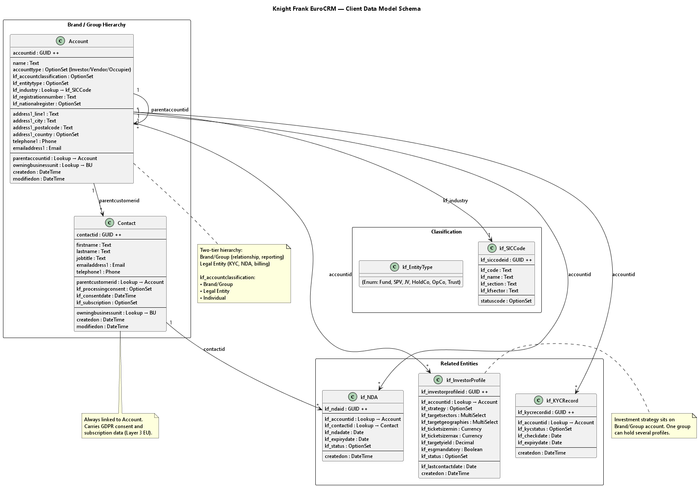

Core Entities

Account
OOB extended | Layer 2 Core
Organisation, brand, legal entity, fund, SPV or investor platform. Shared across every service line.
Core Fields:
• accountid — GUID, primary key
• name — Organisation name
• accounttype — Investor, vendor, occupier
• address1 — Composite address
• telephone1 / emailaddress1 — Primary contact details
• owningbusinessunit — Security ownership
• parentaccountid — Parent account hierarchy

Contact
OOB extended | Layer 2 Core
The individual person, always associated to an Account.
Core Fields:
• contactid — GUID, primary key
• firstname / lastname — Person name
• jobtitle — Role at the organisation
• emailaddress1 — Primary email
• telephone1 — Primary phone
• parentcustomerid — Lookup to Account
• kf_processingconsent — GDPR basis, Layer 3 EU

Brand / Group vs. Legal Entity
A two-tier hierarchy gives one client view across many funds, SPVs and joint ventures.
Brand/Group: Blackstone, Brookfield, AXA IM
• Relationship, reporting, cross-sell
Legal Entity: Blackstone Core Fund (Fund), Blackstone Logistics (SPV), Blackstone Resi JV (JV)
• KYC, NDAs, billing, counterparty
Classification Fields:
• kf_accountclassification — Brand/Group, Legal Entity, Individual
• kf_entitytype — Fund, SPV, JV, HoldCo, OpCo, Trust

International Standards on Client Records
Two fields anchor every account to recognised classifications rather than free text.

KF_INDUSTRY
Industry classification mapped to SIC codes.

KF_REGISTRATIONNUMBER
Legal registration number from the national company register.
National Registers:
• France: SIREN / SIRET
• Germany: Handelsregister HRB
• Spain: Registro Mercantil
• Poland: KRS number
Standard codes make sector reporting comparable across Europe, and a validated registration number underpins KYC and invoicing.

Property Data Model — Site, Property, Deal

Data Schema
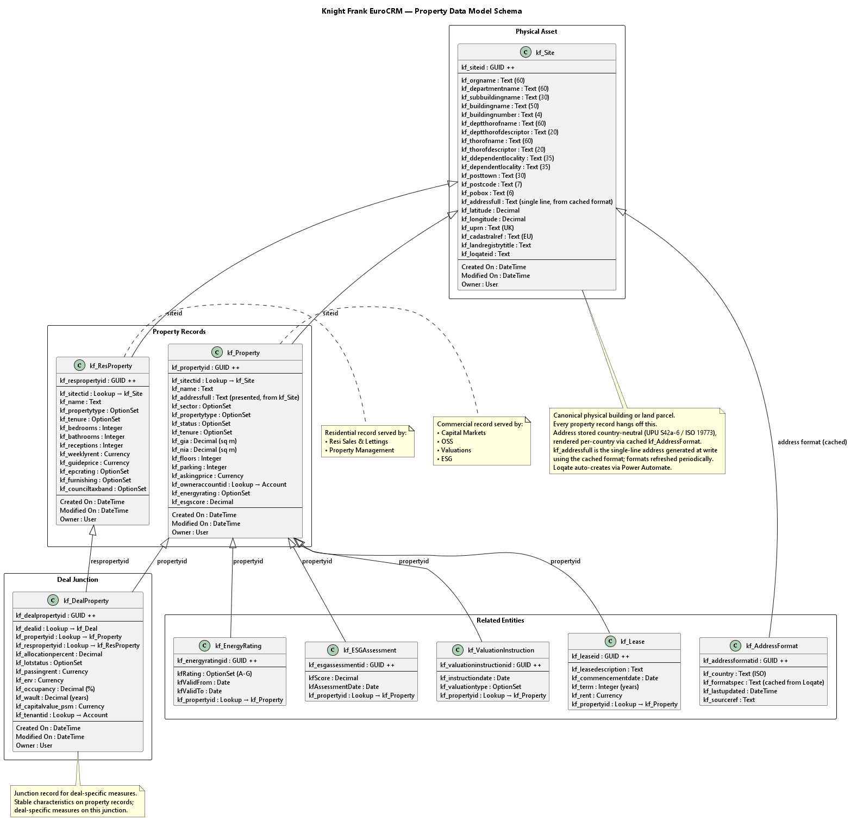

Core Entities

kf_Site — The Physical Asset
The canonical building or land parcel that every other record hangs off.
Key Fields:
• kf_uprn — UK reference
• kf_cadastralref — EU registry
• kf_landregistrytitle — deed
• kf_loqateid — verified address

Address Storage (Country-Neutral Standard)
Because properties span the globe, addresses cannot be stored biased to one country or formatting issues arise. kf_Site stores a single canonical, country-neutral address using a version of the UPU S42a-6 / ISO 19773 standard, split into granular elements:
Element | Field name | Max length
Organisation | Organisation Name | 60
 | Department Name | 60
Premises | Sub Building Name | 30
 | Building Name | 50
 | Building Number | 4
Thoroughfare | Dependent Thoroughfare Name | 60
 | Dependent Thoroughfare Descriptor | 20
 | Thoroughfare Name | 60
 | Thoroughfare Descriptor | 20
Locality | Double Dependent Locality | 35
 | Dependent Locality | 35
 | Post town | 30
Postcode | Postcode | 7
PO Box | PO Box | 6
The correct country-specific display format is then applied via the Loqate international address formats, so the stored data stays country-neutral while presentation follows each market's conventions.
As with the previous schema, the address is also presented as a single line (kf_addressfull), but that line is rendered per the applicable international address format from the country-neutral elements rather than stored as a country-biased free-text field. Identifiers such as kf_uprn (UK) and kf_cadastralref (EU registry) remain as country/regional-specific reference fields alongside the neutral core.
Address format caching: The international address format definitions are cached in a reference table (kf_AddressFormat), updated periodically from the Loqate international address formats source. kf_addressfull is generated at capture/write time from the country-neutral elements using the cached format, and the persisted single-line value is read thereafter. This avoids a live Loqate call (and its per-lookup cost) on every read.

kf_Property — The Commercial Record
The shared asset register that every commercial service line reads.
Key Fields:
• Identity and address, geocoded
• Sector, type, status, tenure
• Areas, floors, parking, planning
• Asking price, owner, ESG

kf_ResProperty — The Residential Record
The residential sibling on the same site, with its own saleable attributes.
Key Fields:
• kf_propertytype, kf_tenure
• Bedrooms, bathrooms, receptions
• Weekly rent, guide price
• kf_epcrating, kf_siteid

kf_DealProperty — The Junction
Deal-specific measures for one asset inside one deal, single or portfolio.
Key Fields:
• kf_allocationpercent, kf_lotstatus
• kf_passingrent, kf_erv
• kf_occupancy, kf_wault
• kf_capitalvalue_psm, kf_tenantid
Design Principle: Stable characteristics live on the property records; deal-specific measures live on the junction, so a deal can never overwrite the master asset.

Why Two Property Tables?

kf_Property (Commercial)
Key Schema Fields: Use class, Floor area, Lease terms, Occupational data, Investor profiles
Service Lines Served:
• Capital Markets — deals, bids, DD, investors
• OSS — engagements, leases, assessments
Deal Cycle: 6-18 months for institutional buyers; 3-12 months for corporate occupiers

kf_ResProperty (Residential)
Key Schema Fields: Bedrooms, Bathrooms, Tenure, Furnishing, Council tax
Service Lines Served:
• Resi Sales, Lettings and Buying Agency
• Resi Property Management
Deal Cycle: Days to weeks for individual buyers and tenants
Merging would create mostly blank columns for two unrelated audiences. What they share is the physical building — which is what kf_Site covers.

Two Real Scenarios

Scenario 1: Change of Use
An office block converts to residential. The commercial record is orphaned, a new resi record is created, and years of deal history are lost.

Scenario 2: Living Sectors — BTR
A Build-to-Rent block is sold as a CM asset, then let unit-by-unit. Duplicate records in both datasets keep cross-sell invisible.

Auto Address Look Up with Loqate
Users do not manually create records for kf_Site — matching and creation happen silently in the background.
1. User types address into existing CRM form
2. Loqate type-ahead returns validated address matches in real time
3. User picks a match and all address fields auto-fill
4. Standard save — no extra steps or new forms
5. Power Automate matches or creates kf_Site silently
Loqate validates and populates the country-neutral address elements above. The addresses it returns conform to the UPU S42a-6 / ISO 19773 standard. The Loqate international address formats are cached in the kf_AddressFormat reference table (updated periodically) and used at capture time to render the display layout, including the single-line kf_addressfull, for each country.

Every Service Line Reads the Same Record
One property record answers ownership, deals, valuations, leases and ESG in a single graph.
Service Line | Entity | Relationship
Capital Markets | kf_DealProperty | Many to many
OSS | kf_Engagement | Many to one
Valuations | kf_ValuationInstruction | Many to one
ESG | kf_ESGAssessment | Many to one
Building Consultancy | kf_BuildingSurvey | Many to one
Development | kf_DevelopmentProject | Many to one
Capital Advisory | kf_DebtMandate | Many to one
Property Management | kf_PropertyMandate | Many to one
Leasing | kf_Lease | Many to one
Residential | kf_ResProperty via kf_Site | Sibling

Capital Markets Data Model

Data Schema
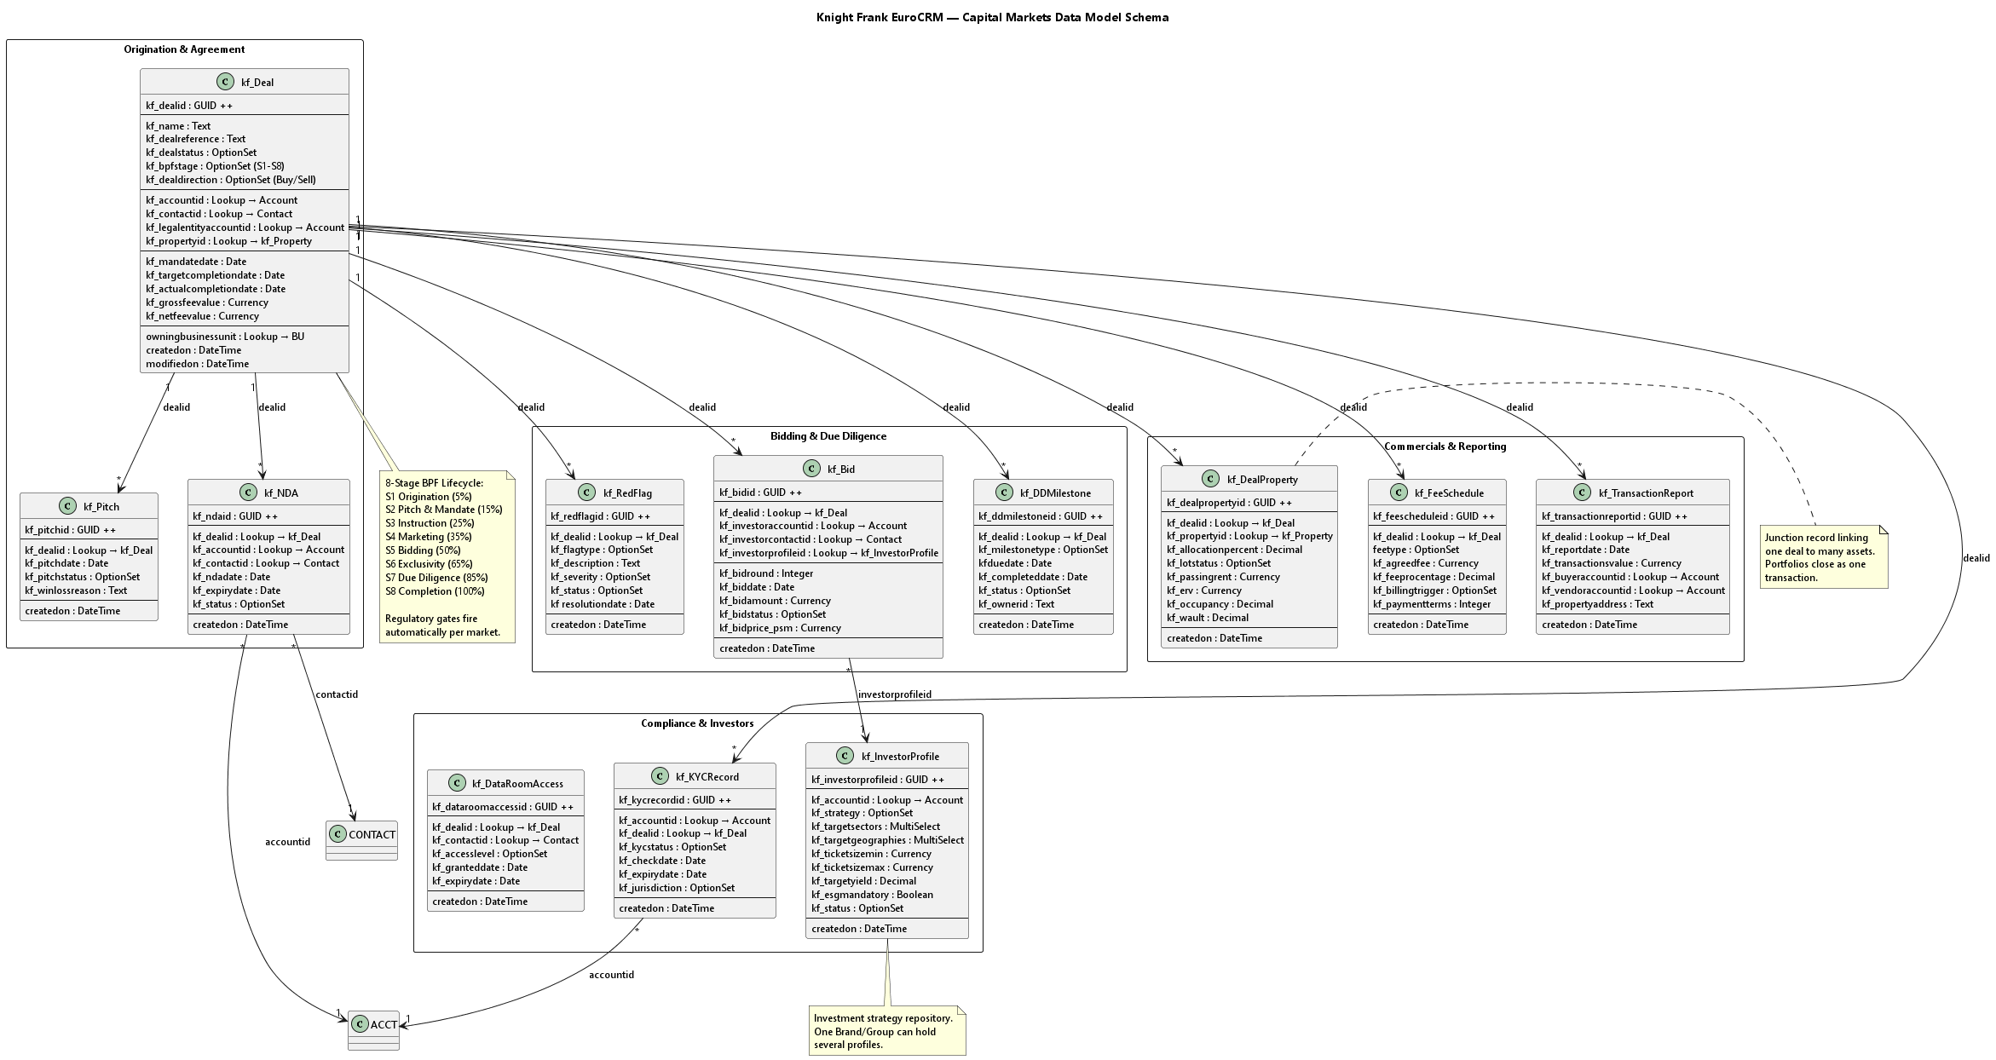

Core Entities
Twelve entities capture every stage of the deal lifecycle, from pitch to completion.

Origination & Agreement
Entity | Description
kf_Deal | Core deal record with full lifecycle tracking
kf_Pitch | Competitive pitch tracking
kf_NDA | NDA management

Bidding & Due Diligence
Entity | Description
kf_Bid | Multi-round bid management
kf_DDMilestone | Due diligence milestone tracking
kf_RedFlag | Risk and red flag tracking

Compliance & Investors
Entity | Description
kf_KYCRecord | KYC/AML compliance tracking
kf_InvestorProfile | Investor preferences and strategy
kf_DataRoomAccess | Data room access management

Commercials & Reporting
Entity | Description
kf_FeeSchedule | Fee structure management
kf_TransactionReport | Auto-generated transaction reports
kf_DealProperty | Portfolio property-level tracking

Portfolio Data Model & Workflow
A junction record links one deal to many assets, so a portfolio stays a single transaction.
Key Relationships:
• kf_Deal (1) → (N) kf_DealProperty → (N:1) kf_Property
• kf_dealid (FK), kf_propertyid (FK), kf_allocationpct
Tracked Per Property: Comparables, Due diligence, Regulatory gates, Bidding, Fee allocation
Why It Stays Simple for Brokers:
• Sub-grid only on multi-asset deals
• Gates fire automatically per market
• DD status rolls up to deal level
• Portfolios close as one transaction

Client Touchpoints Across the Lifecycle
Each entity points at the right level: the group for relationships, the legal entity for compliance & billing.

Deal
• kf_accountid — Brand/Group client organisation
• kf_contactid — Primary deal contact
• kf_legalentityaccountid — Contractual counterparty, required at mandate

Compliance
• kf_NDA — Counterparty legal entity plus signatory
• kf_KYCRecord — AML checks at legal entity level
• Brand/Group explicitly excluded from NDA records

Bid
• kf_investoraccountid — The fund, SPV or JV bidding
• kf_investorcontactid — The individual contact
• kf_investorprofileid — Investment profile behind the bid
Contact Roles: Contacts play contextual roles through entity lookups: deal contact, NDA signatory, vendor, buyer, landlord, tenant.
GDPR Layer, Europe: Contacts carry consent, subscription and segmentation data. kf_processingconsent covers legitimate interest, consent, legal obligation or not assessed.

kf_InvestorProfile: Knowing What Clients Want
Investment strategy sits on the Brand/Group account, so one group can hold several profiles.
Sample Profile: Blackstone Value Add
• Strategy: Core / Core-Plus / Value-Add / Opportunistic
• Target sectors: Offices, Logistics, Residential, Data Centres
• Geographies: UK, France, Germany, Nordics, Iberia, CEE
• Ticket size: kf_ticketsizemin to kf_ticketsizemax
• Yield & ESG: Target yield, ESG mandatory flag
• Status: Active buyer / Watching / Paused / Inactive
Relationship Tracking: Owner and last contact date; Rollups: deals and total invested
Client Strategy: Becomes the formal investor strategy repository for the region.

Capital Markets Regulatory Gates
Local approval gates sit inside the standard eight-stage deal lifecycle.

Country-Specific Gates
• France: city pre-emption and notarial deed
• Spain: right-of-refusal on listed buildings

EIT (Cross-Border Team)
• Multi-jurisdiction KYC and conflict checks
• Intercompany billing across markets

Eight-Stage Deal Lifecycle with Gates
Stage | Gate | Owner
S1 Origination | — | —
S2 Pitch & Mandate | Conflict check | EIT
S3 Instruction | Multi-jurisdiction KYC | EIT
S4 Marketing | — | —
S5 Bidding | — | —
S6 Exclusivity | — | —
S7 Due Diligence | City pre-emption | France
 | Notarial process | France
 | Right of refusal | Spain
 | Pre-emption delegation | EIT
S8 Completion | Notarial deed signing | France
 | Intercompany billing | EIT

WIP Data Model — Work in Progress

Data Schema
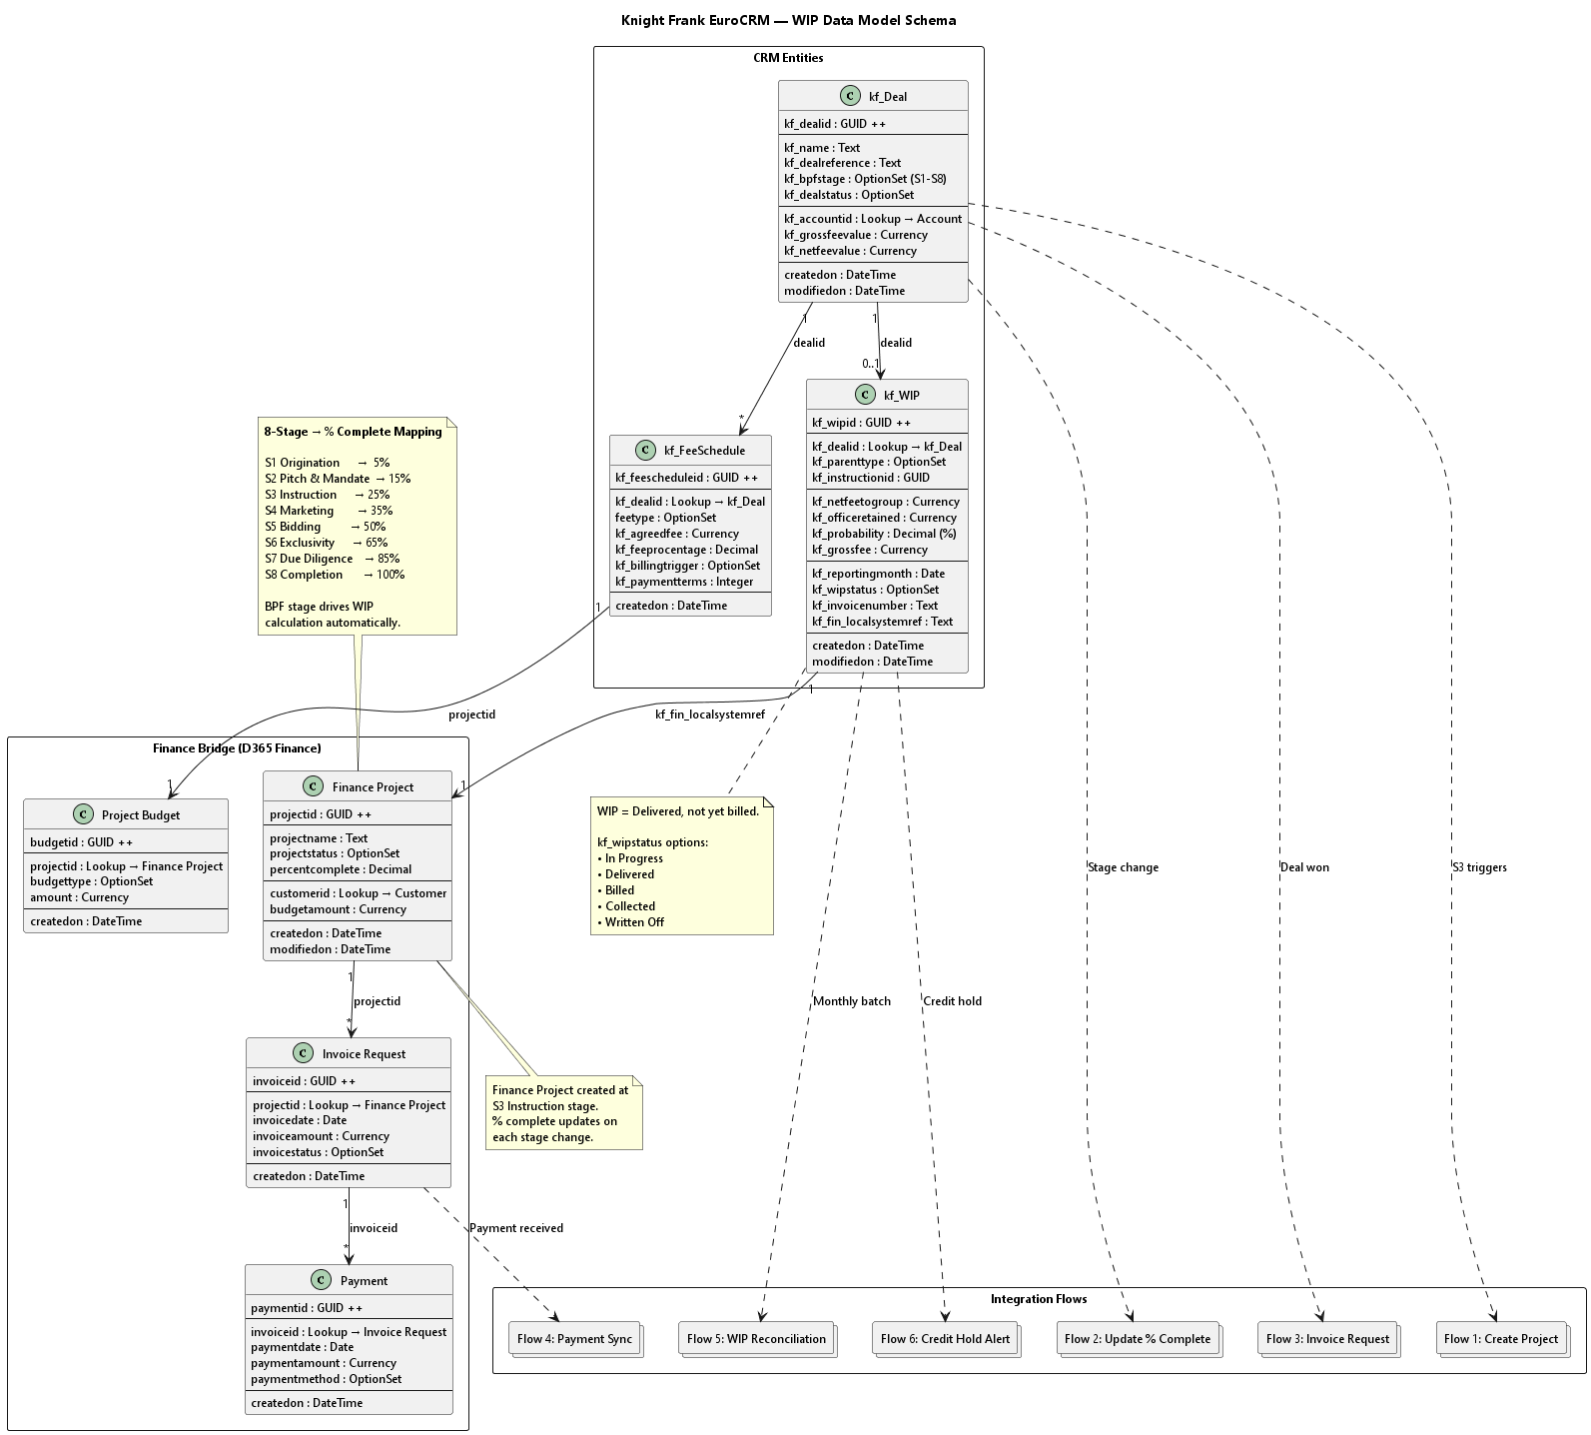

What is WIP?
WIP is the period from deal creation to fee earned: delivered, not yet billed.
Example Timeline:
• Month 1: Deal created in CRM
• Month 2: Due diligence in progress
• Month 3: Negotiation ongoing
• Month 4: Deal closes, fee earned
This is all WIP Revenue at Knight Frank.

WIP Data Model: CRM to Finance
Every CRM deal becomes a project in D365 Finance, and that bridge enables WIP reconciliation.
CRM Concept | Finance Concept | Why They Map
kf_WIP line | Project | Both track the same billable engagement
kf_FeeSchedule | Project budget / contract line | Both define expected revenue
BPF stage % complete | Both measure progress to completion
Deal status = Won | Milestone / invoice request | Both trigger billing
Account (client) | Customer (debtor) | Both identify who pays

KF_WIP Entity
Key Fields:
• kf_wipid
• kf_parenttype
• kf_instructionid
• kf_netfeetogroup
• kf_officeretained
• kf_probability
• kf_grossfee
• kf_reportingmonth
• kf_wipstatus
• kf_invoicenumber
• kf_fin_localsystemref

The 8-Stage Process Drives WIP
Each deal stage maps to a finance percentage complete that automates the WIP calculation.
Stage | % Complete
S1 | 5%
S2 | 15%
S3 | 25%
S4 | 35%
S5 | 50%
S6 | 65%
S7 | 85%
S8 | 100%

Integration Flows
1. S3 fires Flow 1: the Finance project is created
2. Each stage change updates % complete in Finance
3. Deal won raises a draft invoice request
4. Invoice and payment data returns within hours
5. A monthly batch refreshes WIP balance and ageing
6. A credit hold alerts the broker in Teams

EU CRM Data Model

Overview
Complete inventory of all data tables with service-line mapping and definitions. The data model is structured in layers following the solution package model.

Master Table Index
1302 rows covering all entities across 13 service lines.

Service Lines Covered
Code | Service Line | Layer
CM | Capital Markets | Layer 5 – KF_CapitalMarkets_Core
Res | Residential (Sales, Lettings, Property Management, Buying Agency) | Layer 5 – KF_Residential_Core
OSS | Occupier Strategy & Solutions | Layer 5 – KF_OSS_Core
Val | Valuations | Layer 5 – KF_Valuations_Core
ESG | ESG Consultancy | Layer 5 – KF_ESG_Core
BC | Building Consultancy | Layer 5 – KF_BuildingConsultancy_Core
Dev | Development Consultancy | Layer 5 – KF_Development_Core
CA | Capital Advisory (Debt & Structured Finance) | Layer 5 – KF_CapitalAdvisory_Core
PM | Property Management | Layer 5 – KF_PropertyManagement_Core
IA | Investor Advisory | Layer 5 – KF_InvestorAdvisory_Core
WC | Workplace Consulting | Layer 5 – KF_Workplace_Core
Leasing | Leasing (Commercial Agency) | Layer 5 – KF_Leasing_Core
Mkt | Marketing | Cross-cutting

Core Shared Tables (Layer 2)
See data model core tables for detailed schema definitions.

MVP Tables
Table | Category | Description
Account | CRM Lite | OOB extended — Organisation, brand, legal entity, fund, SPV
Contact | CRM Lite | OOB extended — Individual person, always associated to Account
kf_Property | CRM Lite | Commercial property record
kf_Site | CRM Lite | Physical building or land parcel
kf_SICCode | Supporting | SIC code reference table
kf_Deal | CM Deep Build | Core deal record with full lifecycle tracking
kf_DealProperty | Core Shared | Junction record linking deals to properties
kf_Pitch | CM Deep Build | Competitive pitch tracking
kf_NDA | CM Deep Build | NDA management
kf_Bid | CM Deep Build | Multi-round bid management
kf_DDMilestone | CM Deep Build | Due diligence milestone tracking
kf_RedFlag | CM Deep Build | Risk and red flag tracking
kf_FeeSchedule | CM Deep Build | Fee structure management
kf_KYCRecord | CM Deep Build | KYC/AML compliance tracking
kf_InvestorProfile | CM Deep Build | Investor preferences and strategy
kf_DataRoomAccess | CM Deep Build | Data room access management
kf_TransactionReport | CM Deep Build | Auto-generated transaction reports

Tables by Activation Phase
Phase | Tables Activated
MVP — Phase 0 | Account, Contact, kf_Property, kf_EnergyRating, kf_GDPRRequest, kf_AuditExport, kf_SICCode
MVP — Phase 1 | kf_Deal, kf_DealProperty, kf_Pitch, kf_NDA, kf_Bid, kf_DDMilestone, kf_RedFlag, kf_FeeSchedule, kf_KYCRecord, kf_InvestorProfile, kf_DataRoomAccess, kf_TransactionReport, kf_StageGateRule, kf_IntegrationLog, Lead
Future — Phase 3 | kf_Engagement, kf_Lease, kf_ValuationInstruction, kf_ESGAssessment, kf_BuildingSurvey, kf_DevelopmentProject, kf_DebtMandate, kf_PropertyMandate, kf_MaintenanceRequest, kf_InvestorMandate, kf_WorkplaceAssessment, kf_LocationSearch
Future — Phase 4 | kf_ResProperty, kf_SalesInstruction, kf_LettingsInstruction, kf_Tenancy, kf_Applicant, kf_Viewing, kf_Offer, kf_BuyingBrief

Category Legend
Category | Description
CRM Lite | Core shared tables deployed in Phase 0 — foundational entities used across all service lines
CM Deep Build | Capital Markets-specific tables with full BPF, Finance integration and complex workflows
OSS/Val | Occupier Strategy & Solutions and Valuations service line tables
Residential | Residential property services tables including sales, lettings, and property management
Compliance | Data governance and compliance tables (GDPR, Audit) — deployed in Phase 0
Supporting | Infrastructure tables (Stage Gate Rules, Integration Logs) supporting process automation
Marketing | Marketing and lead generation tables (D365 Customer Insights - Journeys integration)
Finance | Finance integration tables for WIP, billing, and revenue recognition

Related Documents
• data model core tables — Detailed schema for Layer 2 tables
• solution package model — Layer architecture (L0-L7)
• client data model — Client entity definitions
• property data model — Property entity definitions
• capital markets data model — Capital Markets entity definitions

Core Data Model Tables

Data Schema
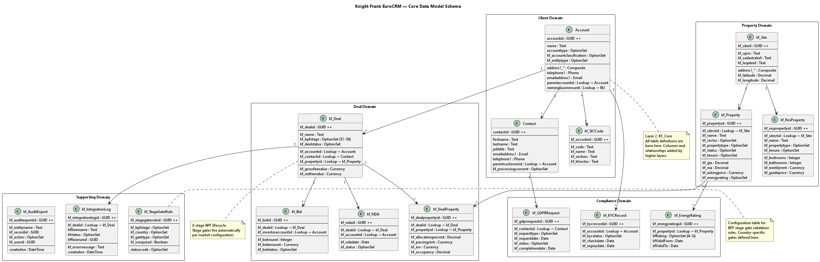

Layer 2: KF_Core
Layer 2 (Global Core) defines every data table used across the business (deals, properties, investors, NDAs, bids, KYC records) as empty "shells." All custom table definitions are born at this layer. Columns and relationships are added by higher layers.

Core Entities

Account (OOB — Extended)
The canonical client organisation record.
Key Fields:
• accountid — GUID, primary key
• name — Organisation name
• accounttype — Investor, vendor, occupier
• address1 — Composite address
• telephone1 / emailaddress1 — Primary contact details
• owningbusinessunit — Security ownership
• parentaccountid — Parent account hierarchy

Contact (OOB — Extended)
The individual person, always associated to an Account.
Key Fields:
• contactid — GUID, primary key
• firstname / lastname — Person name
• jobtitle — Role at the organisation
• emailaddress1 — Primary email
• telephone1 — Primary phone
• parentcustomerid — Lookup to Account
• kf_processingconsent — GDPR basis, Layer 3 EU

kf_Property
The shared asset register that every commercial service line reads.
Key Fields:
• Identity and address, geocoded
• Sector, type, status, tenure
• Areas, floors, parking, planning
• Asking price, owner, ESG

kf_Site
The canonical building or land parcel that every other record hangs off.
Key Fields:
• Country-neutral address elements (UPU S42a-6 / ISO 19773) — see property data model
• kf_addressfull — single-line address rendered per international format
• kf_uprn — UK reference
• kf_cadastralref — EU registry
• kf_landregistrytitle — deed
• kf_loqateid — verified address

kf_DealProperty
Junction record linking one deal to many assets.
Key Fields:
• kf_allocationpercent, kf_lotstatus
• kf_passingrent, kf_erv
• kf_occupancy, kf_wault
• kf_capitalvalue_psm, kf_tenantid

Service Line Tables

Capital Markets (Layer 5)
See capital markets data model for detailed definitions.
Entity | Description
kf_Deal | Core deal record with full lifecycle tracking
kf_Pitch | Competitive pitch tracking
kf_NDA | NDA management
kf_Bid | Multi-round bid management
kf_DDMilestone | Due diligence milestone tracking
kf_RedFlag | Risk and red flag tracking
kf_FeeSchedule | Fee structure management
kf_KYCRecord | KYC/AML compliance tracking
kf_InvestorProfile | Investor preferences and strategy
kf_DataRoomAccess | Data room access management
kf_TransactionReport | Auto-generated transaction reports

Residential (Layer 5)
See property data model for detailed definitions.
Entity | Description
kf_ResProperty | Residential property record
kf_SalesInstruction | Sales instruction tracking
kf_LettingsInstruction | Lettings instruction tracking
kf_Tenancy | Tenancy management
kf_Applicant | Applicant tracking
kf_Viewing | Viewing scheduling
kf_Offer | Offer management
kf_BuyingBrief | Buying brief tracking

Other Service Lines (Future Phases)
Service Line | Entities
OSS | kf_Engagement, kf_Lease, kf_WorkplaceAssessment, kf_LocationSearch
Valuations | kf_ValuationInstruction
ESG | kf_ESGAssessment
Building Consultancy | kf_BuildingSurvey
Development | kf_DevelopmentProject
Capital Advisory | kf_DebtMandate
Property Management | kf_PropertyMandate, kf_MaintenanceRequest
Investor Advisory | kf_InvestorMandate

Supporting Tables
Table | Purpose
kf_SICCode | SIC code reference table
kf_EnergyRating | Energy performance ratings
kf_GDPRRequest | GDPR data subject requests
kf_AuditExport | Audit trail export
kf_StageGateRule | Configuration table for BPF stage gate validation rules
kf_IntegrationLog | Integration transaction logging

Solution Package Model — Layered Architecture

Layer Model
Layer | Name | Description
L0 | External Systems | D365 CI-Journeys (same env); Finance (future); ECS — change notification bus (Major entity events)
L1 | Dataverse Platform | System tables; security framework; audit log (Microsoft-managed)
L2 | KF_Core | 40+ table shells; option sets; BU hierarchy; base security; Outlook sync; SharePoint; BI
L3 | Region | KF_Europe — EUR default, GDPR baseline, Regional Power BI Dashboard
L4 | Country | KF_France; KF_Germany; KF_Poland; KF_Spain
L5 | Service Line Core | KF_CapitalMarkets_Core (8-stage BPF); KF_OSS_Core; KF_Valuations_Core (future); KF_Marketing_Core; KF_Finance_Integration
L6 | Service Line — Country | KF_CM_France; KF_CM_Spain; KF_OSS_France; ...
L7 | Cross-Border Overlays | KF_EIT; KF_Private_Office

Proposed Technical Rules
• KF_Core Layer defines ALL Option sets & ALL custom tables as base — schema name, primary key, and ownership model
• No regional fork can create a duplicate table
• Each layer is a separate managed solution
• No unmanaged customisations in TEST, UAT, or PROD

Layer 6 Extension Rules
• Inherits the Service Line Core Layer BPF
• Adds country-specific columns with prefixes: kf_fr (France); kf_es (Spain)
• Adds regulatory stage gates that block BPF progression
• Provides country-specific form layouts and option set visibility rules
• NEVER renames or removes standard stages — only ADDs within them
• Adding a country = new L4 + L6 solutions | Adding a service line = new L5 solution
• Columns and relationships added by higher layers

Taxonomy Mappings

Client Industry Taxonomy — SIC to KF Mapping
SIC gives the common backbone; KF sectors describe how we actually serve clients.
The Standard: Start from SIC — the recognised statistical classification behind UK and European company records.
The Translation: Map to how we advise — each SIC division is translated into a KF client industry sector and sub-segment, in the language our teams use with clients.
The Bridge: Close the modern gaps — client types SIC could not anticipate, such as sovereign wealth funds, family offices, SPVs, REITs and PropTech, are mapped explicitly.

Strategic Sectors
Strategic KF Client Sector | SIC Mapping | Significance | Notes
Private Equity & Funds | 64.2 / 64.3 | Core | Major investment clients across all asset classes
Sovereign Wealth | 64.3 | Core | Not explicit in SIC — mapped via Other Financial Services
Banking & Financial Services | 64.1 / 66 | Core | Major occupier and investor clients
Insurance & Pensions | 65 | Core | Direct RE investors; large portfolio holders
Real Estate | 68 | Core | REITs, property companies, asset managers, developers
Real Estate Development | 41 | Core | House builders, commercial developers
Technology | 62 / 63 | Core+ | Growing occupier demand; data centre and campus clients
Life Sciences & Pharmaceuticals | 21 / 72 | Emerging | Specialist lab, campus and manufacturing requirements
Logistics & Distribution | 52 | Core+ | 3PL operators, warehouse and fulfilment clients

SIC Gaps
Modern client types not explicitly covered by SIC:
Modern Client Type | KF Enterprise Mapping | Gap Description
Sovereign Wealth Funds | Financial Services & Investment | SIC bundles all investment funds under 64.3
Family Offices | UHNW & Private Individuals | No specific code; split between financial services and household employers
Special Purpose Vehicles (SPVs) | Financial Services & Investment | Grouped under holding companies
REITs | Real Estate | No distinction between listed REITs and operating property companies
PropTech | Technology | Bundled under IT consultancy
Co-Working Operators | Real Estate | Classified as real estate; no distinction from traditional landlords
Infrastructure Funds | Financial Services & Investment | No distinction from other collective investment vehicles
Private Equity (RE-focused) | Financial Services & Investment | No distinction between RE-focused PE and general PE
Pension Fund Direct RE | Insurance & Pensions | No distinction between direct RE investment and general pension activity

Full Mapping
See taxonomy sic kf for the complete mapping of 21 SIC sections to 66 KF client sectors and sub-segments.

Asset Class Taxonomy — HILUCS to KF Mapping
HILUCS gives the common backbone for Knight Frank asset classes.
The Standard: Start from HILUCS — the European INSPIRE land-use classification gives every market one shared way to describe what a building or parcel of land is used for.
The Translation: Map to how we trade — every HILUCS class is translated into the Knight Frank enterprise sector and the asset classes our teams transact.
The Bridge: Close the modern gaps — classes HILUCS could not anticipate, such as data centres, BTR, PBSA and self storage, are bridged to the nearest standard class.

Strategic Sectors
Strategic KF Sector | HILUCS Mapping | Significance | Notes
Office | 3.2.2 | Core | Traditional institutional asset class
Retail | 3.1.1 | Core | Evolving with omnichannel strategies
Industrial | 2.1 / 2.2 / 2.3 | Core | Manufacturing and production facilities
Logistics | 4.2 | Core+ | High growth sector driven by e-commerce
Data Centres | 3.2.3 | Emerging | Not explicit in HILUCS — mapped via ICT Services
Life Sciences | 3.2.2 | Emerging | Not explicit in HILUCS — mapped via Professional Services
Healthcare | 3.3.3 | Core | Defensive sector with demographic tailwinds
Living | 5.x | Core+ | Umbrella for all residential-related sectors
PBSA | 5.3 | Emerging | Not explicit in HILUCS — mapped via Other Residential

HILUCS Gaps
Modern asset classes not explicitly covered by HILUCS:
Modern Asset Class | Enterprise Mapping | Gap Description
Data Centres | Digital Infrastructure | HILUCS treats as generic ICT services
Life Sciences | Life Sciences | Bundled under professional services
Build to Rent (BTR) | Build to Rent (BTR) | No distinction from owner-occupied residential
PBSA | PBSA | Classified as 'Other Residential'
Self Storage | Self Storage | Bundled with logistics
Senior Living | Senior Living | Split between Residential and Healthcare
Co-Living | Co-Living | No recognition of shared living concepts
Multifamily | Multifamily | No distinction from general residential
Cold Storage | Cold Storage | Bundled with general logistics

Full Mapping
See taxonomy hilucs kf for the complete mapping of all Knight Frank sectors and asset classes.

HILUCS to KF Asset Class Mapping

Full Mapping
L1 | HILUCS Level 1 | L2 | HILUCS Level 2 | KF Sector | KF Asset Classes
--- | -------------- | -- | -------------- | --------- | ----------------
1 | Primary Production | 1.1 | Agriculture | Agriculture | Arable, Livestock, Mixed Farming, Orchards, Vineyards +
1 | Primary Production | 1.2 | Forestry | Forestry | Timber Estates, Managed Woodland, Carbon Forestry, Biomass Forestry
1 | Primary Production | 1.3 | Mining & Quarrying | Natural Resources | Quarry, Aggregate Extraction, Mining Operations
1 | Primary Production | 1.4 | Aquaculture & Fishing | Marine Resources | Fisheries, Aquaculture
1 | Primary Production | 1.5 | Other Primary Production | Rural & Land Holdings | Sporting Estates, Hunting Estates, Managed Rural Land
2 | Secondary Production | 2.1 | Raw Industry | Industrial Manufacturing | Chemical Plants, Steelworks, Cement Works, Processing Plants
2 | Secondary Production | 2.2 | Heavy End Product Industry | Advanced Manufacturing | Automotive, Aerospace, Engineering Manufacturing
2 | Secondary Production | 2.3 | Light End Product Industry | Light Industrial | Food Production, Consumer Manufacturing, Electronics Production
2 | Secondary Production | 2.4 | Energy Production | Energy | Power Stations, Solar Farms, Wind Farms, Battery Storage +
2 | Secondary Production | 2.5 | Other Industry | Specialist Industrial | Defence Manufacturing, Specialist Production Facilities
3 | Tertiary Production | 3.1.1 | Wholesale & Retail Trade | Retail | Shopping Centres, Retail Parks, High Street, Outlet Centres +
3 | Tertiary Production | 3.1.2 | Real Estate Services | Mixed Commercial | Mixed Use Commercial Developments
3 | Tertiary Production | 3.1.3 | Accommodation & Food Services | Hotels & Hospitality | Hotels, Resorts, Aparthotels, Serviced Apartments, Extended Stay
3 | Tertiary Production | 3.1.3 | Accommodation & Food Services | Food & Beverage | Restaurants, Bars, Cafés, Pubs
3 | Tertiary Production | 3.2.2 | Professional Technical & Scientific Services | Office | Prime Office, Grade A Office, Flexible Workspace, Corporate HQ +
3 | Tertiary Production | 3.2.2 | Professional Technical & Scientific Services | Life Sciences | Research Campuses, Laboratory Space, Wet Labs, Science Parks
3 | Tertiary Production | 3.2.3 | Information & Communication Services | Digital Infrastructure | Data Centres, Hyperscale, Colocation, Edge Facilities
3 | Tertiary Production | 3.2.3 | Information & Communication Services | Telecom Infrastructure | Exchanges, Telecom Hubs, Fibre Facilities
3 | Tertiary Production | 3.2.1 | Financial & Insurance Services | Financial Services | Banking HQs, Financial District Offices
3 | Tertiary Production | 3.3.2 | Educational Services | Education | Schools, Universities, Colleges, Training Centres
3 | Tertiary Production | 3.3.3 | Health & Social Services | Healthcare | Hospitals, Medical Centres, Clinics
3 | Tertiary Production | 3.3.3 | Health & Social Services | Care & Senior Living | Care Homes, Nursing Homes, Assisted Living
3 | Tertiary Production | 3.3.1 | Public Administration Services | Public Sector | Government Buildings, Civic Estate, Local Authority Buildings
3 | Tertiary Production | 3.4.1 | Cultural Services | Culture & Heritage | Museums, Galleries, Heritage Assets
3 | Tertiary Production | 3.4.2 | Entertainment Services | Leisure | Cinemas, Casinos, Theme Parks
3 | Tertiary Production | 3.4.3 | Sports Infrastructure | Sports & Stadia | Stadiums, Arenas, Golf Courses, Sports Complexes
3 | Tertiary Production | 3.4.4 | Open Air Recreation | Recreation | Parks, Visitor Attractions, Recreation Grounds
4 | Transport, Logistics & Utilities | 4.1.1 | Road Transport | Road Infrastructure | Service Stations, Major Road Assets
4 | Transport, Logistics & Utilities | 4.1.2 | Railway Transport | Rail Infrastructure | Stations, Rail Hubs, Freight Rail Assets
4 | Transport, Logistics & Utilities | 4.1.3 | Air Transport | Aviation | Airports, Cargo Airports, Airfields
4 | Transport, Logistics & Utilities | 4.1.4 | Water Transport | Maritime | Ports, Marinas, Container Terminals
4 | Transport, Logistics & Utilities | 4.2 | Logistical & Storage Services | Logistics | Big Box Logistics, Distribution Centres, Fulfilment Centres
4 | Transport, Logistics & Utilities | 4.2 | Logistical & Storage Services | Urban Logistics | Last Mile Logistics, Parcel Hubs
4 | Transport, Logistics & Utilities | 4.2 | Logistical & Storage Services | Self Storage | Self Storage Facilities
4 | Transport, Logistics & Utilities | 4.2 | Logistical & Storage Services | Cold Storage | Refrigerated Logistics Facilities
4 | Transport, Logistics & Utilities | 4.3.1 | Electricity, Gas & Thermal Distribution | Energy Infrastructure | Substations, Grid Infrastructure
4 | Transport, Logistics & Utilities | 4.3.2 | Water & Sewage Infrastructure | Water Infrastructure | Reservoirs, Treatment Plants
4 | Transport, Logistics & Utilities | 4.3.3 | Waste Treatment | Environmental Infrastructure | Recycling Facilities, Waste Treatment Plants
5 | Residential Use | 5.1 | Permanent Residential Use | Residential | Houses, Apartments, Residential Blocks
5 | Residential Use | 5.1 | Permanent Residential Use | Multifamily | Multifamily Housing
5 | Residential Use | 5.1 | Permanent Residential Use | Build to Rent (BTR) | Institutional Rental Housing
5 | Residential Use | 5.1 | Permanent Residential Use | Luxury Residential | Prime Residential, Super Prime Residential
5 | Residential Use | 5.2 | Residential with Compatible Uses | Mixed Use Living | Residential Led Mixed Use
5 | Residential Use | 5.3 | Other Residential Use | PBSA | Purpose-Built Student Accommodation
5 | Residential Use | 5.3 | Other Residential Use | Co-Living | Shared Living Assets
5 | Residential Use | 5.3 | Other Residential Use | Senior Living | Retirement Villages, Independent Living
5 | Residential Use | 5.3 | Other Residential Use | Serviced Living | Branded Residences, Serviced Apartments
6 | Other Uses | 6.1 | Transitional Areas | Development Land | Construction Sites, Regeneration Projects
6 | Other Uses | 6.2 | Abandoned Areas | Brownfield Regeneration | Redevelopment Opportunities
6 | Other Uses | 6.3 | Natural Areas | Environmental Assets | Conservation Land, Biodiversity Assets
6 | Other Uses | 6.4 | Areas Where Any Use Allowed | Strategic Land | Long-Term Development Land
6 | Other Uses | 6.5 | Areas Without Specified Planned Use | Unallocated Land | Future Planning Allocations
6 | Other Uses | 6.6 | Not Known Use | Unknown | Unclassified Assets

SIC to KF Client Sector Mapping

Full Mapping
SEC | SIC Section | Divisions | KF Client Sector | KF Sub-Segments
A | Agriculture, Forestry and Fish | 1 | Agriculture & Farming | Arable Farms, Livestock, Mixed Farming, Estate Owners, Agricultural Cooperatives
A | Agriculture, Forestry and Fish | 2 | Forestry & Woodland | Timber Companies, Forest Management, Carbon Forestry Operators
A | Agriculture, Forestry and Fish | 3 | Marine & Aquaculture | Fisheries Operators, Aquaculture Companies
B | Mining and Quarrying | 5, 7, 8, 9 | Mining & Extraction | Coal Mining Operators
B | Mining and Quarrying | 6 | Oil & Gas | Upstream Operators, E&P Companies
C | Manufacturing | 10, 11 | Food & Beverage Manufacturing | Food Producers, Processors, Packagers
C | Manufacturing | 12, 13, 14, 15, 31, 32 | Consumer Goods Manufacturing | Tobacco Companies
C | Manufacturing | 16, 17, 18, 22, 23, 25 | Industrial Manufacturing | Timber Processing, Wood Products
C | Manufacturing | 19, 20 | Energy & Chemicals | Refineries, Petrochemical Plants
C | Manufacturing | 21 | Life Sciences & Pharmaceuticals | Pharma Companies, Biotech, Drug Manufacturing
C | Manufacturing | 24 | Heavy Industry | Steelworks, Smelters, Metal Production
C | Manufacturing | 26, 27 | Technology Manufacturing | Semiconductor, Electronics, Optics
C | Manufacturing | 28 | Advanced Manufacturing | Machine Builders, Capital Goods
C | Manufacturing | 29 | Automotive | Vehicle Manufacturers, OEMs, Tier 1 Suppliers
C | Manufacturing | 30 | Aerospace & Defence | Aircraft, Shipbuilding, Rail Manufacturing
C | Manufacturing | 33 | Industrial Services | Maintenance Providers, Equipment Installers
D | Electricity, Gas, Steam and AC | 35 | Energy & Utilities | Power Companies, Gas Distributors, District Heating, Renewable Generators
E | Water Supply, Sewerage, Waste | 36, 37, 38, 39 | Environmental Services & Utilities | Water Companies, Treatment Operators
F | Construction | 41 | Real Estate Development & Construction | House Builders, Commercial Developers, Design & Build
F | Construction | 42 | Infrastructure & Civil Engineering | Civil Engineers, Infrastructure Contractors
F | Construction | 43 | Construction Services | Electrical Contractors, Plumbing, Fitout, Demolition
G | Wholesale and Retail Trade | 45 | Automotive Retail | Motor Dealers, Vehicle Distribution, Showrooms
G | Wholesale and Retail Trade | 46 | Wholesale & Distribution | Wholesalers, Import/Export, B2B Distribution
G | Wholesale and Retail Trade | 47 | Retail & Consumer | High Street Retailers, Supermarkets, E-commerce, Convenience, Discount
H | Transportation and Storage | 49 | Transport & Mobility | Rail Operators, Bus Companies, Road Freight, Pipeline Operators
H | Transportation and Storage | 50 | Shipping & Maritime | Shipping Lines, Ferry Operators, Inland Waterway
H | Transportation and Storage | 51 | Aviation | Airlines, Cargo Airlines, Charter Operators
H | Transportation and Storage | 52 | Logistics & Distribution | 3PL, Warehousing Operators, Freight Forwarders, Fulfilment
H | Transportation and Storage | 53 | Postal & Courier | National Mail, Parcel Companies, Last-Mile Delivery
I | Accommodation and Food Service | 55 | Hotels & Hospitality | Hotel Operators, Resort Groups, Serviced Apartment Operators, Hostels
I | Accommodation and Food Service | 56 | Food & Beverage Operators | Restaurant Groups, QSR Chains, Pub Companies, Caterers, Cafés
J | Information and Communication | 58 | Media & Publishing | Publishers, Digital Media, News Organisations
J | Information and Communication | 59, 60 | Media & Entertainment | Film Studios, Production Companies, Streaming Platforms
J | Information and Communication | 61 | Telecommunications | Mobile Operators, ISPs, Fibre Providers, Tower Companies
J | Information and Communication | 62, 63 | Technology | Software Companies, IT Consultancies, SaaS, PropTech, Cyber Security
K | Financial and Insurance Activities | 64 | Financial Services & Investment | Banks, Building Societies, Investment Funds, Holding Companies, PE, VC, SWFs
K | Financial and Insurance Activities | 65 | Insurance & Pensions | Insurers, Reinsurers, Pension Funds, Life Companies
K | Financial and Insurance Activities | 66 | Financial Services Support | Fund Administration, Brokerage, Financial Advisory, Wealth Management
L | Real Estate Activities | 68 | Real Estate | REITs, Property Companies, Asset Managers, Developers, Agents, Landlords, PropTech
M | Professional, Scientific and Technical | 69 | Legal & Accounting | Law Firms, Accountancy Practices, Tax Advisory
M | Professional, Scientific and Technical | 70 | Professional Services | Management Consultancies, Corporate HQs, Strategy Firms
M | Professional, Scientific and Technical | 71 | Design & Engineering | Architects, Engineers, Surveyors, Testing Laboratories
M | Professional, Scientific and Technical | 72 | Research & Development | R&D Centres, Research Institutes, Biotech R&D
M | Professional, Scientific and Technical | 73 | Marketing & Creative | Advertising Agencies, Market Research, PR Firms
M | Professional, Scientific and Technical | 74 | Specialist Professional Services | Design Studios, Photography, Translation, Consulting
M | Professional, Scientific and Technical | 75 | Veterinary | Veterinary Practices, Animal Hospitals
N | Administrative and Support Services | 77 | Rental & Leasing | Vehicle Leasing, Equipment Rental, Plant Hire
N | Administrative and Support Services | 78 | Staffing & Recruitment | Recruitment Agencies, Temp Staffing, HR Outsourcing
N | Administrative and Support Services | 79 | Travel & Tourism | Travel Agencies, Tour Operators, OTAs
N | Administrative and Support Services | 80 | Security Services | Security Companies, Investigation Services, Guarding
N | Administrative and Support Services | 81 | Facilities Management | FM Companies, Cleaning, Landscaping, Building Maintenance
N | Administrative and Support Services | 82 | Business Support Services | BPO, Call Centres, Shared Service Centres
O | Public Administration and Defence | 84 | Government & Public Sector | Central Government, Local Authorities, Defence, Emergency Services, Diplomatic
P | Education | 85 | Education | Universities, Schools, Colleges, Training Providers, EdTech, Academy Trusts
Q | Human Health and Social Work | 86 | Healthcare | NHS Trusts, Private Hospitals, GP Practices, Dental Chains, Diagnostics
Q | Human Health and Social Work | 87 | Care & Senior Living | Care Home Operators, Nursing Home Groups, Assisted Living, Retirement Villages
Q | Human Health and Social Work | 88 | Social Services | Charities, Social Enterprises, Community Services
R | Arts, Entertainment and Recreation | 90 | Creative & Cultural | Theatres, Music Venues, Art Galleries, Creative Studios
R | Arts, Entertainment and Recreation | 91 | Cultural Institutions | Museums, Libraries, Heritage Organisations
R | Arts, Entertainment and Recreation | 92 | Gaming & Betting | Casinos, Betting Shops, Online Gambling Operators
R | Arts, Entertainment and Recreation | 93 | Sports & Leisure | Gym Operators, Sports Clubs, Leisure Centres, Golf Clubs
S | Other Service Activities | 94 | Membership & Associations | Trade Bodies, Professional Associations, Trade Unions, Religious Organisations
S | Other Service Activities | 95 | Repair Services | IT Repair, Household Appliance Repair
S | Other Service Activities | 96 | Personal Services | Hairdressers, Spas, Funeral Services, Laundry
T | Activities of Households as Employers | 97, 98 | UHNW & Private Individuals | UHNW Individuals, Family Offices, Private Estates
U | Extraterritorial Organisations | 99 | International & Diplomatic | Embassies, International Organisations, UN Bodies, EU Institutions, NATO

Alignment with Enterprise Architecture

Architecture — Principles Compliance

Reference Document
CTO Architecture Principles.pptx

Principles Compliance Mapping
Principle | Compliance Status | Evidence | Notes
Cloud-first | ✅ Compliant | Dataverse (EU-hosted), Power Platform | All components are cloud-native
Security by design | ✅ Compliant | Entra ID, MFA, encryption, audit trails | Security embedded in architecture
Data residency | ✅ Compliant | EU-hosted Dataverse, regional BUs | Data stays within EU jurisdictions
Scalability | ✅ Compliant | Power Platform autoscaling, Dataverse | Platform handles growth automatically
Integration-first | ✅ Compliant | 9 Finance flows, Outlook, SharePoint, CI-Journeys | Designed for integration from day one
Modularity | ✅ Compliant | L0-L7 layer model, managed solutions | Components can be deployed independently
Compliance | ✅ Compliant | KYC, GDPR, audit trails, regulatory gates | Built-in compliance mechanisms
User experience | ✅ Compliant | Model-driven apps, Copilot for Sales | Modern, intuitive interface
Cost optimisation | ✅ Compliant | Power Platform licensing, phased rollout | Pay-as-you-grow model
Future-proofing | ✅ Compliant | Layer model supports new regions/service lines | Extensible architecture

Detailed Compliance Analysis

Cloud-first
• Requirement: Prefer cloud solutions over on-premises
• Implementation: Dataverse (EU-hosted), Power Platform, Microsoft 365 integration
• Evidence: No on-premises components, all services are SaaS/PaaS
• Status: ✅ Fully compliant

Security by design
• Requirement: Embed security in architecture from the start
• Implementation: Entra ID authentication, MFA, Conditional Access, encryption at rest/transit, audit trails
• Evidence: Security roles, BU-based isolation, field-level security, 7-year audit retention
• Status: ✅ Fully compliant

Data residency
• Requirement: Keep data within legal jurisdictions
• Implementation: EU-hosted Dataverse, country-specific BUs, regional data isolation
• Evidence: West Europe/France Central regions, BU hierarchy by country
• Status: ✅ Fully compliant

Scalability
• Requirement: Architecture must support growth
• Implementation: Power Platform autoscaling, Dataverse storage tiers, phased rollout
• Evidence: 8 phases, new regions/service lines added via layer model
• Status: ✅ Fully compliant

Integration-first
• Requirement: Design for integration from day one
• Implementation: 9 Finance flows, Outlook, SharePoint, CI-Journeys, Loqate
• Evidence: Integration bridge, API-first design, standard connectors
• Status: ✅ Fully compliant

Modularity
• Requirement: Components should be independently deployable
• Implementation: L0-L7 layer model, managed solutions per layer
• Evidence: Each layer is a separate managed solution, can be deployed independently
• Status: ✅ Fully compliant

Compliance
• Requirement: Build compliance into the platform
• Implementation: KYC/AML, GDPR consent, audit trails, regulatory gates
• Evidence: Automated gates, consent tracking, 7-year retention, exportable audit logs
• Status: ✅ Fully compliant

User experience
• Requirement: Modern, intuitive interface
• Implementation: Model-driven apps, Copilot for Sales, Outlook integration
• Evidence: Familiar Microsoft interface, AI-assisted features, seamless integration
• Status: ✅ Fully compliant

Cost optimisation
• Requirement: Optimise costs while delivering value
• Implementation: Power Platform licensing, phased rollout, shared foundation
• Evidence: Pay-as-you-grow, reuse across service lines, no custom code
• Status: ✅ Fully compliant

Future-proofing
• Requirement: Architecture must support future changes
• Implementation: Layer model, managed solutions, extensible data model
• Evidence: New regions (L3), new service lines (L5), new countries (L4) can be added without rework
• Status: ✅ Fully compliant

Gaps and Remediation
Gap | Impact | Remediation | Timeline
CTO Principles document not available | Medium | Request from CTO office | Pre-implementation
Enterprise data residency standards not documented | Medium | Align with legal team | Phase 0
Security baseline not documented | Medium | Align with security team | Phase 0
Integration patterns not documented | Low | Document during Phase 0 | Phase 0

Related Documents
• architecture target state — Target state architecture
• architecture technology — Technology stack
• architecture application — Application components

Architecture — Target State

Target State Architecture

Vision
A unified, cloud-native CRM platform serving all Knight Frank European service lines and countries, built on Microsoft Power Platform with Dataverse as the single source of truth for client, property, and deal data.

Target State Components
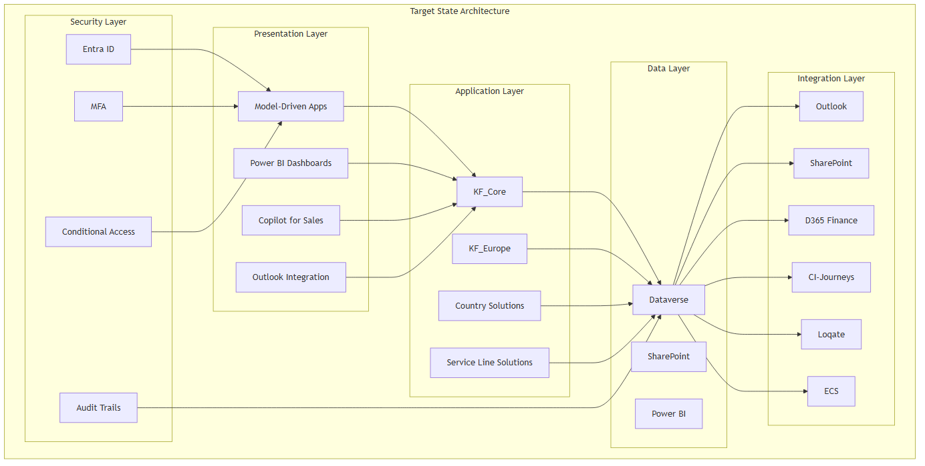

Standards, PADs, and Blueprints
Standard/Blueprint | Status | Relevance | Compliance
CTO Architecture Principles | Referenced | High | ✅ Compliant
Enterprise data residency standards | TBD | High | ✅ Compliant (EU-hosted)
Security baseline | TBD | High | ✅ Compliant (Entra ID, MFA, encryption)
Integration patterns | TBD | Medium | ✅ Compliant (API-first, standard connectors)
Power Platform Centre of Excellence | Referenced | Medium | ✅ Aligned

Target State Capabilities

Client Management (Phase 0)
• Single source of truth for all client data
• Two-tier hierarchy: Brand/Group → Legal Entity
• SIC-coded industry classification (66 KF sectors)
• Multi-country, multi-service line view

Property Management (Phase 0)
• Canonical physical sites with addresses and coordinates
• Commercial and residential properties
• Energy ratings and EPC data
• 10 service lines read same property record

Deal Management (Phase 1)
• 8-stage BPF from lead generation to completion
• 12 CM entities for full deal lifecycle
• Regulatory gates per market
• Cross-border portfolio management

Financial Management (Phase 1)
• WIP tracking with % complete tied to BPF stage
• Fee management with billing triggers
• 9 integration flows to D365 Finance
• Transaction report automation

Compliance & Governance (Phase 0)
• KYC/AML checks at legal entity level
• GDPR consent tracking with audit trail
• 7-year retention with exportable audit logs
• Red flag tracking and conflict checks

Integration & Analytics (Phase 1)
• Outlook email tracking and activity logging
• SharePoint deal folder auto-provisioning
• CI-Journeys marketing handoff
• Power BI dashboards and reports
• ECS change notification: Major entity create/update events published to the Knight Frank ECS message bus (see architecture application)

Target State vs Current State
Capability | Current State | Target State | Gap
Client data | Manual spreadsheets | Centralised Dataverse | High
Property data | Fragmented systems | Single source of truth | High
Deal tracking | Email-based | Automated BPF | High
Financial tracking | Manual WIP | Integrated bridge | Medium
Compliance | Ad-hoc processes | Automated gates | High
Reporting | Siloed data | Unified Power BI | High

Implementation Roadmap
Phase | Scope | Duration | Status
Phase 0 | Foundation (L2-L4) | 8-10 weeks | Planning
Phase 1 | Paris CM Deep Build (L5-L6) | 12-16 weeks | Planning
Phase 2 | Madrid + EIT (L6-L7) | 10-14 weeks | Not started
Phase 3 | Additional Service Lines | Future | Not started
Phase 4 | Residential / Private Office | Future | Not started
Phase 5 | Regional Expansion | Future | Not started
Phase 6 | Hub Replacement | Future | Not started
Phase 7 | Consolidated Finance ERP | Future | Not started

Success Criteria

Technical Success
• [ ] All components deployed and functional
• [ ] Security model implemented and tested
• [ ] Integrations working end-to-end
• [ ] Performance meets requirements
• [ ] Compliance requirements met

Business Success
• [ ] User adoption targets met
• [ ] Process efficiency improvements achieved
• [ ] Data quality targets met
• [ ] Financial targets achieved
• [ ] Compliance requirements satisfied

Related Documents
• architecture principles compliance — Principles compliance mapping
• architecture overview diagrams — Architecture diagrams
• solution package model — Layer architecture
• implementation phases — Phase definitions

Dependencies and Constraints

Key Dependencies
Dependency | Type | Impact | Status
TDA Approval | Governance | Must have | Pending
CTO Architecture Principles | Document | Must have | Referenced
Regional legal review | Compliance | Must have | Pending
Enterprise integration platform | Technical | Must have | TBD
ECS (Enterprise Connectivity Services) | Technical | Must have | TBD
Note: Major entity create/update events must be published to the Knight Frank ECS platform — the internal notification and message bus that notifies other systems of changes. ECS access, topic contracts, and payload schemas are an integration dependency to be confirmed with the enterprise integration team.
Vendor selection | Decision | Must have | Pending

Constraints
• TDA governance oversight required
• Regional data residency requirements
• Existing system integrations
• Budget and resource limitations (TBD)

Key Functional and Non-Functional Requirements

Functional Requirements

Requirements
To be gathered from business stakeholders across all four regions.

Contact Management
• Create, read, update, delete contacts
• Contact hierarchy and relationships
• Multi-language support

Opportunity Management
• Pipeline stages and workflows
• Activity tracking
• Reporting and analytics

Data Management
• Import/export capabilities
• Data quality controls
• Duplicate detection

Non-Functional Requirements

Performance
• Response time targets: TBD
• Concurrent user capacity: TBD
• Data volume requirements: TBD

Security
• Authentication method: TBD
• Authorisation model: TBD
• Data encryption: TBD
• Audit logging: TBD

Compliance
• GDPR requirements: TBD
• Regional data residency: TBD
• Data retention policies: TBD

Availability
• Uptime requirements: TBD
• Disaster recovery: TBD
• Backup strategy: TBD

Risks and Issues

Risk of Inaction
The register below captures the risks of not proceeding with the EuroCRM programme — i.e. the cost of maintaining the status quo. Likelihood/impact ratings are provisional and to be confirmed with stakeholders during the requirements phase.

Risk Register
Risk | Likelihood | Impact | Mitigation | Owner
Missed cross-border opportunities — relationship and client/market intelligence sits locally and isn't visible across Europe; where it is, unlocking it takes tremendous manual effort | Medium | High | Deliver a single, trusted view of clients, contacts, properties and opportunities across the region | TBD
No institutionalised client knowledge — knowledge sits with individuals in Excel trackers, mailboxes, and black books | High | High | Centralise fragmented data into a common client/contact/property foundation | TBD
Employee frustration and attrition — HR surveys flag frustration with the current technology landscape and manual effort; modernising improves efficiency, satisfaction, and talent retention | High | Medium | Streamline lead and deal management and reduce manual reporting processes | TBD
Excessive data management and reporting effort — reconciling information and assembling regional reports consumes significant time and effort | High | Medium | Reduce reliance on manual reporting; provide a foundation for standardised reporting | TBD
Missed AI / advanced analytics value — fragmented data blocks leveraging AI and advanced analytics | Medium | High | Establish a clean, structured data foundation enabling reporting, analytics and future AI-driven insights | TBD

Issues
No issues logged yet.

Assumptions
To be documented during requirements phase.

Solution Options and Trade-offs

Options Analysis
To be completed with vendor evaluation and architecture assessment.

Option 1: TBD
• Pros: TBD
• Cons: TBD
• Cost: TBD

Option 2: TBD
• Pros: TBD
• Cons: TBD
• Cost: TBD

Recommendation
Pending analysis.

Power Apps Model-Driven Apps Rationale

Current Hypothesis
Power Apps model-driven apps on Dataverse are a better fit where the value sits in a custom Knight Frank data model rather than a packaged sales process.

Where D365 Sales May Be a Poor Fit
• Packaged CRM assumes a lifecycle that differs from KF advisory
• D365 Sales entity fit — 11 core KF entities
• Unwanted features bundled in D365 Sales
• D365 model: Lead → Opportunity → Quote → Order → Invoice
• KF lifecycle (Capital Markets): Competitive pitching; NDA issuance; Multi-round bidding; Due diligence with milestone tracking; Regulatory gates per jurisdiction
• Product Catalogue; LinkedIn Sales Navigator

Entity Fit Assessment
Entity | D365 OOB Fit
Opportunity, Quote, Product/Price List | Poor fit (3)
kf_Pitch, kf_NDA, kf_Bid, kf_DDMilestone, kf_RedFlag, kf_InvestorProfile, kf_DataRoomAccess, kf_KYCRecord | No equivalent (8)

What Dataverse Provides Natively
Core platform capabilities (to validate):
• Custom tables with relationships
• Business Process Flows (BPFs)
• Security roles + Business Units
• Power Automate
• Power BI
• Outlook / Teams integration
• SharePoint document management
• Dataverse audit trail
• API access (OData + custom)
• Mobile access

Implementation Roadmap

Implementation Roadmap — Phases

Proposed Phases
Phase | Description | Dependencies | Status
Phase 1 | TBD | TDA Approval | Planning
Phase 2 | TBD | Phase 1 | Not started
Phase 3 | TBD | Phase 2 | Not started

Approach
Phasing to be defined based on regional priorities and dependencies.

Implementation Roadmap — Timelines

Timeline Overview
8 phases spanning 6-12 months for MVP (Phases 0-1), with future phases dependent on business priorities.

Detailed Timeline

Phase 0: Foundation ("CRM Lite")
Week | Milestone | Deliverable | Owner
1 | Kick-off | Project plan finalised | Project Lead
2 | Environments Ready | DEV, TEST, UAT, PROD provisioned | IT
3 | KF_Core Deployed | 40+ table shells, option sets | Solution Architect
4 | BU Hierarchy Configured | Security roles, BU isolation | Security Lead
5 | KF_Europe Deployed | EUR defaults, GDPR baseline | Solution Architect
6 | Country Layers Deployed | FR, DE, PL, ES solutions | Solution Architect
7 | SharePoint Integration | Deal folder auto-provision | Integration Lead
8 | Power BI Foundation | Regional dashboard | BI Lead
9 | UAT Complete | Phase 0 testing signed off | QA Lead
10 | Phase 0 Sign-off | Ready for Phase 1 | Project Lead
Critical Path: Environments → KF_Core → BU Hierarchy → Country Layers → SharePoint → Sign-off

Phase 1: Paris CM Deep Build
Week | Milestone | Deliverable | Owner
11 | Kick-off | CM requirements finalised | Business Analyst
12 | BPF Designed | 8-stage BPF configured | Solution Architect
13 | CM Entities Deployed | Deal, Pitch, NDA, Bid | Solution Architect
14 | CM Entities Deployed | DDMilestone, RedFlag, KYC | Solution Architect
15 | CM Entities Deployed | InvestorProfile, DataRoom | Solution Architect
16 | CM Entities Deployed | FeeSchedule, TransactionReport | Solution Architect
17 | Finance Bridge Designed | 9 integration flows mapped | Integration Lead
18 | Finance Bridge Implemented | D365 Finance integration | Integration Lead
19 | French Regulatory Gates | City pre-emption, notarial deed | Compliance Lead
20 | Marketing Handoff | CI-Journeys integration | Marketing Lead
21 | Copilot Pilot | Copilot for Sales configured | AI Lead
22 | UAT Complete | Paris CM team testing | QA Lead
23 | UAT Fixes Applied | Issues resolved | Development Team
24 | Pre-Go-Live | Final validation | Project Lead
25 | Go-Live Prep | Training materials, rollout plan | Change Lead
26 | MVP Go-Live | Phase 1 live | Project Lead
Critical Path: BPF → CM Entities → Finance Bridge → Regulatory Gates → UAT → Go-Live

Phase 2: Madrid + EIT CM Deep Build
Week | Milestone | Deliverable | Owner
27 | Kick-off | Spanish requirements finalised | Business Analyst
28 | KF_CM_Spain Deployed | Spanish regulatory gate | Solution Architect
29 | KF_EIT Deployed | Cross-border overlay | Solution Architect
30 | Cross-Border Portfolios | Multi-jurisdiction view | Solution Architect
31 | Multi-Jurisdiction KYC | Cross-border compliance | Compliance Lead
32 | Hub Coexistence | Manual transition strategy | Integration Lead
33 | UAT Complete | Madrid team testing | QA Lead
34 | Phase 2 Sign-off | Ready for Phase 3 | Project Lead

Visual Timeline (Mermaid)
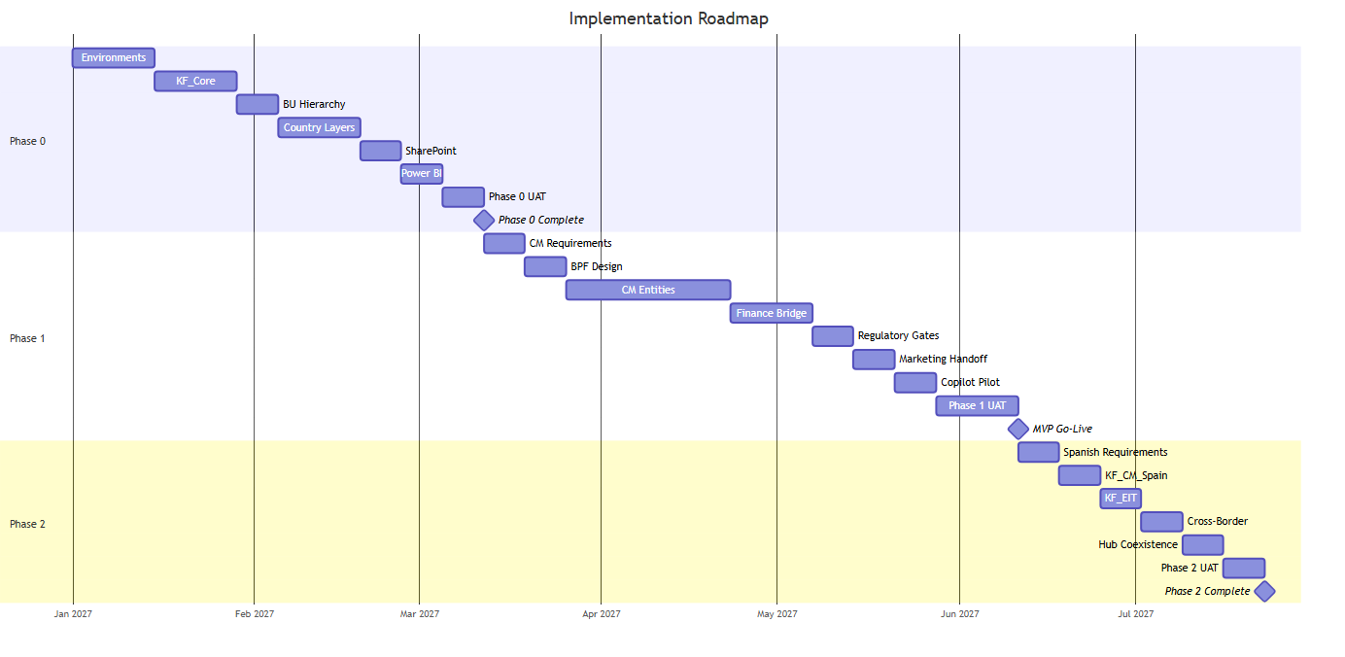

Key Milestones
Milestone | Target Week | Phase | Dependencies
Environments Ready | Week 2 | Phase 0 | IT provisioning
KF_Core Deployed | Week 4 | Phase 0 | Environment ready
BU Hierarchy Configured | Week 6 | Phase 0 | KF_Core deployed
Country Layers Deployed | Week 8 | Phase 0 | BU hierarchy configured
Phase 0 Complete | Week 10 | Phase 0 | All Phase 0 tasks complete
BPF Configured | Week 12 | Phase 1 | Phase 0 complete
CM Entities Deployed | Week 16 | Phase 1 | BPF configured
Finance Bridge Tested | Week 20 | Phase 1 | CM entities deployed
UAT Complete | Week 24 | Phase 1 | Finance bridge tested
MVP Go-Live | Week 26 | Phase 1 | UAT complete

Resource Requirements

Phase 0 (8-10 weeks)
Role | FTE | Duration
Project Lead | 0.5 | 10 weeks
Solution Architect | 1.0 | 8 weeks
Security Lead | 0.5 | 4 weeks
Integration Lead | 0.5 | 2 weeks
BI Lead | 0.5 | 2 weeks
QA Lead | 0.5 | 2 weeks
**Total** | **3.5**

Phase 1 (12-16 weeks)
Role | FTE | Duration
Project Lead | 0.5 | 16 weeks
Solution Architect | 1.0 | 14 weeks
Business Analyst | 0.5 | 4 weeks
Integration Lead | 1.0 | 6 weeks
Compliance Lead | 0.5 | 2 weeks
Marketing Lead | 0.5 | 2 weeks
AI Lead | 0.5 | 2 weeks
QA Lead | 0.5 | 4 weeks
Change Lead | 0.5 | 2 weeks
**Total** | **5.5**

Timeline Risks
Risk | Likelihood | Impact | Mitigation
Phase 0 overruns | Medium | High | Early environment provisioning, parallel workstreams
Phase 1 overruns | High | High | Phased CM entity deployment, early UAT
Resource availability | Medium | Medium | Cross-training, shared resources
Licensing delays | Medium | Medium | Early procurement, Microsoft engagement
Regulatory changes | Low | High | Regular legal review, flexible design

Related Documents
• implementation phases — Phase definitions and scope
• roadmap dependencies — Dependency register
• solution package model — Layer architecture

Implementation Roadmap — Key Dependencies

Dependency Overview
Dependencies categorised by type: Governance, Technical, Compliance, Resource, and External.

Pre-Implementation Dependencies
Dependency | Type | Owner | Status | Impact if Blocked
TDA Approval | Governance | TDA | Pending | Cannot start any phase
CTO Architecture Principles Review | Governance | CTO | Referenced | Architecture decisions blocked
Budget Approval | Governance | Finance | TBD | Cannot procure resources
Environment Provisioning | Technical | IT | TBD | Phase 0 blocked

Phase 0 Dependencies
Dependency | Type | Owner | Status | Impact if Blocked
Dataverse Tenant | Technical | IT | TBD | Cannot provision environments
Microsoft 365 Licensing | Licensing | IT | TBD | No Outlook/SharePoint integration
Power Platform Licensing | Licensing | IT | TBD | No Power Apps access
BU Hierarchy Design | Governance | Business | TBD | Security model blocked
SIC Code Reference Data | Data | Business | TBD | Industry classification incomplete
Country Legal Review | Compliance | Legal | TBD | GDPR fields may be incorrect

Phase 1 Dependencies
Dependency | Type | Owner | Status | Impact if Blocked
Phase 0 Complete | Technical | Project | TBD | Cannot start Phase 1
Finance Integration Design | Technical | Finance + IT | TBD | WIP bridge blocked
D365 Finance Environment | Technical | IT | TBD | Integration flows cannot be tested
D365 CI-Journeys Licensing | Licensing | Marketing | TBD | Marketing handoff blocked
Copilot Licensing | Licensing | IT | TBD | AI features unavailable
Loqate API Key | Integration | IT | TBD | Address validation blocked
CM Requirements Sign-off | Business | CM Team | TBD | BPF design may be wrong
French Regulatory Review | Compliance | Legal | TBD | Regulatory gates may be incorrect

Phase 2 Dependencies
Dependency | Type | Owner | Status | Impact if Blocked
Phase 1 Complete | Technical | Project | TBD | Cannot start Phase 2
Spanish Regulatory Review | Compliance | Legal | TBD | Right-of-refusal gate blocked
EIT Team Onboarded | Resource | Business | TBD | Cross-border features untested
Hub Coexistence Design | Technical | IT | TBD | Migration strategy unclear
Cross-Border Data Agreement | Compliance | Legal | TBD | Multi-jurisdiction KYC blocked

Phase 3-4 Dependencies
Dependency | Type | Owner | Status | Impact if Blocked
Phase 2 Complete | Technical | Project | TBD | Cannot start Phase 3
OSS Requirements Gathered | Business | OSS Team | TBD | OSS BPF design blocked
Valuations Requirements Gathered | Business | Val Team | TBD | Valuations BPF design blocked
Residential Requirements Gathered | Business | Resi Team | TBD | Residential pipeline blocked
Private Office Requirements Gathered | Business | PO Team | TBD | UHNW features blocked

Phase 5-7 Dependencies
Dependency | Type | Owner | Status | Impact if Blocked
Phase 4 Complete | Technical | Project | TBD | Cannot start Phase 5
Regional Business Cases | Governance | Regional MDs | TBD | Expansion blocked
Hub API Availability | Technical | IT | TBD | Phase 6 blocked
Finance ERP Selection | Decision | Finance | TBD | Phase 7 blocked
Regional Compliance Review | Compliance | Legal | TBD | Region-specific requirements unknown

Critical Path
TDA Approval → Environment Provisioning → Phase 0 → Phase 1 → Phase 2
↓
Finance Integration Design
↓
D365 Finance Environment

Dependency Risk Register
Risk | Likelihood | Impact | Mitigation
TDA approval delayed | Medium | High | Early engagement, pre-approval meetings
Finance integration design delayed | High | High | Start design in Phase 0, parallel workstream
Licensing procurement delayed | Medium | Medium | Early engagement with Microsoft
Resource availability across regions | High | Medium | Phased approach, shared resources where possible
Regulatory requirements change | Low | High | Regular legal review, flexible configuration
Hub roadmap changes | Medium | Medium | Design for API integration; Hub is an internal system

External Dependencies
Dependency | Type | Owner | Notes
Microsoft Platform Updates | External | Microsoft | Dataverse, Power Platform updates
Hub Roadmap | External | Internal Hub team | API availability and support
Regional Data Residency | External | Microsoft | EU data centre availability
SIC/HILUCS Standards | External | Regulatory | Standard updates and revisions

Related Documents
• dependencies and constraints — Full dependency register
• implementation phases — Phase definitions
• roadmap timelines — Timeline view

Implementation Phases

Phase Overview
8 phases from foundation to full ERP integration. MVP is Phases 0-1 (20-26 weeks).
Phase | Label | Duration | Layers | Status
Phase 0 | Foundation ("CRM Lite") | 8-10 weeks | L2-L4 | Planning
Phase 1 | Paris CM Deep Build | 12-16 weeks | L5-L6 | Planning
Phase 2 | Madrid + EIT CM Deep Build | 10-14 weeks | L6-L7 | Not started
Phase 3 | Additional Service Lines | Future | L5 | Not started
Phase 4 | Residential / Private Office | Future | L5-L7 | Not started
Phase 5 | Regional Expansion | Future | L3 | Not started
Phase 6 | Hub Replacement | Future | Integration | Not started
Phase 7 | Consolidated Finance ERP | Future | Integration | Not started

Phase 0: Foundation ("CRM Lite")
Duration: 8-10 weeks Layers: L2 (KFCore), L3 (KFEurope), L4 (Country) Dependencies: TDA approval, Environment provisioning

Scope
• Dataverse environment setup (DEV, TEST, UAT, PROD)
• KF_Core layer: 40+ table shells, option sets, BU hierarchy
• KF_Europe layer: EUR defaults, GDPR baseline
• Country layers: KFFrance, KFGermany, KFPoland, KFSpain
• Security roles and BU configuration
• SharePoint integration (deal folder auto-provision)
• Power BI foundation (regional dashboard)

Tables Activated
Table | Category
Account | CRM Lite
Contact | CRM Lite
kf_Property | CRM Lite
kf_EnergyRating | Compliance
kf_GDPRRequest | Compliance
kf_AuditExport | Compliance
kf_SICCode | Supporting

Deliverables
• [ ] Dataverse environments provisioned
• [ ] KF_Core solution deployed
• [ ] KF_Europe solution deployed
• [ ] Country solutions deployed (FR, DE, PL, ES)
• [ ] Security roles configured
• [ ] BU hierarchy established
• [ ] SharePoint integration tested
• [ ] Power BI regional dashboard created

Acceptance Criteria
• Users can create/view Account and Contact records
• BU-based security isolation working
• GDPR consent fields visible and functional
• SIC code lookup operational
• SharePoint folders auto-provision on record creation

Phase 1: Paris CM Deep Build
Duration: 12-16 weeks Layers: L5 (KFCapitalMarketsCore), L6 (KFCMFrance) Dependencies: Phase 0 complete, Finance integration design, Copilot licensing

Scope
• Capital Markets 8-stage BPF
• All 12 CM entities (Deal, Pitch, NDA, Bid, etc.)
• French regulatory gates (city pre-emption, notarial deed)
• Finance integration bridge (9 flows to D365 Finance)
• Marketing handoff to CI-Journeys
• Copilot for Sales pilot
• WIP tracking and fee management

Tables Activated
Table | Category
kf_Deal | CM Deep Build
kf_DealProperty | Core Shared
kf_Pitch | CM Deep Build
kf_NDA | CM Deep Build
kf_Bid | CM Deep Build
kf_DDMilestone | CM Deep Build
kf_RedFlag | CM Deep Build
kf_FeeSchedule | CM Deep Build
kf_KYCRecord | CM Deep Build
kf_InvestorProfile | CM Deep Build
kf_DataRoomAccess | CM Deep Build
kf_TransactionReport | CM Deep Build
kf_StageGateRule | Supporting
kf_IntegrationLog | Supporting
Lead | Marketing

Deliverables
• [ ] 8-stage BPF configured and tested
• [ ] All 12 CM entities deployed
• [ ] French regulatory gates implemented
• [ ] Finance bridge (9 flows) tested
• [ ] WIP tracking operational
• [ ] Marketing handoff to CI-Journeys working
• [ ] Copilot for Sales pilot completed
• [ ] UAT with Paris CM team

Acceptance Criteria
• Brokers can manage deals through 8-stage lifecycle
• French regulatory gates fire at correct stages
• Finance project created at S3
• WIP % complete updates on stage change
• Transaction reports auto-generated
• Copilot matching provides actionable suggestions

Phase 2: Madrid + EIT CM Deep Build
Duration: 10-14 weeks Layers: L6 (KFCMSpain), L7 (KF_EIT) Dependencies: Phase 1 complete, EIT team onboarded, Hub coexistence design

Scope
• Spanish CM extension (right-of-refusal gate)
• EIT cross-border overlay
• Cross-border portfolio management
• Hub coexistence (manual CRM ↔ Hub transition during Phase 6)
• Multi-jurisdiction KYC and conflict checks

Deliverables
• [ ] KFCMSpain solution deployed
• [ ] Spanish regulatory gate implemented
• [ ] KF_EIT solution deployed
• [ ] Cross-border portfolio view working
• [ ] Multi-jurisdiction KYC functional
• [ ] Intercompany billing flows tested
• [ ] Hub coexistence strategy documented
• [ ] UAT with Madrid CM team

Acceptance Criteria
• Spanish brokers can manage deals with local gates
• EIT team can view and manage cross-border portfolios
• KYC checks work across jurisdictions
• Intercompany billing generates correctly

Phase 3: Additional Service Lines
Duration: Future (TBD) Layers: L5 (new service line cores) Dependencies: Phase 2 complete, Service line requirements gathered

Scope
• KFOSSCore (Occupier Strategy & Solutions)
• KFValuationsCore
• New Layer 5 solutions with their own BPFs
• OSS engagement workflow
• Valuation instruction workflow

Tables Activated (Future)
Table | Service Line
kf_Engagement | OSS
kf_Lease | OSS
kf_WorkplaceAssessment | OSS
kf_LocationSearch | OSS
kf_ValuationInstruction | Valuations

Deliverables
• [ ] KFOSSCore solution deployed
• [ ] KFValuationsCore solution deployed
• [ ] OSS BPF configured
• [ ] Valuations BPF configured
• [ ] Integration with shared foundation tested

Phase 4: Residential / Private Office
Duration: Future (TBD) Layers: L5 (KFResidentialCore), L7 (KFPrivateOffice) Dependencies: Phase 3 complete, Residential requirements gathered

Scope
• KFResidentialCore (Sales, Lettings, Property Management)
• KFPrivateOffice at Layer 7 (cross-service-line for UHNW)
• Residential pipeline (Sales/Lettings instruction → Tenancy)
• Private Office spanning CM, Residential, Valuations

Tables Activated (Future)
Table | Service Line
kf_ResProperty | Residential
kf_SalesInstruction | Residential
kf_LettingsInstruction | Residential
kf_Tenancy | Residential
kf_Applicant | Residential
kf_Viewing | Residential
kf_Offer | Residential
kf_BuyingBrief | Residential

Deliverables
• [ ] KFResidentialCore solution deployed
• [ ] KFPrivateOffice solution deployed
• [ ] Residential pipeline BPF configured
• [ ] Private Office cross-SL view working

Phase 5: Regional Expansion
Duration: Future (TBD) Layers: L3 (new regions) Dependencies: Phase 4 complete, Regional business cases approved

Scope
• KF_APAC (Asia-Pacific)
• KF_Americas
• KF_MiddleEast
• New Layer 3 regional solutions
• Country layers within each region

Deliverables
• [ ] Regional solutions designed
• [ ] Regional compliance requirements gathered
• [ ] Regional deployments planned

Phase 6: Hub Replacement
Duration: Future (TBD) Layers: Integration Dependencies: Phase 2 complete, Hub roadmap evaluation

Scope
• Full API integration replacing manual CRM ↔ Hub transition
• Real-time data sync between CRM and Hub
• Eliminate manual data entry

Deliverables
• [ ] Hub API integration designed
• [ ] Real-time sync implemented
• [ ] Manual transition process deprecated

Phase 7: Consolidated Finance ERP
Duration: Future (TBD) Layers: Integration Dependencies: Phase 2 complete, Finance ERP selection

Scope
• Consolidated Finance ERP
• Activates all 9 integration flows
• Full WIP reconciliation
• Automated billing and revenue recognition

Deliverables
• [ ] Finance ERP selected
• [ ] 9 integration flows fully operational
• [ ] WIP reconciliation automated
• [ ] Billing process streamlined

MVP Summary (Phases 0-1)
Total Duration: 20-26 weeks Total Tables: 22 Service Lines: Capital Markets (France) Countries: France (primary), others (foundation only)

Critical Path
Phase 0 (8-10 weeks) → Phase 1 (12-16 weeks) → MVP Complete

Key Milestones
Milestone | Target | Phase
Environments Ready | Week 2 | Phase 0
Core Tables Deployed | Week 4 | Phase 0
Security Configured | Week 6 | Phase 0
Country Layers Deployed | Week 8 | Phase 0
BPF Configured | Week 12 | Phase 1
CM Entities Deployed | Week 16 | Phase 1
Finance Bridge Tested | Week 20 | Phase 1
UAT Complete | Week 24 | Phase 1
Go-Live | Week 26 | Phase 1

Related Documents
• roadmap timelines — Detailed timeline view
• roadmap dependencies — Dependency register
• solution package model — Layer architecture
• data model overview — Table inventory

Cost and Benefits Summary

Cost Estimates

Capital Expenditure (CAPEX)
N/A — to be quantified during options analysis.

Operational Expenditure (OPEX)
N/A — to be quantified during options analysis.

Cost Breakdown
Category | Estimate | Notes
Software licensing | TBD | Pending vendor selection
Implementation services | TBD | TBD
Infrastructure | TBD | TBD
Training | TBD | TBD
Ongoing support | TBD | TBD

Cost Model
To be developed during business case phase.

Expected Benefits

Quantifiable Benefits
Benefit | Metric | Target | Timeline
TBD | TBD | TBD | TBD

Qualitative Benefits
• Unified customer view across European operations
• Improved data quality and consistency
• Standardised business processes
• Enhanced reporting and analytics
• Regulatory compliance confidence

Benefits Realisation
To be quantified during business case development.

Governance and Approval

Governance — Approval

Approval Requirements
• All identified Key Stakeholders must approve
• TDA approval is mandatory
• Solution sits under Technical Design Authority (TDA)

Approval Workflow
1. SOD completion and review
2. Stakeholder review and feedback
3. TDA submission
4. Approval decision
5. Implementation authorisation

Approval Record
Approver | Role | Date | Decision | Notes
TBD | TBD | TBD | Pending | TBD

Governance — Oversight

Governance Structure
This solution is in the purview of the Technical Design Authority (TDA).

TDA Responsibilities
• Architecture review and approval
• Standards compliance oversight
• Design authority for technical decisions
• Escalation point for architectural conflicts

Reporting
• Regular status reporting to TDA
• Architecture review gates
• Progress against roadmap

Compliance

Regulatory Requirements
Regulation | Region | Requirements | Status
GDPR | All | Data protection, consent, right to erasure | TBD
CNIL | France | French data protection authority requirements | TBD
BDSG | Germany | German Federal Data Protection Act | TBD

Compliance Controls
To be defined during architecture phase.

Audit Requirements
• Regular compliance audits
• Data protection impact assessment
• Security assessment

Glossary

Terms
Term | Definition
CRM | Customer Relationship Management
TDA | Technical Design Authority
GDPR | General Data Protection Regulation
CNIL | Commission Nationale de l'Informatique et des Libertés
BDSG | Bundesdatenschutzgesetz (German Federal Data Protection Act)
SOD | Solution Overview Document
PAD | Platform Architecture Document
CAPEX | Capital Expenditure
OPEX | Operational Expenditure
ECS | Enterprise Connectivity Services — Knight Frank's internal notification and message bus. Notifies other systems that a change has happened; it does not replicate data
Major entity | A core shared entity whose create/update events are published to ECS (candidates: Client, Property, Deal domains — definitive list to be confirmed with TDA)

References
The following wiki notes were used as the source of this document:
• architecture-application.md
• architecture-business.md
• architecture-data.md
• architecture-key-components.md
• architecture-overview-diagrams.md
• architecture-principles-compliance.md
• architecture-target-state.md
• architecture-technology.md
• business-capabilities.md
• business-context.md
• business-goals.md
• capital-markets-data-model.md
• client-data-model.md
• compliance.md
• cost-estimates.md
• crm-lite-mvp-scope.md
• data-model-core-tables.md
• data-model-overview.md
• dependencies-and-constraints.md
• expected-benefits.md
• functional-non-functional-requirements.md
• functional-requirements.md
• glossary.md
• governance-approval.md
• governance-oversight.md
• implementation-phases.md
• key-stakeholders.md
• kpis-and-success.md
• power-apps-rationale.md
• problem-statement.md
• property-data-model.md
• risks-and-issues.md
• roadmap-dependencies.md
• roadmap-phases.md
• roadmap-timelines.md
• solution-options.md
• solution-overview.md
• solution-package-model.md
• solution-scope-in-scope.md
• solution-scope-out-of-scope.md
• taxonomy-hilucs-kf.md
• taxonomy-mappings.md
• taxonomy-sic-kf.md
• wip-data-model.md

