*Reviewer 4 raised the following issue: Page 15 line 50 and table 3, for compound 1a and 1d, DSC results show the decomposition reaction happens after melting (liquid phase reaction). The temperatures for Isothermal tests are not high enough to melt the samples. this may explain the low Pmax in isothermal tests. However, I don’t know how the authors get the full integrated ΔH from the isothermal test since there is not much reactivity observed in days. how long time is these isothermal tests?*

We conducted all flow calorimetry experiments at temperatures significantly lower than the melting points in order to adequately approximate kinetic curves to normal conditions. To clarify the issue, we added the melting points to the Table 1 in the revised manuscript.

The isothermal test was carried out until the heat flux decreased below 2 μW. This value is less than 1% of the maximum heat flux and corresponds to the conversion degree α> 0.99. Time was varied from several hours to 50 days depending on sample and temperature.

The reaction enthalpy was calculated by integrating a curve approximating the experimental heat flux (equation 6), in the time interval (0, ∞). We added the calculation algorithm to the description of equations (2) and (4) in the revised manuscript.

The following kinetic equation describing autocatalytic reaction was applied: ***a A → c C***

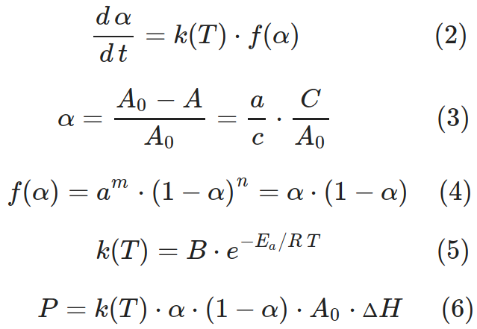,

where α – conversion degree; *k(T)* – rate constant, [s-1]; *f(α)* – the kinetic model in differential form; *A0*, *A* – initial and current concentration of DS, which for solid-phase reactions is measured in mol/g units; *С0*, *С* – initial and current concentrations of products, [mol/g]; *a*, *c* – stoichiometric coefficients, for the processes studied *a/c*=1; *P*, *P0* – current and initial heat flow; *ΔH* – reaction enthalpy; *B* - is the pre-exponential factor, a constant for each chemical reaction; *Ea* - an experimentally determined parameter that indicates the sensitivity of the reaction rate to temperature; *R* - the universal gas constant (8.315 J⋅K−1⋅mol−1); *T* - the absolute temperature (in K).

The kinetic equation 2 is used to model solid phase reactions 13, and can be expressed in terms of the conversion degree α (equation 3). The kinetic curves for the reactions studied are best described by equation 4 at *m*=1 and *n*=1. The temperature dependence of the reaction rate is expressed by the Arrhenius equation (5). The reaction enthalpy is calculated by integrating a curve approximating the experimental heat flux (equation 6), in the time interval (0, ∞). The half-life corresponds to the conversion degree of 0.5. Due to the symmetry of the approximating kinetic curve 4, the half-life coincides with the maximum heat flux (in the case of more complex kinetics, this rule is not fulfilled).