**Supporting Information For**

**The first study of the thermal and storage stability of arenediazonium triflates comparing to 4-nitrobenzenediazonium tosylate and tetrafluoroborate by calorimetric methods**

Alexander A. Bondarev1*, Evgeny V. Naumov1, AssiyaZh. Kassanova2, Elena A. Krasnokutskaya3, Ksenia S. Stankevich3, Victor D. Filimonov3*

1Department of Biomedicine, Altai State University, Barnaul, Russia, [alex_root@mail.ru](mailto:alex_root@mail.ru)

2S. Toraighyrov Pavlodar State University, Pavlodar, Kazakhstan

3The Kizhner Research Center,National ResearchTomsk Polytechnic University, Tomsk, Russian Federation

**1s. Results of modeling and deconvolution of heat flow experimental kinetic curves acquired in isothermal conditions**

Deconvolution was performed by computer simulation of combinations of two independent and two consecutive autocatalytic reactions with varying values of thermal effects and kinetic parameters and minimization of the standard deviation from the experimental curve using the Broyden–Fletcher–Goldfarb–Shanno algorithm (BFGS)1a implemented in our computer program,1b as well as Nelder–Mead 1c method implemented in the R statistics software package for statistical analysis and processing.2 The initial values for the first approximation were taken from the DSC-TGA data (endothermic reaction). Figures 1s.1-6 show the results of deconvolution. The model of two independent autocatalytic processes was found to describe the experimental dependencies more accurately.

**Table 1s.1.** The result of the deconvolution of the heat flow measured during the isothermal decomposition of 2-nitrobenzenediazonium triflate **1a** using the model of two independent autocatalytic processes.

|  |  |  |  |  |  |  |  |
| --- | --- | --- | --- | --- | --- | --- | --- |
| **T оС** | **k1** | **k2** | **C01** | **C02** | **dH1** | **dH2** | Quality |
| 75 | 0.5222 | 0.0480 | 0.00133 | 0.00304 | 48.5 | -500.6 | 7.3·10-10 |
| 80 | 0.4046 | 0.0489 | 0.00111 | 0.00230 | 30.7 | -441.0 | 7.1·10-9 |
| 85 | 0.9554 | 0.0611 | 0.00070 | 0.00272 | 32.5 | -453.9 | 1.3·10-8 |

**Table 1s.2.** The result of the deconvolution of the heat flow measured during the isothermal decomposition of 2-nitrobenzenediazonium triflate **1a** using the model of two consecutive autocatalytic processes.

|  |  |  |  |  |  |  |  |
| --- | --- | --- | --- | --- | --- | --- | --- |
| **T оС** | **k1** | **k2** | **C01** | **C02** | **dH1** | **dH2** | Quality |
| 75 | 0.4679 | 0.0642 | 0.00191 | 0.00204 | 39.2 | -520.7 | 1.1·10-9 |
| 80 | 0.5791 | 0.0435 | 0.00122 | 0.00263 | 36.7 | -493.9 | 6.1·10-9 |
| 85 | 1.0512 | 0.0631 | 0.00075 | 0.00259 | 31.8 | -483.4 | 1.3·10-8 |

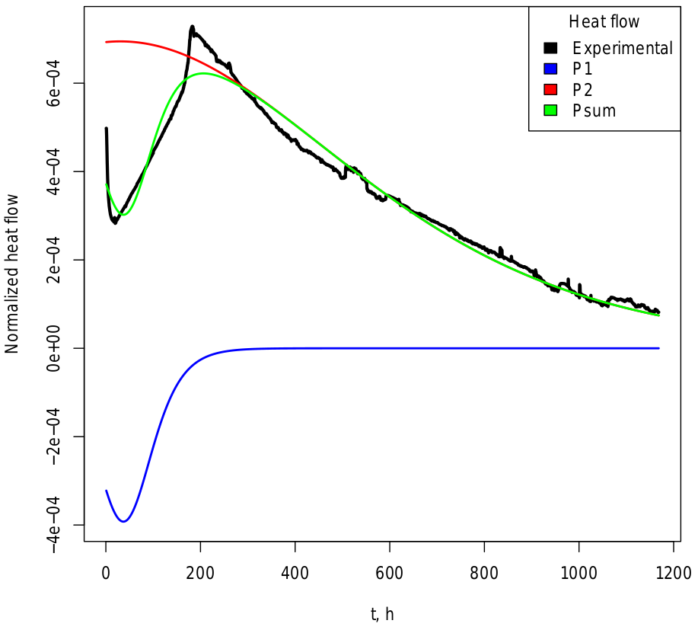

**Figure 1s.1.** The heat flow experimental curve and its deconvolution results for the isothermal decomposition of 2-nitrobenzenediazonium triflate **1a** at 75 оС. The deconvolution was done using the model of two independent autocatalytic processes.

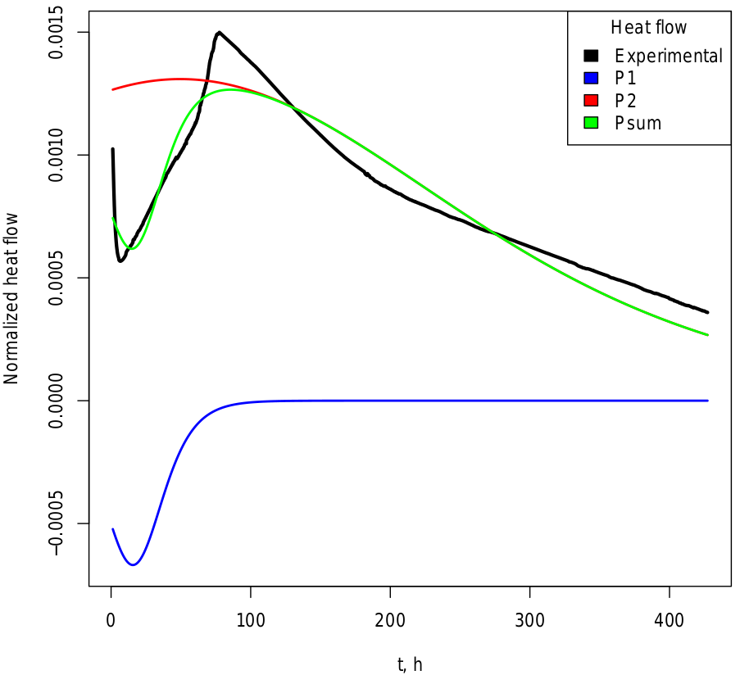

**Figure 1s.2.** The heat flow experimental curve and its deconvolution results for the isothermal decomposition of 2-nitrobenzenediazonium triflate **1a** at 80 оС. The deconvolution was done using the model of two independent autocatalytic processes.

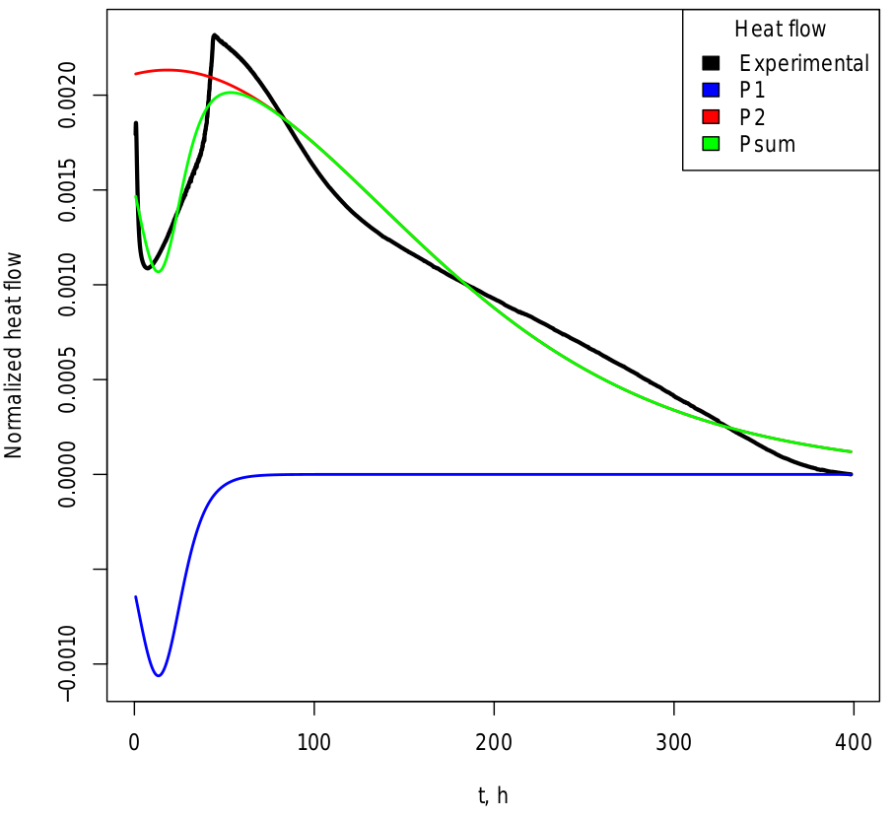

**Figure 1s.3.** The heat flow experimental curve and its deconvolution results for the isothermal decomposition of 2-nitrobenzenediazonium triflate **1a** at 85 оС. The deconvolution was done using the model of two independent autocatalytic processes.

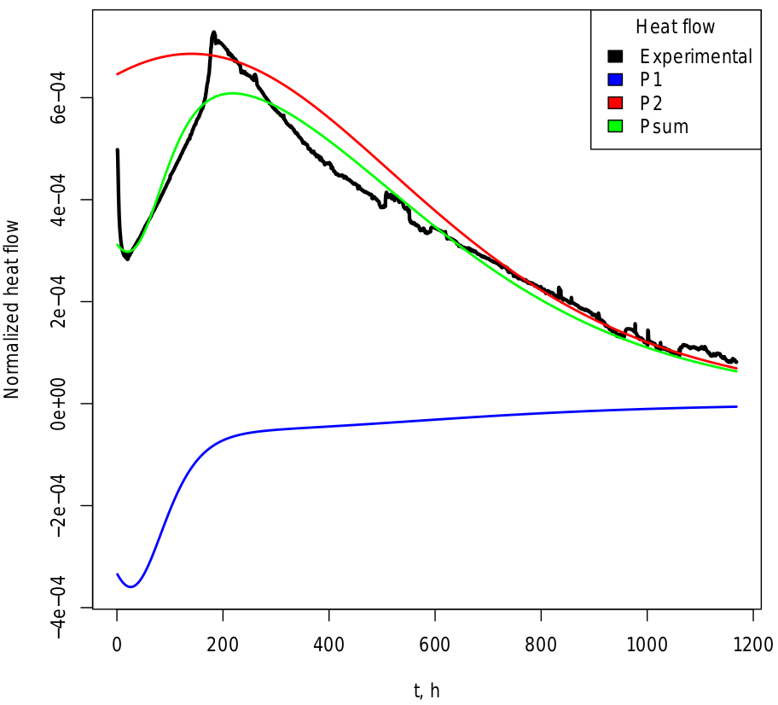

**Figure 1s.4.** The heat flow experimental curve and its deconvolution results for the isothermal decomposition of 2-nitrobenzenediazonium triflate **1a** at 75 оС. The deconvolution was done using the model of two consecutive autocatalytic processes.

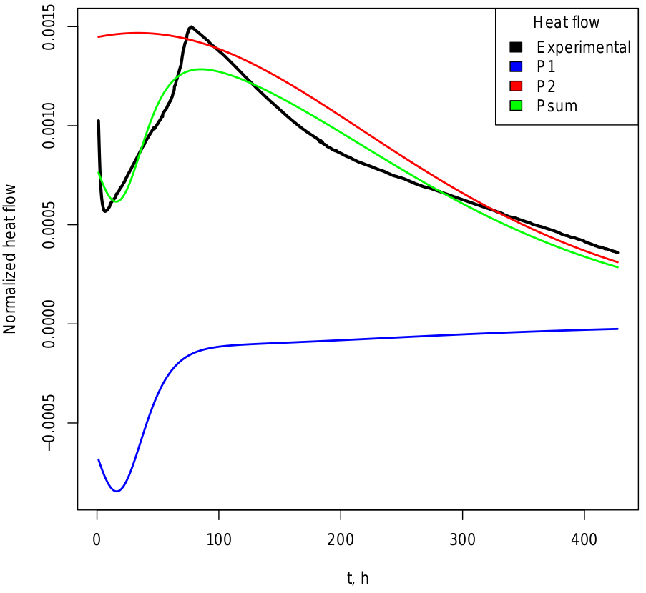

**Figure 1s.5.** The heat flow experimental curve and its deconvolution results for the isothermal decomposition of 2-nitrobenzenediazonium triflate **1a** at 80 оС. The deconvolution was done using the model of two consecutive autocatalytic processes.

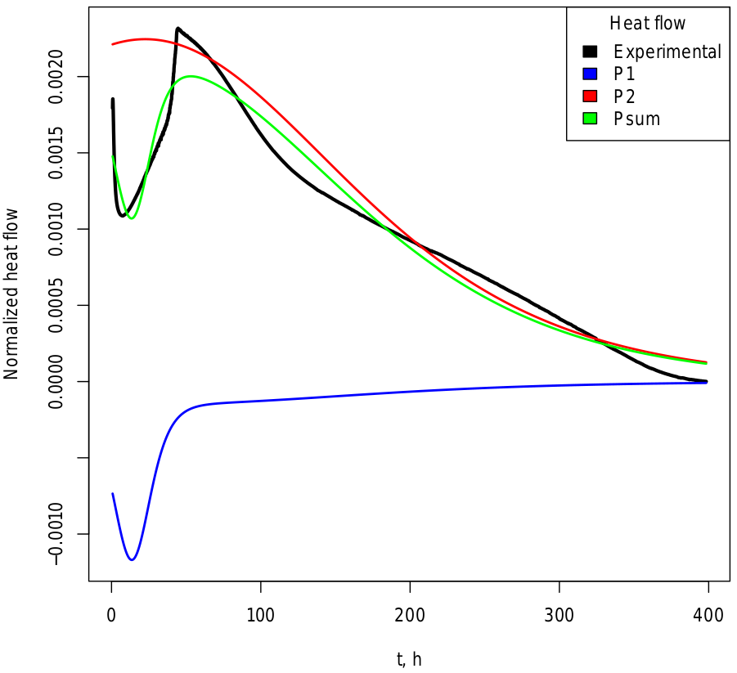

**Figure 1s.6.** The heat flow experimental curve and its deconvolution results for the isothermal decomposition of 2-nitrobenzenediazonium triflate **1a** at 85 оС. The deconvolution was done using the model of two consecutive autocatalytic processes.

**REFERENCES**

Perry, R. H.; Green, D. W. Perry’s Chemical Engineers’Handbook; The McGraw-Hill: 1999.

1. (a) Fletcher, R. Practical methods of optimization (2nd ed.), New York: John Wiley & Sons: 1987, ISBN 978-0-471-91547-8, (b) Bondarev, A. Deconvolution-Kinetic. Zenodo November 7, **2018**. <https://doi.org/10.5281/zenodo.1478946>, (c) Nelder, J. A.; Mead, R. A Simplex Method for Function Minimization. The Computer Journal **1965**, 7 (4), 308–313. <https://doi.org/10.1093/comjnl/7.4.308>.
2. (a) Williams, T.; Kelley, C. Gnuplot 4.5: an interactive plotting program. URL http://gnuplot.info. 2011, (b) R Core Team. R: A language and environment for statistical computing. R Foundation for Statistical / Computing, Vienna, Austria. URL https://www.R-project.org/, 2017

**Supporting 2s. GC-MS spectra of the decomposition products of diazonium salts studied**



**Figure 2s.2.** The decomposition products of DS **1a** according to GC-MS data.



**Figure 2s.2.** The decomposition products of DS **1b** according to GC-MS data. (Peak at 9.246 min corresponds to compound 3-NO2-C6H4-OSO2CF3, Fig. 21)



Figure 2s.3 The decomposition products of DS **1c** according to GC-MS data. (Peak at 13.314 min corresponds to compound 4-NO2-C6H4-OSO2CF3, peak at 14.912 min corresponds to compound 1-iodo-4-nitrobenzene, Fig. 22)



**Figure 2s.4.** The decomposition products of DS **1d** according to GC-MS data. (Peak at 8.337 min corresponds to compound 4-CH3О-C6H4-OSO2CF3, Fig. 23)

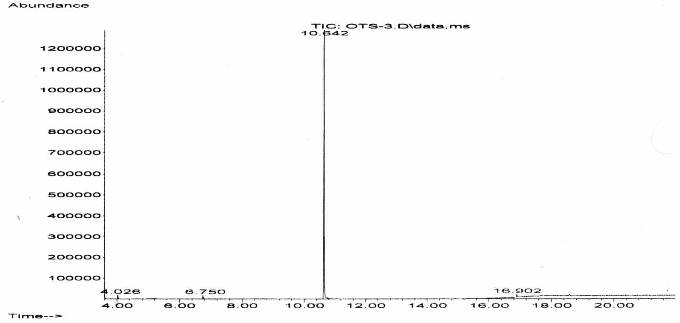

**Figure 2s.5** The decomposition products of DS **2** according to GC-MS data. (Peak at 6.750 min corresponds to 1-fluoro-4-nitrobenzene, peak at 10.642 min corresponds to 1-iodo-4-nitrobenzene, Fig. 24)



**Figure 2s.6** The decomposition products of DS **3** according to GC-MS data. (Peak at 6.307 min corresponds to 1-fluoro-4-nitrobenzene, peak at 10.515 min corresponds to 1-iodo-4-nitrobenzene, Fig. 25)



**Figure 2s.7.** The major product of decomposition of DS **1b** according to GC-MS data. Fragmentation pattern corresponds to 3-NO2-C6H4-OSO2CF3 M/Z: 271, 161, 95, 92, 69, 64.





**Figure 2s.8.** The major products of decomposition of DS **1c** according to GC-MS data. Fragmentation patterns correspond to 4-NO2-C6H4-OSO2CF3 M/Z: 271, 177, 95, 69 and 1-iodo-4-nitrobenzene M/Z: 249, 203, 76.



**Figure 2s.9.** The major product of decomposition of DS 1d according to GC-MS data. Fragmentation pattern corresponds to 3-CH3O-C6H4-OSO2CF3 M/Z: 256, 123, 69, 52.

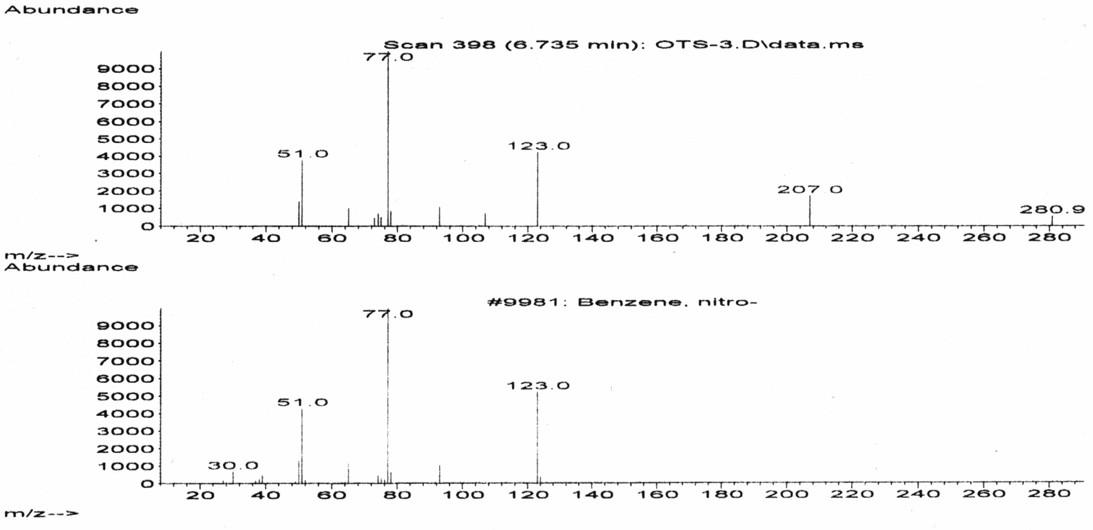

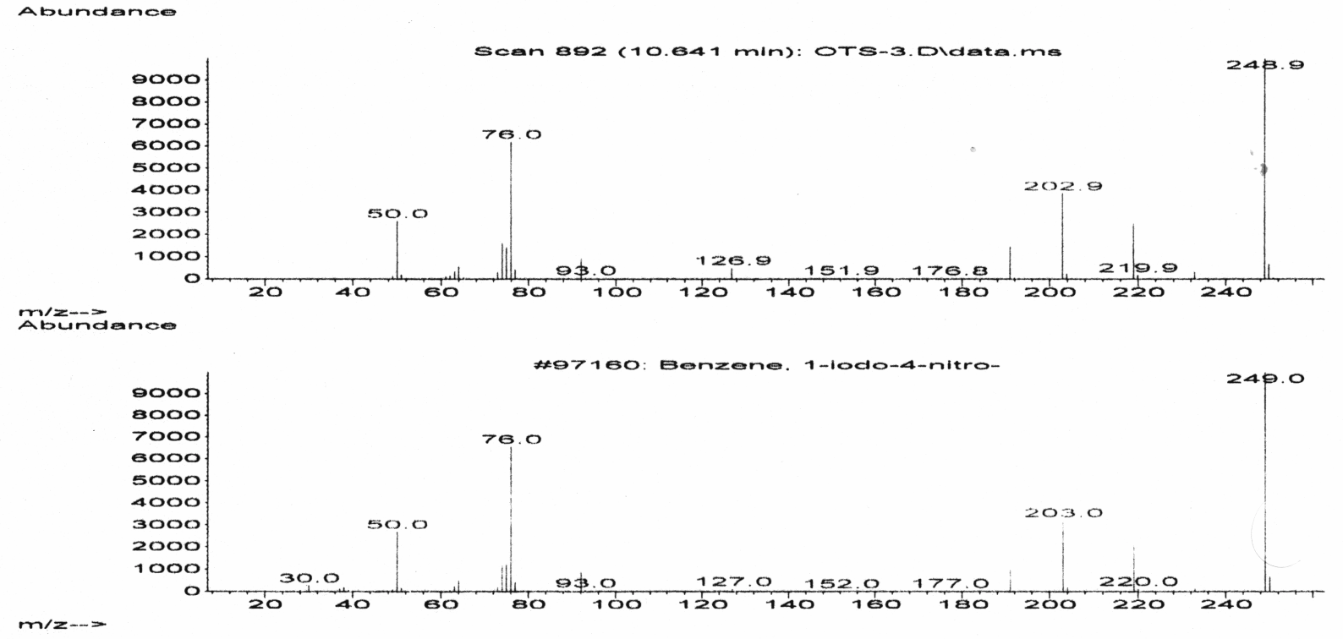

**Figure 2s.10.** The major products of decomposition of DS 2 according to GC-MS data. Fragmentation patterns correspond to nitrobenzene M/Z: 123, 77, 51 and 1-iodo-4-nitrobenzene M/Z: 249, 203, 76, 50.





**Figure 2s.11.** The major products of decomposition of DS **3** according to GC-MS data. Fragmentation patterns correspond to 1-fluoro-2-nitrobenzene M/Z: 141, 111, 95, 75, 50 and 1-iodo-4-nitrobenzene M/Z: 249, 203, 76.

**Supporting 3s. LS-MS spectra of the decomposition products of diazonium salts studied**

**Supporting 4s. Results of quantum-chemical calculations**