Kinetics Decomposition of Some Substituted Benzendiazonium Salts in HCl Solution.

Khulood Al-saadie, Israa M. Al-Mousawi and Nadia Abdul karime
Department of Chemistry ,College of Science University of Baghdad, Jadiriya, Baghdad ,Iraq.

(NJC)

(Received on 27/9/2006) (Accepted for publication on 18/2/2007)

Abstract
The decomposition rate, rat constant and decomposition activation energy of substituted benzendiazonium salts ( N⁺ ≡ NCl⁻) were calculated by folloing the quantity of nitrogen gas produced as a function of time at several temperatures ranging from (35 to 50)ºC. The effect of the R group type on the rate of decomposition ,rat constant and activation energy, was studied. The effect of variation of R group position (o, p, m) has been studied as well.

R
Keywords : Diazonium salts, kinetics, Substituted effect, SN¹.
الخلاصة
تم حساب سرعة التفكك, ثابت السرعة وطاقة تنشيط التحلل لاملاح دايازونيوم البنزين المعوضة ( N⁺≡ NCl⁻ ) حيث تمت متابعة حجم غاز النيتروجين المتحرر كدالة للوقت عند درجات حرارية مختلفة ضمن المدى الحراري (35-50) ºم.

R
كما تمت دراسة تاثير المجاميع المعوضة R (ساحبة او واهبة للالكترون) على سرعة التفكك, ثابت السرعة وكذلك على طاقة التنشيط , كما تمت دراسة تأثير تغيير موقع مجموعة R في المواقع (o, p, m) للمركبات العشرة قيد الدراسة.

Introduction
The Aromatic diazonium ions are stable in cold solution. The solid diazonium salts are very dangerous, explosive and rarely can be separated and some diazonium salts are cancerous⁽¹⁾. In an acidic aqueous solution, benzendiazonium ion (phN⁺₂) will decompose ⁽²⁾ to form nitrogen and phenol:
C₆H₅N₂⁺ + H₂O → C₆H₅OH + N_{2(g)} + H⁺……(1)

The rate of reaction (1),- d(C₆H₅N₂⁺)/dt, can be written in terms of the concentration of the reacting species as:
-d(C₆H₅N₂⁺)/dt = k\(C₆H₅N₂⁺) ^{n} (H₂O)^{m} ……….(2)
As written above, the reaction would be of n th order with respect to C₆H₅N₂⁺ and of m th order with respect to water, and would have an overall order of (n+m).

The reaction is not acid-catalyzed⁽³⁾,although very high acid concentrations (say 12N HCl) seem to slightly increase the rate ⁽²⁾. Thus the effect of changes in the H⁺ concentration due to reaction (1) can be completely neglected. Since the present experiment will be performed in a dilute aqueous solution, the concentration of water (H₂O) will be very nearly constant throughout the reaction. Thus the factor (H₂O)^{m} can be absorbed into the rate constant and Eq. (2) can be rewritten as:
-dc/dt =kC^{n} ………..(3)
Where C represents the instantaneous concentration (C₆H₅N₂⁺). Eq.(3) can readily be integrated to give:
C=C_{o} e^{-kt} for n=1 …..(4)
If the value of a rate constant is measured at several different temperatures, it is almost always found that the temperature dependence can be represented by:
k = A e ^{–E*/RT} ……..(5)

Where the factor A is independent of temperature, the Arrhenius activation energy E* can be easily determined by plotting Log k versus 1/T .This should give a straight line with slope (-E*/2.303 R).

Rate of reaction can be established by means of other than simple chemical determination of concentration, after various time intervals, of residual starting materials. Thus in the reaction (1) ,the volume of gaseous nitrogen evolved may be measured directly with a burette or a gas syringes, i.e at constant pressure.

Experimental Procedure
The progress of the reaction is studied by measuring the quantity of gas produced as a function of time. At any given time, the volume of nitrogen evolved is directly proportional to the number of moles of benzendiazonium chloride (or substituted benzendiazonium chloride ( N₂⁺Cl), that have decomposed. The rate of the reaction is therefor proportional to the rate of nitrogen evolution. The apparatus used in this experiment is shown in Fig.1.

R

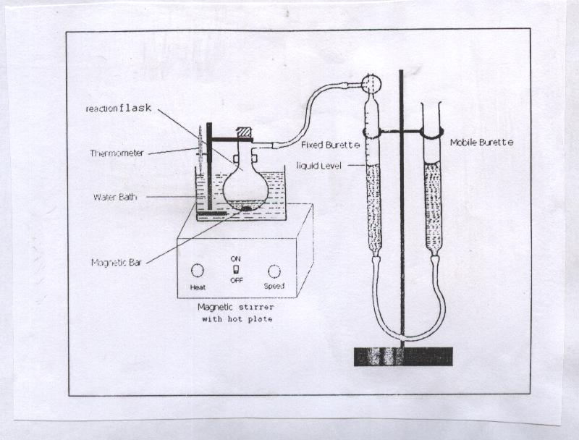

Fig.1: Apparatus for studying the rate of evolution of gas.

The reacting solution is attached to the gas burette. The incoming gas depresses the liquid level. To measure the volume of gas at any time, the leveling mobile burette is raised or lowered until the liquid is at the same level in both burette. At that moment, the burette reading and the time are both recorded. The pressure of nitrogen in the burette is atmospheric pressure minus the vapor pressure of water in the burette. Since the vapor pressure of water is constant during the run, the nitrogen pressure is also constant and the burette reading is directly proportional to the amount of nitrogen produced and therefore to the quantity of benzenediazonium decomposed.

Requirements
Small round bottom flask with side arm connected to Hempel gas burette Fig. 1, magnetic stirrer hot plate, magnetic stirring bar, thermometer, {aniline, p-chloro aniline, p-nitro aniline, p-amino benzoic acid ,o-amino phenol, m- amino phenol, p-amino phenol, m-Toluidine, o- Toluidine, p- Toluidine} all chemicals were of purum grade, obtained from Fluka with high purity ranging (98-99.9)%. The procedure includes the flowing steps:

- 1.6 g of aniline or substituted aniline dissolved in few volume of methanol and 5 ml conc. HCl in ice bath.
- Cold solution of 1.8 g NaNO₂ in 18 mLH₂O at 5ºC, was added to the first step slon. drop by drop, then the volume completed to 250 mL by distilled water.
- 50 mL from each solon. prepared was used in each experiment for each temperature and the decomposition is carried out at different temperatures (35-50) º C for each diazonium salt derivative.

Measurements and Results
The volume of N₂ as a function of time was taken periodic at four temperature with stirring the flask in the water bath. The readings were continually until less than 0.5 ml of gas generated per 2 min. interval.
Without detaching the flask from the burette, the reaction mixture was heated in a beaker of boiling water for about 1 min. in order to decompose the unreacted salt, then the flask cooling down to 35 º C before reading the final volume. This step was repeated at 40, 45, 50 ºC. The reaction is first order with respected to diazonium salt, and the kinetic equation expressed as ⁽⁴⁾:
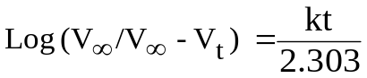………. (6)
Where V∞= final gas volume at ∞ time
V_{t} = volume at time t.
The slope of the graph is k/2.303, where k is the specific rate constant (k/min⁻¹).
Figs.(2-3) show a liner relations between log(V∞/V∞-V_{t}) at four temperatures, and the data are shown in Table 1.

Table 1 experimental values for all compounds at different temperatures (35-50) ºC
Compound | 308.15 K |  |  | 313.15 K |  |  | 318.15 K |  |  | 323.15 K
Compound | Time | V∞-V_{T} | LOG  (V/ V∞-V_{T}) | Time | V∞-V_{T} | LOG  (V/ V∞-V_{T}) | Time | V∞-V_{T} | LOG  (V/ V∞-V_{T}) | Time | V∞-V_{T} | LOG  ( V/ V∞-V_{T})
Aniline | 1 | 72 | 0.0617 | 1 | 54.6 | 0.1819 | 2 | 48 | 0.2378 | 1 | 41 | 0.3063
Aniline | 7 | 66 | 0.0995 | 9 | 44 | 0.2756 | 6 | 31 | 0.4277 | 4 | 31 | 0.4277
Aniline | 12 | 60 | 0.1409 | 14 | 37 | 0.3509 | 11 | 21 | 0.5969 | 8 | 19 | 0.6403
Aniline | 15 | 54 | 0.1867 | 18 | 28 | 0.4719 | 14 | 14 | 0.7729 | 11 | 11 | 0.8777
Aniline | 21 | 43 | 0.2856 | 23 | 20 | 0.618 | 17 | 7 | 1.0739 | 13 | 5 | 1.2201
p-chloro aniline | 1 | 26 | 0.2382 | 1 | 56.4 | 0.0271 | 1 | 65.4 | 0.042 | 1 | 18 | 0.5576
p-chloro aniline | 3 | 22 | 0.3108 | 3 | 49.8 | 0.0813 | 3 | 53.9 | 0.1261 | 3 | 10 | 0.8129
p-chloro aniline | 7 | 18.7 | 0.3814 | 7 | 38.8 | 0.1896 | 7 | 36.6 | 0.2941 | 8 | 5 | 1.1139
p-chloro aniline | 12 | 17 | 0.4228 | 13 | 26.7 | 0.3522 | 13 | 20.5 | 0.5464 | 15 | 2 | 1.5118
p-nitro aniline | 1 | 64 | 0.1232 | 1 | 49 | 0.2392 | 1 | 40 | 0.3274 | 1 | 30 | 0.4997
p-nitro aniline | 5 | 53 | 0.2051 | 3 | 40 | 0.3273 | 3 | 21 | 0.6072 | 4 | 21 | 0.6546
p-nitro aniline | 8 | 45 | 0.2762 | 5 | 32 | 0.424 | 7 | 12 | 0.8502 | 8 | 8 | 1.0737
p-nitro aniline | 10 | 40 | 0.3274 | 8 | 23 | 0.5677 | 10 | 4 | 1.3274 | 12 | 2 | 1.6758
p-nitro aniline | 13 | 35 | 0.3854 | 13 | 17 | 0.6989
p-amino benzoic acid | 1 | 67 | 0.1424 | 1 | 59.3 | 0.1714 | 1 | 51 | 0.2369 | 1 | 46 | 0.2817
p-amino benzoic acid | 3 | 61 | 0.1736 | 3 | 48 | 0.2632 | 4 | 39 | 0.3534 | 2 | 39 | 0.3534
p-amino benzoic acid | 5 | 51 | 0.2048 | 5 | 42.8 | 0.313 | 7 | 26 | 0.5295 | 4 | 25 | 0.5465
p-amino benzoic acid | 8 | 46 | 0.2516 | 8 | 37 | 0.3763 | 9 | 20 | 0.6435 | 6 | 17.2 | 0.7089
p-amino benzoic acid | 14 | 42 | 0.3452 |  |  |  | 15 | 10.5 | 0.9233 | 11 | 11 | 0.9031
p-amino phenol | 1.5 | 87.1 | 0.00931 | 1 | 54 | 0.2169 | 1 | 48.7 | 0.3391 | 1 | 41 | 0.3366
p-amino phenol | 3 | 85.3 | 0.01863 | 5 | 40 | 0.3473 | 5 | 32.5 | 0.4083 | 7 | 17 | 0.7189
p-amino phenol | 8 | 79.4 | 0.04967 | 10 | 32 | 0.4442 | 13 | 20 | 0.5467 | 11 | 12 | 0.8702
p-amino phenol | 12 | 75 | 0.07452 | 18 | 26 | 0.5344 | 26 | 17 | 0.7716 | 18 | 7 | 1.1043
p-amino phenol |  |  |  | 26 | 23 | 0.5877
o-amino phenol | 1 | 38 | 0.2264 | 1 | 33 | 0.2808 | 1 | 28 | 0.4279 | 1 | 28 | 0.4666
o-amino phenol | 3 | 34 | 0.27 | 3 | 21 | 0.4771 | 3 | 18 | 0.6198 | 5 | 13 | 0.7998
o-amino phenol | 8 | 29 | 0.3438 | 7 | 15 | 0.6232 | 7 | 8 | 0.9719 | 10 | 2 | 1.6128
o-amino phenol | 17 | 23.8 | 0.4296 | 12 | 10 | 0.7993 | 12 | 5 | 1.1761
o-amino phenol | 36 | 23 | 0.4445 | 19 | 2 | 1.4983
m-amino phenol | 1 | 63 | 0.0504 | 1 | 61 | 0.1641 | 1 | 38 | 0.4025 | 1 | 24.1 | 0.6003
m-amino phenol | 5 | 43 | 0.3452 | 6 | 33 | 0.4309 | 3 | 21 | 0.6601 | 2 | 13.1 | 0.865
m-amino phenol | 10 | 25 | 0.7137 | 11 | 11 | 0.908 | 5 | 13 | 0.8683 | 3 | 6.1 | 1.1969
m-amino phenol | 14 | 11 | 1.0085 | 15 | 6 | 1.1712 | 7 | 7 | 1.1372
m-amino phenol | 16 | 4 | 1.1559
p-Toluidine | 1 | 25 | 0.2552 | 5 | 25 | 0.4082 | 1 | 36 | 0.3934 | 1 | 39.6 | 0.2921
p-Toluidine | 3 | 16 | 0.449 | 10 | 17 | 0.5757 | 2 | 21 | 0.457 | 4 | 27.6 | 0.4489
p-Toluidine | 7 | 13 | 0.5392 | 15 | 11 | 0.7647 | 6 | 12 | 0.7114 | 8 | 9.6 | 0.9075
p-Toluidine | 13 | 10 | 0.6532 | 20 | 7.7 | 0.9196 | 12 | 6.2 | 1.093 | 15 | 0.6 | 2.1117
p-Toluidine | 20 | 6.3 | 0.8538 | 25 | 5.8 | 1.0427
o-Toluidine | 1 | 76.4 | 0.02031 | 1 | 78.7 | 0.03359 | 1 | 80.9 | 0.0511 | 1 | 77.8 | 0.07763
o-Toluidine | 5 | 63.4 | 0.1016 | 3 | 62.5 | 0.10076 | 3 | 63.9 | 0.1532 | 3 | 54.4 | 0.2329
o-Toluidine | 8 | 55.1 | 0.1625 | 7 | 49.5 | 0.2351 | 6 | 44.9 | 0.3064 | 5 | 38.1 | 0.3881
o-Toluidine | 13 | 44.1 | 0.2641 | 10 | 39.3 | 0.3358 | 10 | 28.1 | 0.5103 | 9 | 18.6 | 0.6987
o-Toluidine | 18 | 34.5 | 0.3656 | 15 | 26.6 | 0.5039 | 13 | 19.9 | 0.6621 | 11 | 13.1 | 0.8539
m- Toluidine | 1 | 61 | 0.1123 | 5 | 53 | 0.0108 | 1 | 39.8 | 0.2866 | 1 | 57.7 | 0.2023
m- Toluidine | 5 | 52 | 0.1816 | 9 | 40 | 0.186 | 3 | 24 | 0.5063 | 4 | 14.3 | 0.8094
m- Toluidine | 12 | 43.8 | 0.2562 | 16 | 28 | 0.4926 | 7 | 13 | 0.7725 | 12 | 1 | 2.4283
m- Toluidine | 19 | 34 | 0.3661 | 26 | 17 | 0.9306 | 13 | 5 | 1.1875
m- Toluidine | 29 | 26.8 | 0.4695 | 38 | 3 | 1.4562
m- Toluidine | 42 | 22 | 0.5552
m- Toluidine | 54 | 16 | 0.6935

Relationship between log (V∞/V∞-V_{t}) ) against time.
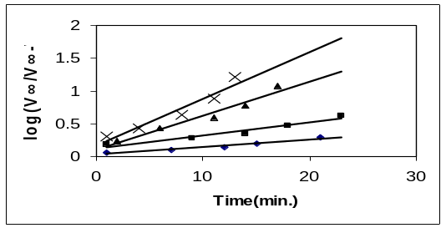 | 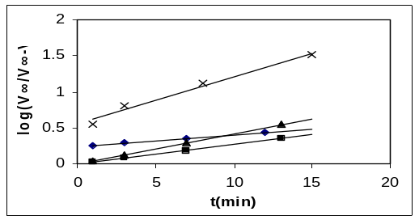
Fig.2: aniline | Fig. 3: p-chloro aniline
Where :35 ºC :40 ºC :45 ºC x:50 ºC

Table 2 gives the rate constant values calculated from Fig.(2-3), at four temperatures. Generally k (rate constant) increases with temperature, and a linearrelations were obtained when ploted the logarithm of k against 1/T, (T/k), and the activation energy, Arrhenius constant were obtained from the slope and intercept respectively (eq. 5).

Table 2 Values of rate constants for all compounds.

No. | Compound | k (min)⁻¹ at different temperatures (K)
No. | Compound | T=308.15 | T=313.15 | T=318.15 | T=323.15
1 | Aniline | 0.02556 | 0.04514 | 0.1198 | 0.1649
2 | p-chloro aniline | 0.03685 | 0.06241 | 0.0967 | 0.1502
3 | p-nitro aniline | 0.05112 | 0.08959 | 0.2379 | 0.2485
4 | p-amino benzoic acid | 0.03593 | 0.0654 | 0.1154 | 0.1449
5 | p-amino phenol | 0.0143 | 0.03247 | 0.03984 | 0.1025
6 | o-amino phenol | 0.01359 | 0.14439 | 0.1571 | 0.2966
7 | m-amino phenol | 0.1697 | 0.1822 | 0.2777 | 0.6870
8 | p-Toluidine | 0.06448 | 0.07369 | 0.1465 | 0.3079
9 | o-Toluidine | 0.04675 | 0.07738 | 0.1172 | 0.1787
10 | m- Toluidine | 0.02441 | 0.10087 | 0.1681 | 0.4661

Figs. (4-5) show the Arrhenius relations for the decomposition of the ten daizonium salts prepared in this study. Table 3 gives the E_{a} (kJmol⁻¹) and log ( A/min⁻¹) for the ten reactions.

Arrhenius relationship
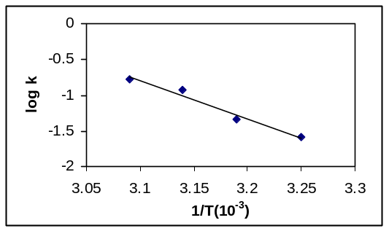 | 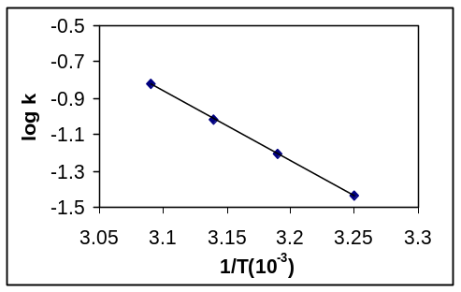
Fig.(4): aniline | Fig. (5): p-chloro aniline

Table 3 Values of activation energy and Arrhenius constants for all compounds.
No. | Compound | E_{a} (kJmol⁻¹) | Log A
1 | Aniline | 102.893 | 15.86
2 | p-chloro aniline | 73.019 | 10.96
3 | p-nitro aniline | 89.932 | 13.99
4 | p-amino benzoic acid | 74.842 | 19.96
5 | p-amino phenol | 95.929 | 14.44
6 | o-amino phenol | 159.844 | 25.50
7 | m-amino phenol | 71.086 | 11.20
8 | p-Toluidine | 83.177 | 12.84
9 | o-Toluidine | 69.634 | 10.49
10 | m-Toluidine | 147.519 | 23.48

Discussion
A linear relationship was found to exist between the experimental values of log A and the corresponding values of E_{a} as in Fig. 6. which could be expressed as ⁽⁵⁾:

Log A=I+ m E_{a} ………. (7)
Where I and m are a constant.

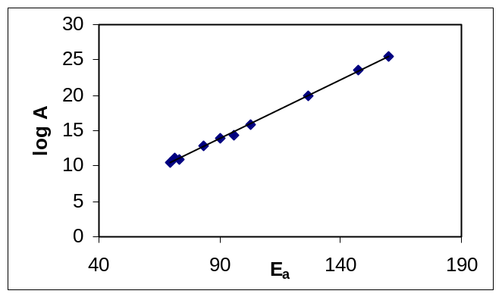
Fig.6 relationship between log A and E_{a} (kjmol⁻¹) for all salts.

Where m and I are respectively the slope and the intercept of the plots in Fig.6. Such a relationship is termed a "Compensation effect" which is frequently found to describe the kinetics of catalytic reactions ⁽⁶⁻⁸⁾. Equation (7) shows that simultaneous increases in E and log A for a particular system tend to compensate from the standpoint of reaction rate, In order for a reaction to take place, free energy of activation ∆#G must be added. When a reaction has progressed to the point corresponding to the top of the curve, the term transition state is applied to the positions of the nuclei and electrons. The transition state possesses a definite geometry and charge distribution but has no finite existence.
The system at this point is called an activated complex. In the transition – state theory the starting materials and the activated complex are taken to be in equilibrium. According to the theory, all activated complexes go on to product at the same rate, so that the rate constant of the reaction depends only on the position of the equilibrium between the starting materials and the activated complex. Like ∆G, ∆#G is made up of enthalpy and entropy components.
∆#G =∆#H -T∆#S ………. (8)
∆#H the enthalpy of activation, is the difference in bond energies, including strain, resonance, and solvation energies, between the starting compounds and the transition state. In many reactions bonds have been

broken or partially broken by the time the transition state is reached; the energy necessary for this is ∆#H. It is true that additional energy will be supplied by the formation of new bonds, but if this occurs after the transition state, it can affect only ∆H and not ∆#H. Entropy of activation ∆#S, which is the difference in entropy between the starting compounds and the transition state. Table (4) shows the ∆#G, ∆#H and ∆#S for the decomposition of the ten diazonium salts prepared in this study. ∆#S calculated from Arrhenius constant (eq. 5), using the following equation⁽¹⁷⁾:
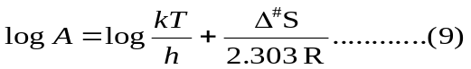
Where; k, is Boltzman constant; T is the temperature in K; h plank constant and R is gas constant.
Arrhenius eq. can be written:

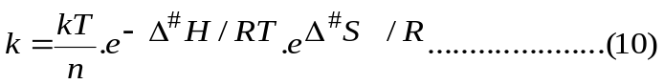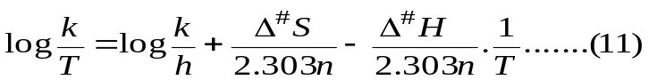
∆H = 2.303 m₂ R …….. (12)

Where m₂ is the slope of a liner relation between log k/T and 1/T as shown in Figs. (7-16).

Relationship between log k/T against 1/T
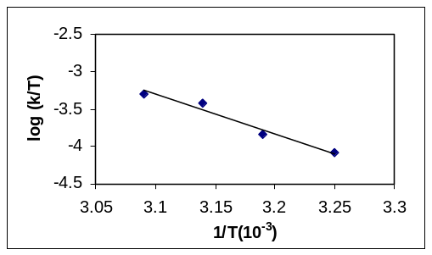 | 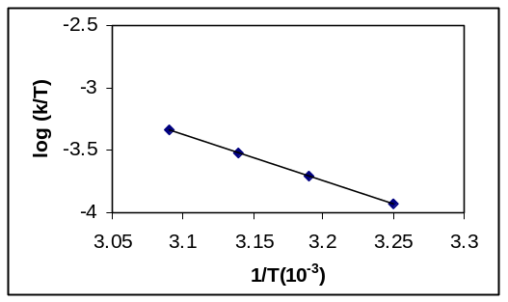
Fig.(7): aniline | Fig. (8): p-chloro aniline
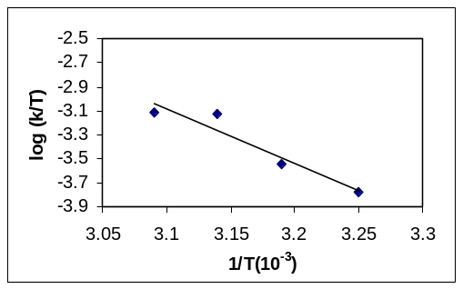 | 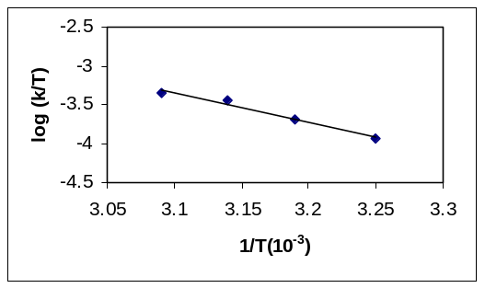
Fig.(9): p-nitro aniline | Fig.(10):p-aminobenzoic acid
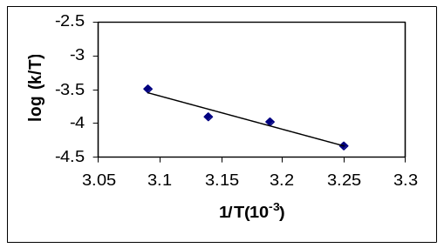 | 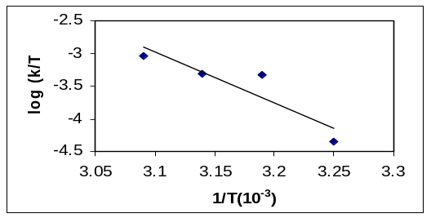
Fig.(11): p-amino phenol | Fig.(12): o- amino phenol
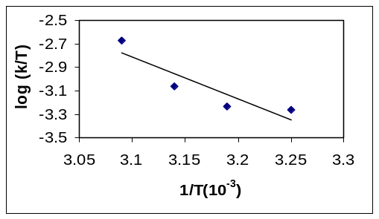 | 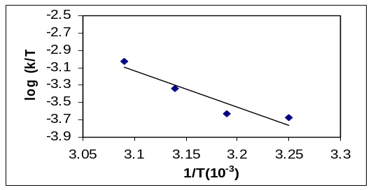
Fig.(13): m-amino phenol | Fig.(14): p-Toluidine
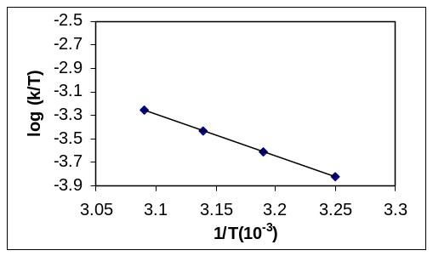 | 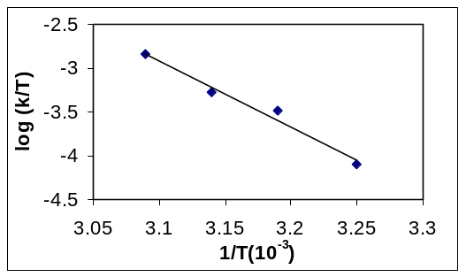
Fig.(15): o-Toluidine | Fig.(16): m-Toluidine

∆#G calculated from eq. 8. Table (4) shows that o-amino phenol have a highest ∆#S while o- Toluidine have the lowest value. The existence of –OH group in the ortho position (o-amino phenol ) cause to increase ∆#H for aniline from 100.415 kJmol⁻¹ to 147.027 kJmol⁻¹.
In general the electron rich benzene ring stabilizes the –N⁺≡N group as shown in Table (3), where –CH₃ group in m-Toluidine increase the E_{a} from 102.893 kJmol⁻¹ for aniline to 147.519 kJmol⁻¹ for m-Toluidine. Also –OH group increase E_{a} for o- amino phenol to 159.844 kJmol⁻¹ . While the groups with drawing like –Cl group decrease the stability of the ring and the activation energy for p- chloro aniline decreases to 73.019 kJmol⁻¹. The difference in the position, (o, p or m) causes a large differences in the stability of the ring and then in the activation energy of the decomposition of the salt as shown in Table (4).

Table 4 Thermodynamic values for the compounds.
No. | Compounds | ∆#H  kJmol⁻¹ | ∆#S  JK⁻¹mol⁻¹ | ∆#G₃₀₈  kJmol⁻¹ | ∆#G₃₁₃  kJmol⁻¹ | ∆#G₃₁₈  kJmol⁻¹ | ∆#G₃₂₃  kJmol⁻¹
1 | Aniline | 100.415 | 50.429 | 84.875 | 84.623 | 84.371 | 84.119
2 | p-chloro aniline | 70.544 | -43.393 | 83.915 | 84.132 | 84.349 | 84.566
3 | p-nitro aniline | 87.447 | 14.490 | 82.982 | 82.909 | 82.837 | 82.764
4 | p-amino benzoic acid | 72.3685 | -37.271 | 83.856 | 84.042 | 84.229 | 84.415
5 | p-amino phenol | 93.444 | 23.183 | 86.299 | 86.184 | 86.068 | 85.952
6 | o-amino phenol | 147.027 | 200.963 | 85.100 | 84.096 | 83.091 | 82.086
7 | m-amino phenol | 68.606 | -38.778 | 80.556 | 80.750 | 80.944 | 81.137
8 | p-Toluidine | 80.665 | -7.467 | 82.966 | 83.003 | 83.041 | 83.078
9 | o-Toluidine | 67.208 | -52.250 | 83.309 | 83.570 | 83.832 | 84.093
10 | m- Toluidine | 145.042 | 196.215 | 84.578 | 83.597 | 82.616 | 81.635

Fig.17 The variation of the ∆#S and #Ea for the decomposition of the ten salts prepared in this study.

 |  |  | 6 |  | 6
 |  |  | 10 |  | 10 |  | ∆#E_{a}  (kJmol⁻¹)
 |  |  | 1 |  | 1 |  | ∆#E_{a}  (kJmol⁻¹)
 |  |  | 5 |  | 5 |  | ∆#E_{a}  (kJmol⁻¹)
∆#S  (JK⁻¹mol⁻¹) |  |  | 3 |  | 3 |  | ∆#E_{a}  (kJmol⁻¹)
∆#S  (JK⁻¹mol⁻¹) |  |  | 8 |  | 8 |  | ∆#E_{a}  (kJmol⁻¹)
 |  |  | 4 |  | 4 |  | ∆#E_{a}  (kJmol⁻¹)
 |  |  | 7 |  | 2 |  | ∆#E_{a}  (kJmol⁻¹)
 |  |  | 2 |  | 7 |  | ∆#E_{a}  (kJmol⁻¹)
 |  |  | 9 |  | 9 |  | ∆#E_{a}  (kJmol⁻¹)

Fig.17: variation of the ∆#S and #Ea for the ten salts prepared from
compounds (1-10).

The most important mechanism for the decomposition of diazonium salt is (S_{N}¹) mechanism⁽⁹⁾. The nitrogen molecule lost from diazonium salt.

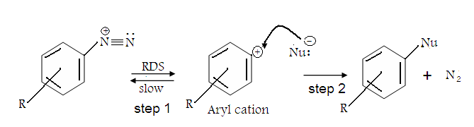

The most important evidence for this reaction mechanism comes from kinetic studies that indicate that the reaction is first order in diazonium salt, so the slow step of the reaction is the decomposition of the salt. Since the nucleophilie is not involved in the RDS (Rate Determining Step), the reaction is actually an S_{N}¹ reaction for aromatic substitution. Among the evidence for the S_{N}¹ mechanism with aryl cations as intermediates⁽¹⁰⁾, is the following⁽¹¹⁾ :
- The reaction rate is first order in diazonium salt and independent of concentration of nucleophil.
- When high concentrations of halide salts are added, the product is an aryl halide but the rate is independent of the concentration of the added salts.
- The effects of ring substitutions on the rate are consistent with a unimolecular rate- determining cleavage⁽¹²⁾ .
- When reactions were run with substrate in the ortho position, isotope effects of about 1.22 were obtained ⁽¹³⁾. It is difficult to account for such high secondary isotope effects in any other way except that an incipient phenyl cation is stabilized by hyper conjugation, which is reduced when hydrogen is replaced by deuterium.

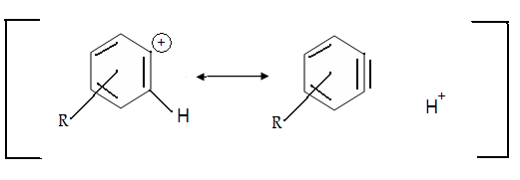

- That the first step is a reversible cleavage⁽¹⁴⁾ was demonstrated by the observation when Ar¹⁵N⁺≡N was the reacting species recovered starting material contained not only Ar¹⁵N⁺≡N but also ArN⁺≡¹⁵N. This could arise only if the nitrogen breaks away from the ring and then returns.

Additional evidence was obtained from phN≡¹⁵N with unlabeled N₂ at various pressures. At 300 atm the recovered product had lost about 3% of the labeled nitrogen, indicating that phN₂⁺ was exchanging with atmospheric N₂¹⁵. There is kinetic and other evidence ⁽¹⁶⁾ that step 1 is more complicated and involves two steps, both reversible:

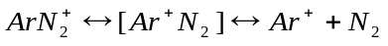 (x)
(x) is probably some kind of a tight ion-molecule pair.

Conclusions
The reaction of the decomposition of diazonium salt is of first order and S_{N}¹ mechanism. The –CH3 and –OH groups lead to more stability of the salts with activation energy, 147.519 kJmol⁻¹,159.844 kJmol⁻¹ respectively with compare for aniline with Ea=102.893 kJmol⁻¹.
References
- Organic Chemistry an overview, translated by Dr. M.N. Ibrahim & Dr. M. Zakaria
- E.A. Mecluyn-Hughes and P. Johnson. Trans. Faraday Soc., 36, 948 (1940); M.L. Crossley, R.H. Kienle, and C.H Benbrook, J. Am. Chem. Soc., 62, 1400,(1940).
- David P. Shoemaker Carl W. Garland Jeffery I. Steinfeld Experiments in Physical Chemistry (1974).
- Physical Chemistry Laboratory: Principals and Experiments, Hugh W. Salzburg, Jack I. Morrow, Stephen R. Cohen and Michael E. Green. (MACMILLIAN PULISHENG Co. Inc New York (1978).
- L.M Al- Shamma, J.M. Salah and N.A. Hikmat, corros.sci.,1987, 27, 22 .
- S.A. Isa and J.M. Salah, J. Physical Chemistry, 1972, 76, 2530 .
- Y.M. Dadiza and J.M. Salah, J. Chem. Soc. Faraday Trans. I, 1972, 68, 269.
- Y.K Al-Haidari, J.M. Salah, M.H. Mahoob, J. Phys. Chem. 1985, 89, 3286.
- Advanced Organic Module, Trudy A. Dickneider, Ph.D., Department of Chemistry, University of Scranton, (2005).
10. Ambroz & Kemp, chem. soc.Rev.8, 353-365 (1979).
11. Zollinger, Angew. chem. Int. Ed. (Eng), 1978, 17, 141.
12. Miller ,J. Am. chem. soc., 1953, 75, 429 .
13. Swain, Sheats, Gorenstein & Harbison, J.Am. chem. soc. 1975, 97, 791.
14. Zolling, pure Appl. Chem.. 1983, 55, 401.
15. Bergstrom, landells, Wahl & Zollinger, J.Am. chem. soc, 1976, 98, 3301.
16. Maurev, Szele & Zollinger, Helv. Chem. Acta, 1979, 62, 1079 .
17. Khulood Al-Saadie, Ph.D thesis, college of science, university of Baghdad
(1997).

