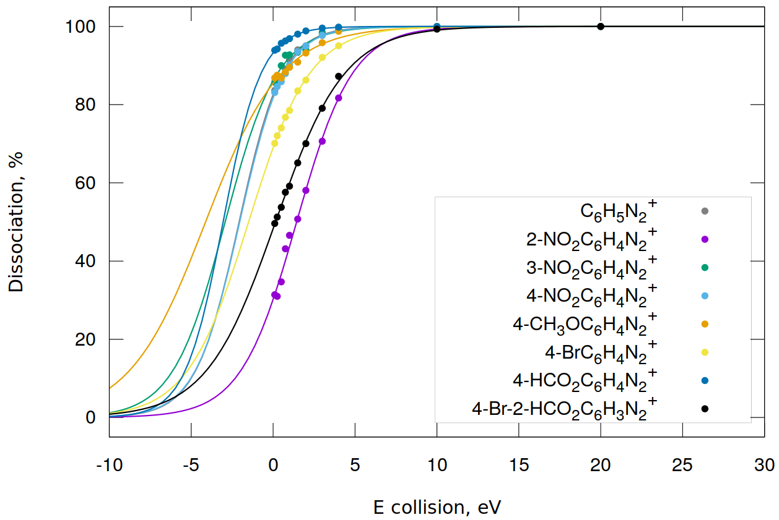

Fig. 1. Dissociation some aren diazonium cations

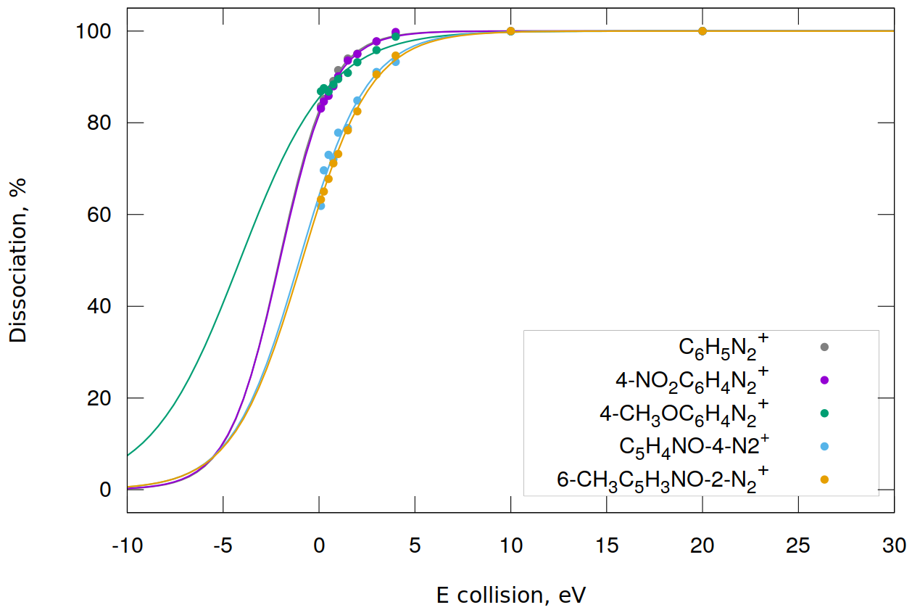

Fig. 2. Dissociation some NO-pyridines and aren diazonium cations

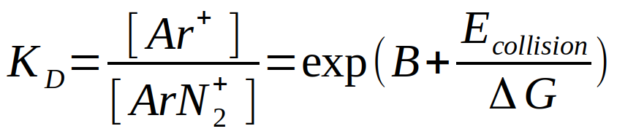 (1)

Table 1.

Parameters of aproximation equation (1) for some diazonium salts

|  |  |  |  |
| --- | --- | --- | --- |
| **№** | **Diazonium salts** | **DG, eV** | **B** |
|  | C6H5N2+ TfO- | 1.33 | 1.56 |
|  | 2-NO2C6H4N2+ TfO- | 1.71 | -0.84 |
|  | 3-NO2C6H4N2+ TfO- | 1.60 | 1.83 |
|  | 4-NO2C6H4N2+ TfO- | 1.36 | 1.50 |
|  | 4-NO2C6H4N2+ TsO- | 1.42 | 1.56 |
|  | 4-NO2C6H4N2+ BF4- | 1.27 | 1.56 |
|  | 4-CH3OC6H4N2+ TfO- | 2.33 | 1.77 |
|  | 4-BrC6H4N2+ TfO- | 1.77 | 0.80 |
|  | 4-HCO2C6H4N2+ TfO- | 1.16 | 2.63 |
|  | 4-Br-2-HCO2C6H3N2+ TfO- | 2.12 | -0.07 |
|  | C5H4NO-4-N2+ TfO- | 1.76 | 0.58 |
|  | 6-CH3C5H3NO-2-N2+ TfO- | 1.80 | 0.49 |
|  | 4-Br-2-NO2C6H3N2+ TfO- | 2.11 | -0.21 |
|  | C10H7-2-N2+ TfO- | 1.29 | 2.92 |