# Methods

## Data extraction

For the consecution of this project we extracted * 120K tweets from the 40 main business association accounts in Spain * 269K tweets from the 35 main companies (ibex 35) in Spain * 17K tweets from the 30 main business association accounts in Peru * 72K tweets from the 20 main companies in Peru

These tweets cover the period dated from january 2017 to march 2020.

In order to train a spanish sentiment analysis neural network we also extracted 100K rated user reviews. These reviews covered very variated items such as films, products and places and were extracted using *web crawling* software in public websites.

## Spanish sentiment analysis neural networks training using reviews data

As a key component of our analysis we needed to capture the negativity or positivity of the tweets. This is achieved using sentiment classification. Unfortunately, there is not a standard library for sentiment classification in the spanish language. So we build a neural network classification model to achieve this goal.

Using the 100K rated reviews in spanish extracted using web crawing we separated them in two groups: *positive reviews* and *negative reviews*. Since there were more positive than negative reviews, we balanced the two classes removing enough positive ones to have the same size in both groups.

For the neural network architecture we used an embedding layer, four convolutional (1 dimensional) layers, two poolings and a one dimensional output dense layer. Other architectures were tried, but we obtained poorer results in terms of validation accuracy.

|  |  |  |  |  |
| --- | --- | --- | --- | --- |
| data | accuracy | precission | recall |  |
| training data | 0.9988 | 0.9991 | 0.9992 |  |
| test data (validation) | 0.9869 | 0.9840 | 0.9870 |  |

## Tweets processing using sentiment analysis

Using the neural network sentiment model described in the previous section, we proceed with the analysis of the tweets from the business associations and companies using the following steps:

1. We run the sentiment analysis on each tweet. This gives us a number between 0 and 1 expressing the positivity or negativity of the tweet.
2. We calculate the average of all the tweets published in the same day in each group.
3. We calculate the difference between the average sentiment in each given day and the day before to remove the trend component and make the data more comparable.

This transforms the data into a time series that we can study and compare to macro economic data. In particular we obtain four time series: daily sentiment of main companies and business associations both in Spain and Peru.

This four time series are the starting point in our analysis and modeling process. See figure 1

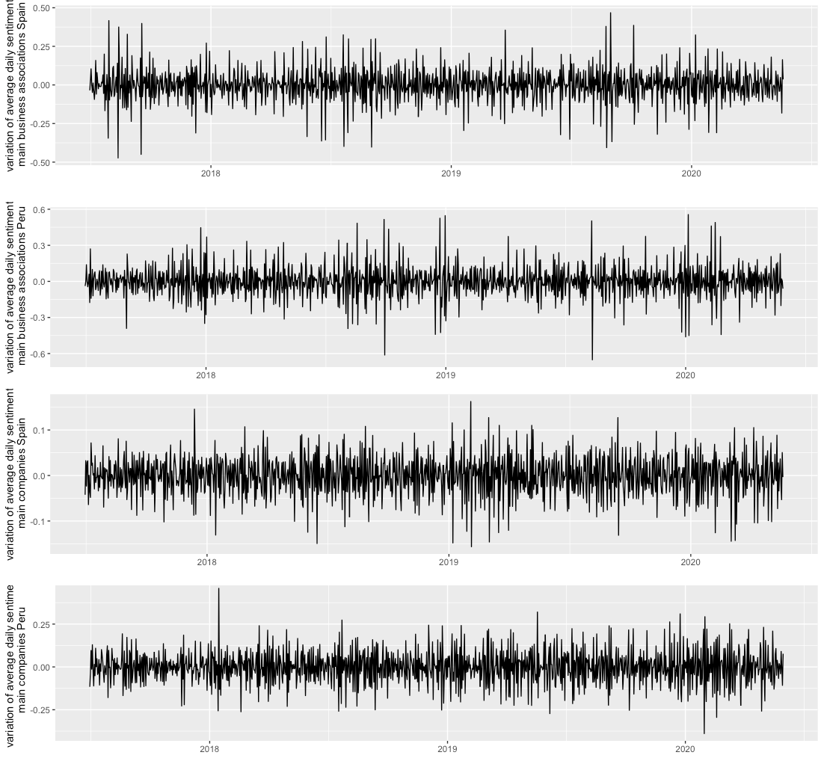 **figure 1** Taking a look to the beginning of 2020, we see how the time series become more anomalous which could complicate the modeling process. We will come back to this later .

# Results

## Prediction of Madrid and Lima stocks change using traditional models

We use the daily average sentiment data described in the previous section to predict the fluctuations of stock values.

First, we see that the daily average sentiment is a stationary time series (both for associations and main companies in both countries). This are the p-values of the Dicker-Fuller test for the four time series |p-value| results daily variation sentiment business asociation| results daily variation sentiment main companies| |-|-|-| |Spain|3.541674e-23|3.280194e-26 | |Peru|0.000116|0.002758 |

We studied the Granger causality of the variation of the sentiment and the stock values, but we only found significant p-values by restricting the data to the last 5 months of the study (from January 2020 to May 2020). The significative p-values were only obtained for the stocks in Spain.

This are the p-values of the Granger causality test of the daily variation of sentiment and the prize change in the stock value (Madrid and Lima respectively)

|  |  |  |
| --- | --- | --- |
| p-value | variation sentiment business association vs variation stock prize | variation sentiment main companies vs variation stock prize |
| Spain | 0.0282 (lag 5), 0.0530 (lag 6), 0.0378 (lag 7) | 0.0170 (lag 5) |
| Peru | >0.05 (all lags) | >0.05 (all lags) |

Using a VAR model to predict the variation of stocks change one day in advance from the variation in the sentiment both for business associations and companies, we obtain a MAE (mean absolute error) of 0.8735 for Spain and 0.5212 for Peru

Nevertheless, we see that there is a great volatility in the months of COVID-19 pandemic, so removing those three months (february, march and april 2020) we see that the model performs much better in terms of MSE: 0.6931 for Spain and 0.5101 for Peru.

figure 2 shows the sock values (removing the pandemic months) in blue and the prediction in orange.

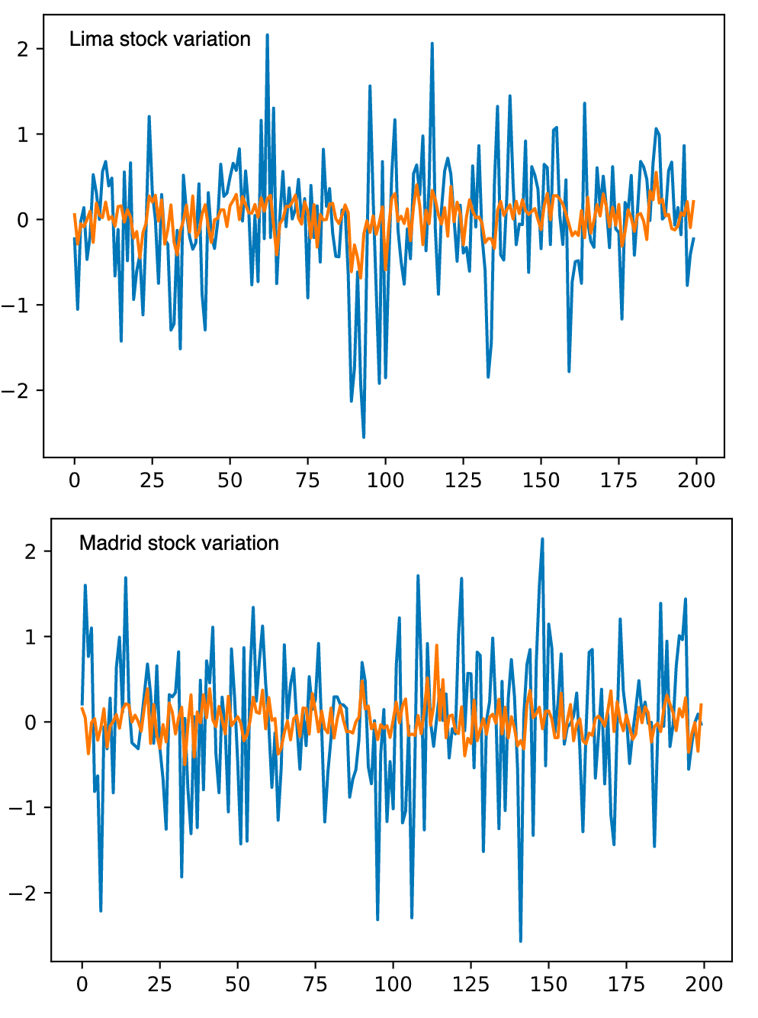

## Prediction of Madrid and Lima stocks change using neural networks models

Neural network models present a different approach to forecasting time series. We compare LTSM neural networks and Convolutional neural network models.

The model is designed to forecasts a day in advance using a window of the previous 7 days an input. The neural network models were trained taking all the 7 day windows of sentiment data and stock data and splitting them into test data (15%) and train data (85%).

This are the model designs: * The LTSM model is componed by a 200 size layer of LSTM neurons, a dense layer with 100 neurons and an output layer of 1 neuron. * The Convolutional model is composed by two one dimensional convolutional layers with 64 filters, a pooling layer, a dense layer with 100 neurons and an output dense layer with 1 neuron.

The outputs have size 1 because we are only predicting one day in advance.

These are the mean absolute errors of the two models

|  |  |  |
| --- | --- | --- |
|  | LSTM mean absolute error | Convolutional networks mean absolute error |
| Madrid stocks data | 0.7061 | 0.8172 |
| Lima stocks data | 0.7529 | 0.6754 |

As we did with the VAR models, due to the high volatility during the COVID months, it makes sense to repeat the training of the model using only the data from the months prior to the pandemic. These are the results obtained after the restriction

|  |  |  |
| --- | --- | --- |
|  | LSTM mean absolute error | Convolutional networks mean absolute error |
| Madrid stocks data | 0.5030 | 0.6908 |
| Lima stocks data | 0.5459 | 0.5576 |

figure 3 shows the 200 sock values (taken removing the pandemic months) in blue and the prediction in orange. The prediction in the figure was obtained using the LSTM model.

