1. **Description of Corresponding articles across the 3 sources**

First, we visualize the descriptive words used for various entities present across corresponding articles of all three sources, using a word cloud. This is done in order to see how different sources highlight the different entities present in their corresponding articles. Here, the size of each descriptive word in the word cloud is proportional to its frequency of occurrence.

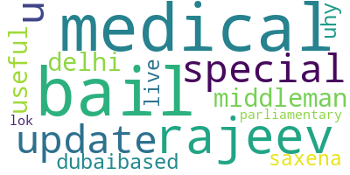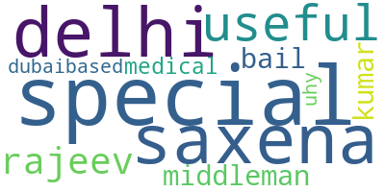

**DD NDTV**

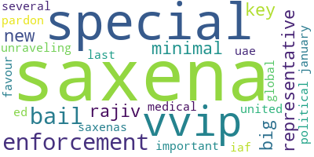

**TIMES**

**2) Centrality Gaps in different sources**

Next, we compare the focus on various entities, across corresponding articles in different sources, using a centrality word cloud. Here the size of each word is proportional to its prominence in the corresponding article, which is denoted by its centrality score and the colour highlights the sentiment (Green: Positive, Red: Negative, Gray: Neutral) Further we also highlight the sentiment revolving around the various entities, to compare how different sources may show these entities as positive or negative, instead of neutral. This may be a possible indicator of sensational bias in media, especially if all three sources show different sentiment around the same entity. 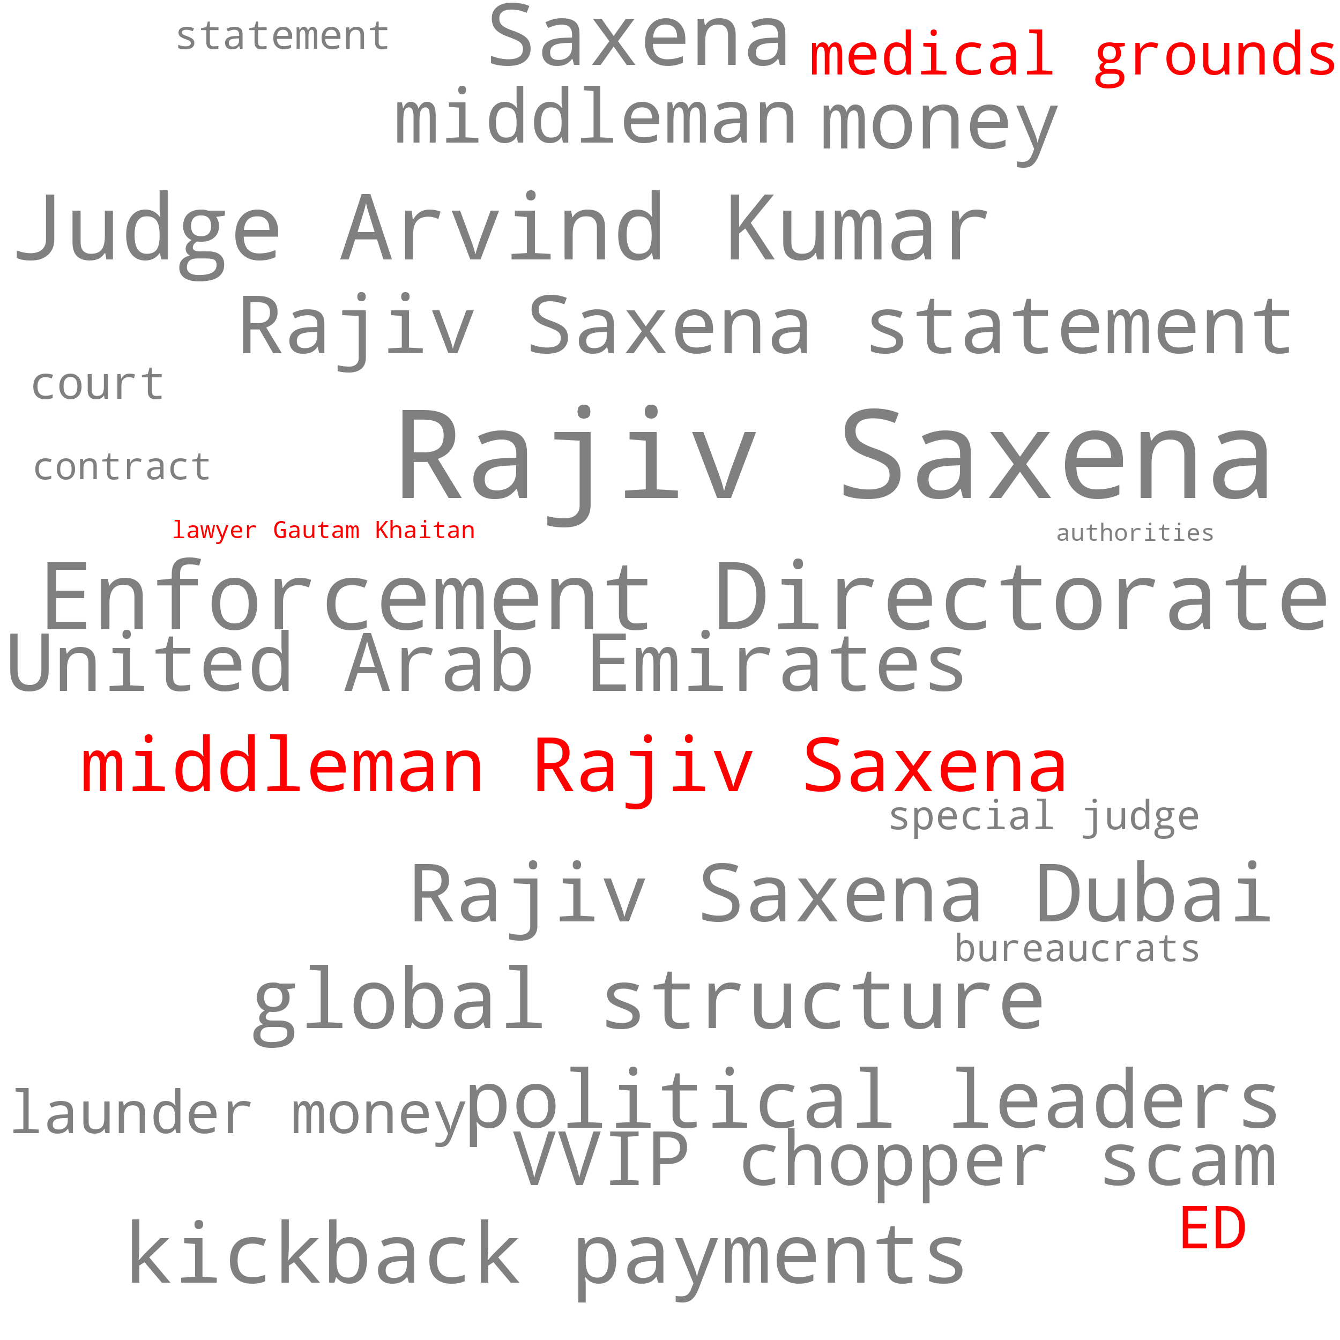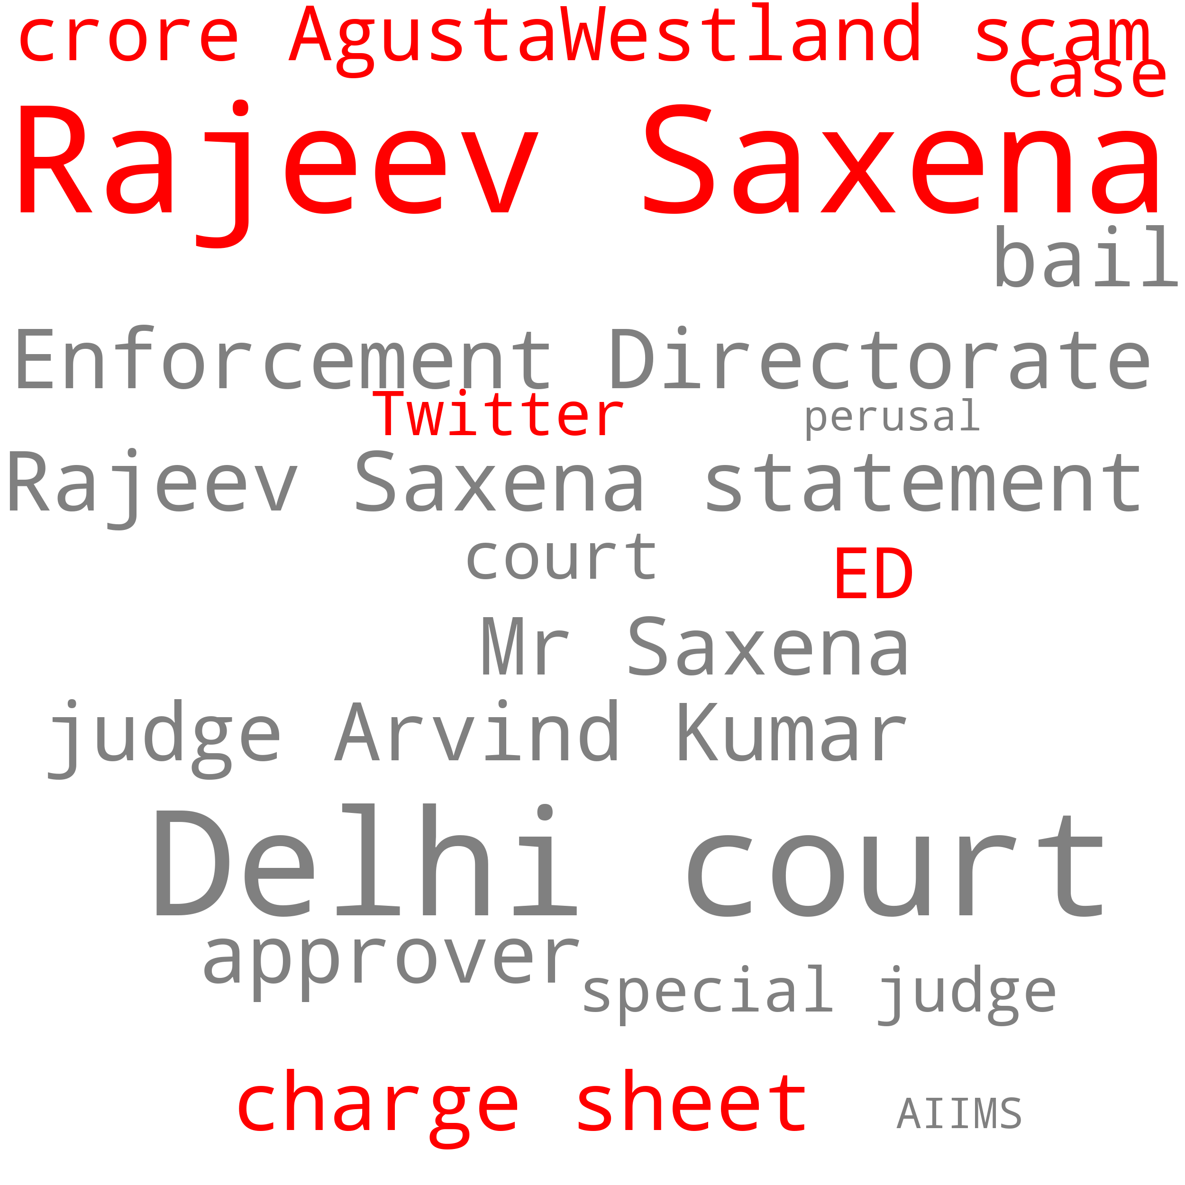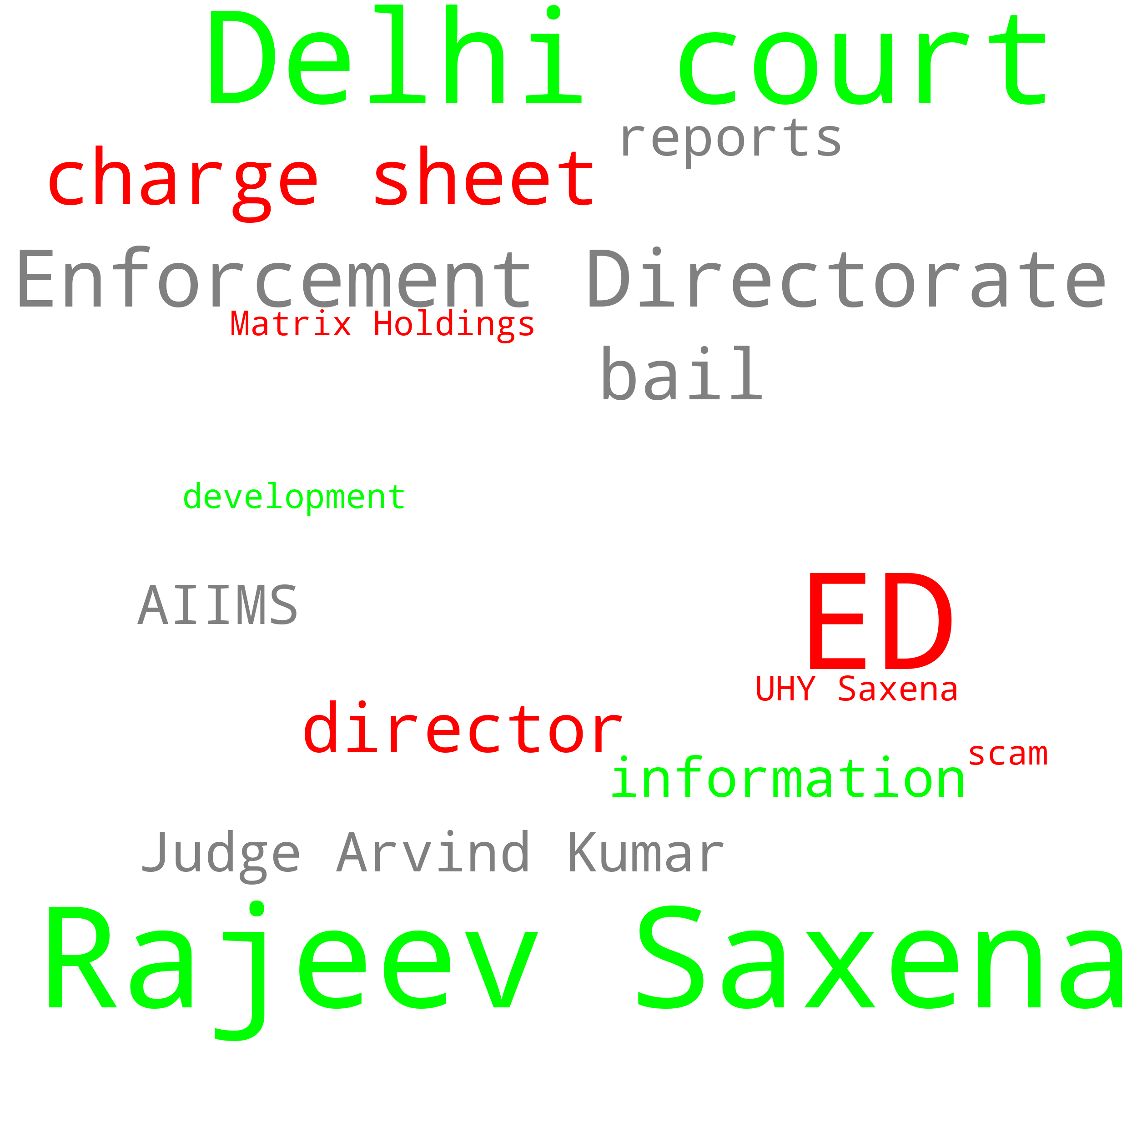

**DD NDTV Times**

**3) Comparison of centralities entities across various sources**

Further, in order to compare the shift in centralities across articles of different sources, we plot the centralities using a bubble chart. This chart represents the prominence of various entities present across corresponding articles from all three sources using a centrality score. The X-Axis shows various entities from the articles, and the Y-Axis represents the corresponding sources. Size of the bubble is proportional to the centrality score.

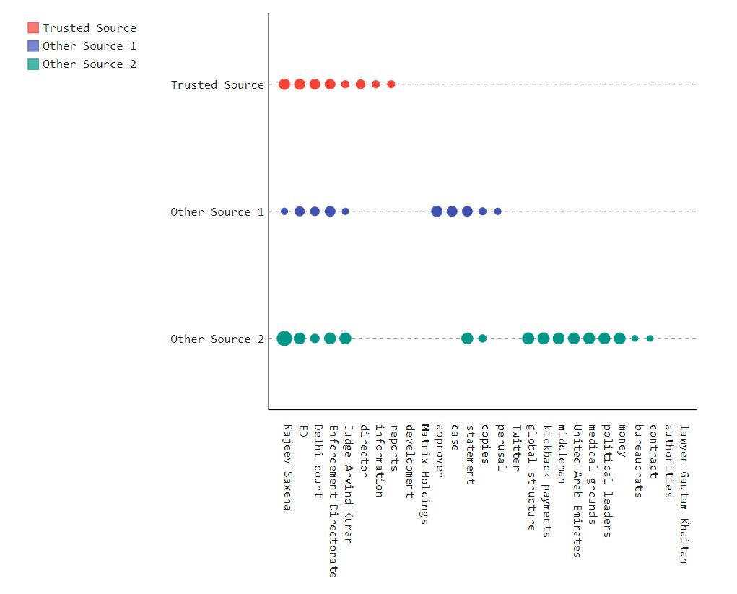

4) **Reduced Content**

Next, we want to analyze and compare the missing entities across all three sources. This gives us insights into the reduced content of across various sources. We plot a word cloud for those entities which are present in the trusted source and absent across the other two. Simultaneously we also plot those entities which are present in the other two sources, but not in the trusted source. This tells us, about some essential information that the trusted source might have missed out, as compared to the other sources, and vice versa, which is again an indicator of bias. Along with this we also, do a sentiment comparison for the missing entities. Size of the word is proportional to its centrality score and the colour highlights its sentiment: Green for positive, red for negative, gray for neutral.

**Present in DD, not in others Present in NDTV, but not in DD Present inTImes,not** 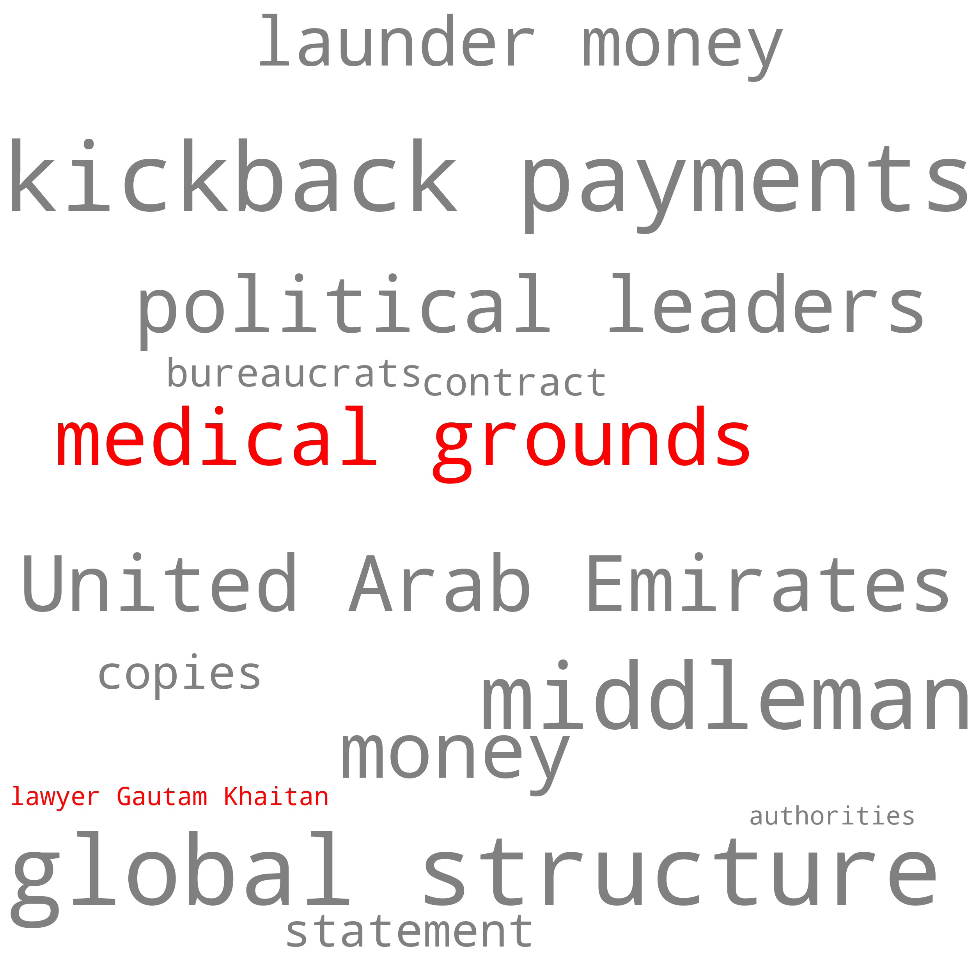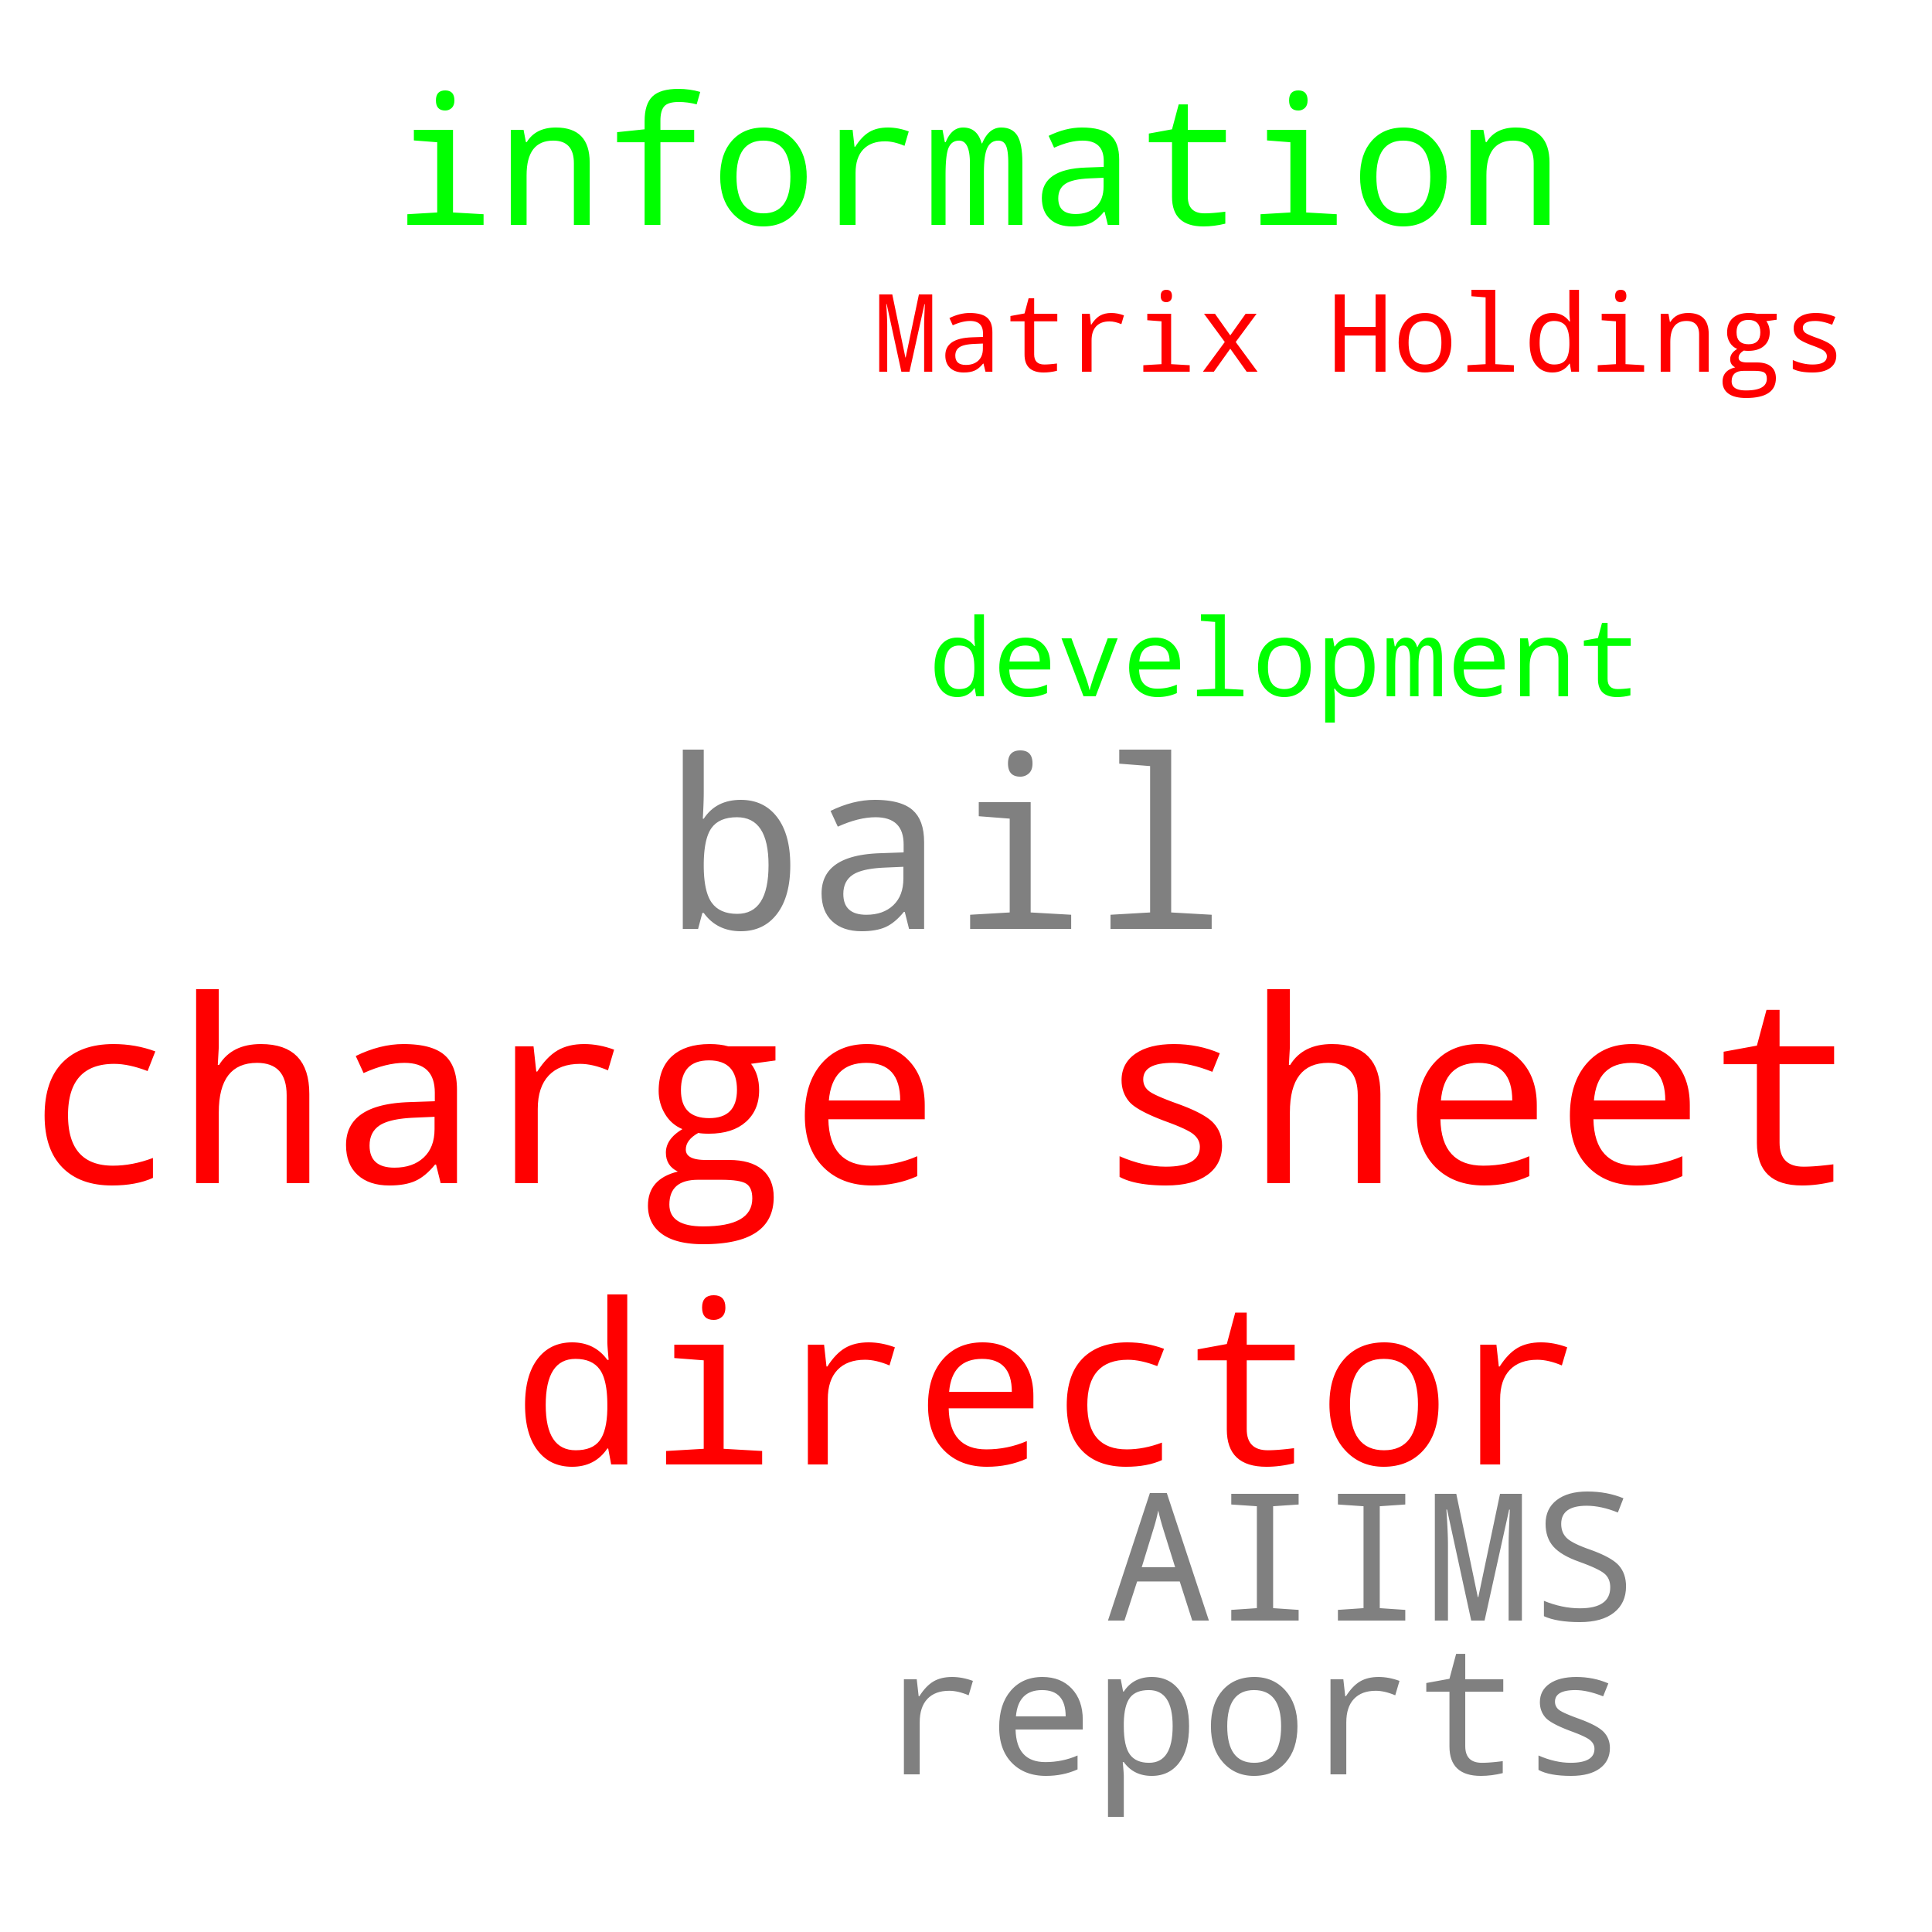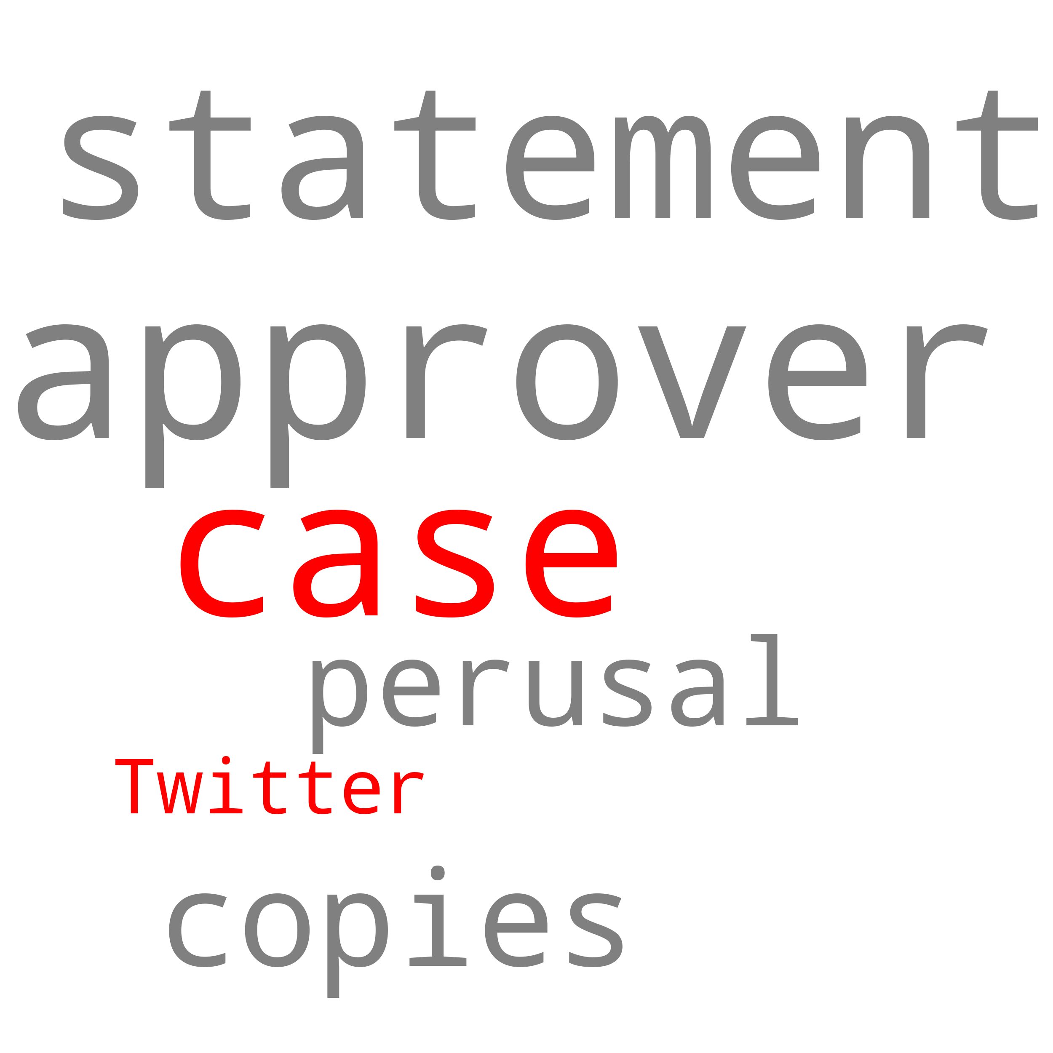

**5) Attention Visualisation**

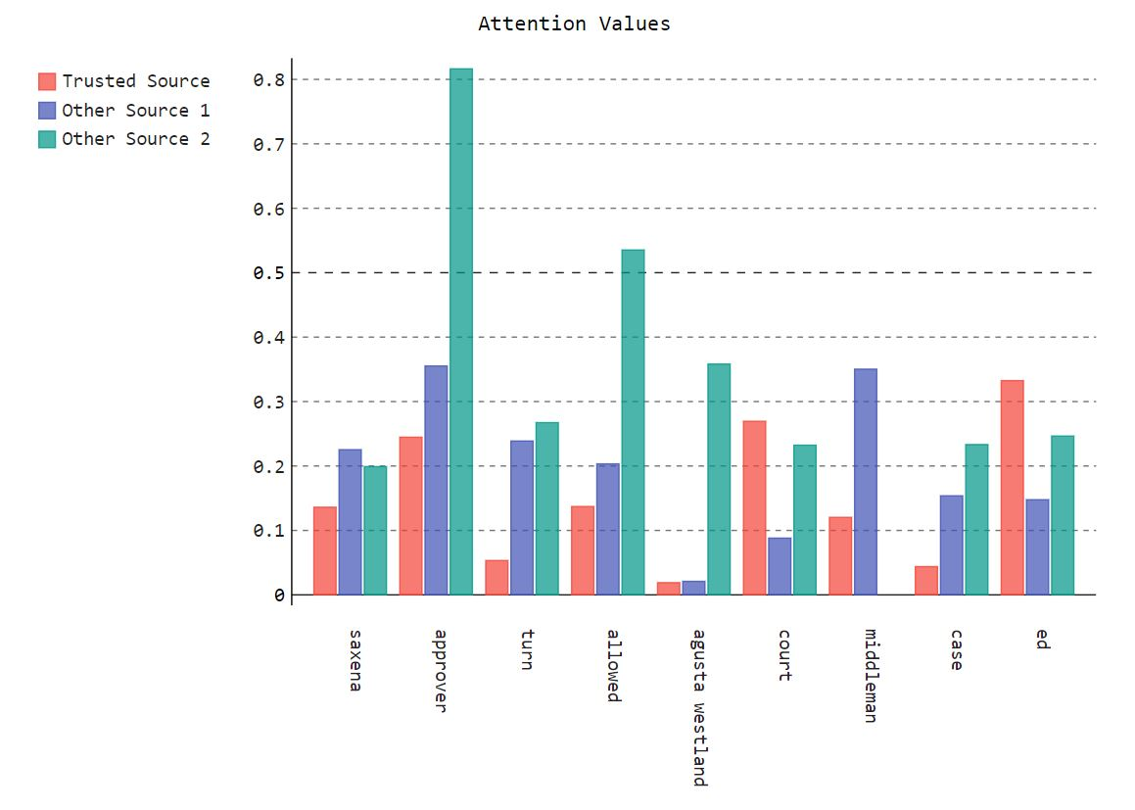

**Comparison of Attention Drift of keywords across various sources**

Using this chart we show the attention drift across various sources. This is done to see, how the attention given to various entities changes across different sources, which is again an indicator of sensational bias. The X axis represents the various words, and the Y axis represents the attention score, colour coded with respect to the different sources.

**6)** **Emotions of entities present in trusted source, absent in other sources**

These charts represent the emotions and around those words which are present in the trusted source article but not in the other source articles, w.r.t. their context in the corresponding article. The X-Axis represents the words in both the charts and the Y-Axis represents the values corresponding to different emotions in the emotions chart and sentiment scores in the sentiment chart.

**Emotions of entities present in DD but not in the other two**

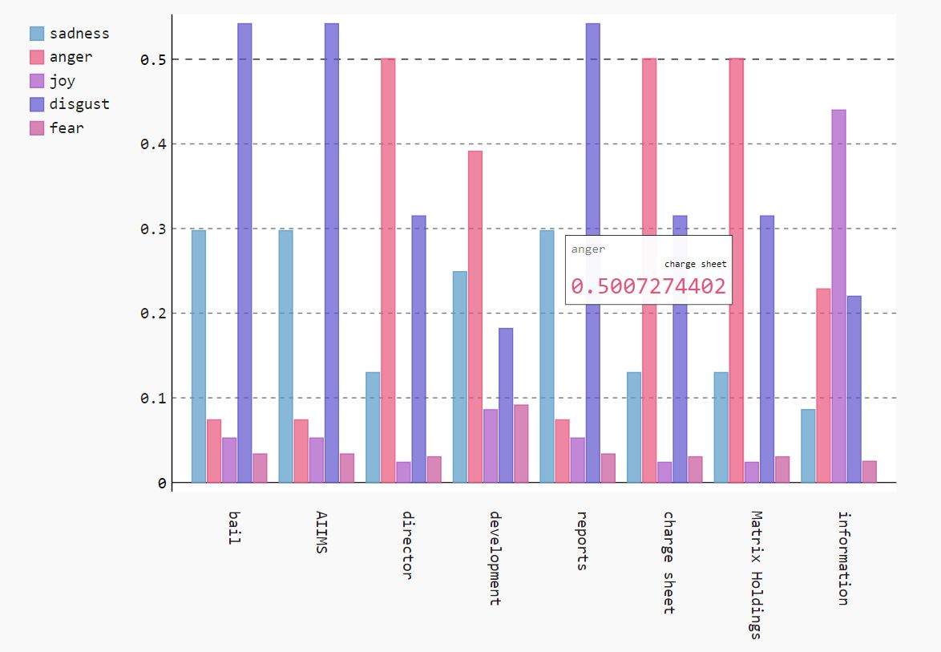

**7) Comparison of sentiments of common entities**

This chart captures the sentiments revolving around common entities using a sentiment score, with respect to the context of entities in the corresponding articles across all three sources. The sentiment score can be positive, zero, or negative. The X axis represents the entities, and the Y axis represents the sentiment score, colour coded with respect the three sources.

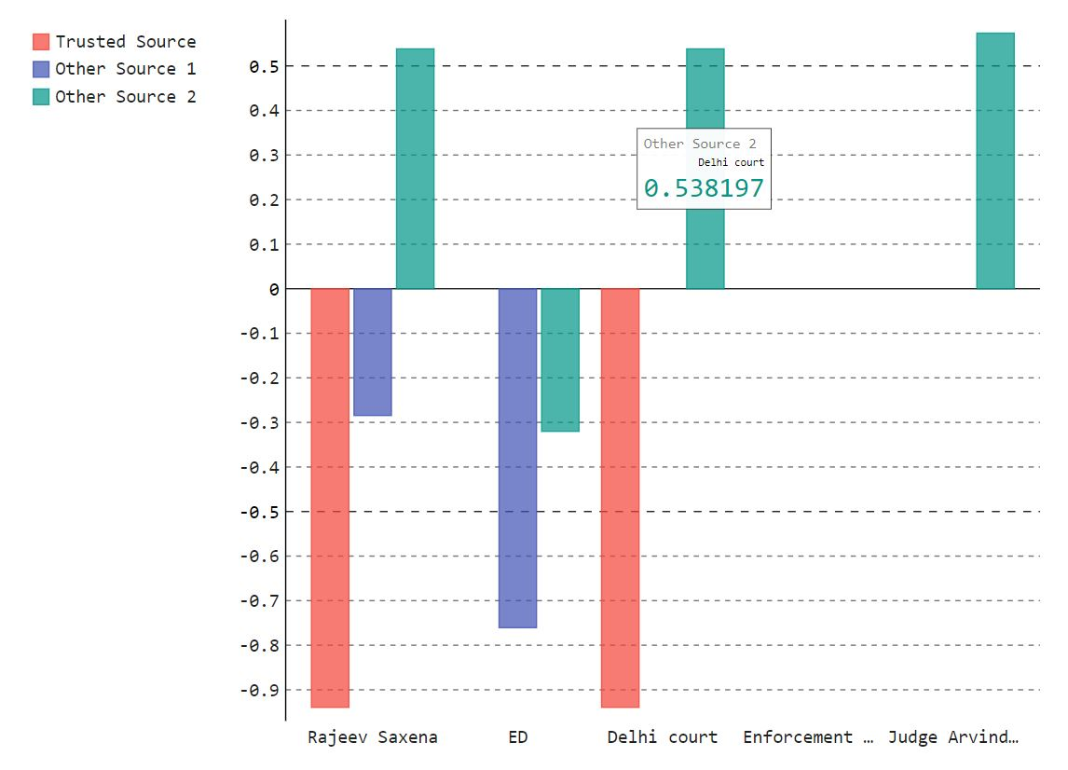

**Wordnet Plot:**

In these charts we wanted to visualize the similarity of the titles of corresponding articles across the three sources, and compare it using the trusted source. Here the x axis represents the words present in the trusted source and the y axis represents the words in the other source. Further the dots represents the wordnet similarity score between the words.

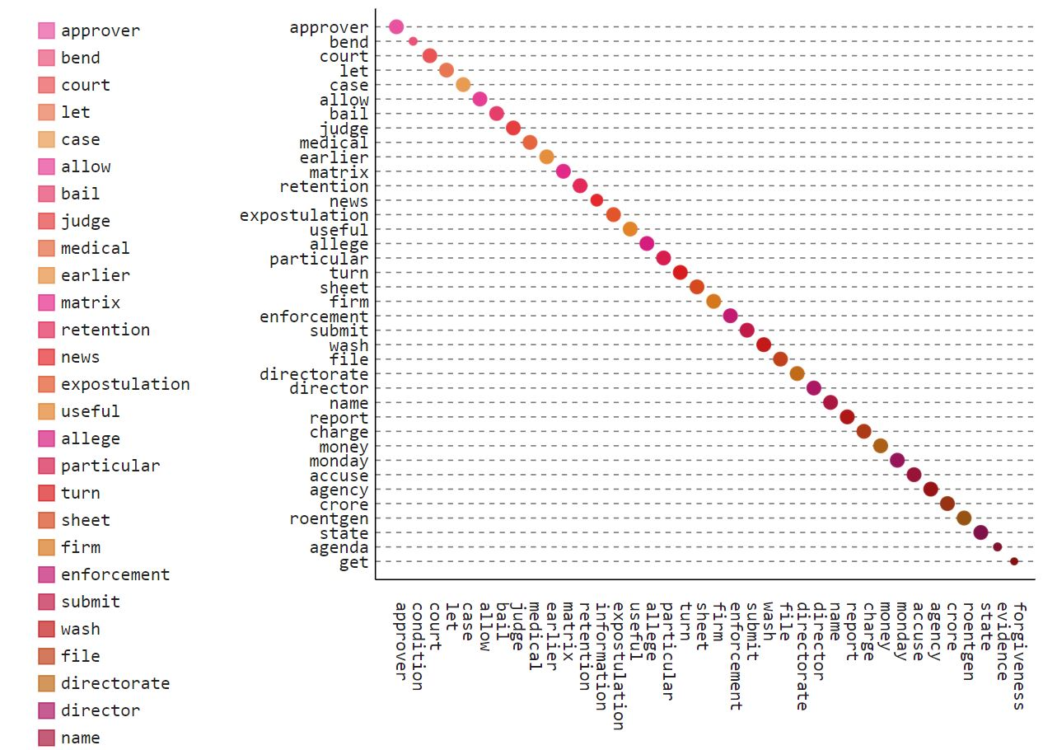

**Comparison of titles of DD and NDTV**

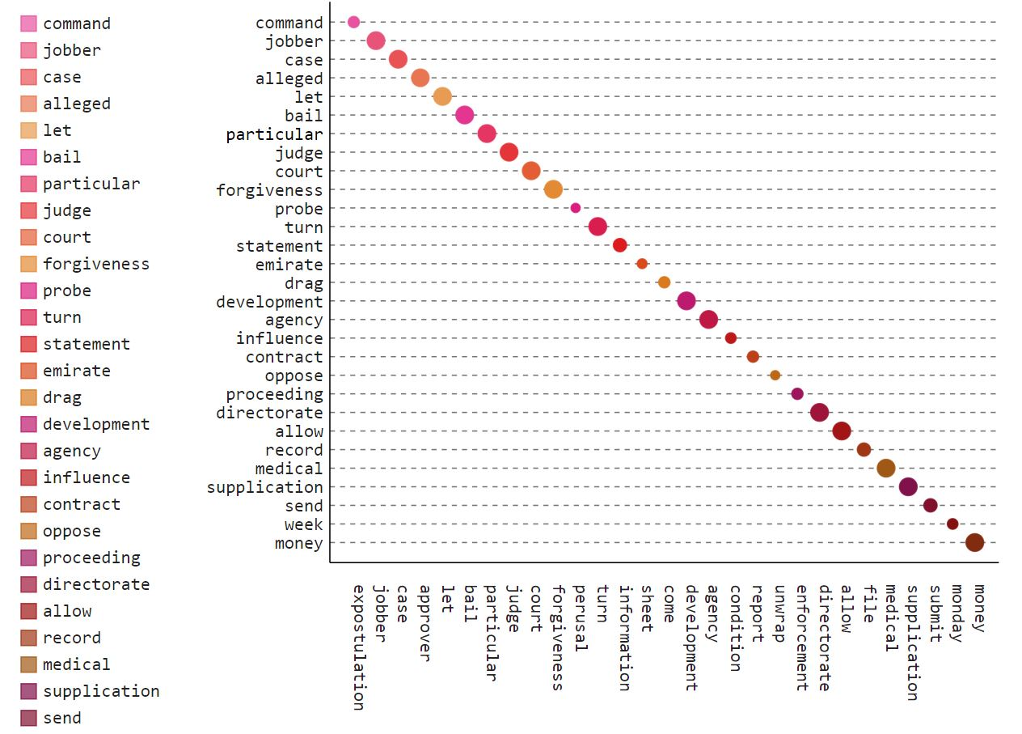

**Comparison of titles of DD and Times**