**Sepideh Hadadi**

**Homework 1, Course DSP, section 2**

**Problem 1:**

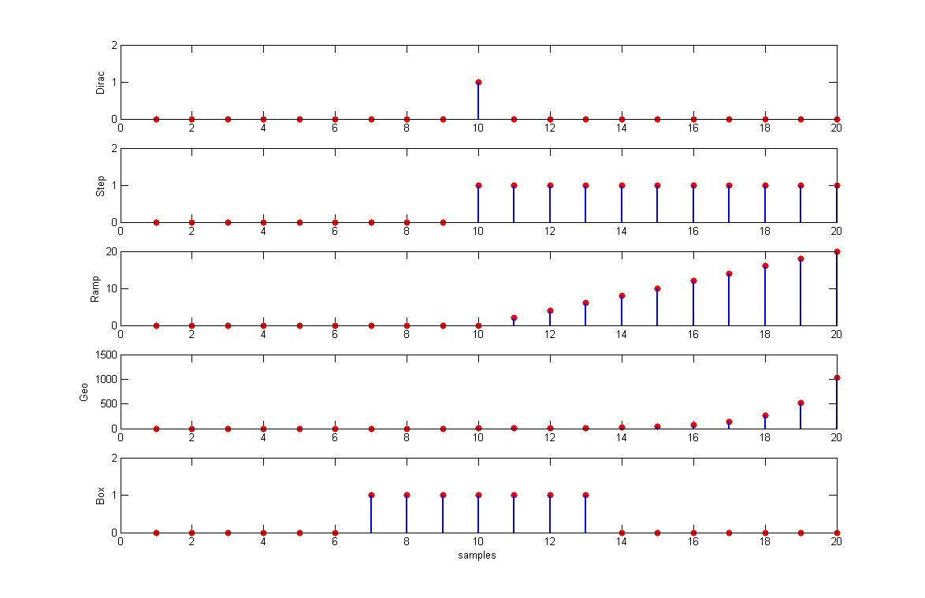

Fig.1 different function plot for the requested set points

Dirac, Step, Ramp, Geo, and finally box function were developed in the MATLAB with different setting. The MATLAB M-file will be sent for further review and advising in the attachment of the report. Besides, each function was plotted for a short period of 20 samples and with the requested setting.

The MATLAB function files named exactly as given in the problems. Meaning, for instance, a Dirac function requested to be developed. An M-file with the same name exists among the m-files attached. If you open the file you can see the function inside. If the wrong value is putted in the function an error message will be generated to guide the user to select correct value. Besides, a default values were set up for each function as recommended. In case, the function is called without parameter then the default values will be used as base of the calculations.

Since, several samplings were requested for the sin function therefore the result were plotted separately to reveal the sampling effects. For instance, as seen when the sampling frequency is very close to the fundamental frequency of the signal the sampled signal is less similar to the original expected sin wave then when higher sampling frequency. This shows the effect of the Nyquist sampling low during the digitization.

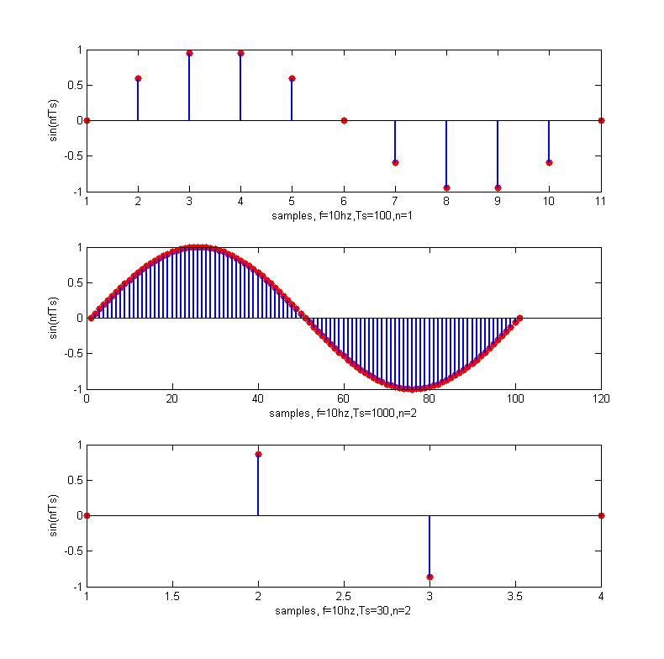

Fig.2 plotting the same sin wave with different sampling time

**Problem 2:**

Two random sequence were generated the first one by a Gaussian random process. The second one was generated by uniform law of the random process u, onetime 1000 samples and the other time 10000 samples. Besides, the theoretical distribution also was plotted simultaneously ($μ=0,σ=1$), using below equations.

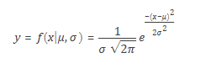

Studying the autocorrelation shows this factor remains almost unchanged with little variation. However, the energy of noise will change for that reason it cannot be a white noise.

