1. Why I am prefect for your project.

* I have enough experience in integrating APIs into website.
* I researched eSIM GO APIs for 2 days and understood all.
* I have already started developing 4 days ago and nobody knows about this project than me.

1. Project Structure
   1. Dashboard

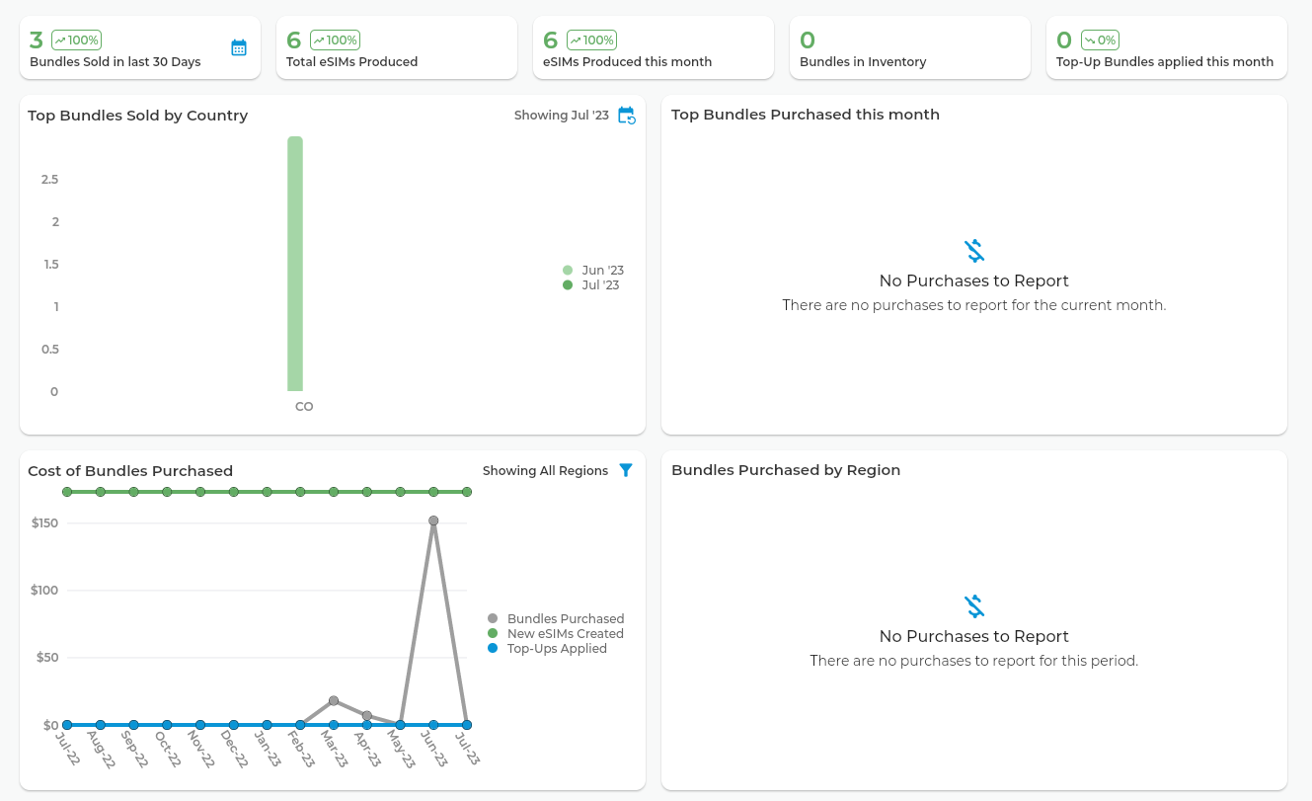

* Company account

Once login as Company account, you can see total statistic data of company.

Bundles sold in last month/this month

Total eSIMs Produced

eSIMs Produced this month

Bundles in Inventory

Top-up Bundles applied

Top Bundles Sold by Country

Top Bundles Purchased this month

Cost of Bundles Purchased

Bundles Purchased by Region

* Reseller/Distributor account

Once login as Reseller/Distributor account, you can see only the statistic data of you.

Bundles you sold in last month/this month

Total eSIMs Produced by you

eSIMs Produced this month by you

Bundles in your Inventory

Top-up Bundles applied

Top your Bundles Sold by Country

Top your Bundles Purchased this month

Cost of Bundles you Purchased

Your Bundles Purchased by Region

* User account

Once login as user account, you can see only the statistic data of you.

Bundles you bought in last month/this month

Total eSIMs Produced by you

eSIMs Produced this month by you

Bundles in your Inventory

Top-up Bundles applied

Top Bundles you bought by Country

Top Bundles you purchased this month

Cost of Bundles you Purchased

Your Bundles Purchased by Region

* 1. View eSIMs

Once you login as certain account level, you can only see your eSIM info.

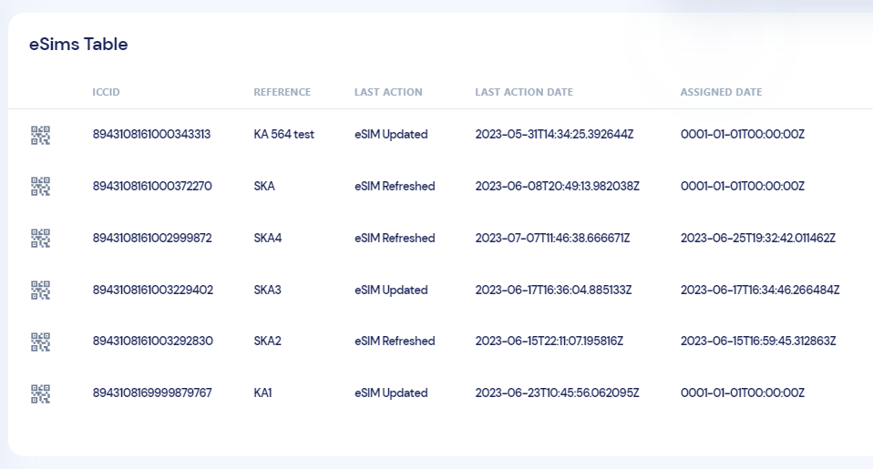

Field: ICCID, Reference, Last Action, Last Action Date, Assigned Date, Actions

* 1. View Charges

Once you login as certain account level, you can only see your charge history.

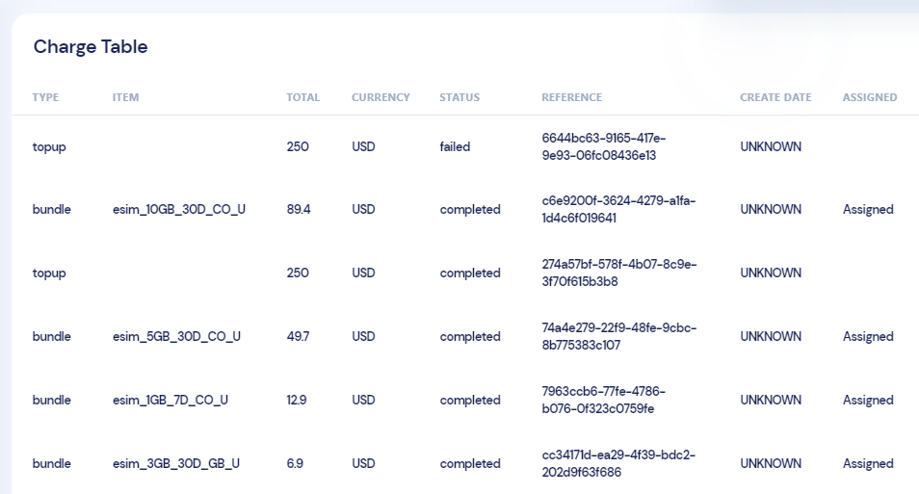

Field: Reference, Type, Total, Bundle counts, Status, Charge Date, Actions

* 1. Payment and Billing

This functionality is the same as supplier’s functionality.

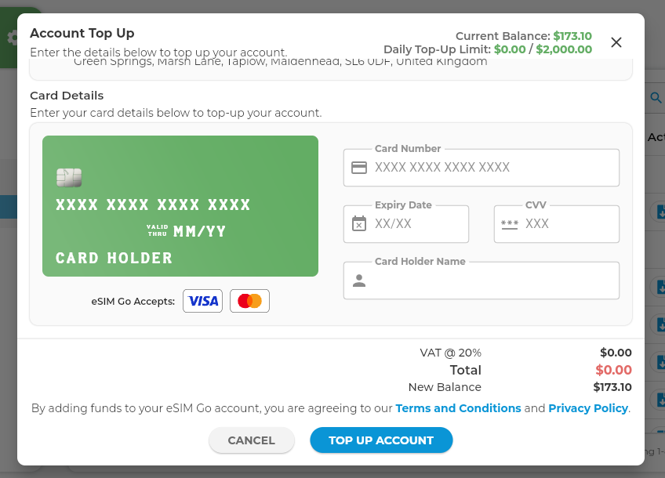

* 1. eSIM plans purchased and optional

Sorry, I didn’t understand what you mean exactly.

I wish you explain about eSIM plans in more detail.

Obviously where can I find eSIM plans in suppler’s website?

* 1. User management

Sign up / sign in , logout

UI portal and functionalities according to user account level

1. Milestone

3.1 Summary

As a full stack developer, only to fork the supplier’s eSIMGO website, I need more than 2K USD. And in this project I have to fork and custom functionalities such as user management and statistic data. So more budget is needed.

But I planed this project in direction of reducing project budget but implemented most of functionalities.

In the forward, I can also add extra functionalities you want to have.

3.2 Milestone

- plan

Plan is most important in all thing.

You can add sth you want in my plan.

Timeline: July 7(4 days)

Budget: 200GBP

- dashboard, View eSim, View charge

Timeline: July 9(2 days)

Budget: 200GBP

* Payment and billing

Timeline: July 11(2 days)

Budget: 200GBP

* eSim plan purchased and optional

This will be determined after discussion.

[Timeline: July 11(2 days)]

[Budget: 200GBP]

* user management, setting and test

Timeline: July 15(2 days)

Budget: 200GBP

1. Contact Info

Gmail: [bg.newstar121@gmail.com](mailto:bg.newstar121@gmail.com)

TG: newstar121

Skype: live:.cid.56cdbf1245dd3cad

Discord: <https://discord.gg/SvWNm8wc>