SPN线性攻击

姓名：张刘明 学号：2110049

# 实验要求：

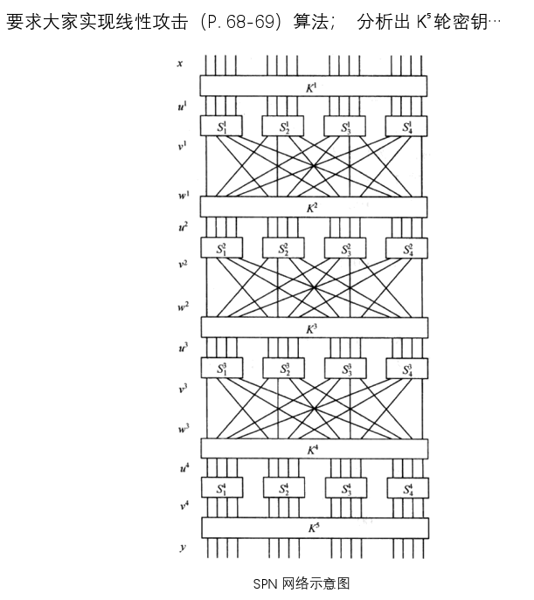

# 实验过程：

### 相关概念：

#### SPN线性密码分析：

是一种基于S盒逼近的分析方法，需要已知明文以及较多的明密文对，SPN先行密码分析算法只能分析最后一轮子密钥，缩小了密钥穷举范围，但是当使用该方法分析出最后一轮密钥时，由于密钥生成算法固定，为分析第一轮密钥提供了可能。

#### 堆积引理：

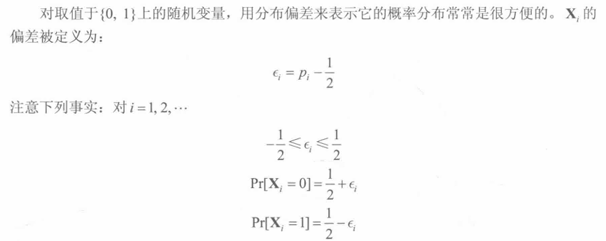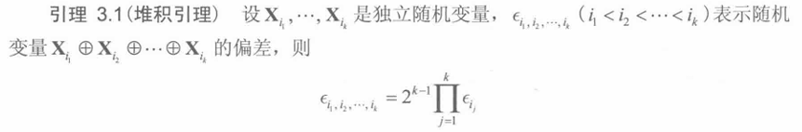

#### S盒的线性逼近

如果

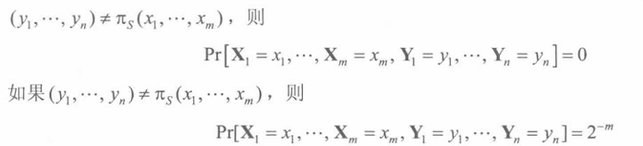

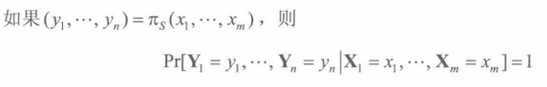

#### 线性分析原理：

#### 线性分析过程：

SPN的线性分析过程需要首先找出一组S盒的线性逼近，用于导出一整个SPN的线性逼近

本次实验中的逼近包括如下的四个活动S盒：

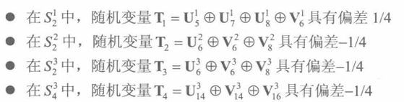

因此，我们可以得出线性分析的过程如下：

1. 收集大量明密文对；
2. 选择一个固定的输入位，以便构建S盒线性逼近；



1. 构建线性逼近表：通过收集的明密文对，根据上面构造的in(x,y)构建线性逼近表，记录输入位和输出位之间的线性关系；
2. 构建线性逼近链：根据输入，选取线性逼近表中偏差最大的作为输出，找到对应位置进行输入；再根据线性逼近表找到输出；以此类推，构建出线性逼近链（偏差越大，越具有线性关系）；
3. 化简关系式：根据该线性逼近链，通过将中间过程中的输入输出相异或来化简过程，最终化简为只剩下输入和最后一轮输入异或的关系式test()
4. 遍历密钥和明文密文对：遍历所有可能的密钥，遍历所有收集到的明密文对，通过y和当前测试的密钥计算出最后一轮输入，将该值带入关系式test()中，若该关系式为0，则该密钥对应count值应该加一；
5. 输出最可能的密钥：遍历结束后输出count值最大的密钥

#### SPN线性分析伪代码：

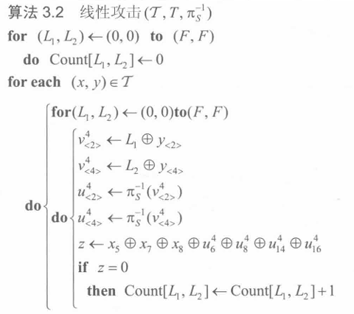 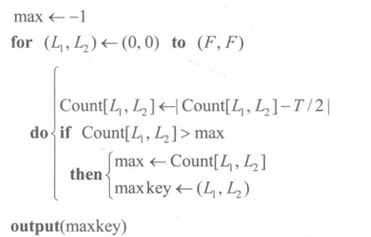

#### 代码：

#include<stdio.h>

#include<iostream>

unsigned short sbox[16] = { 0xe,0x4,0xd,0x1,0x2,0xf,0xb,0x8,0x3,0xa,0x6,0xc,0x5,0x9,0x0,0x7 };//s盒

unsigned short pbox[16] = { 1,5,9,13,2,6,10,14,3,7,11,15,4,8,12,16 };//p盒

unsigned short vsbox[16] = { 0xe,0x3,0x4,0x8,0x1,0xc,0xa,0xf,0x7,0xd,0x9,0x6,0xb,0x2,0x0,0x5 };//s盒逆盒

unsigned short vpbox[16] = { 1,5,9,13,2,6,10,14,3,7,11,15,4,8,12,16 };//p盒逆置换

int read();//快速读入

void spn(unsigned int key, unsigned short x);

void roundkeys(int i, unsigned short& k, unsigned int key);//获取轮密钥

void sreplace(unsigned short u, unsigned short& v);//s盒代换

void preplace(unsigned short v, unsigned short& w);//p盒置换

void vsreplace(unsigned short v, unsigned short& u);//s盒逆代换

void vpreplace(unsigned short w, unsigned short& v);//p盒逆置换

int main()

{

int i, n;

unsigned int key;

unsigned short x;

std::cin >> n;

getchar();

for (i = 0; i < n; i++) {

key = read();

x = read();

spn(key, x);

}

}

int read() {//快速读入

char ch;

int i = 0;

int x = 0;

ch = getchar();

while (ch != ' ' && ch != '\n')

{

x *= 16;

if (ch >= '0' && ch <= '9') x += ch - '0';

else x += ch - 'a' + 10;

ch = getchar();

}

return x;

}

void spn(unsigned int key, unsigned short x)

{

unsigned short w = x;

unsigned short k, u, v;

unsigned short y;

int n = 4;

int i;

for (i = 1; i <= n - 1; i++) {//三轮加密

roundkeys(i, k, key);

u = k ^ w;

sreplace(u, v);

preplace(v, w);

}

roundkeys(n, k, key);

u = k ^ w;

sreplace(u, v);

roundkeys(n + 1, k, key);

y = v ^ k;

printf("%04x ", y);

y ^= 0x1;

v = y ^ k;

vsreplace(v, u);

roundkeys(n, k, key);

w = u ^ k;

for (i = n - 1; i >= 1; i--)//三轮解密

{

vpreplace(w, v);

vsreplace(v, u);

roundkeys(i, k, key);

w = u ^ k;

}

x = w;

printf("%04x\n", x);

}

void roundkeys(int i, unsigned short& k, unsigned int key)//获取轮密钥

{

unsigned int temp = 0xffff0000;

i -= 1;

temp = temp >> (4 * i);

k = (key & temp) >> (4 - i) * 4;

}

void sreplace(unsigned short u, unsigned short& v)//s盒代换

{

unsigned short temp[] = { 0xf000,0x0f00,0x00f0,0x000f };

unsigned short j, t = 0x0000;

int i;

for (i = 0; i < 4; i++) {

j = (u & temp[i]) >> (4 * (3 - i));

t |= (sbox[j] << (4 * (3 - i)));

}

v = t;

}

void preplace(unsigned short v, unsigned short& w)//p盒置换

{

unsigned int temp = 0x10000;

unsigned short t, j = 0x0000;

int i;

for (i = 0; i < 16; i++) {

temp = temp >> 1;

t = (v & temp) >> (15 - i);

j |= (t << (16 - pbox[i]));

}

w = j;

}

void vsreplace(unsigned short v, unsigned short& u)//s盒逆代换

{

unsigned short temp[] = { 0xf000,0x0f00,0x00f0,0x000f };

unsigned short j, t = 0x0000;

int i;

for (i = 0; i < 4; i++) {

j = (v & temp[i]) >> (4 * (3 - i));

t |= (vsbox[j] << (4 * (3 - i)));

}

u = t;

}

void vpreplace(unsigned short w, unsigned short& v)//p盒逆置换

{

unsigned int temp = 0x10000;

unsigned short t, j = 0x0000;

int i;

for (i = 0; i < 16; i++) {

temp = temp >> 1;

t = (w & temp) >> (15 - i);

j |= (t << (16 - vpbox[i]));

}

v = j;

}

Github仓库地址：https://github.com/newstarming/Crypto.git