Statistics_of_BloodPressure.R

busra

2019-05-22

#Büşra_GÖKMEN_  
HW1_Data_v1 = read.csv("Downloads/HW1_Data_v1.csv")  
manSYSBP = HW1_Data_v1[HW1_Data_v1$GENDER == 0, "SYSBP"]  
womenSYSBP = HW1_Data_v1[HW1_Data_v1$GENDER == 1, "SYSBP"]  
manDIASBP = HW1_Data_v1[HW1_Data_v1$GENDER == 0, "DIASBP"]  
womenDIASBP = HW1_Data_v1[HW1_Data_v1$GENDER == 1, "DIASBP"]  
#a  
manMean1 = mean(manSYSBP)  
womenMean1 = mean(womenSYSBP)  
manMean2 = mean(manDIASBP)  
womenMean2 = mean(womenDIASBP)  
#b  
mansvar1 = var(manSYSBP)  
mansvar2 = var(manDIASBP)  
womenvar1 = var(womenSYSBP)  
womenvar2 = var(womenDIASBP)  
#c  
mansd1 = sd(manSYSBP)  
mansd2 = sd(manDIASBP)  
womensd1 = sd(womenSYSBP)  
womensd2 = sd(womenDIASBP)  
#d  
manq1=quantile(manSYSBP,0.25)  
manq2=quantile(manSYSBP,0.75)  
manq3=quantile(manDIASBP,0.25)  
manq4=quantile(manDIASBP,0.75)  
  
womenq1=quantile(womenSYSBP,0.25)  
womenq2=quantile(womenSYSBP,0.75)  
womenq3=quantile(womenDIASBP,0.25)  
womenq4=quantile(womenDIASBP,0.75)  
#e  
menmin1 = min(womenSYSBP)  
menmax1 = max(womenSYSBP)  
menmin2 = min(womenDIASBP)  
menmax2 = max(womenDIASBP)  
  
womenmin1 = min(womenSYSBP)  
womenmax1 = max(womenSYSBP)  
womenmin2 = min(womenDIASBP)  
womenmax2 = max(womenDIASBP)  
#f  
menran1 = range(manSYSBP)  
menran2 = range(manDIASBP)  
  
womenran1 = range(womenSYSBP)  
womenran2 = range(womenDIASBP)  
#g  
menrate1 = menran1/mansd1   
menrate2 = menran2/mansd2   
  
womenrate1 = womenran1/womensd1  
womenrate2 = womenran2/womensd2  
#h  
menmed1 = median(manSYSBP)  
menmed2 = median(manDIASBP)  
  
womenmed1 = median(womenSYSBP)  
womenmed2 = median(womenDIASBP)  
#i  
menIQR1 = IQR(manSYSBP)  
menIQR2 = IQR(manDIASBP)  
  
womenIQR1 = IQR(womenSYSBP)  
womenIQR2 = IQR(womenDIASBP)  
#j  
mensummary1 = fivenum(manSYSBP)  
mensummary2 = fivenum(manDIASBP)  
  
womensummary1 = fivenum(womenSYSBP)  
womensummary2 = fivenum(womenDIASBP)  
#k  
boxplot(HW1_Data_v1$SYSBP ~ HW1_Data_v1$GENDER)

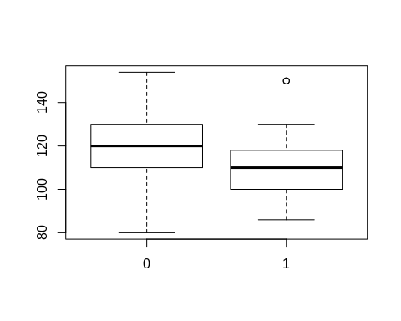

boxplot(HW1_Data_v1$DIASBP ~ HW1_Data_v1$GENDER)

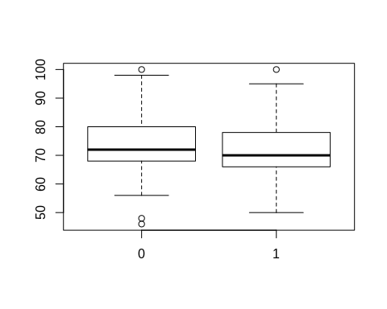

#l  
stem(HW1_Data_v1$SYSBP[HW1_Data_v1$GENDER==0])

##   
## The decimal point is 1 digit(s) to the right of the |  
##   
## 8 | 0  
## 9 | 066  
## 10 | 000456666888  
## 11 | 0000000000002222224566668888888  
## 12 | 000000000000001222444448  
## 13 | 000000002244666  
## 14 | 000000002445  
## 15 | 04

stem(HW1_Data_v1$DIASBP[HW1_Data_v1$GENDER==0])

##   
## The decimal point is 1 digit(s) to the right of the |  
##   
## 4 | 68  
## 5 | 668  
## 6 | 000000224444445566688  
## 7 | 000000000000000000000022222224444466688888888  
## 8 | 00000000004444666666  
## 9 | 00004458  
## 10 | 0

stem(HW1_Data_v1$SYSBP[HW1_Data_v1$GENDER==1])

##   
## The decimal point is 1 digit(s) to the right of the |  
##   
## 8 | 688  
## 9 | 000055888  
## 10 | 000000000000000000024444444568888  
## 11 | 00000000000000002222444445566888  
## 12 | 00000000002246668  
## 13 | 0000  
## 14 |   
## 15 | 00

stem(HW1_Data_v1$DIASBP[HW1_Data_v1$GENDER==1])

##   
## The decimal point is 1 digit(s) to the right of the |  
##   
## 5 | 00588  
## 6 | 0000000000000444444668888  
## 7 | 000000000000000000000000000000000224444666668888  
## 8 | 00000000002226888  
## 9 | 0025  
## 10 | 0

#m  
hist(HW1_Data_v1$SYSBP[HW1_Data_v1$GENDER==0])

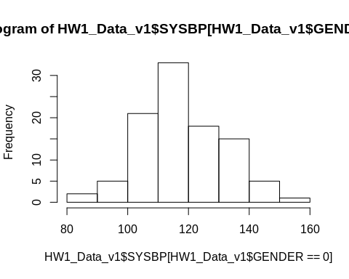

hist(HW1_Data_v1$DIASBP[HW1_Data_v1$GENDER==0])

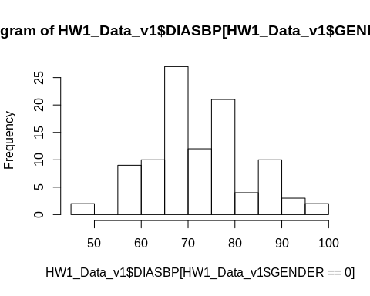

hist(HW1_Data_v1$SYSBP[HW1_Data_v1$GENDER==1])

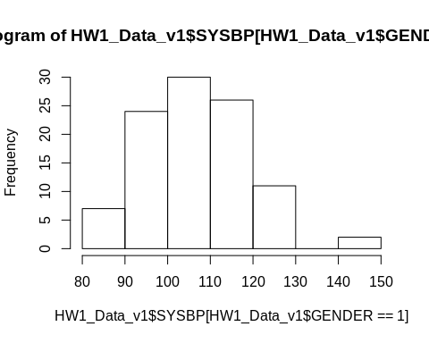

hist(HW1_Data_v1$DIASBP[HW1_Data_v1$GENDER==1])

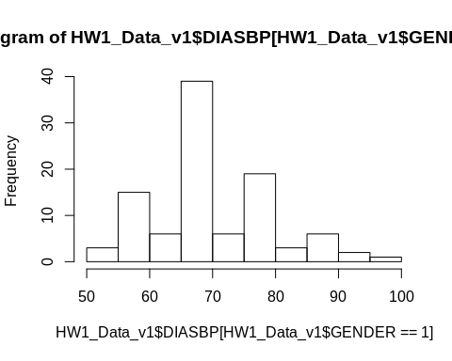

#n  
dotchart(HW1_Data_v1$SYSBP[HW1_Data_v1$GENDER==0])

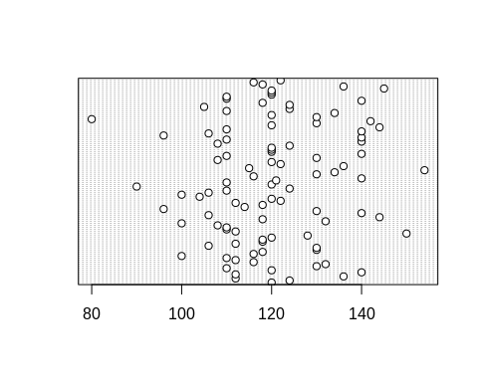

dotchart(HW1_Data_v1$DIASBP[HW1_Data_v1$GENDER==0])

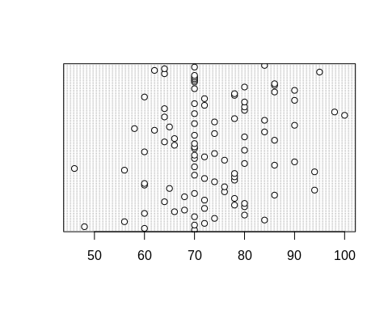

dotchart(HW1_Data_v1$SYSBP[HW1_Data_v1$GENDER==1])

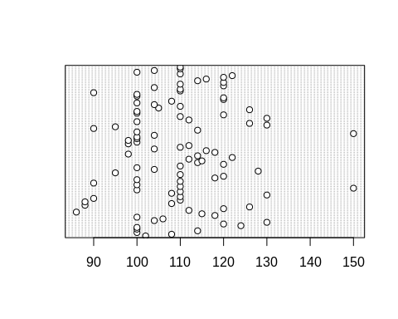

dotchart(HW1_Data_v1$DIASBP[HW1_Data_v1$GENDER==1])

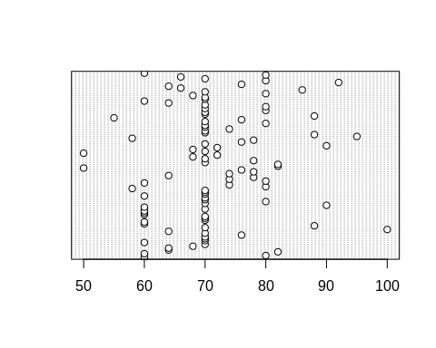

#q  
plot(HW1_Data_v1$SYSBP[HW1_Data_v1$GENDER==0],HW1_Data_v1$DIASBP[HW1_Data_v1$GENDER==0])

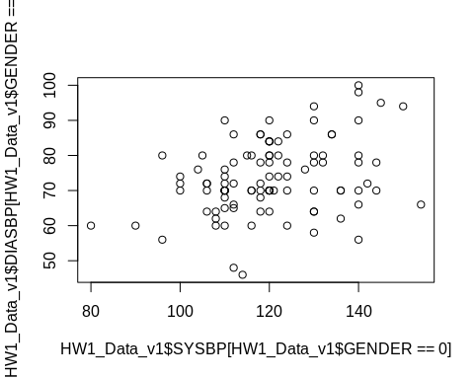

plot(HW1_Data_v1$SYSBP[HW1_Data_v1$GENDER==1],HW1_Data_v1$DIASBP[HW1_Data_v1$GENDER==1])  
  
#r  
library(HistogramTools)

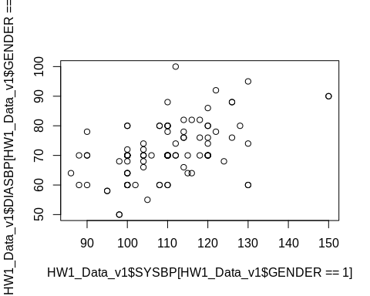

PlotRelativeFrequency(hist(HW1_Data_v1$SYSBP[HW1_Data_v1$GENDER==0],plot = F))

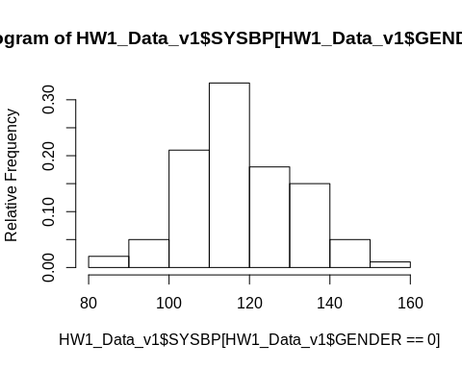

PlotRelativeFrequency(hist(HW1_Data_v1$DIASBP[HW1_Data_v1$GENDER==0],plot = F))

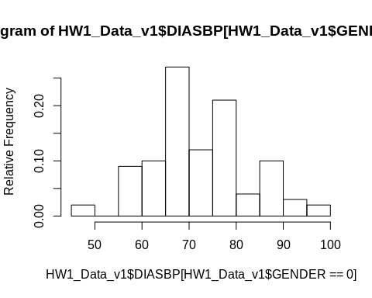

PlotRelativeFrequency(hist(HW1_Data_v1$SYSBP[HW1_Data_v1$GENDER==1],plot = F))

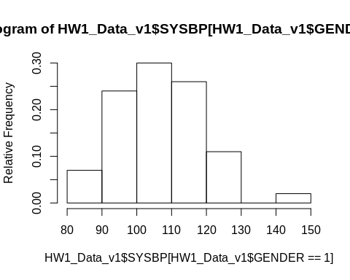

PlotRelativeFrequency(hist(HW1_Data_v1$DIASBP[HW1_Data_v1$GENDER==1],plot = F))

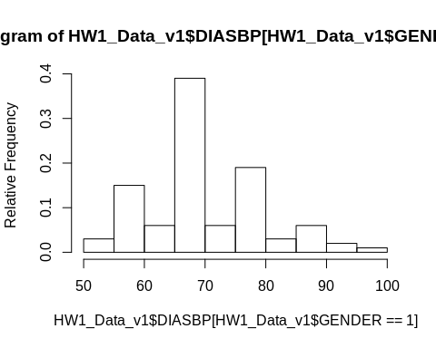

#s  
zscoremenlargestSYSBP = (menmin1-manMean1)/mansd1  
zscoremenlargestDIASBP = (menmin2-manMean2)/mansd2  
zscoremensmallestSYSBP = manMean1  
zscoremensmallestDIASBP = manMean2  
  
zscorewomenlargestSYSBP = (womenmin1-womenMean1)/womensd1  
zscorewomenlargestDIASBP = (womenmin2-womenMean2)/womensd2  
zscorewomensmallestSYSBP = womenMean1  
zscorewomensmallestDIASBP = womenMean2