Hungary Ceases Gas Aid Amid Ukraine War
By: Rodrigo Tello

The ongoing conflict between Russia and Ukraine has taken a new turn as Viktor Orbán, Hungary’s prime minister, announced that the country will no longer supply gas to support Ukraine. The decision, revealed in March 2026, raises concerns across Europe as energy remains a critical factor in the war. This shift matters because it could affect both Ukraine’s resilience and regional stability.

Hungary’s decision reflects ongoing tensions within the European Union regarding how to handle the war. While many EU countries continue supporting Ukraine, Hungary has often taken a more cautious stance due to its reliance on Russian energy. This move may weaken unity among European nations at a crucial moment.
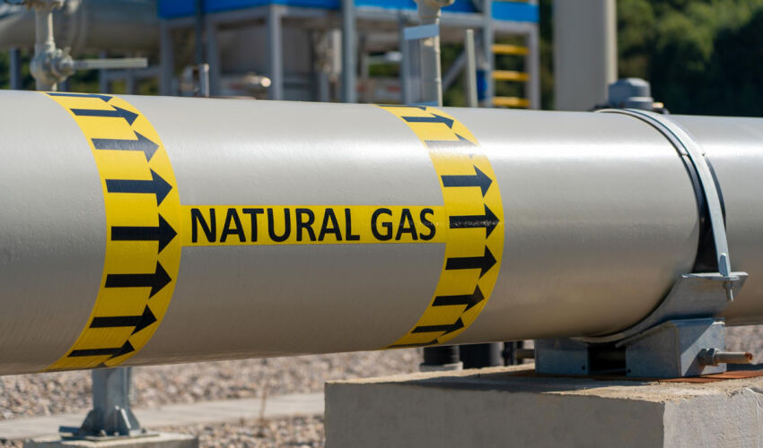
According to political analysts, the reduction in gas support could increase pressure on Ukraine's infrastructure and economy. Analyst Rizzi warns that continuous Russian attacks on Ukraine's energy infrastructure have already eliminated roughly 55% of the country's domestic gas production, forcing Kyiv to draw from strategic storage and seek new imports, a situation that Hungary's withdrawal only worsens. As noted in Foreign Affairs, the use of energy as a weapon in this conflict is back "with a vengeance," with both sides seeing it as a strategic lever capable of influencing outcomes well beyond the battlefield. This highlights how decisions outside direct military action still play a major role in the war.

Furthermore, the announcement may strengthen Russia’s position, as energy exports remain one of its key economic tools. Since the beginning of the Russian invasion of Ukraine, control over energy resources has been central to geopolitical strategies. Hungary’s decision could therefore shift the balance of influence in subtle but significant ways.

In conclusion, Hungary’s halt in gas support signals a potential change in European involvement in the war. As the conflict continues, decisions like this demonstrate how economic and political actions can shape the future of the region. The coming months will likely reveal whether this move leads to broader changes within Europe’s response to the war.

Bibliography:

“Russia Analytical Report, Nov. 17–24, 2025 | Russia Matters.” Russiamatters.org, 2025, www.russiamatters.org/news/russia-analytical-report/russia-analytical-report-nov-17-24-2025. Accessed 28 Mar. 2026.

‌
‌

