Indonesia Moves to Ban Social Media for Under-16s
By: Rodrigo Tello

Indonesia is planning to ban social media access for users under the age of 16 in an effort to protect young people online. The policy, announced in 2026 by the Indonesian government, would require platforms to verify users' ages before allowing them to create accounts. Officials argue that the measure is necessary to reduce younger individuals' exposure to harmful content, cyberbullying, and online addiction. If implemented, it could affect millions of teenagers and spark a global debate about youth safety on the internet.
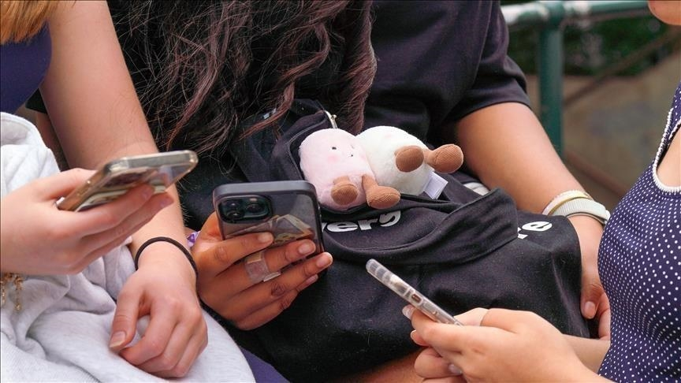
One of the main reasons for the proposed ban is the growing concern over the mental health effects of social media on children. According to Indonesian officials, platforms such as Instagram, TikTok, and YouTube expose children to harmful material, unrealistic expectations, and excessive screen time. By limiting access until the age of 16, the government hopes to create a safer digital environment within its population. This policy aims to reduce risks such as cyberbullying and online exploitation among minors.

However, the proposal has also raised concerns about freedom and practicality. Critics argue that teenagers often rely on social media for communication, learning, and creative expression. Researchers Oonagh Wesley-Smith and Terry Fleming highlight the importance of considering young people’s perspectives when creating regulations. As they explain, “Policies must balance safeguarding with respect for youth rights and perspectives. Their lived experience is vital to crafting responses that are effective and legitimate.”

Despite the debate, Indonesia is not the only country exploring stricter online rules for minors. Governments around the world are increasingly discussing ways to regulate social media use among children and teenagers. These discussions reflect a broader concern about how technology shapes young people’s development and well-being. The Indonesian proposal could therefore influence future policies in other countries.

Indonesia’s plan to ban social media for users under 16 highlights the growing challenge of balancing digital freedom with safety online for the youth population. While the policy aims to protect young people, it also raises important questions about enforcement and personal rights. As governments continue to address the current risks of the digital age, the debate over how and when young people should access social media is likely to continue.

Bibliography:

- Welsey‐Smith, Oonagh, and Terry Fleming. “Debate: Social Media in Children and Young People – Time for a Ban? From Polarised Debate to Precautionary Action – a Population Mental Health Perspective on Social Media and Youth Well‐Being.” Child and Adolescent Mental Health, vol. 30, no. 4, Wiley, Sept. 2025, pp. 416–18, https://doi.org/10.1111/camh.70033. Accessed 14 Mar. 2026.
‌

