Oil in Crisis: How Global Conflicts Are Driving Prices and Economic Instability
By: Isabella Plascencia
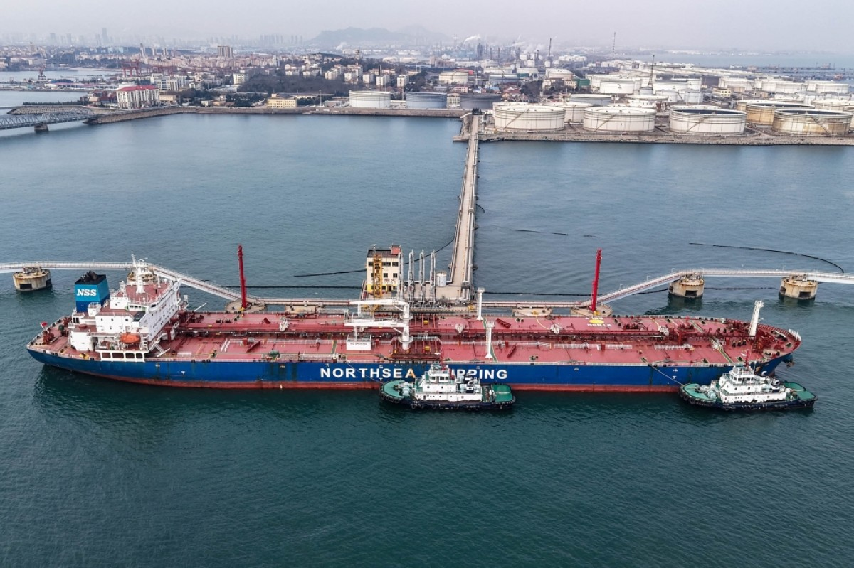
Currently, oil is one of the most valuable resources worldwide, thanks to its high energy density, ease of transportation, and versatility as a raw material, which improves and powers the majority of the world's transportation. Question yourself, what does your car need to work? How do you travel to another country? All these methods of transportation require oil to work. Recently, oil has increased its price due to geopolitical tensions and economic instability, causing an effect on the world.
Conflicts in oil producer regions have made markets fear supply disruptions. This means current tensions, such as the conflict involving Iran, Israel, and the United States, have created a moderate effect. Having on account that the Middle East is one of the largest oil-producing regions in the world, any military conflict there affects oil production. For example, the Strait of Hormuz is a critical location; it is the world's most important maritime “chokepoint”, with over 20% of global oil and liquefied natural gas consumption flowing through it daily. It connects Persian Gulf producers such as Saudi Arabia, Iran, the United Arab Emirates, Kuwait, and Iraq to international markets, particularly Asia.
As the conflict escalates, this route becomes unsafe for tankers. The problem here is that there are very few alternatives for bypassing this route. Because of this risk, traders in energy markets react quickly by increasing oil prices. Some consequences we will see would be a stagflationary shock, a rare and severe economic event combining high inflation, slowing growth, and rising unemployment, as well as a significant increase in global inflation, slowing economic growth, and higher production and logistics costs.
Beyond immediate economic effects, rising oil prices also impact everyday life for people around the world. Transportation costs increase, making goods more expensive since they rely on fuel for shipping and distribution. This can lead to higher prices for food, clothing, and basic necessities, affecting especially low- and middle-income households. Additionally, governments may struggle to maintain economic stability, as they face pressure to subsidize fuel or control inflation. In the long term, these challenges highlight the urgent need for alternative energy sources and more sustainable solutions, reducing global dependence on oil and making economies more resilient to geopolitical conflicts.

