When Being An Afghan Girl Means Losing Your Education
By: Emilia Samalvides
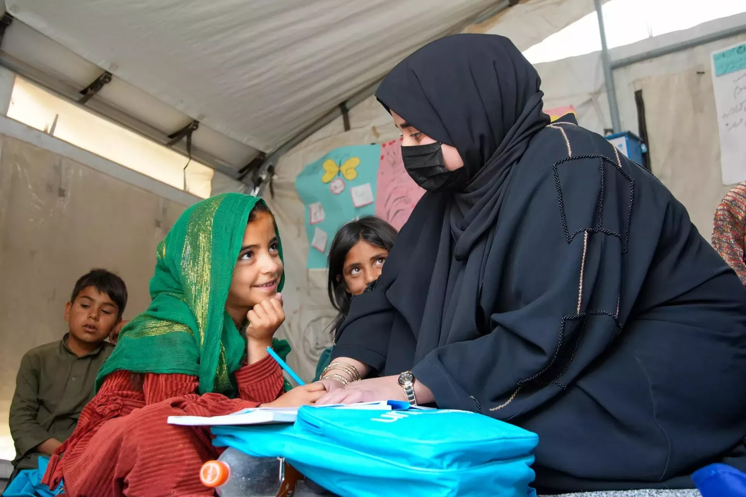
Imagine waking up one day and being told that you can never return to school simply because you are a girl. For millions of girls in Afghanistan, this is not imagination—it is reality. Since the Taliban returned to power in 2021, Afghan women and girls have been losing more and more rights each year. Yet, while the world looks away, the crisis continues to grow, and people keep suffering in silence.
Women in Afghanistan have lost most, if not nearly all, of their rights in recent years. Since the Taliban regained control, many restrictions have been placed on women’s lives, including limits on work, movement, and public participation. In many ways, respect for women has become almost absent from daily life. Some people are beginning to forget that women are human beings just like everyone else; the only difference is their gender. One of the most devastating consequences has been the loss of access to education, a right that Afghan women once valued deeply but that was suddenly taken away almost overnight.
Education is one of the most powerful tools for personal and national development. It is like a door: once opened, it reveals a world full of opportunities, challenges, and lessons that last a lifetime. However, girls in Afghanistan are no longer allowed to attend school beyond sixth grade. According to UNICEF, “education is a fundamental right for every child and essential for the future of any society.” More than one million Afghan girls have been denied secondary education since 2021. This restriction not only limits the future of millions of girls but also weakens the country’s ability to grow and remain stable.
Access to education is not just a privilege; it is a fundamental human right. When girls are allowed to learn, they gain opportunities to become what they have dreamed of all their lives: doctors, teachers, scientists, and leaders who can contribute to society and make a difference in this world full of injustice. Without access to education, millions of Afghan girls face a future with fewer opportunities and greater inequality. While the global conversation about Afghanistan may be fading, the harsh reality for these girls remains unchanged.
The doors of many classrooms in Afghanistan remain closed to girls, but the importance of education has not disappeared, it has only been forgotten. Around the world, organizations and individuals continue to advocate for the rights of Afghan women and girls. As the world moves on to other headlines, it is important not to forget those who are still waiting for the chance to learn.
Bibliography:

Amnesty International. Afghanistan: The Taliban’s War on Women. Amnesty International, https://www.amnesty.org.
Human Rights Watch. Afghanistan: Girls’ Education. Human Rights Watch, https://www.hrw.org.
Malala Fund. Girls’ Education in Afghanistan. Malala Fund, https://malala.org.
UNICEF. Girls’ Education in Afghanistan. UNICEF, https://www.unicef.org/afghanistan/education.
UN Women. Women’s Rights in Afghanistan. UN Women, https://www.unwomen.org.

