**DMAP Utility**

**Newt Global Consulting**

1300 W Walnut Hill Ln | Suite # 230 | Irving TX 75038

Phone: +1 972 887 3159 | Fax: +1 214 260 6051

Table of Contents

Introduction 3

Steps to run 3

Utility 2 4

Utility 2 5

Utility 3 5

Utility 4 7

# Introduction

This Utility helps you assess the potential impact of data type changes on your codebase.

# Steps to run

Step 1: From DMAP Dashboard, Navigate to DMAP Utilities tab and download the utility based on your preferred OS.

For Windows: Utility.zip will be downloaded. Unzip the file and run Utility.exe

For Linux: Utility.tar.gz will be downloaded. Untar the file using below command and execute the exe using ./Utility.exe:

* tar -xzvf Utility.tar.gz

Step 2: It will prompt for input

Step 3: Select the Utility you need to run which further prompts for the inputs as below

# Utility 1

**Input 1:** Connection Details excel will the input

Provide the connection details excel path as below to run the utility. Once Utility runs you will get the output in Output folder

# Utility 2

**Input 1:** Place all Table Validation files in one folder as show below

Provide the above folder path as input to Utility 2 which runs and generates the output in Reports folder.

# Utility 3

**Input 1:** Provide application assessment report

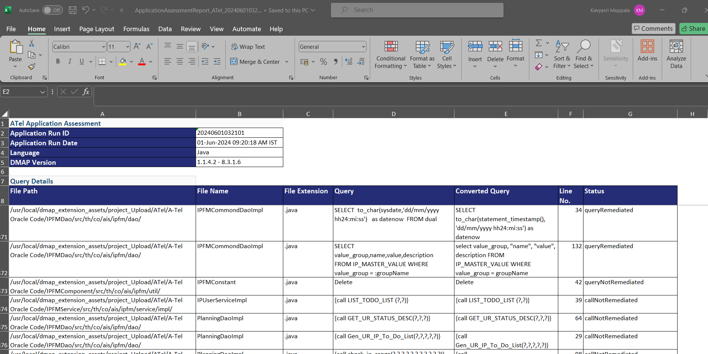

**Input 2:** Provide Java code comparison output file (i.e., output of Utility 2)

Provide the above two files as input to Utility 3 which runs and generates the output in Output folder.

# Utility 4

**Input 1:** Provide application assessment report

**Input 2:** Provide Source Target Parameters Comparison output file (i.e., output of Utility 1)

Provide the above two files as input to Utility 4 which runs and generates the output in Output folder.

# Utility 5

**Input 1:** Provide excel with list of SQL to remediate

**Input 2:** Enter Host IP address where DMAP DB container is running

**Input 3:** Enter Host Port where DMAP DB container is running

Provide the above three inputs to Utility 5 which runs and generates the output in Output folder

# Utility 6

**Input 1:** Provide application assessment report

**Input 2:** Provide Java Code Data Type Mapping excel (i.e., output of Utility 3)

Provide the above two inputs to Utility 5 which runs and generates the output in Output folder