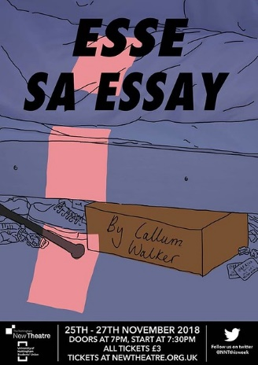



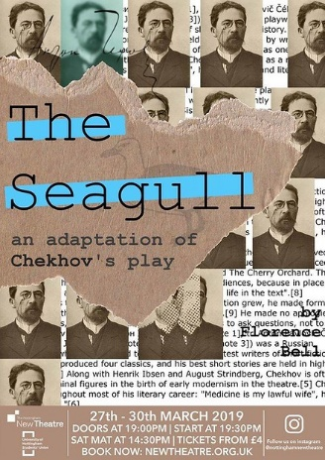

Proposals Pack

2019/20



Contents

Committee 2019/20: 3

A Note from Coordinators: 4

Season Dates: 5 – 6

The Proposals Process:

Fringe or In-House?: 7

Performance Rights: 8

Proposals Advice Meeting: 9

Proposals Forms (A How to Guide): 9 – 13

How Proposals Work: 13

Floor Plans: 14 – 15

 **Committee 2019/20**

**President:** Rohan Rakhit

[president@newtheatre.org.uk](mailto:president@newtheatre.org.uk)

**Secretary:** Boo Jackson

[secretary@newtheatre.org.uk](mailto:secretary@newtheatre.org.uk)

**Treasurer:** Jonathan Davies

[treasurer@newtheatre.org.uk](mailto:treasurer@newtheatre.org.uk)

**Theatre Manager:** Nadia Elalfi

[theatremanager@newtheatre.org.uk](mailto:theatremanager@newtheatre.org.uk)

**In-House Co-ordinator:** Ellie Roberts

[productions@newtheatre.org.uk](mailto:productions@newtheatre.org.uk)

**Fringe Co-ordinator:** Cameron Brett

[fringe@newtheatre.org.uk](mailto:fringe@newtheatre.org.uk)

**Front of House Manager:** Ellen Dennis

[boxoffice@newtheatre.org.uk](mailto:boxoffice@newtheatre.org.uk)

**Publicity Manager:** Caitie Pardoe

[publicity@newtheatre.org.uk](mailto:publicity@newtheatre.org.uk)

**Publicity Manager:** Jake Levy

[publicity@newtheatre.org.uk](mailto:publicity@newtheatre.org.uk)

**Social and Fundraising Co-ordinator:** Tara Phillips  
[social@newtheatre.org.uk](mailto:social@newtheatre.org.uk)

**External Relations Manager:** Zoe Smith

[externalrelations@newtheatre.org.uk](mailto:externalrelations@newtheatre.org.uk)

**Costume, Props and Make-up Manager:** Alice Walker

[costume@newtheatre.org.uk](mailto:costume@newtheatre.org.uk)

**Company Stage Manager:** Sophy Baxter

[csm@newtheatre.org.uk](mailto:csm@newtheatre.org.uk)

**Company Technical Manager:** Skylar Hurd

[techmanager@newtheatre.org.uk](mailto:techmanager@newtheatre.org.uk)

**Company Technical Director:** Luwa Adebanjo

[techdirector@newtheatre.org.uk](mailto:techdirector@newtheatre.org.uk)

**Company Master Carpenter:** Barney Hartwill

[workshop@newtheatre.org.uk](mailto:workshop@newtheatre.org.uk)

**Unscripted Coordinator and Engagement Officer:** Lillian Race

[participation@newtheatre.org.uk](mailto:participation@newtheatre.org.uk)

**A note from your In-House Coordinator:**

Hello! I’m Ellie and I’m your In-House Coordinator for this year.

One of my main jobs is to run the In-House proposals process. Proposals is where the committee select the upcoming season from the proposals made to us by our membership. The In-House season specifically makes use of our auditorium space and each show has a 4-day run. Part of the process is guiding people who are interested in putting something on in the In-House season, and that’s where this pack comes in. It aims to provide all of the necessary information that you will need when completing a proposals form and how the full process runs.

If you have any questions about your proposal, the In-House season or how you can get involved, please get in touch at [productions@newtheatre.org.uk](mailto:productions@newtheatre.org.uk)!

All the best!

Ellie Roberts

**A note from your Fringe Coordinator:**

Hey! I’m Cam, this year’s Fringe Coordinator.

I am here to support all teams in proposing for the Fringe seasons and throughout the proposals process. Proposing is really exciting and the information in this pack should help make it significantly clearer and hopefully easier for you, particularly regarding how to tackle the proposals form.

There are a few changes to Fringe this year so if you have any questions about these sections, the process or anything to do with the season at all please don’t hesitate to contact me at [fringe@newtheatre.org.uk](mailto:fringe@newtheatre.org.uk). Proposing can be confusing and daunting so no question is a silly one; my role is to help facilitate getting your ideas onto the stage.

Good luck and get Fringey!

Cameron Brett

**IN-HOUSE SEASON 2019/20 – IMPORTANT DATES**

**Proposal Dates:**

Autumn:

Forms Deadline – 02/10/19

Proposals – 05/10/19

Spring:

Forms Deadline – 29/01/20

Proposals – 01/02/20

**Launches and Auditions:**

Autumn:

Season Launch – 09/10/19

Auditions – 10/10/19 to 11/10/19

Recalls – 12/10/19

Casting – 13/10/19

Spring:

Season Launch – 05/02/20

Auditions – 06/02/20 to 07/02/20

Recalls – 08/02/20

Casting – 09/02/20

**Show Dates:**

Autumn:

Slot 1 – 30/10/19 to 02/11/19

Slot 2 – 06/11/19 to 09/11/19

Slot 3 – 13/11/19 to 16/11/19

Slot 4 – 20/11/19 to 23/11/19

Slot 5 – 27/11/19 to 30/11/19

Slot 6 – 04/12/19 to 07/12/19

Slot 7 – 10/12/19 to 13/12/19 (Tuesday to Friday run)

Spring:

Slot 1 – 26/02/20 to 29/02/20

Slot 2 – 04/03/20 to 07/03/20

Slot 3 – 11/03/20 to 14/03/20

Slot 4 – 18/03/20 to 21/03/20

Slot 5 – 25/03/20 to 28/03/20

Slot 6 – 31/03/20 to 03/04/20 (Tuesday to Friday run)

Slot 7 – 06/05/20 to 09/05/20

Slot 8 – 13/05/20 to 16/05/20

**FRINGE SEASON 2019/20 – IMPORTANT DATES**

**Proposal Dates:**

Autumn:

Forms Deadline – 16/10/19

Proposals – 19/10/19

Spring:

Forms Deadline – 12/02/20

Proposals – 15/02/20

**Launches and Auditions:**

Autumn:

Season Launch – 23/10/19

Auditions – 24/10/19 to 25/10/19

Recalls – 26/10/19

Casting – 27/10/19

Spring:

Season Launch – 19/02/20

Auditions – 20/02/20 to 21/02/20

Recalls – 22/02/20

Casting – 23/02/20

**Show Dates**

The number of performances in a Fringe slot is flexible. The slot dates are non-negotiable but a performance does not have to occur on every date within a slot. I.e. you do not have to utilise the Sunday slot.

Autumn:

Slot 1 – 10/11/19 to 12/11/19

Slot 2 – 17/11/19 to 19/11/19

Slot 3 – 24/11/19 to 26/11/19

Slot 4 – 01/12/19 to 03/12/19

Slot 5 – 08/12/19 to 09/12/19 (Sunday to Monday run)

Spring:

Slot 1 – 08/03/20 to 10/03/20

Slot 2 – 15/03/20 to 17/03/20

Slot 3 – 22/03/20 to 24/03/20

Slot 4 – 29/03/20 to 30/03/20 (Sunday to Monday run)

Slot 5 – 04/05/20 to 05/05/20 (Monday to Tuesday run)

Slot 6 – 10/05/20 to 12/05/20

**FRINGE OR IN-HOUSE?**

One of the first decisions any proposing team must make is deciding which season to propose for. To aid with this decision, here are the main differences between the In-House and Fringe seasons and why a show may be suited to either season.

**SPACE:**

The main difference between the seasons is the space that the show is performed in. In-house shows use the main auditorium space whereas Fringe shows, whilst usually using Studio A, can make use of any venue or space.

One of the main reasons for proposing In-House would be the ability to use the auditorium and so justifications for the use of the space should be shown in the proposal. The auditorium could be more suitable for complex tech or set due to its increased capabilities and sizing, however ambitious set and tech can be achieved in the Studio A. Please note that the auditorium also has use of wing space and multiple doors/entrances. (For more information on use of venues other than Studio A please refer to the **External Venues pack**.)

**PERFORMANCE DATES:**

In-House shows have 5 performances across 4 days typically running Wednesday to Saturday with a Saturday matinee (excluding Slot 7 in autumn and Slot 6 spring which run from Tuesday to Friday with a Friday matinee).

Fringe shows will have between 2 and 4 performances traditionally on Monday and Tuesday. However, this year, alongside the option of 9.30pm shows we have decided to open up Sundays for shows that are longer or more physical to have the opportunity for up to 4 performances. Certain slots do have stipulations i.e. limited dates. Please see the above dates for more information.

**BUDGET:**

As outlined in the budget breakdown section of this pack the maximum budget for an In-House show is generally £750 unless a show does not require rights and therefore the budget is reduced to £500. For Fringe there is a £150. Therefore, when considering which season to propose for shows with more expensive rights, set pieces or costumes/props, In-House may be more suitable whereas shows that have cheaper rights or that make use of existing or minimal set and costume/props may work better in the Fringe season.

**Remember, it is still possible to create ambitious sets or put on shows with performance rights in the Fringe season, just as it is possible to put on student writing or lower budget shows In-House!**

**THE PROPOSALS PROCESS**

The aim of this pack is to show you all of the necessary requirements that will need to be fulfilled in order for your production team to make a proposal to the Nottingham New Theatre. It will guide you through filling out the form and how the proposals day works.

In order to submit a proposal you must make sure that you have:

* Ensured performance rights for your desired show are available (where required)
* Have completed all sections of the proposals form
* Have sent the form to the relevant coordinator by midnight on the Wednesday before proposals (dates above)

**PERFORMANCE RIGHTS:**

You will probably need to contact the playwright, their agents, their estate or a licencing agency to be able to get permission to perform your chosen play.

**No rights? No performance.** We, as a theatre, are required by law to obtain the relevant performance rights for every production we put on. If rights are not obtainable, we simply cannot consider your proposal. It is your responsibility as proposal teams to enquire about rights.  If you need any help, please speak to the relevant coordinator.

Rights are not needed for a play that is self/student written or if it is in the public domain.

**Rights Availability**

There is no guarantee that rights for a play will be available. There are many reasons as to why rights might be withdrawn – professional companies touring the play currently is the most common one. Who owns the performance rights will be detailed on the legal page of the script and usually contact details are given there. However, details on how to obtain rights can also be found online.

Contact the rights company early as it can sometimes take a few weeks to get formal confirmation.

**How to make an enquiry**

* Often, you will be asked to complete an enquiry form or application to provide the basic information about your production.
* For dates of the performance, most companies will allow you to enter the dates for the entire season when enquiring if rights are available. You can then amend the dates to your specific slot if the show gets on upon purchasing the rights.
* For the In-House auditorium, the capacity is 86. For Fringe shows, it depends on the venue being used. In Studio A, capacity is often between 20 and 30.
* If rights are available, you will be given a quote. This needs to be provided on the proposal as part of your budget.
* If you have any questions for the rights holder, there will often be a ‘Questions/Comments’ section. This is a good place to ask about anything that might affect the obtaining the rights – such as whether characters can be cast gender neutral. It is important to get permission from the right’s holder before making changes to a play.
* Depending on the company or person who holds the rights, there may be room to negotiate the price of rights (because of the size of our venue and the fact we are a student company). It is always worth trying to negotiate with the cost of rights as this will give you more overall budget!
* For some companies, you will need to email them directly to make an enquiry. The sample email below is a good example of the level of detail needed when enquiring.

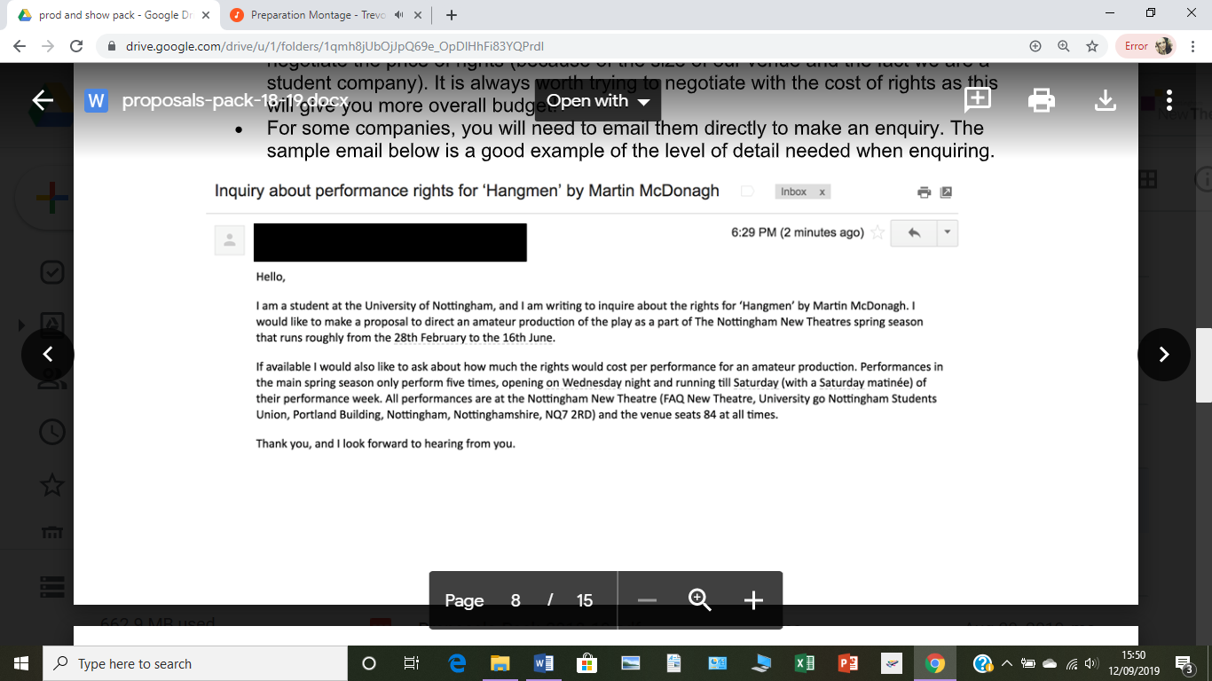

**PROPOSALS ADVICE MEETING (PAM):**

This is a session run by the coordinators in the week before proposals to allow anyone who is thinking of proposing to have a further insight into the process, as well as giving a prime opportunity to speak to relevant committee members about parts of the form. This meeting is highly recommended for anyone who wants to propose – especially first time teams. The meeting date and times will be posted on the Nottingham New Theatre Facebook page.

* **Speaking to the relevant committee members is vital for your proposal. It will work against you if there is a fault/something unfeasible in your form and you haven’t spoken to the relevant committee member.**
* There is no such thing as a stupid question! It is much better that you ask committee if you have any queries (as opposed to guessing what the answer might be).
* If you are unsure who to talk to, the season coordinators can point you to the correct member of committee for your question.

**PROPOSALS FORMS (A HOW TO GUIDE):**

This section will break down each section of the proposals form and show you what is expected of you in each question.

* All production teams must have submitted a typed proposal form to the relevant coordinator by midnight on the Wednesday before proposals (see key dates).
* Handwritten proposals will not be accepted.
* Word counts are approximates and guidelines.
* If you would like to see an example form, please contact the relevant coordinator.
* The key to filling out a proposals form is to be as detailed as possible whilst still remaining clear and succinct.
* It is completely okay to not be certain on all ideas – please don’t be afraid to include a few different ideas for things such as set, costume or tech in your form.
* The form should be treated as an application to the theatre and is a chance for you to justify why you want to put your play on.
* The best advice for the form is to be prepared to justify all of the decisions you make. It is great to push yourself but being aware of your own limitations too.
* Forms will be shared in their entirety with all other proposing teams. If you would like to redact any creative aspects from your form from other teams, such as plot spoilers, you must speak to the relevant coordinator first. A complete form must still be submitted alongside a redacted version. Any redactions made without permission will be ignored.

**FORM SECTIONS**

**Key Information**

This is simply a list of the key elements of your proposal and production.

* Please make sure the mobile numbers in the section are accurate and workable as this is how we will contact you to tell you the outcome of the proposals
* A good way to approximate run time is by pages of script where 1 page of script correlates to 1 minute of stage time. If you are going to have an interval, please include this in the overall run time and specify that there is interval time included (eg 120 mins inc interval).
* We ask if you are happy for your form to be shared with other teams for the sake of transparency and to help eliminate any doubt of committee bias. If you allow your form to be shared, you will be given access to all of the forms being proposed with teams who have also said that they are willing to share forms. If you opt out of sharing your form, please also provide a reason as to why you are opting out of the form share. It is worth noting that by not sharing your form, you may not have access to the forms that have been shared by other teams.

**Synopsis**

This is the first opportunity to sell your show to committee. This will also be the synopsis that is used to advertise your show to the membership if your proposal is successful. The best way to think about this is if your production was a book, this would be the back page blurb.

**Plot Summary**

It is very important to provide a brief summary of the play’s plot. A scene-by-scene breakdown is suggested but if your play does not have traditional scenes then it is okay to use your own judgement on how to present this. We advise that you be succinct in this section but please make sure you highlight the key areas of the story so that a complete understanding of the plot can be formed from this section.

**Cast Breakdown**

This is your chance to further introduce us to the characters in your play. It is important that these are written well and that percentage stage/speaking times are as accurate as possible as this information will be presented to the membership at auditions. The best way to work out percentage stage time is to calculate how many pages of the script each character appears on. Similarly, percentage speaking time is best calculated by counting individual lines of the script. This is also a place to highlight which (if any) characters are gender-bent/gender neutral or multirole parts.

**Welfare**

It is advisable that you have a plan of action as to how you will make sure that difficult elements of your play are treated sensitively. Consider both the depictions of certain topics as well as any overarching discussions or themes that the play presents. Also consider the levels and intensities of these elements - for example whether violence is slapstick or realistic - as this will alter how welfare is addressed within the production.

In this section, also outline if there are any physical as well as mental and emotional welfare considerations within your play (e.g. how you would maintain actors’ safety during rehearsals on physically strenuous sections, such as lifts).

Welfare issues need to be considered from different perspectives as the response to problems could differ between groups (for example, cast, crew and audience welfare may all be handled in very different ways).

We advise that you talk to the Secretary or the relevant coordinator if there are any possible welfare issues.

**Number of performances (FRINGE)**

The amount of performances a Fringe show can have varies dramatically depending on the length of show and venue. If you wish to include additional shows or you have a reduced capacity and expect to sell out, you should factor this into your budget. Rights are often bought for individual shows, and external venues may only be available for a certain amount of time. Bear in mind that every show in the 2017/18 seasons ended up having at least 3 performances.

**Interpretations**

This section is so that you can tell us why you want to put on this play: why this play is important to you, what you want it to say to the audiences of NNT, your specific directorial choices for the style of the show, or any other information that you think is crucial. It is largely up to you what you focus on when answering these questions. Committee want to see why you are passionate about the show and why it is good for NNT.

**Key Challenges**

For this section we are looking for show specific issues that may arise throughout the production process. You can choose to answer this question how you see fit and highlight the parts that you consider necessary. The nature of these challenges will differ greatly between shows and could be about style, rehearsals, themes etc.

**Slot Allocation**

If your show is successful in proposals, you will be offered a slot. These slots are non-negotiable and so it is vital that you only list slots you can commit to. We cannot guarantee that you will be given your first choice slot so it is worth considering your preference order carefully. The amount of slots that you can do will not impact your play being successful so don’t worry about only being able to do a limited number of dates.

**Set Design**

We ask for a set design so that we have a sense of how you plan to use the space. It can be drawn very simply but we do ask that measurements are accurate. If you would like a set designer for your play, please contact the Company Master Carpenter. For non-end-on auditorium seating and for all seating in Studio A we make use of Flexible Staging. Please contact the CSM if you have any questions about using this.

A floor plan of our spaces are included at the end of this pack. It is strongly advised that you submit a floor plan set design alongside any other design drawings you may have. The auditorium stage dimensions are **7.2mx7.8m with 2.5m between the stage and seating block**. There are stage extensions that can be added into this 2.5m gap if you wish. The stage-right wing measures 4.8mx3.8m, while the left-wing measures 3.3mx2.25m. The largest entrance to the stage is 1.3mx1.9m – if you want big set pieces, they may need to be assembled in parts. For Fringe, Studio A with the curtains fully drawn the space is **9mx5m.** If you are in an external venue, please include staging details here.

In this section you should mention if you plan on using the stage extenders, or hanging any set pieces from the lighting rig. If you would like anything hung from the rig, you **must** contact either the Theatre Manager or Technical Manager.

We can help you recruit a set designer to help develop your set after proposals. Make sure you speak to the Company Master Carpenter if you are unsure about set design or construction, or to the Company Stage Manager for logistical matters.

**Design Ideas**

It is good to get creative in this section as you are explaining the aesthetics of your play. You are welcome to include a range of ideas but it is advisable to include reasons and justifications. It is a good idea to include pictures and drawings and also to ensure this aligns with your overall interpretation.

**Tech**

For proposals it is not expected that teams will have a detailed technical knowledge however some understanding of the limitations of space are useful.

Any electrical items that do not come from the theatre will have to be PAT tested and therefore require budgeting for. Similarly if you want to use anything like fairy lights, fluorescent lights (which both require use of a smartpack), microphones, haze, smoke, or additional speakers the Technical Manager should be consulted. The New Theatre also regularly hires equipment from TEC, to enquire about hire costs and availability of equipment contact either the Technical Manager or Company Technical Director.

**Publicity**

It is important that you have considered target audiences for your show and how you will attract them. A fully realised poster design and marketing plan is not necessary, merely an understanding of who you wish to attract and how you will do it. You should think about possible university societies you could contact or any social media campaigns you could run to market your show, this could include personalised profile pictures and show trailers.

**Budget Breakdown**

Please be as thorough as possible. We are happy for estimates to be provided but please put effort into researching/talking to relevant members of committee to find the best possibilities. It is a good idea to include links to specific items you plan to buy. Check your numbers for the total budget carefully. Overall, committee are looking for a well thought-out budget and evidence that productions teams have given some thought to attempting to break even in show week. This is especially important to consider with smaller capacity shows (alternative seating for In-House or Fringe shows).

If you are planning on having staging other than end-on such as traverse, this will mean that you will have a reduced capacity for audience members. It is therefore advisable that you edit your budget to reflect the number of audience and, therefore, your expected profit.

Maximum budget is **£750** for an In-House show which requires rights. In-House shows that do not require rights (a show in the public domain or a student written piece) are permitted a budget up to £500. The maximum budget for a Fringe show is **£150**. However, if your show has exceptional costs please feel free to discuss it with the Treasurer before submitting your proposal.

**Creative Team**

If you have recruited any creative team members before proposals, please list their names and what position they will hold. An additional member may be added to your team if your show is successful. We ask that you have an idea of where this team member will be most useful to your show. Please note that the role of a stage manager has been reformed and is now a compulsory position in every In-House show. You are permitted to pre-assign one, otherwise a stage manager will be attached to your show post-season launch. For more information please attend the Proposal Advice Meeting and contact the Company Stage Manager.

Most shows will be assigned either Shadow or Assistant production team members (directors/producers). It is completely up to you if you would prefer Shadow or Assistant team members. Shadow team members are there to learn about the production team roles. They tend to want a more passive, observer role in rehearsals and during show week. Assistant team members take a more active role in the putting on of the show and can be used to help develop the show.

**HOW PROPOSALS WORK:**

Each show being proposed will be allocated a 15 minute slot on the Saturday of proposals where the director and producer will have a chance to discuss their form with the whole committee. The session takes on a round table, Q&A format. You may be asked to prepare and deliver a short (max 3 minute) speech about your show.

The allocations of proposal slots will be dependent on how many shows are being proposed. The relevant coordinator will contact each team to allocate a time. If you have a specific time requirement due to other commitments then please let the coordinator know when submitting the form.

We ask that all proposing teams arrive at least 10 minutes early and wait in the dressing room for your slot. Please use the side entrance to the dressing room as proposals takes place in the foyer. The relevant coordinator will come and collect you for your allocated time slot.

There is no real way to prepare for the questions other than being able to justify your decisions. The most important tip is to keep calm and try and be as confident as possible. Everyone on committee knows how nerve-wracking proposals is and they aren’t looking to trip you up! It is also important to take it seriously and answer the questions truthfully.

Following your proposal, it is essential that both director and producer keep their phones on at all times. Usually committee discussions run late into the evening before a final decision is made but you may receive a call at any point in the day so stick to your phone.

Every production team will be called once the final decision has been made regardless of whether they are successful or not. Successful teams will be rang first so that they can confirm their slot and the season can be ‘locked in’. If you are a successful team but we are unable to get hold of you this may result in you forfeiting your show and the slot will be allocated to another team. This is rare but has happened so keep your phones charged and on loud.

All other teams will then also be phoned. Unsuccessful teams will be sent written feedback about their proposal by Monday. If the team wishes, the relevant coordinator will be happy to make a meeting time for a face-to-face feedback meeting on the Monday or Tuesday before the season launch. Successful teams will also be given written feedback and the option of a face-to-face meeting but this is less urgent and may be given later in the season.

