Abstract
This report presents the design and implementation of a PWM (Pulse Width Modulation) monitoring system using the STM32F401 microcontroller. The system provides real-time monitoring of PWM signals and ADC voltage feedback with configurable threshold-based monitoring. The implementation integrates multiple peripherals including TIM2 for PWM capture, ADC1 for voltage monitoring, USART2 for debug communication, and GPIO for user interface via LEDs and buttons.

The system achieves 10Hz ADC sampling rate with ±0.2V threshold tolerance and provides visual status indication through LED outputs. Software based low pass filter for stable measurements, while a lookup table-based threshold system supports 10 monitoring configurations. The design emphasizes modular software architecture, efficient interrupt handling, and comprehensive testing validation.
Code repo newton047/RealTimePWMMonitor

Contents
1 INTRODUCTION 4
1.1 Problem Statement 4
1.2 Challenge 4
1.3 Constraints for design 4
1.4 Assumptions 4
1.5 Proposed Solution 5
1.6 System Block Diagram of Prototype. 6
1.6.1 Input and Outputs 6
1.7 Control Objectives 7
1.8 RC Filter Calculation 7
1.9 Cortex-M4 Features Utilized: 7
2 Project Overview 7
2.1 Pin – Mapping 7
2.2 Hardware connection 8
2.3 Bill of Material 8
2.4 Peripheral Used 8
2.5 Software Design 9
2.5.1 ADCReadHandler (10Hz - Every 100ms) 9
2.5.2 UserButtonHandler (5Hz - Every 200ms) 10
2.5.3 ErrorCheckerHandler (1Hz - Every 1000ms) 11
2.5.4 SecondIncrementer (1Hz - Every 1000ms) 12
2.5.5 Systick Timer 13
3 Prototype 15
3.1 Test Setup 15
3.2 Case 1 ( Duty Cycle =10 ) 15
3.3 Case 2 (Duty Cycle =50) 16
3.4 Case 3 (Duty Cycle = 90 percent) 17
3.5 Case 4 ( Error Generated at 90 percent) 18
4 Lessons Learned: 19

List of Figures
Figure 1 Typical Motor Control using PWM driver 4
Figure 2 Proposed Solution 5
Figure 3 ProtoType Block Diagram 6
Figure 4 Hardware Connections 8
Figure 5 Software Architecture 9
Figure 6 ADC Handler SnapShot 10
Figure 7Filter code implementation 10
Figure 8 Button Code interface 11
Figure 9 Snapshot of ErrorHandler 12
Figure 10 SnapShot of DebugTask 12
Figure 11 Calling Timer Callback 13
Figure 12 Snapshot of Register callback 13
Figure 13 Test Setup 15
Figure 14 Timing Diagram 15
Figure 15 Debug Window Snapshot 16
Figure 16 DutyCycle of 50 percent 16
Figure 17 Debug Window log 17
Figure 18 PWM Snapshot of 90 percent 17
Figure 19 Debug Window snapshot of 90 percent 17
Figure 20 Snapshot at 90 percent dutycycle 18
Figure 21 Debug window snapshot of error being detected 18

List of Tables
Table 1 Input Signals 6
Table 2 Output Signals 6
Table 3 Pin Map 7
Table 4 BOM 8
Table 5 Peripherals used 9
Table 6 UART Debug log 16
Table 7 Debug UART Output for 50 percent Duty Cycle 17
Table 8 UART log for 90 percent duty cycle 18
Table 9 UART Log with error detected 19

INTRODUCTION

Problem Statement
In modern automotive systems, PWM signals are extensively used for motor control, power regulation, and various actuation systems. Hence, monitoring the actual output of PWM-driven systems is crucial for:
1. Safety Verification: Ensuring the PWM signal produces the expected output voltage/response
2. Fault Detection: Identifying discrepancies between commanded and actual system behaviour

Challenge
A typical PWM based controls looks as below.
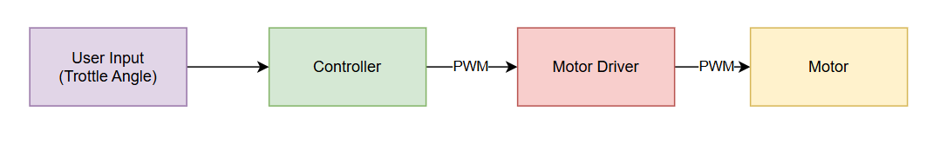
Figure 1 Typical Motor Control using PWM driver
- For controlling a motor, we always need a driver circuit because the motor is an inductive load which is high current consuming. The controller lacks the current capability
- In the event when the motor driver circuit is at fault, the only way to observe the fault is for motor to stop working, or connect a oscilloscope to troubleshoot the error.
- Once deployed on field, it is not possible to do so, hence a real-time fault monitoring system is preferred.

Constraints for design
- The design should create minimal impact to the current design
- The system update should be a low-cost solution
- System should check the health every 1s

Assumptions
- PWM frequency is set to 100kHz which suffices he the application

Proposed Solution
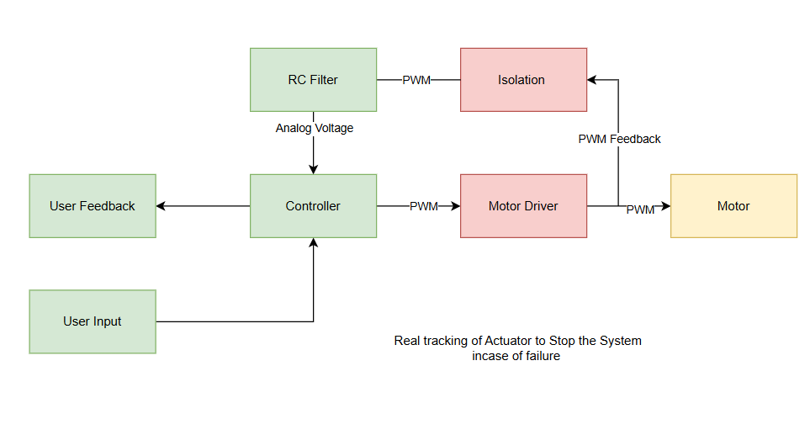
Figure 2 Proposed Solution
- Instead of relying on system failure to troubleshoot the problem, a low-cost solution would be using the internal ADC to monitor the PWM generated voltage.
- In an event of voltage fluctuation, the user would be given feedback, the feedback may be a led, pop on display or an DTC
- The solution is demanded to be low cost, hence using internal ADC and simple RC filter which adds less cost to the update.

System Block Diagram of Prototype.
(For demonstrating the application in prototype certain blocks are removed to focus on problem at hand)

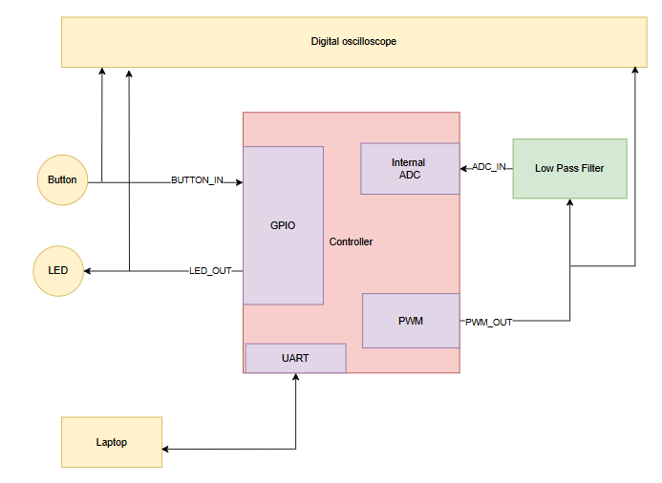
Figure 3 ProtoType Block Diagram
- To keep the prototype low cost, Motor driver is ignored and PWM is directly looped back to internal ADC
- The User input is simulated by button, where each click of button will increase the duty cycle by 10
- The user interface is emulated using LED output which will be triggered once an error is triggered.

Input and Outputs
SIGNAL NAME (INPUTS) | DESCRIPTION
ADC_IN | ADC feedback input from PWM
BUTTON_IN | Button used to simulate user input, per click will increase the duty cycle by 10
Table 1 Input Signals
SIGNAL NAME (OUTPUT) | DESCRIPTION
LED_OUT | User interface which will be turned on in case of a error.
PWM_OUT | PWM generated by controller
UART_TX | UART is used as debug port, which will transmit debug logs to laptop
Table 2 Output Signals

Control Objectives
- The PWM duty cycles are read in feedback through internal adc, each duty cycle will have a pre-defined value, if the ADC value goes beyond the deadband an error must be generated. The deadband is +-0.2 V of the expected voltage.
- The button generates the user input which will increase the PWM by 10 percent in every click.

RC Filter Calculation
- Since the PWM is a digital signal we can’t directly read it using ADC
- The high frequency PWM signal must be converted in DC voltage using LPF
- Assuming the PWM frequency is 100kHz
    - $fc=\frac{1}{RC}$
    - $RC=\frac{1}{fc}=\frac{1}{100000}=10*{10}^{-6}$
- Hence taking $C=100uF and R=200Ω$
$$RC=200×100×10-6=0.02s$$
$$fc​=2π×0.021​≈8Hz$$
The cutoff frequency is intentionally kept much lower than PWM frequency to convert PWM into its average DC equivalent. This ensures minimal ripple but introduces a response delay (~100 ms), which is acceptable for a system operating at 10 Hz sampling.

Cortex-M4 Features Utilized:
- SysTick Timer for real-time task scheduling
- Register-level programming for efficient peripheral control

Project Overview
This project implements a comprehensive PWM monitoring system using the STM32F401RE microcontroller (ARM Cortex-M4). The system generates PWM signals through TIM2, monitors system voltage response via ADC1, compares measured values against a lookup table (LUT), and provides status indication through LED and UART debug output.

Pin – Mapping
SIGNAL NAME | MCU PIN
ADC_IN | A0
BUTTON_IN | C13
LED_OUT | A5
PWM_OUT | A1
UART_TX | A2
Table 3 Pin Map

Hardware connection
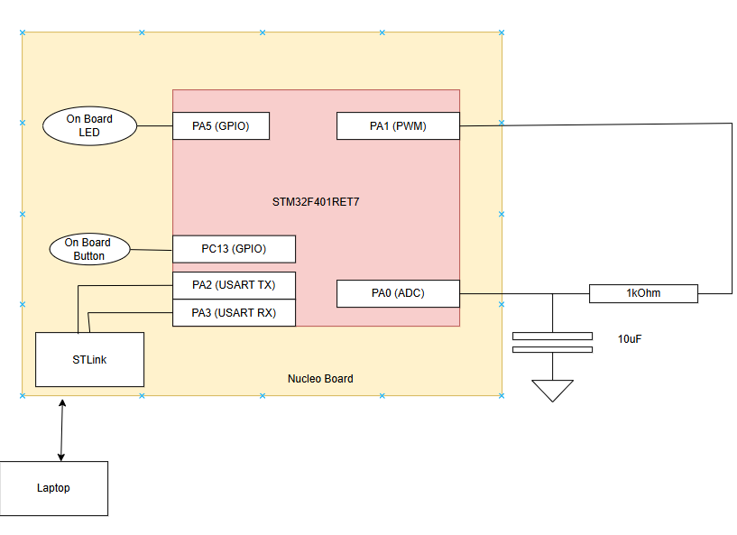
Figure 4 Hardware Connections

Bill of Material
The Prototype was built on STM32F401RET7 Nucleo Board, hence on-board led and buttons are used for prototype
COMPONENT | DESCRIPTION
LED | On-Board of Development board
Button | On-Board of Development board
Resistor (200) | For RC Filter
Capacitor (100uF) | For RC Filter
UART to RS232 converter | Handled by on-board stlink
Table 4 BOM

Peripheral Used

PERIPHERAL | DESCRIPTION
ADC (ANALOG TO DIGITAL CONVERTER) | - 12 bit resolution  - 56 Sampling cycles  - Input range from 0-3.3V
PWM | - 100khz Frequency  - 0-100 Duty cycle variable
SYSTICK | Running as Free Timer for generating timebase, configured to run at 1ms
UART | - 9600 Baud Rate  - 8 Data bit and 1 Stop bit
GPIO | For Button and LED
Table 5 Peripherals used

Software Design
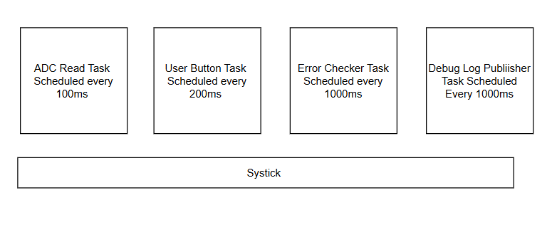
Figure 5 Software Architecture
The system is divided in to multiple task, each task is scheduled by Systick timer IRQ, based on the periodicity of the task.

ADCReadHandler (10Hz - Every 100ms)
Purpose:
- Reads and processes analog voltage feedback from ADC
- Reads raw 12-bit ADC value from PA0
- Converts ADC reading to voltage (0-3.3V range)
- Applies exponential moving average filter (α = 0.5) to reduce noise
- Stores filtered voltage for threshold comparison
- Critical for: Real-time voltage monitoring and noise reduction
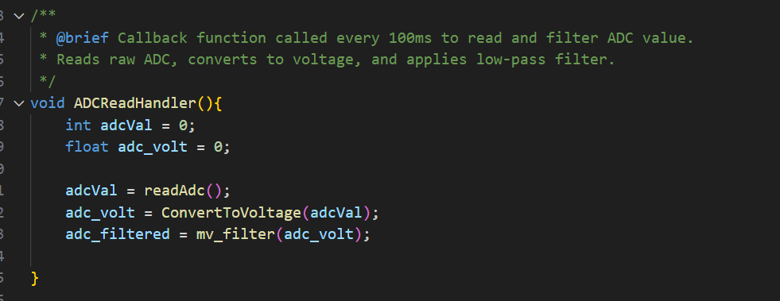
Figure 6 ADC Handler SnapShot
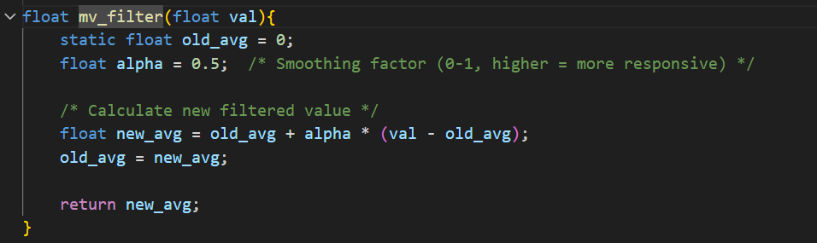
Figure 7Filter code implementation

UserButtonHandler (5Hz - Every 200ms)
- Processes user input for monitoring setting selection
- Reads user button state (active low on PC13)
- Cycles through 11 monitoring settings (0-10) when button pressed
- Updates PWM monitoring parameters via MotorSpeedUpdate()
- Implements settling time delay (skips error check for one cycle)
- Used to mock user input

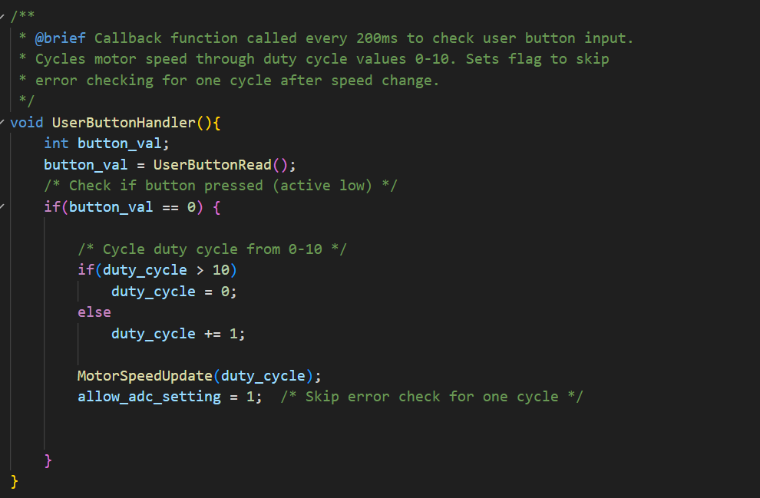
Figure 8 Button Code interface

ErrorCheckerHandler (1Hz - Every 1000ms)
- Validates voltage against configurable thresholds
- Compares filtered ADC voltage against lookup table values
- Checks ±0.2V tolerance band around target voltage
- Sets error flag and controls status LED (OFF: OK, ON: Error)
- Implements settling delay after setting changes
- Critical for: System monitoring and status indication
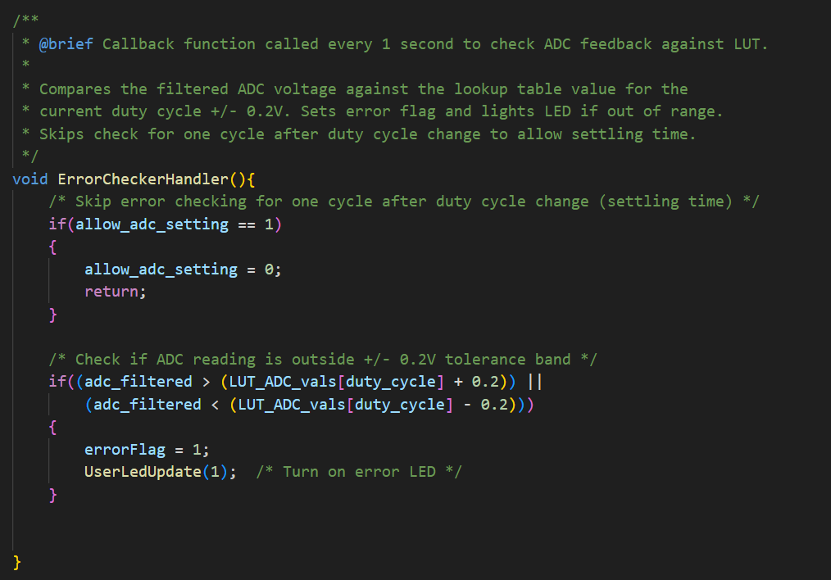
Figure 9 Snapshot of ErrorHandler

SecondIncrementer (1Hz - Every 1000ms)
- Provides debug output and system monitoring
- Increments seconds counter for timestamping
- Formats and transmits debug data via UART (9600 baud)
- Sends: timestamp, ADC voltage, duty cycle, threshold, error status
- Enables real-time system monitoring and troubleshooting
- Critical for: Debugging, system validation, and data logging
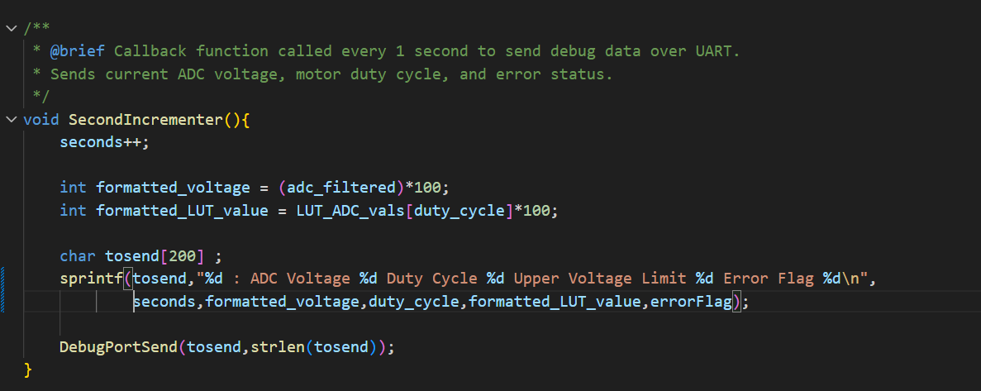
Figure 10 SnapShot of DebugTask

Systick Timer
The IRQ of the systick timer works as a scheduler, in the main loop the callback is registered.
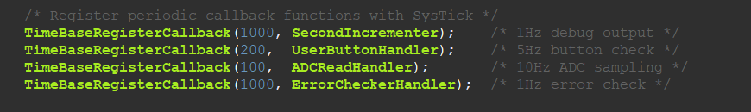
Figure 11 Calling Timer Callback
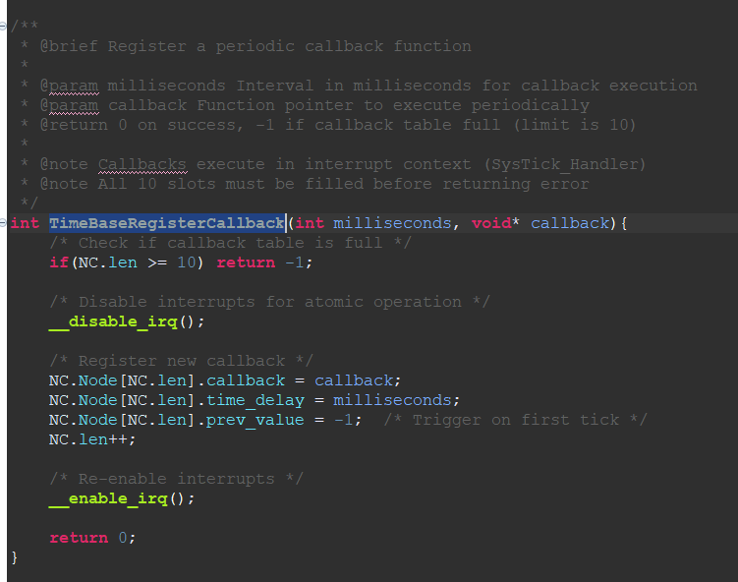
Figure 12 Snapshot of Register callback
The systick timer module has a data structure which will store the registered callback and timeout in milliseconds.

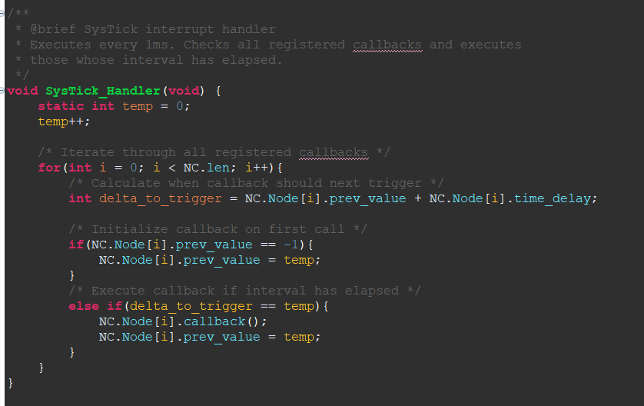
The systick timer loops through the data structure to check if the timeout for any registration is occurred. Based on timeout each callback is called.

Flow Chart of Error Detection
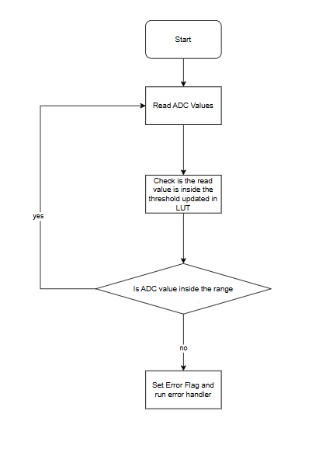
Figure 13 Error Detection logic

Prototype

Test Setup
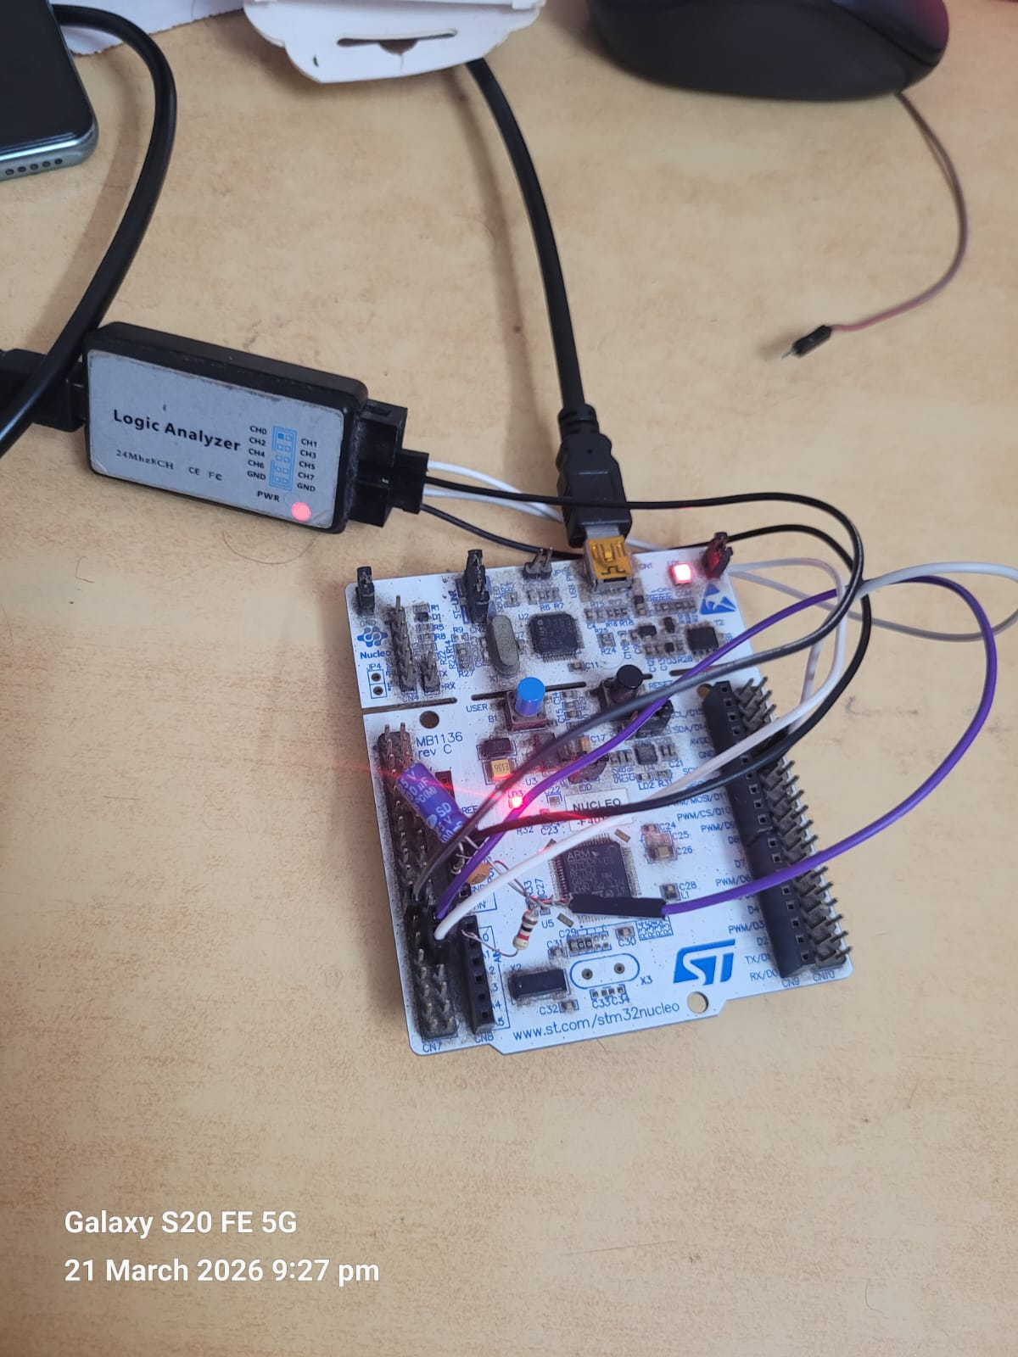
Figure 14 Test Setup

Case 1 ( Duty Cycle =10 )

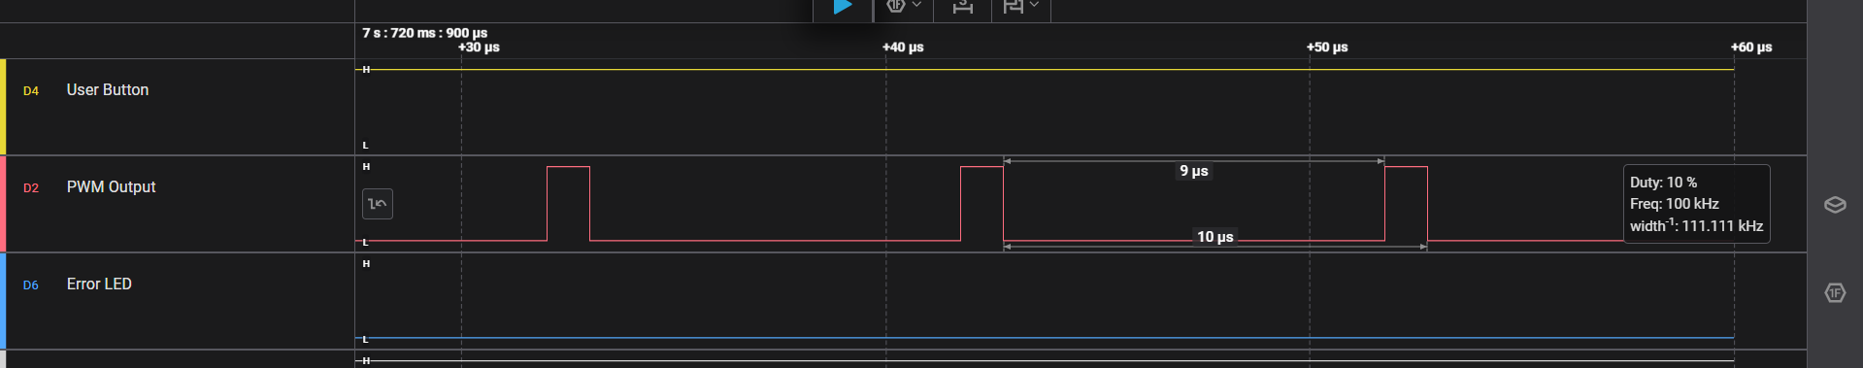
Figure 15 Timing Diagram
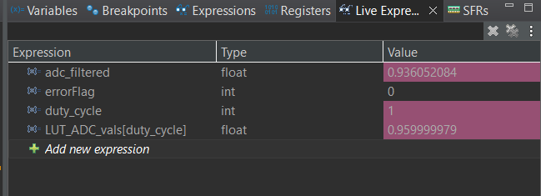
Figure 16 Debug Window Snapshot
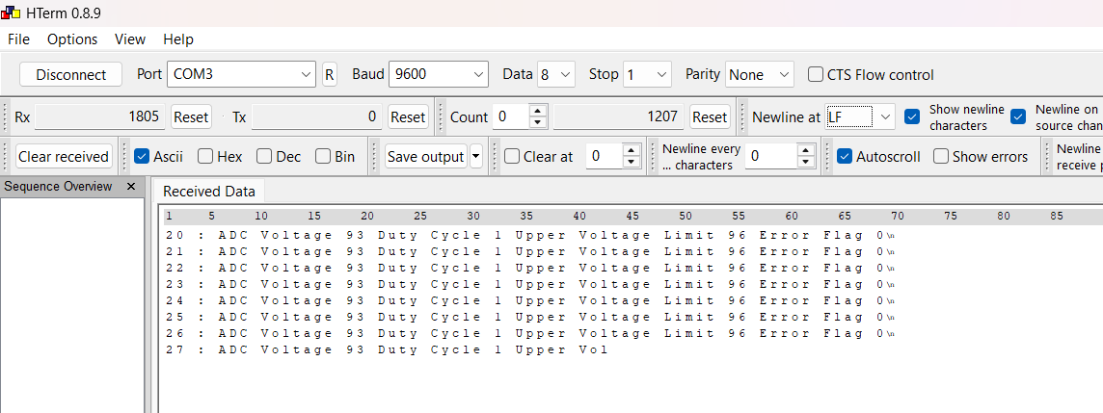
Table 6 UART Debug log

Case 2 (Duty Cycle =50)
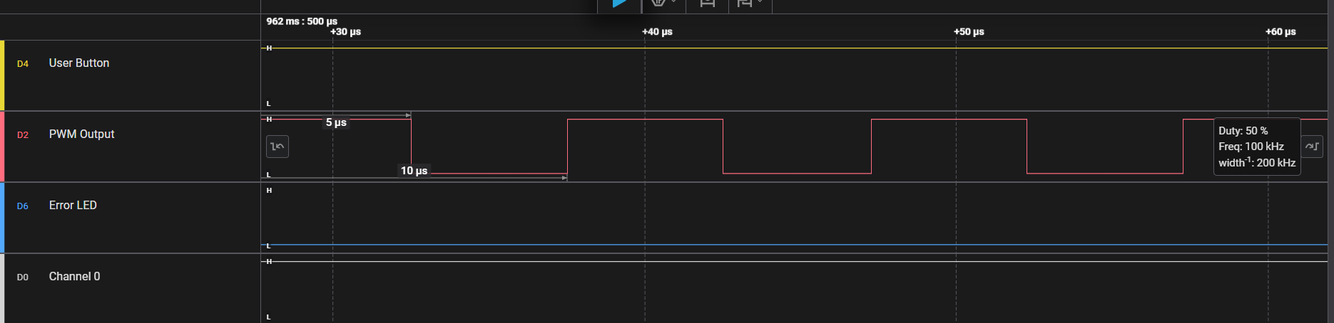
Figure 17 DutyCycle of 50 percent
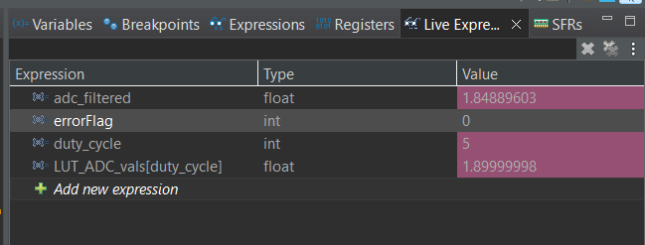
Figure 18 Debug Window log
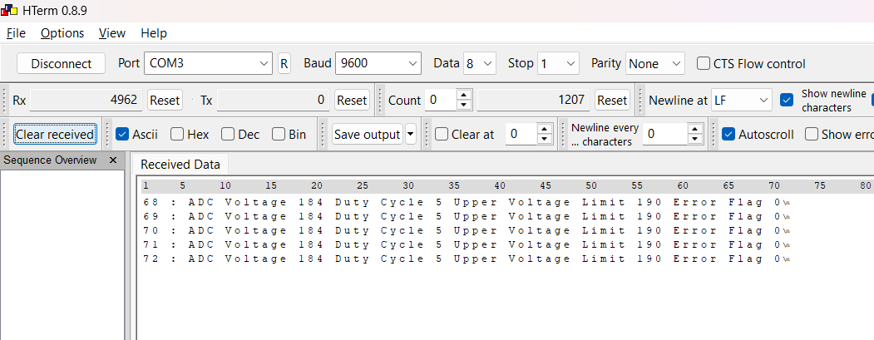
Table 7 Debug UART Output for 50 percent Duty Cycle

Case 3 (Duty Cycle = 90 percent)
Figure 19 PWM Snapshot of 90 percent
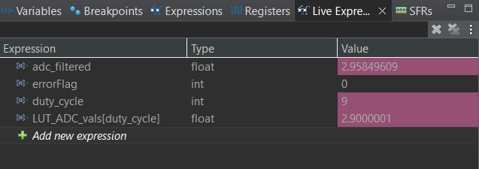
Figure 20 Debug Window snapshot of 90 percent
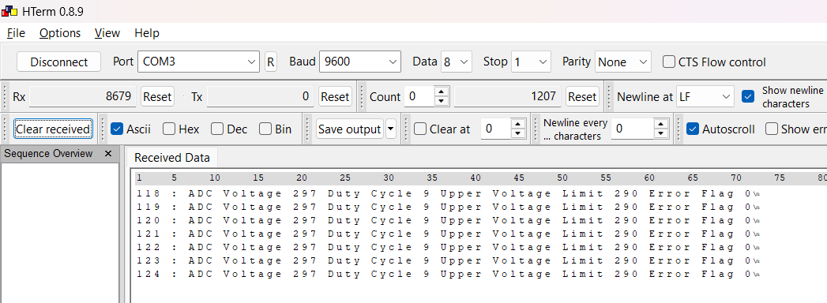
Table 8 UART log for 90 percent duty cycle

Case 4 ( Error Generated at 90 percent)
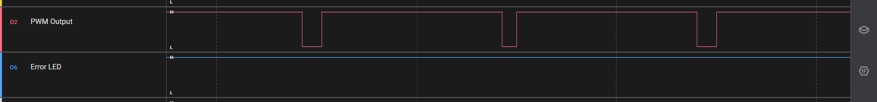
Figure 21 Snapshot at 90 percent dutycycle
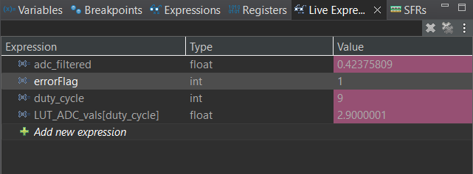
Figure 22 Debug window snapshot of error being detected
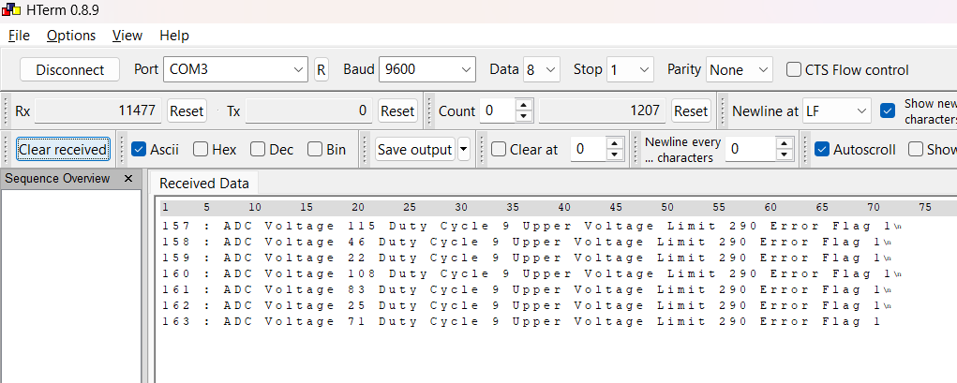
Table 9 UART Log with error detected

Lessons Learned:
- ADC cannot directly read PWM; filtering is required
- RC filter design is critical for balancing ripple and response time but adds delay
- Interrupt-based scheduling improves efficiency
- System response time is affected by both filter and software timing
- Real-world systems require isolation and protection circuits

