Clinic Management Web Application
System Design and Implementation Report
PRJ301 Fall 2026

Members:
Tran Quang Khai HE201233
Do Hoang Tuan Anh HE201491
Nguyen Manh Duc HE201319

This report describes the current clinic application, its three user roles and the main screens used to book visits, manage medical records and record payments.

Report contents
I Overview
II Web Application Workflows
III Project Contribution
IV Appendix

I Overview
The application supports patients, doctors and managers. It uses Java 17, Jakarta Servlets, JSP, JDBC, SQL Server and Apache Tomcat. Patients access their own information; staff manage clinic operations according to their role.

1 1 User requirements
Role | Main functions
PATIENT | Register, sign in, change password, book or cancel eligible appointments, browse services and view personal records and invoices.
DOCTOR | Create and confirm assigned appointments, maintain assigned medical records, add services and prescriptions, record payment and maintain patients and catalogs.
MANAGER | Oversee clinic appointments and records, manage users and doctors, maintain patients and catalogs, and review revenue.

1 2 Use case diagram
Associations show which role can perform each use case. Account management includes sign in, sign out and changing the current password.
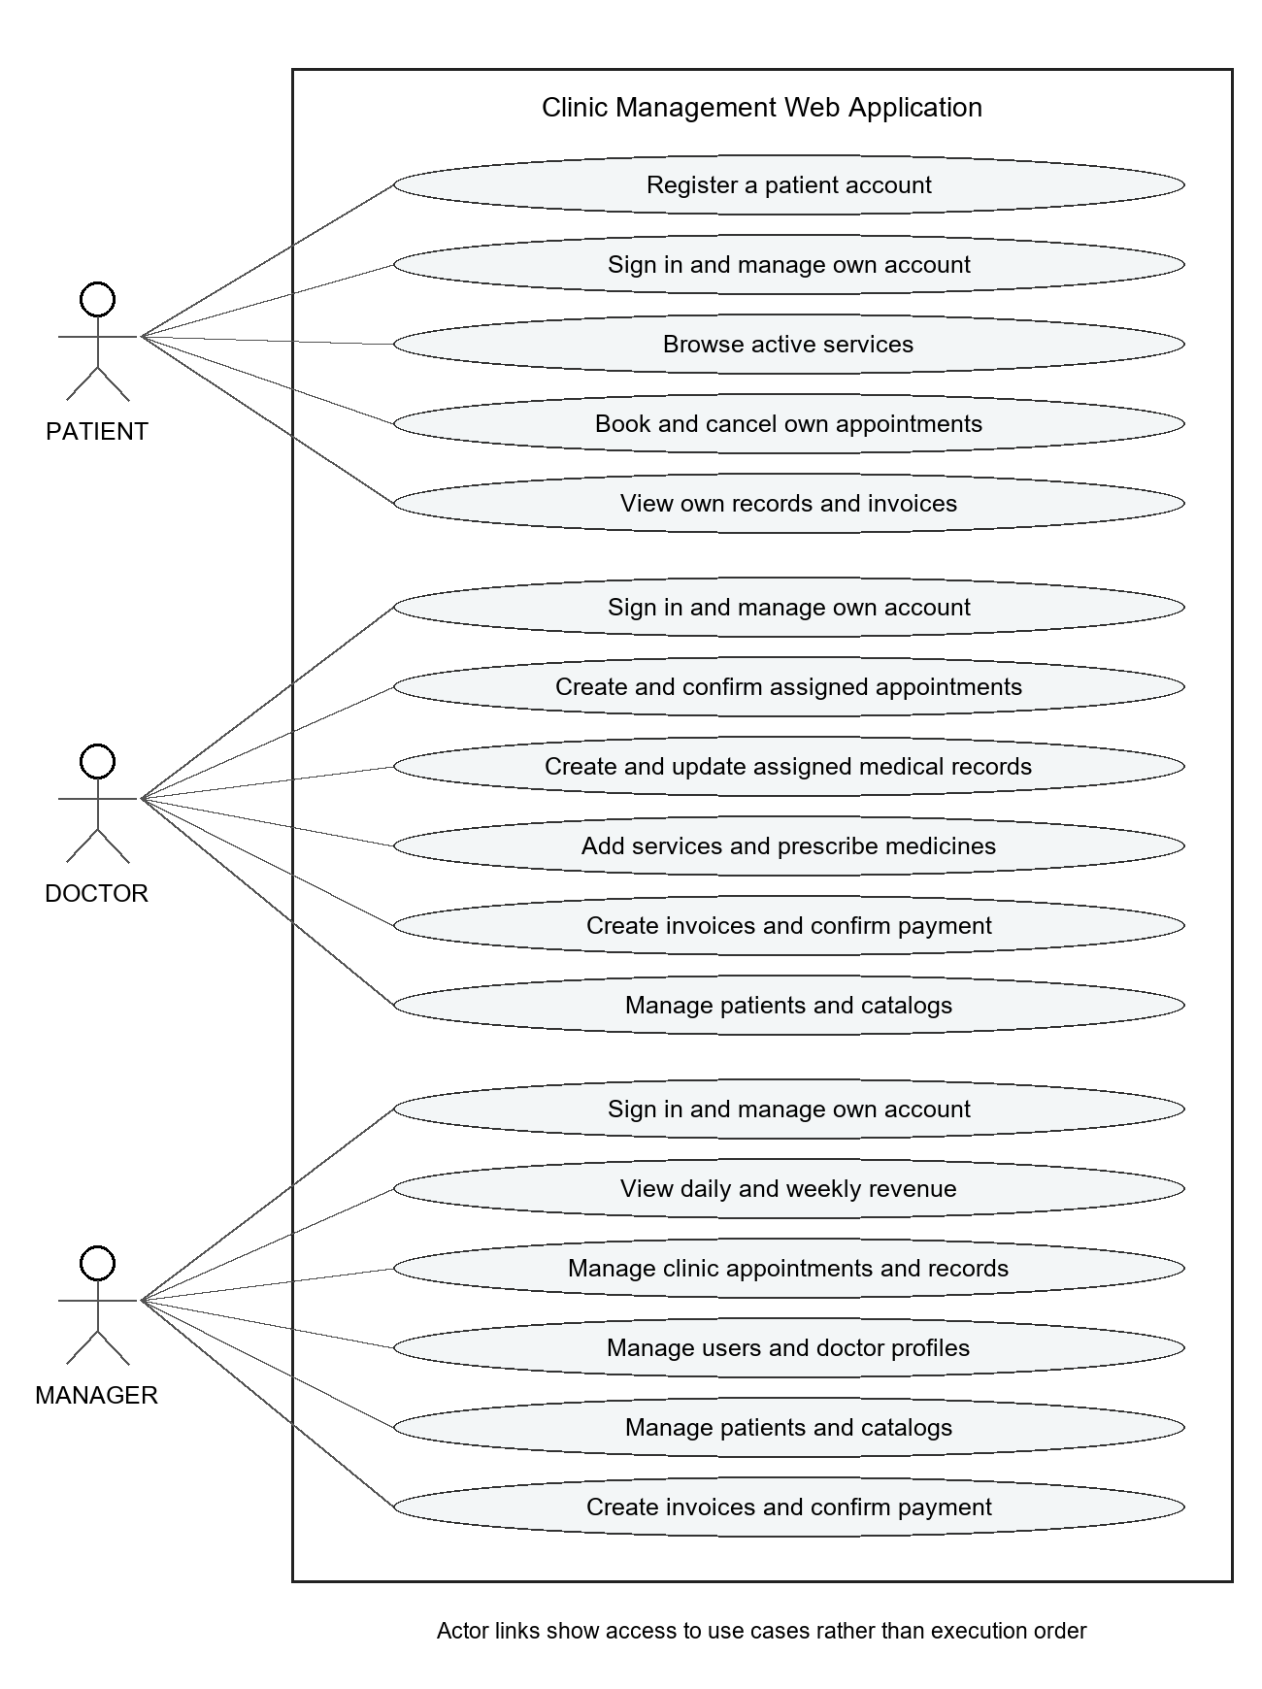
Figure 1 Clinic use cases by role

1 3 Role authorization
Function | PATIENT | DOCTOR | MANAGER
Appointments | Own records | Assigned doctor | All doctors
Medical records | View own | Manage assigned | Manage all
Patient profiles | No self editing | Create and edit | Create and edit
Services and medicines | Browse services | Manage catalogs | Manage catalogs
Invoices | View own | Create and confirm | Create and confirm
Users and doctors | No access | No access | Manage
Revenue dashboard | No access | No access | View

Servlets check the session and role. Patient and doctor record queries also check ownership. Manager access covers all clinic records.

1 4 Database tables
Table | Purpose
Users | Login credentials, role and active status.
Patients | Patient identity, contact details and optional account link.
Doctors | Doctor information, specialty, active status and optional account link.
Appointments | Patient, doctor, appointment time, reason and status.
Services | Service catalog, current price and active status.
Medicines | Medicine catalog, current price, stock and active status.
MedicalRecords | Visit details, clinical notes and optional appointment link.
MedicalRecordServices | Services used in a visit with quantity and saved unit price.
Prescriptions | Prescription header and notes for a visit.
PrescriptionDetails | Medicine quantities, instructions and saved prices.
Invoices | One bill per visit, totals and payment status.

An appointment can link to at most one medical record. Each medical record can have at most one invoice. Service and medicine lines retain their saved unit prices.

II Web Application Workflows
Each screenshot represents one use case. The sections follow the account roles shown in the screenshots.

2 1 Common access
Shared entry screens for all users.

UC 01 Browse public services
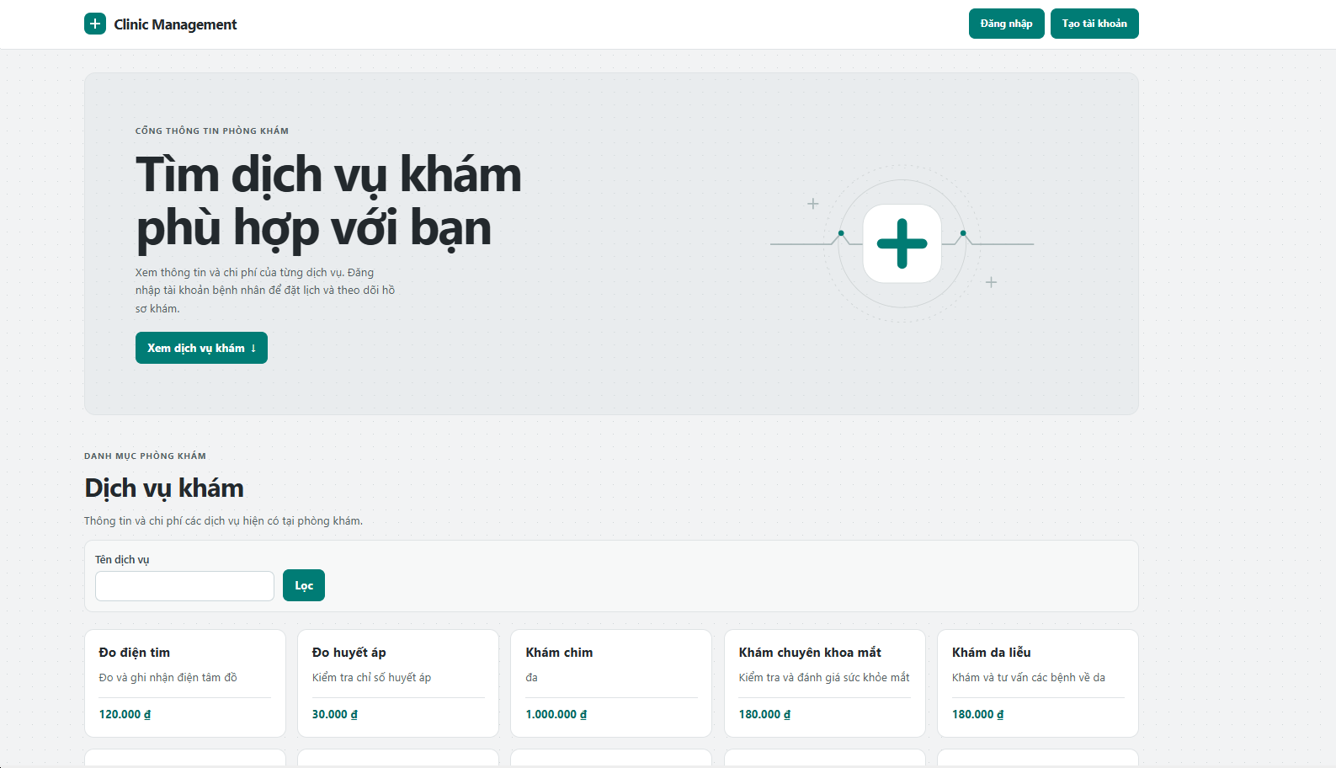
Figure 2 Browse public services
Flow: Open the home page. Enter a service name and select Filter. The application displays active services and their prices.

UC 02 Register a patient account
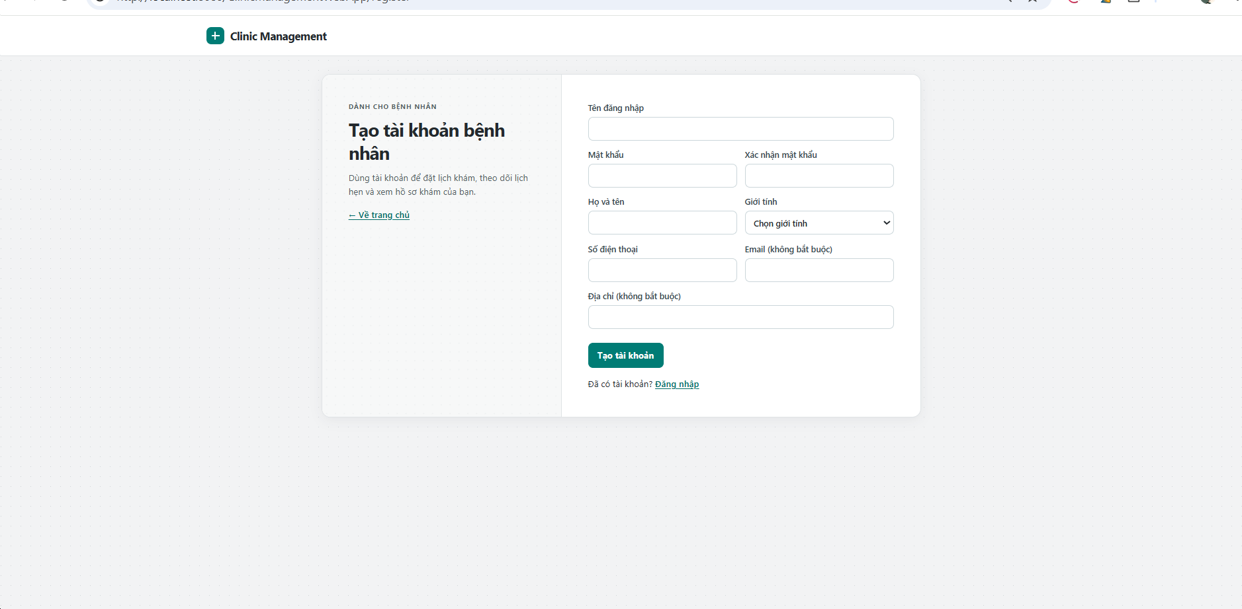
Figure 3 Register a patient account
Flow: Select Create account. Enter username, matching passwords and patient contact details. Submit the form; valid details create a linked patient account and return to sign in.

UC 03 Sign in
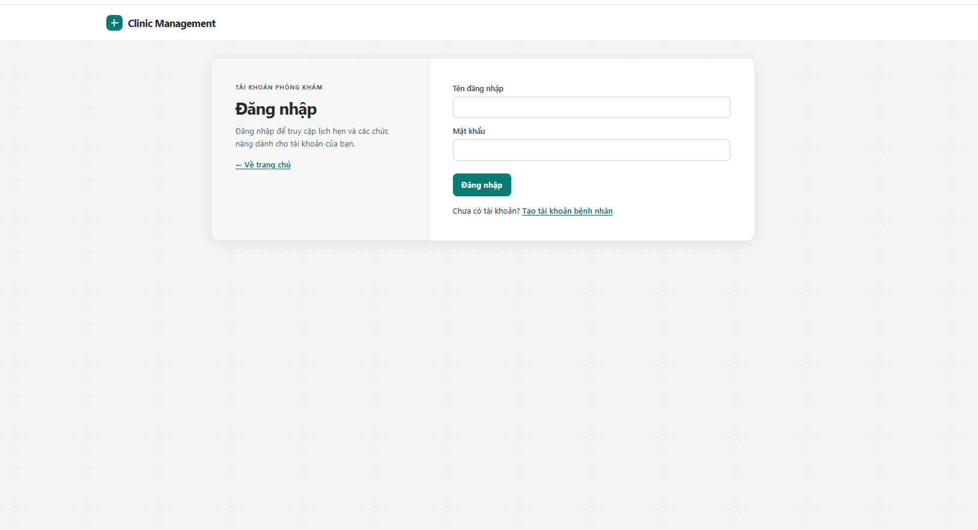
Figure 4 Sign in
Flow: Enter username and password, then select Sign in. The system checks the active account and opens the patient appointments, doctor appointments or manager dashboard according to the role.

2 2 PATIENT workflows
Screenshot account: thanhtam.

UC 04 Change own password
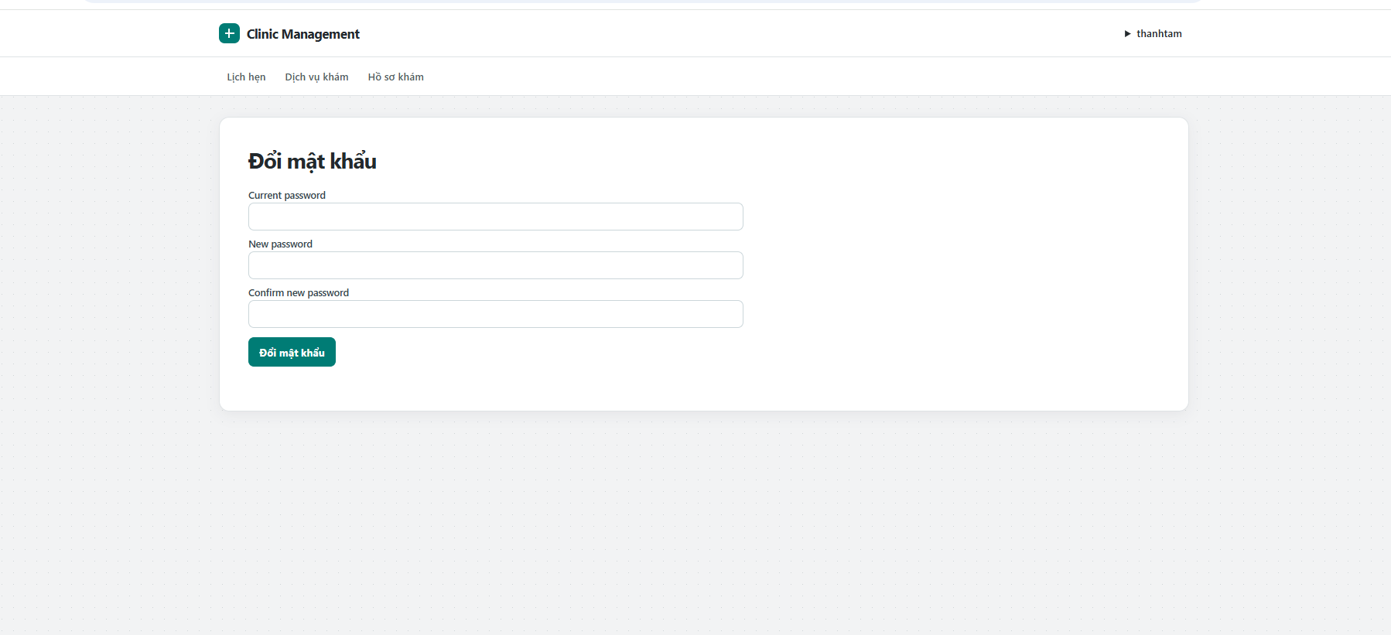
Figure 5 Change own password
Flow: Open the account menu and select Change password. Enter the current password and matching new passwords. Submit the form to update the password.

UC 05 Book an appointment
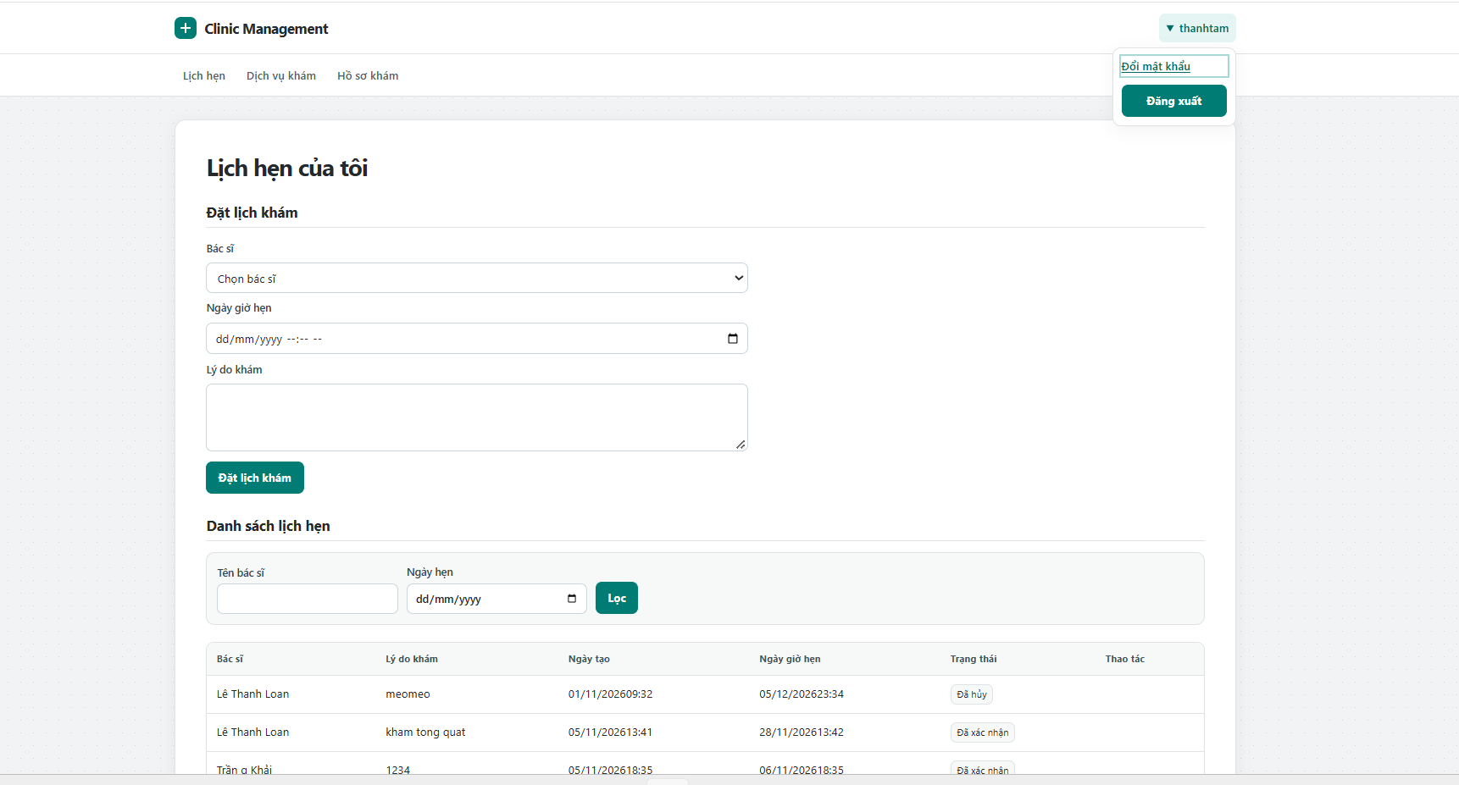
Figure 6 Book an appointment
Flow: Open Appointments. Select a doctor, choose a future date and time, enter a reason, then submit. The system rejects a conflicting doctor or patient time; otherwise, it creates a BOOKED appointment.

UC 06 Browse available services
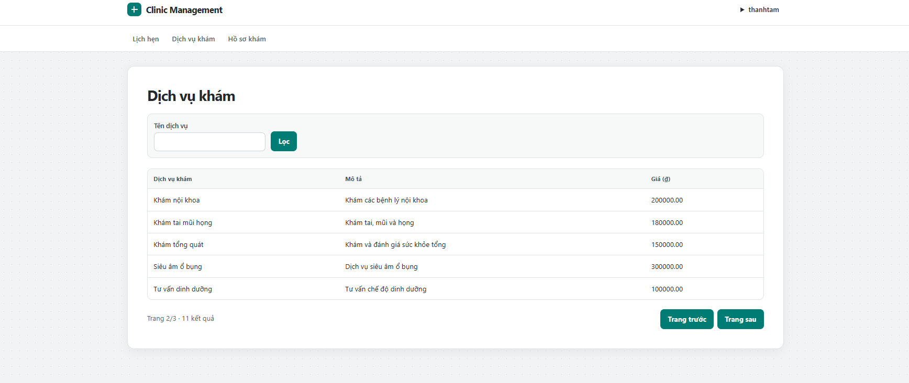
Figure 7 Browse available services
Flow: Open Services. Enter a service name and select Filter. Review the matching active services and prices, then use the page controls to view more results.

UC 07 View personal medical records
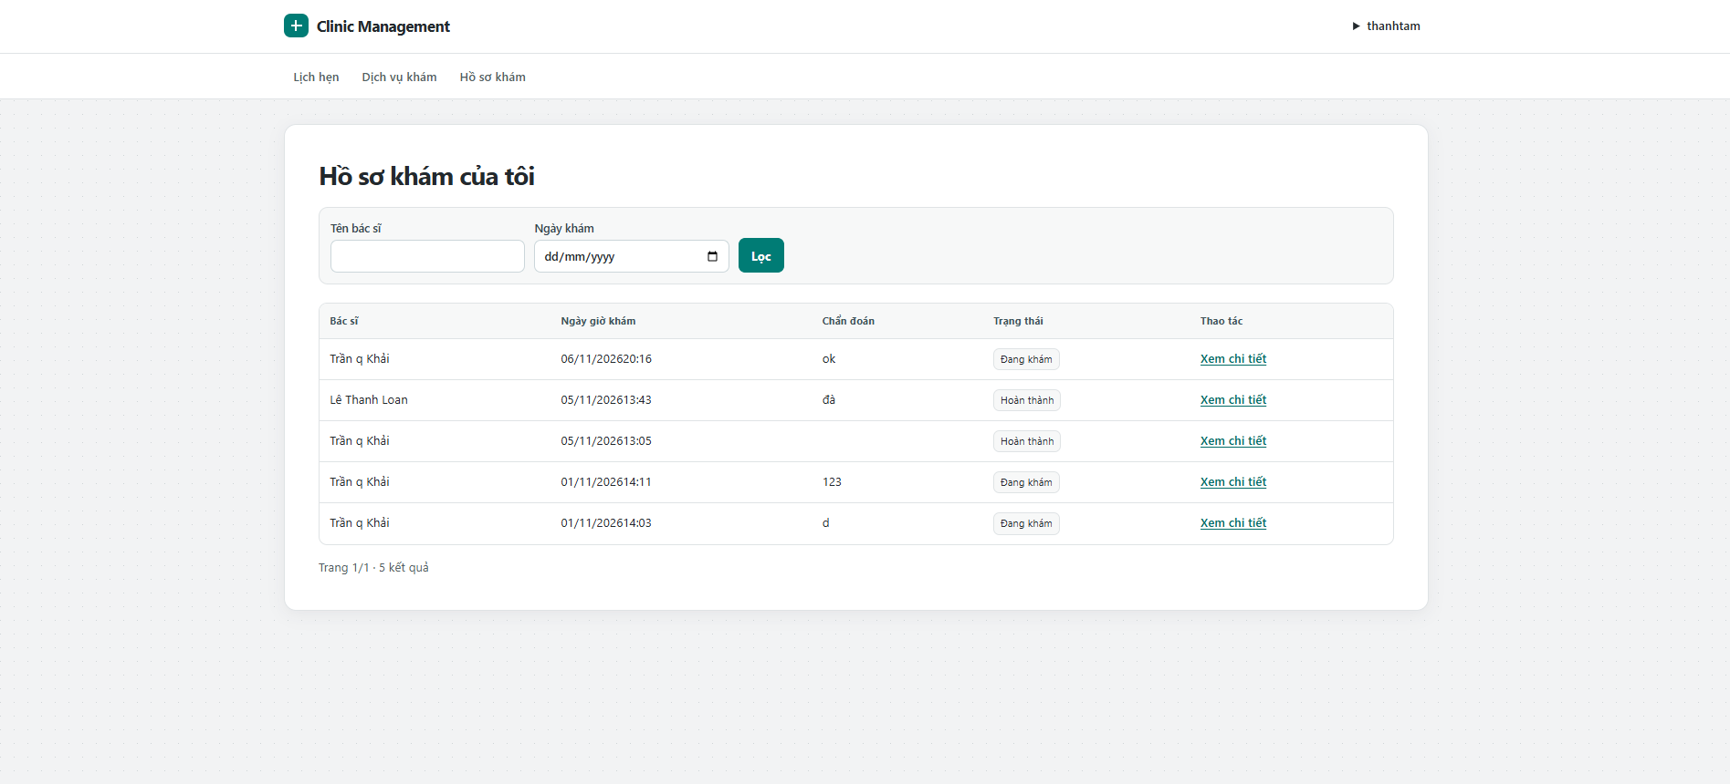
Figure 8 View personal medical records
Flow: Open Medical records. Search by doctor or choose a visit date, then select Filter. The system lists only records linked to the signed in patient.

UC 08 View a medical record in detail
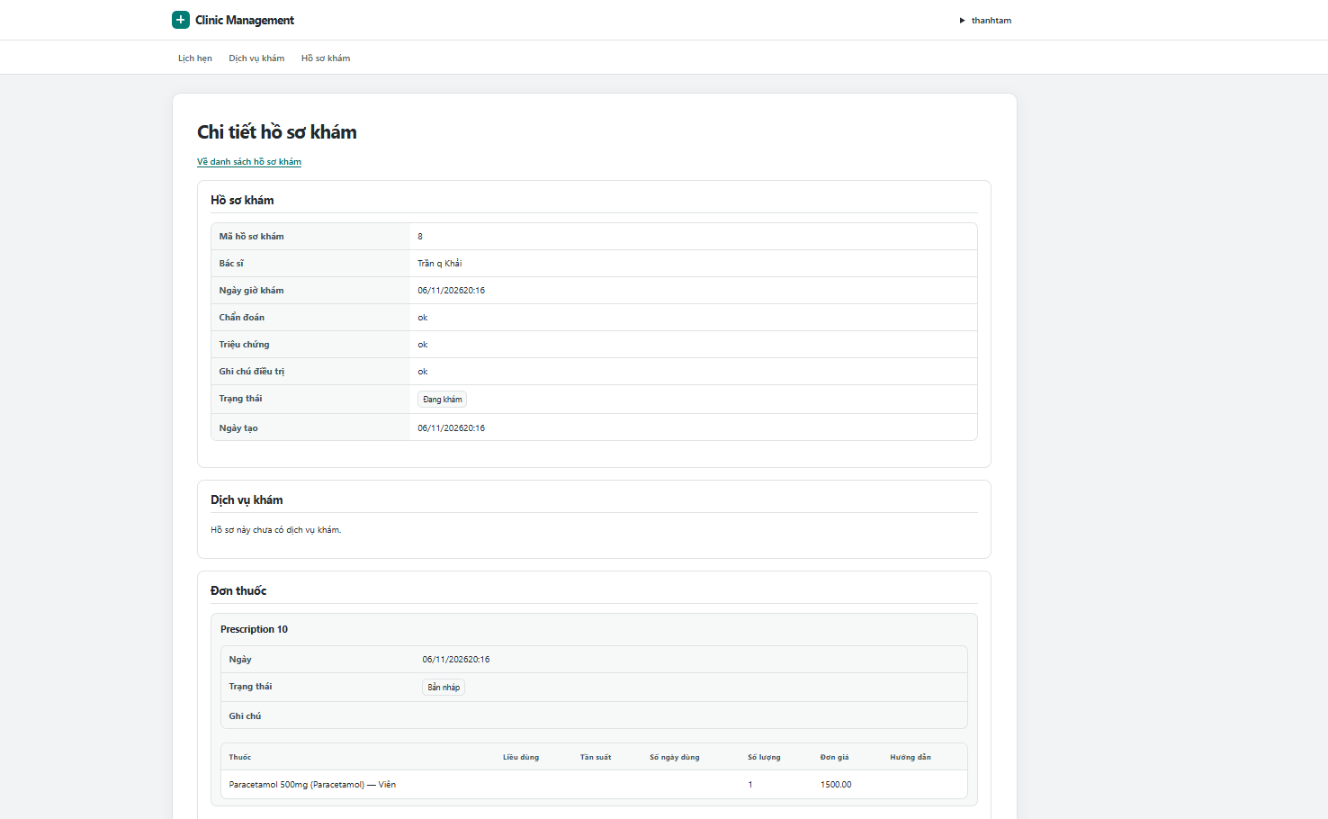
Figure 9 View a medical record in detail
Flow: Select View details on a personal record. Review the symptoms, diagnosis, treatment notes, services, prescriptions and invoice when available. The patient has read access only.
Patients can also cancel their own future BOOKED appointments. The account menu provides Sign out, which ends the session.

2 3 DOCTOR workflows
Screenshot account: tranqkhai.

UC 09 Review assigned appointments
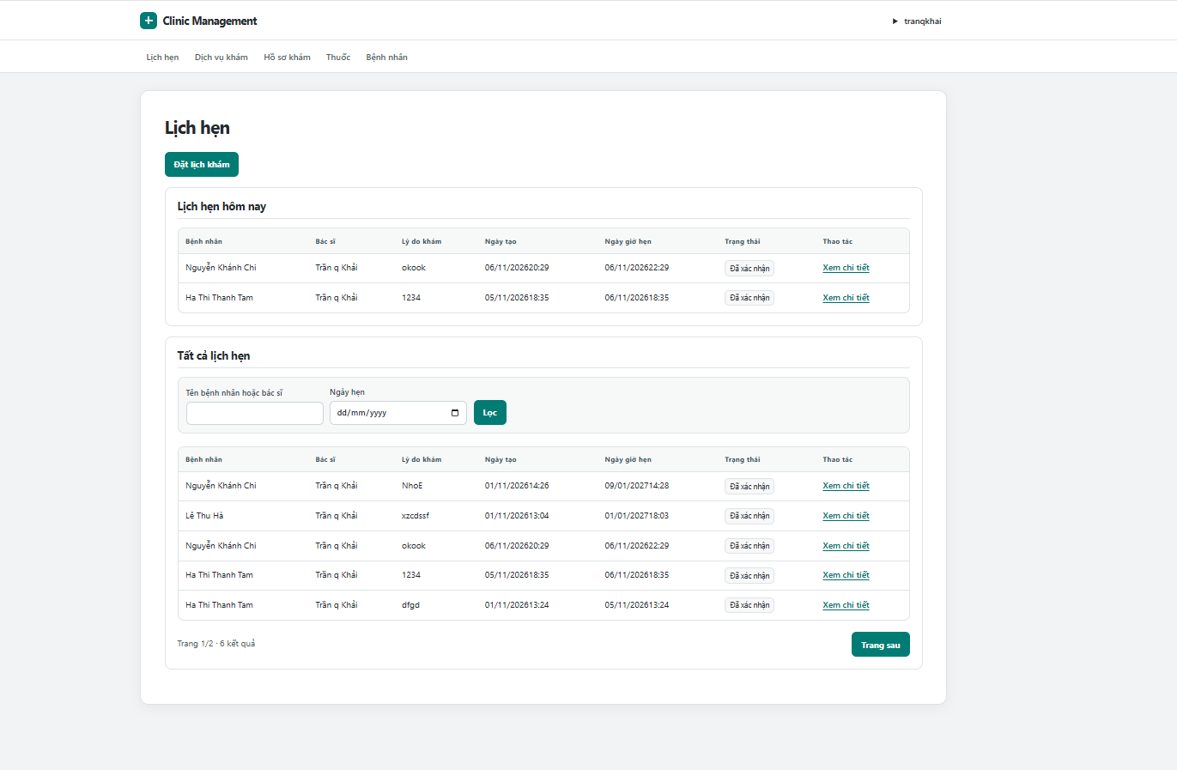
Figure 10 Review assigned appointments
Flow: Open Appointments. Review the appointments for today and the full assigned list. Search by name or date and select View details for an appointment.

UC 10 Create an appointment for a patient
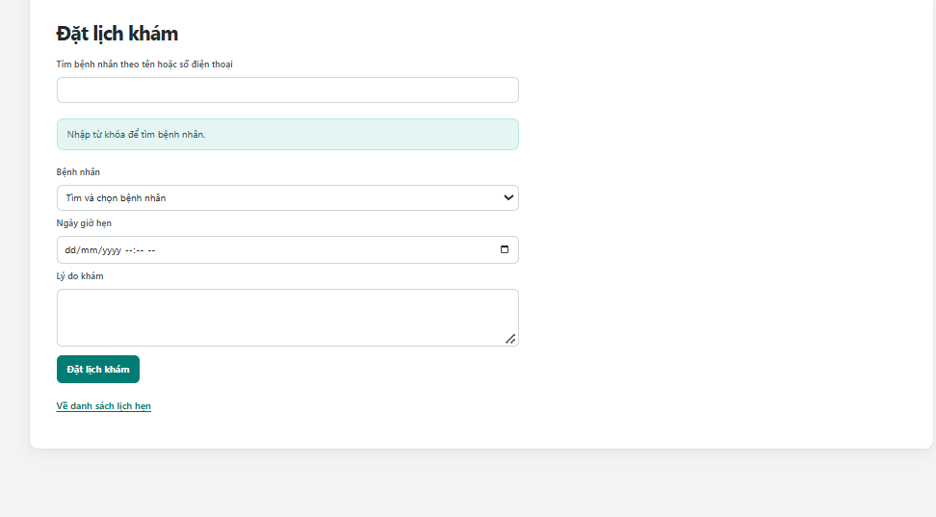
Figure 11 Create an appointment for a patient
Flow: Select Book appointment. Search for and select a patient, enter a future date and time and a reason, then submit. The signed in doctor is assigned automatically and duplicate times are rejected.

UC 11 Review and confirm an appointment
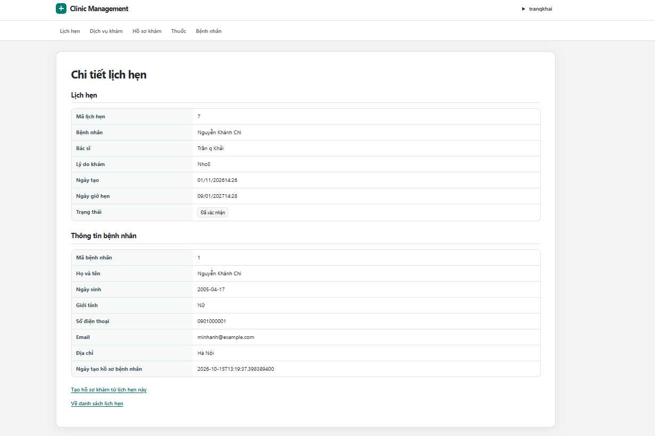
Figure 12 Review and confirm an appointment
Flow: Open an assigned appointment. Review its time, reason and patient information. If its status is BOOKED, select Confirm to change it to CONFIRMED.

UC 12 Add a service
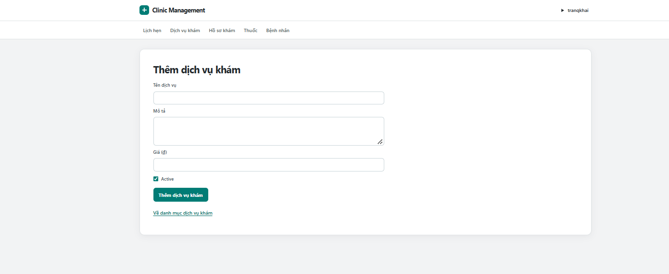
Figure 13 Add a service
Flow: Open Services and select Add service. Enter the service name, description and price, choose its active status, then submit. The service is added to the catalog.

UC 13 Edit a service
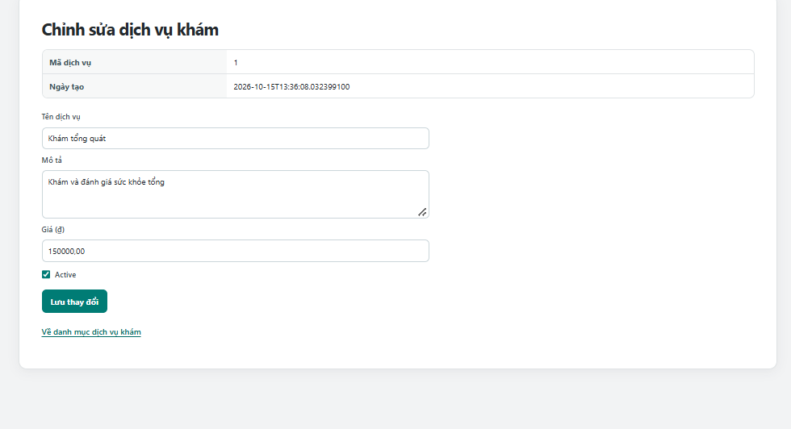
Figure 14 Edit a service
Flow: Select Edit for a service. Change its name, description, price or active status, then save. The catalog is updated while prices already saved on visit lines are retained.

UC 14 Browse the medicine catalog
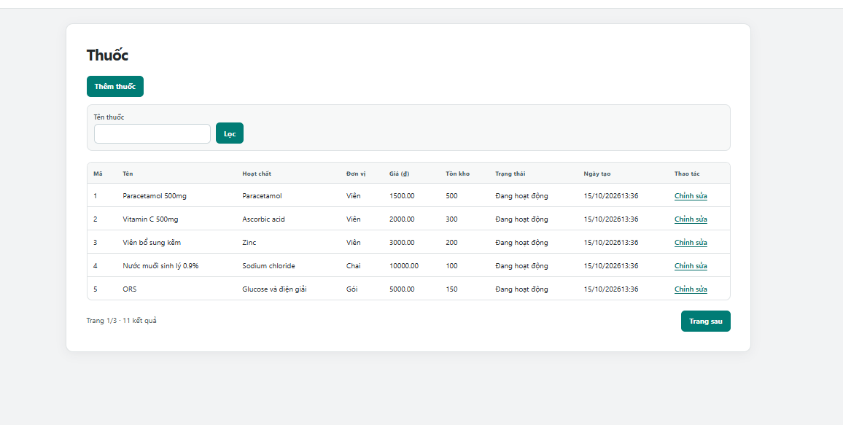
Figure 15 Browse the medicine catalog
Flow: Open Medicines. Search by medicine name and select Filter. Review the price, stock and active status, or choose Edit for a medicine.

UC 15 Add a medicine
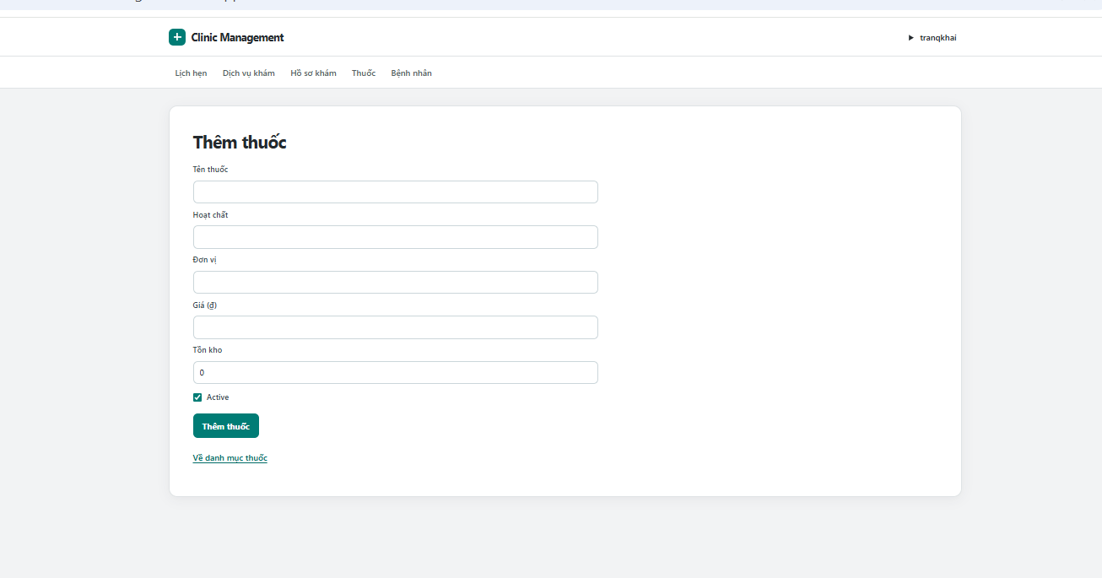
Figure 16 Add a medicine
Flow: Select Add medicine. Enter its name, ingredient, unit, price and nonnegative stock, choose active status, then submit. The system validates and saves the medicine.

UC 16 Edit a medicine
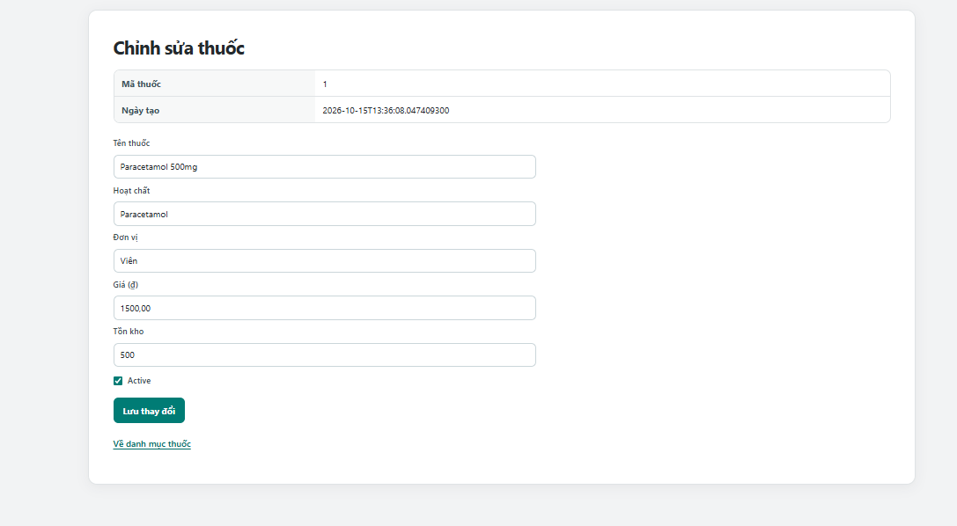
Figure 17 Edit a medicine
Flow: Select Edit for a medicine. Update its information, price, stock quantity or active status. Select Save changes to update the catalog entry.

UC 17 Register a patient profile
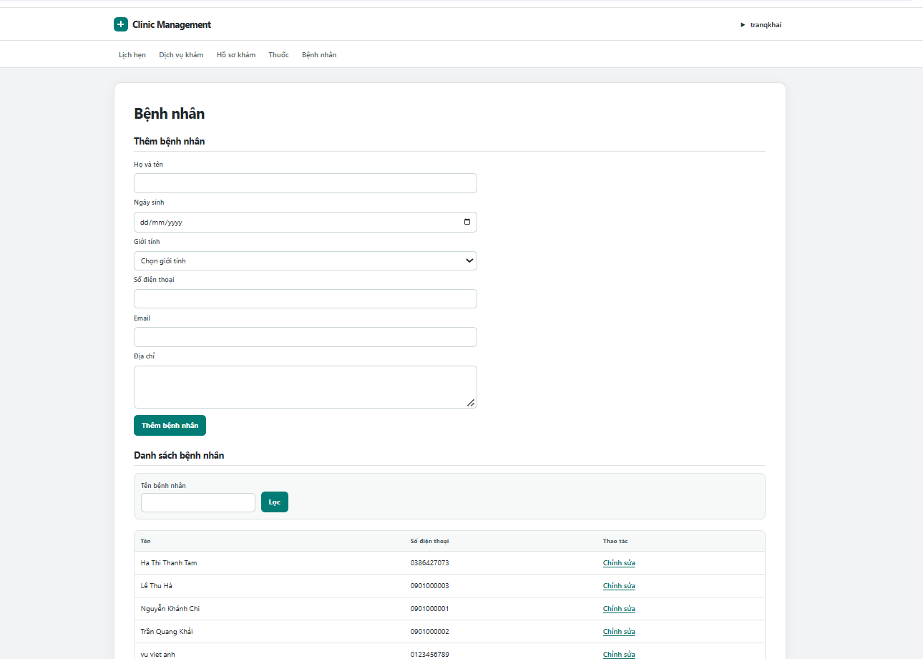
Figure 18 Register a patient profile
Flow: Open Patients. Enter the patient name, contact information and optional birth date, then select Add patient. The system checks the phone number is unique and adds the profile to the list.

UC 18 Edit patient information
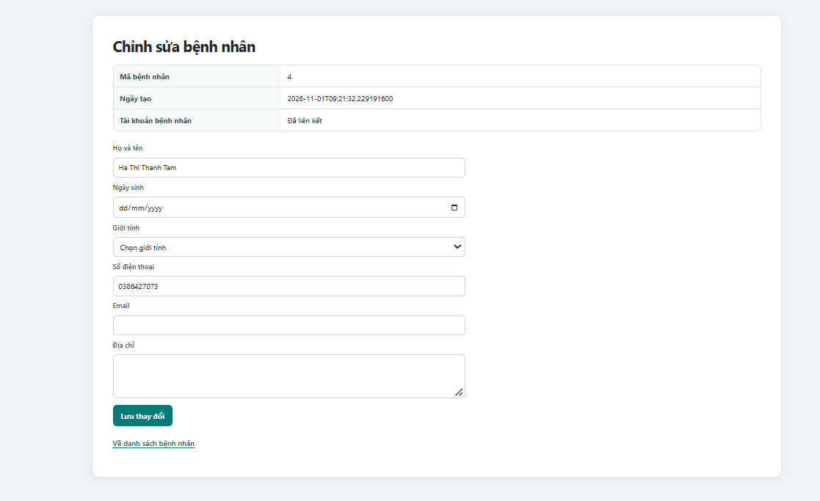
Figure 19 Edit patient information
Flow: Select Edit beside a patient. Update the personal and contact fields, then save. Valid information replaces the profile details; the linked account is unchanged.

UC 19 Browse assigned medical records
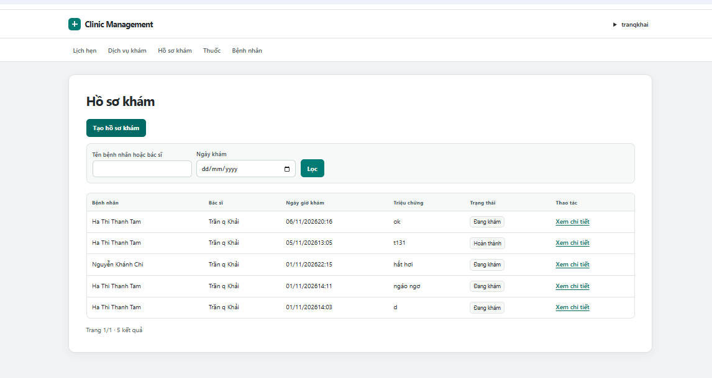
Figure 20 Browse assigned medical records
Flow: Open Medical records. Search by patient or doctor name, or filter by visit date. Select View details to open an assigned record.

UC 20 Create a medical record
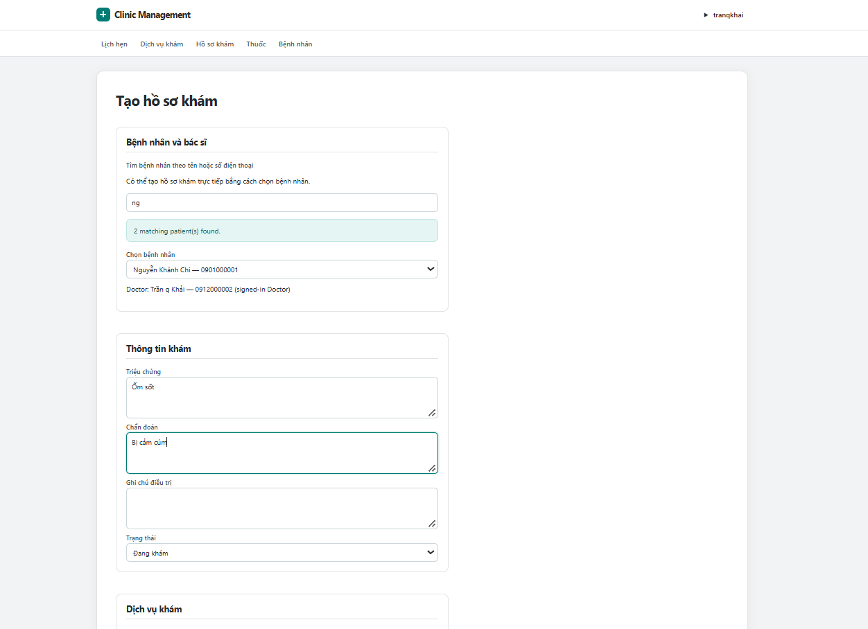
Figure 21 Create a medical record
Flow: Select Create medical record, or open the creation link from an appointment. Select the patient when needed and enter symptoms, diagnosis and treatment notes. Save to create an IN_PROGRESS visit record.

UC 21 Add visit services and prescription items
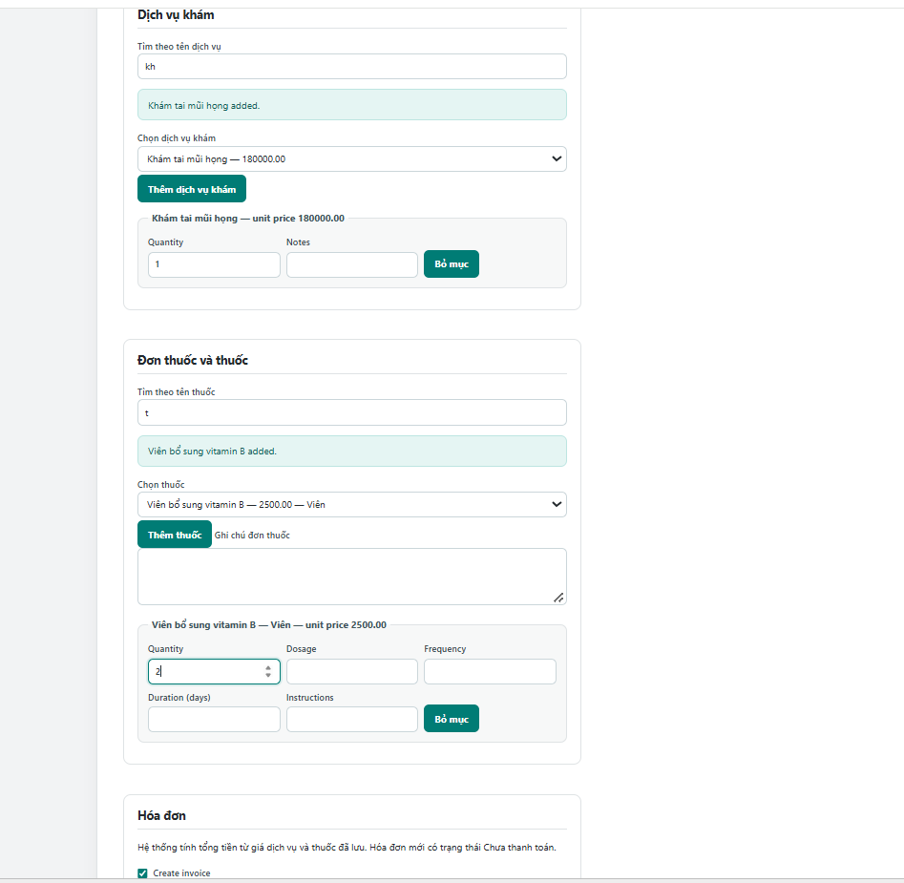
Figure 22 Add visit services and prescription items
Flow: Search for and select active services and medicines. Add quantities and medicine instructions; remove unwanted lines. Save the record; selecting Create invoice also generates an unpaid bill from the saved prices.

UC 22 Save clinical notes and confirm payment
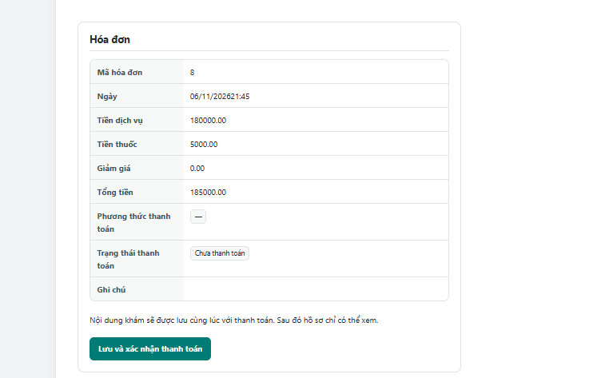
Figure 23 Save clinical notes and confirm payment
Flow: Review the unpaid invoice and finish the clinical notes. Select Save and confirm payment. One transaction saves the notes, marks the invoice PAID and completes the medical record; failures roll back the changes.

2 4 MANAGER workflows
Screenshot account: phamkhanhlinh.

UC 23 Review clinic revenue
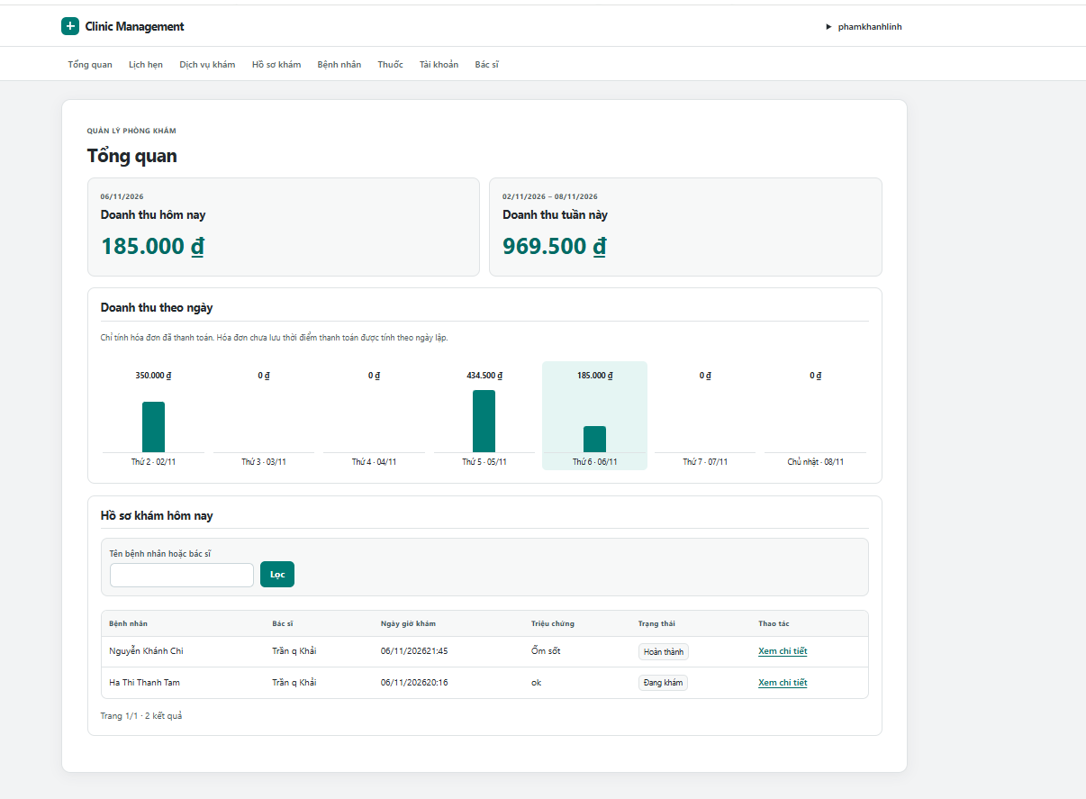
Figure 24 Review clinic revenue
Flow: Open Overview. Review paid invoice totals for today and the current week, together with the daily chart. Search the records for today and select a record to see its details.

UC 24 Review clinic appointments
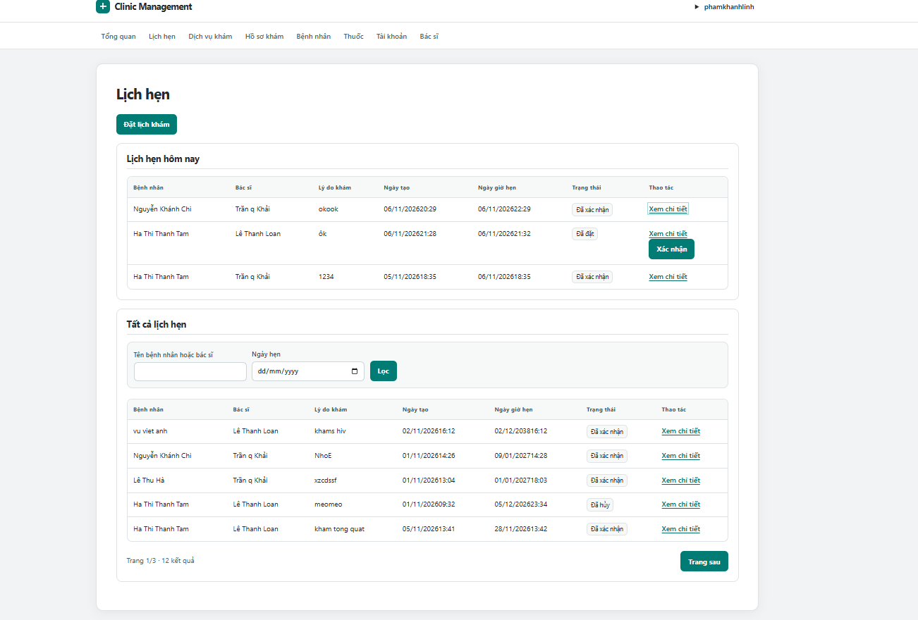
Figure 25 Review clinic appointments
Flow: Open Appointments. Review appointments for all doctors, including the list for today. Filter by name or date, open details and confirm a BOOKED appointment when appropriate.

UC 25 Schedule a clinic appointment
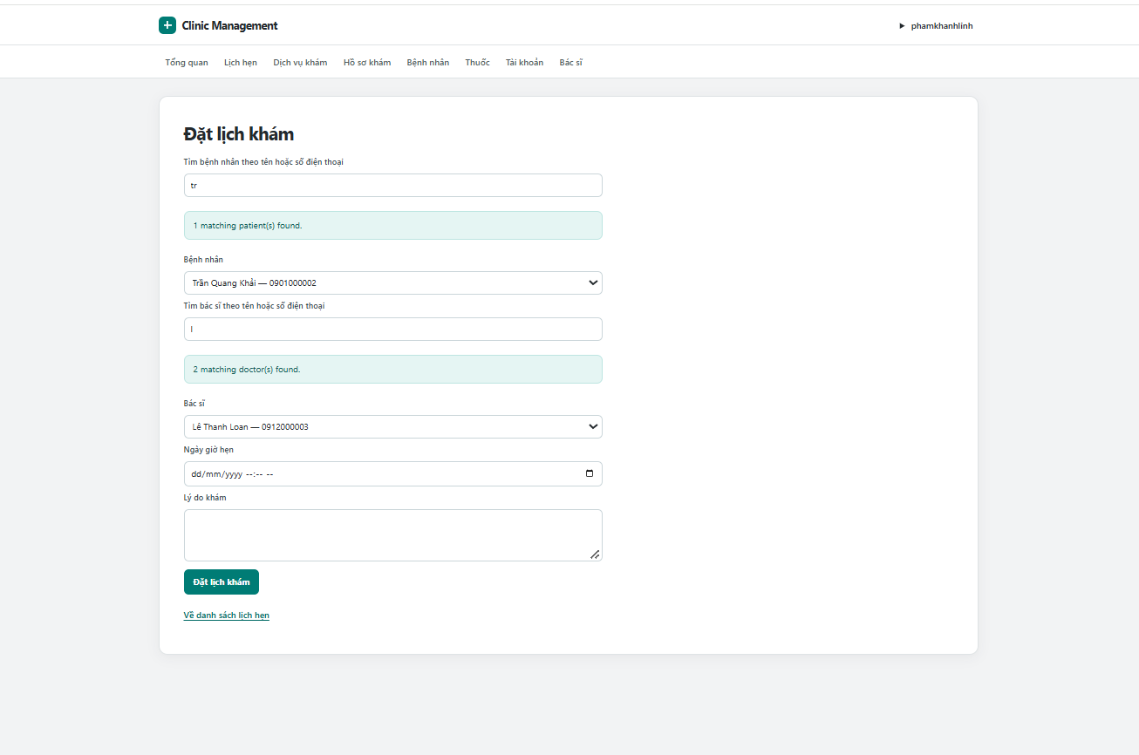
Figure 26 Schedule a clinic appointment
Flow: Select Book appointment. Search for and select both a patient and an active doctor. Enter a future time and reason, then submit; the system checks both schedules before saving.

UC 26 Browse user accounts
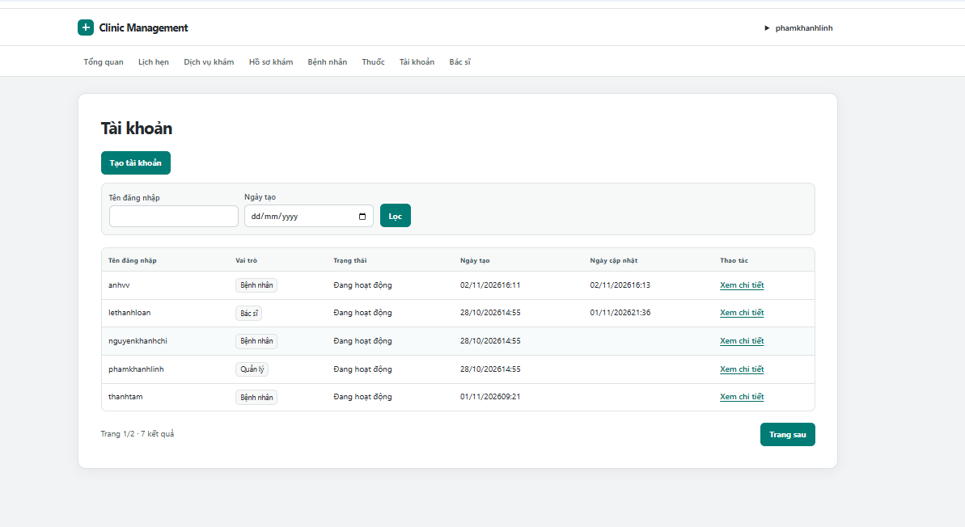
Figure 27 Browse user accounts
Flow: Open Accounts. Search by username or filter by creation date, then review the results. Select View details to inspect the account and access its update form.

UC 27 Create a user account
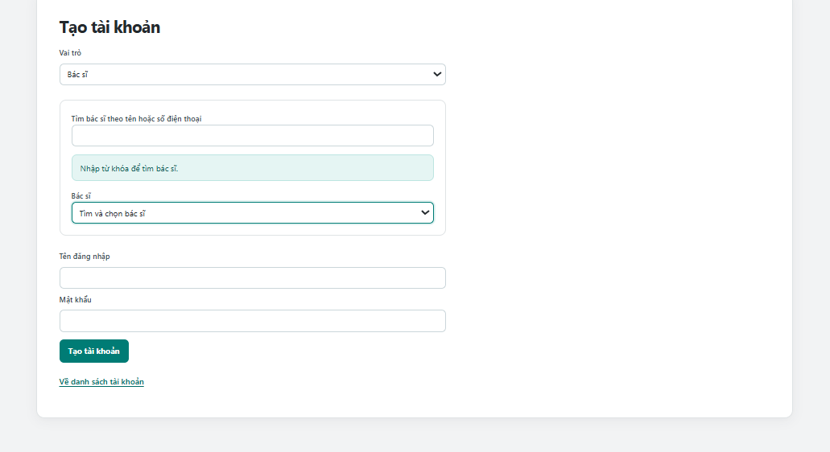
Figure 28 Create a user account
Flow: Select Create account and choose a role. For PATIENT or DOCTOR, search for and select an unlinked profile. Enter username and password, then submit to create the account and link the profile in one transaction.

UC 28 Browse doctor profiles
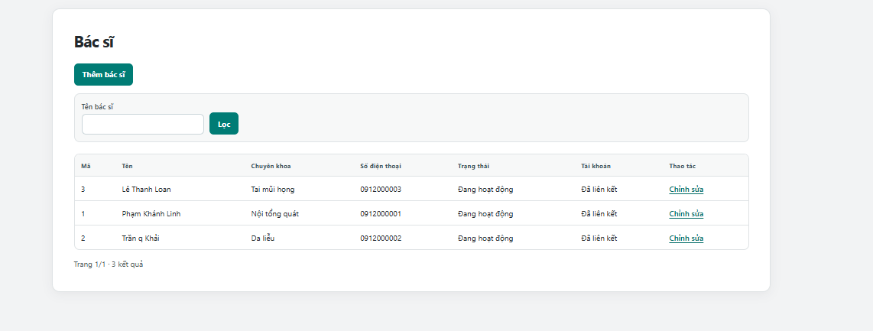
Figure 29 Browse doctor profiles
Flow: Open Doctors. Search by doctor name and review specialty, active status and account linkage. Select Edit to update a doctor or use Add doctor to create a new profile.

UC 29 Add a doctor profile
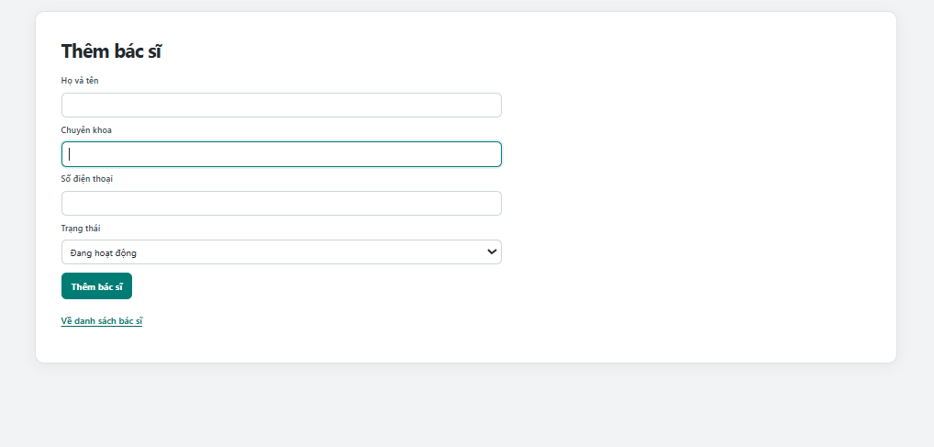
Figure 30 Add a doctor profile
Flow: Select Add doctor. Enter the full name, specialty, phone and active status, then submit. To enable sign in, create a DOCTOR account separately and link it to this profile.
Managers also use the shared patient, service, medicine, medical record and payment functions. In account details, they can change a username, reset a password or update active status.

III Project Contribution
The project work covers database design, Servlet and DAO implementation, JSP interfaces, role checks and verification of appointment and payment flows. The report presents the completed work at team level.

IV Appendix

4 1 Setup
- Use Java 17, Tomcat 10.1 and SQL Server.
- Create the database with ClinicTableGenerate.sql and load ClinicSEEDdata.sql in the clinic database.
- Configure the database connection in WEB-INF/ConnectDB.properties, build the WAR and deploy it to Tomcat.

4 2 Business rules
- Usernames and patient phone numbers must be unique.
- New appointments require an active doctor and a future time. A BOOKED or CONFIRMED appointment blocks the same exact time for that doctor or patient.
- Patients may cancel only their own future BOOKED appointments.
- A visit may have no appointment, but an appointment cannot have two medical records.
- Quantities must be positive; prices and stock cannot be negative. Invoice totals use saved item prices.
- Once an invoice exists, its service and medicine lines cannot be changed through the visit form.
- Payment saves the submitted clinical notes and updates the invoice and medical record in one transaction. Completed records are read only.

4 3 Verification and limits
Java and JSP compilation passed. The regression suite contains 18 payment checks and 7 appointment checks using JDBC test doubles. These checks do not verify concurrent requests on a live SQL Server.
Current limits include no online payment gateway, no automatic stock deduction or prescription issuance, and no automatic completion of the linked appointment after payment. Appointment conflicts use exact times rather than visit durations. Password hashing and immediate session revocation after account deactivation remain pending.
The medical record form displays a cancellation choice, but ordinary saving does not yet apply that selection. Staff rescheduling, cancellation of confirmed appointments and invoice correction are not implemented.

