Meeting Summary
Summary Date: November 21, 2025

Timelines (Times are in Eastern time (GMT-5) unless otherwise noted):
06/24/2025, 15:20:29 Aryan Hi, Nitish.
06/24/2025, 15:20:30 Neerav ABC Hello, Aryan. Thank you so much for initiating this bridge.
06/24/2025, 15:20:34 Aryan Can you tell me why you're trying to contact us?
06/24/2025, 15:20:42 Neerav ABC We have a global number starting with plus one and the Atos desk number we used in the past.
06/24/2025, 15:20:55 Aryan You can reach us by calling the service desk.
06/24/2025, 15:21:03 Aryan If you ask them to raise a P1 and need to initiate a bridge, the service desk can contact us. There is an option, blind option 7. If you call the service desk number, just blindly press it.
06/24/2025, 15:21:17 Neerav ABC Can you share this service number 121?
06/24/2025, 15:21:21 Aryan I'll do that after the call; tell me what is the issue?
06/24/2025, 15:21:27 Neerav ABC It's a high critical site in the US. It's a factory site, and everyone is focused on it. We received an incident and checked that both of the AB are not reachable. Praveen confirmed a power issue at the site. On-site persons are checking because it was related to building electricity that made the circuit breaker trip. We need to initiate a bridge and send the notification as per the process.
06/24/2025, 15:22:50 Aryan Hi, Praveen. Thanks for joining the call. Is the entire factory down right now?
06/24/2025, 15:22:58 Praveen It's down. The network is down.
06/24/2025, 15:23:00 Aryan Shared the following in the chat: MIM Bridge initiated. Critical Site is isolated with network.-INC02222
06/24/2025, 15:23:03 Praveen The whole plant lost power for 10 or 15 minutes. When it came back, the telco room where some network gear is, the power is still bad. They're trying to figure out why. The factory itself is running with lights and power. It's just that one room where some equipment is totally down, meaning their entire network is down.
06/24/2025, 15:23:27 Aryan What applications are getting impacted?
06/24/2025, 15:23:37 Neerav ABC All the applications.
06/24/2025, 15:23:38 Praveen It's for that one site. All the applications.
06/24/2025, 15:23:39 Aryan OK.
06/24/2025, 15:23:41 Neerav ABC Obl. S.
06/24/2025, 15:23:47 Aryan Right now, as you have confirmed that the power is back and still the Internet is not up. Neerav, what are you investigating? What else are we doing now?
06/24/2025, 15:24:02 Neerav ABC We are just waiting for confirmation from the onsite users if they have checked everything is back.
06/24/2025, 15:24:10 Praveen No. Nothing's back because the entire network is down.
06/24/2025, 15:24:14 Neerav ABC I was just referring to the network room, especially the network devices.
06/24/2025, 15:24:16 Praveen The electricians are looking into the problem. We're helpless until the electricians get the power back in that room.
06/24/2025, 15:24:50 Aryan Sorry, I missed that. Praveen, you're saying the power is up now or is the electrician still working on that?
06/24/2025, 15:24:59 Praveen Let me say it one more time; the main power in the building is up. There is one room in the building where the power has failed; it is the room where we have some of our network equipment. The electricians are trying to resolve that now. That's why the whole network is down.
06/24/2025, 15:25:13 Aryan OK. For your information, I have elevated this ticket to a major incident and will send a notification.
06/24/2025, 15:25:29 Praveen Very good.
06/24/2025, 15:25:35 Aryan Praveen, can you confirm with the electrician how much time they will take approximately?
06/24/2025, 15:25:41 Praveen They have not given me an ETA; I'll try to find out.
06/24/2025, 15:25:47 Aryan OK, fine. Sure. Thank you.
06/24/2025, 15:30:44 Neerav ABC I can see the board devices are showing up to me. I'm logging into the devices to check. In the meantime, you can check with the site users as well.
06/24/2025, 15:31:03 Praveen I'll do some checking.
06/24/2025, 15:31:11 Aryan Thank you, Goutham, for joining the call. As a recap, this is a critical site. There is a power failure at the site, and when the power came back, there is a network room that still has some power issues. Praveen informed us that the electrician was working on that, and due to that, the network devices went down, and the site got isolated completely. We have raised this up. Neerav confirmed that the devices are back up.
06/24/2025, 15:31:41 Goutham OK.
06/24/2025, 15:31:46 Aryan All is checking on that and validating.
06/24/2025, 15:31:51 Goutham Thank you. Do we have the site ID?
06/24/2025, 15:31:59 Neerav ABC Yes, we have the site ID, it's XXXX.
06/24/2025, 15:32:03 Goutham XXXX, OK. Got it. Thanks.
06/24/2025, 15:32:04 Neerav ABC Devices are up from the last 7 minutes; they made the adjacency, and most tunnels are up.
06/24/2025, 15:36:34 Aryan Praveen, can you confirm when the site went down?
06/24/2025, 15:36:45 Praveen Stand by. I'll put it in the chat.
06/24/2025, 15:37:13 Aryan This is 2:42, Eastern Time, correct?
06/24/2025, 15:37:57 Praveen Yes, I just put the GMT in the chat; it started at 2:42 PM local time. Devices started to ping at 3:29 PM.
06/24/2025, 15:38:01 Aryan I'll put this as a start time.
06/24/2025, 15:38:33 Praveen Can you check all devices on site, Neerav, to ensure they all came up?
06/24/2025, 15:38:46 Neerav ABC Yes, Bol, I'm just checking on them.
06/24/2025, 15:38:52 Praveen Thank you.
06/24/2025, 15:39:56 Aryan Praveen, you're confirming that at 3:29 PM, the devices started working, and users at the site can log in or use their operations?
06/24/2025, 15:40:09 Praveen I'll check with them. I haven't talked to the end users yet, but I'll reach out to a couple of guys.
06/24/2025, 15:42:04 Praveen We are checking all their services, so just stand by.
06/24/2025, 15:42:10 Goutham Is the site having just one power source, or are the devices connected to one power source? Can we check that in parallel?
06/24/2025, 15:42:34 Praveen We'll have to check that and ask them afterwards. It should be part of the problem ticket. I think a major issue from the substation caused the power to be down.
06/24/2025, 15:42:43 Goutham Got it. Praveen, do you have the count of users impacted on the site?
06/24/2025, 15:47:23 Praveen I do not know.
06/24/2025, 15:47:26 Goutham OK.
06/24/2025, 15:48:20 Neerav ABC I have seen multiple switches, and all were power rebooted, but now they are reachable. Some are left, and I will update soon.
06/24/2025, 15:48:36 Goutham Thanks, Neerav.
06/24/2025, 15:58:00 Praveen Shared the following in the chat: ABs not registering to the controller: AB US-01111ab-04, on switch -sw00; AB US-01111ab-45, on switch -sw09; AB US-01111-12, on switch -sw07.
06/24/2025, 16:06:00 Gautham Shared the following in the chat: Current status ======================== Network devices in Floura Site went down due to Power issues.
06/24/2025, 16:34:00 Praveen Shared the following in the chat: it's ab-02, not ap-07
06/24/2025, 16:46:00 Chandhan ABC Shared the following in the chat:
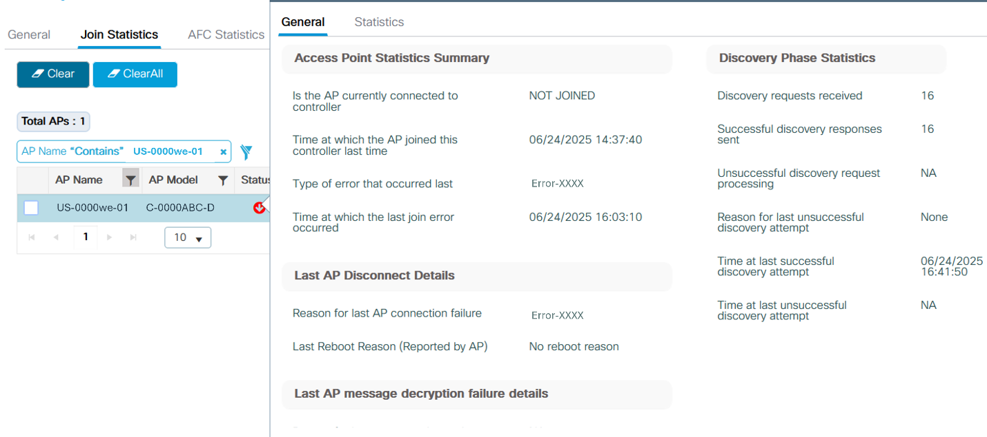

06/24/2025, 16:55:00 Neerav ABC Shared the following in the chat: obc-7111-sw01#sh crb ne X ------------------------- Device ID: UB-01111ab-45 Entry address(es): IP address: 111.XX.XXX.XX IPv6 address: AB12::7XX1:XXXXAAA:1AAA (link-local) Platform: ABCDE ABC-AB1111-A-B9, Capabilities: OOO Trans Interface: X, Port ID (outgoing port): QQQ Holdtime : 122 sec
06/24/2025, 17:10:00 Aryan Shared the following in the chat: Issue resolved MIM Closed. Problem ticket - PRB001111

Action Items
Action Item | Team
Check all devices on site to ensure they all came up after the power issue. | ABC Team

Key Observations
- A P1 incident was raised due to a critical site in the US experiencing a network outage caused by a power issue.
- A major issue from the substation caused the power to be down, and it should be part of the problem ticket.
- Problem ticket PRB001111 was discussed as a high priority issue.

